Does improvement in irrigation technologies of winter wheat (Triticum aestivum L.) improve both, water and energy, productivity: case study from the Fergana valley
Annual Report 2015
International Water Management Institute
Abstract
Improved irrigation technologies are one of the options of adaptation to growing water shortage conditions. This study, carried on loam soils of Fergana Valley with groundwater of 1.5-2 m deep, analyzed the impact of introducing improved irrigation technologies on water and energy productivity for three varieties of winter wheat. The findings of the study indicate that improvements in irrigation technologies may produce gains in water productivity for high yielding varieties of winter wheat, only. The study found that increasing water productivity by improving irrigation technology is not necessary results in increased energy productivity except of high yielding varieties of winter wheat.

Introduction

For the last 20 years the share of water allocated for agricultural purposes in Central Asia has reduced from 90% to 83%. Growing demand from non-agricultural water uses is the main challenge creating pressure on water available for agriculture. Since 1992, increased demand for energy and the shift of the upstream reservoir in the Syrdarya River from irrigation to hydropower generation mode caused reduction of water available for irrigation in average by 2 km³/year. The similar risk exist in the Amudarya River basin. Climate change may also effect on future water availability for agriculture. Central Asia is referred to be highly vulnerable to climate change and adaptation programs under development (World Bank, 2009)¹. Over the last 70 years, the air temperature in the Central Asia has increased by 0.029 ºC per year while precipitation exhibited high multi-annual and multi-decadal fluctuations. It is already caused reduction of the volume of glaciers by third in the upstream of the Syrdarya River and Amudarya River. One of the ways of mitigating the competition for water for food and water for energy is to reduce the energy intensity and to improve water and energy productivity in agriculture.
The agriculture of Uzbekistan, one of the Central Asian countries, is heavily dependent on energy inputs generated from fossil resources. The crop production system is characterised by the intensive use of inorganic fertilizers, pesticides and water for irrigation. Planning to conserve energy and water for supplying the food needs of the growing population requires a comprehensive study of energy-water usages in agriculture. This study analyses energy and water productivities of winter wheat, one of two most important crops in Uzbekistan. Previous studies were limited to estimation of the crop energy or water requirements. In this study it was hypothesized that there is high interrelation between water productivity and energy productivity. The objective of this study was better understanding water productivity and energy productivity linkages for purposes of improving irrigation water management.
The experimental field scale approach, applied in this study, to improve water use efficiency was focused on exploring improved irrigation technologies for new varieties of winter wheat. Winter wheat is the most important cereal grown in Central Asia, mainly used for making bread. Whereas worldwide about 65% of the produced wheat originates from irrigated agriculture, in Uzbekistan, virtually all winter wheat is cultivated on irrigated land (FAO and WFP 2000). Proper farming practices can contribute to meeting grain quality standards. During the past 22 years, the area under irrigated cereals in Uzbekistan is increased more than seven times from 221,000 ha to about 1.6 million ha, and gross yields rose from 1.54 in 1991 to 4.46 t/ha in 2012 (Uzbekistan Statistical collection, 2013). Improving irrigation water supply played important role in increasing the yield of winter wheat. Winter wheat was sown in October and harvested in mid-June. The duration of the wheat grown period is 255-265 days with about 2800ºC sum of positive temperature requires for maturing wheat grains. The harvesting period takes place in summer in June when maximum temperatures cause high evaporation losses. Analyses of water and energy productivity become important under new environment with reducing water available for agriculture.

- Study area
The study was conducted in Fergana valley, Central Asia where the total amount of surface water available in the range of 14-15 km³ per annum (Karimov, Molden, 2011) (Fig. 1). Kyrgyzstan, Tajikistan and Uzbekistan are the countries sharing borders within the valley. Farming practices for winter wheat cultivation were monitored in 2014-2015 at the Gulomjon Mashrab Ugli farm, Komiljon Umarov Mirob Water Users Association, Toshloq district, Ferghana province. The soil of the farm is loam in the top 0-30 cm underplayed with sandy loams; groundwater is 1.5-2.0 m deep. The farm is located at latitude of 40º31’59.9’’N, longitude of 71º47’4.1’’E and elevation of 461 m (Fig. 1). The farmer has 43.8 ha of land and specialized on growing mainly cotton (23 ha), winter wheat (20.8 ha) and vegetables as a second crop after harvesting of winter wheat if irrigation water is available. The main source of irrigation is the canal water and groundwater. There is unreliable water supply from the canal because the farm is located in its’ tail ends.
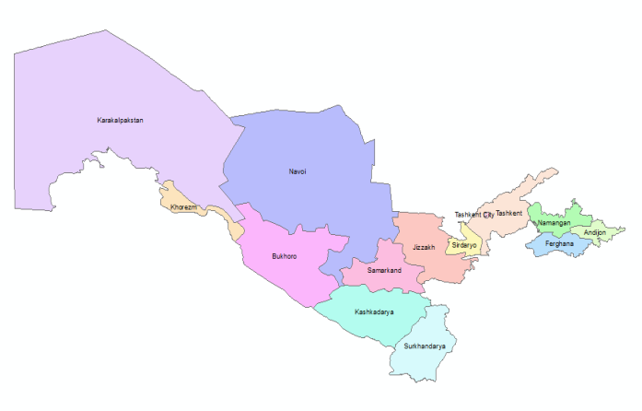
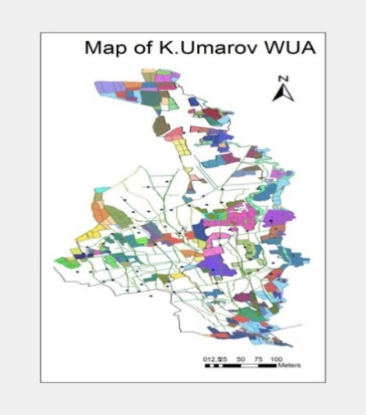
Fig. 1. Map of the Komiljon Umarov WUA
Climate of the study area is arid continental; the average summer temperatures varies from 26-30ºС and the maximum temperature reaches 45-47ºC, whereas the winter temperatures fall below 0ºС. Long-term annual precipitation ranges from 200 to 250 mm, with 90% occurring from October through May. Soil texture is loam in the top 30 cm underplayed with sandy loams. Soil bulk density has wide range from 1.38 (±0.03) Mg m⁻³ in the top arable layer, increasing to 1.52(±0.02) Mg m⁻³ at the soil layer of 15-30 cm and in range of 1.43-1.48 Mg m⁻³ in the layer 50-100 cm (Table 1).

Table 1. Physical properties of the soil at the Gulomjon Mashrab Ugli farm
Depth | SBD | Clay | Silt | Sand | Texture
Cm | kg/cm³ | %
0-15 | 1.38(±0.03) | 14.6(±1.3) | 38.3(±0.1) | 47.1(±1.2) | Loam
15-30 | 1.52(±0.02) | 14.3(±1.1) | 39(±2.9) | 46.8(±4) | Loam
30-50 | 1.44(±0.02) | 6.7(±.2) | 23.1(±3) | 70.2(±2.8) | Sandy Loam
50-75 | 1.48(±0.03) | 3.9(±.4) | 19.6(±5.5) | 76.6(±6) | Loamy Fine Sand
75-100 | 1.43(±0.05) | 3.2(±.4) | 25.4(±3.6) | 71.4(±4) | Sandy Loam

Major nitrients content in the soil profile is given in Table 2.

Table 2. Content of organic carbon and total NPK in the soil profile
Depth, cm | SOC* | N % | P % | K %
0-15 | 0.61(±.04) | 0.08(0) | 0.16(0) | 0.41(±0.08)
15-30 | 0.61(±.04) | 0.07(±.01) | 0.14(±0.01) | 0.36(±0.06)
30-50 | 0.46(±.18) | 0.05(±0.02) | 0.11(±0.01) | 0.33(±0.03)

*soil organic carbon

Data given in Table 2 indicates that the soil organic carbon stocks to a depth of 50 cm were 121.5 t/ha, N – 14.46 t/ha, P – 29.65 t/ha and K – 79.55 t/ha.

- MATERIALS AND METHODS

Farming practices

The experiment was laid out in fall 2014 with three varieties of winter wheat – ‘Nota’ from Russia and two locally breaded varieties, namely ‘Elomon’ and ‘Hisorak’. Three irrigation technologies tested for each variety of winter wheat were as follows: farmer furrow irrigation practices; cutback irrigation and alternate furrow irrigation. The experiment randomized against irrigation technologies had three replications. The total area under trial was 1.3 ha. Furrows were 0.6 wide and 100 m long. Irrigation applications were measured using trapesidial weirs Chippoletti at entry and runoff points. In addition irrigation application at furrows were measured using triangle weirs Thomson. Seeds were applied using tractor T-28 with rate of 275 kg/ha.

Energy Analysis
Energy Coefficient for Various Sources of Energy

Each agricultural input has its own energy values and energy is invested to produce individual component. These individual energy inputs may be in the form of labor, machinery, fuel etc. Analysis of energy coefficients of winter wheat were based on energy equivalents available in published international papers and local recommendations (Table 3). It was noted that the estimates of energy equivalents (EE) used in international and local studies are close. In this study the estimates of EE found in the local studies were applied to calculate energy values of the inputs.

The energy values used in this study are the dietary energy values of agricultural outputs obtained from fossil energy spent to grow winter wheat. The energy inputs can also be classified into direct - indirect, renewable- non-renewable energy forms (Thakur and Makan, 1997, Mandal et al., 2002).^{6,7} The direct energy consists of human power, tractor and electric motor. The total energy is the combination of direct energy and indirect energy from seeds of crops, fertilizers and chemicals used in crop production processes. The renewable energy component consists of human labor, farm yard manure (FYM), and irrigation water, while non-renewable energy consists of diesel, electricity, fertilizers and chemicals.

Table 3. Energy equivalents for farming inputs
Inputs |  | Energy equivalent (MJ/unit) | Reference | Energy equivalent (MJ/unit) | Reference
Human Labour (h) |  | 1.96 | Sing et al. (2002).⁸ | 1.86 | ISO 13600. ¹⁶
Machinery (h) |  | 13.06 | Ozkan et al. (2004). ⁹ | 55
Chemicals (fertilizer [kg]) | Nitrogen | 60.6 | Sing et al. (2002). ⁸ | 86.6 | I.P. Kondrakhin et al. (n.d.). ¹¹ available: http://www.info.  crimea.edu  /crimea/ac/kant  /3_6.html
 | Phosphorus | 11.1 |  | 12.6
 | Potassium | 6.7 |  | 8.3
Chemicals (pesticide [kg]) | Insecticide | 199 | Helsel (1992). ¹⁰ | 253.2
 | Fungicides | 92 |  | 116.6
 | Herbicides | 238 |  | 263.6
 | Sulfur | 68.2 | I.P. Kondrakhin¹¹ | 68.2
Farmyard manure |  | 0.3 | Rafiee et al. (2010). ¹² | 0.42
Diesel-oil (L) |  | 56.31 | Sing et al. (2002). ¹ | 42.7
Electricity (Kwh) |  | 10.59 | Acaroglu and Aksoy (2005). ¹³ | 8.7 | GOST R 51750-2001.¹⁷
Water for irrigation (m3) |  | 0.63 | Yaldiz et al. (1993). ¹⁴
Output (Wheat, kg) |  | 14.7 | Sing (2002), Ozkan et al., 2007.⁸
Output (Straw, kg) |  | 9.25 | Tabatabaeefar et al. 2009.¹⁵
*

Energy Conversion. For this study, the following procedures of energy conversion were adopted:
Human Labor. To estimate the energy input, working days of agricultural workers were recorded on hourly base. Then, the human power (man-hours) was converted into energy inputs by multiplying the number of man hours and estimated power rating of human labour (Khan and Singh, 1996).¹⁸
Electric Motors. The pump installed on the thirtary canal, supplied water for irrigation is operated by electricity. Electricity used in irrigation was recorded. The output of electric motor was calculated by the product of rated power of the electric motor, time consumed in operation and load factor. The load factor is equal to actual electricity consumed (read from energy meter) during operation over electricity consumed at rated power (Khan and Singh, 1996). ¹⁴⁸
Diesel Engines and Tractors. Fuel usage for each farming practice was monitored at the pilot farm. The output of tractor and diesel engine was calculated by the product of fuel consumed by tractor or diesel engine, time spent, caloric value of the fuel and load factor. The load factor is the ratio of actual fuel consumed and fuel consumed at rated power (Khan and Singh, 1996). ¹⁸
Seed, Fertilizer, Agro-Chemicals and Farm Yard Manure. Agro-chemicals use rate was monitored at the pilot farm. The chemical fertilizers, FYM and other agro-chemicals used in crop production were transformed into energy equivalent by multiplying the quantity of the material used in the plots with the energy value of each material (Khan and Singh, 1996). ¹⁸
Energy Efficiency, Energy and Water Productivity. In this study, energy efficiency, energy productivity and water productivity for winter wheat production were calculated. Energy efficiency is estimated as ratio of total energy output (KWh) to total energy input (KWh). Energy productivity estimated as grain yield (kg/ha) to total energy input (KWh) and water productivity as grain yield to amount of water applied (m³/ha).

- Results
4.1. Farming inputs
Soil tillage
Field data on soil tillage during winter wheat growing season is given in Table 4
Table 4. Inputs used for soil tillage
Applied farming practices |  |  |  | Human labour (ha/hour) | Machinery (ha/hour) | Diesel (l)
Tillage
Date | Farming practice | Tractor | Device
10/5/2014 | Interrow cultivation | T-28 | Cultivation (KTU-4) | 1.4 | 1.4 | 8
10/10/2014 | Interrow cultivation | T-28 | Cultivation (KTU-4) | 1.4 | 1.4 | 8
10/18/2014 | Sowing seeds | T-28 | SUS+KTU-4 | 12 | 3 | 8
Total |  |  |  |  | 5.8 | 24

Two inter-row cultivations were applied before sowing of wheat in fall 2014.
Manual work
The farmer used human labor for cleaning irrigation ditches and cleaning field from the steams of cotton harvested in fall 2014 (Table 5).
Table 5. Manual farming practices
Date | Farming practices | Labour number |  | Human labour (ha/hour)
 |  | Temporary | Permanent
10/22/2014 | Cleaning irrigation ditches |  | 7 | 35
11/28/2014 | Cleaning field from cotton steams |  | 8 | 128
Total |  |  |  | 163

Irrigation applications
Dates and rates of the irrigation applications are given in Table 6.
Table 6. Irrigation application dates and rates
Irrigation practices applied (per ha) |  |  |  |  |  |  | Labour intensity (ha/hour) | Electricity (kW/h) | Water (m3)
Irrigation events | Date | Irrigation application |  |  |  | Energy consumption
 |  | Source | Irrigation applied | m³ | Tailwater | kW
Farming practices
1 | 10/22/2014 | Pump | 856 | 736 | 120 | 103 | 10 | 103 | 736
2 | 03/08/2015 | Pump | 1004 | 794 | 210 | 120 | 10 | 120 | 794
3 | 04/19/2015 | Pump | 706 | 610 | 96 | 85 | 10 | 85 | 610
4 | 05/04/2015 | Pump | 748.5 | 683 | 66 | 90 | 8.5 | 90 | 683
5 | 06/03/2015 | Pump | 992 | 861 | 131 | 119 | 8 | 119 | 861
 |  |  | 4306 | 3683 |  | 517 | 47 | 517 | 3683
Cutback irrigation
1 | 10/22/2014 | Pump | 856 | 736 | 120 | 103 | 10 | 103 | 736
2 | 03/08/2015 | Pump | 1004 | 794 | 210 | 120 | 10 | 120 | 794
3 | 04/19/2015 | Pump | 292 | 292 | 0 | 35 | 10 | 35 | 292
4 | 05/04/2015 | Pump | 318 | 318 | 0 | 38 | 8 | 38 | 318
5 | 06/03/2015 | Pump | 492 | 492 | 0 | 59 | 8 | 59 | 492
 |  |  |  | 2632 |  | 355 | 46 | 355 | 2632
Alternate furrow irrigation
1 | 10/22/2014 | Pump | 856 | 736 | 120 | 103 | 10 | 103 | 736
2 | 03/08/2015 | Pump | 1004 | 794 | 210 | 120 | 10 | 120 | 794
3 | 04/19/2015 | Pump | 614 | 492 | 122 | 74 | 10 | 74 | 492
4 | 05/04/2015 | Pump | 587 | 543 | 43.75 | 70 | 7.2 | 70 | 543
5 | 06/03/2015 | Pump | 513 | 446 | 67 | 62 | 7.2 | 62 | 446
 |  |  |  | 3011 |  | 429 | 44.4 | 429 | 3011

Water was pumped from secondary canal using pump. In total, fiver irrigations were applied with 3683 m³/ha of water under conventional practices, 2632 m³/ha under cutback furrow irrigation and 3011 m³/ha under alternate furrow irrigation. Net irrigation rate was 3166 m³/ha under conventional practices, 2277 m³/ha under cutback furrow irrigation and 2582 m³/ha under alternate furrow irrigation.
Fertilizers
Fertilizer applications are given in Table 7.
Table 7. Fertilizer application under winter wheat
Fertilizer application |  |  | Labor intensity (ha/hour) | Machinery intensity (ha/hour) | Diesel (l/ha) | Active ingredient
 |  |  |  |  |  | Fertilizer (kg/ha)
Date | Fertilizer | Quantity applied (kg/ha) |  |  |  | Nitrogen | Phosphorus | Potassium
12/15/2014 | Carbamide | 100 | 10 | 0 | 0 | 46
1/18/2015 | Superphosphate | 500 | 1.8 | 0.6 | 3 | 55 | 120
2/20/2015 | Selitra | 500 | 1.8 | 0.6 | 3 | 170
15/03/2015 (Suspension) | Carbamide | 8 |  |  |  | 3.68
 | Superphosphate | 5 |  |  |  | 0.6 | 1.4
 | Potassium | 3 |  |  |  |  |  | 1.8
22/03/2015 (Suspension) | Carbamide | 8 |  |  |  | 3.7
 | Superphosphate | 5 |  |  |  | 0.6 | 1.4
 | Potassium | 3 |  |  |  |  |  | 1.8
Total |  |  | 13.6 |  |  | 279.5 | 122.8 | 3.6

Weed and insect control
Weed and insect control data is given in Table 8.
Table 8. Weed and insect control

Date | Pesticide | Quantity applied (g/ha) | Device used | Labor intensity (ha/hour) | Machine (ha/hour) | Herbicide (kg/ha) | Insecticide (kg/ha) | Diesel (l/ha)
 |  | 20 | T-28/OVX | 1.2 | 0.6 | 0.02 |  | 3
 |  | 100 | T-28/OVX | 1.2 | 0.6 |  | 0.1 | 3
Total |  |  |  | 2.4 | 1.2 | 0.02 | 0.1 | 6

4.2. Water and energy productivity
Water and energy productivity estimates for winter wheat variety Nota is given in Table 9.
Table 9. Water and energy productivity for winter wheat variety Nota.
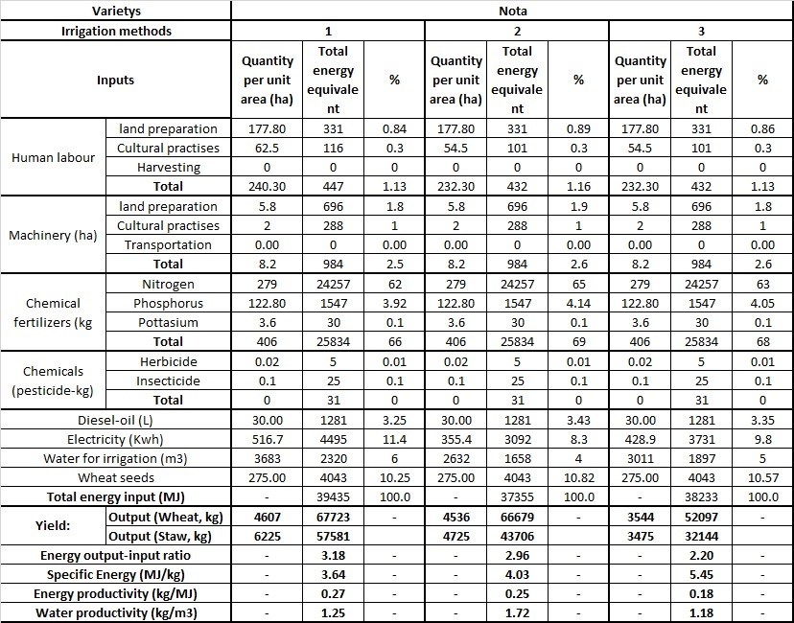
- Farming furrow irrigation; 2- cutback furrow irrigation; 3- alternate furrow irrigation

Data presented in Table 9 shows that with improving irrigation technologies, Nitrogen based energy input share in total energy inputs is increasing from 63 to 69%, electricity based energy input for water lift is reducing from 11 to 4%. Energy output-input ratio was at maximum level under conventional farming practices, and minimum under alternate furrow irrigation. While water productivity was at highest level under cutback irrigation, energy productivity was still high under conventional irrigation practices.

Water and energy productivity for winter wheat variety Hisorak is given in Table 10.
Table 10. Water and energy productivity for winter wheat variety Hisorak
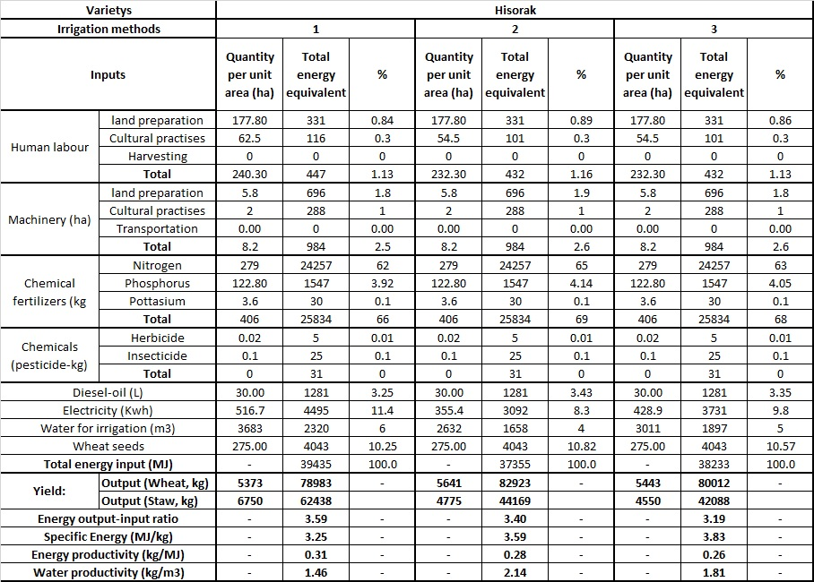
- Farming furrow irrigation; 2- cutback furrow irrigation; 3- alternate furrow irrigation

Data presented in Table 10 shows that with improving irrigation technology for wheat variety Hisorak Nitrogen based input is increasing from 62 to 65%, electricity based input is reducing from 11 to 8%. Energy output-input ratio was at maximum under conventional farming practices, and minimum under alternate furrow irrigation. While water productivity was at highest level under cutback irrigation, energy productivity was still high under conventional irrigation practices.

Water and energy productivity for winter wheat variety Elomon is given in Table 11.
Table 11. Water and energy productivity for winter wheat variety Elomon
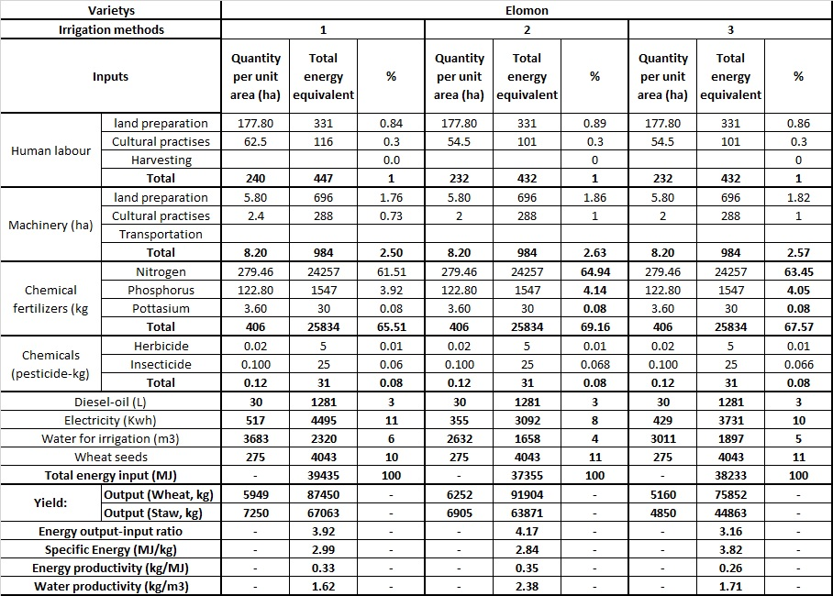
Data given in Table 11 shows that for high yielding variety Elomon, with improving irrigation practices, Nitrogen based energy input share is increasing from 62 to 65% of total energy input. Electricity based inputs are reducing from 11 to 8%. Energy output-input ratio was at maximum under cutback furrow irrigation, and minimum under alternate furrow irrigation. Water and energy productivity was at highest level under cutback irrigation.
Summary table of water and energy productivity as affected by variety of winter wheat and irrigation technology is given in Table 12.

Table 12. Water and energy productivity under different irrigation technologies
Variety | Irrigation technology | Energy output-input ratio | Specific energy | Energy productivity | Water productivity
 |  |  | MJ/kg | kg/MJ | kg/m³
Nota | Farming practices | 3.18 | 3.64 | 0.27 | 1.25
Nota | Cutback irrigation | 2.96 | 4.03 | 0.25 | 1.72
Nota | Alternate furrow irrigation | 2.20 | 5.45 | 0.18 | 1.18
Hisorak | Farming practices | 3.59 | 3.25 | 0.31 | 1.46
Hisorak | Cutback irrigation | 3.40 | 3.59 | 0.28 | 2.14
Hisorak | Alternate furrow irrigation | 3.19 | 3.83 | 0.26 | 1.81
Elomon | Farming practices | 3.92 | 2.99 | 0.33 | 1.62
Elomon | Cutback irrigation | 4.17 | 2.84 | 0.35 | 2.38
Elomon | Alternate furrow irrigation | 3.16 | 3.82 | 0.26 | 1.71

The data presented in Table 12 indicates that introducing high yielding varieties has significant impact on improving energy output-input ratio, energy and water productivity. Gains in water productivity resulted in gains in energy productivity only for high yilding variety of winter wheat. Improvements in irrigation technologies resulted in improved energy output-input ratio only for high yielding variety of winter wheat.

Conclusions

Introducing water saving irrigation technologies allows improving energy/output ratio, reducing specific energy, increasing energy and water productivity for high yielding varieties of winter wheat. Low yielding varieties of winter wheat, with improving irrigation technologies, did not produce gains in energy productivity. The study found that increasing water productivity by improving irrigation technology did not result in increased in energy productivity except of high yielding variety Elomon. This indicates that improvements in technologies of using other inputs is to be considered along with improving irrigation technologies and introducing new high yielding varieties of winter wheat. System approach is required to improve both, energy and water productivity. Further studies are required to make recommendations on improving water and energy productivity at WUA level for different cropping systems.

References
- World Bank (2009). Adapting to Climate Change in Europe and Central Asia. available: http://www.worldbank.org/eca/climate/ECA_CCA_Full_Report.pdf
- Karimov, A., Molden, D., Platonov, A., Khamzina, T. (2011) From improved water accounting to increased water productivity in the Fergana valley. ICID 21st Congress, Tehran, October 2011 R.56.1.11
- Thakur, C.L. and G.R. Makan. 1997. Energy scenarios of Madhya Pradesh (India) agriculture and future requirements. Energy Conver. and Mgt. 38(3): 237-244.
- Mandal, K.G., Saha, K.P., Ghosh, P.K., Hati, K.M. and Bandyopadhyay, K.K. (2002). Bioenergy and economic analysis of soybean-based crop production systems in central India. Biomass Bioenergy 23(5): 337–345.
- Singh H, Mishra D, Nahar NM (2002). Energy use pattern in production agriculture of a typical village in Arid Zone India (Part I). Energy. Conversion. Manage. 43: 2275–2286.
- Singh H, Mishra D, Nahar NM, Ranjan, M (2003). Energy use pattern in production agriculture of a typical village in Arid Zone India (Part II). Energy Conversion and Management. 44:1053–1067.
- Ozkan B, Akcaoz H, Fert C (2004). Energy input output analysis in Turkish agriculture. Renewable Energy. 29:39-51.
- Helsel ZR (1992). Energy in world agriculture. In: Energy and alternatives for fertilizer and pesticide use (Edit: RC Fluck). Vol. 6. Elsevier Science Publishing, pp: 177-210.
- I.P.Kondrahin. Science in Crimea Proceedings of the Crimean Academy of Sciences AGRICULTURE I.P.Kondrahin - BIOLOGICAL BASIS OF HIGH PRODUCTIVITY AND LIVESTOCK HEALTHI.P. available: http://www.info.crimea.edu/crimea/ac/kant/3_6.html
- Rafiee S, Mousavi avval SH, Mohammadi A. (2010). Modeling and sensitivity analysis of energy inputs for apple production in Iran. Energy, 35(8), 3301-3306.
- Acaroglu M, Aksoy AS (2005). The cultivation and energy balance of Miscanthus-giganteus production in Turkey. Biomass Bioenerg. 29:42-48.
- Yaldiz O, Ozturk HH, Zeren Y, Bascetincelik A (1993). Energy use in field crops of Turkey (Turkish). V. International Congress of Agricultural Machinery and Energy. 12–14 October. Kusadası-Turkey.
- Tabatabaeefar A, Emamzadeh H, Ghasemi Varnamkhasti M, Rahimizadeh R, Karimi M. 2009. Comparison of energy of tillage systems in wheat production. Energy. 34: 41–45.
- GOST R ISO 13600-2011 technical energy systems. Basic (Dokipediya: GOST R ISO 13600-2011 technical energy systems. The main provisions) http://docipedia.ru/document/5144505
- Energy conservation. Methods for determination of energy capacity on production of output and rendering of services in technological energy systems. General principles. available: http://vsegost.com/Catalog/67/6713.shtml
- Khan M.A., Singh G., 1996. Energy inputs and crop production in Western Pakistan. Energy, 21: 45–53.

