Report on

“Implementation of micro irrigation system in dryland system”

June 2015

Krishna Reddy K,

Introduction:
In rural areas of South Asia, one of the biggest challenges is to move people out of poverty. Climate change and variability further influence the development of the rural sector hindering the agriculture sector. This is obviously means an impact on the lives and livelihoods of millions of farmers and farm labour. The small and marginal farmers are more vulnerable to the climate change because of their limited adaptive capacity, socio-economic background and unfavourable policy environment. Nevertheless, there are many potential adaptation options available for exiting agricultural systems to meet the current climate risks (Palanisami et al 2015). It consists of the In situ soil and moisture conservation practices such as contour cultivation, contour bunding, border trenches, deep trenches in dryland orchards and ex situ practices such as development of check dams, percolation tanks, farm ponds on watershed basis.
Researchers reveal that farm pond technology is economically. Studies in Ananthapur and Kurnool districts of Andhra Pradesh show that water harvesting in a farm pond of size 271 m³ is useful for supplemental irrigation and is economically viable with a cost benefit ratio of 1.7 (Goyal et al, 1995). The results of supplemental irrigation in medium black soils at Bijapur over a period of 5 years indicate that crop yields with one life saving irrigation could be enhanced by 40-90%. The harvested runoff in farm ponds is costly and scarce commodity in dryland agriculture for supplemental irrigations. Adding technical inventions, such as drip kit to the farm pond can have higher efficiency of resource use.
On the other hand groundwater extraction for the supplemental source has become critical due to the frequent power cuts. Farmers in the Bijapur district has developed the system of water storage tanks by pumping groundwater and storing it for supplemental irrigations. The supplemental irrigations are provided through gravity or micro irrigation system. The economics of such double pumping are crucial for the policy making. However, cost benefits of such system depends on the crop selection, electricity charges, etc. which need to be sightseen. Hence, investments on different farm level investment options such as farm ponds, percolation ponds, open well irrigation with micro irrigation based accessories, and solar pumps has to be explored in detail. In Ananthapur district of Andhra Pradesh farmers have instigated the solar pump from the bore wells with the support of Rural Development Trust (RDT). But the economics of solar energy vs electricity and groundwater access in the long-run is not accessible for improving the intervention. Regional Agricultural Research Station, University of Dharwad, Bijapur is also testing the intervention of farm pond with solar energy and drip/sprinkler.
As a part of CRP dryland system program, Ananthapur, Kurnool districts from Andhra Pradesh and Bijapur from Karnataka were identified as action sites. Balaganur and Mannur villages from Sindagi taluk of Bijapur district were selected for the implementation of micro irrigation system management and capacity building program. Three farmers from the Balaganur and one farmer from Mannur were identified for the implementation purpose based on the water resources access. Farmers are growing vegetables (tomato, brinjal, onion) and orchard crop (Citrus, mango) in the villages. In Balganur, one farmer is identified for the solar pump with open well and drip irrigation (vegetables) flooding for sugarcane. The details of implementation plan in the district is presented in table 1.
Similarly, 7 farmers from Ananthapur and Kurnool districts were identified for the implementation. Micro irrigation in vegetables through groundwater and farm pond was taken up in the action sites. The details are presented in the table below.
Table 1: Implementation plan on micro irrigation in the action sites
 | Description | Crops | Area under each demonstration (acres) | Villages | District /State
1 | Timmaraju, – 6 acres,  Demo: Drip irrigation with irrigation schedule, fertigation and system maintenance | Vegetables | 0.5 | V.Bonthirala | Kurnool (AP)
2 | K.Madhava Raidu, 2 acres (chilly)  Demo: Drip with irrigation schedule, fertigation and system maintenance | Vegetables | 0.5 | V.Bonthirala | Kurnool (AP)
3 | Giddaiah, 3 acres (Marigold, tomato, g.nut)  Demo: Farm pond with drip kit | vegetables | 0.5 | Yerraguntla | Kurnool (AP)
4 | T.Nagarjuna, 5 acres (G.nut, sorghum, onion & carrot)  Demo: Drip with irrigation schedule, fertigation and system maintenance | Vegetables | 0.5 | Yerraguntla | Kurnool (AP)
5 | K.Ramanujamma, 4 acres (Mango, vegetables intercrop)  Demo: Drip with irrigation schedule and fertigation | vegetables | 0.5 | Mallapuram | Ananthapur (AP)
6 | B.K.Govindarajulu, 5 acres (groundnut)  Demo: High density mango plantation with drip, irrigation schedule and fertigation | Mango | 0.5 | Mallapuram | Ananthapur (AP)
7 | K.Chiranjeevi, (Mango)  Demo: Drip for vegetable crop as intercrop for mango | Vegetables/Mango | 0.5 | Mallapuram | Ananthapur (AP)
8 | Appanna Kolageri, 7ac (Tomato, Brinjal, Sugar cane)  Demo: Solar system connected with open well source and integrated with drip and flood irrigation | Vegetables, sugar cane | 7 | Balaganur | Bijapur (Karnataka)
9 | Vimala Honnapa Pasodi, (Mango, lemon, sapota)  Demo: Intercrop with drip vegetable | Vegetables | 1 | Balaganur | Bijapur (Karnataka)
10 | Amruth Siddappa jetagi (onion, brinjal, Tomato)  Demo: Drip with vegetables | Vegetables | 1 | Balaganur | Bijapur (Karnataka)
11 | Bhimappa Basappa Pujari, 7 acres (citrus, rainfed crops)  Demo: Drip with citrus (4 years old) | Citrus | 1 | Balaganur | Bijapur (Karnataka)

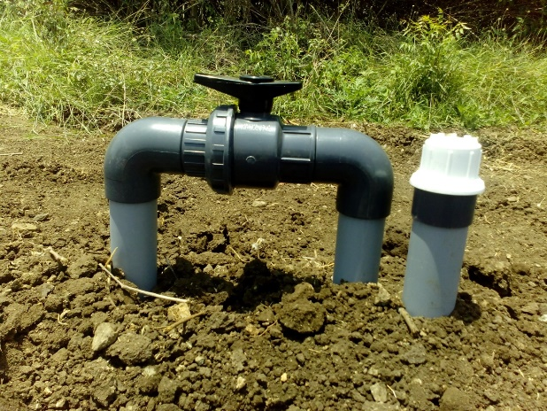
Pictures: Installation of drip and solar system
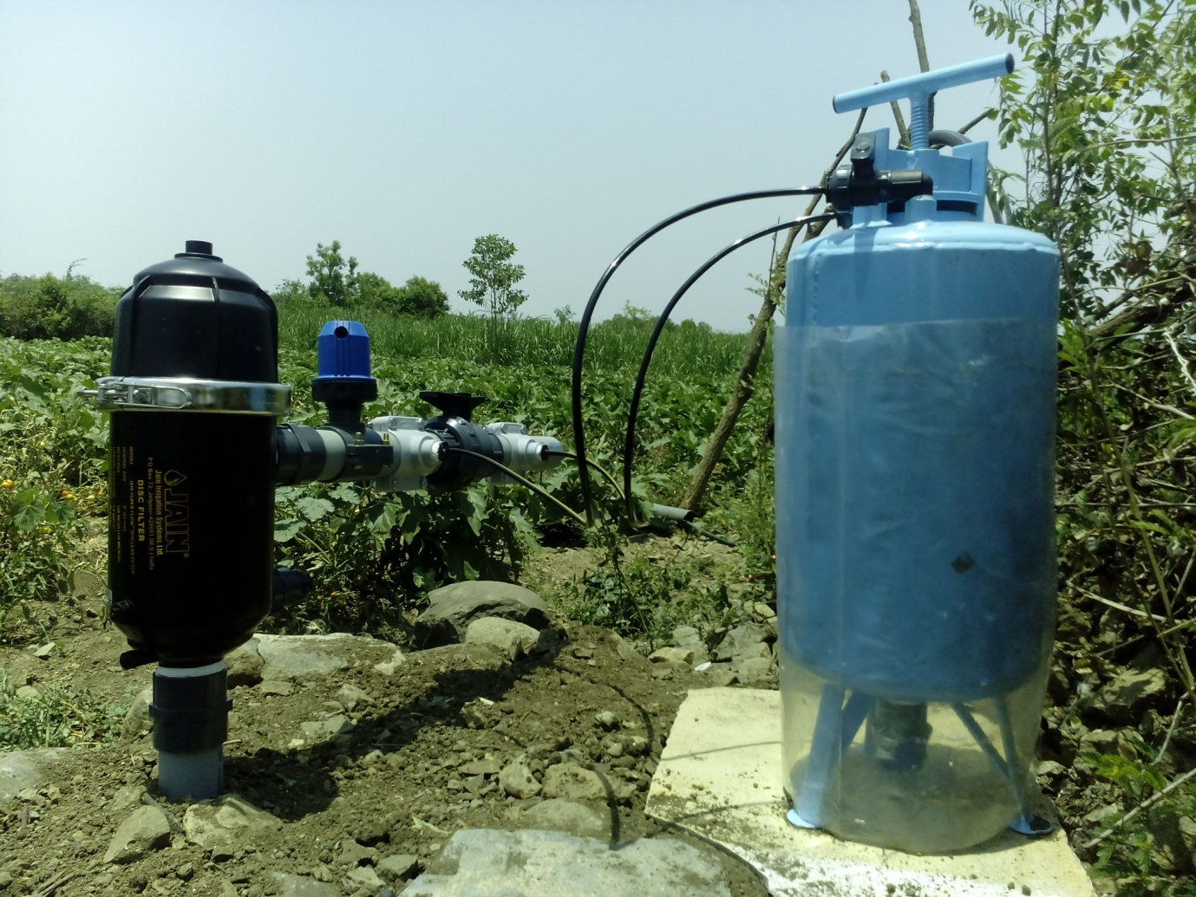
Filter and Fertigation tank installed for vegetables
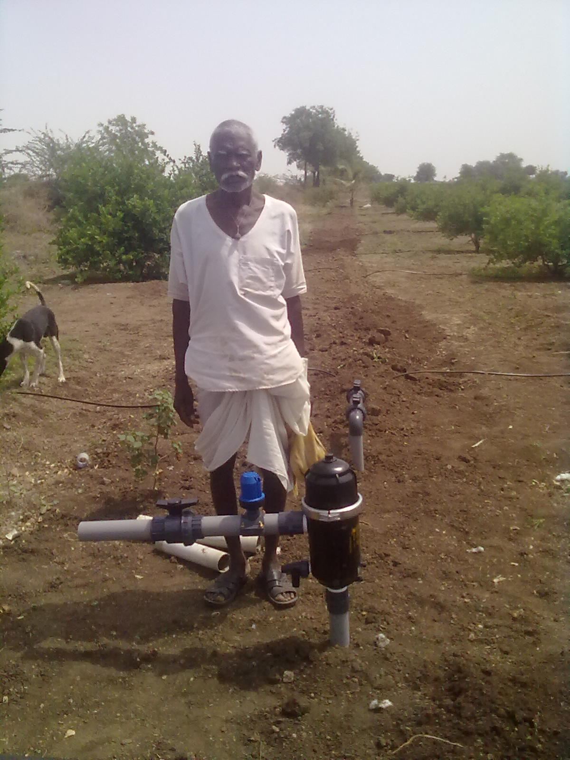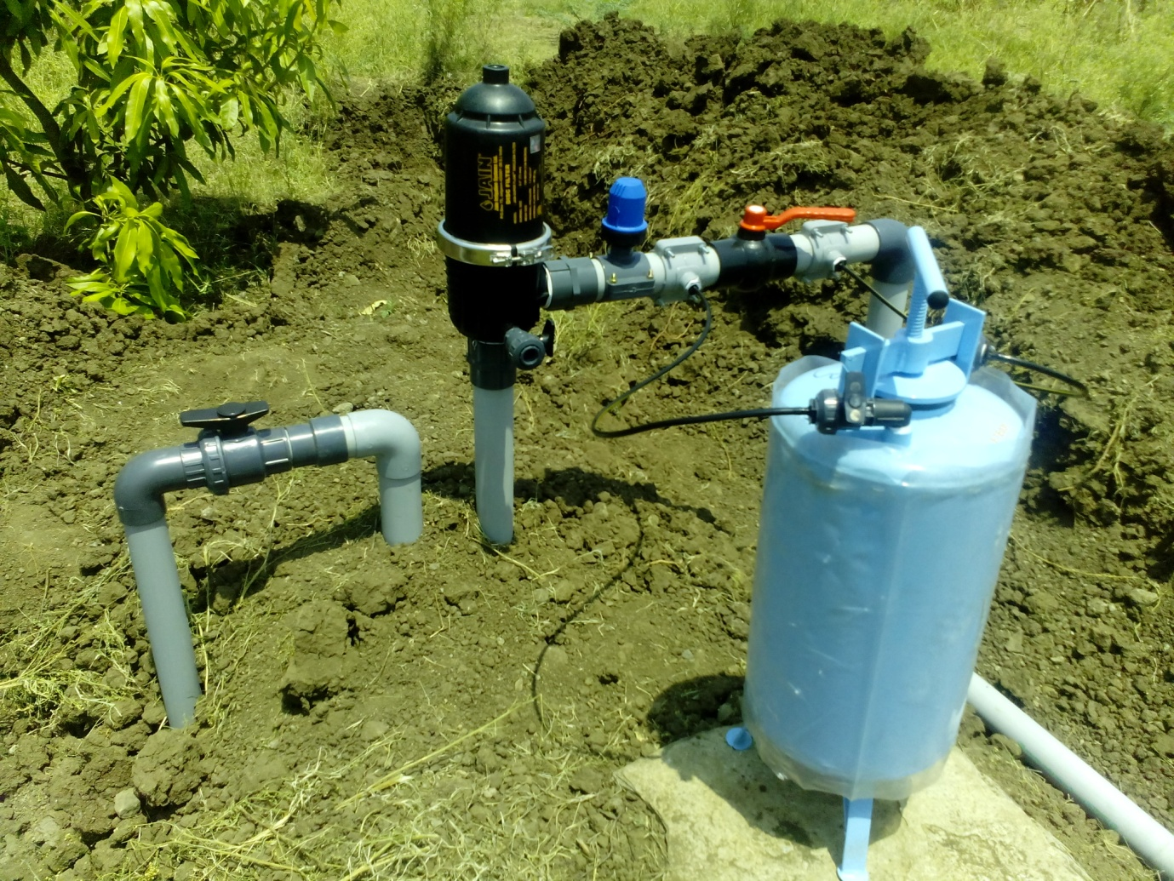
Drip installed for lemon crop in Bijapur
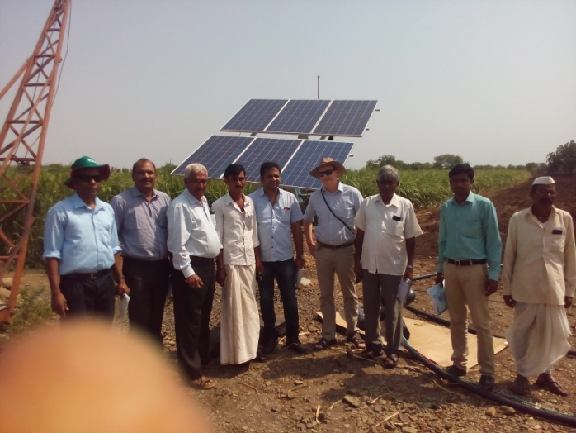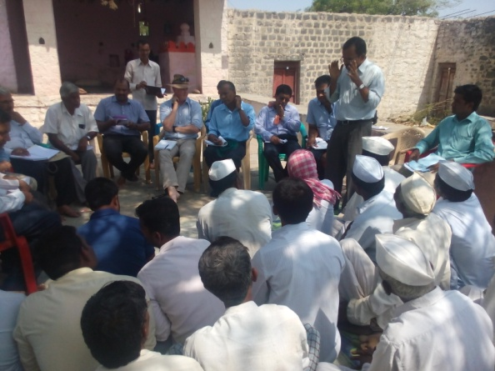
Solar drip farmers at Balaganur village, Bijapur on 03-06-2015 and awareness meeting

