Implementation report on

“Testing and dissemination of improved dual purpose crops”

June 2015

Michael Blummel and Y. Ramana Reddy
A field visit to Nandyal, Balaganur and Mannur villages of Bijapur was made on 2nd and 3rd June, 2015 under dry land research program to understand the mixed crop-livestock farming in dry land system of Vijayapura district, Karnataka. Purpose of visit include to forecast the crops to be sown by the farmers based on the rainfall pattern received from the ICRISAT weather center for the Kharif season of the year 2015 to make the farmers resilient for climate change. Interaction with farmers on cropping pattern and livestock revealed the following details:
Cropping pattern
Kharif: Red gram, green gram (if early rain fall), bajra (if early rain fall) cotton, maize (if irrigation available), sugarcane (if irrigation available), groundnut
Rabi: Mainly sorghum and chickpea
Pinnacle and 900 M are popular varieties/hybrids of maize in these villages (RARS scientist report).
Dharani variety of groundnut and maize NK 6240 will be provided to the farmers.
Dharani variety of groundnut (RDS, ICRISAT) and dual maize hybrid NK 6240 (ILRI) will be provided to the farmers for sowing in Nandyal and Balaganur villages where maize under irrigation and groundnut under rain fed are cultivated.
Interaction with farmers on livestock revealed that the dry land agricultural system is dominated by goats and drought animals followed by nondescript/indigenous cattle and buffalo cows. They are not keeping crossbred animals since their male calves are not suitable for draught purpose. Other reasons for not maintaining the crossbreds were labor, water and fodder shortage. Local Killari breed cows are maintained for bulls production. Buffaloes are mostly of non-descript type. The average milk yield in cattle and buffaloes ranges from 1-2 and 2-3.5 l/d. No village is selling the milk instead the three villagers are purchasing the milk daily (150-300 l) from the Karnataka Milk Federation due to shortage of milk availability in the village. Quantity of dry fodder offered daily per animal (cow/buffalo/bullock) was approximately 8 kg. Majority of the farmers are offering dry fodder without chopping where as few are chopping but to a size of 15-20 cm (Fig. 1) leading to wastage of about 25% (Fig. 2). Concentrate feeding was not practiced by the farmers except in Mannur village where homemade concentrate was fed to the large ruminants by some farmers only. Inter-calving interval in dairy animals ranged from 18 (cows)-24 (buffaloes) months. Among the small ruminants goats are more in number and is a good choice for dry land system as income proof against draught. Does of local non-descript goat breed (Fig. 3) has high prolificacy with 30% twinning and 15%, triplets in each kidding, respectively. The farmers asked for technology to increase reproductive efficiency in goats in order to improve their income and livelihoods in dry land farming system.

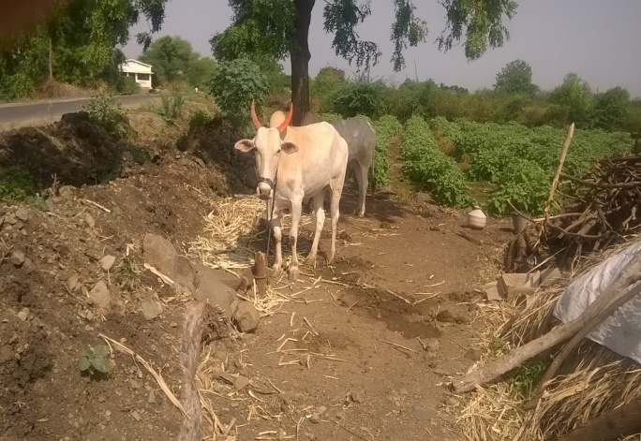
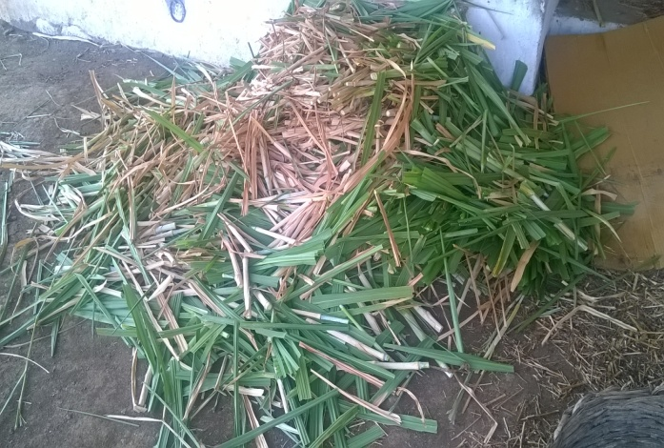
Fig. 1. Chopped green fodder (25-30 cm size) Fig. 2. Dry fodder feeding practice in nandyal village

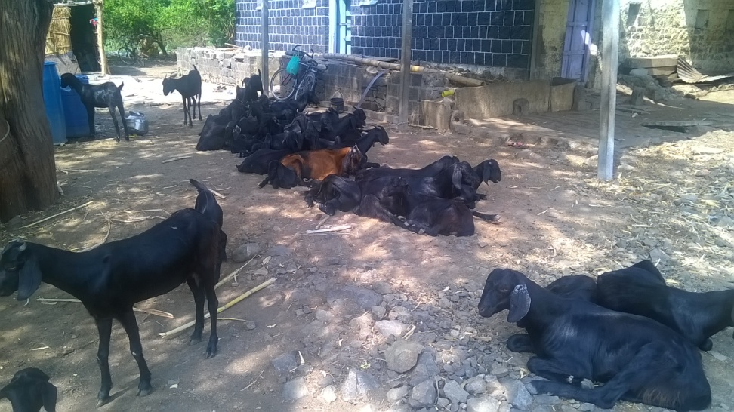
Fig. 3. Local goats rearing as a livelihood source in resilient dry land systems
Based on the interaction with the farmers, the following interventions/technologies may be considered to increase their resilience against climate change in dry land systems.
- Introduction of thermos-tolerant milch breed of cattle
- Challenge feeding of local cattle and buffaloes to test their production potential
- Intensive type of male kid rearing and bucks selection for exchange between villages
- Feed and fodder library for the dry land system
- Analyzing current feeding regimens and correcting if required
- Dual purpose crops for increased grain/pod and stover yields with high stover quality.
- Documenting wastage of dry/green fodder in the existing feeding practices and comparing with data after introduction of simple crop residue processing machines
- Dry/green fodder wastage with or without introduction of simple feed mangers (baskets)
- Documenting local goat breed performance and comparing with data after introduction of Sirohi bucks
- Development of indicators to measure resilience before and after the project work with definite scoring system
- Knowledge sharing and capacity building among the line departments and farmers on climate resilience to withstand dry spell years.
- Improving reproductive efficiency in cattle, buffaloes and goats (3 kiddings in two years) through feed and management.
ILRI activities for the year 2015
- Dissemination of dual purpose maize
- Development small scale business models around simple chaffing machines to promote improved crop residue utilization and reduce wastage of fodder resources

1. Dissemination of dual purpose maize

A dual purpose maize hybrid NK 6240 identified by ILRI through multi-dimensional crop improvement program with high stover quality without affecting the grain and stover yield were disseminated in Nandyal and Balaganur villages under rain fed dry land systems where maize is cultivated kharif season.
200 kg of seed was provided for dissemination in 10 ha area on a pilot scale. The advantage with dual maize is high stover digestibility and more grain/stover yield which results in improved income and livelihoods to the farmers besides quality stover for feeding their livestock which either reduces the fodder required to meet the energy for maintenance or results in improved milk production if the animal has genetic potential. In fact when stover with high digestibility was offered to buffaloes after fortification and densification resulted in 41% increase in milk production with cost benefit ratio of 1:6.

2. Development of small scale business models around feed and fodder

ILRI has identified two models of chaff cutters and a shredder with electric, diesel and tractor driven engines for developing small scale business models around feed and fodder to transfer the same to the field for piloting and scaling up. The details of chaff cutters are mentioned below:

Two pieces of SARDAR brand power driven chaff cutter machine with output capacity of 200kg/h (Fig. 4)
One pieces of UNISON brand tractor driven chaff cutter (a blower type machine). The output capacity is about 5000-6000 kg/h (Fig. 5).
Two pieces of TRAPP shredder (power/diesel operated model) with output capacity of 500-900 (Fig. 6) and 600-1200 kg/h, respectively
A protocol is going to be developed with the help of Agri-business incubator, ICRISAT for working out economics of each machine considering fixed and variable costs to identify to suitable small feed and fodder business model for on-farm transfer in dry land systems.

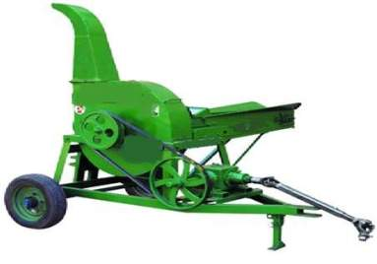
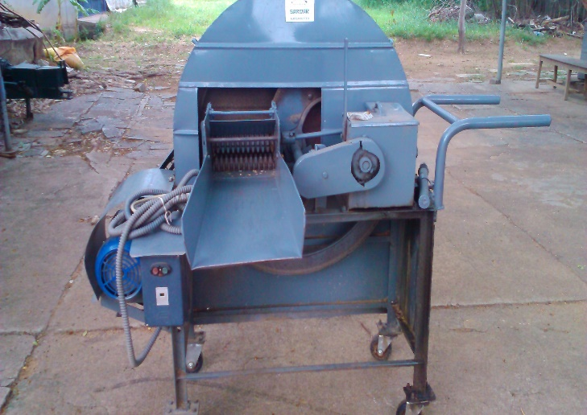

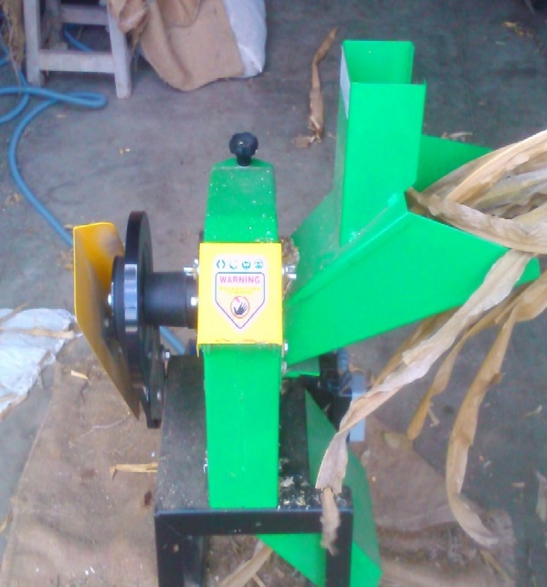
Fig. 4. Power operated chaff cutter (SADDAR) Fig. 5. Tractor driven chaff cutter

Fig. 6. Power operated shredder

