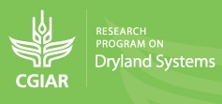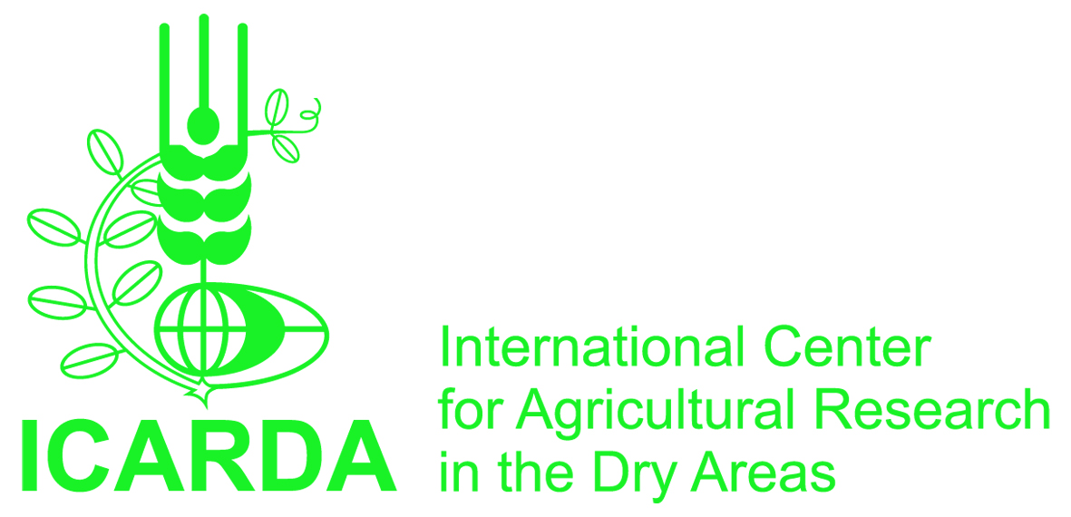
EMBARGO: MONDAY MAY 19, 00:01
New global research partnership tackles the problems of drylands agriculture
Unique approach will test and deliver ‘science packages’ that bring food security and income to millions in rural communities
May 21, 2013. Amman, Jordan/Montpellier, France. An ambitious new science program launched today – the CGIAR Research Program on Dryland Systems – aims to raise agricultural productivity and strengthen food security in the driest areas of the developing world. This $120 million initiative (covering an initial three years) with funding from the CGIAR Fund is the latest ‘research for development’ initiative of CGIAR, the world’s leading agricultural research partnership.
The Dryland Systems program is a new partnership of more than 60 research and development organizations. It proposes a unique ‘holistic’ approach to improving the food security and income of rural communities that live on tropical and non-tropical dry areas that cover some 40% of the earth’s surface. These areas are the home of more than two billion people. Following an intense consultation and planning phase among a wide range of stakeholders in 2012, including scientists, civil society partners and policy makers, the program is now being put into action to address challenges facing dry areas in five target regions: West African Sahel and the Dry Savannas, East and Southern Africa, North Africa and West Asia, Central Asia and the Caucasus, and South Asia.
The program is led by the International Center for Agricultural Research in the Dry Areas (ICARDA, a member of the CGIAR Consortium). It brings together leading research specialists with a range of national partners from low-income countries and development specialists to answer the following questions: how can vulnerability be reduced for people in the world’s most marginal rural areas; and how can people in higher-potential lands substantially increase productivity and income while protecting the environment?
"The dry areas of the developing world are likely to experience increasing poverty, out-migration and food insecurity under a business-as-usual scenario," says Dr. Frank Rijsberman, CEO of the CGIAR Consortium. "Climate change is already affecting rural communities in these regions and immediate action is required. The Dryland Systems research partnership is working alongside communities to identify, develop, and encourage the use of new innovations - whether improved technologies, farming practices, or policies - and facilitating access to new agri-business and market opportunities. These diverse approaches will help communities better adapt to climate change and increase food production for their rapidly growing populations."

Dr. Mahmoud Solh, Director General of ICARDA, explains that with the serious climate change implications in dry areas, an increasing number of people living in dry areas are facing a critical situation regarding their future food security. “New thinking that considers all aspects of an agro-ecosystem is urgently needed if research is to be applied in a practical way that helps dryland populations. The Dryland Systems program is tightly focused on understanding what combinations of technologies and practices work best following an integrated production system approach in specific agro-ecosystems, and what is needed for them to be scaled-up to improve the lives of millions of people living in these areas.”
The dry areas of the developing world occupy over 40% of the earth’s surface and are home to some 2.5 billion people. Many in these regions struggle to provide sufficient food for their growing populations and face a series of daunting physical and demographic challenges: high poverty levels and unemployment, rapid urbanization, severe water scarcity, and land degradation. Many of these problems and constraints are expected to worsen as a result of climate change.

Many of the individual technologies to improve food security are known, according to Program Director, Dr. Bill Payne, but these are often applied in a piecemeal way that looks at a single crop or a small set of technologies. “The unique aspect of the Dryland Systems program is how we combine and test a wide range of interventions – improved crop varieties, innovative farming practices, income generating approaches, and policy options – and develop these packages with our partner countries to see how they can be spread across dryland food production systems,” he explains.
The program is unique in several ways. This is the first global research program that targets a series of common problems faced by dry land production systems across low-income countries. By combining and testing ‘technology and policy packages’ the Program identifies high-potential integrated approaches that can be scaled-up to improve the lives of rural communities. The program targets improvements following approaches to two dry area agro-ecosystems: minimizing the risk and vulnerability of agricultural production systems of communities living in low-potential dry areas; and in higher potential areas, the sustainable intensification and diversification of production systems to enhance people’s food security and income in a sustainable way.
The integrated approach applied by the Dryland Systems program includes combinations of crop, livestock, rangeland, aquatic, and agroforestry activities. These activities will combine natural resource management and inputs, genetic improvement of crops and livestock, and socio-economic, policy and institutional support. Potential solutions will include more sustainable farming techniques, including better water productivity. ‘Climate smart’ strategies and technologies for farmers and communities also play an important role.
ENDS
Media Contacts
ICARDA – Michael Devlin m.devlin@cgiar.org +962 799 136 111; Richard Sanders r.sanders@cgiar.org +962 797 496 845

CGIAR press office - press@cgiar.org

Notes to editors:

About CGIAR
CGIAR is a global agriculture research partnership for a food secure future. Its science is carried out by the 15 research centers who are members of the CGIAR Consortium in collaboration with hundreds of partner organizations. www.cgiar.org

About the CGIAR Dryland Systems Research Program
The CGIAR Dryland Systems program is a global research partnership led by ICARDA, with nine CGIAR research centers and some 60 partners worldwide. Partners include a wide range of specialist organizations, including rural communities and community-based organizations, national governments and their agriculture and research agencies, and a range of national and international development partners. The CGIAR Research Program on Dryland Systems is a global research partnership led by the International Center for Agricultural Research in the Dry Areas (ICARDA) with more than 60 national and international partner organizations in the West African Sahel and the Dry Savannas, East and Southern Africa, North Africa and West Asia, Central Asia and the Caucasus, and South Asia. http://drylandsystems.cgiar.org/

About ICARDA
The International Center for Agricultural Research in the Dry Areas (ICARDA) is the global agricultural research center working with countries in the world’s dry areas, supporting them for the sustainable productivity of their agricultural production systems; increased income for smallholder farmers living on dry lands and in fragile ecosystems, and nutrition and national food security strategies With partners in more than 40 countries, ICARDA produces science based-solutions that include new crop varieties (barley, wheat, durum wheats, lentil, faba bean, kabuli chickpea, pasture and forage legumes); improved practices for farming and natural resources management; socio-economic and policy options to support countries to improve their food security. ICARDA works closely with national agricultural research programs and other partners worldwide – in Central Asia, South Asia, West Asia, North Africa, sub-Saharan Africa. ICARDA is a member of the CGIAR Consortium www.icarda.org

Potential strategies to improve productivity in dryland areas targeted by the CGIAR Research Program on Dryland Systems:
- Improved drought tolerant crops for dryland conditions (e.g. wheat, barley, sorghum, millets lentil, chickpea and grass pea) that resist temperature extremes, and diseases or pests caused by changing climate patterns.
- Crop-livestock systems – the development of integrated crop-rangelands-livestock (sheep and goats) production systems in marginal lands for added resilience in communities for the production and sale of wool, milk, cheese, yoghurt or meat.
- Enhancing productivity of the prevailing surface irrigation systems in dry ares. An example is the raised-bed farming – a practical and cost-effective intervention that has increased wheat yields by 20% in Egypt, using 25% less water
- Supplemental and deficit irrigation that allows farmers to enhance water productivity, taking into consideration crop management with optimal water use and critical time for supplemental irrigation taking into consideration climate variations.
- Conservation agriculture – which combines ‘zero tillage’ and the retention of crop residue for improved soil structure, better water retention/soil moisture conservation, reduced fuel and labor costs, and less pollution.
- Community approach: Effective community approaches will be developed with various stakeholders to ensure sustainable use of natural resources and the impact of technologies, particularly in collective properties like water and rangelands.
- Options for enabling policies: The study and development of policies that encourage the uptake, education, and financing of new approaches and new technologies.

