DRYLAND SYSTEM PROGRAM

FERGANA VALLEY ACTION SITE

Water and energy productivity of winter wheat: case study from the Fergana valley

Half-year report

Submitted by International Water Management Institute

2015

Water and energy productivity of winter wheat: case study from the Fergana valley

Introduction

For the last 20 years river flow available for irrigation of crops in Central Asia is reduced from 90% to 83%. Growing demand from non-agricultural water uses is the main challenge creating pressure on water available for agriculture. Since 1992, increased demand for energy and the shift of the upstream reservoir in the Syrdarya River from irrigation to hydropower generation mode caused reduction of water available for irrigation in average by 2 km³/year. The similar risk exist in the Amudarya River basin. Climate change may also effect on future water availability for agriculture. Central Asia is referred to be highly vulnerable to climate change and adaptation programs under development (World Bank, 2009). Over the last 70 years, the air temperature in the Central Asia has increased by 0.029 ºC per year while precipitation exhibited high multi-annual and multi-decadal fluctuations. It is already caused reduction of the volume of glaciers by third in the upstream of the Syrdarya River and Amudarya River. Water and energy nexus could be mitigated by reducing energy intensity of agriculture, consuming main part of available water, through improving water and energy productivity.
The agriculture of Uzbekistan is heavily dependent on energy inputs mainly from fossil fuels. Today’s agriculture is very energy intensive. The agricultural production system is characterised by the intensive use of inorganic fertilizers, pesticides and irrigation. These inputs are heavily dependent on fossil fuels. Planning to conserve energy and water for feeding the growing population requires a comprehensive analysis of energy-water usage in agriculture. Uzbekistan, one of the Central Asian countries with a population of 30 million (M), strongly needs energy for its economic development, rational utilization of natural resources and protection of environment. A study was undertaken on winter wheat, one of two of the important crops in Uzbekistan. Most of the previous studies were limited on estimation of the crop energy or water requirements. In this study it was hypothesized that there is high interrelation between water productivity and energy productivity – better understanding this linkage will promote further improvement of irrigation water management.
In this study, the experimental field scale approach was focused on improving water use efficiency by introducing new varieties of winter wheat and improving irrigation technology. Winter wheat is the most important cereal grown for making bread in Central Asia. Whereas worldwide about 65% of the produced wheat originates from irrigated agriculture, in Uzbekistan virtually all winter wheat is cultivated on irrigated land (FAO and WFP 2000). Proper cultivation practices by farmers can already support meeting quality standards as is illustrated in the case of winter wheat (Triticum aestivum L.) production in Uzbekistan. During the past 22 years, the area under irrigated cereals increased more than seven times from 221,000 ha to about 1.6 million ha, and gross yields rose from 1.54 in 1991 to 4.46 t/ha in 2012 (Statistical collection 2013). Winter wheat length of growing period is from October to mid-June around 255-265 days and 3000 ºC heat units required for growth stages. The harvesting period of winter wheat is in summer where the maximum temperature exceeds with high evaporation rate. After winter wheat harvesting about 100-110 days and 2600 ºC heat units are remaining till October which is very suitable for the second crop production to convert evaporation loss into useful crop transpiration which will lead to improved water use efficiency, enhanced food security and increase income of farmers in Central Asia. This half year report presents results on evaluating water and energy productivity for winter wheat, only.

- Study area

The study was conducted in Fergana valley of Central Asia where the total amount of surface water available ranges of 14-15 km³ annually (Fig. 1). Kyrgyzstan, Tajikistan and Uzbekistan are the countries sharing borders within the valley. Monitoring farming practices for winter wheat were conducted in the Gulomjon Mashrab Ugli farm, Komiljon Umarov Mirob Water Users Association, Toshloq district, Ferghana province in 2014-2015 years on silt loam soils where the depth of groundwater table is 1.5-2.0 meters. The farm is located in Fergana valley at latitude of 40º31’59.9’’N, longitude of 71º47’4.1’’E and elevation of 461 m (figure-1). The farmer has 43.8 ha land and specialized to grow mainly cotton (23 ha), winter wheat (20.8 ha) and vegetables as a second crop after winter wheat if irrigation water is available. The farm is located in K.Umarov WUA where the main source of irrigation is canal and groundwater. Area is facing problem with shallow groundwater tables and the lack of water because the location of the area is at the last point of the southern big Fergana canal.
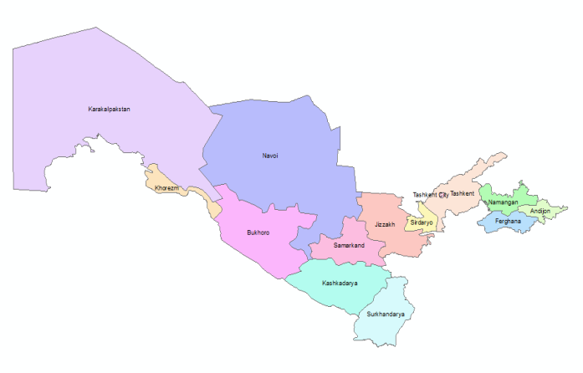
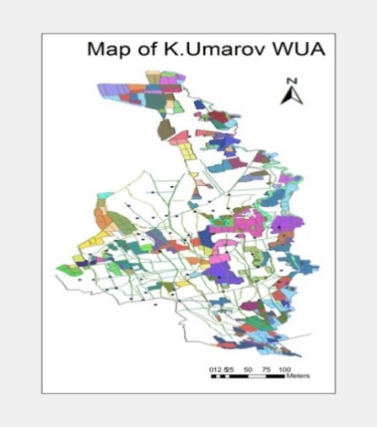
Fig. 1. Location map of the study area
Climate in study area is not only arid, but also continental. According to long period observations, it was investigated that during the vegetative period the average temperature is varying from 26-30ºС and the maximum temperature hits upon 47ºC in summer whereas the minimum temperature declines as low as -4ºС in winter. Long-term annual precipitation ranges from 50 to 150 mm, with 90% occurring from October through May (figure-2). Soil bulk density is 1.47±0.02 Mg m⁻³ in the top, increasing to 1.51±0.03 Mg m⁻³at the soil layer of 0-50 and 50-100 cm (table-1).

Table 1. Physical properties of the soil at the Gulomjon Mashrab Ugli farm
Depth | SBD | Clay | Silt | Sand | Texture
Cm | kg/cm³ |  | %
0-15 | 1.38(0.03) | 14.6(1.3) | 38.3(0.1) | 47.1(1.2) | Loam
15-30 | 1.52(0.02) | 14.3(1.1) | 39(2.9) | 46.8(4) | Loam
30-50 | 1.44(0.02) | 6.7(.2) | 23.1(3) | 70.2(2.8) | Sandy Loam
50-75 | 1.48(0.03) | 3.9(.4) | 19.6(5.5) | 76.6(6) | Loamy Fine Sand
75-100 | 1.43(0.05) | 3.2(.4) | 25.4(3.6) | 71.4(4) | Sandy Loam

Chemical properties of soi lis given in Table 2.

Table 2. Content of humus and NPK in the soil profile
Depth, cm | Humus | N | P | K
0-15 | 1.05(0.06) | 0.08(0) | 0.16(0) | 0.41(0.08)
15-30 | 1.05(0.08) | 0.07(.01) | 0.14(0.01) | 0.36(0.06)
30-50 | 0.79(0.31) | 0.05(0.02) | 0.11(0.01) | 0.33(0.03)

- MATERIALS AND METHODS

Farming practices

The experiment was laid out in fall 2014 with three varieties of winter wheat – Nota from Russia and two locally breaded varieties, namely Elomon and Hisorak. Three irrigation technologies were studied – farming furrow irrigation practices, cutback irrigation and alternate furrow irrigation. The experiment randomized against irrigation technologies had three replications. The total area under trial was 1.3 ha.
Seed rate was 275 kg/ha.

Energy Analysis
Energy Coefficient for Various Sources of Energy

Each agricultural input has its own energy values and energy is invested to produce individual component. These individual energy inputs may be in the form of labor, machinery and fuel etc. Analysis of energy coefficients of winter wheat were based on energy equivalents available in the literature (Table 3). The energy values used in this study are the dietary energy values of agricultural outputs obtained from fossil energy spent to grow winter wheat. The energy inputs can also be classified into direct - indirect, renewable- non-renewable energy forms (Thakur and Makan, 1997, Mandal et al., 2002). The direct energy consists of human power, tractor and electric motor. While the total energy is the combination of direct energy and indirect energy from seed of high yielding varieties, fertilizers and chemicals used in crop production processes. The renewable energy component consists of human labour, farm yard manure (FYM), and irrigation water, while non-renewable energy consists of diesel, electricity, fertilizers and chemicals.

Table 3. Energy equivalents for farming inputs
Input |  | Energy equivalent (MJ/unit) | Reference
Human Labour (h) |  | 1.86 | ISO 13600
Machinery (h) |  | 120
Chemicals (fertilizer [kg]) | Nitrogen | 86.8 | I.P.Kondraxin et al. (n.d.) available: http://www.info.crimea.edu/crimea/ac/kant/3_6.html
 | Phosphorus | 12.6
 | Pottasium | 8.3
Chemicals (pesticide [kg]) | Insecticide | 253.2
 | Fungicides | 116.6
 | Herbicides | 263.6
 | Sulfur | 68.2
Farmyard manure |  | 0.42
Diesel-oil (L) |  | 42.7
Electricity (Kwh) |  | 8.7 | ‘ГОСТ Р 51750-2001’
Water for irrigation (m³)
Output (Wheat, kg) |  | 14.7 | Sing (2002), Ozkan et al., 2007
Output (Straw, kg) |  | 9.25 | Tabatabaeefar et al. 2009

Energy Conversion. For this study, the following procedures of energy conversion were adopted:
Human Labour. The human power (man-hours) was converted into energy inputs by multiplying the number of man hours and estimated power rating of human labour (Khan and Singh, 1996).
Electric Motors. The output of electric motor was calculated by the product of rated power of the electric motor, time consumed in operation and load factor. The load factor is equal to actual electricity consumed (read from energy meter) during operation over electricity consumed at rated power (Khan and Singh, 1996).
Diesel Engines and Tractors. The output of tractor and diesel engine was calculated by the product of fuel consumed by tractor or diesel engine, time spent, caloric value of the fuel and load factor. The Load factor is the ratio of actual fuel consumed and fuel consumed at rated power (Khan and Singh, 1996).
Seed, Fertilizer, Agro-Chemicals and Farm Yard Manure. The materials such as seed, chemical fertilizers, FYM and other agro-chemicals used in crop production were transformed into energy equivalent by multiplying the quantity of the material used in the plots with the energy value of each material (Khan and Singh, 1996).
Energy Efficiency, Energy and Water Productivity. In this study, energy efficiency, energy productivity and water productivity for winter wheat production were calculated. Energy efficiency is estimated as total energy output (KWh) to total energy input (KWh). Energy productivity – as grain yield (kg/ha) to total energy input (KWh) and water productivity as grain yield to amount of water applied (m3/ha).

- Results
Tillage. Field data on soil tillage during winter wheat growing season is given in Table 4
Table 4. Inputs used for soil tillage
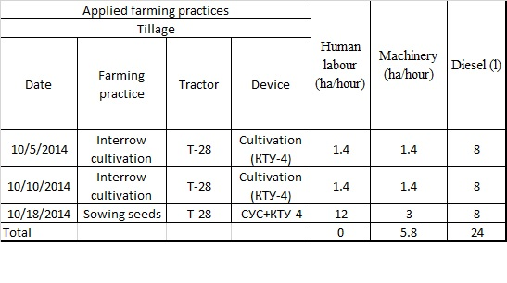
Manual work is given in Table 5
Table 5. Manual farming practices
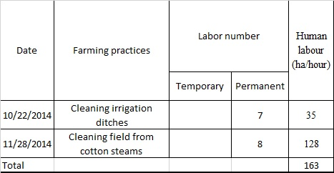
Irrigation application dates and rates are given in Table 6.
Table 6. Irrigation application dates and rates
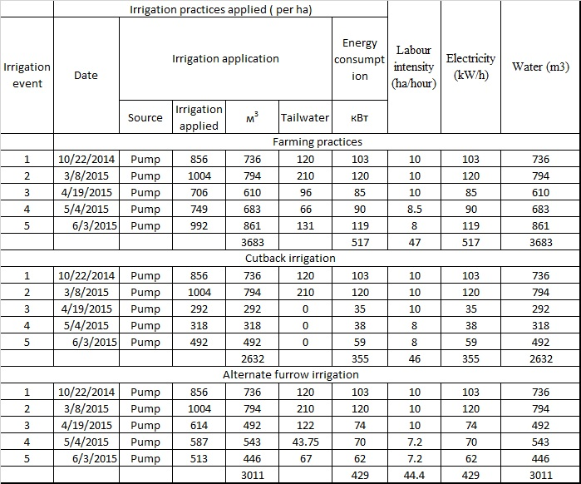
Fertilizers use is given in Table 7.
Table 7. Fertilizer application under winter wheat
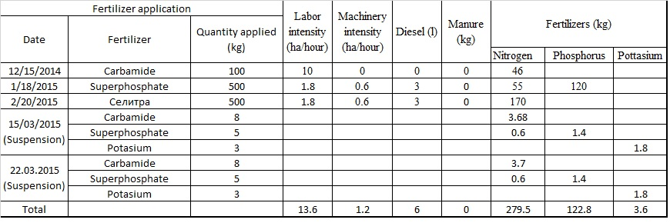
Weed and insect control is given in Table 8

Table 8. Weed and insect control
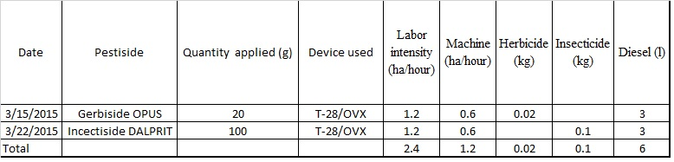
Water and energy productivity
Water and energy productivity estimates for winter wheat variety Nota is given in Table 9.
Table 9. Water and energy productivity for winter wheat variety Nota

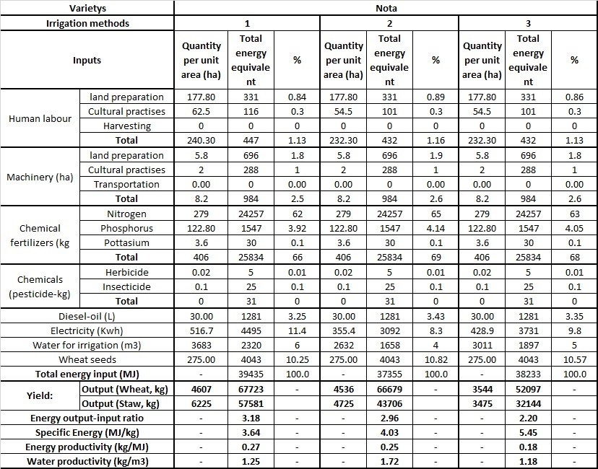
- Farming furrow irrigation; 2- cutback furrow irrigation; 3- alternate furrow irrigation

Water and energy productivity for winter wheat variety Hisorak
Table 10. Water and energy productivity for winter wheat variety Hisorak
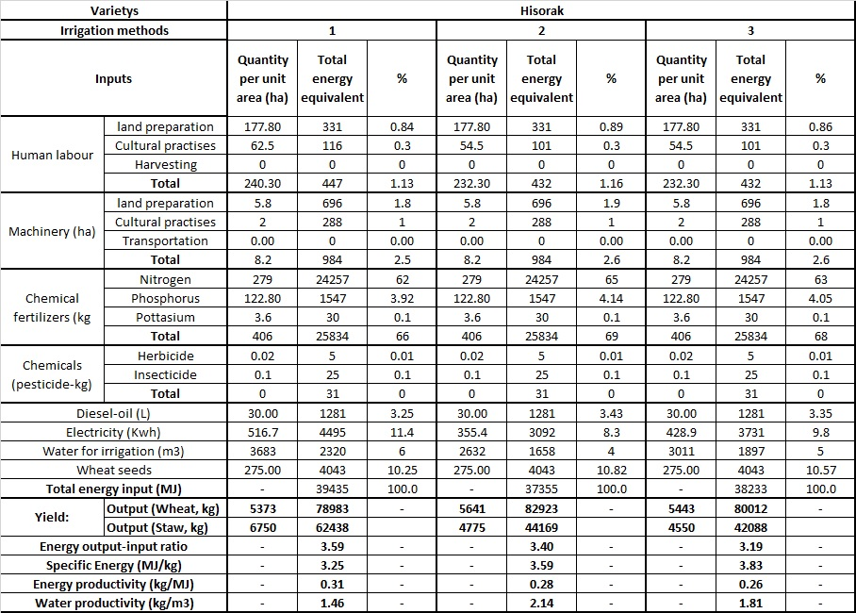
- Farming furrow irrigation; 2- cutback furrow irrigation; 3- alternate furrow irrigation
Water and energy productivity for winter wheat variety Elomon
Table 11. Water and energy productivity for winter wheat variety Elomon
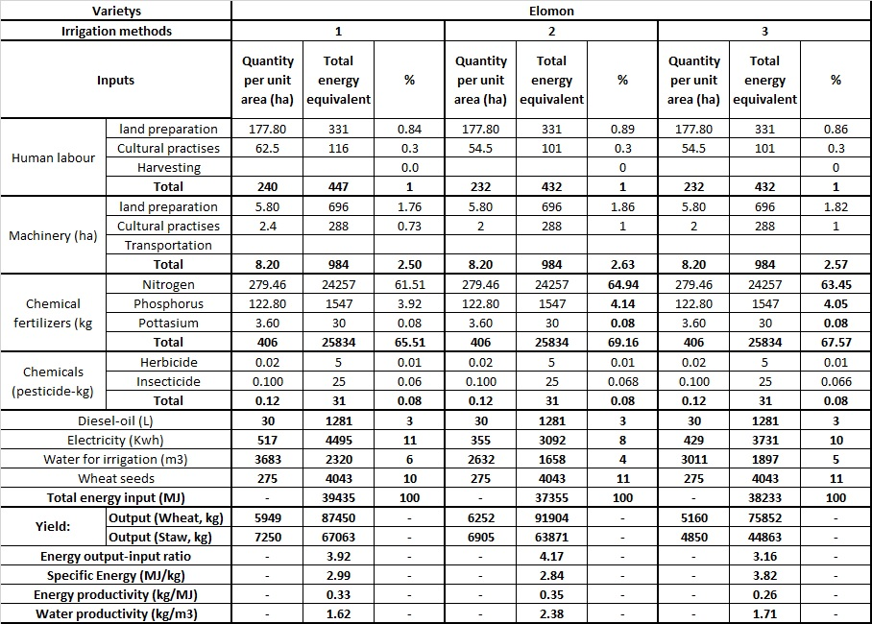
It is noted that 65-66% of energy inputs are associated with fertilizers including 61% with nitrogen and only ~17% with water and electricity for water pumping.
Summary table of water and energy productivity as affected by variety of winter wheat and irrigation technology is given in Table 12.

Table 12. Water and energy productivity under different irrigation technologies
Variety | Irrigation technology | Energy output-input ratio | Specific energy | Energy productivity | Water productivity
 |  |  | MJ/kg | kg/MJ | kg/m³
Elomon | Farming practices | 3.92 | 2.99 | 0.33 | 1.62
Elomon | Cutback irrigation | 4.17 | 2.84 | 0.35 | 2.38
Elomon | Alternate furrow irrigation | 3.16 | 3.82 | 0.26 | 1.71
Hisorak | Farming practices | 3.59 | 3.25 | 0.31 | 1.46
Hisorak | Cutback irrigation | 3.40 | 3.59 | 0.28 | 2.14
Hisorak | Alternate furrow irrigation | 3.19 | 3.83 | 0.26 | 1.81
Nota | Farming practices | 3.18 | 3.64 | 0.27 | 1.25
Nota | Cutback irrigation | 2.96 | 4.03 | 0.25 | 1.72
Nota | Alternate furrow irrigation | 2.20 | 5.45 | 0.18 | 1.18

Conclusions

Introducing water saving technologies allows improve energy/output ratio, reduce specific energy, increase energy and water productivity. These induces are much higher for new drough varieties of winter wheat, such as Elomon and Hisorak,as compared to variety Nota. It was noted that increasing water productivity by improving irrigation technology resulted in reduced energy productivity except of high yielding variety Elomon. It shows needs for improving, along with water, technology of other inputs, such as fertilizers, machinery. System approach is required to improve both, energy and water productivity.

