July 2015

Fostering institutions for water conservation and management

6 Month Report

Srinivasa R. Srigiri, Girish Chander, Murali Krishna Gumma, Anthony Whitbread
- Background
Rainfed agriculture is a predominant land use pattern in the semi-arid dryland regions which is particularly vulnerable to climatic and socio-economic stresses. As a result of these stresses, degradation of land and depletion of groundwater are widespread in the region. The storage in the lakes and tanks has decreased over time due to lack of proper maintenance leading to reduced recharge of groundwater in the region as well as in the action sites. Watershed development interventions since the 90s focused on soil and moisture conservation in both privately and commonly held lands. Water harvested through such interventions is crucial for providing protective irrigation for many smallholder farmers. However, collective action is required to maintain the technical infrastructure in order to sustain the ecosystem services.
The difficulty to observe and understand the nonlinear and uncertain dynamics of the hydrological processes as well as the impacts of conservation activities in watersheds (Syme et al., 2012) poses a huge challenge for evolution of rules for collective maintenance of soil and water conservation structures. Imperfect or asymmetric information on groundwater characteristics such as stock, flow, recharge as well as costs and benefits of collective efforts lead to suboptimal individual and collective decisions.
- Objective of the activity
Shared understanding of the social-ecological system (SES) and reduction in asymmetries in information on groundwater dynamics is assumed to be critical for consensual rules or new institutions and governance mechanism to emerge. Therefore this activity aims at generating community validated scientific information on the groundwater recharge dynamics through participatory modelling with the resource managers of the identified hydrogeological unit. This will lead to new institutional arrangements for conserving and sharing groundwater which will result in increasing the yield of the principal dryland crops for the identified users.
- Brief literature review
There is a growing body of literature providing evidence that conditionality and communication are critical for natural resource users to solve social dilemmas (Runge 1981, Bardhan 1993, Ostrom 1998, Marshall 2004, Fischbacher & Gächter 2010). The gaps in the knowledge of ecological dynamics are however a serious impediment to collectively manage rapidly changing ecosystems (Carpenter et al., 2006, Fisher et al., 2008). Latest laboratory experiments indicate for instance, that making information on resource dynamics available to users has an impact on conditional cooperation and effectiveness of communication (Janssen 2013). The identification and emergence of appropriate institutions and governance structures for water conservation and management in a given context depends on the availability of system information. Information are not only technically constrained but also by social dynamics. Often information on costs and benefits of provision and appropriation of water are asymmetrically distributed within the community. These costs and preference are again a function of the existing institutional framework (Vatn 2001). Community driven modelling of the social-ecological system (SES) dynamics has shown to be a successful method in redefining the problem from the community’s perspective and delineating the scale at which models of systems dynamics can be built (Yadama et al. 2010). By placing the community at the centre, this approach integrates the values of communities and its members for a range of services in a watershed. A shared vision of the watershed management and jointly developed scenarios integrating the local perspectives differentiated by gender coupled with actual data on resource stocks and flows will guide the modelling of SES dynamics.

- Methods
Key methodological steps include –
- Identifying and demarcating the study location and farmers
- Calibrating the hydrological model (Water Impact Calculator) to the biophysical conditions of the study location
- Framed field experiment on water conservation, water use (crop choice and irrigation scheduling) behaviour.
Two treatment groups and one control group of ten players each including men and women will undergo the experiment. The specific treatments are yet to be specified based on the data generated through participatory calibration of the water impact calculator (WIC).

- Progress towards outputs
Field visits, focus group discussions, participation in innovation platform meetings, discussion with key stakeholders and secondary data have helped in identifying a smaller area where the interactions between the resource system (aquifer) which is smaller than the entire watershed and the community are much more constant and observable.
- Identifying and demarcating the study aquifer – Garudapuram Cheruvu (GC)
During the focus group discussions with the community members in Mallapuram, it became evident that many of the tubewells in their farms are recharged from the water body Garudapuram Cheruvu (GC) which falls in the revenue jurisdiction of the neighbouring Garudapuram village (Figure 1). However, the storage capacity of the water body has declined due to neglect and lack of maintenance. This was one of the grave concern expressed by the community members during the focus group discussions as much of the farmland which benefits from the recharged aquifer of water body falls under Mallapuram. Remote sensing images (Figure 2) of the temporal land use and land cover changes in the watershed clearly show the decline in the water body which is further confirmed from the recent visit (Figure 3).
The farmers falling under the area recharged by the GC will be the focus community for the activity. In further steps, in-depth discussions will be conducted with the focus community regarding how the changes in ecosystem services from the aquifer are perceived, how this impacts their farming and livelihood decisions, how and why they acted to cope with the changed ecosystem conditions, and what the reasons were for their coping strategies. Based on the elicited relations between social action and ecosystem dynamics, and secondary data on soil characteristics, rainfall, and other biophysical parameters, the hydrological model or the WIC will be calibrated for the GC aquifer.
Predictions of the model on the impact of various farming and infrastructure maintenance decisions on the tube well recharge will be presented to the community. Besides, recommended irrigation scheduling by the WIC based on the aquifer data and crop water requirement will be presented and discussed with the farmers in the community.

Figure 1: Selected study site and farmers: Garudapuram Cheruvu
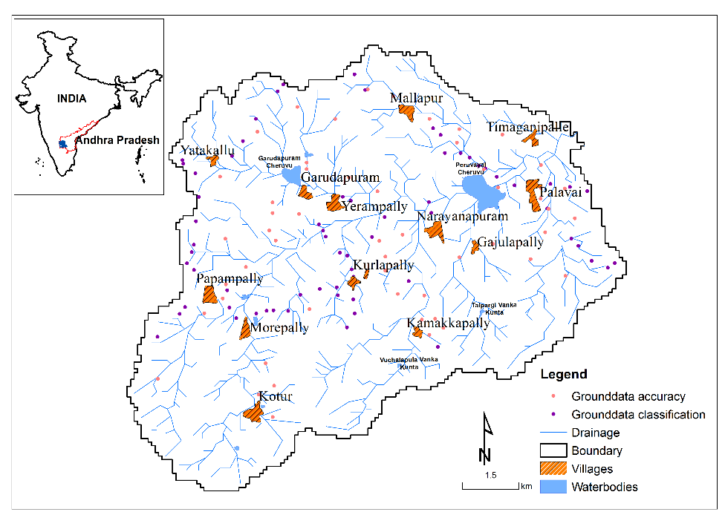
Source: modified from Gumma et al, 2015 (forthcoming)

Figure 2: Temporal land use/ Land cover changes in the watershed
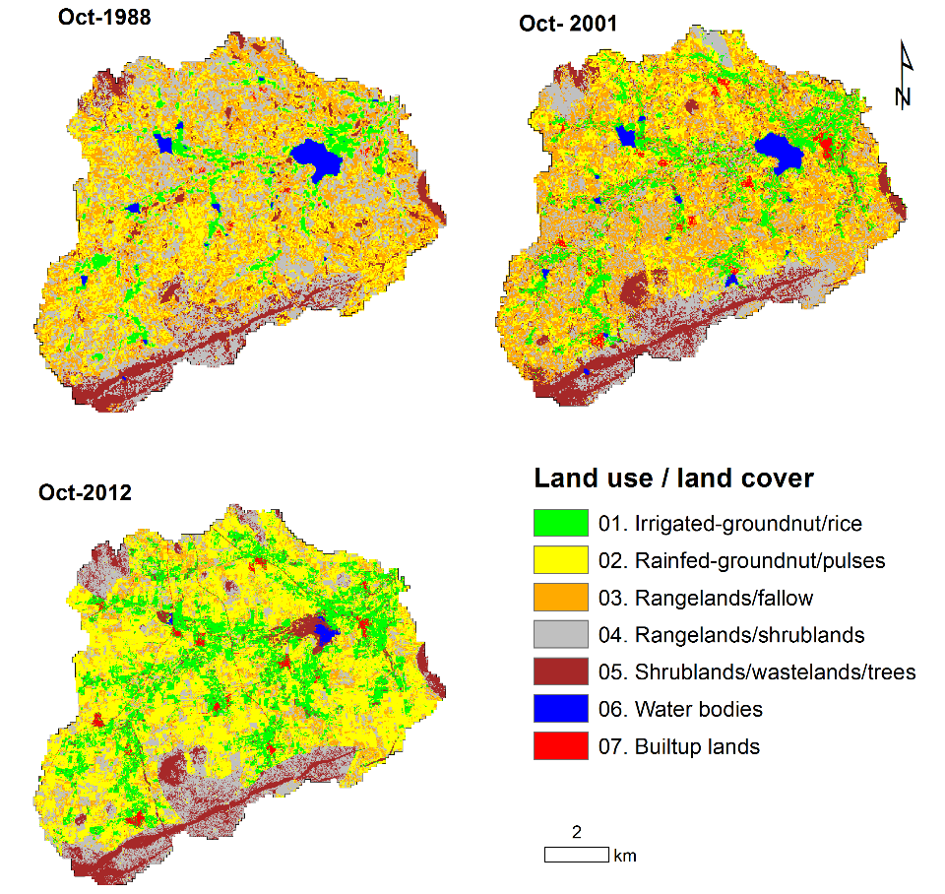

Source: modified from Gumma et al, 2015 (forthcoming)

Figure 3: Garudapuram Cheruvu water body – declined storage capacity filled with shrubs
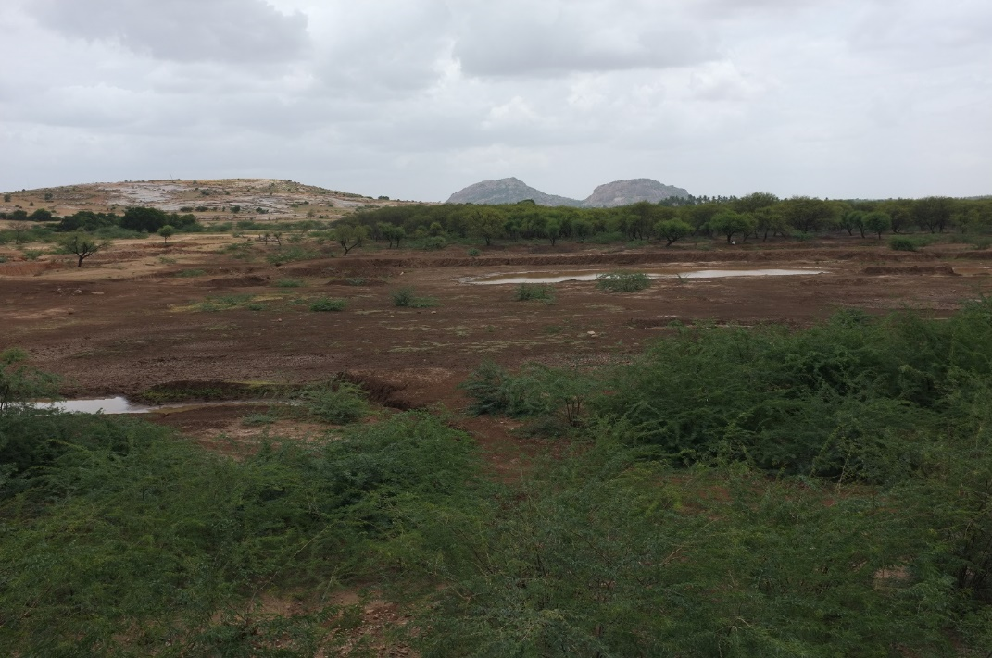

Source: Own picture from Field Visit in on 2 July 2015.
Figure 4: Focus group discussion at Mallapura,
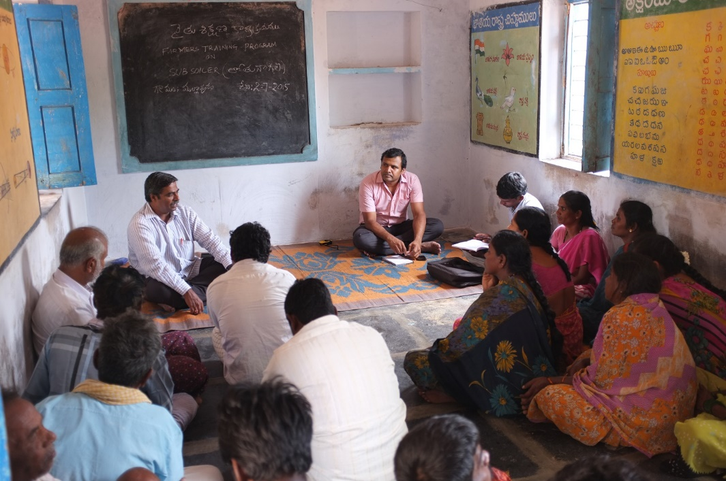
Source: Own picture from Field Visit in on 2 July 2015.

- References
Bardhan, Pranab (1993). Analytics of the Institutions of Informal Cooperation in Rural Development. World Development 21(4), 633–639.
Fischbacher, Urs, and Simon Gachter. 2010. "Social Preferences, Beliefs, and the Dynamics of Free Riding in Public Goods Experiments." American Economic Review, 100(1): 541-56.
Gumma, M.K.; Ahmed, I.M.; Craufurd, P.; Ahmed, I.R. (under review). Land use change and agricultural change dynamics in dryland watersheds of South India.
Janssen, A. Marco. (2013). The role of information in governing the commons: experimental results. Ecology and Society 18(4): 4
Marshall, Graham R. (2004). Farmers Cooperating in the Commons? A Study of Collective Action in Salinity Management. Ecological Economics 51, 271-286.
Ostrom, Elinor (1998). A Behavioral Approach to the Rational Choice Theory of Collective Action. American Political Science Review 92 (1),1-22.
Runge, Ford C. (1981). Common Property Externalities: Isolation, Assurance and Resource Depletion in a Traditional Grazing Context. American Journal of Agricultural Economics 63(4), 595–788.
Syme, G.J.; Reddy, V.R.; Pavelic, P.; Croke, B.; Ranjan, R. (2012). Confronting scale in watershed development in India. Hydrogeology Journal 15 (6).
Yadama, G., Hovmand, P. S., Foundation for Ecological Security Papagini Cell, Chalise, N. (2010). Community Driven Modeling of Social-Ecological Systems: Lessons from Andhra Pradesh, India. In T. Moon (Ed.), Proceedings of the 28th International Conference of the System Dynamics Society, July 26 - 29, Seoul, Korea.

