Better education for rural youth would reduce migration.
This is one of the conclusions of a study supported by Dryland Systems and carried out by HAFL (led by Alessandra Giuliani) in cooperation with YPARD.
One in five youths, or 125 million, are working but live in extreme poverty (on less than US$1/day). 70 percent of the world's poor (youth) live in rural areas with agriculture as main source of income and employment. Youth make up 40% of the world's unemployed in 2013.
The DS/HAFL/YPARD study in Midelt area, Morocco, aimed at a diagnostic analysis of life choices of rural youth especially with respect to agriculture in drylands as livelihood option and migration to urban centers as alternative. Rural youths’ viewpoints, aspirations, challenges, opportunities and options in three agricultural livelihoods systems of dry areas, namely ‘irrigated’, ‘rainfed’ and ‘pastoral’, have been collected through participatory social research approaches.
In areas where food security was assured, youth first raised the issue of the lack of access to education, access to potable water, of roads and infrastructure as well as health care. Rural youth saw themselves as poor and disadvantaged because they possess no or very little land, few livestock, and have no access to wage labour opportunities because of their limited or missing education. The situation is even more critical among young nomad herders and generally among young women, for whom the physical work required in agriculture is seen as demeaning and of low status.
The issue of outmigration from rural areas is not very widespread; the majority of young people in the surveyed area does not want to or cannot leave their parents and families, in particular the young women. And, youths prefer to stay in their villages - if the only the conditions were better. When groups of young women and groups of young men were asked to draw the ‘village of their dreams’, they focused on good infrastructure such as schools, wells and better roads, which would enable them to lead a more comfortable life, building their own families and earning a living as farmers, rather than chasing their ‘dream job’ outside of agriculture and the rural areas.
Resulting from youths’ lack of education, as well as lack of infrastructure, the use of modern information and communication technology (ICT) is limited to mobile phones; internet use is not very widespread. Consequently, the potential benefits of these tools (e.g. improved marketing of agricultural produce, organizational development, etc.) are missed out. Young women’s positions are even more unfavorable, as their level of education is even lower than that of their male peers (apart from the fact that their choices and desires are strongly influenced or decisions taken by their fathers or husbands).
The lack of access to skills and information is also the reason for hardly any value adding activities within the agricultural sector. Only few youths reported that they process or add value to their produce, and often these activities did not encompass what is sold on the markets but were instead limited to subsistence production.
Youth aspire to be educated, have a family, and improve their agricultural activities through owning land, having access to trainings, and establishing a more market-oriented production.
The desire for the majority of the youths interviewed to stay within their villages challenges the prevailing narrative whereby it is assumed that youth are eager to migrate from rural areas.
The high levels of illiteracy suggest that interventions need to focus skills and competencies rather than those used in working with higher educated youth. A research on gender, working conditions and migration within the framework of Dryland Systems adds to this with the recommendation that attention should be paid to the living and working conditions (gender wag gap, social protection, and tenure security), when intervening to create jobs in the agricultural sector.
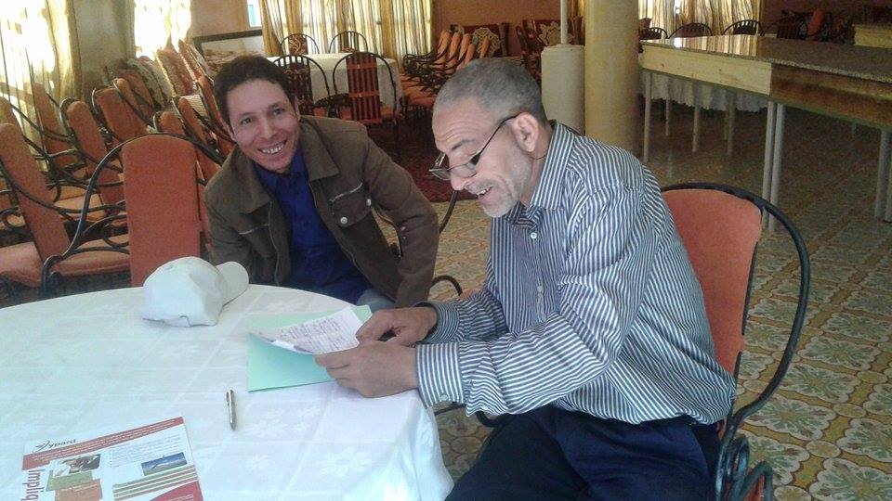
Photo: Karin Reinprecht, Midelt, May 2016 (workshop participants)
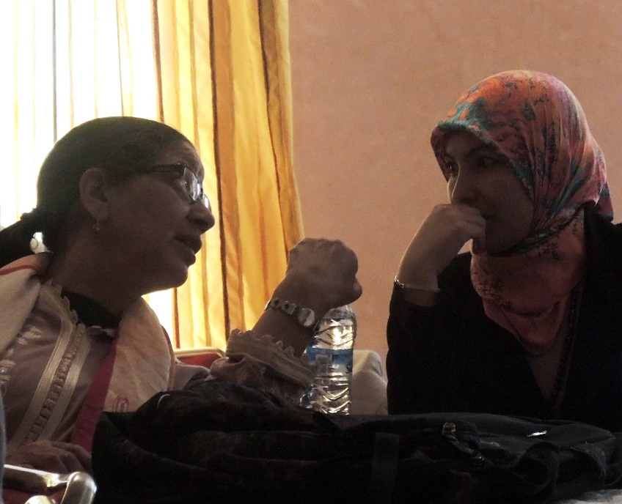
Photo: Karin Reinprecht, Midelt, May 2016 (workshop participants)
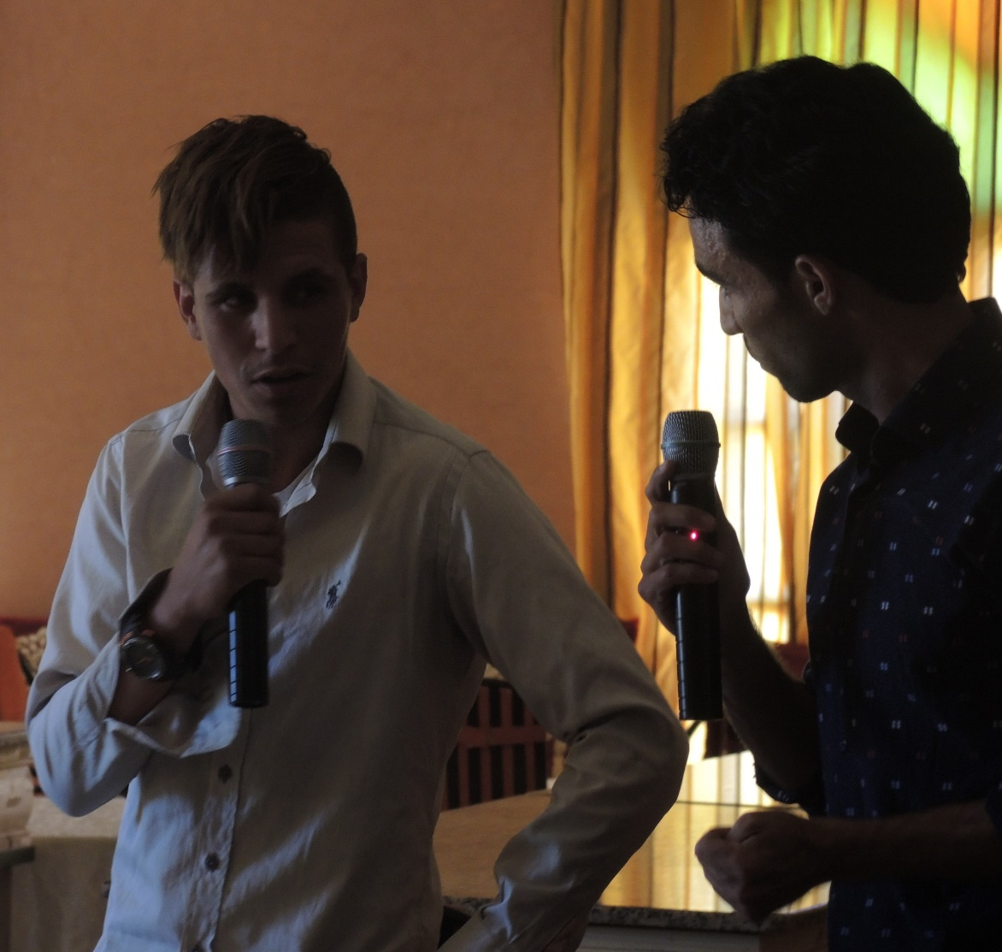
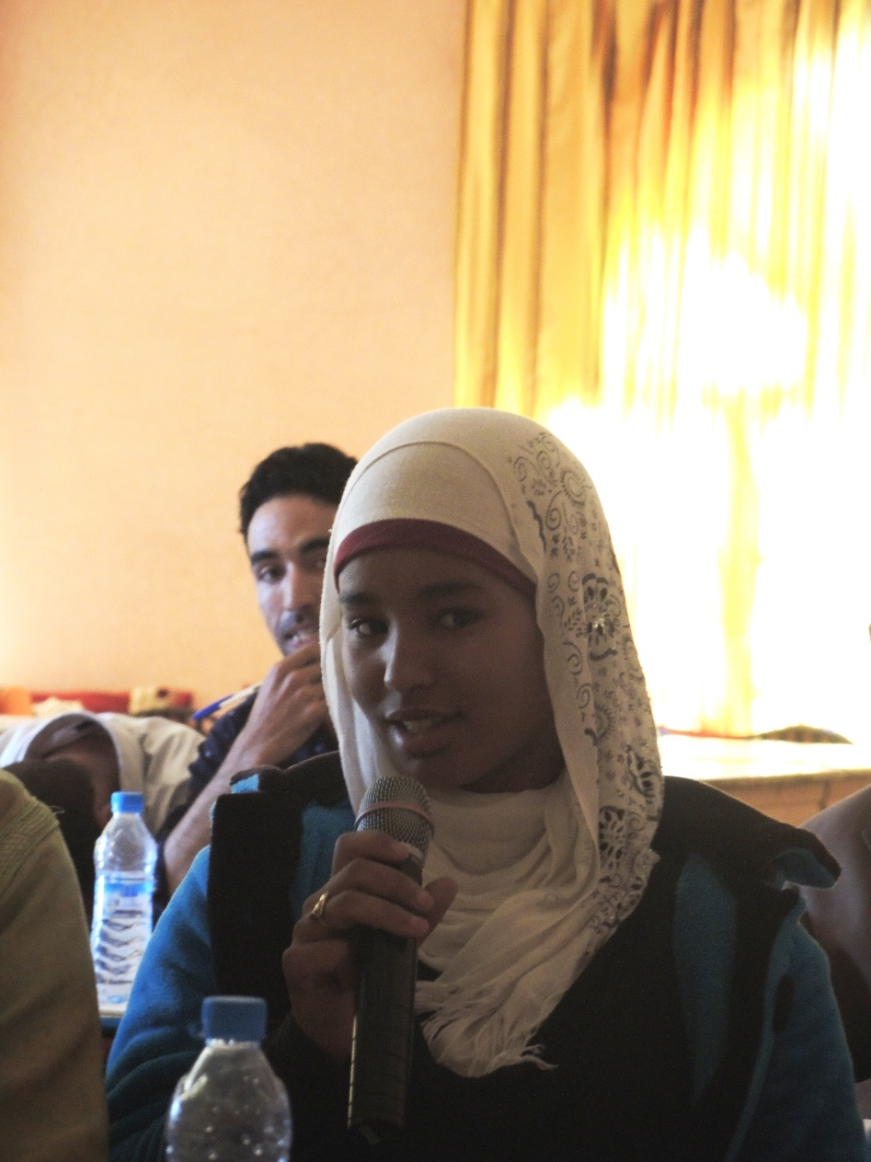
Photo: Karin Reinprecht, Midelt, May 2016 (workshop participant)

Link to journal article of Alessandra Giuliani
http://www.un.org/en/events/youthskillsday/
Population reference bureau – youth % of population 2013; World Economic Forum, 2013;
Link to journal article of Dina Najjar et al.

