EVERGREEN MAIZE FOR AFRICA (EMA) UPDATE – SEPT 2015

PROJECT OVERVIEW

EverGreen Maize for Africa (EMA) is an initiative between the World Agroforestry Centre (ICRAF) and DuPont Pioneer to promote the use of fertilizer trees as part of integrated soil fertility management (ISFM) that helps to improve soil fertility, build soil carbon, improve fertilizer use efficiency and soil water holding capacity, thereby adapting maize farming to climate change. Fertiliser trees improve soil fertility through both nitrogen fixation (as with grain legumes) and through green manure from their nitrogen-rich leaf biomass. A well-established and managed stand of fertiliser trees can produce 5 to 10 times more leaf biomass, compared to grain legume crops such as groundnuts and field beans. On the average, smallholder farmers in Zambia apply 18kg per ha compared to the world average of 60kg per ha. This level of fertilisation is not adequate for farmers to realise the full potential benefit of using improved hybrid cultivars of maize.

EMA is part of wider EverGreen Agriculture (EGA) practices being implemented in Zambia to increase smallholder farmers’ opportunities to improve and sustain maize yields using locally available resources. ICRAF partnered with Pioneer Extension Providers (PEPs), Lead Farmers and Ministry of Agriculture and Livestock staff to reach at least 7,000 farmers in seven districts of Eastern Zambia (Fig 1) with trainings and demonstrations on use of simple agroforestry techniques to improve maize yields. In areas experiencing chronic low cereal yields due to poor crop management practices, farmers will benefit from knowledge on how to interplant maize and agroforestry trees, in addition to access to agroforestry tree seeds that can improve their farms’ productivity. Extension providers were trained on topics such as intercrop production systems, tree nursery establishment, field planting - fertiliser tree management, coppicing and leaf biomass incorporation, and timing of inorganic fertilizer supplementation. The project also trained input suppliers and local level agro-dealers on tree seed collection and handling, nursery establishment and management, enterprise management and agroforestry practices. This was intended both to improve availability of planting materials for agroforestry trees and to provide opportunities for rural enterprise development and opportunities to earn income for rural households.

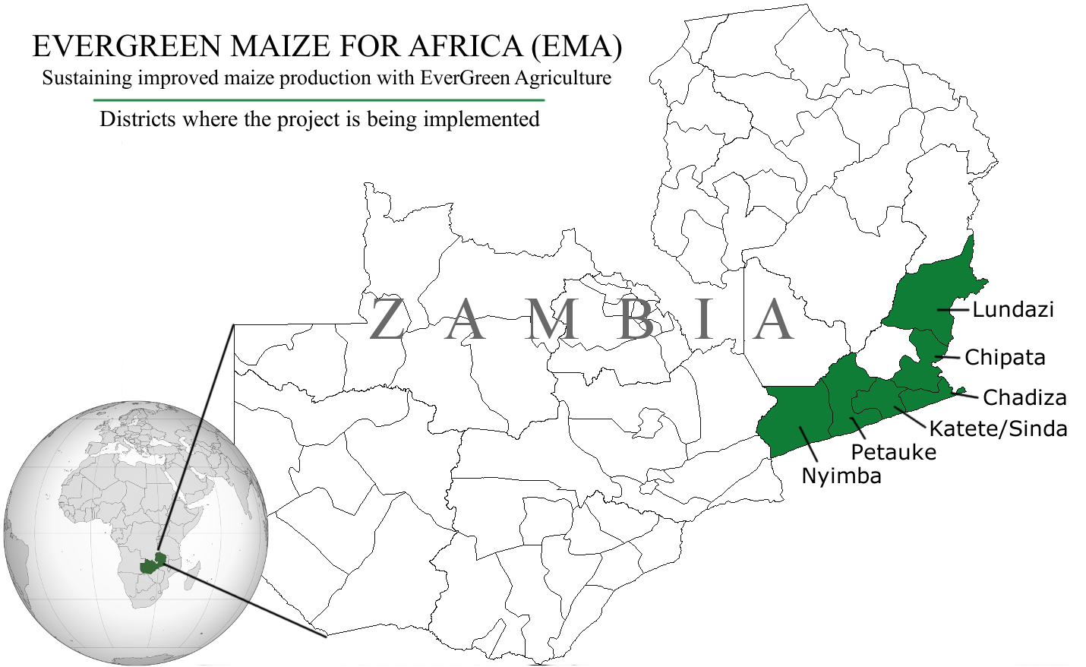
Figure 1: Districts where the project is being implemented in Zambia

At the beginning of the 2014/2015 planting season, the project successfully sourced and packaged planting material (tree seed) for four fertilizer tree species (sesbania, faidherbia, tephrosia, gliricidia) for distribution and demonstration to 7,000 farmers in 50 camps across seven districts of eastern Zambia where DuPont Pioneer operates to maximize on synergies. These species, selected with initial farmer consensus, were recommended to farmer-buyers of maize seed from DuPont Pioneer’s (and other maize seed suppliers) existing crop seed distribution system and other outlets. This partnership reinforced the common goal of ICRAF and DuPont Pioneer to increase farmer adoption of improved and sustainable production practices while promoting maize farming profitability.

PROGRAMME IMPLEMENTATION APPROACH
EMA project design: The project has been innovative in adopting a simple implementation and grassroots reporting structure involving the following:
- District Coordination Office (have roles in integration and oversight for different agricultural related interventions in the district)
- Senior Agricultural Office (coordination of extension and dissemination works in the district)
- Block coordination officers (Oversight on camp officers or twin as camp officers where there are employment gaps (where there are camp officer vacancies)
- Camp officers (Work with Lead Farmers across camp areas on technology dissemination)
- Lead farmers (provide volunteer dissemination for 10 to 20 farmers (up to 50 farmers depending on geographic spread)
- Follower farmers (project beneficiary farmers in a given Camp area)
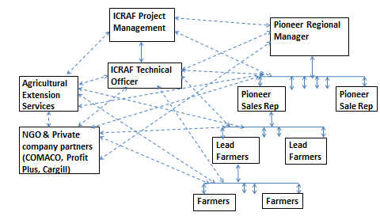
Figure 2: Implementation strategy for the project

The Project team worked directly with SAO, Camp Officers and Lead Farmers in technology dissemination, trainings and material (seed and knowledge products) dissemination. Camp and Block Officers were engaged in data collection and reporting to SAO and DACO and the EMA project team. The figure below provides an illustration of a SAO’s work from trial plots management to consolidation of data provided by Camp officers in her district.

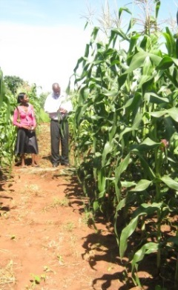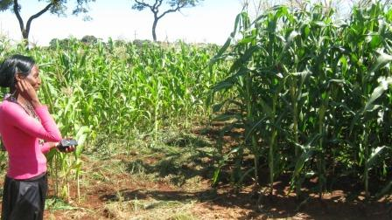
Figure 3: Ms. Prisca Mutale, Senior Agriculture Officer, Petauke District, displays EMA demo trial.

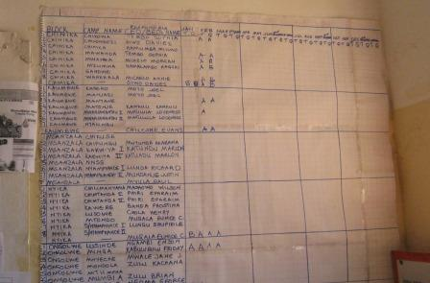
Figure 4: Dash board caption of Camp Officers’ field reports for the district.

PROJECT OBJECTIVES, AND THEIR UPDATES TO DATE

The Evergreen Maize for Africa (EMA) Project implementation in 2014/15 coincided with the November to April maize growing season for Zambia. Though farmers were apprehensive due to delayed rainfall, later field reports indicated a good maize season will be realized overall. The EMA project team were successful in launching the project in time and set up a firm foundation for activity implementation in collaboration with the Ministry of Agriculture and Livestock (MAL) staff and DuPont Pioneer representatives in Eastern province, Zambia. Significant time was spent on sorting logistical issues involving contractual plans between ICRAF and DuPont Pioneer, site selection, awareness raising, staffing, developing collaboration plans with MAL staff, tree seed procurement and planning field follow-ups considering the late start of the current maize season.

The goal of the project was to improve smallholder knowledge and practices involving use of EverGreen methods to improve soil health and ensure improved, more sustained maize yield production in Zambia. Based on this goal, 3 major work packages were designed, and activities implemented are as follows:

Work package 1: Conduct participatory diagnosis and rapid baseline assessments to facilitate development of location-specific interventions.

Activities | Achievements
- Undertake project site selection exercises and map maize/cereal based agro-ecosystems and current EverGreen Agricultural systems, with the potential to demonstrate project success | 50 sites consisting of extension camps selected across 7 districts in Eastern Zambia
- Stakeholder visits, meetings and a workshop at each site to raise awareness on the project ideals, implementation plans and confirmation of project sites, and to facilitate sharing of current experience and skills relevant to the project (e.g. existing sites, resources, skills and expertise) | Project inception workshop held in Sept 2014, with various stakeholders including Ministry officials, extension officers, Pioneer representatives and interested NGOs operating in the project areas.
- Participatory diagnosis of farmer needs and priorities on application of EverGreen Agriculture practices, and conduct participatory species selection with all key stakeholders | Based on farmer needs and preferences, tephrosia, sesbania, gliricidia, and faidherbia selected as key species. Refer Table 1 for complete breakdown.
- Identify and train grassroots agents, farmer networks and private sector suppliers involved in maize seed or agriculture input distribution | 50 Camp Extension Officers (CEOs), 13 Block Extension Officers (BEOs) and 7 FTC Managers were trained, who in turn trained 2,571 farmers and x lead farmers.
- Baseline survey assessment on current farmer cereal cropping practices at the project sites | Assessment of the agricultural systems (farm household characteristics, farmers’ knowledge of soil fertility management practices, access to input and output markets) carried out.

Project sites confirmations and consensus building: During the inception workshop, there was confirmation that project interventions will be implemented across the 7 districts of Chipata, Lundazi, Katete, Petauke, Chadiza, Sinda and Nyimba in Eastern province, covering 50 extension camps. SAO and camp officers were mandated to identify up to 1,500 farmers to benefit from project activities in each district. Blocks, camps and farmers were identified based on observed maize production challenges. Sites where soil fertility decline has become widespread leading to reduced maize yields were recommended. Farmers’ recruitment was based on willing participation for both male and female headed households through local project sensitization meetings, and consensus building exercises with extension officers knowledgeable on their areas of operation.
Project inception workshop held in Chipata, Zambia: At the on-set of September 2014 maize season, a project launch was held in Chipata. In attendance were senior Ministry of Agriculture and Livestock (MAL) staff from Provincial and District Agricultural Coordination offices, Senior Agricultural Officers (SAO), Block Officers, Pioneer Representatives and NGOs such as Profit Plus and Conservation Farming Unit. The workshop deliberations forged an important collaboration with the MAL, especially on the extension staff required to facilitate dissemination of project innovations.
Recommended fertilizer tree choices availed to farmers: Only well researched fertilizer tree species that improve soil fertility through nitrogen fixation and producing large quantities of leaf biomass were offered to farmers for selection. By promoting use of four well known trees species risks on investment are kept low. Camp officers elicited the preference for fertilizer tree species from all the farmers who volunteered to participate in the project. Project farmers were asked to select one tree-based soil fertility management option. The options were: annual relay fallows using Sesbania and Tephrosia; 2-year improved fallows using the same Tephrosia and Sesbania; coppicing trees (A. angustissima and Gliricidia) and full canopy species (Faidherbia). All farmers received Faidherbia if they wished. In the short and medium term, farmers would receive the soil fertility improvement benefits from Tephrosia, Sesbania and Gliricidia while they wait for Faidherbia to grow for the next 5 to 6 years. Faidherbia was interplanted with the other fertilizer tree and the maize crop. A summary record on the number of farmers’ indicating tree preferences for a given type of fertiliser tree for which seed was availed by the EMA project is shown in Table 1.

Table 1. Number of farmer requests for the supply of preferred fertilizers trees by the EMA project in parts of Eastern Zambia.
Districts | Fertiliser tree species |  |  |  |  |  |  |  | Total requests/District
 | Tephrosia candida |  | Sesbania sesban |  | Gliricidia sepium |  | Faidherbia albida
 | No. requests | No. request met | No. requests | No. request met | No. requests | No. request met | No. requests | No. request met | Total requests | Total requests met
Chadiza | 230 | 230 | 50 | 50 | 219 | 219 | 500 | 500 | 999 | 999
Chipata | 530 | 530 | 300 | 300 | 200 | 160 | 500 | 500 | 1530 | 1490*
Katete# | 160 | 160 | 30 | 30 | 68 | 68 | 196 | 217 | 454 | 475
Lundazi | 605 | 882 | 63 | 63 | 784 | 507 | 275 | 275 | 1727 | 1727
Nyimba | 235 | 235 | 150 | 150 | 175 | 175 | 140 | 140 | 700 | 700
Petauke | 532 | 532 | 528 | 264 | 440 | 166 | 235 | 235 | 1735 | 1197¹
Sinda² | 244 | 244 | 84 | 84 | 32 | 32 | 90 | 90 | 450 | 450
Requests/Sp. | 2536 |  | 1205 |  | 1918 |  | 1936 |  | 7595
Requests met/Sp. |  | 2813 |  | 941 |  | 1327 |  | 1957 |  | 7038
Notes: ¹ Requests not fully met. ² New district created in 2012 and largely comprises of territory of the old Katete district.

The project has responded to over 90% of farmer tree planting material requests: Overall, the project was able to meet 92% of the total planting material requests, thereby reaching out to over 7,000 farmers. The project surpassed the target set on seed requests for Tephrosia and Faidherbia but fell short of supply on Gliricidia and Sesbania - both species with a high demand and short supply in Zambia. Some farmers in neighbouring camps not recruited into the project have registered interest with Camp Officers to benefit from future project intervention.

Training of grassroots agents and farmer networks: 50 Camp Extension Officers (CEOs), 13 Block Extension Officers (BEOs) and 7 FTC Managers were trained on establishment of Evergreen Maize for Africa demonstration plots and how trees and crops should be planted in farmers’ fields. After these trainings were held in December 2014 and January 2015, the CEOs, BEOs and FTC Managers in turn trained a total of 2,571 lead farmers, including 950 women lead farmers.

Work package 2: Development and dissemination of knowledge and information products on sustainable maize growing practices involving EverGreen Agriculture

Activities | Achievements
- Use existing or new demonstration sites to show the nature and benefits of EGA on maize production. | Demo plots established, and data analysis conducted on the variances in maize yield without trees, versus yield under different species of trees.
- Prepare educational media programmes on sustainable maize farming practices involving EGA practices | Extension materials prepared and distributed to camp officers, agro-dealers.
- Organize at least 1 field day per project site to link seed and tree supply systems, extension and knowledge supply systems with small holder farmers | 7 field days were held in April 2015, with over 2200 participants attending in total, including 610 women.
- Undertake targeted publicity campaign on relevant benefits of fertiliser trees to increase maize production and improve soil health for farmers through, brochures, seed leaflets, radio, public baraza, and posters | Farmer mobilization campaigns on benefits of Evergreen agriculture conducted during project inception meetings and joint field days with Ministry of Agriculture in all project sites

Demonstration plots established: Ten demonstration plots of Evergreen Maize for Africa (EMA) were established in Eastern province of Zambia. Each demo consisted of four treatments namely ‘No Trees’, Gliricidia sepium, Sesbania sesban and Tephrosia candida + Faidherbia albida. The four treatments were replicated three (3) times. The spacings for Gliricidia sepium, Sesbania sesban, Tephrosia candida and Faidherbia albida were (180 x 90cm), (90 x 90cm), (90 x 75cm) and (300 x 300cm), respectively. Maize which was planted under these four treatments was planted at the spacing of (90 x 25cm) and a recommended chemical fertilizer of 200kg/ha was applied to all the maize under the four treatments.

The EMA project team worked with counterparts from the Zambia Agricultural Research Institute (ZARI) and the Ministry of Agriculture especially in setting up and monitoring the demo plots. Two staff from ZARI (Mr. Amadeus Kasama and Mr. Kalobwe Mwansa) provided follow-up support and were in turn mentored by a senior research scientist from ICRAF (Dr. Smart Lungu) in setting and monitoring demos across sites of contrasting qualities, in order to demonstrate the usefulness of fertiliser trees in improving maize productivity.

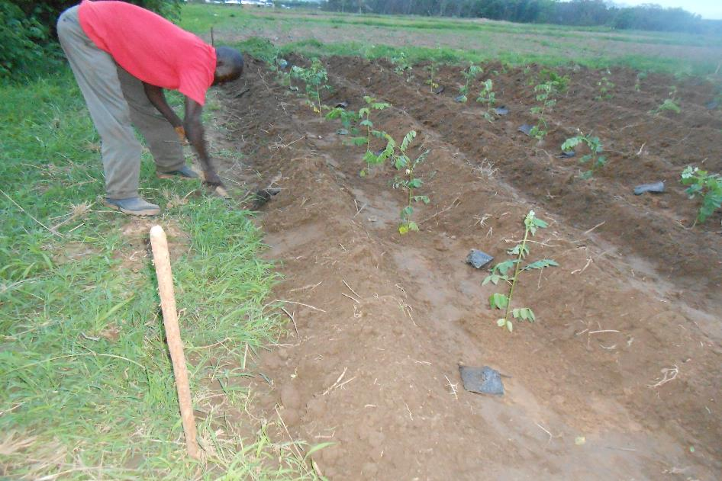
Figure 5: G. sepium plot at Chadiza FTC after demo establishment

Field days: Over 2200 farmers, including 610 women, attended 7 field days in all the districts where the project was implemented, apart from Nyimba and Petauke. Breakdown of attendance at each field day is as follows:

District/ Farmers Training Centre/ Station | Field Day Date | Males | Females | Total
Kalichero FTC | 2nd April 2015 | 236 | 111 | 347
Kalunga FTC | 15th April 2015 | 71 | 94 | 165
Katete | 17th April 2015 | 204 | 68 | 272
Petauke | 10th April 2015 | 220 | 58 | 278
Sinda | 8th April 2015 | 96 | 27 | 123
Chadiza | 14th April 2015 | 126 | 96 | 222
Msekera Research Station | 9th April 2015 | 578 | 224 | 802

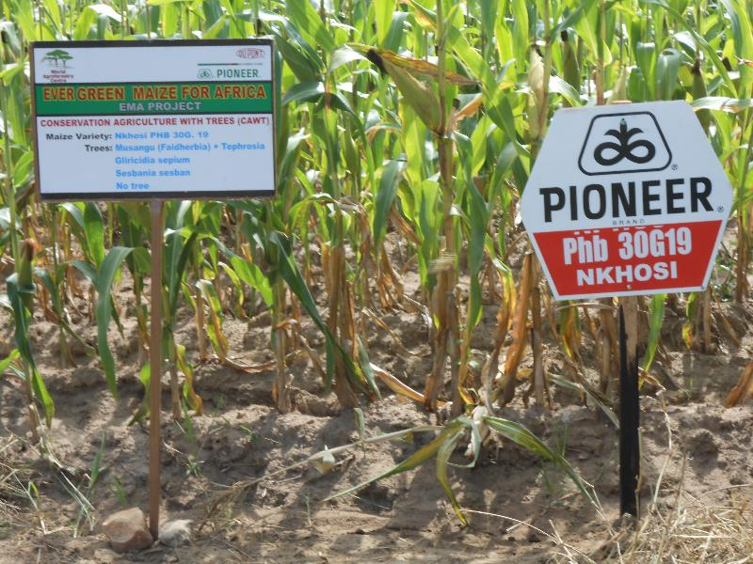
Figure 6: Chadiza FTC’s field just before the field day.

EMA project was highly successful in recruiting farmer beneficiaries and sourcing tree seed supply: The project has recruited over 7,000 farmers, and procured quality seeds for Gliricidia sepium, Sesbania sesban, Tephrosia candida and Faidherbia albida ready for the 2014/15 maize growing season. The project has acquired sufficient quantities of Tephrosia, Sesbania, Faidherbia but laboured hard to procure enough quantities of quality Gliricidia seed. Currently Gliricidia is in short supply with a very high demand across Zambia due to a presence of number of agroforestry activities being undertaken by government and non-governmental agencies, using the species as their flagship. Supplies have been met by sourcing local tree seed suppliers and imports from Malawi making the whole procurement process costly.

Work package 3: Building the capacity of smallholder maize growers, seed dealers and extension service providers on sustainable agriculture practices involving EverGreen Agriculture

Activities | Achievements
- Train and support private entrepreneurs and partners to participate in tree seed supply and distribution | Workshop held in Petauke, Zambia for 37 attendees, who included Ministry of Agriculture and Livestock extension staff, nursery operators, and agro-dealers.
- Conduct farmer and extension staff trainings on use of fertilizer trees and agroforestry to improve maize yields, land health and households incomes | Two ToT sessions already implemented for 70 camp officers, NGO extension officers, and 7 Pioneer sales representatives
- Engage with extension service providers, seed dealers, farmer cooperatives in testing different models to disseminate fertiliser tree seeds | Topics disseminated included collection of tree seeds, tree seed handling, marketing of tree seeds, germination of seeds, and nursery management
- Investigate factors influencing tree seed demand and supply at selected project sites | Workshop conducted for agro dealers tree nursery operators, extension providers to identify approaches to dealing with seed demand and supply bottlenecks.  Upon completion of this phase of the project, a report will be compiled on tree seed demand and supply.
- Identify quality control protocols for tree seed propagation, and train private seed dealers, farmer cooperatives, farmer associations and other farmer input networks on techniques of tree seed handling, packaging, storage and distribution | Seed handling and technical management support provided to extension officers, Pioneer sales representatives, and NGO staff

Agro-dealers and nursery operators’ workshop: 37 participants attended the workshop from seven (7) districts of Eastern Province where the Evergreen Maize for Africa project is being implemented. The districts include Chadiza, Chipata, Katete, Lundazi, Nyimba, Petauke and Sinda. The participants included staff from the agriculture extension service of the Ministry of Agriculture and Livestock (MAL), nursery operators and agro-dealers. Topics cover during training included collection of tree seeds, tree seed handling, marketing of tree seeds, germination of seeds, and nursery management. The participants also identified challenges and opportunities regarding tree seed supply and distribution, and drew up 7 resolutions at the end of the workshop.

Training of Trainers (TOT) successfully implemented in the main project sites: Two Training of Trainers sessions were conducted, reaching 70 camp officers and other staff involved in Conservation Agriculture Scaling Up initiative (CASU) (an EU funded project implemented by the Ministry of Agriculture and Livestock), NGO extension officers, and 7 Pioneer sales representatives. Trainings covered use of fertilizer trees for soil fertility improvement, tree seed propagation, pre-treatment and handling techniques. Following these events, 50 sites were identified to establish 140 demo plots on farmers’ fields, and 8 at Farmer Training Centres. Training on setting up of EMA demonstration plots by camp officers covered all districts.

Seed handling and technical management support: While seeds of Sesbania and Tephrosia can be directly sown in the fields, those of Gliricidia and Faidherbia have to undergo seedlings production via nursery stage to ensure they establish well in the fields. Government extension staff, Pioneer sales representatives and extension staff of NGOs were trained on incorporation of agroforestry trees in the maize production systems, including best practices for nursery management for fertilizer trees. In turn extension staff organized and conducted training sessions for lead farmers and beneficiary farmers. The EMA project team was available to provided technical support to extension staff and lead farmers during trainings, and during nursery establishment, management and out-planting of seedlings. Some lead farmers served as hosts for tree nurseries for their follower farmers and managed nurseries prepared either ‘bare root’ or potted bags seedling production. In most cases, seedlings were raised with labour contribution of fellow farmers and later materials shared equitably between camp members. Mixed tree growth performance has been observed between camps probably due to different soil types, weather conditions, and approaches used in seedling production. Overall most camps managed to raise good healthy seedlings.

Supply of planting materials to project collaborators: Steady efforts were made to distribute planting materials to project partners. At least 3,000 assorted fertilizer seedlings were supplied to Profit plus, and 4,000 Gliricidia seedlings to COMACO. CARITAS Zambia received 30 Faidherbia (musangu) seedlings and 61 Gliricidia seedlings from the EMA nursery at Musekera research station.

Measurements on demo plots: Simple measurements are being undertaken to assess the influence of the fertilizer trees on maize yield in selected sites. Demo trials hosted by the FTC, set up on rather similar conditions and management practices, are preferred for tracking key performance assessments mainly on maize yields under contrasting biophysical limits (see below images on demo plots set-up on sites of varying conditions). It is planned that the first season of the trials forms the baseline to compare subsequent measurements.

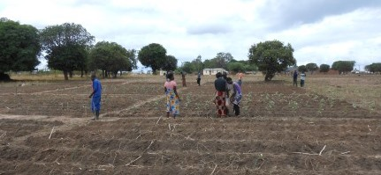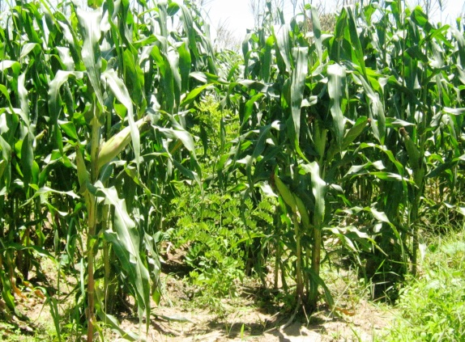

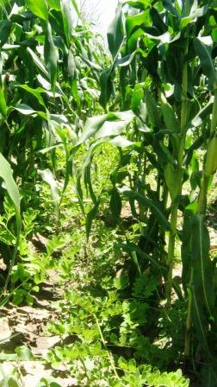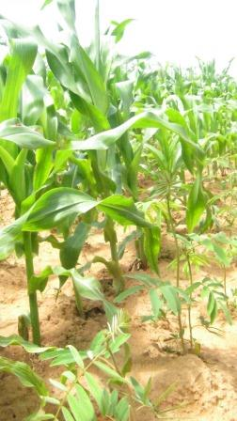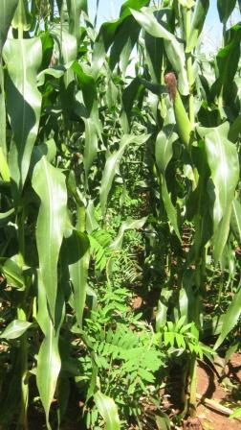
Figure 7: Five months old EMA-demo plots showing Gliricidia and Tephrosia maize intercrop at different FTC sites around Chipata. Notice differences in soil physical characteristics.

MAJOR CHALLENGES

A number of challenges were encountered during the implementation. The major challenges are briefly described below:
- Weather: The rain season in Eastern Zambia typically starts in November. During the 2014/2015 season the rains came late – early December, thereby affecting the farmers’ planting schedule and the planned field work.
- Tree seed procurement challenges: The agroforestry seed system is not formalised in the project area, as tree seed and seedlings are not typically found at agro-dealer outlets. A few independent tree seed collectors exist in the province, especially for sesbania and gliricidia, as these species have been widely used in projects in the recent past. However, gliricidia seed was in short supply and relatively expensive. Sesbania and Tephrosia were not readily available and was imported from Malawi.
- Distribution: The project covered a wide geographic area, with long distances between sites. Tree seed was transported by the project team to the SAO’s officer from which point camp office collected the seed for their respective camps. The geographic distribution also posed challenges for extension efforts, which were ultimately overcome courtesy the multi-layered implementation structure the project adopted.

NEXT STEPS

The project introduced farmers to approaches for improving soil fertility using nitrogen fixing trees and shrubs. The project also developed mechanisms for improving the capacity of stakeholders to use agroforestry practices in their production systems, and channels for improving production and distribution of agroforestry tree seeds. ICRAF and its partners will jointly conduct an assessment to gauge the effectiveness of the project implementation approach, and synthesise the lessons learnt to guide implementation of similar projects and programs in the future.

While the use of agroforestry practices have a long history in the Eastern Province in Zambia, some farmers were using the practices for the first time. There is need to ensure that farmers are provided with continued technical support to ensure that the practices are correctly and effectively used in order to realise the full benefits. The success of early users of the agroforestry practices can provide an effective learning platform for farmers who are currently not using the practices, and this can be critical in efforts to facilitate the widespread use of agroforestry practices.

The EMA project provided an opportunity for ICRAF to cooperate with a private partner to help promote productivity enhancing, sustainable and resilience building production practices. ICRAF would like to build on this experience and the lessons learnt to leverage more resources to continue supporting the farmers through providing technical support, and supporting the emergence of local institutions (e.g., innovation platforms bringing together farmers with other role players in relevant value chains) and agroforestry related enterprises. ICRAF is in the process of developing a proposal that will bring together strategic partners for mobilising resources, to ensure the continuation of the work initiated under EMA, and will approach private sector players including DuPont Pioneer and others. ICRAF would like to use the opportunity provided by its partnership with the private sector to leverage more resources from such sources as Global Development Alliance (USAID) and the African Enterprise Challenge Fund (AECF), whose interest is in providing support to stimulate private sector involvement in initiatives where returns may be deemed to be uncertain.

APPENDIX – IMAGES FROM PROJECT SITES

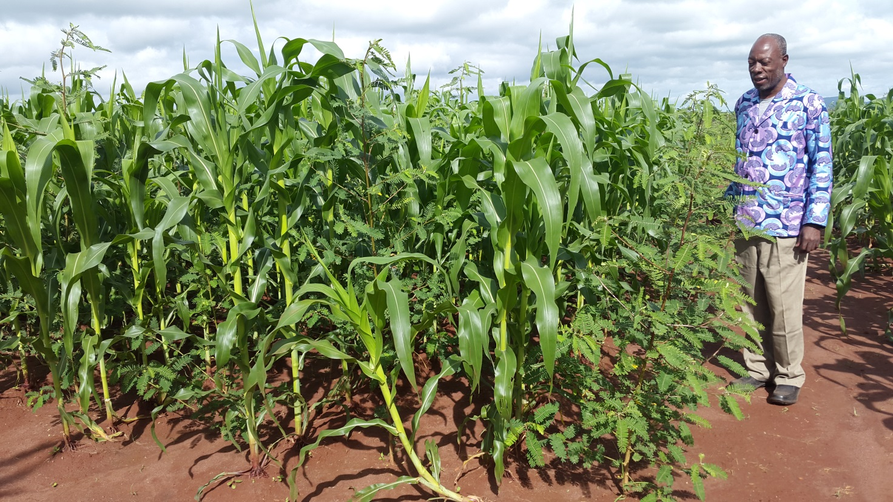
A well-established Sesbania sesban relay intercrop

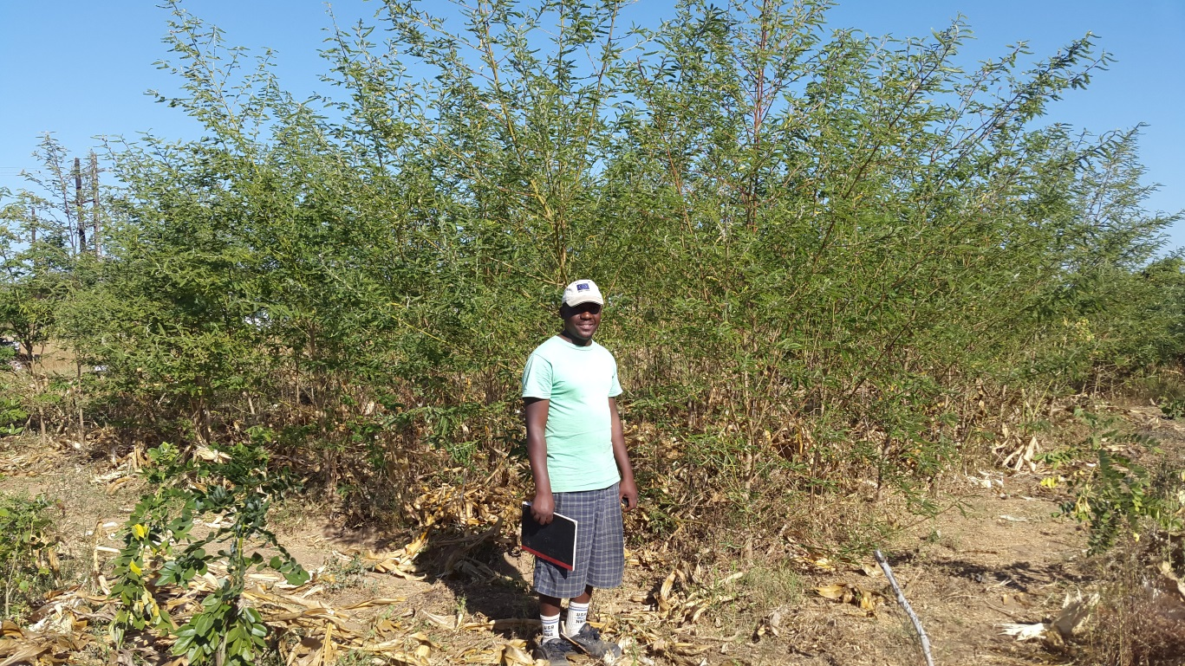
A beautiful stand of relay fallow of Sesbania sesban in this demonstration plot soon after maize harvest in May. The plot will produce sufficient green manure and leaf litter to improve maize yields by between to 50-100% of the current levels.

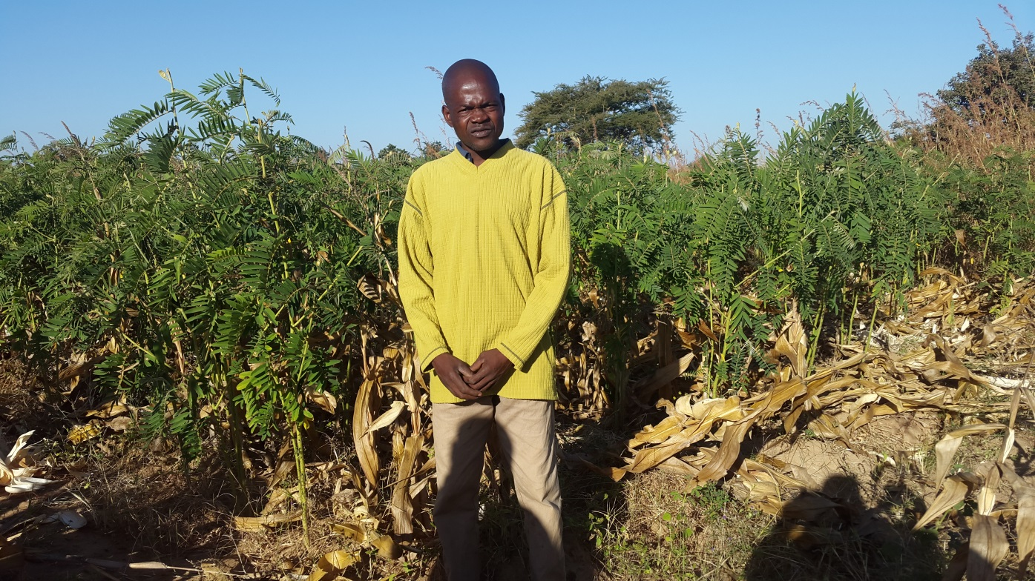
A farmer shows off his well-established Tephrosia relay fallow in June soon after a modest harvest ravaged by drought. Growing on residual moisture this Tephrosia will have more than doubled the nitrogen-rich leaf biomass(approximately 2 metric tonnes) by November 2015 in time for incorporation

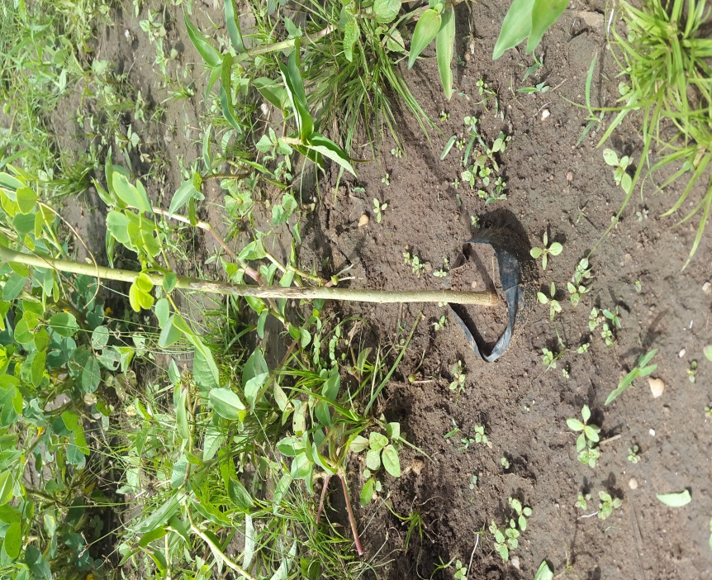
Tree planting is often viewed as simple but a sight of this planted tree indicates otherwise. Training farmers on tree planting and management remains critical to avoid this simple but costly mistake.

