Flagship Project: 2: Improved Varieties and Hybrids
COA: Sorghum-WCA
Multipurpose sorghum development and release in WCA
Baloua Nebie¹, Aboubacar Toure¹, Abdoulaye Diallo², Abocar Toure², Ibrahima Sissoko¹, Mamourou Sidibe¹,
¹ ICRISAT-Mali and ² IER
Objective of activity and intended output
The objective of this activity was to identify multipurpose sorghum adapted to sudanian zone for better integration of crop and livestock (grain, quality fodder production). The second objective was to registrate/release at least one multipurpose sorghum in Mali and/or Burkina
Materials and methods
Sixteen (16) varieties including 9 sweet sorghum from ICRISAT, 5 grains sorghum from IER and 2 checks were evaluated for the second year in contrasted environments, on station (high phosphorus, low phosphorus and striga fields) and on-farm. On-farm evaluation was conducted by 20 farmers belonging to 10 villages in 4 zones (Beleko, Dioila, Koulikoro, and Koutiala). In addition to grain yield, stover yield, around 30 farmers from each villages were invited for variety appreciation using their preferred traits.
Results and interpretation (again succinct, maximum of 250 words).
On station, broad sense heritability is higher for grain yield (H² = 0.85 in High P; 0.63 in low P and 0.77 in striga field), meaning that the performances and differences observed (P<5%) are mainly due to the genotype of the material and not the environment effect. The grain yield average of the multipurpose sorghum is 242g/m2 or 2.42t/ha in High P, 66 g/m2 in low P and 224 g/m2 in the striga fields compared to the local check Tieble (287g/m2; 85g/m2 et 226 g/m2). Varieties like Narichita, Soubatimi and Zalatimi recorded over 3 tons of grain yield. Stover yield, sugar concentration, etc., data will be also analyzed to complete information.

Fig. 1 Variability of grain yield in different environment on station

Table 1: Grain yield of the multi-purpose sorghum on station
Variety | PGrm2_Sko-HP (g/m2) | PGrm2_Sko-LP (g/m2) | PGrm2_Sko-Striga (g/m2)
Soubatimi | 318 | 83 | 265
Dalitimi | 276 | 69 | 169
Torotimi | 100 | 64 | 153
Loubatimi | 261 | 78 | 226
Kolatimi | 158 | 35 | 153
Filatimi | 156 | 42 | 184
Tiokala | 265 | 35 | 216
Jiguikala | 257 | 50 | 196
Zalatimi | 314 | 63 | 222
Niolagne | 146 | 44 | 251
Niobougouma | 225 | 77 | 171
Niotimima | 247 | 80 | 233
Jamadounko | 297 | 66 | 184
Narichita | 347 | 83 | 286
Fadda (Hybrid, check) | 212 | 92 | 252
Tieble (local check) | 287 | 85 | 286
Soumalemba | - | - | 340
Lata | - | - | 248
Min | 121 | 46 | 170
Mean | 242 | 66 | 224
Max | 333 | 83 | 313
Mean SED | 38.400 | 15.982 | 34.936
Mean LSD | 77.342 | 32.210 | 70.138
Heritability | 0.852 | 0.629 | 0.768
p-value | 0.000 | 0.005 | 0.000

On-farm data (Table. 2) show high variability of H² depending to the zone. Only data of two zones are reported here, the data from others zones still under analysis. The best multipurpose varieties based on grain yield are Soubatimi (115 g/m2 in Koulikoro to 148 g/m2 in Dioila) and Niolagne (118 g/m2 in Koulikoro to 138 g/m2 in Dioila). The local check (grain sorghum with poor stover quality) grain yield varies from 108 g/m2 (Koulikoro) to 161 g/m2 (Dioila). In addition to high grain yield of the dual purpose sorghum, the stover yield and especially its quality higher (data analysis not yet finalized).
Table 2 Grain yield of the multi-purpose sorghum evalued on-farm
PGrm2 (g/m2)
Genotypes | Dioila | Koulikoro | Mean
Soubatimi | 148 | 115 | 131
Dalitimi | 110 | 89 | 100
Torotimi | 65 | 51 | 58
Loubatimi | 112 | 104 | 108
Kolatimi | 98 | 82 | 90
Filatimi | 88 | 64 | 76
Tiokala | 125 | 106 | 116
Jiguikala | 112 | 98 | 105
Zalatimi | 112 | 118 | 115
Niolagne | 138 | 118 | 128
Niobougouma | 107 | 91 | 99
Niotimima | 130 | 100 | 115
Jamadounko | 130 | 107 | 119
Narichita | 139 | 96 | 117
Fadda | 87 | 68 | 77
Tieble | 161 | 108 | 134
Min | 65 | 51
Mean | 116 | 95
Max | 161 | 118
Mean SED | 27.55 | 16.66
Mean LSD | 54.63 | 32.89
Heritability (H2) | 0.39 | 0.65
p-value | 0.07 | 0.00

Photo 1 shows some farmers evaluating varieties in the field. Farmer’s preference data analysis in still on-going.
Based on varieties performance on station and also 2015 on-farm data, the first set of multipurpose sweet sorghum was registrated in 2016 in to the national catalogue of Mali. These varieties encompassed 8 multi-purposes sweet sorghum including the first improved guinea type sweet sorghum in WCA. The photo 2 presents a released multi-purpose sorghum named “Soubatimi”, with high grain yield and stay green trait.
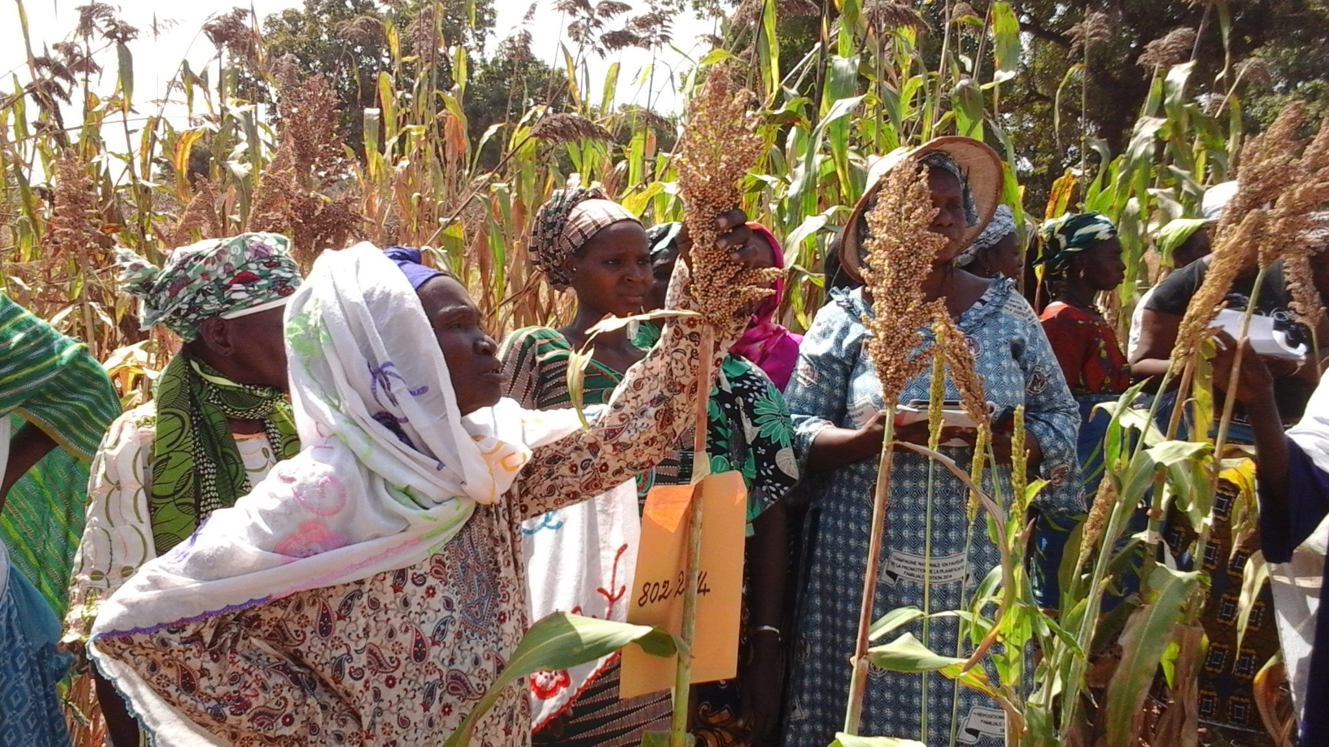

Photo 1: Farmers evaluating multipurpose sorghum in Dioila zone/Mali

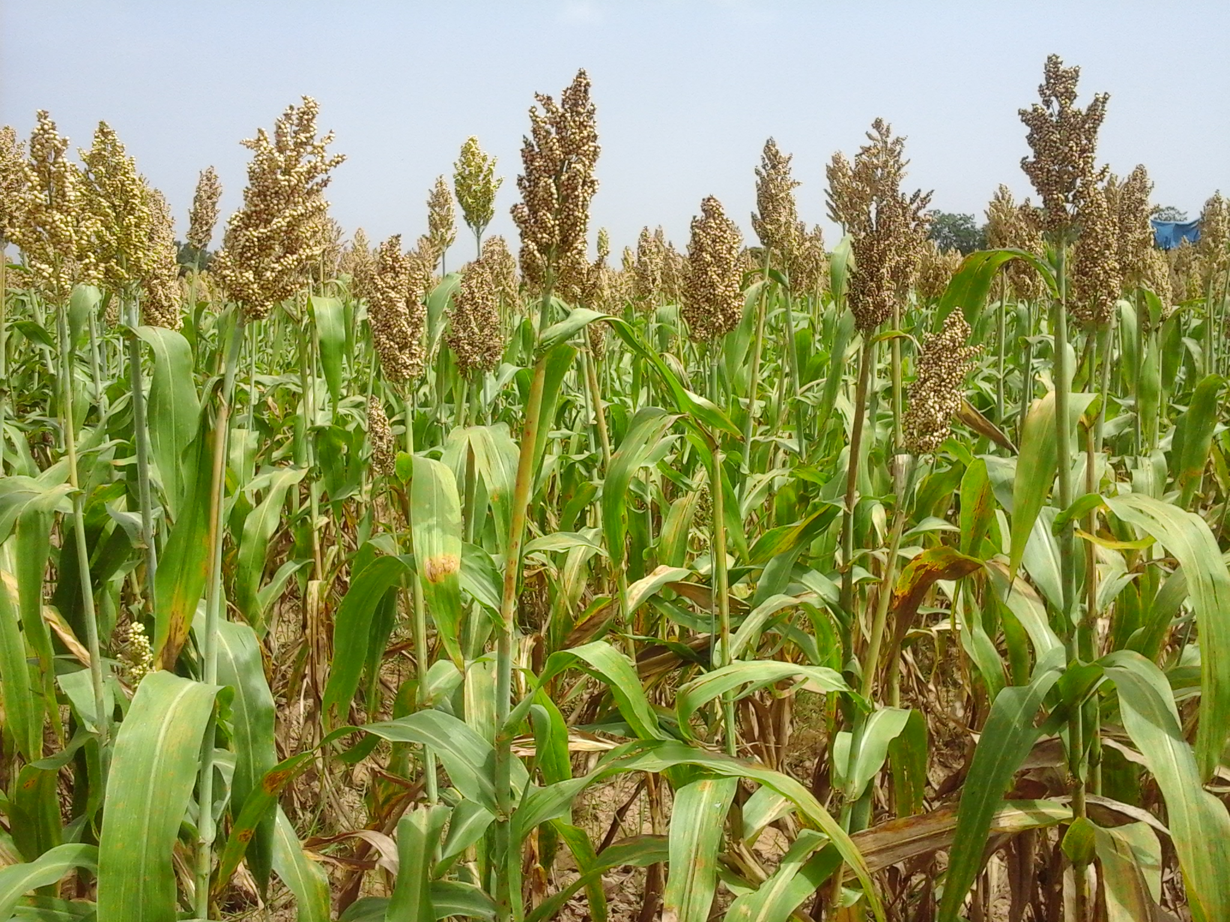

Photo 2: Foundation seed production field of Soubatimi, a dual purpose sweet sorghum registered into the national/regional catalogue in Mali

Next steps
The next steps for this activity is the adaptation tests including animal appreciation of the fodder, culinary tests for newly identified varieties and foundation seed production of registered varieties. In addition, selection/evaluation of new multipurpose sorghum, F1; F2; F3/F4 generations to broad the set of this sorghum.

