**   **

**PROJECT TITLE: SUPPORT TO AGRICULTURAL RESEARCH AND DEVELOPMENT OF STRATEGIC CROPS IN AFRICA**

**COUNTRY: NIGERIA**

**July 2015**

FROM JANUARY TO MARCH 2015 3

Executive summary: 3

COMPONENT 1: GENERATION OF AGRICULTURAL TECHNOLOGIES AND INNOVATIONS 4

1.1 Monitoring of Irrigated Lowland Wheat Trials 4

2. Registration and Release of REYNA 28 and CROW’S’ 5

COMPONENT 2: SUSTAINABLE DISSEMINATION OF AGRICULTURAL TECHNOLOGIES AND INNOVATIONS 6

2.1 Farmer Field School 6

2.2. Farmers’ Field Day and Farmers’ Participatory Selection of Irrigated Wheat trials 6

2.3Seed System Workshop 9

2.4 Monitoring, Inspection and certification of seed production 10

2.5 Stakeholders workshop and Midterm Review Meeting 11

2.6 Strategic Committee Meeting and Wheat Monitoring 12

2.7 Training course on Improving Water Productivity in Irrigated Agriculture with Focus on mechanized Raised Bed Planting 13

2.8 Procurement of Equipment 13

3.0 Problems Related to the Implementation of Activities 15

# FROM JANUARY TO MARCH 2015

# Executive summary:

This quarter report covers the period from 1st January to March 31st 2015. Rice-wheat-vegetable rotation trial was carried out at Kadawa and is being harvested. Field days were organized at Kadawa and Alkamawa on 21 and 22 March, 2015, respectively. A total 200 and 150 participant attended the field days at Kadawa and Alkamawa respectively. The number of female participants was 50 at Kadawa and 40 at Alkamawa. Seed System workshop was organized on 23-24 March, 2015. A total of 61 stakeholders in the seed industry attended the workshop. Papers were presented by relevant stakeholders at the workshop. At the end of the workshop, responsibilities were shared to seed stakeholders in order to achieve effective seed system to meet the national wheat seed supply. Farmer field schools were conducted in all the operating platforms at Kadawa, Bagwai and Alkamawa. A total of 2000 farmers were trained. A total of seven scientists attended the East-West SARD-SC Lowland Wheat travelling workshop at Sudan. Seed production farms of SARD-SC farmers were monitored and inspected by seed certification officers of National Seed Council (NASC). Some the problems encountered in the execution of the project are insecurity in some project sites, incidence of aphids on Norman variety which affected its performance at Alkamawa, slow procurement process and lack of vehicle.

**Introduction**

The Support to Agricultural Research for Development of Strategic crops in Africa (SARD-SC) wheat component has the overall objectives of enhancing food and nutrition security, and poverty reduction. The focus of the project is to generate agricultural technologies and innovations, disseminate agricultural technologies and innovations, capacity building and project management. In Nigeria, efforts have been made towards achieving the targets and objectives of project in the four key areas. Nigeria currently produces less than 5% of its wheat requirements necessitating the country to wheat valued at about $4 billion worth of the commodity annually. The production of wheat is gradually increasing due to the intervention of the project. The project is being complemented by the Nigeria’s government Agricultural Transformation Agenda (ATA) which has the same objectives of boosting wheat production, creating wealth and employment along the value chain. In the current wheat season (2014/15), the Nigerian government has distributed free wheat seed to 40,000 wheat farmers and fertilizer at 50% of market price. In addition, large quantities of threshers, sprayers and water pumps have been procured and will be distributed to wheat farmers in April, 2015.

# COMPONENT 1: GENERATION OF AGRICULTURAL TECHNOLOGIES AND INNOVATIONS

# 1.1 Monitoring of Irrigated Lowland Wheat Trials

Monitoring of the irrigated trials and farmers fields which were reported in to established in the September-December quarter, was carried out in January, 2015. The performances of the crop in germplasm evaluation, on-farm Adaptive Research and farmers’ fields were very impressive at Kadawa, Alkamawa and Bagwai platforms. There were no major incidences of diseases, pests or abiotic stresses on the crops except at Alkamawa where incidence of aphids on Norman variety was reported.

Clips from Farmers fields at the monitoring Visit in January 2015

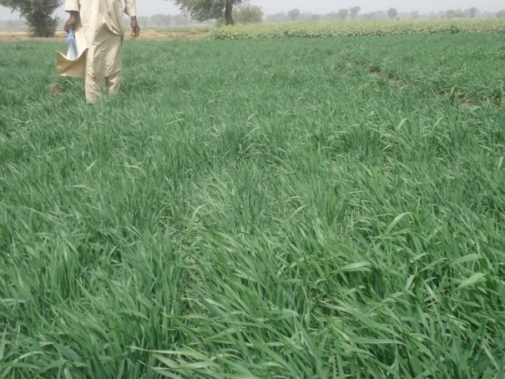

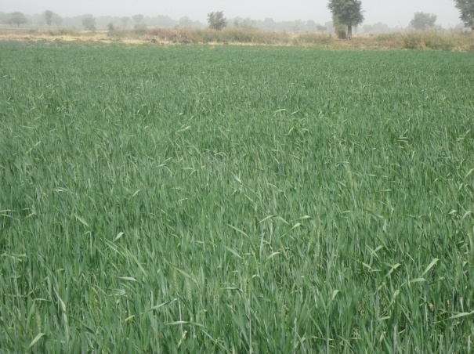

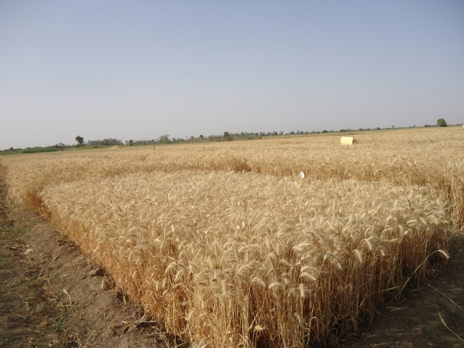

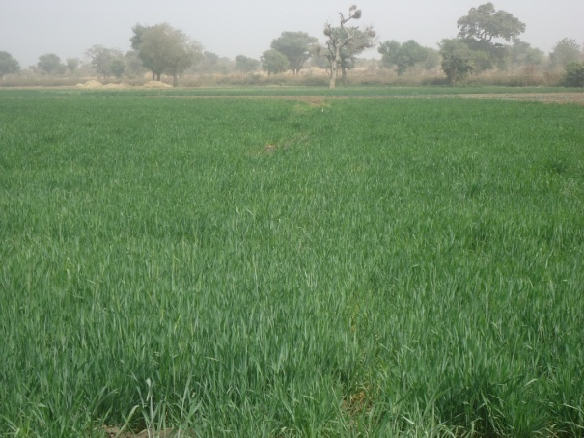

The following irrigated lowland trials were harvested in April 2015 at the four platform locations at Kadawa, Alkamawa, Bagwai and Gombe:

1. Demonstration of Organic manure rate and variety trial at Kadawa and Gombe
2. Demonstration of fertilizer by variety at Kadawa and Gombe
3. Demonstration of Sowing date by variety trial at Kadawa and Gombe
4. Conservation agriculture Trial at Kadawa, Alkamawa and Bagwai
5. SARD-SC Wheat 2013/2014 WA 2013 Elite selections at Kadawa and Gombe
6. SARD-SC / ICARC-WIP 5th ESBWTY (1) 2014/2015 at Kadawa and Gombe
7. SARD-SC/KARC – WIP 5th ESBWTY (2) 2014/2015 at Kadawa and Gombe.
8. Evaluation of deficit irrigation option on 3 varieties of bread wheat at Kadawa.
9. Cow dung, planting, method by variety at Kadawa and Alkamawa.
10. SARD – SC ICARC – WIP 5TH ESBWTY (3) 2015/2015 at Kadawa and Gombe.
11. SARD – SC SSA Low land favorable irrigated areas ESBWTY 2014/2015 at Kadawa and Gombe.
12. 4th Elite SBWTY Preliminary yield trial at Kadawa and Gombe.
13. SARD – SC Wheat project 2014/2015 SARD-SC ESBWTY Entries-14301 – 14372 at Kadawa and Gombe
14. SARD – SC SSA Lowlands SBWON 2014/2015 at Kadawa and Gombe
15. SARD – SC Seed multiplication at Kadawa and Gombe
16. SARD – SC West African lowland HUB National Bread wheat Advance yield Trial (NBWAYT) at Kadawa, Bauchi, Jigawa, Sokoto, Kebbi and Gombe
17. Effect of variety and fertilizer application on yield and yield component of wheat grown in semi-Arid environment of Northern Nigeria at Kadawa.
18. Demonstration of wheat control method on wheat at Kadawa and Gombe.

       19. Wheat seed rate by variety demonstration trial (SARD – SC) at Kadawa and Bagwai.

The yield and other parameters data are being analysed and report being written for the annual review and planning meeting.

# 2. Registration and Release of REYNA 28 and CROW’S’

Two elite wheat lines (REYNA 28 and CROW’S’) which are high yielding and resistant to fungal diseases were registered and released by the National Committee on Registration and Naming of Plant varieties and Animal breeds on 8th June, 2015 at Ibadan, Nigeria. REYNA 28 and CROW’S’ were named LACRIWHIT 6 and 7 respectively and released for the highland wheat growing areas of Nigeria.

# COMPONENT 2: SUSTAINABLE DISSEMINATION OF AGRICULTURAL TECHNOLOGIES AND INNOVATIONS

# 2.1 Farmer Field School

Farmer field school were held periodically from January through March, 2015 to review and teach farmers agronomic practices of wheat production such as weed control, fertilizer application, diseases and pests diagnosis and control, irrigation and water management, tillage and soil management. The farmer field schools are held at the farmers’ field where research and extension scientists interact with farmers, in which field problems are diagnosed and solution proffered. A total of 2000 farmers participated in farmer field school across the four operating platforms. The coordinators of Kano hub together with six research and extension facilitators were actively involved in farmer field schools.

**Clips of pictures taken during some of the farmer field schools**

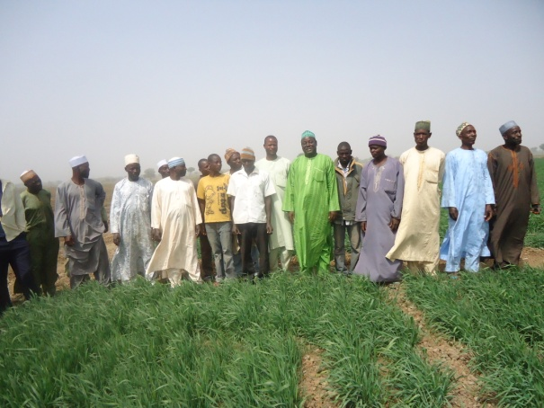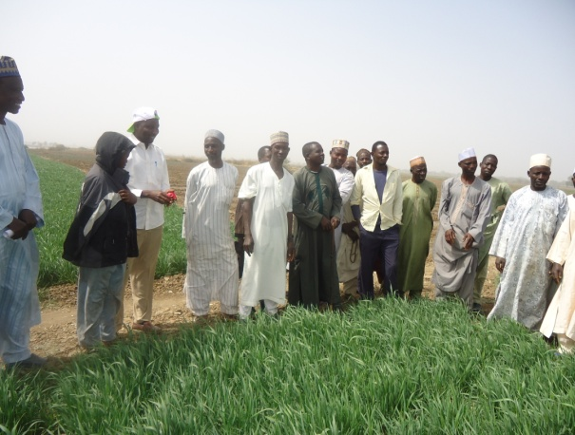

# 2.2. Farmers’ Field Day and Farmers’ Participatory Selection of Irrigated Wheat trials

Three Field days were organized for farmers of irrigated lowland wheat growing areas at at Kadawa and Alkamawa platforms at Kano.

The field day at Kadawa was held on Saturday, 21st March, 2015 and attended by stakeholders including farmers, flour millers, grain marketers, agro-inputs manufacturers and marketers, policy makers and government officials, NGOs, traditional rulers, extension workers and research scientists. Farmers’ seed production fields, germplasm evaluation and agronomic demonstration fields were inspected during the field day. The Federal Government of Nigeria through the representative of the Minister of Agriculture informed farmers during the occasion that it had procured large quantities of threshing machines, sprayers and irrigation pumps to be distributed to wheat farmers. A total of 200 stakeholders participated in the Field day, comprising 50 female participants.

The field day at Alkamawa was held on Sunday, 22nd March, 2015 and attended by stakeholders including farmers, flour millers, grain marketers, agro-inputs manufacturers and marketers, policy makers and government officials, NGOs, traditional rulers, extension workers and research scientists. Farmers’ seed production fields and agronomic demonstration fields were inspected during the field day. The major complain of farmers was incidence of aphids on Norman variety and consequently, grains were not filled. This happened on farmers that planted Norman variety in December. They observed that Norman does not tolerate adverse growing conditions such as high temperature. The situation is reported only at Alkamawa. Atilla/Gan/Atilla that was planted at the same time with Norman was not attacked by aphids and farmers are satisfied with its performance. A total of 150 stakeholders attended the field day, comprising 40 female participants.

**Pictures of Field days at Kadawa (Kadawa Platform) and Alkamawa (Alkamawa platform)**

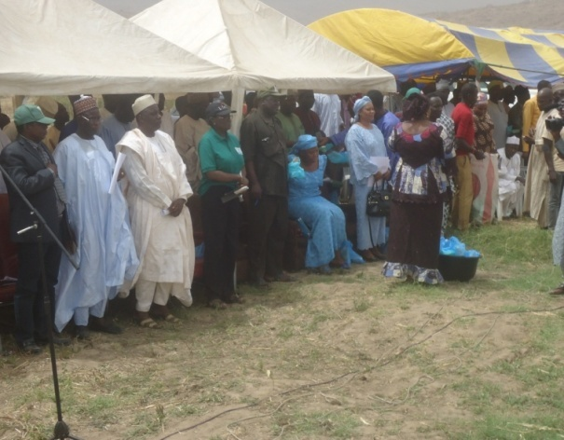

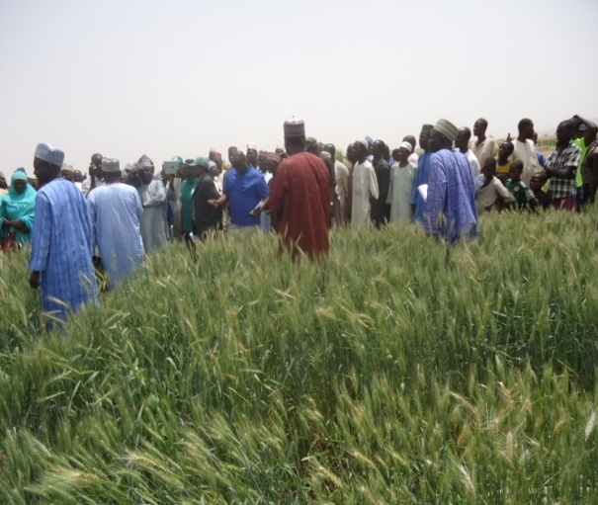

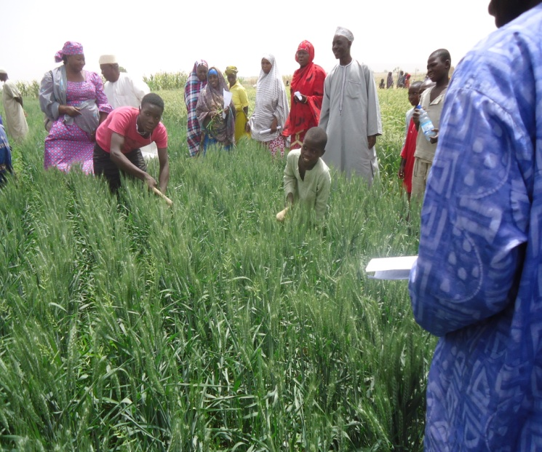

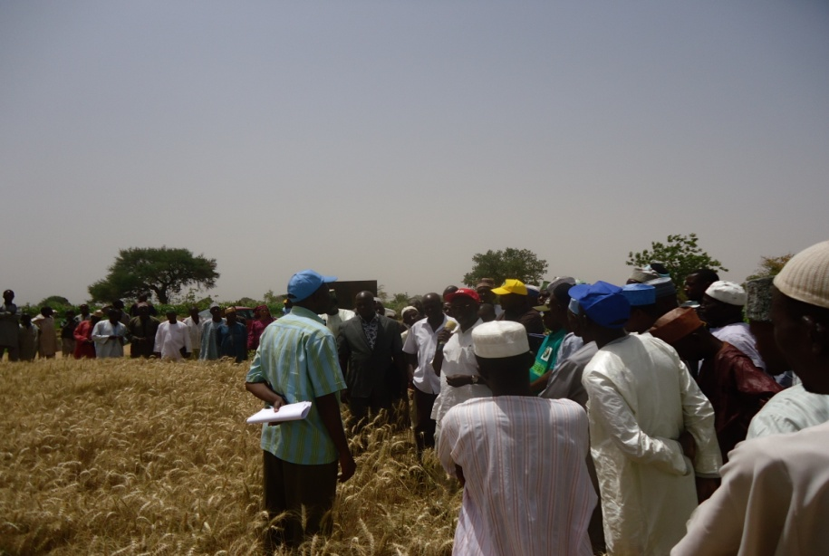

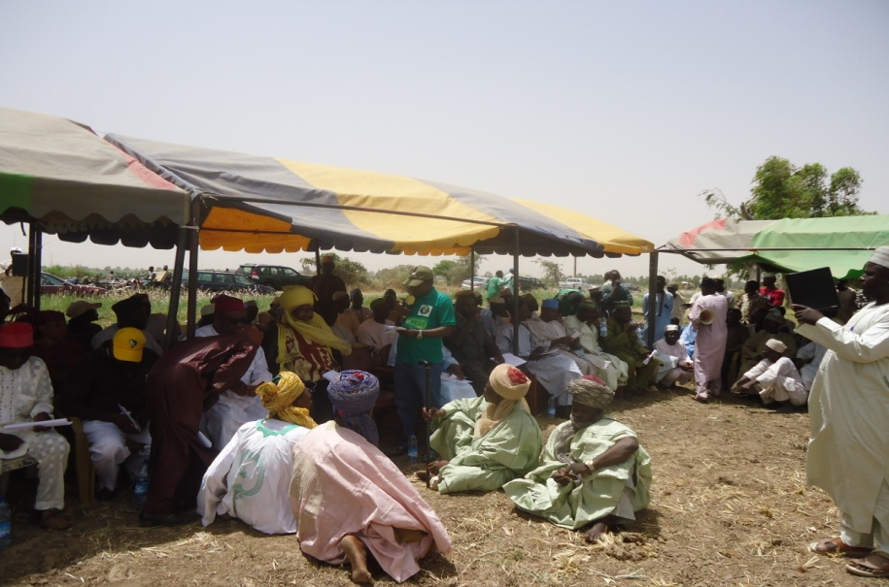

**Some female farmers at Alkamawa**

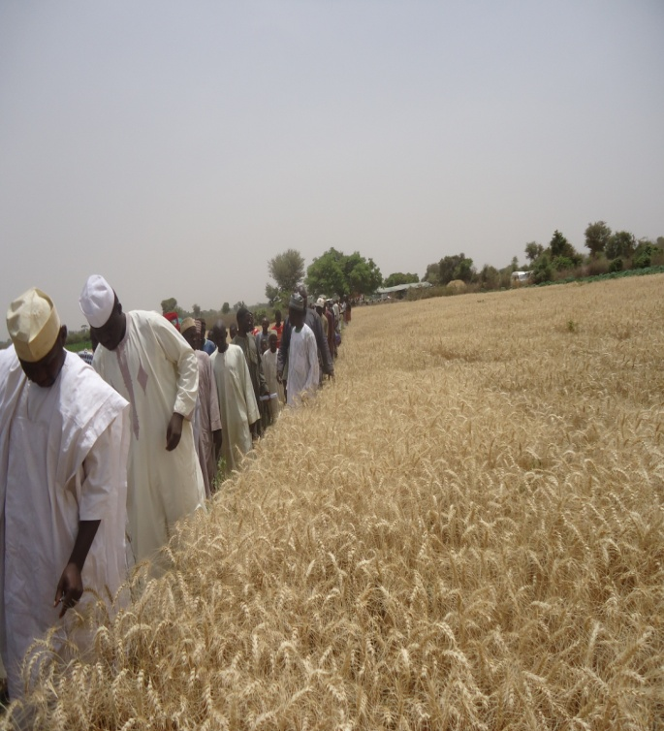

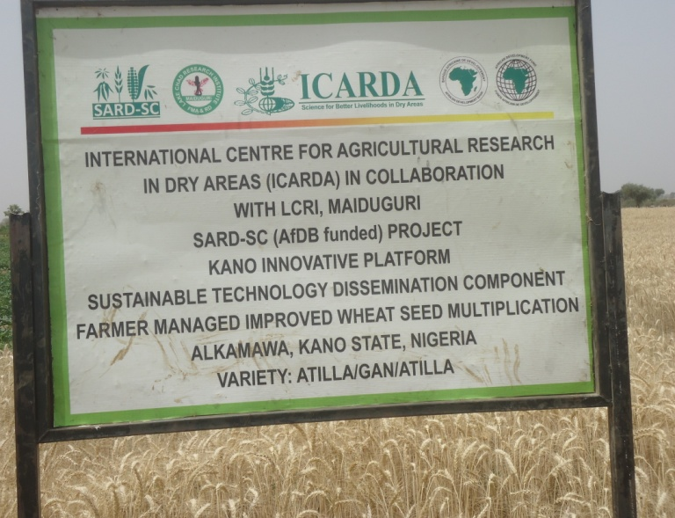

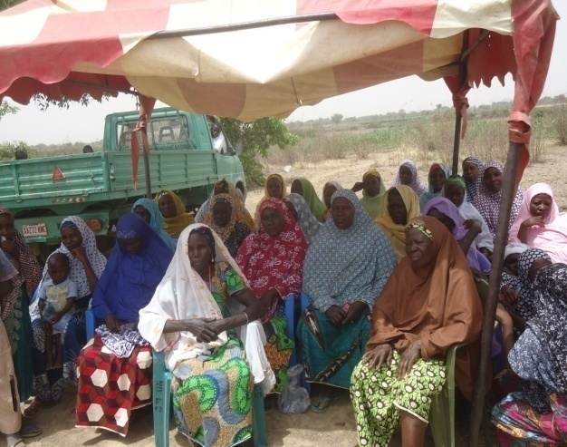

# 2.3Seed System Workshop

The seed system workshop was held at Kano on 23-25 March, 2015. The workshop attracted participants from research institutes, extension institutes, agricultural development projects of the wheat growing states, National Seed Council of Nigeria, National and International NGOs, States and Federal ministry of Agriculture, private seed companies and farmers. A total of 61 stakeholders attended the workshop including 20 female participants. The workshop was facilitated by Dr. Abdul Aziz Niane, the seed specialist of ICARDA. The workshop sought to consult with stakeholders on the current national seed system profile and diversification options to better serve the emerging wheat sector. Presentations were made by National Seed Council of Nigeria, Lake Chad Research Institute, Maiduguri, Institute for Agricultural Research, Zaria, Kano State Agricultural and Rural development Project (KNARDA), Premier Seeds Ltd, Rahama Seeds Ltd and Sassakawa Global 2000 on strengths, challenges and opportunities in the seed system in Nigeria, and rural community organization and empowerment. A workshop synthesis and formulation of recommendation was presented by Dr. Abdul Aziz Niane. At the end of the workshop, specific tasks for each of the stakeholders. The potential for community seed production to complement the national supply of quality seed was discussed during the workshop.

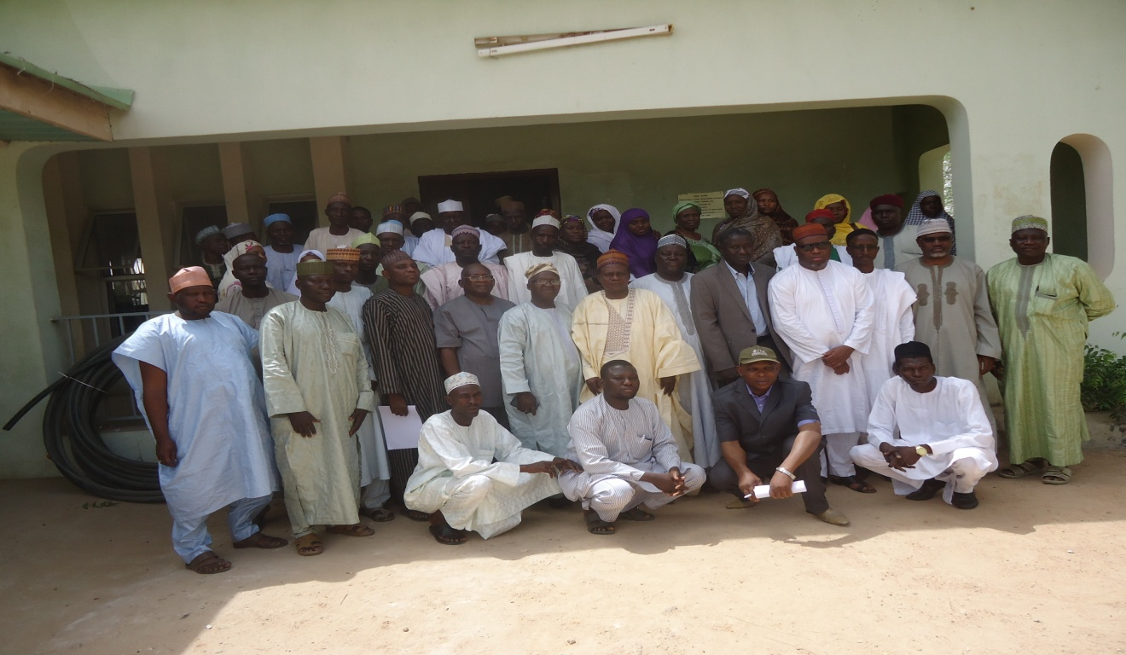

# 2.4 Monitoring, Inspection and certification of seed production

To ensure quality and standards, the National Seed Council (NASC) was invited to monitor and inspect farms of SARD-SC farmers selected to engage in seed production. The inspections were done in February and March, 2015 by the seed certification officer of the Council at Kano. This is Strategic understanding between SARD-SC project and the Council in order to boost quality wheat production to meet the national target of cultivating more than 300,000ha of wheat by 2017.

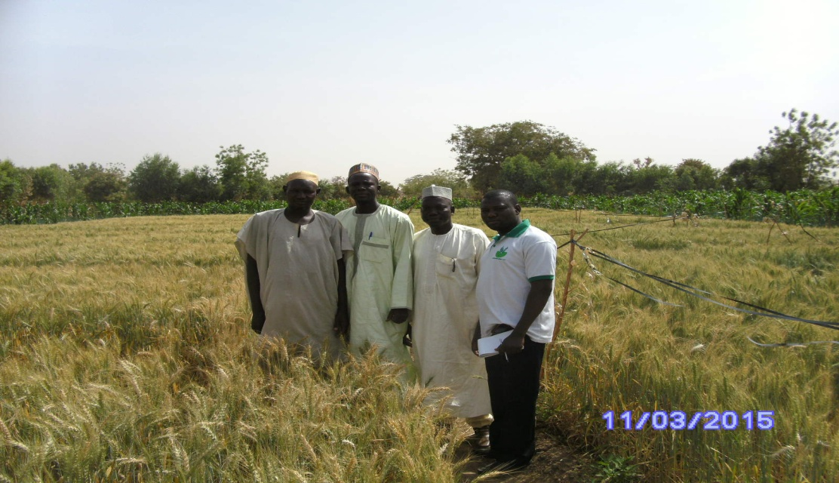

**Seed certification officer with research facilitator in farmer seed production field.**

# 2.5 Stakeholders workshop and Midterm Review Meeting

The Stakeholders Workshop and Midterm Review Report of SARD-SC project for the four commodities were held IITA Ibadan on 13 and 14th may 2015. The workshop was attended by stakeholders in research, extension, policy, end-use and markets for the commodities under the SARD-SC project. The Midterm Review Report was presented during the workshop relevant inputs were made by core scientists of the projects and partner countries. The performances of execution of the project by the various CGIAR centres were reported by the Midterm Review consultant and overall satisfactory report was awarded to the project. The African Development Bank disclosed its satisfaction with the progress of the project. The SARD-SC wheat project used the opportunity of the workshop to meet with various stakeholders from the three hubs and planned on how to further consolidate on the achievements of the project and work on areas the need further improvement.

**Clips from the side meeting of SARD-SC wheat team**

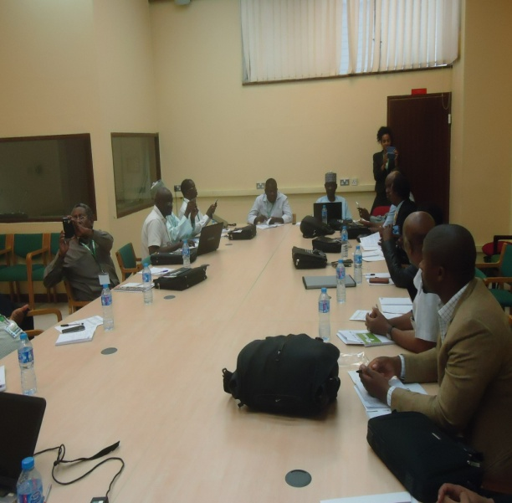 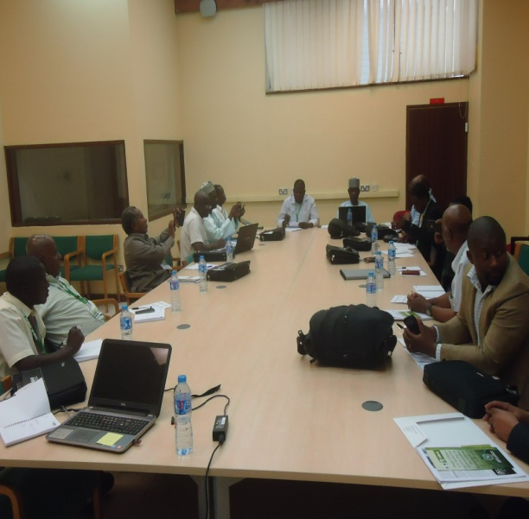

# 2.6 Strategic Committee Meeting and Wheat Monitoring

The National Strategic Committee Meeting was held at Kano on 8th June 2015 to discuss preparation for the National Review and Planning Meeting and ascertain the quantity of seed for next season planting. All Stakeholders were present at the meeting particularly millers and processors. The flour millers had confirmed the high quality of Nigerian wheat and have challenged farmers to increase production in order meet their industrial demand. Prima Dufil Flour Mill will collaborate with SARD-SC platforms farmers to insure continuous supply of wheat grains to their mill. An MOU is being prepared between the Mill and Wheat Farmers Association for the supply of wheat grains. The market is beginning to open for wheat farmers. The wheat farmers Association are in the process of introducing ware house merchandising whereby wheat farmers, at end of the season will store their grains at affordable fee and this will enable flour millers to procure the grains in bulk.

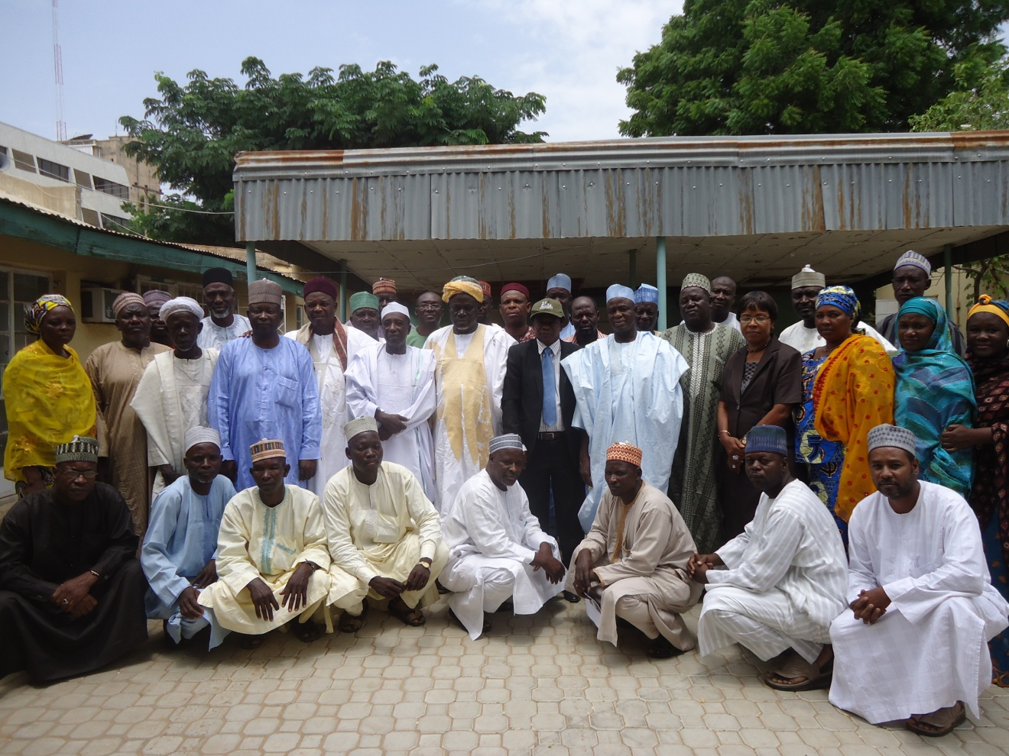 **Group picture of strategic committee meeting**

After the strategic committee meeting, the core team of SARD-SC project in Nigeria and members of the Agricultural Transformation Agenda (Wheat Value Chain) embarked on monitoring of Wheat production in the wheat producing states of Kano, Jigawa, Katsina, Zamfara, Sokoto, Kebbi, plateau, Bauchi and Gombe states.

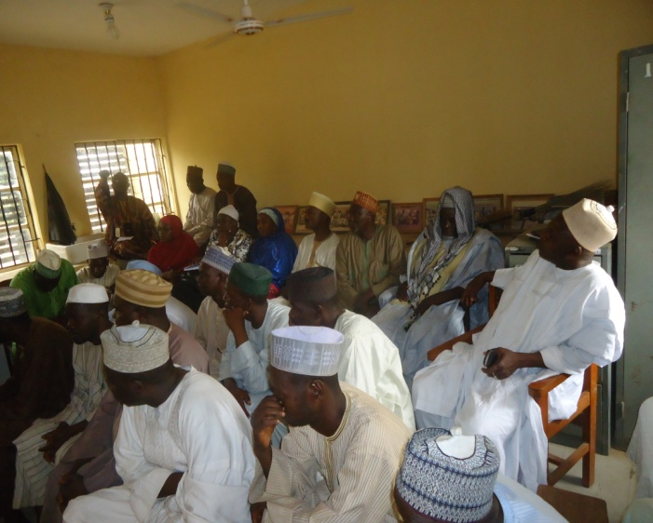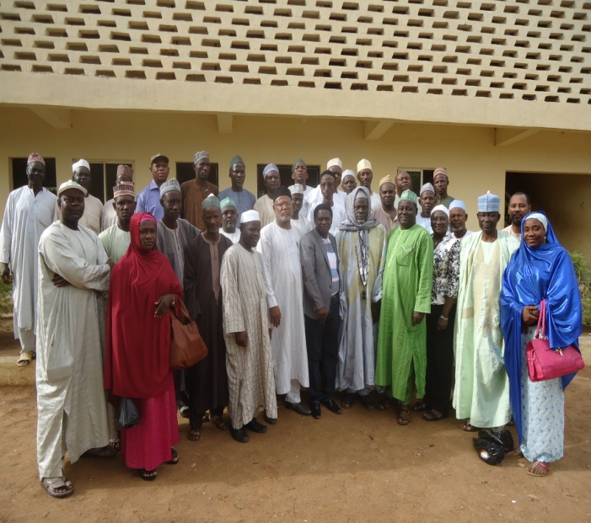

**A cross section of farmers at Kano**

# 2.7 Training course on Improving Water Productivity in Irrigated Agriculture with Focus on mechanized Raised Bed Planting

A course on Improving Water Productivity in Irrigated Agriculture with Focus on mechanized Raised Bed Planting was organized by ICARDA office Egypt on 24-28 May, 2015. The aim of the course was to improve water use under raised bed planting and to acquaint the scientists with the practical use of the equipment. Seven scientists comprising of four Nigerians, one Malian, one Nigerien and one Mauritanian attended the course.

# 2.8 Procurement of Equipment

Three small wheat threshers were procured and distributed to wheat farmers at Kadawa, Alkamawa and Bagwai. Two mechanized raised Bed planter were also supplied to SARD-SC wheat project in Nigeria to be used by farmers at Kano and Borno Platforms.

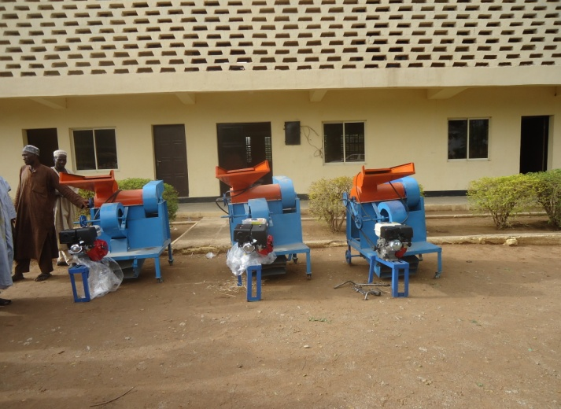  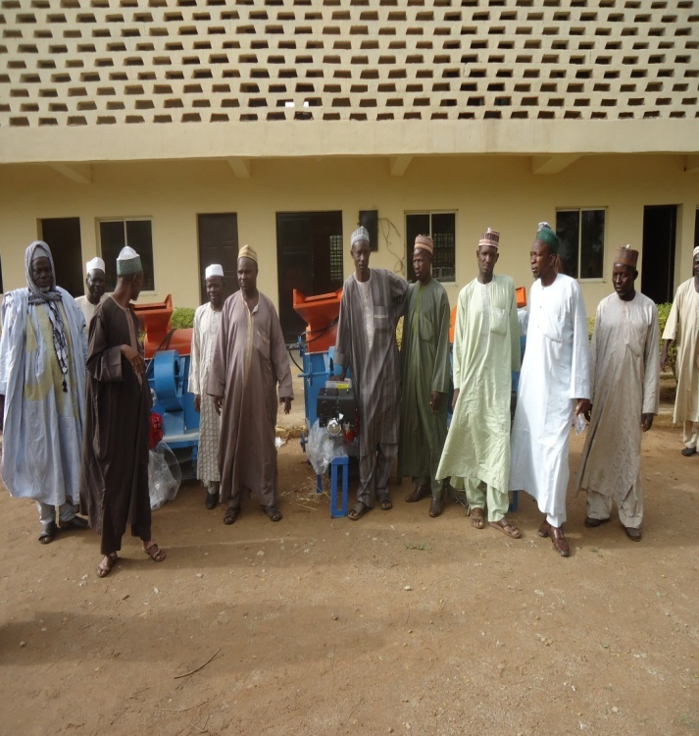

**Pictures of the small threshers and raised bed planter**

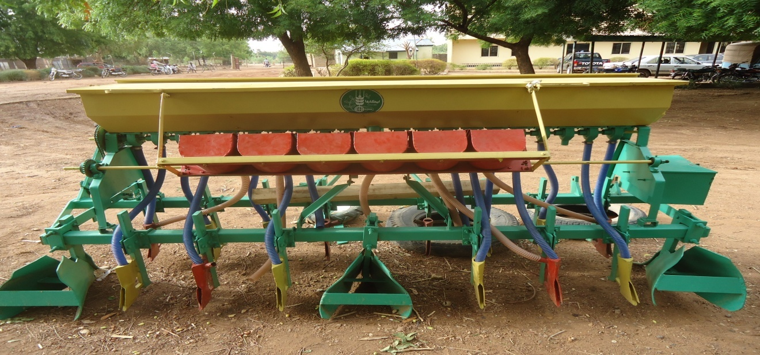

# 3.0 Problems Related to the Implementation of Activities

* Insecurity in some wheat producing states

**4.0** Work plan for next quarter

|  |  |  |
| --- | --- | --- |
| SN | Activity | Date |
| 1 | Data Analysis and Report writing | 1st -2nd week of July, 2015 |
| 2 | National Review and Planning Meeting for Nigeria. | 3rd week of July, 2015 |
| 3 | East-West Review and Planning Meeting of SARD-SC Wheat Lowland Hubs | 4th week of July, 2015 |
| 4 | Recovery and Procurement of Seed | August, 2015 |
| 5 | Strategic Committee Meeting | 1st Week of September, 2015 |
| 6 | Operational Committees Meetings | 2nd Week of September, 2015 |
| 7 | In country training of women on end use and various recipes of wheat | 3rd week of September, 2015 |
| 8 | Quarterly Report | 4th week of September, 2015 |