Bio economic Modeling of farm Household
Thiagarajah Ramilan, Shalander Kumar, Nageswara Rao & Anthony Whitbread

July 2015

Food security and better livelihoods

for rural dryland communities

Six monthly output: Derivation and validation of representative households reported
1 Introduction
Millions of smallholder farmers in South Asia derive their livelihoods from dryland agricultural systems. These agricultural production systems are characterized by low productivity, low farm incomes and natural resource degradation. There is a growing emphasis on sustainable intensification of these systems for improving farmer livelihoods. The CGIAR research program on Dryland Systems has adopted a systems approach to enhance agricultural productivity through technological interventions in South Asia. It is important to identify options that are manageable within the context of the farmer’s resource base and the household’s objectives that could improve farm household well-being. This study focuses on the development of representative farming systems for subsequent development of bio-economic farm model. Representative farming systems are developed using objective approach. We adopted an objective approach to determine the number of representative farming systems by using Model-based clustering method based on finite mixtures (Fraley & Raftery, 2002).
2 Materials and Methods
The typology of representative farms is created through multivariate analysis of 780 observations from panel data from 2009 to 2012, obtained from Village Dynamics in South Asia (VDSA) farm household survey conducted by International Crop Research Institute for Semiarid Tropics (ICRISAT, 2014). Multivariate outliers are eliminated based on Mahalanobis’ distance to enable robust estimation (refer Todoro, et al.,(2011). (Figure 1). Then forty two, socioeconomic and bio physical variables are identified (key variables are listed in the Table 1), then we applied principal component analysis to create latent variables. The typology of representative systems is created through cluster analysis on latent variables. We adopted an objective approach to determine the number of clusters by using Model-based clustering method based on finite mixtures (Fraley & Raftery, 2002). In this method, number of clusters is determined statistically contrary to conventional methods such as hierarchical or kmeans method, which depends on subjective judgment.
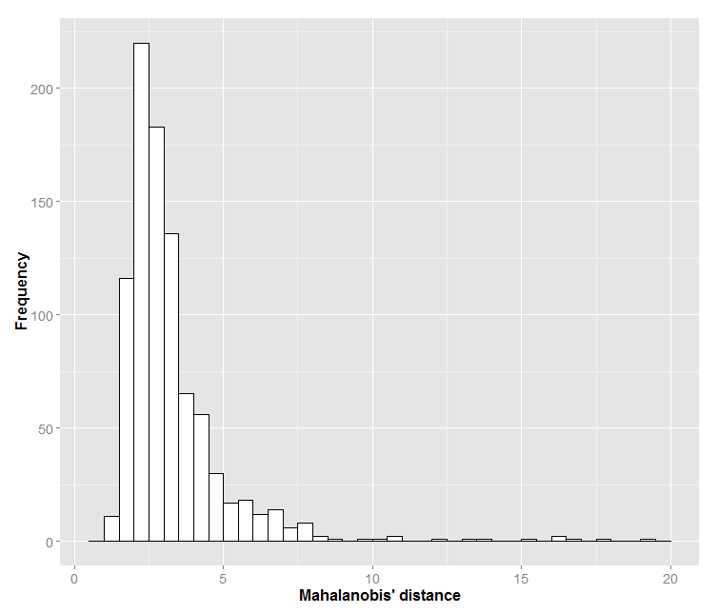
Figure 1: Distribution of multivariate outliers

3 Results - Discussion
Optimal number of clusters is identified based on Bayesian Information Criterion (BIC). In this case, the best model according to BIC is a variable -covariance model (MClust VVV) with 5 components or clusters (Fig, 2).
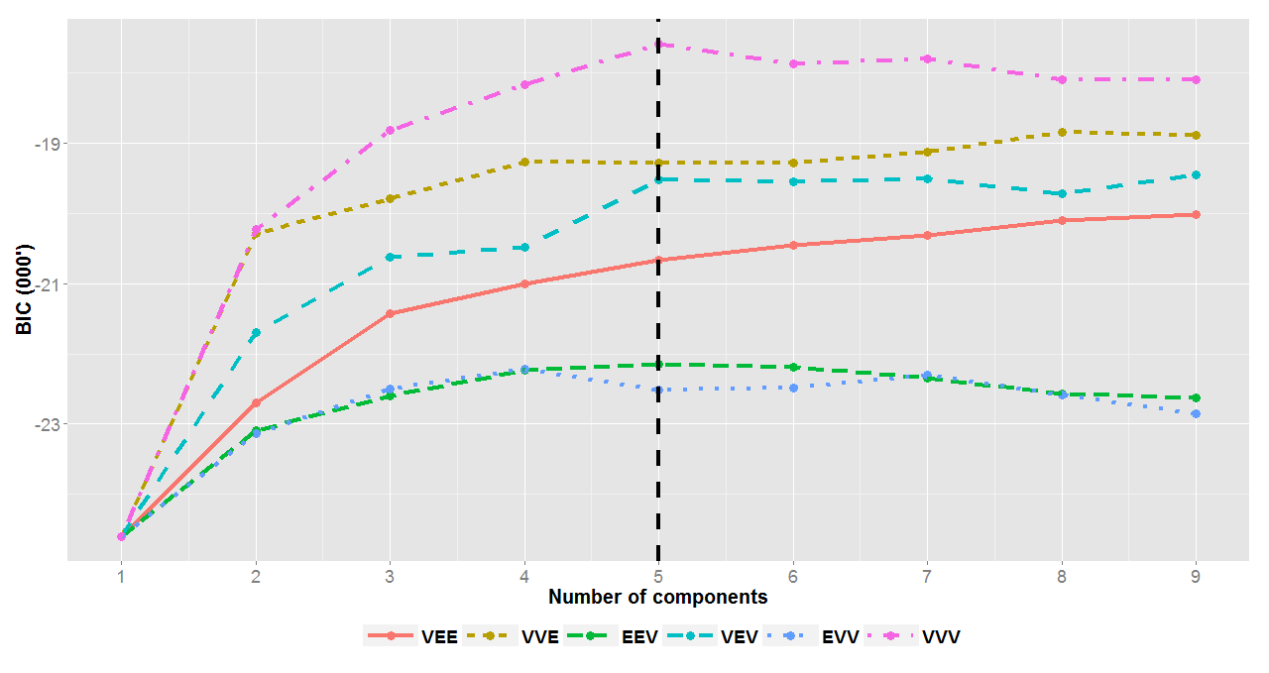
Fig 2. BIC values across the clusters under different covariance structure

Table 1: Descriptive statics of farm clusters
 | Farming Systems
Variables | Type1 | Type 2 | Type 3 | Type4 | Type 5
Adult mean education (years) | 2.6 | 6.0 | 3.5 | 7.2 | 5.4
Farm size (ha) | 1.8 | 5.6 | 0.0 | 1.8 | 2.5
Irrigated area (ha) | 0.0 | 1.9 | 0.0 | 0.2 | 1.2
Good_soil_area | 0.6 | 2.1 | 0.0 | 1.1 | 1.1
Drought tolerant crop area (ha) | 0.8 | 1.8 | 0.0 | 0.6 | 0.8
Value of crop produce marketed (USS) | 157 | 1645 | 1 | 467 | 244
value of livestock product marketed (USS) | 39 | 351 | 1 | 0 | 223
Cash crop area (ha) | 0.1 | 1.3 | 0.0 | 0.2 | 0.7
Tropical Livestock Units (TLU) | 0.5 | 1.0 | 0.1 | 0.0 | 0.8
Fertiliser use (kg/ha) | 44 | 165 | 0 | 62 | 232
Purchased feed (US$) | 14 | 115 | 0 | 0 | 64
Crop gross margin (US$) | 119 | 2315 | 0 | 270 | 848
Livestock gross margin (US$) | 212 | 826 | 38 | 17 | 504
Nonfarm Income (US$) | 504 | 1165 | 991 | 1695 | 812
Off farm income (US$) | 701 | 167 | 482 | 193 | 341
Farm Machinery (US$) | 83 | 966 | 43 | 171 | 362
Value of durable goods (US$) | 887 | 3641 | 1006 | 2001 | 1617
Building assets (US$) | 1628 | 3739 | 1802 | 3031 | 1838
Family.hours.sum | 201 | 844 | 0 | 228 | 533
Hired.working.hours.sum | 108 | 1007 | 0 | 237 | 579
Table 1 reveals the existence of wider heterogenity in farm types. It ranges from land less households to irrigtaed-livestock cropping systems The drivers for the heterogenity are varying access to irrigation, livestock units, non-farm employment and land size The farm types are validated through informal interviews, key informant interviews and focus group discussions. We found potential interactions among different farm types such as landless farmers provide labour as well as linking with markets for trading livestock and restock inputs with farm based systems.
4 Conclusions
Synergies and tradeoffs on range of scenarios on technological interventions and resource constraints will be assessed, relating to changes in current enterprise mixes, potential for intensification and environmental impact. Indicators generated from the model are useful for effective farming system design and up scaling to larger areas, when linked to the typology.
Acknowledgements : Authors are greatfull to National Agricultural Research system Partners
References
Fraley, C., & Raftery, A. E. (2002). Model-based clustering, discriminant analysis and density estimation. Journal of the American Statistical Association, 97, 611–631.

ICRISAT. (2014). Village Dynamics in South Asia (VDSA) database. Retrieved from http://vdsa.icrisat.ac.in/

Todoro, V., Templ, M., & Filzmoser, P. (2011). Detection of multivariate outliers in business survey data with incomplete information. Advances in Data Analysis and Classification, 5(1), 37–56.

