

**TECHNOLOGY: THE DC80-263 CLIMBING BEAN VARIETY**

Ndengu G., Desta L.T., Mponela P., Chataika B. and Chirwa R.

Breeding researchers in Malawi have not yet released any climbing bean variety. However, under the McKnight project DC80-263 beans showed potential in yield and resistance to some diseases. DC80-263 variety is has medium seed size and is a heavy climber. Yield results for the current year were quite low (0.2 ± 0.3 Mgha-1), in contrast to the situation in the 2013 -2014 season (1.4 Mgha-1) when rains were normal. Yield variability was also quite high (CV = 112.5%).

Table 1: Yield of DC-86-263 in the trial sites

|  |  |  |
| --- | --- | --- |
| **DC86-263** | Mean | 0.2 |
| Conf-95% | 0.2 |
| Conf 95% | 0.3 |
| Std | 0.3 |
| CV | 112.5 |

Treatment based analysis showed insignificant differences in yield (p > 0.05) an indication of insignificant differences in responses to yield arising from variabilities in treatments for the variety. The poor performance of the variety was attributed to the terminal drought, as climbers are more sensitive to moisture stress (**See the main report**). The terminal drought (prolonged dry spell) came at a time when the variety was just flowering (**Figure 2**), making it difficult to reach physiological maturity through residual moisture.

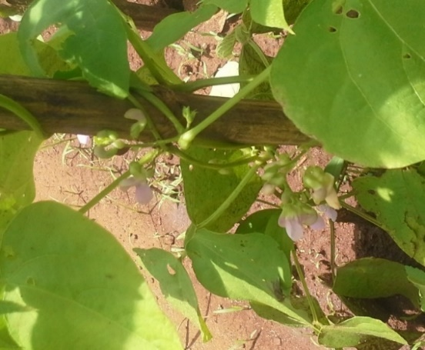  
Figure 1: Response of DC86-263 to different treatments

Figure 2: DC86-263 flowering at the onset of drought (2014-2015 season)

Much as the variety did not do well in the 2014-2015 growing season, it has shown potential of significantly contributing to increased bean production in normal years, as was the case in the 2013/2014 season (**For details see the main report**). Form the current results, it was not clear to determine the best management option for optimum productivity as the variety was seriously affected by the prolonged dry spell of 2014/2015 season.