Activity : Testing wild relative of chickpea under different experimental conditions for TE and plant water budget

Objective of activity and intended output – A collection of chickpea wild ancestors (A. reticulatum and A. aeschinospermum) has recently taken place in Turkey and widened tremendously the genetic diversity of the wild resources (which were, before that collection, essentially reduced to only one population). These wild germplasm (26 populations) have been imported to India, multiplied. Then 16 of them were tested for a range of test informing us of their propensity to adapt to water limited conditions.

Materials and Methods: Three types of assessment were made: (i) the transpiration response to increasing VPD (ii) the transpiration response to soil drying; (iii) the plant water budget of these wild germplasm. 16 wild and 5 cultivated entries were tested. For the transpiration response to increasing VPD conditions, this consisted in growing plants in 8” pots under fully irrigated conditions (see Figure 1 below). At about 4 weeks after sowing, transpiration was assessed gravimetrically (consecutive pot weighings) every hour, in a ladder of VPD conditions. For the transpiration response to soil drying, we used a drydown technique where transpiration is partially compensated on a daily basis, therefore allow all plants to lose a same amount of water per days, thereby controlling the kinetics of water stress imposition (and then control plant size effect). For the plant water budget assessment, plants are grown in lysimeters and water use is monitored throughout the entire life cycle of the plant by weighing tubes on a regular basis (1-2 weeks). This experiment was carried out under fully irrigated conditions (see Figure 1 below).

Results and interpretation:

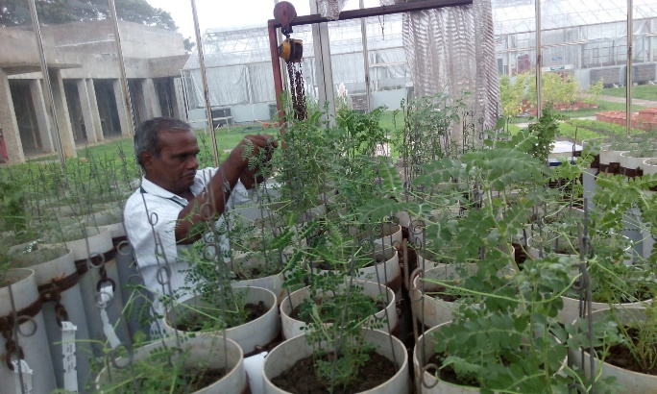 | 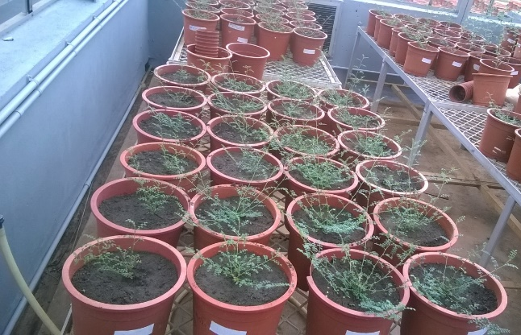
Figure 1. Wild accessions in lysimeters in glass house condition-2016 (left) and in pots for the VPD response and the drydown experiment (right

The table below shows the summary of the water use and the bar chart represents an overall comparison of the plant water use across wild and cultivated. The wild used a lot more water than the cultivated, owing to their very indeterminate nature, especially in the relatively short days environments in which they grew in India, whereas the cultivated used a lot less water, some of them (ICCV96029) being extra short duration lines.

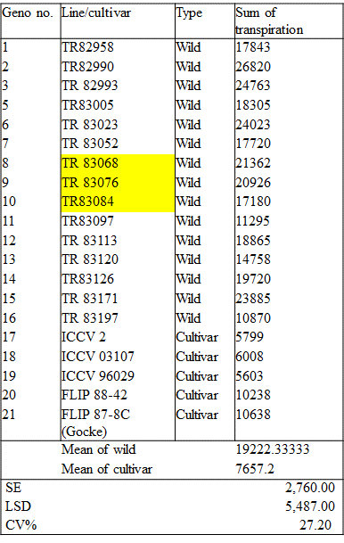 | 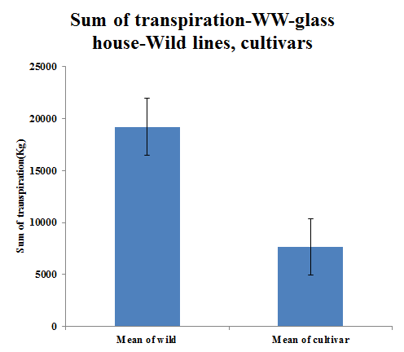
 | Figure 2. Summary statistics of water use in 16 wild (1-16) and 5 cultivated (17-21) chickpea (Table, left) and bar chart representing overall water use of wild and cultivated under fully irrigated conditions (top).

Figure 3 below represents the range of variation in the response of transpiration to increasing VPD conditions, showing the strong response of few cultivated lines but also of several wild germplasm, in opposition to other genotypes, wild or cultivated, showing a much milder response to increasing VPD.

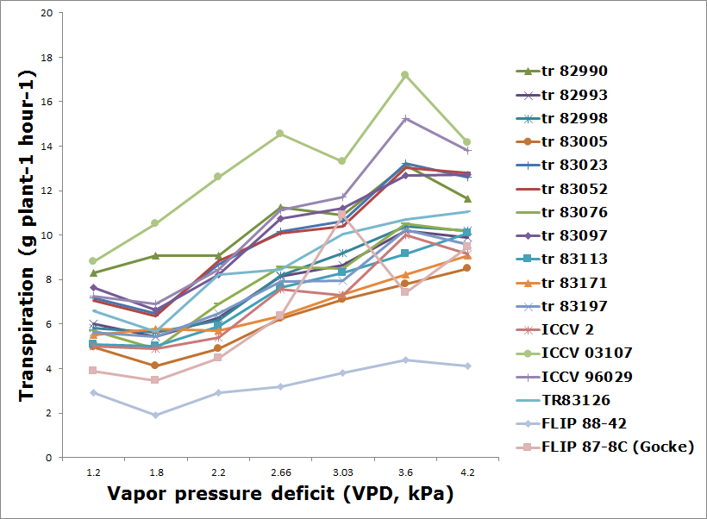 | Figure 3. Transpiration response to increasing VPD in wild cicer germplasm.

This work adds to a parallel and comprehensive work carried out by Fatma Basdemir, PhD student at Dicle University in Turkey, who came for training at ICRISAT and then developed and applied similar protocols for assessing the wild relative at her University. These are similar protocols used here to assess (i) the transpiration response to increasing VPD (ii) the transpiration response to soil drying; (iii) the plant water budget of these wild germplasm.

Next steps Phenotypic data on a newly collected set of wild chickpea relative - Knowledge of the most interesting wild chickpea relative for crossing into cultivated background. Additional assessments will be needed to confirm the results presented here.

