GLDC-FP3-3.13 – ICRAF/SAHEL COMPONENTS – 2019 REPORT

“Complementarity of three main farming components (crop-tree-livestock) for improved household nutrition in Burkina Faso, Mali and Niger” and

“Co-Designing GLDC options for improving farmers' livelihoods and agro-ecosystem resilience in Burkina Faso, Mali, and Niger”

Team members

Catherine Dembele, Jules Bayala, Patrice Savadogo, Adeyemi Chabi

Introduction
In the first year of the project, Grain Legumes and Dryland Cereals (GLDC), surveys were carried out to assess the diversity of household diets in 3 sites of a Dutch funded program named Dryland development program (DryDev) implemented in Niger, Burkina Faso and Mali and coordinated by ICRAF. The results revealed the lack of diversity in the household diet as the main cause of malnutrition in these regions. Based on these results, crop diversification came out strongly as a pathway for reducing nutrition insecurity. Therefore, two complementary topics were suggested to help coping with malnutrition issues, including (1) Complementarity of three main farming components (crop-tree-livestock) for improved household nutrition and (2) Co-design GLDC options for improving farmers' nutrition, livelihoods and agro-ecosystem resilience. An additional study was conducted to determine the effects of contour bunding with woody and herbaceous vegetation on soil water infiltration.
Hence, protocols were developed to introduce (1) small households’ fruit and vegetable gardens, and (2) grain legumes and dryland cereals options for improving farmers' livelihoods and agro-ecosystem resilience through multi-environment trials with about 160 farmers’ households in Mali and Burkina Faso and determining soil water infiltration rate along contour bunds with 4 types of vegetation.
At the end of the raining season, a field visit was organised to gather the farmers involved in one village to discuss about their perception of the options they have tested (varieties and land management). During focus group discussions in each of the 7 villages of Yorosso district, farmers’ assessment of the project in general and especially of the results obtained was collected and included in the present report. Two master students from Mali and 1 PhD student from Burkina Faso have been hired for capacity building. The master students have completed field data collection and are at the writing stage of thesis after the data was analyzed.

Small household fruit and vegetable tree garden
A 36m² (6m x 6m) vegetable garden using improved plant materials including 2 varieties of each of 3 fruit tree species Ziziphus mauritiana (jujube), Tamarindus indica (tamarin), Adansonia digitata (baobab) and 2 vegetable tree species baobab and PKM1 variety of Moringa oleifera were established by the spouses of the men of 87 households involved in GLDC crops testing in Mali. These trees were combined with improved varieties of 4 annual vegetable crops Amaranth (A 2004), Corchorus (Bafia), Okra (Batoumabé), and Roselle (Samatan) obtained from the West and Central regional office of World Vegetable Centre (AVRDC) based in Bamako.
Three months after establishment the survival rate differed between the 2 vegetable tree species baobab and Moringa (Table 1) but not among villages. A. digitata had greater survival rate (80.6±3.1%) than M. oleifera (59.9±3.0%). There was significant interaction between village and species as well as significant single effects of village and species for two growth parameters which are stem collar diameter and number of branches (Figure 1; Tables 1&2). From the focus discussion, it appeared that the ladies involved in the gardening activities showed preference for baobab leaf vegetable while for the annuals, amaranth was the most preferred followed by Roselle and Corchorus. For the this very first year, the team has been able to collect quantitative data for the annual vegetable crops because some were already consumed by the time we started the data collection. A more day to day way needs to be developed to assess this variable because of its continual use as soon harvested by the women.

Table 1. Survival rate, stem height, stem collar diameter and number of branches of tree vegetable established in 36 m² small household gardens in Yorosso, Mali.
Species | Survival rate | Height (cm) | Stem collar diameter (mm) | Branch number
Adansonia digitata | 80.6±3.1a | 40.8±0.8a | 6.1±0.3a | 10.4±0.4a
Moringa oleifera | 59.9±3.0b | 40.51.1±a | 4.1±0.2b | 7.3±0.4b
Values (Mean ± SE) followed by the same letter for a given parameter are not significantly different at the 5% level according to Turkey’s multiple comparison test.

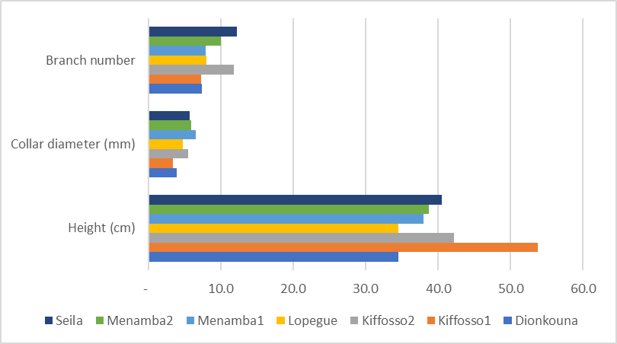
Figure 1. Stem height, stem collar diameter and number of branches for vegetable trees, baobab (Adansonia digitata) and moringa (Moringa oleifera) per village established in 36 m² small household gardens in Yorosso, Mali

Table 2. Stem height, stem collar diameter and number of branches per vegetable tree species per village established in 36 m² small household gardens in Yorosso, Mali
Species / Village | Height (cm) | Stem collar diameter (mm) | Number of branches
Adansonia digitata
Dionkouna | 31.2±2.1d | 4.4±0.9cd | 7.4±1cd
Kiffosso1 | 56.1±2a | 3.8±0.3cd | 8.4±0.7cd
Kiffosso2 | 44.7±1.6bc | 8±1abc | 16.4±1.5a
Lopegue | 34.7±1.4cd | 5.5±0.5abcd | 8.3±0.8cd
Menamba1 | 38.4±1.3cd | 7.8±0.6a | 8.9±0.7cd
Menamba2 | 37.6±1.8cd | 6.4±0.8abc | 12.2±1.3abc
Seila | 38.4±1.5cd | 6.6±0.6abc | 14.7±1.4ab
Moringa oleifera
Dionkouna | 39±4.4bcd | 3.4±0.6cd | 7.2±1.5cd
Kiffosso1 | 50.8±2.6ab | 3±0.3d | 6.2±0.7d
Kiffosso2 | 37.7±3.4cd | 2.8±0.5d | 7.1±1.3cd
Lopegue | 34.2±2.2cd | 4±0.5cd | 7.5±0.9cd
Menamba1 | 37.4±2.1cd | 5.1±0.6bcd | 6.8±0.8d
Menamba2 | 40.2±3.4bcd | 5.3±1.1abcd | 7.8±1.4cd
Seila | 43.3±3.4bcd | 4.8±0.8bcd | 9.6±1.4bcd
Values (Mean ± SE) followed by the same letter for a given parameter are not significantly different at the 5% level according to Turkey’s multiple comparison test.

For fruit trees, the survival rate of the grafts varied significantly among villages and species (Table 3) but not between accessions nested within species. The lowest survival rate was observed in Dionkouna with less than 50% alive at the time of the observation. In Kiffosso2, Lopegue and Menamba1 the survival rate exceeded 70%. Z. mauritiana showed the best survival rate (73.4±4.5) compared to A. digitata (61.1±3.8). For growth parameters, stem height differed among villages and species while stem collar diameter differed only among villages. Number of branches did not show any significant difference for any of the factors. The greatest values for stem height were recorded in Koffosso1 (27.6±1.4 cm) and Menamba1 (25.3±0.9 cm) in contrast to Kiffosso2 (19.1±1.0 cm) and Menamba2 (18±1.3 cm) showing the lowest values.

Table 3. Survival rate (%) of fruit trees established in the small household garden established in Yorosso, Mali per village and per species
 | Survival rate (%)
Village
Dionkouna | 48.2±5.5b
Kiffosso1 | 67.8±5.6ab
Kiffosso2 | 70.4±5.5a
Lopegue | 74.2±5.5a
Menamba1 | 76.3±3.5a
Menamba2 | 63.3±3.3ab
Seila | 66.7±8.6ab
Species
Adansonia digitata | 61.1±3.8b
Tamarindus indica | 65.6±3.5ab
Ziziphus mauritiana | 73.4±4.5a
Values (Mean ± SE) followed by the same letter for a given factor (village or species) are not significantly different at the 5% level according to Turkey’s multiple comparison test.

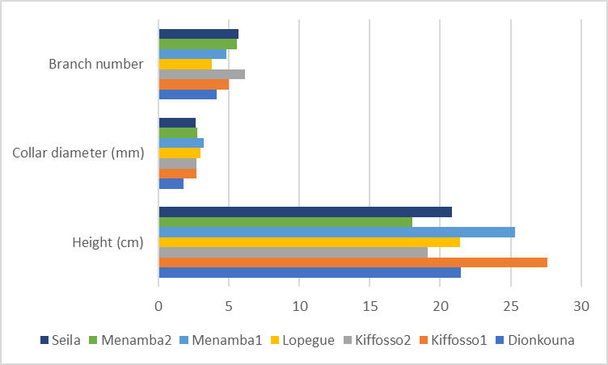
Figure 2. Stem height, stem collar diameter and number of branches for fruit trees, Adansonia digitata, Tamarindus indica, and Ziziphus mauritiana per village established in 36 m² small household gardens in Yorosso, Mali

Table 4. Stem height (cm), stem collar diameter (mm) and number of branches of fruit trees established in 36 m² small household gardens in Yorosso, Mali.
Species | Height (cm) | Stem collar diameter (mm) | Number of branches
Adansonia digitata | 24.7±1.0a | 2.9±0.2a | 4.9±0.4a
Tamarindus indica | 23.4±0.8a | 2.7±0.2a | 5.4±0.4a
Ziziphus mauritiana | 20.8±0.7b | 2.8±0.1a | 4.6±0.3a
Values (Mean ± SE) followed by the same letter are not significantly different at the 5% level according to Turkey’s multiple comparison test.

Multi-location trials for designing suitable crops
Improved seeds of 14 GLDC crop varieties (4 sorghum, 4 millet, 2 peanut, 4 cowpea) along with mineral fertilizer (DAP or NPK) were distributed to 160 farmers’ households in Mali (100), and Burkina Faso (60). They were all biofortified and their dissemination and adoption will contribute to overcome nutrition insecurity for adopting farmers. Seeds were sown according to the developed protocols in farmers’ fields using participatory and multi-environment field trial approach. Each variety were established on 200 m² plot. Seeds were provided by ICRISAT Mali and Niger and NARS partners including Institut de l’Environnement et de Recherches Agricoles (INERA) of Burkina Faso and Institut de l’Economie Rurale (IER) of Mali.
The yield was evaluated as grain per ha and analyzed. The statistical analysis did not reveal significant difference between yield of 2 varieties of the crops except peanut with Fleur11 having greater mean yield (807∓56 kg ha⁻¹) than ILGV86024 (652∓46 kg ha⁻¹). Difference among villages were observed only for millet with the highest mean yield (609.0±156 kg ha⁻¹) observed in Lopegue. In general, the yields observed were lower than the expected yield exceeding 1,000 kg ha⁻¹ according to the scientists (from ICRISAT for sorghum, millet and peanut, IER for cowpea) who developed the varieties (Table 5). Such low results are similar to the general yield obtained by farmers in Mali because of various poor management practices (FAO statistics 2011).
Focus group discussions revealed that the 2 pearl millet varieties did not perform well where they have been tested because they matured early and as a consequence their grains were eaten by birds. Despite lack of statistical difference in yields, collaborative farmers have shown preference for Soubatimi compared to Fadda for sorghum and Wilibali compared to Korobale for cowpea. Subatimi was appreciated as it matures earlier, produces bigger grains and its straw a good fed for their livestock. Earlier maturity and sweat taste were the reasons for the preference of Wilibali. Farmers also showed pference for the taste of Fleur11.
A multi-year evaluation of the selected varieties for 2 more seasons (2020 – 2021) will give some indications on their performance with regards to climate variability and suitability for Yorosso district. Likewise, about 80 other households are willing to join the trials. Seeds of the most appreciated varieties including Fleur11, Subatimi and Wilibali will be distributed for upscaling.

Table 5. Mean crop yield (kg ha⁻¹) per variety obtained on farmers’ field in Yorosso district, Mali in 2019.
Legumes/Varieties | Mean±SE | Cereals/Varieties | Mean±SE
Cowpea |  | Millet
Korobale | 635.0±41.5a | Nakowa | 272.5±27.2a
Wilibali | 576.2±39.2a | Siaka | 315.9±48.5a
Peanut |  | Sorghum
Fleur11 | 806.5±55.6a | Fadda | 429.3±32.5a
ILGV86024 | 652.1±46.4b | Soubatimi | 522.0±39.6a
Values (Mean ± SE) followed by the same letter for a given crop are not significantly different at the 5% level according to Turkey’s multiple comparison test.

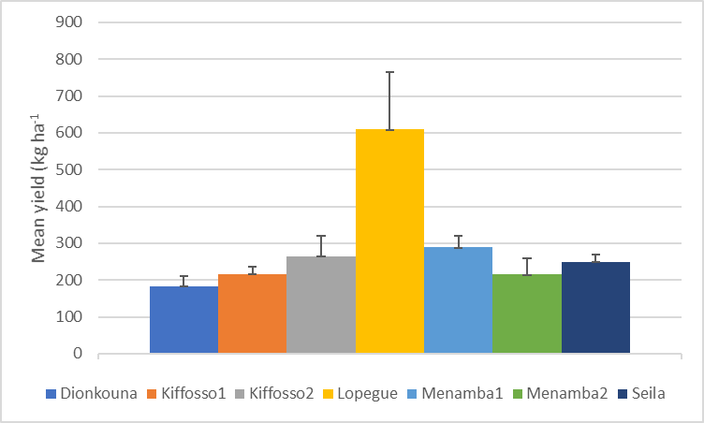
Figure 3. Mean yield per village of Millet on farmers’ field in Yorosso district, Mali in 2019. Mean followed by the same

Effects of contour bunding on soil water infiltration rate
Soil infiltration measurements were done using single ring upstream along contour bunds with 4 types of vegetation, natural herbaceous vegetation, herbaceous Andropogon gayanus, woody Gliricidia sepium and Acacia colei from September to December 2019. Infiltration rate was estimated from the data collected and submitted to statistical analysis to determine the effects of contour bunding and vegetation type on soil water infiltration rate.
The results of analysis revealed significant difference between vegetation type established along earth contour bunds constructed in the field for improving water and soil conservation. The infiltration rate also differed significantly between position nested within the vegetation type. The greatest infiltration rate was on bunds with woody species, G. sepium followed by A. colei, A. gayanus and the natural herbaceous vegetation (Table 6). Soil water infiltration rate was higher for downstream areas compared to upstream for the 2 woody species (Figure 4). These results revealed the positive impact of woody species on improving soil water infiltration rate compared with herbaceous A. gayanus. As the presented data overlap end of rainy season and dry season, we will redo the same measurements during the dry season for all treatments to ascertain the treatment effect.

Table 6. Mean soil infiltration (mm ha-1) per vegetation type along contour bund established in Mpessoba, Kiffosso1, Kiffosso2, Dionkouna and Ngolonianasso in Sikasso district, Mali
Vegetation | Infiltration rate (mm ha⁻¹)
Acacia colei | 232.2±3.2b
Andropogon gayanus | 189.4±2.5c
Gliricidia sepium | 299.5±3.6a
Natural vegetation | 132.8±2.3d
Values (Mean ± SE) followed by the same letter are not significantly different at the 5% level according to Turkey’s multiple comparison test.

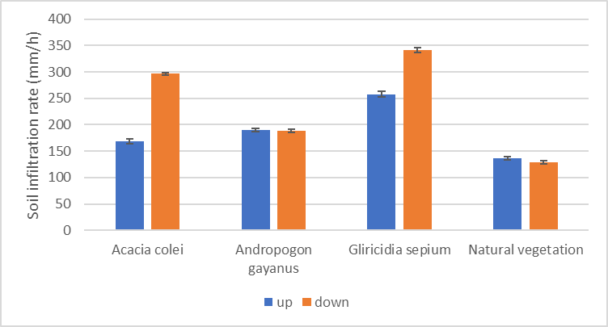
Figure 4. Mean soil infiltration per position (upstream vs. downstream) and per vegetation type along contour bund established in Mpessoba, Kiffosso1, Kiffosso2, Dionkouna and Ngolonianasso in Sikasso district, Mali

Conclusion and perspective
The additional fund is used to analyze the nutritional content of the diversified food types including cereals, legumes, vegetables and fruits. We will continue carrying out the trials to get more robust data for determining suitable crops and vegetables for household diet diversification. Therefore, such multi-year evaluation of the selected varieties for 2 more seasons (2020 – 2021) will give more indications on their performance with regards to climate variability and suitability for Yorosso district. Likewise, about 80 other households are willing to join the trials. Seeds of the most appreciated varieties including Fleur11, Subatimi and Wilibali will be distributed for upscaling. In addition, culinary demonstration will be organized to show various ways of consuming these food.

