

Annual Report
2017-18

Integrated crop-rangeland-livestock management to improve system productivity and to build resilience of agro-pastoral systems in semi-arid North Kordofan in Sudan

Submitted to
ICARDA

Summary
ICRISAT and ARC El Obeid, Sudan under the “Increased effectiveness of agro-pastoral management, watershed management and sustainable intensification of wheat - legume systems” initiative tested a number of sorghum, pearl millet, pigeonpea and groundnut varieties sourced from ICRISAT Nairobi, Malawi and India. Trials under rainfed conditions were planted late and were destroyed by livestock. However, trials planted under irrigation at Gezira, Eldal and Wadmedani were successful and data were obtained. The varieties had good grain yields and forage. In the dual-purpose pearl millet trial, lines HSD 1618 and 1642 with high grain yields (852 and 696 kg/ha respectively) also had high forage yield (4040 and 4928 kg/ha respectively). In the determinate short duration Pigeonpea trial, genotype ICEAP 01107/10 attained grain yield of 1658 kg/ha against 637 kg/ha attained by check genotype Taiba. In the indeterminate short duration Pigeonpea trial the best genotype ICEAP 01130 out yielded the checks Baladi and Taiba by 4% and 211% respectively. The varieties will be evaluated further in 2018. Repeat planting will also be done in 2018 for rainfed trials. Technical capacity building of 4 technicians was done at ICRISAT Kiboko field station for 2 weeks. The training covered sorghum, pearl millet and groundnut breeding techniques theory and practice, experimental design, field layout, planting and trial management, trait ontologies, digital data capture and data management. Three scientists from ARC-El Obeid visited the ICRISAT breeding program at Kiboko and one scientist visited the groundnut breeding program in Malawi not only to exchange ideas with the ICRISAT scientists but also to select sorghum, pearl millet and groundnut lines for testing in Sudan. A training course in enhancing efficiency of irrigation was held for one week in Bahir Dar, Ethiopia and was attended by six scientists from ARC Sudan. The training covered understanding soil-plant-water relationships, crop water requirements, irrigation scheduling, irrigation water quality, irrigation scheme management, with case studies, watershed management and soil fertility management in irrigation schemes and irrigation agronomy for enhanced irrigation efficiency. One of the trainees was also facilitated to visit te Melkassa sorghum research program.

- Introduction/Background

ICRISAT was invited to be part of the Sudan government-funded Sudan - ICARDA collaborative research initiative titled “Increased effectiveness of agro-pastoral management, watershed management and sustainable intensification of wheat - legume systems”. ICRISAT’s participation was expected in the following three themes:

- Improvement of the livelihoods of crop-range-livestock producers in semi-arid North Kordofan
- Sustainable intensification of wheat -legume systems to improve livelihoods and adaptation to climate change
- Watershed management for improving agricultural water productivity in the rainfed areas of Gadaref State.
During the inception workshop held in Khartoum from 6-7 March 2016, to discuss and agree on work plans for 2016 (where ICRISAT participated), it was agreed that ICRISAT would assist in research capacity building in the form of hands-on training of ARC research technicians and scientists. However, due to logistical issues, activities for ICRISAT were not included; hence funds for 2016/17 were not disbursed to ICRISAT.
A follow-up meeting hosted by ICARDA was held in Cairo, Egypt from 4-7 July 2017 with the following objectives:
- Review work plans for 2016
- Share results and lessons learnt
- Develop 2017/18 work plans
- Budget for 2017/18.

Since ICRISAT did not receive funds for 2016/17 and had no activities for the period, its entry was at objectives 3 and 4. It was reiterated that ICRISAT had a very important role in this collaborative initiative considering its relevance to R4D in Sudan and that it had key roles in the three themes identified.
- Work plans and budgets
Work plans were reviewed, continuing activities indicated, and new ones included, especially those under ICRISAT for the year 2017/2018 (see Table 1). The activities based on thematic areas included:
Theme 1 -Integrated Crop-rangeland livestock management of agro-pastoral systems in North Kordofan
- Test on-station sorghum, pearl millet and pigeonpea cultivars at El Obeid research station
- Host 4 technicians at Kiboko station for training in sorghum, pearl millet, pigeonpea and groundnut breeding techniques, digital data capture and data management
- 4 Sudan scientists visit Kiboko in February 2018 to share knowledge and experiences and select germplasm for their programs.

Theme 2- Watershed management. ICRISAT-Ethiopia was to:
  - Train 6 researchers and facilitate a learning tour to Ethiopian watersheds
  - Provide backstopping guidance on integrated watershed management.
(see report by Dr Tilahun Amede herein)
Table 1. Activities, deliverables and budget.
Component | Research Activities | Budget (USD)
Rainfed Component | Testing improved varieties of pearl millet, sorghum pigeonpea and groundnut | 30,000
Rainfed Component | Four technicians trained (two-week training) in Kenya on sorghum, pearl millet, pigeonpea and groundnut field breeding techniques and digital data capture | 10,000
Rainfed Component | Facilitate the visit of four ARC Sudan scientists to take part in a two-day visit to Kenya - research fields | 10,000
Irrigated Component | Germplasm for yield potential and heat tolerance identified. Physiological characteristics that are related to grain yield under heat stress conditions identified | 7,000
Irrigated Component | Heat-tolerant genotypes of faba bean, chickpea and lentil identified | 7,000
Irrigated Component | Some genotypes for high yield and other desirable traits identified | 7,000
Irrigated Component | Effect of optimum sowing date, seed rate and intra-row spacing on growth and yield of pigeonpea determined | 5,000
Irrigated Component | Suitable herbicides with mixture for weed control identified | 5,000
Irrigated Component | Suitable raised bed dimensions under different N fertilizer doses determined | 5,000
Irrigated Component | The best balance nutrition for faba bean and chickpea identified | 5,000
Watershed Component | Capacity development: Enhance the capacity of researchers’ cadre (scientists, assistants and technicians) and the field team as well as supply of on-farm crop husbandry and water management laboratory equipment | 7,500
Watershed Component | Resilience of watersheds and communities to climate change: climate analysis, prediction and modelling | 5,000
 | Total | 74,500
*The total budget allocated to ICRISAT included funding for ARC to fund activities in the field arebroken down as follows:

Component | Amount (USD)
Rainfed | 12,500
Irrigated | 2,500
Watershed | 2,500

- Seed production
In the 2017/18 season, a total of 350 kg of breeder seed was produced at Kiboko Kenya and at Chitezde Malawi for the project (Table 2).

Table 2. Breeder seed produced in 2017/18.
Crop | Number of lines | Quantity of seed produced (kg)
Sorghum | 116 | 100
Pearl millet | 87 | 100
Pigeonpea | 32 | 100
Groundnut | 65 | 50

- Evaluation of elite sorghum, pearl millet and pigeonpea lines
In July 2017, 49 sorghum OPVs and 25 hybrids, 87 pearl millet varieties and 32 pigeonpea varieties were sent to ARC El Obeid station. The trials were established and details are given in section B. Repeat nurseries and trials were sent in 2018.

- Capacity building

Training of ARC Sudan technicians in sorghum, pearl millet and pigeonpea field breeding techniques and digital data capture

A training was organized by ICRISAT- Nairobi with the aim of equipping technicians from ARC Sudan with breeding techniques and digital data capture in dryland cereals and grain legumes (see Annexure 1). The training was conducted from 18 February- 3 March 2018 at ICRISAT-Kiboko field station, Kenya. A total of 4 technicians working on sorghum, pearl millet and groundnuts from El Obeid research station were trained.

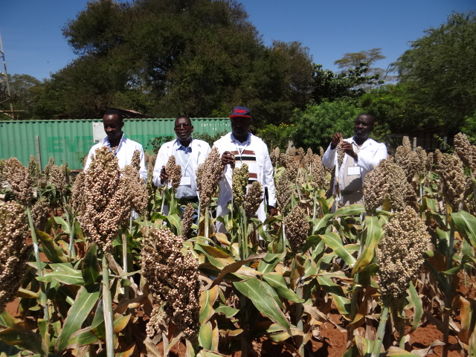
Figure 1. ARC Sudan technicians appreciating a sorghum variety in the field trials at Kiboko.

The four trainees -- Ahmed, Eldaw, Abdorahman and Abdalrhim – were trained in both theory and practical sessions (see Annex 1). The participants were given insights into the status of sorghum, pearl millet, pigeonpea and groundnuts in ESA. The participants were trained on the biology and pests and disease of sorghum, pearl millet, pigeonpea and groundnuts, and on breeding techniques employed in dryland cereals and grain legumes improvement at ICRISAT.

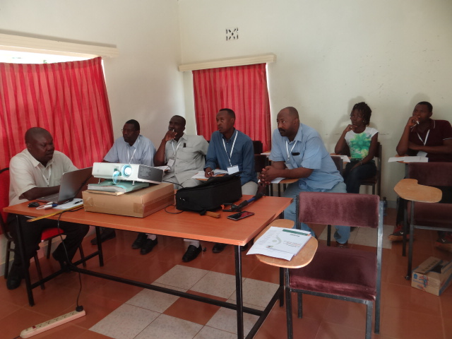
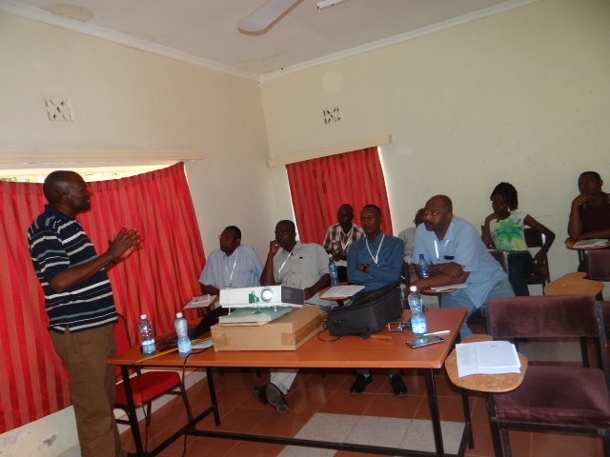
Figure 2. ARC trainees in theory sessions at Kiboko station.

The trainees further, got hands-on experience in hand emasculation, plastic paper bag technique and hot water emasculation in sorghum and finger millet. They also participated in pollination of emasculated plants, crossing in hybrids, maintenance of sorghum hybrid parents and selfing in seed multiplication plots.

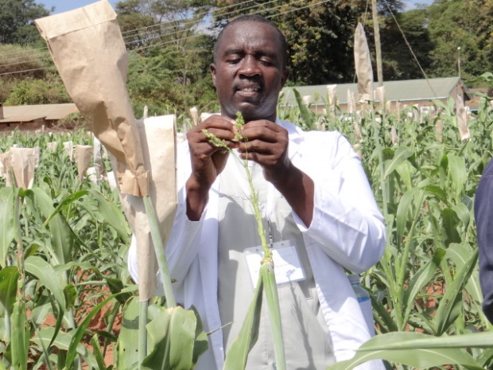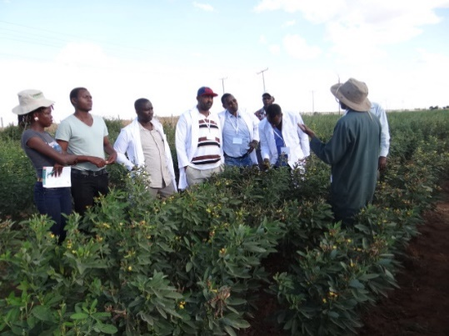
Figure 3. A trainee emasculates sorghum for crossing.
Figure 4. A practical session in a pigeonpea field.

During the training, the participants were exposed to the development of sorghum hybrids and hybrid parents. The trainees were taken through field layout procedures, experimental designs, labelling, and barcoding of trials and nurseries. They were taught the nuances of trait ontologies and digital data capture using the field book app installed on their tablets. Data management in BMS, comprising of trial generation, generating crosses, advancing crosses, generation of labels and field layout, uploading data and storage were described in detail. The training was facilitated by Dr Eric Manyasa, Dr Henry Ojulong, Dr Ganga Rao, Patrick Sheunda and Viola Furaha. During the same period, crop breeders Dr Elgailani Adam Abdalla (groundnut and pigeonpea), Dr Yasir Ahmed Gamar Hussin (sorghum) and Mr Omar Abdalla Bakhit (pearl millet) from El Obeid research station visited the ICRISAT breeding program at Kiboko research station with an aim of sharing ideas with ICRISAT breeders and selecting germplasm for their breeding programs. They went through the field trials and nurseries and selected 44 sorghum lines as shown in Table 3.

Table 3. Sorghum lines selected by breeders from ARC Sudan, 2018.
SNO. | Entry name | Source
1 | IESV 92174DL | Advanced Sorghum Variety Yield Trial-Short
2 | Macia | Advanced Sorghum Variety Yield Trial-Short
3 | IESV 99078DL | Advanced Sorghum Variety Yield Trial-Short
4 | ICSV 142036 | Advanced Sorghum Variety Yield Trial-Short
5 | ICSV 142011 | Advanced Sorghum Variety Yield Trial-Short
6 | IESV 92172DL | Advanced Sorghum Variety Yield Trial-Short
7 | ICSV 142027 | Advanced Sorghum Variety Yield Trial-Short
8 | IESV 94077-1DL | Advanced Sorghum Variety Yield Trial-Short
9 | ICSV 142028 | Advanced Sorghum Variety Yield Trial-Short
10 | IESV 92029DL | Advanced Sorghum Variety Yield Trial-Short
11 | IS 28203 | Advanced Sorghum Variety Yield Trial-Tall
12 | IS 28215 | Advanced Sorghum Variety Yield Trial-Tall
13 | IS 29026 | Advanced Sorghum Variety Yield Trial-Tall
14 | IS 28131 | Advanced Sorghum Variety Yield Trial-Tall
15 | IESV 92036SH | Advanced Sorghum Variety Yield Trial-Tall
16 | IESV 92038DL | Advanced Sorghum Variety Yield Trial-Tall
17 | IS 17589 | Advanced Sorghum Variety Yield Trial-Tall
18 | ICSV 142022 | Advanced Sorghum Variety Yield Trial-Tall
19 | MACIA x WAHI-5-2-1 | Preliminary Yield Variety Trial
20 | MACIA x MOSHI LOCAL-1-4-4 | Preliminary Yield Variety Trial
21 | MACIA x WAHI-5-1-3 | Preliminary Yield Variety Trial
22 | MACIA x WAHI-5-1-4 | Preliminary Yield Variety Trial
23 | MACIA x ICSB 479-1-1-3 | Preliminary Yield Variety Trial
24 | MACIA x WAHI-5-2-4 | Preliminary Yield Variety Trial
25 | MACIA x ICSB 479-1-1-1 | Preliminary Yield Variety Trial
26 | MACIA x WAHI-2-1-3 | Preliminary Yield Variety Trial
27 | MACIA x WAHI-4-2-1 | Preliminary Yield Variety Trial
28 | MACIA x WAHI-4-2-2 | Preliminary Yield Variety Trial
29 | MACIA x WAHI-2-1-1 | Preliminary Yield Variety Trial
30 | MACIA x WAHI-5-1-2 | Preliminary Yield Variety Trial
31 | MACIA x WAHI-5-1-3 | Preliminary Yield Variety Trial
32 | ATX 623 X IESV 91131DL | Preliminary Yield Hybrids Trial
33 | ICSA 101 X IESV 91036DL | Preliminary Yield Hybrids Trial
34 | ICSA 101 X SDSL 98018 | Preliminary Yield Hybrids Trial
35 | ICSA 11040 X IESV 91130DL | Preliminary Yield Hybrids Trial
36 | P 9509A X SV4 | Preliminary Yield Hybrids Trial
37 | ATX 623 X MACIA | Preliminary Yield Hybrids Trial
38 | ICSA 88006 X SDSL 98018 | Preliminary Yield Hybrids Trial
39 | ICSA 12 X IESV 99073DL | Preliminary Yield Hybrids Trial
40 | IESV 214002DL | Elite
41 | IESV 91104 DL | Elite
42 | IESV 92174 DL | Elite
43 | ICSV 210 | Elite
44 | F6 YQ 212 | Elite

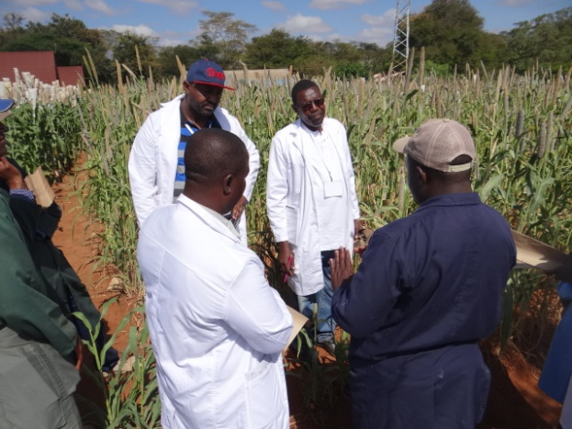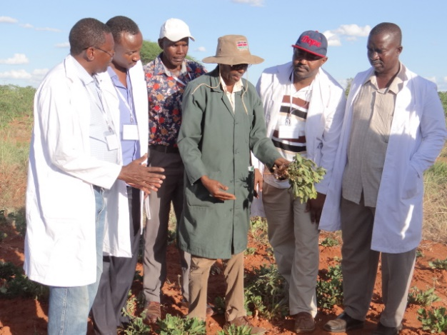
Figure 5. A practical session in a pearl m millet field.
Figure 6. A practical session in a groundnut field.

Vi. Nurseries and trials sent to ARC El Obeid- Sudan

Details of nurseries and trials sent to the breeders at El Obeid station are given in Tables 4-8.

Table 4. Sorghum lines sent to ARC Sudan, 2017 and 2018.
Sorghum Hybrids Trial |  |  |  | Sorghum Variety Trial
Entry | Name | Type |  | Ent | Name | Type | Ent | Name | Type
1 | ICSH 15009 | Hybrid |  | 1 | CR:35:5 | OPV | 26 | IESV 23008 DL | OPV
2 | ICSH 152001 | Hybrid |  | 2 | Dinkmash | OPV | 27 | IESV 23010 DL | OPV
3 | ICSH 152002 | Hybrid |  | 3 | Gadam Hamam | OPV | 28 | IESV 91049 DL | OPV
4 | ICSH 152004 | Hybrid |  | 4 | ICSR 161 | OPV | 29 | IESV 91089 DL | OPV
5 | ICSH 152010 | Hybrid |  | 5 | ICSR 24001 | OPV | 30 | IESV 91104 DL | OPV
6 | ICSH 152011 | Hybrid |  | 6 | ICSV 111 IN | OPV | 31 | IESV 91111 DL | OPV
7 | ICSH 152018 | Hybrid |  | 7 | ICSV 142002 | OPV | 32 | IESV 91131 DL | OPV
8 | IESH 214015 | Hybrid |  | 8 | ICSV 142010 | OPV | 33 | IESV 92021 DL | OPV
9 | IESH 22002 | Hybrid |  | 9 | ICSV 142011 | OPV | 34 | IESV 92028 DL | OPV
10 | IESH 22010 | Hybrid |  | 10 | ICSV 142012 | OPV | 35 | IESV 92038DL sel 2 | OPV
11 | IESH 22019 | Hybrid |  | 11 | ICSV 142015 | OPV | 36 | IESV 92043 DL | OPV
12 | IESH 22022 | Hybrid |  | 12 | ICSV 142016 | OPV | 37 | IESV 92151 DL | OPV
13 | IESH 22023 | Hybrid |  | 13 | ICSV 142018 | OPV | 38 | IESV 92162 DL | OPV
14 | IESH 25007 | Hybrid |  | 14 | ICSV 89064-1 | OPV | 39 | IESV 92171 DL | OPV
15 | IESH 25008 | Hybrid |  | 15 | IESV 214007 DL | OPV | 40 | IESV 92174 DL | OPV
16 | IESH 28001 | Hybrid |  | 16 | IESV 214008 DL | OPV | 41 | IESV 94077 DL sel 2 | OPV
17 | IESH 28002 | Hybrid |  | 17 | IESV 214010 DL | OPV | 42 | IESV 99061 DL | OPV
18 | IESH 28005 | Hybrid |  | 18 | IESV 214011 DL | OPV | 43 | IESV 99072 DL | OPV
19 | IESH 28009 | Hybrid |  | 19 | IESV 214012 DL | OPV | 44 | IESV 99078 DL | OPV
20 | IESH 28014 | Hybrid |  | 20 | IESV 214013 DL | OPV | 45 | KARI Mtama 1 | OPV
21 | IESH 28015 | Hybrid |  | 21 | IESV 214022 DL | OPV | 46 | Kiboko local 1 | OPV
22 | IESH 28018 | Hybrid |  | 22 | IESV 214024 DL | OPV | 47 | Mexico R-line 5 | OPV
23 | IESH 28020 | Hybrid |  | 23 | IESV 214027 DL | OPV | 48 | ZSV 3 | OPV
24 | IESH 28021 | Hybrid |  | 24 | IESV 23005 DL | OPV | 49 | Check
25 | Check |  |  | 25 | IESV 23007 DL | OPV

Table 5. Pearl millet lines sent to ARC Sudan, 2017 and 2018. .
Entry no. | Genotype  name | Type | Ent | Genotype name | Type | Ent | Genotype name | Type
1 | IP 7368 | OPV | 34 | 25-1A-P1 x IP 8856 | Hybrid | 75 | LC ICMA 6-P2 x ICMV 221-2 | Hybrid
2 | IP 7388 | OPV | 35 | 25-1A-P1 x Okoa | Hybrid | 76 | LC ICMA 6-P2 x ICMV 93771 | Hybrid
3 | IP 8647 | OPV | 36 | 25-1A-P1 x SDMV 94014 | Hybrid | 77 | LC ICMA 6-P2 x ICMV 94151 | Hybrid
4 | IP 15668 | OPV | 37 | 25-1A-P1 x SDMV 96063 | Hybrid | 78 | LC ICMA 6-P2 x IP 8772 | Hybrid
5 | IP 15698 | OPV | 38 | 25-1A-P1 x Shibe | Hybrid | 79 | LC ICMA 7-P4 x 15073(S-11 Plot) | Hybrid
6 | IP 15733 | OPV | 39 | 253 x 254/KOG x IP 8768 | Hybrid | 80 | LC ICMA 7-P4 x IP 5876 | Hybrid
7 | IP 15748 | OPV | 40 | 253 x 254/KOG x SDMV 94005 | Hybrid | 81 | SDEA 4L-160-P6 x Dembi yellow | Hybrid
8 | IP 15763 | OPV | 41 | 4-2A-P1 x ICMV 88908 | Hybrid | 82 | SDEA 4L-160-P6 x IP 6800 | Hybrid
9 | IP 11218 | OPV | 42 | 4-2A-P1 x ICMV 96603 | Hybrid | 83 | SDEA 4L-160-P6 x SDMV 94151 | Hybrid
10 | IP 17088 | OPV | 43 | 47-3A-P6 x 15058(S-11 Plot)4A Restorer line | R-line | 84 | SDEA 4L-160-P6 x SDMV 96053 | Hybrid
11 | IP 18490 | OPV | 44 | 47-3A-P6 x ICMV 221-3 | Hybrid | 85 | ICMV 221 | OPV
12 | IP 18591 | OPV | 45 | 47-3A-P6 x IP 8765 | Hybrid | 86 | Shibe | OPV
13 | IP 18621 | OPV | 54 | 47-3A-P6 x IP 8774 | Hybrid | 87 | Okoa | OPV
14 | IP 18625 | OPV | 55 | 47-3A-P6 x SDMV 94014 | Hybrid
15 | IP 18789 | OPV | 56 | 47-3A-P6 x Shibe | Hybrid
16 | IP 19040 | OPV | 57 | 863A x SDMV 95009 | Hybrid
17 | IP 19229 | OPV | 58 | ICMA 00111 x Shibe | Hybrid
18 | IP 8689 | OPV | 59 | ICMA 02777B1 x 15058(S-11 Plot)4A Restorer line | R-Line
19 | IP 13946 | OPV | 60 | ICMA 02777B1 x ICMR 08888 | Hybrid
20 | IP 16380 | OPV | 61 | ICMA 10777 x ICMV 221 white | Hybrid
21 | IP 18824 | OPV | 62 | ICMA 10777 x IP 8768 | Hybrid
22 | IP 19151 | OPV | 63 | ICMA 10777 x IP 8856 | Hybrid
23 | IP 19263 | OPV | 64 | ICMA 10777 x IP 9946 | Hybrid
24 | IP 19270 | OPV | 65 | ICMA 89666 x ICMV 221-1 | Hybrid
25 | IP 19372 | OPV | 66 | ICMA 90P7 x Dembi yellow | Hybrid
26 | ICMV 221 - 3 | OPV | 67 | ICMA 90P7 x ICMV 88908 | Hybrid
27 | IP 8767 | OPV | 68 | ICMA 90P7 x SDMV 96063 | Hybrid
28 | IP 8774 | OPV | 69 | ICMV 221 White | Hybrid
29 | ICMV 221 -White Br | OPV | 70 | LC ICMA 1-P1 x ICMR 08888 | Hybrid
30 | ICMV 221 -White | OPV | 71 | LC ICMA 1-P1 x ICMV 96603 | Hybrid
31 | 25-1A-P1 x 15058(S-11 Plot)4A Restorer line | Hybrid | 72 | LC ICMA 1-P1 x IP 6800 | Hybrid
32 | 25-1A-P1 x ICMV 221-1 | Hybrid | 73 | LC ICMA 1-P1 x Shibe | Hybrid
33 | 25-1A-P1 x ICMV 94151 | Hybrid | 74 | LC ICMA 6-P2 x 15073(S-11 plot) A4 | Hybrid

Table 6. Groundnut trials sent to ARC Sudan, 2018.
Regional elite groundnut variety trial-Valencia, 2018 season |  |  |  |  | Regional elite groundnut variety trial-Virginia, 2018 season
S.No | Variety name |  |  |  | S.No. | Variety name
1 | ICGV-SM 07530 |  |  |  | 1 | CG 7
2 | ICGV-SM 01514 |  |  |  | 2 | Chalimbana
3 | ICGV-SM 05534 |  |  |  | 3 | ICGV 1706
4 | ICGV-SM 07532 |  |  |  | 4 | ICGV-SM 02724
5 | ICGV-SM 07501 |  |  |  | 5 | ICGV-SM 03710
6 | ICGV-SM 09511 |  |  |  | 6 | ICGV-SM 05562
7 | ICGV-SM 09528 |  |  |  | 7 | ICGV-SM 05702
8 | ICGV-SM 09540 |  |  |  | 8 | ICGV-SM 05738
9 | ICGV-SM 10028 |  |  |  | 9 | ICGV-SM 06518
10 | ICGV-SM 10031 |  |  |  | 10 | ICGV-SM 06718
11 | ICGV-SM 10034 |  |  |  | 11 | ICGV-SM 06729
12 | ICGV-SM 10035 |  |  |  | 12 | ICGV-SM 07504
13 | ICGV-SM 10036 |  |  |  | 13 | ICGV-SM 07510
14 | ICGV-SM 10037 |  |  |  | 14 | ICGV-SM 07599
15 | ICGV-SM 10043 |  |  |  | 15 | ICGV-SM 08503
16 | ICGV-SM 10044 |  |  |  | 16 | ICGV-SM 01711
17 | ICGV-SM 10050 |  |  |  | 17 | ICGV-SM 01731
18 | ICGV-SM 09570 |  |  |  | 18 | ICGV-SM 10014
19 | ICGV-SM 95741 |  |  |  | 19 | ICGV-SM 10021
20 | JL 24 |  |  |  | 20 | ICGV-SM 10023
 |  |  |  |  | 21 | ICGV-SM 10036
 |  |  |  |  | 22 | ICGV-SM 15523
 |  |  |  |  | 23 | ICGV-SM 15558
 |  |  |  |  | 24 | ICGV-SM 15607
 |  |  |  |  | 25 | ICGV-SM 90704

Table 7. Pigeonpea lines send to ARC Sudan, 2017 and 2018.
Entry no. | Name
1 | ICEAP 01107/8
2 | ICEAP 00612
3 | ICEAP 01101/1
4 | ICEAP 01101/2
5 | ICEAP 01284
6 | ICEAP 00652/2
7 | ICEAP 01107/5
8 | ICEAP 01103/3
9 | ICEAP 01249
10 | ICEAP 01113/1
11 | ICEAP 01111/1
12 | ICEAP 01107/10
13 | ICEAP 01107/4
14 | ICEAP 86012
15 | ICPL 87091
16 | ICEAP 01135
17 | ICEAP 01125
18 | ICEAP 00654/2
19 | ICEAP 01131
20 | ICEAP 01134
21 | ICEAP 00660/3
22 | ICEAP 00654
23 | ICEAP 00661
24 | ICEAP 01139
25 | ICEAP 01130
26 | ICEAP 01137
27 | ICEAP 00658
28 | ICEAP 00659
29 | ICEAP 90011
30 | KAT 60/8
31 | ICPL 87091
32 | ICEAP 01550

Table 8. Regional elite groundnut variety trial –
Spanish, 2018 season.
Entry no. | Variety name
1 | ICGV-SM 03517
2 | ICGV-SM 01514
3 | ICGV-SM 05738
4 | ICGV-SM 06519
5 | ICGV-SM 06525
6 | ICGV-SM 06637
7 | ICGV-SM 06737
8 | ICGV-SM 07517
9 | ICGV-SM 07540
10 | ICGV-SM 07544
11 | ICGV-SM 07553
12 | ICGV-SM 08572
13 | ICGV-SM 08577
14 | ICGV-SM 08583
15 | ICGV-SM 08586
16 | ICGV-SM 99537
17 | ICGV-SM 99551
18 | ICGV-SM 99566
19 | ICGV-SM 08513
20 | JL 25

- Integrated crop-rangeland-livestock management to improve system productivity and to build resilience of agro-pastoral systems in semi-arid North Kordofan in Sudan
Elgailani Adam Abdalla; National project coordinator
Introduction
Testing improved varieties of pearl millet, sorghum, pigeonpea, and groundnut is part of the joint collaborative effort between El Obeid Research Station and ICRISAT, aimed at developing drought- tolerant, high-yielding cultivars, as they are important food and feed sources in the target villages. Two trials, each of pearl millet with 76 entries (OPVs and hybrids), sorghum with 74 entries (OPVs and hybrids), and pigeonpea with 32 entries (determinate and indeterminate) were received from ICRISAT. These entries, in addition to 50 sweet juicy pearl millet entries from the ARC gene bank, were tested under rainfed conditions at Faris village.
1. ICRISAT sorghum, pigeonpea and pearl millet trials
1.1 Location: Faris
These trials were received in late July and planted late in September. With supplementary irrigation, the establishment and growth of all experiments were excellent. However, due to late planting, flowering started in late November. As the trials were the only green plants along the animal migration corridor, they were completely destroyed by grazing and no data was recorded.
1.2 Juicy Sweet Stem Dual Purpose Pearl Millet Variety Trial (El Obeid Research farm)
Elgailani Adam Abdalla & Omar Abdalla Bakhit
Material and methods:
Thirty pearl millet accessions were evaluated for grain and forage production in the 2017 season at two locations, El Obeid demonstration farm and Faris. The experiments were planted on 27 and 31 July 2017 at the El Obeid research station and Faris, respectively, using RCBD with four replications. Each experimental unit consisted of four rows each, 2.5-meter long, with a spacing of 75 cm between rows and 50 cm between holes. Seedlings were thinned to two plants per hole after two weeks of emergence. Microdosing with 0.3 g of NPK was applied. All normal cultural practices were followed according to ARC recommendations. Data were taken from two central rows, and five plants were selected randomly to estimate means of plant height, panicle length, panicle weight, and number of leaves per plant. In addition, plant population, dry forage weight, grain yield data were taken. The season saw 286 mm of rainfall.
Results:
Data were obtained only from El Obeid site because the experiment at Faris was destroyed by animals. The results are presented in Table 11. Very highly significant differences (P≤0.001) were found in number of leaves per plant whereas significant differences (P≤0.05) were found in plant population per hectare, panicle width, and dry forage weight (kg/ha). Differences were not significant in plant height, panicle length, number of panicles per hectare and grain yield. Plant population per hectare ranged from 46,176 to 13,320, the highest entries being HSD 11173, HSD 11147, HSD 11250, HSD 11212, HSD 11190 and HSD 11189. Plant height ranged from 175 cm to 121.5 cm, with a grand mean of 145 cm. The tallest entries were HSD 11125, HSD 11043, HSD 11173, HSD 11005 and HSD 11254. Average leaves per plant was 5.6. (Table 9) Number of leaves per plant ranged from 3.4 to 8. HSD 11005, HSD 1684, HSD 1642, HSD 11753, HSD 1773, and HSD 11015 gave the highest number of leaves. HSD 1618, HSD 11005, HSD 1642, HSD 1684, HSD 11261, HSD 11227, HSD 1684, HSD 11250, and HSD 11015 obtained the highest number of panicles per hectare. Number of panicles ranged from 122,100 to 34,188 per hectare. Panicle length ranged from 27.67- 20.75 cm with the general mean of 24 cm. The longest panicles were recorded in HSD 11015 (28 cm), HSD 11019 (27 cm), HSD 11212 (26 cm), HSD 11043 (26 cm) and HSD 1682 (25 cm). Panicle width ranged from 2.6-1.7 cm with the mean of 2.1 cm. The widest panicles were recorded by HSD 1716 (2.6 cm), HSD 1642 (2.5 cm), HSD 11043 (2.4 cm) and HSD 11093 (2.4 cm). The highest dry forage yield was from HSD 1642 (4928 kg/ha), followed by HSD 11015 (4854 kg/ha), HSD 11217 (4677 kg/ha), HSD 11005 (4040 kg/ha), and HSD 1618 (4040 kg/ha). The highest grain yield was from HSD 1618 (852.3 kg/ha), followed by HSD 11015 (775.5 kg/ha), HSD 11261 (754.9 kg/ha), HSD 1642 (695.9 kg/ha), HSD 11005 (783 kg/ha) and HSD 11217 (684.5 kg/ha). Among the five top dry forage producing entries (HSD 1642; HSD 11015; HSD 11217; HSD 11005; and HSD 1618), four were among the top grain producing entries. Seed production was successfully done according to the pearl millet procedures to provide seeds for the next seasons.
Some entries expressed good performance in both forage and grain yield and will further be evaluated in multi-locational trials across the pearl millet production zone.
Table 9. Evaluation of 30 pearl millet entries as dual-purpose varieties at El Obeid demonstration farm, 2017 season.
Treatment number | Entry | Plant population (n/ ha) | Plant height (cm) | No of leaves/plant | Panicle length (cm) | Panicle width  (cm) | No of panicles/ha | Dry forage weight (kg/ha) | Grain yield (kg/ha)
Treatment number | name
1 | HSD 1618 | 23976 | 143 | 7 | 25 | 2.2 | 122100 | 4040 | 852
2 | HSD 1642 | 29304 | 137 | 8 | 21 | 2.5 | 113664 | 4928 | 696
3 | HSD 1682 | 24864 | 139 | 5 | 26 | 1.7 | 49136 | 2072 | 252
4 | HSD 1684 | 20424 | 140 | 8 | 23 | 1.9 | 113220 | 1172 | 564
5 | HSD 1691 | 28416 | 132 | 4 | 21 | 2.2 | 68376 | 1909 | 378
6 | HSD 1716 | 23088 | 142 | 5 | 25 | 2.6 | 50172 | 1125 | 392
7 | HSD 1760 | 30192 | 134 | 4 | 22 | 2.2 | 93240 | 3041 | 550
8 | HSD 1773 | 20424 | 140 | 7 | 23 | 2.2 | 52096 | 3434 | 319
9 | HSD 11005 | 17760 | 163 | 8 | 24 | 2 | 117216 | 4040 | 687
10 | HSD 11015 | 25308 | 153 | 7 | 28 | 2.2 | 100344 | 4854 | 775
11 | HSD 11019 | 26640 | 129 | 5 | 27 | 1.9 | 35520 | 1421 | 130
12 | HSD 11031 | 31080 | 126 | 7 | 23 | 2.1 | 58608 | 2975 | 358
13 | HSD 11043 | 26640 | 175 | 5 | 26 | 2.4 | 74592 | 3818 | 587
14 | HSD 11093 | 33744 | 145 | 4 | 22 | 2.4 | 72372 | 3374 | 431
15 | HSD 11125 | 33300 | 176 | 6 | 25 | 2.1 | 73260 | 3330 | 471
16 | HSD 11145 | 23088 | 155 | 6 | 24 | 2.1 | 50616 | 2309 | 315
17 | HSD 11147 | 37296 | 138 | 6 | 24 | 2 | 83028 | 2664 | 476
18 | HSD 11148 | 18648 | 151 | 6 | 23 | 2 | 60384 | 1554 | 259
19 | HSD 11173 | 46176 | 164 | 5 | 24 | 2.1 | 67488 | 3197 | 430
20 | HSD 11189 | 34632 | 122 | 4 | 23 | 2.2 | 70596 | 2353 | 422
21 | HSD 11190 | 35520 | 152 | 3 | 24 | 2.2 | 75480 | 2886 | 468
22 | HSD 11212 | 35520 | 134 | 4 | 27 | 2.1 | 34188 | 1909 | 228
23 | HSD 11217 | 27528 | 147 | 7 | 23 | 2 | 80808 | 4677 | 459
24 | HSD 11227 | 26640 | 147 | 6 | 25 | 2.2 | 101232 | 3730 | 685
25 | HSD 11250 | 35520 | 138 | 5 | 24 | 2.2 | 103008 | 3286 | 656
26 | HSD 11254 | 32856 | 160 | 4 | 24 | 1.9 | 96792 | 3374 | 542
27 | HSD 11261 | 23088 | 145 | 6 | 23 | 2.6 | 105672 | 3108 | 755
28 | HSD 11292 | 25752 | 138 | 7 | 23 | 2.2 | 52392 | 2842 | 363
29 | HSD 11297 | 27232 | 136 | 4 | 25 | 1.9 | 81104 | 1598 | 492
30 | HSD 11753 | 13320 | 139 | 8 | 24 | 2 | 47952 | 3419 | 283
Mean |  | 27933 | 145 | 5.6 | 24 | 2.1 | 76822 | 2948 | 476
SE± |  | 1040* | 2.2ns | 0.2*** | 0.4ns | 0.03* | 4527ns | 161* | 29ns
C.V (%) |  | 23 | 8 | 16 | 9 | 9 | 31 | 34 | 35

1.3 Location: Wadmedani (irrigated clay)
1.3.1 Evaluation of introduced determinate, short-duration pigeonpea genotypes for yield and other traits under Gezira conditions
Sara A. Babiker, Hala M. M. Elamein, Omer A. E and AbdElmagid Adlan
The trial was conducted at Gezira Research Station Farm (GRSF) during the season of 2017/2018 to evaluate the performance of some determinate short-duration pigeonpea genotypes for their yield and other traits under Gezira conditions. Fifteen genotypes of pigeonpea obtained from ICRISAT (Table 10) and two local checks, Baladi and Taiba variety, were planted in a randomized complete block design (RCBD) with two replications. The experimental area was disc ploughed, harrowed, levelled and then ridged 80 cm apart. The subplot size was 4 m² [2.5 (length of ridge) x 0.8 (between ridge) x 2 (number of ridges)]. Seeds were sown in holes 20 cm apart with two seeds per hole. The sowing date was 19 September 2017. Sowing was delayed due to the late receipt of materials. Fertilizer in the form of urea was applied at the rate of 19 kg/feddan at second irrigation. Irrigation was given every 14 days. Hand weeding was performed as needed. The harvested area was 2 m². At harvest, data was collected on number of plants/m², number of fruiting branches/ plant, number of seeds/ pod, plant height (cm), 1000-seed weight (g) and seed yield (kg/ha).
Very highly significant differences were observed among the 17 genotypes evaluated in the trial for grain yield, number of grains/ pod, 1000-seed weight and plant height. The lines showed no significant differences for the other measured traits (number of seeds / pod, number of fruiting branches / plant and number of plants / m²) (Table 10). The grain yield of the 17 genotypes ranged from 637 (Taiba) to 1658 kg/ha (genotype 12). All the tested lines were higher in yield than Taiba. Eight of them (genotypes 12, 1, 13, 4, 8, 10, 6 and 3) gave better yields than the best check (Baladi). This trial will be planted next season (2018/2019) to evaluate the performance of these lines under rainfed conditions and to confirm their superiority over the local checks.

Table 10. Mean grain yield (kg/ha), number of seeds/pods, number of fruiting branches/plant, number of plants/m², 1000-seed weight (g) and plant height (cm) of genotypes tested in the determinate pigeonpea yield trial compared to checks Baladi and Taiba.
Entry no. | Genotypes | Grain yield (kg/ha) | Number. of seeds / pod | Number of fruiting branches / plant | Number of plants / m² | 1000-seed weight | Plant height  (cm)
1 | ICEAP 01107/8 | 1598 | 4 | 10 | 15 | 128 | 133
2 | ICEAP 00612 | 1078 | 4 | 8 | 15 | 126 | 98
3 | ICEAP 01101/1 | 1402 | 4 | 7 | 15 | 118 | 119
4 | ICEAP 01101/2 | 1515 | 4 | 11 | 15 | 132 | 96
5 | ICEAP 011284 | 1315 | 4 | 8 | 16 | 124 | 108
6 | ICEAP 00652/2 | 1408 | 4 | 7 | 15 | 128 | 101
7 | ICEAP 01107/5 | 1035 | 5 | 8 | 12 | 118 | 116
8 | ICEAP 01103/3 | 1468 | 4 | 11 | 15 | 118 | 108
9 | ICEAP 01249 | 1078 | 5 | 10 | 15 | 126 | 101
10 | ICEAP 01113/1 | 1448 | 5 | 9 | 11 | 124 | 114
11 | ICEAP 01111/1 | 1310 | 4 | 10 | 14 | 120 | 106
12 | ICEAP 01107/10 | 1658 | 4 | 7 | 13 | 130 | 109
13 | ICEAP 01107/4 | 1558 | 4 | 9 | 15 | 126 | 115
14 | ICEAP 86012 | 890 | 4 | 10 | 13 | 122 | 110
15 | ICPL87091 | 1258 | 3 | 11 | 17 | 128 | 106
16 | Baladi | 1331 | 4 | 8 | 15 | 98 | 70
17 | Taiba | 637 | 4 | 11 | 16 | 98 | 166
 | Overall Mean | 1598 | 4 | 10 | 15 | 128 | 133
 | SE± | 201.5 | 0.2 | 1 | 1.4 | 2.2 | 3.9
 | Level of sig. | *** | NS | NS | NS | *** | ***
 | LSD | 607.5 | 0.6 | 3 | 4.2 | 6.6 | 11.8
 | CV (%) | 22 | 6.6 | 15.1 | 13.7 | 2.5 | 5

1.3.2 Evaluation of indeterminate short-duration pigeonpea genotypes for yield and other traits under Gezira conditions
Sara A. Babiker, Hala M. M. Elamein, Omer A. Elnour and AbdElmagid Adlan
The study was carried out at the Gezira Research Station Farm during 2017/2018 season to evaluate the performance of indeterminate short-duration pigeonpea genotypes for yield and other traits under Gezira conditions. The treatments comprised of 16 genotypes of pigeonpea obtained from ICRISAT (Table 11). The treatments were arranged in a RCBD with two replications. The land was prepared by disc ploughing, disc harrowing, levelling and then ridging 80 cm apart. The plot size was 4 m² [2.5 (length of ridge) x 0.8 (between ridges) x 2 (number of ridges)]. The seeds were sown in holes 20 cm apart with two seeds per hole. Nitrogen fertilizer (19 kg urea\feddan) was applied at second irrigation. The sowing date was 19 September 2017. The delay in sowing was due to the late receipt of the materials. The experiments were irrigated according to the need of the crops. The crops were hand-hoed to control weeds. At harvest, the parameters measured were number of fruiting branches/ plant, number of seeds/ pod, plant height (cm), 1000-seed weight (g), biomass (kg/ha) and seed yield (kg/ha).
Very highly significant differences were recorded among the 18 genotypes evaluated in this trial for all the measured traits, including grain yield, number of seeds/pod, number of fruiting branches/plant, biomass, 1000-seed weight and plant height (Table 11) indicating the presence of considerable genetic variability which could further be exploited for pigeonpea improvement. The grain yield of the 18 genotypes ranged from 487.5 (Taiba) to 1520 kg/ha (genotype 10). All the tested lines gave higher yields than Taiba (an early-maturing variety whose yield may have been affected as the trial was planted in late September). Genotype 10 (1520 kg /ha) outyielded the best check (Baladi, 1462.5 kg/ha) by about 4% (Table 11). This line is shorter in height, has higher number of seeds/pod and 1000-seed weight than Baladi. This trial will be planted next season (2018/2019) to evaluate the performance of these lines under rainfed and irrigated conditions.
Table 11. Mean grain yield (kg/ha), number of seeds/pod, number of fruiting branches/plant, biomass (kg/ha), 1000-seed weight (g) and plant height (cm) of genotypes tested in the indeterminate pigeonpea yield trial compared to checks Baladi and Taiba.
Entry no. | Entry name | Grain yield  (kg/ha) | Number. of seeds / pod | Number of fruiting branches/plant | Biomass  (kg/ha) | 1000 seed weight | Plant height  (cm)
1 | ICEAP 01135 | 1193 | 6 | 30 | 6012 | 124 | 147
2 | ICEAP 01125 | 663 | 5 | 32 | 4347 | 124 | 147
3 | ICEAP 00654/2 | 855 | 5 | 22 | 4865 | 133 | 149
4 | ICEAP 01131 | 1260 | 4 | 20 | 8242 | 139 | 149
5 | ICEAP 01134 | 735 | 4 | 24 | 4918 | 134 | 160
6 | ICEAP 00660/3 | 1345 | 4 | 17 | 7277 | 118 | 147
7 | ICEAP 00654 | 1295 | 5 | 30 | 7502 | 137 | 154
8 | ICEAP 00661 | 543 | 5 | 126 | 6153 | 153 | 155
9 | ICEAP 001139 | 1088 | 5 | 14 | 6327 | 134 | 157
10 | ICEAP 01130 | 1520 | 5 | 22 | 7137 | 114 | 144
11 | ICEAP 01137 | 1255 | 5 | 26 | 6637 | 126 | 145
12 | ICEAP 00658 | 760 | 6 | 28 | 5702 | 134 | 139
13 | ICEAP 00659 | 1275 | 6 | 29 | 5870 | 112 | 161
14 | ICEAP 90011 | 583 | 4 | 25 | 3907 | 108 | 117
15 | KAT-60 -8 | 1297.5 | 5 | 27 | 6245 | 114 | 148
16 | ICEAP 01550 | 0 | 0 | 0 | 0 | 0 | 0
17 | Baladi | 1462.5 | 3 | 75 | 6580 | 96 | 188
18 | Taiba | 487.5 | 4 | 29 | 1770 | 104 | 73
 | Overall mean | 978.6 | 5 | 32 | 5527 | 117 | 138
 | CV (%) | 12.4 | 15.3 | 16.1 | 11.2 | 2.8 | 14.9
 | Level of sig. | *** | *** | *** | *** | *** | ***
 | LSD | 262.6 | 1.3 | 11.3 | 1344 | 7.0 | 5.1

- Watershed management. ICRISAT-Ethiopia

Training course on Enhancing irrigation efficiency in East African settings
May 7-12, 2018, Bahir Dar, Ethiopia
Tilahun Amede (ICRISAT-Ethiopia)
The threat of water scarcity in East Africa is real, due to increasingly competing needs of upstream and downstream countries, expanding agricultural needs, climate variability and inappropriate use of irrigation water. Agriculture will remain SSA’s largest water user, accounting for about 75% of current human water use (CA, 2007), a trend expected to be maintained for a long time to come. Irrigation for agriculture is becoming a necessity to satisfy the growing needs an increasing population and to minimize the impacts of climate change on agricultural production and productivity. The expansion of irrigation, however, could be challenged by water scarcity with potentially negative effects on wetlands and other aquatic ecosystems and deteriorating water quality. Major trade-offs are forecast between agriculture and other uses, including those between increasing food security and safeguarding ecosystems. With increasing demand for water and competition among different users and uses, water scarcity will probably dominate all other challenges in the next generation, which would be aggravated by increasing impact of climate change. According to recent FAO (2009) estimates, farming, industrial and urban needs will increase water demand by 40% by 2030 in developing countries like Sudan and Ethiopia. In Ethiopia, despite the availability of a large volume of fresh water - including 12 river basins with an annual runoff volume of 122 billion m³ and an estimated 6.5 billion m³ of ground water potential - the production of food and feed is still constrained by water scarcity in about 80% of the country. On the other hand, irrigation in downstream Sudan has been well developed over decades and is becoming the major source of food and income for the communities and the country.
There have been major investments in water management in the region, though the returns from these are irregular and sometimes disappointing. Interventions are required not only to increase productivity of irrigation schemes but also to enhance sustainability of investments and minimize risk of climate change and food insecurity. Currently, most farmers do not adopt farm-level land and water management practices though these are of prime importance for satisfying the needs of crops and other agricultural ecosystems. As a result, they rarely endeavour to optimise the water supply of their crops within the limits of their knowledge and the farming operations practised. On-farm water management generally strives to optimise soil-water-plant relationships in order to achieve a desired and sustainable yield.
The major objectives of the training course, conducted on 7 -12 May 2018 in Bahir Dar, Ethiopia were:
- To create regional capacity in appropriate planning and managing of irrigation schemes in Sudan and Ethiopia
- To enhance the irrigation and agronomy skills of professionals in Sudan and Ethiopia;
- To facilitate learning between Ethiopian and Sudanese irrigation professionals and create linkages between the two teams.
The 16 participants (4 women and 12 men) in the training course comprised of irrigation engineers, irrigation agronomists and social sciences from Ethiopia and Sudan. Six professionals from Sudan, (Drs Bakri, Hannan, Seif ElDola, Hameem, Waleed, and Khalafalla) participated in the event. The week-long training saw more time allocated for group work and joint team learning. Experiences from Sudan and Ethiopia were presented by the participants and discussions centered around lessons learned.
The training covered the following topics (see Annex 2):
- Understanding soil-plant-water relationships
- Crop water requirements
- Irrigation scheduling, irrigation water quality
- Irrigation scheme management, with case studies
- Watershed management and soil fertility management in irrigation schemes
- Irrigation agronomy for enhanced irrigation efficiency
The trainers included:
- Dr Tilahun Amede, Principal Scientist in systems agronomy, ICRISAT (overall training coordinator)
- Dr Lulseged Tamene, Senior Scientist, Landscape management, CIAT
- Dr Kifle Woldargay, Associate Professor, Hydrology, Mekele University
- Mr. Hune Nega, National Chief Technical Advisor, Small Scale and Micro Irrigation Support Project (SMIS), Canada.
We also organized a full day’s field visit to two districts in Gojam (Enjibara and Merawi) to show trainees best-bet interventions in soil fertility management, agroforestry and water user associations and irrigation scheme management in Koga irrigation scheme, which has a command area of 7000 ha. We also organized a visit for Dr Hannan to see the sorghum germplasm and research at Melkassa Research Centre.
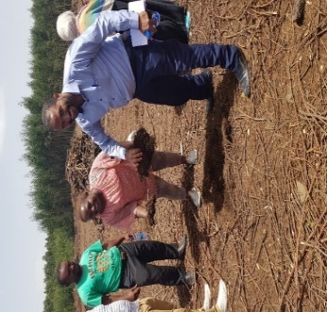
a)
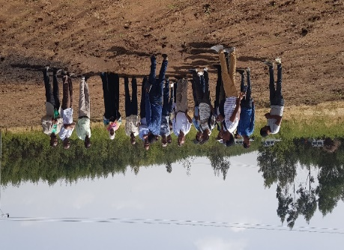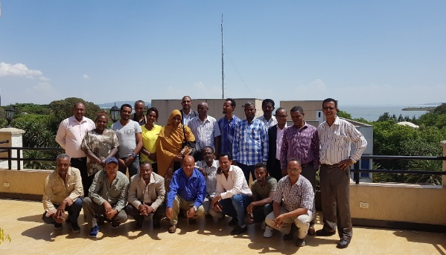
b)
c)
Figures 7a, b and c: Training on Enhancing irrigation efficiency in Ethiopia.

Annex 1. Program details of the training course on dryland cereals and grain legumes breeding techniques and digital data capture, 18 Feb -3 March 2018, Kiboko Field Station, Kenya.
Program
Date | Time | Session | Facilitator
18 Feb 2018 |  | Arrival in Nairobi | Lynette/Henry/Eric
18 Feb 2018 |  | Travel to Kiboko | Lynette/Henry/Eric
19 Feb 2018 | 0800–0830 | Registration | P. Sheunda/Viola
 | 0830-0840 | Introduction of participants | Henry/Eric/Ganga
 | 0840-0850 | Welcome remarks – OIC KARI Kiboko | Mweki
 | 0850-0900 | Opening remarks | Moses Siambi (RD)
 | 0900–0920 | Objectives and course content | Eric manyasa
 | 0930–1000 | Sorghum status in ESA | Eric Manyasa
 | 1000–1030 | Pigeonpea status in ESA | Ganga Rao
 | 1030-1050 | Tea break
 | 1050-1120 | Pearl millet status in ESA | Henry Ojulong
 | 1120–1150 | Groundnut status in ESA | Ganga Rao
 | 1150-1220 | Sorghum biology | Eric Manyasa
 | 1220-1300 | Pearl millet biology | Henry Ojulong
 | 1300–1400 | Lunch
 | 1400-1430 | Pigeonpea biology | Ganga Rao
 | 1430-1500 | Groundnut biology | Ganga Rao
 | 1500-1700 | Practicals - Crop biology and pests/diseases | Patrick/Sheila/Viola
 | 1700-1730 | Tea break
20 Feb 2018 | 0830-0900 | Breeding procedures in sorghum | Eric Manyasa
 | 0900-0930 | Breeding procedures in pigeonpea | Ganga Rao
 | 0930-1000 | Breeding procedures in pearl millet | Henry Ojulong
 | 1000-1030 | Tea break
 | 1030-1100 | Breeding techniques in groundnut | Ganga Rao
 | 1100-1300 | Emasculation techniques | Eric /Henry /Ganga
 | 1300-1400 | Lunch
 | 1400-1700 | Practicals – Hand and chemical emasculation | Patrick/Viola/Sheila
 | 17000-1730 | Tea break
21 Feb 2018 | 0830-1030 | Pollination and crossing | Patrick/viola/sheila
 | 1030-1100 | Tea break
 | 1100-1300 | Hands-on emasculation | Patrick/viola/sheila
 | 1300-1400 | Lunch break
 | 1400-1700 | Hands-on emasculation | Patrick/viola/sheila
 | 1700-1730 | Tea break
22 Feb 2018 | 0800-1030 | Trait ontologies – Cereals and legumes | Patrick/viola/sheila
 | 1030-1100 | Tea break | Patrick/viola/sheila
 | 1100-1300 | Practicals: Trait ontologies | Patrick/viola/sheila
 | 1300-1400 | Lunch break | Patrick/viola/sheila
 | 1400-1700 | Practicals: Trait ontologies | Patrick/viola/sheila
 | 1700-1730 | Tea break | Patrick/viola/sheila
23 Feb 2018 | 0800-1030 | Barcoding of nursery and trial plots | Patrick/viola/sheila
 | 1030-1100 | Tea break | Patrick/viola/sheila
 | 1100-1300 | Practicals: Barcoding of nursery and trial plots | Patrick/viola/sheila
 | 1300-1400 | Lunch | Patrick/viola/sheila
 | 1400-1700 | Practicals: Barcoding of nursery and trial plots | Patrick/viola/sheila
 | 1700-1730 | Tea break | Patrick/viola/sheila
24 Feb 2018 | 0800-0900 | Field books and data recording | Patrick/viola/sheila
 | 0900-1000 | Practicals: Barcoding of nursery and trial plots | Patrick/viola/sheila
 | 1000-1030 | Tea break | Patrick/viola/sheila
 | 1030-1300 | Practicals: Barcoding of nursery and trial plots | Patrick/viola/sheila
 | 1300-1400 | Lunch break | Patrick/viola/sheila
 | 1400-1700 | Practicals: Barcoding of nursery and trial plots | Patrick/viola/sheila
 | 1700-1730 | Tea break | Patrick/viola/sheila
26 Feb 2018 | 0830-0930 | Hybrids and hybrid Parents development | Eric
 | 0930-1000 | Sorghum seed production | Eric
 | 1000-1030 | Pearl millet seed production | Henry
 | 1030-1100 | Tea break
 | 1100-1300 | pigeonpea/groundnut seed production | Ganga Rao
 | 1300-1400 | Lunch
 | 1400-1700 | Practicals - Pollination and crossing | Patrick/viola/sheila
 | 1700-1730 | Tea break
27 Feb 2018 | 0830-1030 | Practicals - Hybrid parents development and seed production | Patrick/viola/sheila
 | 1030-1100 | Tea break
 | 1100-1300 | Plastic bag emasculation | Patrick/viola/sheila
 | 1300-1400 | Lunch
 | 1400-1700 | Hot water techniques | Patrick/viola/sheila
 | 1700-1730 | Tea break
28 Feb 2018- | 0800-1700 | Data management – Uploading data and BMS | Patrick/viola/sheila
1 March 2018 | 0800-1700 | Data management – Uploading data and BMS | Patrick/viola/sheila
2 March 2018 | 0800-1000 | Data management – Uploading data and BMS | Patrick/viola/sheila
 | 1030-1100 | Tea break | Patrick/viola/sheila
 | 1100-1300 | Recap of the training/issuing certificates | Patrick/viola/sheila
 | 1300-1400 | Lunch | Patrick/viola/sheila
 | 1400-1700 | Depart to Nairobi | Patrick/viola/sheila
3 March 2018 |  | Trainees depart | Eric/Henry/Ganga

Annex 2. Programme of events
 | 8.45-10.30 | Health break | 11.00-12.30 | Lunch break | 14.00-15.30 | Health break | 16.00-17.00
Monday  (May 7th) | Overall design, planning, implementation and evidence generation of watersheds |  | Watershed design continue… |  | Irrigation design, typology, management and cost efficiency |  | Irrigation design continue…
Tuesday  (May 8th) | Alternative water sources development and management |  | Alternative water sources continue… |  | Drought management and enhancing productivity watersheds, agronomy |  | Drought management…
Wednesday  (May 9th) | Water and watershed institutions, byelaws, water conflict management |  | Institutions, discussions |  | Ethiopian and Sudanese team experience sharing presentations |  | Discussion on communal issues and joint learning & Dinner
Thursday  (May 10th) | Field trip to Koga Irrigation scheme |  |  |  |  |  | Feedback session
Friday (May 11th) | Field visit to a watershed management site (tentative |  |  |  |  |  | Free afternoon

