SCIENTIFIC PLANNING MEETING OF THE CGIAR RESEARCH PROGRAM (CRP) ON DRYLAND SYSTEMS (CRP1.1) FOR WEST AFRICAN SAHEL AND DRY SAVANNA
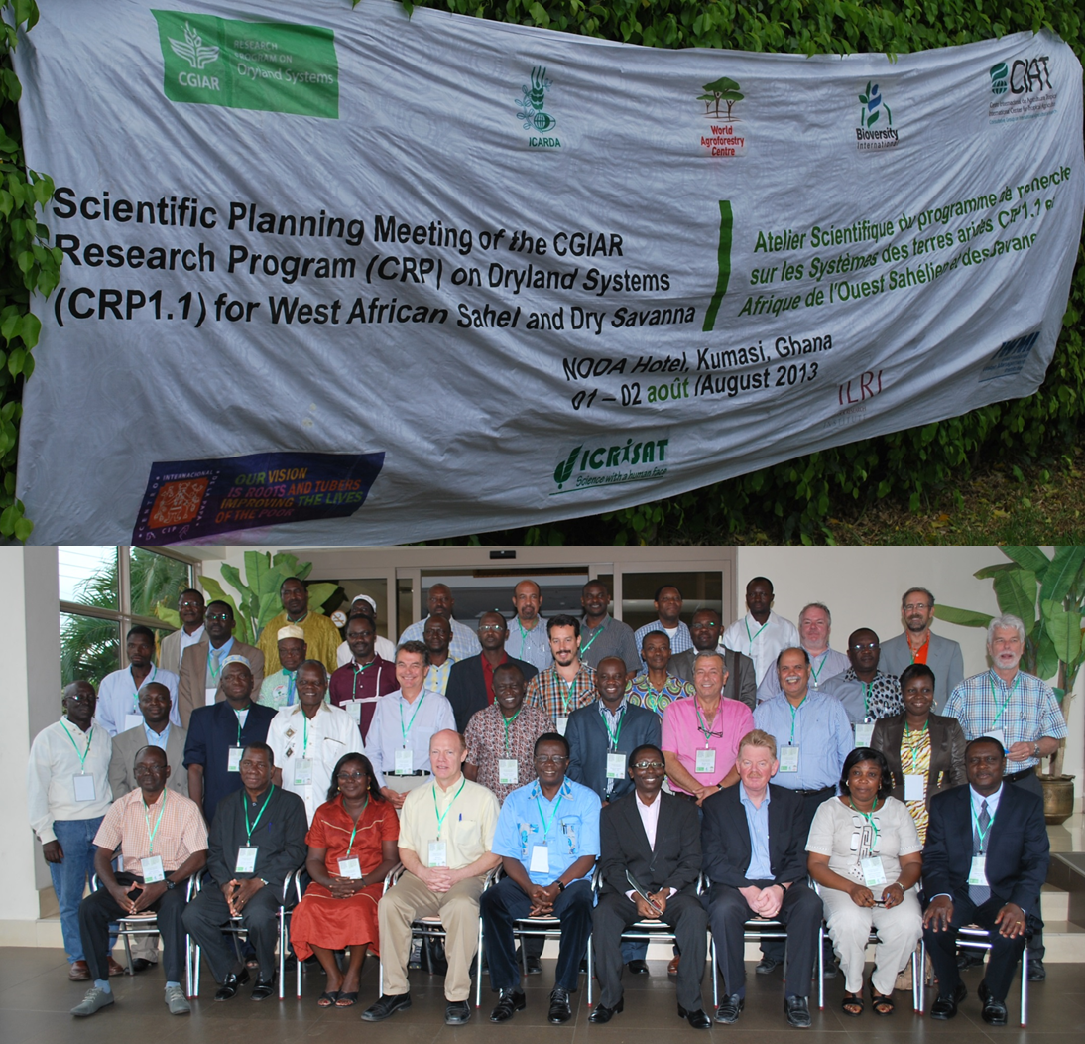
Noda Hotel, Kumasi, Ghana
1st – 2nd August 2013
Report Prepared by Patrice Savadogo

August 2013

TABLE OF CONTENTS
Pages
1. - BACKGROUND TO THE WORKSHOP 1
2. - INTRODUCTION 2
3. - OPENING CEREMONY 2
4. –PROCEEDINGS OF THE WORKSHOP 4
4.1. –Work Organisation 4
4.2. –Plenary Sessions 4
4.3. - Preparatory communications to the work group 14
4.4. –Group Work 14
4.5. – Restitution in plenary 15
5. – SUMMARY OF WORKPLAN, BUDGET AND GOVERNANCE 16
6. – LEVEL OF SATISFACTION 16
6. –CLOSING CEREMONY 16
ANNEXES 18

1. - BACKGROUND TO THE WORKSHOP
As part of the Consultative Group on International Agricultural Research (CGIAR) reform, a consortium comprising,
- International Center for Agricultural Research in the Dry Areas (ICARDA), Lead Center
- International Crops Research Institute for the Semi-Arid Tropics (ICRISAT)
- Bioversity International
- Centro Internacional de Agricultura Tropical (CIAT)
- Centro Internacional de la Papa (CIP)
- International Livestock Research Institute (ILRI)
- International Water Management Institute (IWMI)
- World Agroforestry Centre (ICRAF)
- WorldFish Center
- Sub-Saharan Africa Challenge Program (SSA-CP)
developed a mega research program on Dryland Agricultural Production Systems entitled Integrated Agricultural Production Systems for the Poor and Vulnerable in Dry Areas also known as CRP1.1. Dry areas are home to most of the world’s poor, and some of its most vulnerable agro-ecosystems. CGIAR Research Program 1.1 (CRP1.1) targets the poor and highly vulnerable populations of the dry areas. It aims to develop technology, policy and institutional innovations to improve livelihoods, using an integrated systems approach. It embodies a new approach to integrate and “holistic” agricultural research. It combines several research disciplines, including crop improvement, natural resources management and socio-economics.

To put the Dryland Systems program into action, the Consortium is moving forward with a series of implementation workshop where research teams will design workplans, set priorities and design action plans in the programme five target region and action. Within this context, ICRAF leader of West African Sahel and Dry Savanna region has taken the initiative to organize the scientific planning meeting in collaboration with CGIAR partners in the region, national research services, extension agencies, universities and civil society organization.

2. - INTRODUCTION
From 1st to the 2nd of August 2013, a scientific planning workshop on the CGIAR research program on dryland systems (CRP1.1) for West African Sahel and Dry Savanna was held in Kumasi, Ghana.

The workshop was attended by 44 persons representing 24 (national and international research centers, universities, development services, NGOs, sub-regional) institutions based in from six countries (Burkina Faso, Ghana, Mali, Niger, Nigeria, Cameroun, Benin, Italy, Kenya, Ethiopia, Jordan, Tunisia, Egypt). The detailed list of participants is provided in the Appendix I.

The agenda of the workshop is to focus on the following subjects:
- Develop the region – level work plans that are consistent with the CRP proposal.
- Discuss on strategies on building consensus on set of activities at action sites.
- Address aspects of governance and communication with reference to optimizing opportunities for sustainable pastoral and agro-pastoral livelihoods, and cross cutting themes, including capacity building and development, gender and youth.

3. - OPENING CEREMONY
Under the chairmanship of the Directorate of CSIR-Crops Research Institute, the opening ceremony of the workshop was marked by four addresses i.e. the welcome address by the Regional Coordinator of ICRAF for West and Central Africa, Dr. Zac Tchoundjeu assisted by Dr Antoine Kalinganire, ICRAF Sahel Node Coordinator, the DDG of ICARDA, Dr van Ginkel Maarten, The Coordinator of the Dryland Systems Dr Bill Payne, and the opening remarks from the Deputy Director of CSIR-Crops Research Institute, Pr. J. N. L. Lamptey.

In his welcome speech, taken on the behalf of Dr Tony Simons DG of ICRAF, the regional coordinator welcomed participants and acknowledged the diversity of institutions participating in this workshop. The diversity is an asset for partnership, collaboration, data sharing, multidisciplinary, closer links between research and development. He first put the dryland ecosystem into perspective and outlined the key challenges in the dryland belt of West Africa. According to him, they are food security for those most in need, addressing hard core poverty and mitigating climate change. In his view, despite the challenges, it is important to look at the other side of the coin as they may constitute opportunities for researchers and their partners. He then briefly set the background of the workshop and gave its objectives. He urged partners to continue joining hands with the CGIAR centers to address the WAS & DS challenges and develop solutions, together with rural communities. He express the need to upscale outstanding initiatives to include large landscapes and more communities and encourage participant to devise hand in hands innovative strategies in order to increase the capacity of the societies to manage their natural resources. Finally, he expressed the wish that the workshop may be productive and that participant will be able to be able to build the networks needed to tackle the emerging issues in dryland, learn from each other and chart ways forward.

In the second address, van Ginkel Maarten conveyed the greetings from the ICARDA DG. He then mentioned some current important issues regarding the dryland system program: the funding issues, the necessity to develop new projects, necessity of moving the research to existing action site for increase resilience and intensification, develop activities in action sites, map the activities to intermediate outcomes. He highlighted that although 3 years budget is currently put on purpose, this should be a 9-12 years project and we should look ahead in 20 years. According to him there is a need to create confidence and get donors stopping with annual funding. He recalls that in this workshop we should also work on prioritization. He talked about complexity of our agro-ecosystems to which we often do not have answer. He emphasized the importance of education, and focusing on youth, gender and marginalized groups to better integrate the livelihood aspect into this complexity.

In the third address, Dr Bill Payne first indicated that this workshop is an opportunity to bring to an end some of the long process of planning and prioritization of the dryland systems program which has been going one for the last three year. He highlighted three important aspects of the process: i) seeking for target impact, ii) increase and get donors funding, iii) improved partnership. He recalled the key milestones along the way which include a meeting for setting the research agenda, the inception phase which included and intensive ground work, identification of sites and partners, writing a complex proposal, a meeting in Aman where certain concepts such as “IDOs” was introduced to the group and recently the donor meeting in Montpellier France. He indicated that this workshop requires further organization and prioritization and identification of all the key players in the region.

In his opening speech, the DDG of CSIR first expressed his gratitude to the organizers of the meeting for giving the opportunity to his institution to take the chairmanship of the meeting. He brought to the attention of the audience the global importance of dryland which are home to 2.5 billion people and pinpointed the key production constraints. In his opinion development of strategies to promote integrated agriculture and develop technologies are important in managing the risk imposed by the environment in dry land communities and improved agricultural productivities. He highlighted some of the ongoing research at CSIR targeting improvement of livelihood and food security in dry areaas. These include, development drought resistant and high yield crop, improved varieties of fish and livestock strategies to reduce degradation and for degraded land reclamation and involvement in training. He ended his speech with the wish that this meeting take into consideration the following important issues:
- Development of effective and efficient Research and Development partnership to provide lasting solutions and impact positively on agricultural production in DL
- Development of more resilient and sustainable dryland agriculture to reduce risk and vulnerability of communities in dry areas
- Develop more productive, profitable, diversified and sustainable dryland agriculture
- Develop techniques, tools to target, measure and maximize the impact of R & D on dryland agriculture.
After the opening session, all participants went for a group photo (see cover page).

4. –PROCEEDINGS OF THE WORKSHOP

4.1. –Work Organisation
The workshop was structured around plenary and groups sessions. This workshop was, under the facilitation of Carey Edward, from CIP who is also member of the interdisciplinary team that has to implement the Dryland Systems Program in West Africa; Patrice Savadogo was chosen as general rapporteur. They were assisted daily by session chairperson and rapporteurs. During group work, group members chose a Chairperson and a Rapporteur.

4.2. –Plenary Sessions
Plenary sessions were devoted to introductory presentations, restitution of group work and discussions.

4.3.1. Introductory Presentations
The first day was marked by introductory presentations aimed at providing a better understanding of the context to participants, presenting the issues and objectives of the workshop and preparing participants for group work.

☞ First presentation by Antoine Kalinganire (Coordinator for ICRAF Sahel Node and for CRP 1.1 for WAS & DS) focused on the theme « Long term socio-ecological research sites for CRP6 progress and challenges ahead ». This introduced the concept of landscape in general. In his presentation, AK first recalled what the Dryland Systems targets: i) Improved crop, trees and livestock productivity in target areas; ii) new agribusiness and market opportunities –diversification of production systems and adding value to agricultural production; iii) Increased capacity of vulnerable smallholder farmers to adapt to climate change; iv) Equitable access to natural resources and better resource management; v) Innovation platforms – access to new knowledge for policy makers and all other actors in target areas. He then highlighted the overarching goal of the scientific planning meeting workshop which aim at providing a platform to build-up and develop a West Africa Sahel and Dry Savanna regional –level work plan that is consistent with the CRP proposal. He later summarized the specific objectives before giving to the participants a set of working rules during the meeting and key persons to contact when needed.
Before ending his presentation, Antoine Kalinganire asked participants to introduce themselves and express their expectations from the workshop. The floor was thus given to all participants’ whose main expectations are summarised below:
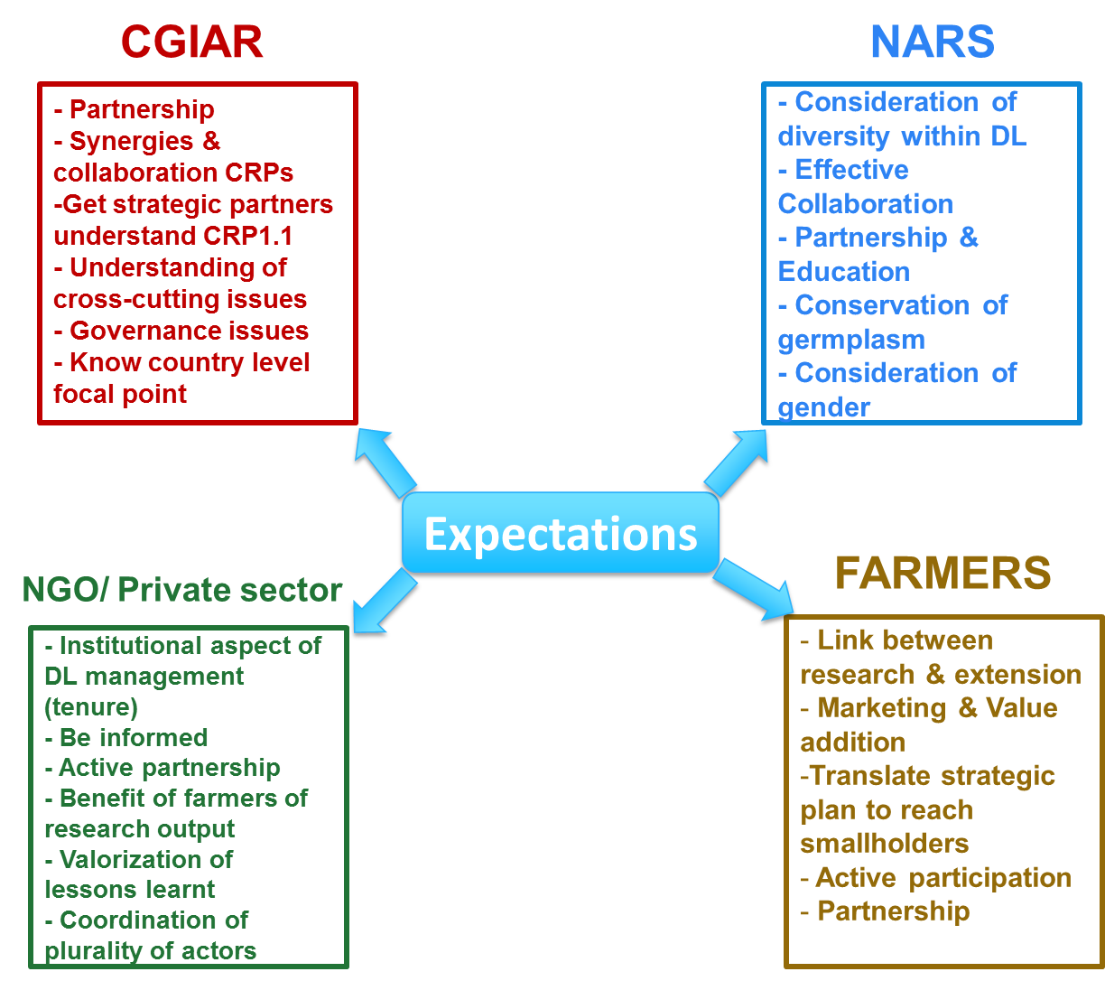
Among the expectations expressed, the need of partnership was the most recurrent. This is understandable because targeting resilience and livelihoods is an issue which requires synergy of action.
The second presentation focused on CGIAR Drylands Systems and was presented by Bill Payne from ICARDA. He began his presentation by providing to the participants the CGIAR level outcomes of the Dryland Program namely: reducing rural poverty; improving food security; better nutrition and health; and sustainable management of natural resources. He then summarized the dryland specificities, its characteristics, highlighting the conceptual research framework and strategic research themes, and cross cutting themes. He recalled what was accomplished during the inception phase (i.e. groundwork for baseline characterization, workshops to set research priorities). He recalled the concept of Intermediate Development Outcomes (IDOs) and what impacts are expected from the IDOs. He subsequently provided a summary of the donors meeting held in Montpellier in May 2013 and the main observations they made on the IDOs. He ended his presentation by noting his expectations from the meeting. He wished that by the end of the two days meeting, participants will be able to:
- “Cluster” the activities in prioritized workplans to achieve seven IDOs
- Use of standard logframe template
- Provide specificity on: Sites, Outputs, Outcomes, Deliverables, Activity Leaders, Partnerships, Timelines
- Design activities for “better impact targets”
- Understand the budget Principles
After this presentation, time was given to the participants for questions and discussions. The questions were: how youth and capacity building was considered? How prioritization will be done and number of sites selected.
The third presentation of the day focused on site selection and was titled “sampling the vulnerability reduction ⇔ sustainable intensification continuum” and was presented by Sibiry Pierre Traoré from ICRISAT. He first put the Dryland System CRP into context and targeted categories of dryland production systems. He elaborated on the selection criteria for identifying Dryland Systems CRP target areas using a cutting edge science method. He mentioned that both biophysical and socio-economic criteria were considered and summarized those criteria as follow:

Biophysical (n=25) | Socioeconomic (n=16)
Accessibility: closeness to partners headquarters, proximity to research facilities | Demography: population, poverty, employment (e.g. women/men differential aspects), nutrition status
Climate: rainfall patterns, temperature profile, drought and heat indices, length of growing period, elevation | Access to markets: distance, size, competitiveness
Soils: nutrient-supply capacity, water-holding capacity, morphology, soil erodability, degradation / desertification | Access to water and land: communal/private ownership, pricing, access
Biotic stresses: diseases, pests, weeds (e.g. Striga spp.) | Gender and disadvantaged groups’ responsiveness: differential aspects, absolute aspects
Farming systems: crops, vegetables, livestock, trees, mixed systems, gap between actual economic and potential yields | Governance, institutions, and policy: inclusiveness of stakeholders, equity, accountability, transparency
Sensitivity to global change: climate (variation and change parameters), globalization
Land degradation: physical, chemical

He then explained how these criteria vary over space and time. For him SRT2 and SRT3 are not mutually exclusive because many dryland agricultural systems will contain areas or elements of both. Also socio-economic criteria vary on shorter distances than biophysical (over space AND time), therefore site selection is scale-dependent, could follow a nested design:
- global to continental: mostly biophysical (e.g. AI)
- regional to district: increasingly socio-economic (e.g. population density, market access)
- district to community: essentially infrastructural (e.g. partnerships, accessibility)
He subsequently mentioned additional practical constraints we face for site selection in WAS&DS among which security issues need to be mentioned. The last section of his presentation focused on approach to site selection in which he explained a step by step process with pictorial maps. The sites considered were for SRT2 Kano-Katsina-Maradi and for SRT3 Wa-Bobo-Sikasso.
After this presentation, time was given to the participants for questions and discussions. The questions and answered provided are given in the table below.

Questions | Answers
Why Chad is not taken into consideration? | Mainly because of low population
Uniformity in term of biophysical and socio-economic? | Variation in population density
Did you population density in rural versus peri-urban areas? | Yes it was taken into account
How are you covering the prevailing farming system? | Knowledge of the region: in KKM we encountered nearly all types of farming systems
What is the importance of the biophysical factor as compared to the socio-economic? | It is difficult to know the weight of each factor for the time being
How did you consider government priorities with action sites? | There is no need to consider when the question are framed at the site level

➢The fourth presentation was focused on outcomes of the inception phase for WAS & DS and was presented by Antoine Kalinganire. He first defined the 10 key activities for which the CRP 1.1 will work in the region in relation to 7 IDOs. He subsequently reviewed all the 10 activities and classified them by year of implementation and indicated that he wanted the participants to agree and confirm the sites presented in the previous presentation by Sibiry. He also listed the range of partners who will be participating in the project and what each partner will do. He mentioned the current projects and their donors which are currently contributing to this CRP and elaborated on what will be done in the working groups, highlighted the aspect of prioritization of the activities, agreement on intervention sites and location and some linkages with other projects being implemented in the region and engagement of cross-cutting themes. He then touched briefly on the regional governance issue within the CRP. He concluded his presentation by showing a picture of agricultural system in a Faidherbia albida parkland combined with crops which to him would be the ideal situation for the dryland.
Before moving to the next session of the day, the chairman Zac Tchoundjeu gave opportunity to participants to raise questions and comment. Luckily it appeared that the presentations were clear as none of the participants had question.

4.3.2. – CG centres’ summary report and planned activities for 2013 and beyond
In the session before lunch 10 mn time was given to each CG center to report it conducted and planned activities. Also a feedback of the donor meeting was provided by Fergus Sinclair.

International Livestock Research Institute-ILRI
The first CG to report was ILRI and the presentation was made by Augustine Ayantunde. He first breakdown what have been done over the past for years in connection with CRP 1.1. In terms of activities done he mentioned among other the participation in various iIRT/IRT meetings, and collation of background data on Fakara (one of the satellite sites for KKM action transect) and contribution to groundwork report. The ongoing activities at ILRI span from staff recruitment to work on pastoralism issues in connection with the CRP, a review and synthesis of ILRI long-term (1994 – 2008) systems research activities in Fakara, southwestern Niger to enhance learning from the past (done by Pierre Hiernaux, Consultant, France). Considering the rich history of the site, this synthesis report on systems research in Fakara will allow identification of gaps and recommendations for future research. He mentioned the farming research systems which include biophysical research (climate, soil, hydrologic system, vegetation, crop experiment, livestock experiment and assessment) and socio-economic (rural population assessment and mobility studies, institutions, trade market, household economy). He subsequently charted the main approaches used by the research projects in Fakara.
He ended his presentation highlighting the planned activities. ILRI intend to review past System wide Livestock Program (SLP) projects on crop-livestock intensification in West Africa Sahel and Dry Savanna, assess trade-offs in resource use in the farming systems, undertake research on vulnerability and risk assessment including indigenous knowledge on coping strategies and analysis of promising crop-livestock value chains in the action sites.

Centro Internacional de Agricultura Tropical (CIAT)
CIAT summary report and planned activities was presented by Fred Kizito. He first put CIAT work into context by presenting the trajectory frontiers graph taken from Carberry et al., 2011. He subsequently reviewed their planned activities which comprise 6 work packages:
- WP 1: Landscape and soil health assessment through farm-plot characterization;
- WP2: Characterization of representative household typologies
- WP 3: Catalogue, characterize and evaluate existing technologies/interventions
- WP 4: Conduct agronomic survey of selected, representative farmers’ fields
- WP 5: Conduct ex-ante analysis to evaluate the potential impacts of interventions (includes Cost-Benefit analysis)
- WP 6: Perform agronomic and ‘technology’ response trials
Before ending his presentation, he mentioned CIAT contribution to SRTs (SRT3: Sustainable intensification, SRT4: Out-scaling and tradeoff analysis, SRT2: Reducing vulnerability and managing risk, SRT1: Innovation systems) indicating that CIAT will focus on implementing its activities in the 3 action areas. He concluded that depending on collaboration with other CGs and CRPs, they may seek the possibility to expand their activities to the Western Africa Sahel and Dryland Savanna. He ended by asking whether it will be possible to include other areas in East Africa (e.g. Malawi).

Centro Internacional de la Papa (CIP)
CIP summary report and planned activities was presented par Edwards Carry. He recalled that CIP started to engage with CRP1.1 last year in March. Later CIP participated to regional inception workshop in Ouagadougou (July) which was a great opportunity to meet new friends, colleagues. As activities conducted in 2012 he mentioned the Sweet potato survey done at Ghana Benchmark sites by CSIR-SARI scientists, multiplication work of sweet potato started at same sites. Other work in connection with CRP comprise, value chain study contracted by B&MGF in Ghana, Burkina Faso, Nigeria (Overlap with benchmark sites in each country), dry season multiplication work (enterprise approach) started at benchmark sites in Ghana and recent survey in Soukouraba a benchmark site in Burkina Faso. In the future, CIP will invest for dryland systems in W. Africa by allocating 60K (operational cost) and try to understand how to appropriately engage in the region, across sites.

Bioversity international
Bioversity summary report and planned activities was presented par Mauricio R. Bellon. He first highlighted that although dryland ecosystems are dry they harbor rich biodiversity, both wild and domesticated, contributing to a range of ecosystem services that are central for the well-being of farmers and pastoralists. Also both types of biodiversity are threatened by land degradation, while their loss may accelerate land degradation itself creating an undesirable positive feedback loop. He subsequently indicated that there is a little understanding of the links between agrobiodiversity loss and land degradation, and of how agrobiodiversity can be used to restore degraded dryland ecosystems. He then recalled the IDOs and conceptualizes Bioversity assessment work while providing numerous example of plant consumed in Benin. As data to be collected he mentioned on-farm diversity, dietary diversity, market diversity, livelihood outcome indicators. As part of Bioversity achievement he mentioned a desk study on agricultural ecological intensification options in the West African Sahel and Dry Savannas: current knowledge and possible scenarios.

World Agroforestry Centre (ICRAF)
ICRAF summary report and planned activities was presented Joachim Binam. He first mentioned ICRAF involvement in past meetings and the ground work conducted in the selected countries for CRP1.1. This work has allowed biophysical and socio-economical characterization (climate, soil types and health, land cover and use, farming systems, poverty, linkages to markets, etc.), identified the major constraints to enhanced agricultural productivity, and set the key research questions, hypotheses & key activities in different sites as well as key partnerships and potential roles in the implementation of the program. He subsequently elaborated on the planned activities. They comprise among others, establishing reference situation, monitoring and assessment of biomass and resource flow in action sites, reviewing of past work on dryland systems in the region and lessons on successes, failures and gaps in knowledge for sustainable intensification and vulnerability reduction; and evaluation of vulnerability and risk management strategies in the action sites; facilitation of effective linkage and knowledge exchange, develop and test value adding strategies for post-harvest management. He recalled the IDOs and key activities contributing to the IDOs before mentioning the different partners which are: local institutions, regional and international institutions and CGs. He then mentioned the current research and development projects contributing to the DS CRP before setting the way forward at ICRAF.

International Crops Research Institute for the Semi-Arid Tropics (ICRISAT)
ICRISAT investments into the Dryland Systems CRP in West Africa (2012-14) was presented by Sibiry Pierre Traoré. He first mentioned the Dryland Systems staffing at ICRISAT and mapped the main activities as indicated below.
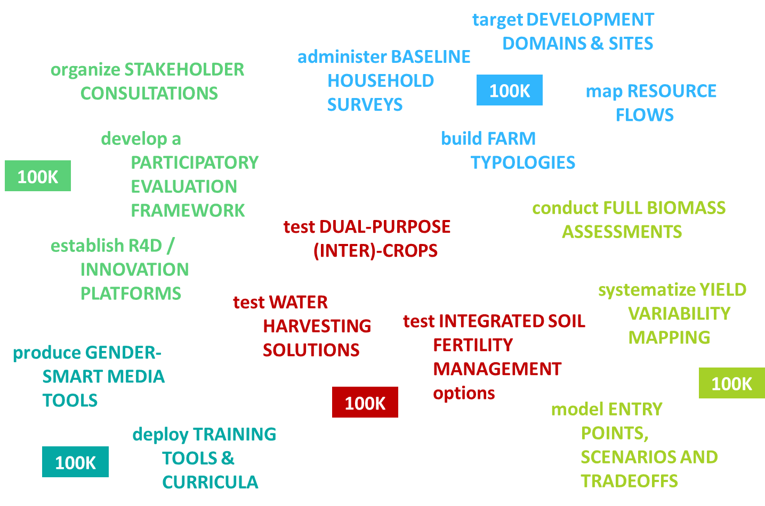
He then proposed conceptual schematic framework in which CRP activities at ICRAT are conducted. He elaborated on short note on the inception phase mentioning the research methods testing, the rationality of capacity building before mapping ICRISAT bilateral projects to Dryland Systems. He ended his presentation mentioning “Dryland Systems leveraging thrusts at ICRISAT” through new data systems for rapid appraisal, monitoring & evaluation, new participatory approaches (at district-level for scenario planning, co-production of farm/climate services) and improved trans-disciplinarily and CRP cross-fertilization.

Montpellier Meeting (CRPs joint Program in Burkina faso).
The feedback on Montpellier meeting was presented by Fergus Sinclair. As background he presented the Bonn meeting held in June 6-7 (meeting of WLE, FTA and CCAFS in Bonn discussed areas of cross-CRP synergy both issue and place-based). It came to surprise that Burkina Faso was chosen as a good location to develop and elaborate joint work as all three CRPs have major new research programs there, and there is potential to link to Dryland Systems. It was then agreed to proceed with a scoping of shared objectives, entry points and impact pathways in Burkina Faso. He presented the join implementation strategies in Burkina Faso as follows:
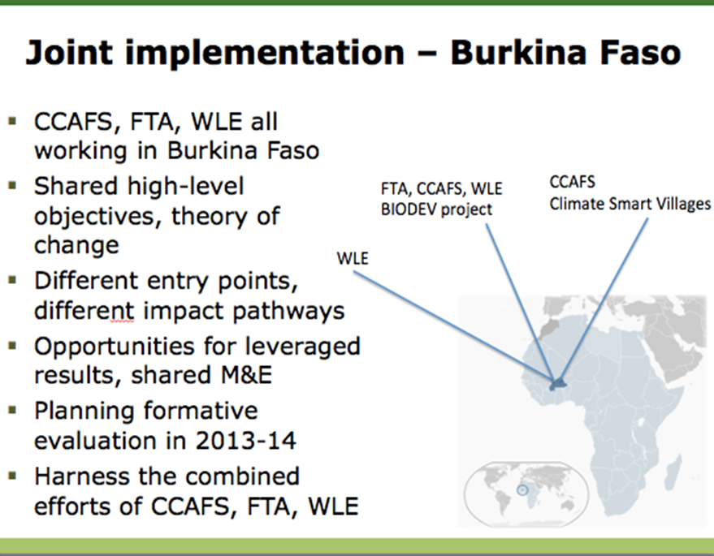
He subsequently shared the Montpellier meeting objectives with the participants before providing the agreed timeline.

Before Lunch, the chairman Zac Tchoundjeu gave opportunity to participants to raise questions and comments on all the presentation made. In addition to some comprehension questions and comment, a representative of farmers’ organization in Ghana, asked to know what take home message can be drawn from all the presentations made. Privilege was given to Bill to answer. He responded that although we are in the implementation phase of CRP 1.1 there is indeed a set of knowledge that farmers can have with the respective CGIAR and NARS.

4.3. - Preparatory communications to the work group
After the lunch break, participants were expected to present ideas on the planning and prioritization of the activities. To provide the tools to participants for this task, Antoine Kalinganire presented in plenary the Terms of References (see Annexe 3).

4.4. –Group Work
The workshop had two group work sessions.

4.4.1. –First session: work plan development per action site
The first session which took place on the first day after the lunch break focused work plan development per action site. The participants were divided in two groups and had to work on the terms of reference each focusing on one of the two sites:
1 Wa-Bobo-Sikasso (WBS) transect ≈ Intensification Target area
2 Kano-Katsina-Maradi (KKM) transect ≈ Vulnerability Target area
Guidelines and templates were provided by Bill to allow comparison between all sites of CRP 1.1. Each group selected his rapporteur and chairman.

4.4.2. –Session II: Allocation of responsibilities among partners and budget
The second work group session took place the 2nd and last day. It focused on allocation of responsibilities among partners and budget. To facilitate reflections, the plenary had provided a template to fill in.

4.5. – Restitution in plenary

During the restitution in plenary, the rapporteur for each group made a detailed account of their group work and their presentation were followed by brief time for complementary comment.
Raymond Vodouche presented on Wa-Bobo-Sikasso (WBS) transect ≈ Intensification Target area
Augustine Ayantunde on Kano-Katsina-Maradi (KKM) transect ≈ Vulnerability Target area

NB: Both Augustine and Raymond were asked to review the file presented and send later to Patrice that will check and forward later to Sibiry.

5. – SUMMARY OF WORKPLAN, BUDGET AND GOVERNANCE
After the plenary session of the group work, the floor was given to Bill Payne to inform the participants on the budget and governance issues within the CRP 1.1. He raised the importance of continued work to get more funding in order to implement some of the activities.

6. – LEVEL OF SATISFACTION
Before the closing ceremony of the workshop, the map of their expectation was shown to them. They were then asked to rank their level of satisfaction of the workshop. There was satisfaction from the participants from the CGs and the NARS, while for participanting farmers and NGO representatives “satisfied” accounted for the large number of respondants. The analysis of level of satisfaction is presented in the following figure.

Distribution of participants per level of satisfaction

It is worth noting the active participation of all participants in the discussions during the 3 days, which helped meet the expectations of the workshop.

6. –CLOSING CEREMONY
The closing ceremony was marked by a several addresses. First Mr. Bougouna Sogoba, from the NGO – AMEDD in Mali, speaking on behalf of participants from other NGO, farmers organizations and NARS, first acknowledge the importance of partnership in order to efficiently implement CRP 1.1. He later conveyed his thanks the organizers of the meeting and wished a safe journey to everyone. The second address was from Zac Tchoundjeu. He first noted that this workshop was extraordinary for him as compared to the first CRP workshop he attended. He also noted that he was impressed by the fact that everyone was actively participating from the beginning to the end of the workshop. Then he noted with satisfaction the mutual acquaintance achieved amongst participants from different countries and institutions, the improved understanding of the CRP 1.1. According to him, the great interest shown by all participants is because the issue of drylands is everyone responsibility. Before concluding his remarks he thanked all direct or indirect stakeholders who contributed to the success of the meeting.

The last and concluding address was made by Mr Karbo speaking on the behalf of the Director General of CSIR. After summarizing the content of the workshop, he thanked the participants for their active participation. He also invited the participants to continue interacting because dryland management is a long-term process and commitment. By these words, the workshop was closed around 17:30 pm.

ANNEXES
I –List of participants
No. | Institution | Country | Name | Address | Email
1 | INERA | Burkina Faso | Some Koussao P. A. | 01 BP 476 Ouagadougou, Burkina Faso. Tel: (00226) 76615894 | koussao@hotmail.com
2 | IDR / UPB | Burkina Faso | Hien MIPRO | 01 BP 1091 Bobo-Dioulasso 01, Burkina Faso Tel: (00226) 70247404 | miphien@gmail.com
3 | TreeAid | Burkina Faso | Sylvestre Bangre Ouedraogo | 06 BP 9321 Ouagadougou 06 Tel: (00226) 50363534 (office) / 70444616 | sylvestre.ouedraogo@treeaid.org.uk
4 | Confédération Paysanne du Faso (C.P.F) | Burkina Faso | Sawadogo Inoussa | BP 533 OHG Burkina Faso Tel: (00226) 70 25 95 74 / 75 43 43 16 | cpf@fasonet.bf / inoussa2011@yahoo.fr
5 | CSIR - Crops Research Institute | Ghana | Ansah Isaac O.O. | P.O.Box 3785 Kumasi Ghana Tel. (233) (0)244730779 / (0) 204730779 | ansahisaac2002@gmail.com / ansike@yahoo.co.uk
6 | CSIR - Plant Genetic Ressources Research Institute | Ghana | Aboagye Lawrence Misa | P.O.Box 7 Bunso, Ghana Tel. (233) (0) 277766955 | aboagyelawrencemisa@yahoo.com
7 | CSIR Water Research Institute | Accra, Ghana | Kwabena Kankam Yeboah | P.O.Box M 32,  Accra  Tel:(00233) (0)248305981 | kyeb59@yahoo.com
8 | CSIR- Forestry Research Institute of Ghana / ICRAF | Ghana | Tereza Peprah | P.O.Box KNUST Kumasi | tesspeprah@yahoo.co.uk
9 | CSIR | Accra, Ghana | Naaminong Karbo | CSIR - Animal Research Institute P.O.Box AH 20, Achimota Accra Ghana Tel. (233) (0) 208129300 | minongkordam@yahoo.com
10 | University for Development Studies | Tamale, Ghana | Samuel Kingsley Oppong | Faculty of Renewable Natural Resources of UDS, Tamale  P.O.Box 1882 TL Tamale, Ghana Tel: (00233) (0) 244535692 / 206915406 | kobbyoppong@yahoo.com
11 | ROPPA/GFAP/FONG | Accra, Ghana | King-david Kwao Amoah | P.O.Box DK 216 Darkuman Accra, Ghana  Tel. (233) (0) 243863567 | farmersorgaisation@yahoo.com  kdkamoah@yahoo.com
12 | Savanna Farmers and Marketing Company | Tamale, Ghana | Agatha Ayirewogye | c/0 Box 2668 Tamale, Ghana Tel. (233)(0)244130304 | ayirewogye@gmail.com
13 | CSIR-Crop Research Institute/ YPARD | Kumasi, Ghana | Osei Michael | Horticulture Division P.O.Box 3785 Kumasi, Ghana Tel. (233) (0)244432152 | oranigh@hotmail.com
14 | CSIR-Crop Research Institute (CRI) | Kumasi, Ghana | Lamptey Joseph | Box 3785 Kumasi Ghana Tel. (233) 60381/91 (Off.) / (0) 244861290 (cel) | jniilamptey@yahoo.co.uk
15 | CSIR-Crop Research Institute (CRI) | Kumasi, Ghana | Issa Umar Sanda | P.O.Box 3785 Kumasi Ghana Tel. (233) (0)277113944 | umar19sanda@yahoo.co.uk
16 | Howard Buffett Foundation Rep. | Kumasi, Ghana | Kofi Boa | P.O.Box 172, Nkawie-Toase, Ashanti Ghana Tel. (233) 208624048 | kboa55@yahoo.co.uk
17 | Institut d'Economie Rurale | Mali | Amadou Sidibé | IER/URG BP 258 Av. Mohammed V Bamako Mali Tel. (223) 66768757 | amadousidibe57@yahoo.fr
18 | NGO - AMEDD | Mali | Bougouna Sogoba | BP 212 Koutiala Mali Tel. (223) 76474732 | bougouna.sogoba@ameddmali.org / bsogoba67@yahoo.fr
19 | Sahel Eco | Mali | Mamadou Diakite | Sevare Mopti Mali Tel. (223) 76031713 | madoudiakite2003@yahoo.fr
20 | AOPP | Mali | Dakouo Boba Abed Nego | Cultivateur a Kangna Touminian Tel. (223) 76109333 / 65657361 | aopp_segou@yahoo.fr
21 | Kissima Insdustries | Mali | Simpara Assitan Keita | Titibougou Face terrain de Foot porte AB 08/03  Tel : +223 66730849 | kissimaindustrie@yahoo.fr
22 | Institut National de la Recherche Agronomique du Niger (INRAN) | Niger | Mossi Maiga Illiassou | BP : 429 Niamey-Niger  Tél :(227) 97 71 99 35 | imossim@yahoo.fr
23 | Institut National de la Recherche Agronomique du Niger (INRAN) | Niger | Issaka Ahmadou | BP 429 Niamey/ CERRA de Kollo, BP 60 Kollo, Niger Tel. (227) 96766271 | ahmad455@yahoo.fr
24 | Groupements semenciers | Niger | Neino Ali | Union Alheri Aguié, Maradi, Niger Tel. (227) 96807736 / 90477732 | c/o Abasse Tougiani (abasse.tougiani@gmail.com
25 | ILRI | Burkina Faso | Ayantunde Augustine | BP 9478 Ouagadougou Burkina Faso Tel. (226) 75851859 | A.Ayantunde@cgiar.org
26 | ICRISAT | Mali | Sibiry Pierre Traoré | Bamako, Mali | p.s.traore@CGIAR.ORG
27 | ICRAF/ ICRISAT | Niger | Patrice Savadogo | BP 1204 Niamey Niger Tel. (227)99734682 | P.Savadogo@cgiar.org
28 | ICRISAT | Nigeria | Hakeem A. Ajeigbe | ICRISAT Kano, Nigeria Tel. (234) 7034889836 | h.ajeigbe@cgiar.org
29 | ICRISAT | Kenya | Said Silim | P O Box 39063 Nairobi, Kenya Tel .(254) 20 7224555 | s.silim@cgiar.org
30 | ICRISAT/CCAFS | Mali | Abdoulaye S. Moussa | BP 320 Bamako Mali Tel.(223) 20709200 / 69554038 | a.s.Moussa@cgiar.org
31 | ICRAF | Mali | Antoine Kalinganire | BPE 5118 Bamako, Mali Tel : (223) 20 70 92 20 | a.kalinganire@cgiar.org
32 | ICRAF | Kenya | Sinclair Fergus | Nairobi, Kenya | F.Sinclair@cgiar.org
33 | ICRAF WCA | Cameroun | Zac Tchoundjeu | Yaounde, Cameroon | Z.Tchoundjeu@cgiar.org
34 | ICRAF | Mali | Joachim Binam | BPE 5118 Bamako, Mali Tel : (223) 20 70 92 20 | J.Binam@cgiar.org
35 | CIP | Kumasi, Ghana | Carey Edward | c/o CSIR-CRI P.O.Box 3785 Kumasi, Ghana Tel.(233) 546938599 | e.carey@cgiar.org
36 | Bioversity International | Benin | Vodouhe Sognon Raymond | 08 BP 932 Tri Postal Cotonou Benin Tel. (229) 95713333 / 96300397 | r.vodouhe@cgiar.org
37 | Bioversity International | Italy | Bellon Mauricio | Via Del Tre Denari 472/A Maccarese (RM) 00057, Italy Tel. (39) 066118 336 | m.bellon@cgiar.org
38 | CIAT | Kenya | Fred Kizito | Nairobi, Kenya | F.Kizito@cgiar.org
39 | ICARDA | Accra, Ghana | Paul Vlek |  | p.vlek@uni-bonn.de
40 | ICARDA | Ethiopia | Bill Payne | c/o ILRI Addis Ababa, Ethiopia Tel.(251) 116172001 | w.payne@cgiar.org
41 | ICARDA | Jordan | van Ginkel Maarten | Amman, Jordan Tel.(97) 1 505584043 | m.vanginkel@cgiar.org
42 | ICARDA | Tunisia | Ahmed Amri | 3, Rue Mahmoud Ghaznaoui Menzah IV, Tunis, Tunisia tel. (216) 53204402 | a.amri@cgiar.org
43 | ICARDA | Egypt | Karajeh Fawzi | P.O.Box 2416 Cairo Egypt Tel. (202) 35724358 (ext. 112) | f.karajeh@cgiar.org
44 | CIFOR | Burkina Faso | Mathurin Zida | 06 BP 9478 Ouagadougou 06, Burkina Faso Tel.(226) 50304742 | m.zida@cgiar.org

II –Workshop Agenda
Day 1:
1st August 2013
Time | Activity | Chairperson | Rapporteur
8.30-9.00 | Registration: Ms Carine Kan
 | Session 1:  Opening ceremony | Karbo Naaminong
9.00-9.30 | - Welcome address: Zac Tchoundjeu, Regional Coordinator ICRAF WCA  - Address by William (Bill) Payne, Director Dryland Systems, ICARDA  - Address by the Director General of CSIR, Ghana
9.30-10.00 | Coffee break (Group photo)
 | Session 2:  The Dryland Systems | Zac Tchoundjeu | Patrice Savadogo
10.00-10.30 | - Introduction of participants  - Expected outcomes and setting up the scene: Antoine Kalinganire , Regional Coordinator for West African Sahel and Dry Savannas
10.30-11.15 | Presentations: (15 min each)  - Highlights on the Dryland System: IDOs & Cross Cutting Themes, William (Bill) Payne  - Outcomes of the Inception phase: ground work and governance, Antoine Kalinganire  - System site selection and characterization of action sites: Sibiry P. Traore
11.15-11.35 | Discussions
 | Session 3:  CG Centers’ summary report and planned activities for 2013 and beyond (15 min each) |  | Joachim Binam
11.35-13.20 | - ILRI  - ICRISAT  - CIAT  - CIP  - IWMI  - Bioversity  - ICRAF
13.30-14.30 | Lunch
 | Session 4:  Working groups | Antoine Kalinganire | IRT
14.30-15.00 | TORs of working groups: Antoine Kalinganire
15.00-17.30 | Breakout sessions by working groups (WGs): WG1, WG2 and WG3  Work plans development per site
Day2:  2nd August 2013 |  | Chairperson | Rapporteurs
8.30- 10.30 | Plenary presentation of work plan | Antoine Kalinganire | IRT
10.30 -11.00 | Coffee break
Session 4:
Working groups
11.00 -13.00 | Allocation of responsibilities among partners and budget
13.00 -14.30 | Lunch
14.30-16.00 | Plenary presentation of Allocation of responsibilities among partners and budget
16.00-16.30 | Coffee break
16.30-17.00 | Summary of working plan and budget | Bill Payne | tba
17.00-17.30 | Governance and closing session

III Terms of Reference for the working groups

- Breakout Session: Work plans development per action site

Purpose. The purpose of this breakout session is to critically review, complete and validate planned activities at the regional level and to both action sites: Kano-Katsina-Maradi (KKM) and Wa-Bobo-Sikasso (WBS). The breakout session will involve 2 concurrent working groups, each per action site.
Process. Proposed composition of the groups is per action site individual experience. Each working group will be chaired by a NARS Member to be designated and a CG a rapporteur. A table showing priority activities per action site and per research location and corresponding IDOs will be filled by each group. For efficiency, country groups may want to subdivide according to locations and available local expertise, and then consolidate inputs in the table. Breakout groups will report back to plenary.
Expected outputs: A logframe (see template) showing priority activities and corresponding IDOs per action site.
- Breakout Session: Allocation of responsibilities among partners and budget

Purpose. The purpose of this breakout session is to critically review, complete and validate partners list for both action sites (KKM and WBS) and allocating responsibilities/roles as per the workplan and activities. The breakout session will involve 2 concurrent working groups, each per action site.
Process. Proposed composition of the groups is per the action site individual experience. Each working group will be chaired by a NARS Member to be designated and a CG rapporteur. A table showing partners, their roles and agreed budget/contributions to the Dryland Systems agenda per action site and per research location will be filled by each group Breakout groups will report back to plenary.
Expected outputs. A table showing partners, roles and budget specific to action sites.

ICRAF-ICRISAT, Niamey Niger, Email: P.Savadogo@cgiar.org

