Activity: Diversification of male sterility sources in hybrid breeding programme.

- Objective of activity and intended output:
To combat danger of homogeneity in hybrid breeding programme.
- Materials and methods:
Wild relatives accessions are crossed with the cultivated types and the derived populations are searched for the expression of male sterility traits. The identified male sterile are tested for the stability of the sterility expression. The stable types are introgressed through subsequent back crossings. Subsequently search will be done to identify stable complete fertility restorers. Test crosses will be made in Line X Tester design and heterotic hybrids will be identified.
- Results and interpretation:
Male sterile lines from Cajanus reticulatus were crossed with 27 elite lines. The F1 was studied in 2016 and all the reactions were found to be maintainer. New crosses were made with 33 elite lines in 2016 season and the F1 reaction will be studied in 2017.

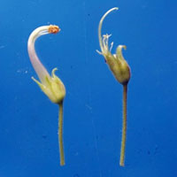
Cajanus cajanifolius (left) and Cajanus reticulatus (right) male sterile sources
- Next steps:
Stability of expression of male sterility across locations and across environments will be studied.

