Improving water use efficiency of degraded land by applying conservation agriculture: pilot study at Gairatdin farm, Karauziak district, Karakalpakistan
July, 2015

Introduction

Conservation tillage is increasingly used in rainfed agriculture for winter wheat in many areas. The extreme form of this soil tillage is direct sowing. Comparison of conventional and conservation soil tillage methods shows that they have significant effect on soil bulk density, structure and total porosity (Auskalnis, 2005).According to the results of many investigations, soil hydraulic conductivity, bulk density and compaction increased and porosity decreased because of the applicaton of a zero tillage system (Munkholm et al., 2001; Strudley et al., 2008).
By other results, the minimalisation of soil tillage had no significant influence on variation of these indices (Aura, 1993; Ferreras et al., 2000). In most cases, extensively tilled soils contain more moisture in springtime than in the case of intensive primary tillage (Cannel & Hawes, 1994; Lafond et al., 2006; Tsuji et al., 2006; Strudley et al., 2008). Mostly, conservation soil tillage improves physical properties, although this was observed only after 4-5 years of such soil tillage system application (Håkansson, 1993).

Effect of direct sowing on soil physical properties, such as reducing porosity or compaction, may be significant. The foreseeing such impact becomes especially important for summer fodder crops under irrigation. It may reduce soil available moisture storages, reduce losses of irrigation water for deep percolation and increase surface and subsurface evaporation.

It is important to note that zero tillage needs to be adapted to site-specific conditions, therefore it is important to ensure a comprehensive management that ensures the selection of the most appropriate system for particular soil and climatic conditions on the farm in question and the selection and operation of appropriate equipment.

Site description

The Aral Sea Action Site, located in the lowest part of Amudarya and Syrdarya, the two main Central Asian rivers (43°2.048'N; 60°0.803'E) stretches from southern Kazakhstan to central Karakalpakstan (in the west of Uzbekistan), and to northern Turkmenistan. This study is under implementation jointly with ICARDA at Gairatdin farm, Karauziak district, Karakalpakistan.
The Gairatdin farm is characterized by rising saline water table and loss of agricultural land productivity, which mean insecure food supplies and low income for poor people. Water shortage and soil salinization are the main issues farmers facing. The access to irrigation water has dramatically decreased in the last years, which resulted in low yield of main crops. For the last 10 years, steady decrease of cotton and wheat yields has been observed (for example cotton yield does not exceed 1.6 t/ha and wheat 2.5 t/ha).
The focus of the main study led by ICARDA is to explore conservation tillage for sowing fodder crops which will diversify cropping system. This comparative study aims to determine water use efficiency under traditional 23-25 cm deep soil tillage practices and zero tillage. The study was initiated in April 2015 on the territory of the Gairatdin farm in Karauziak district, Karakalpakistan. The field size is 3.62ha. The farm is belong to cotton growing area. The topsoil is represented by ‘takyr’ soils of heavy texture represented by loams and compacted clays with thin sand and loam sand interlayers.

Methods

The study monitors changes in soil properties as affected by shifting from traditional deep plowing to zero tillage. Following soil parameters are under control:
- soil texture;
- soil moisture content;
- soil bulk density;
- soil porosity;
- soil field capacity;
- irrigation efficiency.
In April –June following studies were carried at the project site:
- Soil sampling and texture analyzes up to 3 m depth.
- Soil bulk density up to 3 m depth (Table 1).
- Soil samples taken submitted to the chemical laboratory for analyzing soil solution extract.
- EC levels determined at 20 points for soil layers at 5-20 cm, 20-40 cm, 40-60 cm, 60-80 cm, and 80-100 cm below the soil surface.

Observation well was installed in spring 2015 and measurements were done once each 5 days from 2 May to 15 July, 2015.

Results

- Soil bulk density is given in Table 1

Table 1. Soil bulk density on 11/04/2015

Depth, cm | Replication 1 | Replication 2 | Average
0-20 | 1.52 | 1.49 | 1.51
20-40 | 1.55 | 1.58 | 1.57
40-60 | 1.38 | 1.41 | 1.40
60-80 | 1.53 | 1.49 | 1.51
80-100 | 1.60 | 1.56 | 1.58
100-125 | 1.52 | 1.53 | 1.53
125-150 | 1.38 | 1.46 | 1.42
150-200 | 1.56 | 1.58 | 1.57
200-250 | 1.58 | 1.61 | 1.60
250-300 | 1.60 | 1.64 | 1.62

- Soil salinity levels are given in Table 2.
Table 2. Soil salinity levels on 11/04/2015
Soil layer |  | EC
cm | Max | Min | Average
0-20 | 0.10 | 0.00 | 0.02
20-40 | 0.20 | 0.00 | 0.06
40-60 | 0.44 | 0.00 | 0.16
60-80 | 0.64 | 0.00 | 0.22
80-100 | 0.84 | 0.00 | 0.36
average | 0.32 | 0.01 | 0.16

According to FAO classification, soil is not saline except some points where soil is low saline at depths of 40-100 cm. This is consequence of intensive leaching applied before sowing fodder crops.

Pre-sowing soil leaching was applied on 5-7 May and the second on 16 June. Total irrigation water applied in these two applications amounted to 3,200-3,500 m³/ha.

The comparative values of irrigation applications under conventional deep tillage and zero tillage are given in Table 5.

Table 5. Irrigation applications under zero and conservation tillage (on 04.07.15).

 | Irrigation technology | Crop | Furrow length | Furrow width | Zero tillage |  | Conventional tillage
 |  |  |  |  | Flow | Rate | Flow | Rate
 |  |  | m | m | l/s | m³ | l/s | m³
 | Alternate furrow | Sorghum | 21 | 0.9 | 1.47 | 191 | 1.25 | 253
 |  | Mungbean | 21 | 0.9 | 1.25 | 154 | 1.3 | 257
 |  | Sunflower | 51 | 0.9 | 1.4 | 198 | 1.25 | 181
 | Zero slope furrow | Sorghum | 22 | 0.9 | 1.5 | 369 | 1.25 | 181

The effect of first irrigation on soil water storages can be observed through dynamics of soil moisture content.

- Changes of soil moisture content are given in Fig. 1 for 20-40 cm soil layer.

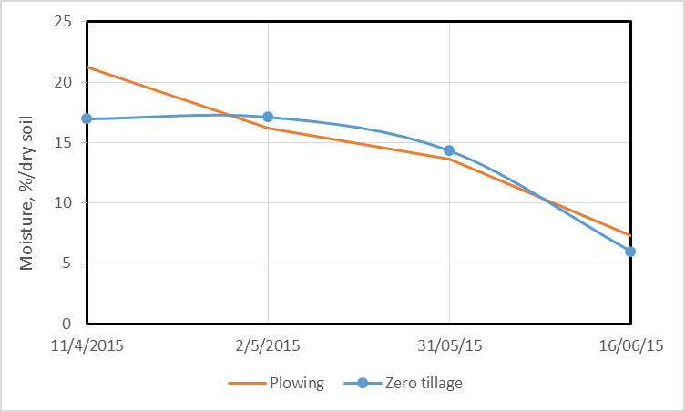

Fig. 1. Soil moisture content dynamics under plowing and zero tillage at 20-40 cm soil layer

Fig. 1 shows that there is significant difference in soil moisture content in the first days after irrigation applications, but then these difference disappear.

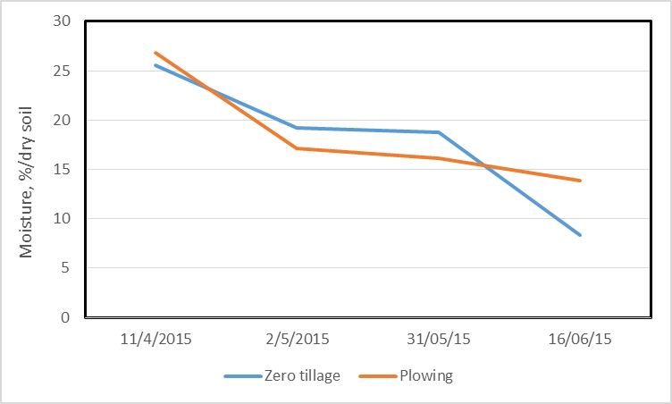
Fig. 2. Soil moisture content dynamics under plowing and zero tillage at 40-60 cm soil layer
Fig. 2 shows that significant difference in soil moisture content occurs in long run. Zero tillage practices require high frequency irrigation practices.

- Change of groundwater depths is given in Fig. 1
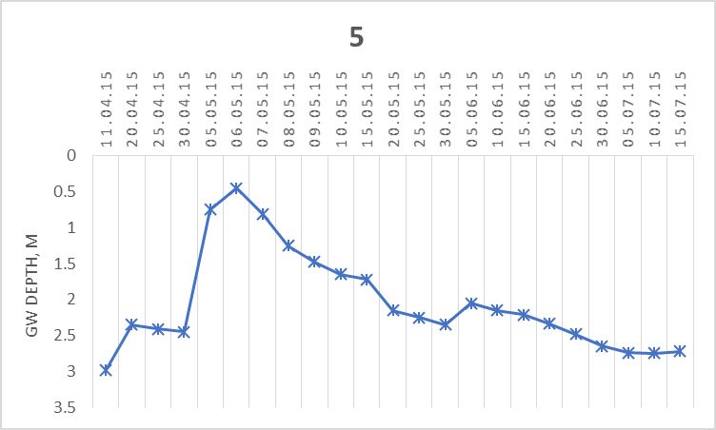

Fig. 1. Groundwater depth change, m
The raise of groundwater table on 5-7 May is the consequence of pre-sowing heavy irrigation. Fig.1 indicates also the second irrigations applied on 16 June. Total irrigation amounts to 3,200-3,500 m³/ha.

Conclusions

At this stage it is early to make any conclusion regarding the impact of zero tillage on water use efficiency. Preliminary recommendations are as follows:
- Considering heavy compaction of thick heavy soils it is necessary to apply inter-row tillage, especially under zero tillage and apply irrigation to prevent lowering soil moisture below 10-12%.
- Because of deep drainage crossing the area on southern border of the pilot farm there is low risk of salinization of soils.

