CRP: Dryland Systems
Center: ICARDA
Flagship: South Asia
Action Site: Chakwal (Pakistan)
Activity title: Evaluation, demonstration and dissemination of fodder and feed intervention.
Short Title: Evaluation, demonstration and dissemination of fodder and feed intervention
Activity leader: Dr. Abdul Majid
Key partner(s): Fodder Program CSI, NARC, Islamabad, Pakistan
Progress report: Six months (January-June, 2015)

Objective: Validate promising fodder varieties and silage making; develop informal seed enterprise (Oat)
Outputs Report III.
Two (2) tonnes seed of improved oat variety produced and distribution for 50 acres

Seed is one of the most important input in crop production. It carries the genetic potential of the variety and determines the ultimate productivity of other inputs. The main role of other inputs is to exploit to a maximum the genetic potential of the seed. Seed of improved variety is not available in the target areas, so there has been a scarcity of fodder in terms of both quantity and quality. Therefore, this activity was initiated to make ensure the availability of improved oat variety seed to the targeted area farmers.
Methodology
Seed enterprise was initiated in two villages by engaging two farmers one at Sagher and one at Latifal. NARC-Oat variety was sown on two acres in each village using seed rate of 100 kg per hectare. Sowing was done during the first week of November 2014. Full dose of Phosphatic fertilizer (P₂O₅ @ 57 kg) and Nitrogen fertilizer @ 75 kg per hectare in form of DAP and urea were applied at the time of sowing.
Latifal village was rainfed (450 mm) and Sagher farmers gave one supplemental irrigation at tillering stage. Weeding was down once manually on early stage of tillering at both locations. Disease was not recorded in oat crop stands. Harvesting was carried out manually during last week of May 2015. Crop was threshed by a threshing machine. After sun drying, oat seeds were packed into plastic bags and kept under room temperature in the respective farmer storehouse. It was fumigated with aluminium phosphate tablets to protect it from store grain pest. Farmers at Sagher and Latifal produced 1.20 tonnes and 1.04 tonnes seed.

Farmers Engaged in Improved Oat Variety Seed Production
S.No | Name of the Farmer | Village | Seed Produced (tons)
1 | Syed Qasim Shah S/O Syed Muhammad Shah | Sagher | 1.20
2 | Jahangir Haider S/O Sufi Mohammad Muzafar | Latifal | 1.04

Oat Seed Production Block at Farmers Field in Sagher Village
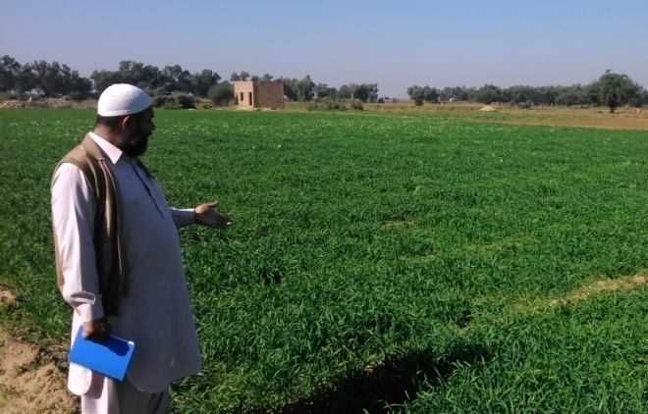  Figure-1: Oat seed crop at Tillering Stage | 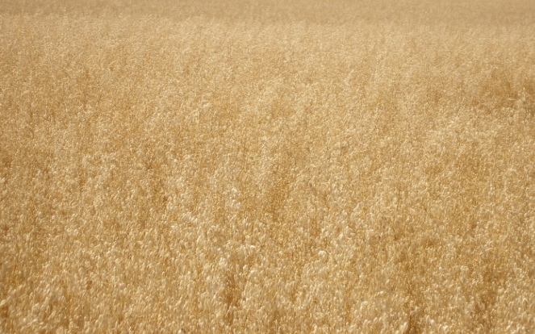  Figure-2: Oat seed crop at Maturity Stage

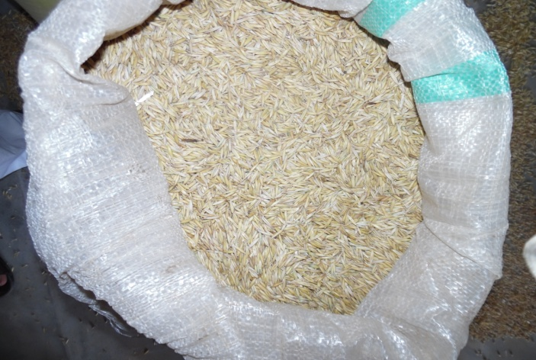  Figure-3: Oat seed packed at Sagher village | 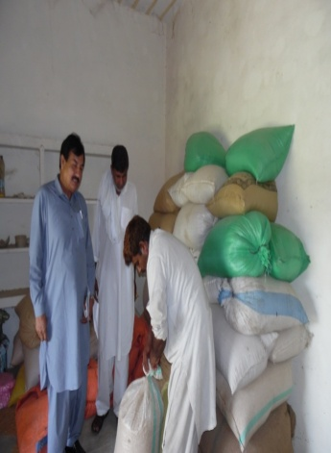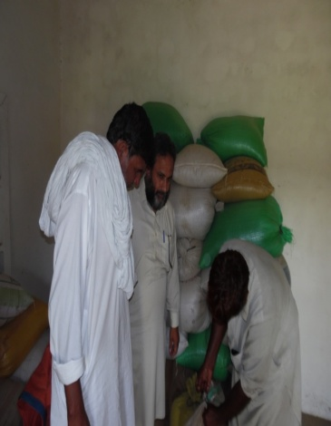  Figure-4: Seed stored at Sagher on farmer storehouse

Distribution for 50 acres
Seed produced at both the villages (2.24 tons) of improved oat variety is sufficient for planting 56 acres at targeted sites. Farmers have stored the seed due to low market price. The seed will be sold to the farmers of both the villages before planting season during 2015.

