CRP: Dryland Systems
Center: ICARDA
Flagship: South Asia
Action Site: Chakwal (Pakistan)
Activity title: Evaluation, demonstration and dissemination of fodder and feed intervention.
Short Title: Evaluation, demonstration and dissemination of fodder and feed intervention
Activity leader: Dr. Abdul Majid
Key partner(s): Fodder Program CSI, NARC, Islamabad, Pakistan
Progress report: 12 months (July-December, 2015)

Objective: Validate promising fodder varieties and silage making; develop informal seed enterprise (Oat)
Outputs Report V.
Maize silage tested at 2 male farmers’ fields for 3 large animals with each farmer

Introduction/Importance of Maize
The shortage of green fodder especially during lean periods from November-January is big obstruction to improve animal productivity at targeted areas. Therefore, there is need to manage and preserve green fodder during surplus period. Maize is considered as major forage component in the ration of dairy cows in targeted areas. Maize fodder can safely be fed at all stages of growth without any danger of oxalic acid, prussic acid as in case of sorghum or other fodders. Therefore, green maize fodder is referred as ‘king of crops’ suitable for good silage making. Silage is preservation of fodder at its highest nutritional stage for longer period of time. So, maize silage technology was demonstrated in targeted areas to cover the lean period from November-January. Maize silage feeding effect was also evaluated with normal feeding on large ruminants for milk production with two farmers at Saghar village.

Methodology
To cover the scarcity of fodder in terms of both quantity and quality during lean period from November-January maize silage technology was demonstrated to the farming community at Mial village on 29 October, 2015. To create the awareness about the silage technology among the farming community a brochure on maize silage technology was prepared in local language and distributed in targeted areas farmers. Twenty eight livestock owners and service providers participated on maize silage demonstration at Mail (Table 3).
Table 3: List of farmers participated on maize silage demonstration at Mial village.

Syed Qasim Shah S/O Syed Muhammad Shah | Muhammad Tanweer S/O Gul Muhammad
Shah Nawaz S/O Sher Khan | Malik Taj Muhammad S/O Mehr Khan
M. Raees S/O Khuda Yar | Malik Mumtaz Wanhar S/O Khan Zaman
Abdul Wahid S/O Ghulam Asghar | Syed Maqsood Shah S/O Syed Muhammad Shah
Syed Kazim Abbas S/O Syed Iftikhar haider Shah | Syed Imtiaz Haider Shah S/O Syed Ghulam Muhammad Shah
Naeem Iqbal S/O Malik Iqbal | Babar Ali S/O Ashiq Hussain
Abdul Ghani S/O Noor Din | Syed Sajjad Haider Shah S/O Syed Ghulam Ahmed Shah
Ghulam Muhammad Khan S/O Atta Muhammad | Muhammad Ramzan S/O Muhammad Bashir
Tanweer Ahmad S/O Bashir Ahmed | Itbar Khan S/O Gohar Khan
Ghulam Abbas S/O Sher Muhammad | Abdul Rashid S/O M. Bashir
Zafar Din S/O Fakher Din | Muhammad Waseem S/O Muhammad Iqbal
Muhammad Nawaz S/O Haji Mian Muhammad | Zulfiqar S/O Muhammad Javed
Muhammad Hanif S/O Yaran Khan\ | Abdul Karim S/O Abdul Hye
Subadar Abdul Rashid S/O Abdul Hye | Javed Iqbal S/O Haji Khan Mulk

Maize silage making
For maize silage making, S-2002 maize variety was planted at two farmers’ field at Saghar village at the last week of July 2015. The plot size was two acres, with seed rate of 30 kg ha⁻¹ was tractor drilled by keeping 60 cm row-to-row spacing. Fertilizer was applied at the rate of 58 kg P₂ O₅ and 46 kg N per hectare at the time of sowing whereas, 35 kg N was applied after one month of sowing. The crop was harvested at milky stage when grain was half matured. The silage making process was demonstrated at farmer field of targeted site at Mail village.

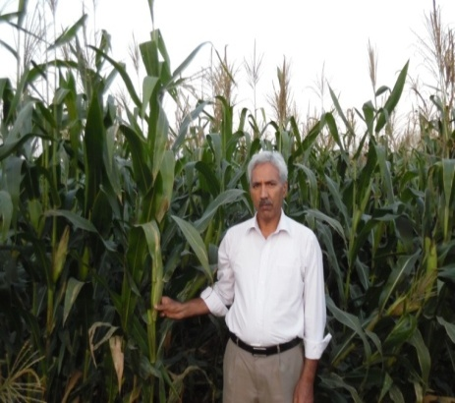
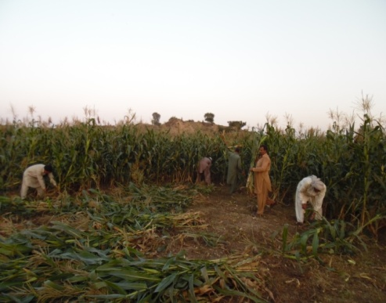
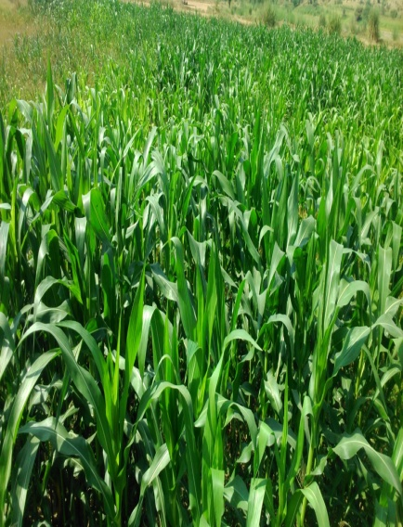
Pic-1: Maize plantation Maize at harvesting stage Harvesting for silage making
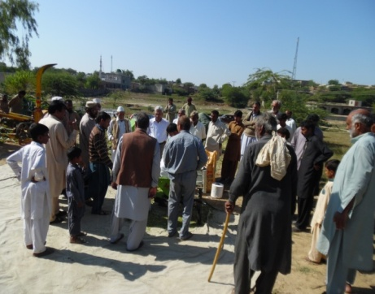
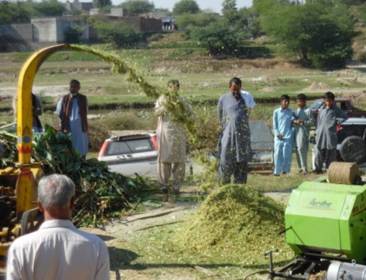
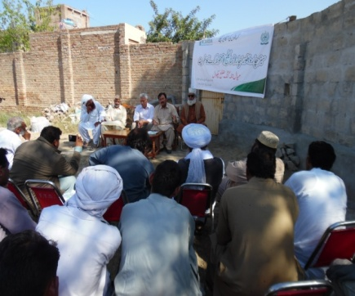

Pic-2: Famers participation on maize silage demonstration at Mail village; Chopping of harvested maize
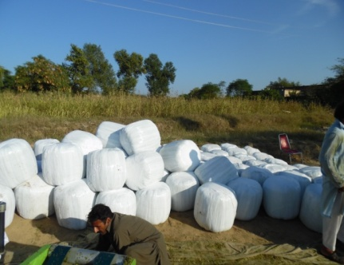
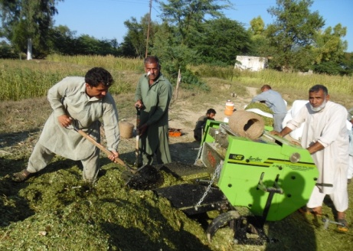
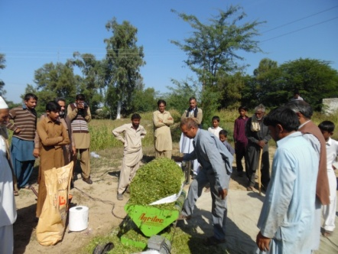

Pic-3: Pressing of chopped maize; Raping of pressed maize silage bales; maize silage bales ready for storage.

Silage Testing Methodology:
Maize silage feeding was tested at two male farmers field for three large animal (cows) with each farmers versus two farmers having same number of animals with normal feeding at Saghar and Mail villages. Treatments details are as below.
2 Treatments:
T₁ = Silage feeding
T₂ = Normal feeding
No of Farmers: 4 (Details in Table 2)
No of Animals: 3 lactating animals with each farmers (4×3=12 animals)
Data Collected: Milk Yield (litter per day)
Interval of data collection: 7 days (one week)

Results
The results of the feeding trial indicates that initially there were average of 7.42 and 7.33 liters milk production per day in silage feeding and normal feeding cows, respectively (Table 4). After 15 days of silage feeding, milk production increased to 8.67 liters per day. Whereas, in normal feeding milk decreased from 7.33 to 6.79 liters per day. There was 27.6% increase in milk yield in silage feeding cows. It might be due to the fact that maize has high protein efficiency ratio (PER), relatively high digestible energy (DE) and total digestible nutrients compared to normal feeding lactating animals.
Table 1: Effect of maize silage vs. normal feeding on milk production of 12 cows of four farmers at different feeding intervals.
Feeding | Milk yield with feeding days intervals  (litter per day) |  |  | Effect of feeding stuff on milk yield
 | 25.11.015 | 2.12.015 | 9.12.015 | Increase/Decrease
Maize silage Feeding (MSF) Animals (T₁)
MSF 1 | 6 | 7 | 8 | 2
MSF 2 | 8 | 8.5 | 9 | 1
MSF3 | 5 | 6 | 7 | 2
MSF4 | 9 | 9.25 | 9.5 | 0.5
MSF5 | 8 | 8.5 | 9 | 1
MSF6 | 8.5 | 9 | 9.5 | 1
Mean | 7.42 | 8.04 | 8.67 | 1.25
Normal Feeding (NF)Animals (T₂)
NF1 | 7 | 6.75 | 6.25 | -0.75
NF2 | 8 | 8.5 | 7.75 | -0.25
NF3 | 9.5 | 9.25 | 9 | -0.5
NF4 | 6 | 5.75 | 5.25 | -0.75
NF5 | 8 | 8 | 7.5 | -0.5
NF6 | 5.5 | 5 | 5 | -0.5
Mean | 7.33 | 7.21 | 6.79 | -0.54

Table 2: Farmers Engaged in Silage feeding trial
S No | Farmer Name | Village | Feeding
1 | Qasim Shah S/O Muhammad Shah | Saghar | Silage Feeding
2 | M. RaeesS/o Ahmad Khan | Saghar | Ordinary Feeding
3 | Malik Mumtaz S/O Khan Zaman | Mial | Silage Feeding
4 | Shah Nawaz S/O Sher Khan | Mial | Ordinary Feeding

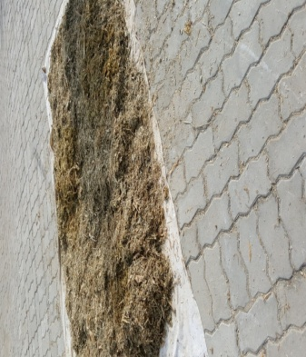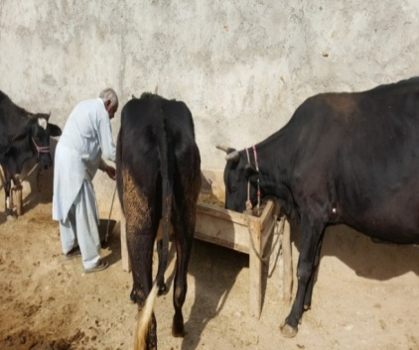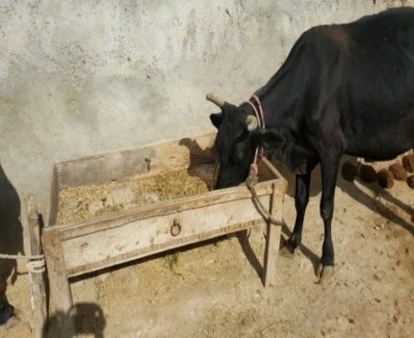
Pic-4: Silage ready for feeding; Silage feeding to cattle at Saghar village

