**Drylands System East & Southern Africa - East Shewa Transect**

**Diversification into Goat Production**

A Training and Consultative Workshop

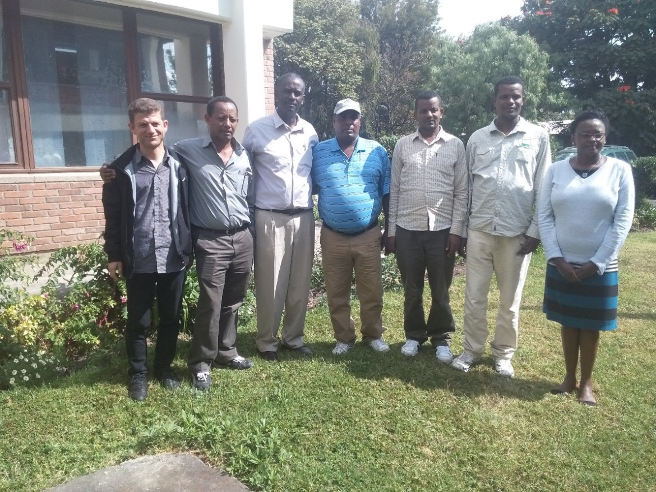

Participants of the Workshop, ILRI Campus, Addis Ababa, Dec. 14-15, 2015

The main research issues of CRP Dryland Systems in East & Southern Africa – East Shewa transect focus on sustainable intensification. Crop production dominates in the mixed crop-livestock systems within the Transect. The livestock component of the project seeks to work with the communities in Adami Tullu to diversify into small ruminant production and simultaneously enhance their capacity to manage. Breeding and feeds & feeding to improve goat production are the focal issues. The research questions that the livestock component is seeking to address include whether small ruminant feeding systems can benefit from improved crop production, whether food-feed crops can benefit small ruminant production, which simplistic schemes for selection and communal use of bucks could be designed for improved productivity, whether a fattening program can be adapted by selected farmers to increase their income and how market linkage can benefit goat production. Various activities are ongoing to address these research questions.

To embark on whether a fattening program can be adapted by selected farmers to increase their income, ICARDA organized a training and consultative workshop for Adami Tullu Researchers on 14-15th December 2015 encompassing breeders, animal nutritionists and socio-economists to plan for an on-farm goat fattening project with a total of 60 smallholder farmers and 150 goats in two peasant associations (*kebeles)* namely Dodicha and Haleku Gulenta. The objectives of the workshop were to integrate improved feed strategies in goat flocks in Dodicha and Haleku communities, to review approaches and methods required to operationalize the feed interventions that would work, to review selection and communal use of bucks for improved productivity, to identify market linkages that would benefit goat production.

Discussions were made on results of feed scenarios in Adami Tullu as captured by feed assessments using the FEAST Tool in June, 2015. Researchers were trained on strategies for improved goat production in community breeding, goat nutrition, ration formulation and ration balancing. They were also introduced to improved feed analysis methodologies in a tour to the ILRI Animal Nutrition Laboratory.



The next step for the participants is to undertake on-farm fattening with smallholder goat farmers that will assess the economic viability of fattening bucks for various local and export markets.

*Story by Jane Wamatu (ICARDA-Ethiopia)*