Progress of Research Activities and Plan of work
Title of the Experiment/Activity:
Genetic and nutritional profiling of finger millet germplasm collection in ESA
Lead Scientist: Rajneesh Paliwal
Collaborating Scientists:
Henry Ojulong, Damaris A. Odeny, Eric Manyasa,

Objectives:
To identify responsible genes/QTLs for nutritional traits by using high-throughput SNP markers with genome-wide association approach

Location of Experiment: ICRISAT sub field research station at Kiboko, Kenya; ICRISAT-molecular Lab Nairobi

Materials and Methods: Total 400 diverse fingermillet lines were planted for DNA extraction in poly house for DNA extraction at ICRAF-Nairobi. These lines have been characterized at the ICRISAT field research station at Kiboko, Kenya for nutritional traits.

Salient Results progress till date (Feb 2017):
- The high quality DNA was extracted from 400 diverse lines at ICRISAT molecular lab at ICRAF, Nairobi, Kenya. Out of 400 lines, DNA from 380 randomly selected lines were sent to Cornell university, Ithaca, NY, USA for GBS sequencing to generate SNP markers.
- Total 0.27M SNPs were discovered with 0.0005 minMAF (minimum minor allele frequency) and 0.5 maxMAF from 85.62 GB compressed/zipped raw sequenced GBS data using Tassel 3.0 UNEAK pipeline. The proportion of missing data and heterozygote was 62% and 0.06% respectively (Table1). This high proportion missing data percentage was due to very poor GBS SNP data of 109 lines, out of 380 lines. We excluded 109 lines with poor GBS data from total 380 accessions. Total 22.8K SNPs were maintained in rest 271 accessions after filter with 0.05 minMAF, 1.0 maxMAF and minCount 70% (allele scored in 70% of the population) to reduce missing data, minor alleles. There were 4% missing data and 59% heterozygosity in 271 lines (Table2).
- The cladogram analysis clustered most of fingermillet accessions independently in four different sub clusters (Figure 2) with 22.8K SNPs and reveal the available genetic diversity in ESA fingermillet collection. The results of principal component analysis (PCA; Figure 3a, b) were also confirming the results of cladogram analysis.
- Dr. Henry Ojulong has already characterized these diverse 400 fingermillet lines for nutritional traits including calcium and iron in two seasons/environments.
- Genome-wide association study will complete and research will submit to publish in reputed research journal in year 2017.

Table1: Overall SNP summary for 0.27M SNP data
Number of Taxa | 380.0
Number of Sites | 269058.0
Sites x Taxa | 1.0224
Number Not Missing | 3.9336744E7
Proportion Not Missing | 0.3847
Number Missing | 6.2905296E7
Proportion Missing | 0.6152
Number Gametes | 2.0448408E8
Gametes Not Missing | 7.8673488E7
Proportion Gametes Not Missing | 0.3847
Gametes Missing | 1.25810592E8
Proportion Gametes Missing | 0.6152
Number Heterozygous | 5799816.0
Proportion Heterozygous | 0.05672
Table2: Overall SNP summary for 022.8K SNP data
Number of Taxa | 271.0
Number of Sites | 22842.0
Sites x Taxa | 6190182.0
Number Not Missing | 5931289.0
Proportion Not Missing | 0.9581
Number Missing | 258893.0
Proportion Missing | 0.0418
Number Gametes | 1.2380364E7
Gametes Not Missing | 1.1862578E7
Proportion Gametes Not Missing | 0.9581
Gametes Missing | 517786.0
Proportion Gametes Missing | 0.0418
Number Heterozygous | 3620286.0
Proportion Heterozygous | 0.5848

Figure 1a: Missing SNP data proportion in 271 fingermillet accessions. Each circle point represents single fingermillet lines.

Figure 1b: Heterozygotes SNP data proportion in 271 fingermillet lines. Each circle point represents single fingermillet lines.

Figure 2: Genetic diversity explained in cladogram analysis of 271 fingermillet accessions.
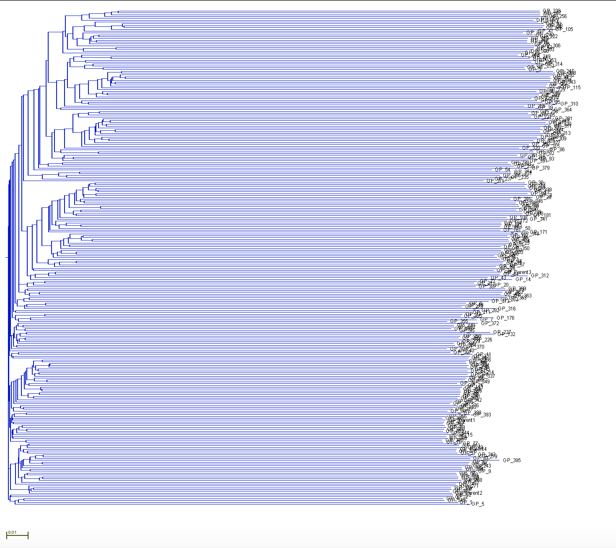

Figure 1a: Principal component analysis PC1vsPC2 and PC1vs PC3 in 271 fingermillet accessions. Each circle point represents single fingermillet lines.

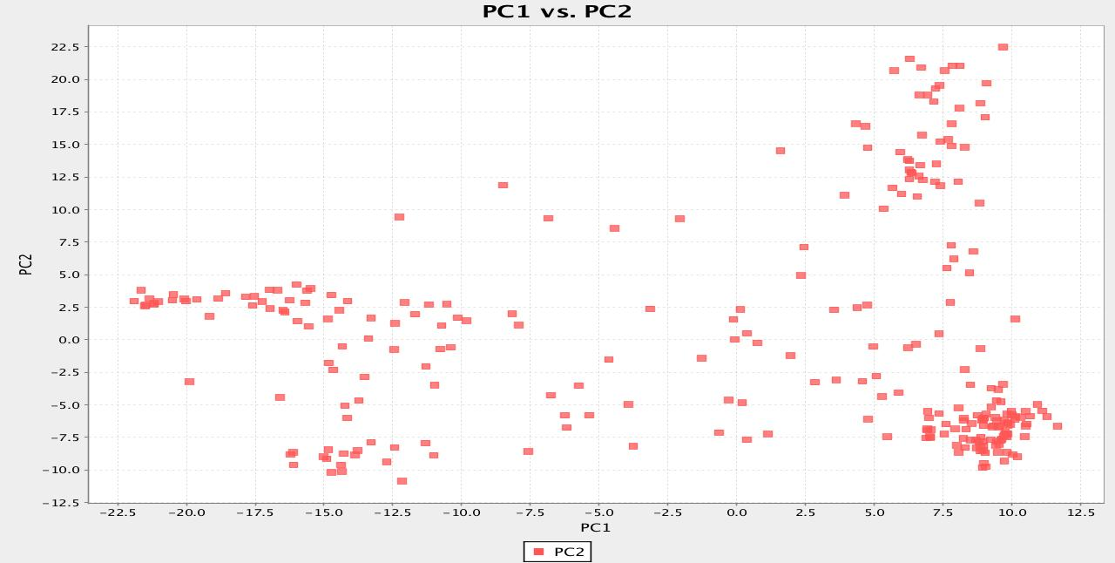
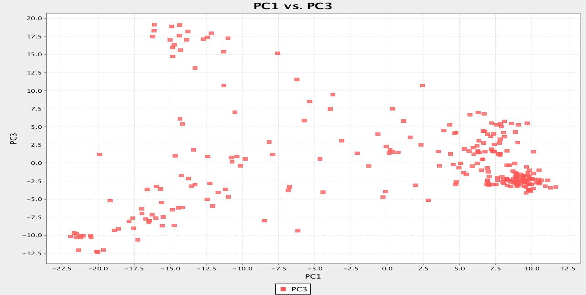

Figure 1b: Genetic variation explained in both individual and cumulative by principal components in 271 fingermillet lines.

Next Steps of Activity in year 2017:
- Phenotypic data will collect from Dr. Henry for doing genome-wide association study for nutritional traits and also for other agronomical characterized traits.
- No research fund requires for year 2017 in this activity. I will complete this research activity and results will publish in reputed research journal.

Expected Outputs:

- The responsible genes/markers will be identified for different nutritional traits in finger millet and these associated genes can be useful for develop nutritional enriched finger millet lines using MAS breeding.
- The generated SNP marker will be helpful to explore the genetic variability available in ESA finger millet collection.
- The generated molecular SNP markers will also be useful for future molecular research on biotic/abiotic stresses.
- This genetic variability information will be helpful for developing new crossing population for future molecular and breeding research.

Challenges, Constraints & Mitigations
Generally, the nutritional traits are showing quantitative genetic nature and success of study depends on large population size.

