



Innovation Platform evaluation report

Assessing the influence of the IP on livelihoods and resilience
In Marara/Changara, Tete Province, 10-15 May, 2015

By Sabine Homann-Kee Tui, Michael Hauser, Julio O. Rainde


The work is supported by the CGIAR Research Program Dryland Systems

1. Background
At the final phase of the MOREP project (August 2013-July 2015) we engaged in participatory assessment of the IP achievements in Marara, Tete. We used qualitative and quantitative assessments, including focus group discussions with farmers (influence diagrams, matrix scores) and complementary semi-structured interviews with experts.
The project activities accommodated CRP Dryland systems activities:
- Take the systems model to the farmers and other stakeholders: the approach suggested by Lance Robinson was modified and the influence diagram used for illustrating the effects of the IP on the livelihood system.
- ii. investigate impact of IP: assessing the influence of the IP on livelihoods was combined with the special focus on how the IP has strengthened the ability of communities to self-organize, key aspect in resilience assessments.
The assessments therewith contribute to the following research questions
- How does agro ecological risk influence farmers’ capacity for self-organization and socio-ecological resilience?
- How did the IP influence livelihoods?
- How effective is the IP in strengthening self-organization?
- What effects does improved self-organization have on socio-ecological resilience?
Objectives
- Understand farmers core livelihoods, as influenced by the IP, other local mechanisms and external influences
- Visualize livelihoods from the perspective of more market oriented farmers and those with resource limitations, and capture important gender implications
- Visualize farmers perception on IP’s contribution to enhancing self-organization of the overall innovation system, including communities and partners
- Discuss major contributions, successes, failures, lessons and future priorities for the IPs
- Complementary: discussion with experts on achievements and weaknesses along the IP led development process

Methods overview
Activity | Rationale | What we get/What they get
- Systems/IP influence diagram with communities  Farmers illustrate IP achievements, revisit challenges and opportunities, contribution of IP for desirable change | This will ground the discussion on IP achievements and self organization, systems effects at various scales, inform lessons on the past IP and key entry points for interventions and requirements for future IPs. | We understand where people are in terms of livelihoods and the IP, what they see as most critical parts of the system, how influences (external, internal) affect the system  Farmers visualize effects of IP, where it was helpful to strengthen positive links; address constraints, remove barriers; identify new opportunities, priorities for future IP interventions  The participants learn from each other different ideas on the system and how it can be changed
- IP effects on self-organization (SO) and resilience outcome variables  Discussion on indicators for SO before and after IP, what changed in the way people organize themselves, contribution of the IP | Taking stock of lessons learned from IP with specific regard to SO | Will give us insights on how IP can support SO more effectively  - What can be done to overcome constraints to SO?  - How can we measure SO and how can IP influence that?  - How can we better understand internal structure, learning, change through IPs  - How does the context affect IPs?
- Individual experts meetings  Share IP assessment with farmers as base for discussion  - DPA  - Local governmt.  - NGOs | To understand progress, challenges, failures in IP contributing to improving farmers livelihoods, how IP can link up with other / follow up activities | We understand how partners see IP progress, their past/future role and contributions to IP and how that can build out  Partners will raise their concerns, questions, suggestions for future activities.

2. Activities
- Before the workshop: Establish the focus of the study on the evaluation of the IPs supported under MOREP – thus IPs as focal area, rather than the livelihoods.
- Introduction of participations and establish who is present – if possible have farmers with different resource endowments and gender; translation across 3 languages might be a problem
- Why we are here: We want to learn from experience of farmers in Marara about the IP process, how and what did the IP contribute to farmers improving their livelihoods, successes and failures and how can it further assist farmers to improve their livelihoods. This is to generate lessons for farmers themselves and also for interventions in future and other areas
- What will we do? Dialogue and visual tools on IP and self-organization, with feedback presentations and discussion
- How will we do it? We start by verifying overall objective of the IP, and also aim at looking at implications for men and women farmers.
  - Visualize the big picture of how IP has influenced farmers livelihoods, identify bottlenecks, feedback loops,
  - identify key areas of improvement and how the IP contributed to that, identify those areas that are still weak and need more attention in future
  - Take this forward to assess a number of indicators for self-organization.
  - Conclude with key messages on IP success, failure, lessons and future priorities.
- After the workshop: We take the picture with farmers influence diagram, discuss it with different support staff, government, NGOs, on their feedback:

Procedure for field data collection
Step 1: Getting started
The facilitator asks the following questions:
- What is the main focus of the IPs to improve Drylands Systems livelihoods?
- What were the specific objectives of the Marara IP?
Duration: 30 minutes
Step 2: Brainstorm on IP achievements and livelihood factors
Brainstorm on major achievements of the IP. Start with a few obvious factors, such as farmers being better connected among themselves, then the facilitators asks questions such as:
- What other social, institutional, technical, achievements of the IP?
- Write / draw symbols with achievements farmers mention on small cards.
- Ask farmers to arrange the symbols around the IP and indicate how they relate to each other, e.g. on the floor.
- Transfer the illustration once everybody agrees on a flip chart so that everybody can see them.
Duration: 30 minutes
Step 3: Draw Influence diagram
- Verify key livelihoods with farmers / other stakeholders
- Draw major livelihood components, factors that influence them and context
- Differentiate contributory and inhibitory causal relationships by using different colour arrows.
  - Contributory relationship: green or + sign
  - Inhibitory relationship: red or – sign
- Discuss / verify these factors (if time allows)
- Discuss / verify
  - Bottlenecks – what 3 key areas does the IP need to address for the livelihoods to grow?
  - Leverage points – what 3 factors would be attractive for farmers to change in the short term?
- Participant volunteers to summarize the diagram, lessons learned to the audience.
Duration: 60 minutes
Step 4. Illustrate the influence of IP on self-organization
- Facilitator explains clusters of indicators for self-organization
- A flipchart is prepared with a table, indictors for self-organization, 10 beans for scoring (10 = strong, 0=no weak)
- Facilitator explains each indicator with an example. Farmers discuss the state of self-organization before and after the IP, and whether the IP had a direct influence on the change.
- Two farmers are responsible for the scoring, allocating each the scores for each indicator before and after the IP.
Duration: 120 minutes
Step 6. Discussions with external partners
Discussion with external partners had the following objectives:
- Feedback result from IP evaluation
- How can the development support the IP?
- What are priorities for future engagement, what are possible obstacles?
It was structured as followed:
- Introduce purpose of the meeting
- Present the results from IP evaluation with farmers in Marara
- Engage in semi-structured discussion

3. Results and documentation of the community meeting
The meeting in Marara took place from 10 am to 17.00 pm, with a lunch break at the local restaurant. 11 men and 5 women farmers participated, 1 extension officer and 3 project support staff. After short introductions, the meeting started with revisiting the overall vision. Due to relatively small group size, and seeing the challenge of translation we decided to engage the entire group in the exercise, and not to split farmers by resource endowments.
3.1 Overall vision
Farmers agreed that the main objective of Marara IP is poverty reduction. They engage in improving crop and livestock production and marketing activities and achievements of the IP are for the goal of poverty reduction.
Farmers first listed and designed symbols for all activities that contributed to achieve poverty reduction. They focused on activities done or influenced by the IP during the past five years. They then discussed in more details how the IP contributed to these activities; they arranged the activities in relation to the IP and each other and discussed links among the IP and the activities (green/blue arrows). They then highlighted the activities with strong achievements (green star), and those that were not yet accomplished (red star).
Overall the results reflect strong improvement in farmers’ relations among themselves and with partners, good potential for future activities. Structures for knowledge exchange and learning were developed and improved; the recently legalized farmer association AAPACHIMA provides this formal structure, but needs capacity development.
3.2 Influence of the IP on livelihoods
Strong improvements through the IP
- Farmers are better connected amongst themselves
Farmer say through the IP they are now better organised. Before farmers knew each other and had different views. IP meetings have opened farmers’ minds, by engaging farmers in activities, within and across villages. The IP has also brought farmers of different resource endowments together. Farmers have seen how other farmers developed their crop and livestock production. They have increased crop production because of the IP. By meeting other farmers they exchanged also on other issues, e.g. how to use water for irrigation of vegetables.
Farmer now communicate more and better, and also share information beyond the IP. Farmers visit each other also across villages. “We compare the results of our activities.” Thereby farmers improve learning. Farmers feel that they could better share information and technologies among themselves as through the extension officers, as the extension officers are often absent. A future project should make direct contacts with farmers for improving knowledge exchangem e.g. in groups of 10.

- Improved relationship between the association AAPACHIMA and the administrator
Farmers now have now better relations with the local administrator. The project funded the IP to become formalized as association. AAPACHIMA is the first farmer association in Marara. Through AAPACHIMA the project has supported the delineation of 13,000 ha community land and the feira market place. AAPACHIMA then presented the MOREP project to the new administrator. The administrator encouraged AAPACHIMA to better organize and write a proposal for funding the market infrastructure under district development funds (7Mio funds).

- Farmer are better connected to external partners
Linkages between the farmers and external partners improved. AAPACHIMA is building the links to DPA, Aceagrarios, ICRISAT, extension and others. Since farmers have an association they can easier contact outside organizations, as they themselves now are better organized and have a formal structure. Farmers now know better how to contact new partners.
- Farmers – district extension: Extension officers understand the IP functions. However, the relationship between farmers and extension is not strong, as extension officers do not visit the farm adequately. Extension officers are engaged in other activities than local agriculture. Especially since the division of Changara and Marara districts, creating new localities, extension officers aim at becoming heads of new localities. As a result farmers miss important information and do not get inputs in time. For example, pesticides were not distributed to farmers in time. Mucuna, grown at the posto fomento was only distributed to farmers in February. Next time inputs should be shared with farmers for distribution among themselves.
- Farmers – provincial level extension: The relation is better as compared to local extension, even though provincial staff does not frequently visit the area.

- Delienation of rangeland and cropland
The threat of land taken away by mining companies, without compensation to farmers, was a big issue before the IP. Through the legalization of the IP as AAPACHIMA association and the delineation of 13,000 ha community land and the feira place (DUATT) they now have tenure security over land for crops and grazing. Farmers have now security and land is protected against people from outside taking the land for free. “We now have to be compensated”.
However, the process of land delineation and formal title deeds is tedious. Individually, farmers don’t feel that they have tenure security over their land. The process of delineation is not easy and local structures are not effective. The process for AAPACHIMA has taken long time. Some farmers from the IP requested feedback from SDAE but the head of SDAE told them to wait.
- Education of children
Education is result from income that farmers generate from improving crop and livestock production. A farmer said that he can now send his children to secondary school. Because of trainings on crop and livestock production and gaining experience with other farmers the crop system and livestock production has improved. The animals are now in better condition because of better feeding. This increased his income from livestock. Now he can send his children to secondary school, as he can pay school fees with less difficulties. He can sell nice animals with better prices, as he learned to feed the animals. “We now know how to keep feed for dry season. We also have more crops for sale”.

- Improved livestock production
Today farmers feel more knowledgeable about livestock production. The IP members worked hard to reduce livestock mortalities. The IP mobilized farmers to better manage livestock, take the animals to diptank and vaccination. In the past many farmers did not take livestock to diptanks and vaccinations. Farmers suggest to now visit a place with animal fattening. Farmers talked about the machine to cut residues and biomass to easier process biomass and improve livestock production. DPA assistance was helpful, when assisting on the distribution of improved cattle breeds.

- Crop production
Farmers feel that they are better in growing crops, including maize, sorghum, groundnuts. Demonstrations brought up better ways of crop management, e.g. seeding density, cropping in line, new varieties. Now yields increased as varieties are better. Groundnuts in the past in the same area had 5 kg, this season the yield was more than 120kg. Last year they received large grain variety, but the rains were poor and they had planted too late. This year they received small grain ground nut seed in time and the rains were better. This year the groundnuts developed well, and farmers would have preferred large grain seed. Combining different types of varieties seems a way to hedge against unforeseeable climate risks.

Activities that need further improvement through the IP

- Improved cattle theft control
Before the IP theft was out of control. During the IP implementation farmers organized local control, together with community police, to control livestock movements in grazing areas in the evening. Government is assisting to control theft. In the past thieves were however often released, now they are put to jail. DPA had supported cattle theft control by branding cattle. Farmers did however not accept that because they did not feel that it was of advantage for them. Now the better organized farmers and improved assistance from government helps them to control cattle theft. They also better control the burning of forests. Two arrows illustrate this. Cattle theft and forest burning has been reduced, but they still cause damages to farmers. Participants therefore decided to put weak arrows, so that we know that this still needs improvement.

- Livestock fodder production and feeding
Farmers learned about fodder technologies. They understand the value of feeding livestock, that fodder production is critical to reduce dry season mortalities and improve animal qualities. Farmers received training on fodder production, but poor farmers often don’t use these technologies. Those with many animals face too much labor and cannot process the feeds. They require mechanized fodder processing.
Farmers with large herds are faster in taking up technologies like fodder production. Poor farmers also work on other peoples’ farm and therefore delay in the promoted technologies. The IP has developed different measures to improve fodder production for different types of farmers.
“This year we had a problem with mucuna. The rains were good but we received the seed late. Some farmers found mucuna seed from last season in their field. Those plants developed well this year. We can see that the seeds retained from last year developed better.”
“Even though we learned about dry season fodder technologies, we still face feed shortages during dry seasons.” They expressed the need for further information and training.

- Livestock (and crop) marketing
One of the first outcomes of the Innovation Platorm is that they now link to markets better than before. However, livestock marketing still has not yet been sufficiently improved; prices are still not good. “We talked about the scale for several years but up to now we don’t have the infrastructure for weighing animals and are still losing money. The old sales system continues.” One farmer said that business has changed with a new abattoir in Tete. While other buyers would pay for one cattle 12.000 MT, this abattoir pays more than 20.000 MT. They pay carcasses at 80 MT/kg, without head and legs. This abattoir buys directly from the farmers. Farmers have to agree on a collection point in a village, or among organized farmers or as a farmer with a reasonable number of animals. Payment is done after slaughter. The abattoir buys local cattle breeds, improved breeds, goats and sheep. In the future, IP members would like to be control of the livestock sales at the feira. Government should set minimum floor prices for livestock.

The prices of goats are better than of cattle. Farmers started to cluster their goats for sale. “We now organize our sales.” Farmers plan better when they want to sell goats. We know good quality animals bring better prices. The IP facilitated the introduction of new buyers like Mozagri. Farmers understand that buyers like Mozagri do not want to drive around to collect the goats, but buy at certain collection points. Farmers collect information on how many goats are available for sale and call Mozagri. Mozagri want to buy more goats than they currently get. Mozagri has a contact person, unlike carne de Zambezi, who does not have a contact person in the community. Carne de Zambezi does not have the financial capacity to buy large volumes of goats.

Prices for goats could however be better. “The buyers say that our goat quality is not good enough. If quality would be higher, buyers would pay a higher price.” Mozagri has informed farmers that they would make higher income from goats if they would ensure better quality, and ensure selling healthy animals. Due to infectious diseases they often lose the animals or parts of them, e.g. intestines etc. Buyers would pay higher prices if farmers could proof that they control animal health.

- Livestock transport to urban markets
Transport could be better for farmers, but they don’t know how to organize that. Trucks have to come to collect livestock in villages. It is difficult and expensive for farmers to organize own transport. AAPACHIMA would like to buy own means of transport, but they need to better understand the viability of the business. Once we have increased crop and livestock production we will need to organize transport ourselves.

- Irrigation system
Even though the project has not supported irrigation, it indirectly pulled in irrigation technologies, through new contacts that farmers made. There is a weak arrow to the irrigation system, as this was not really addressed by the IP. Farmers still rely on rain for crop production. They would like to improve water management not only for crops but also for livestock. During the dry season the animals walk long distance to find water. Farmers could take a loan to buy water pump. Others said that they can also sell some animals to buy water pumps. If livestock production is improved more people can buy a motorpump. Farmers can help each other in this process, providing each other with advice, e.g. some people stayed in Zimbabwe and know how to select and use the pump.

Photo 1.IP impact diagram by farmers from Marara; achievements (symbols), links between the achievements, good satisfaction (green stars), need for improvement (red stars).
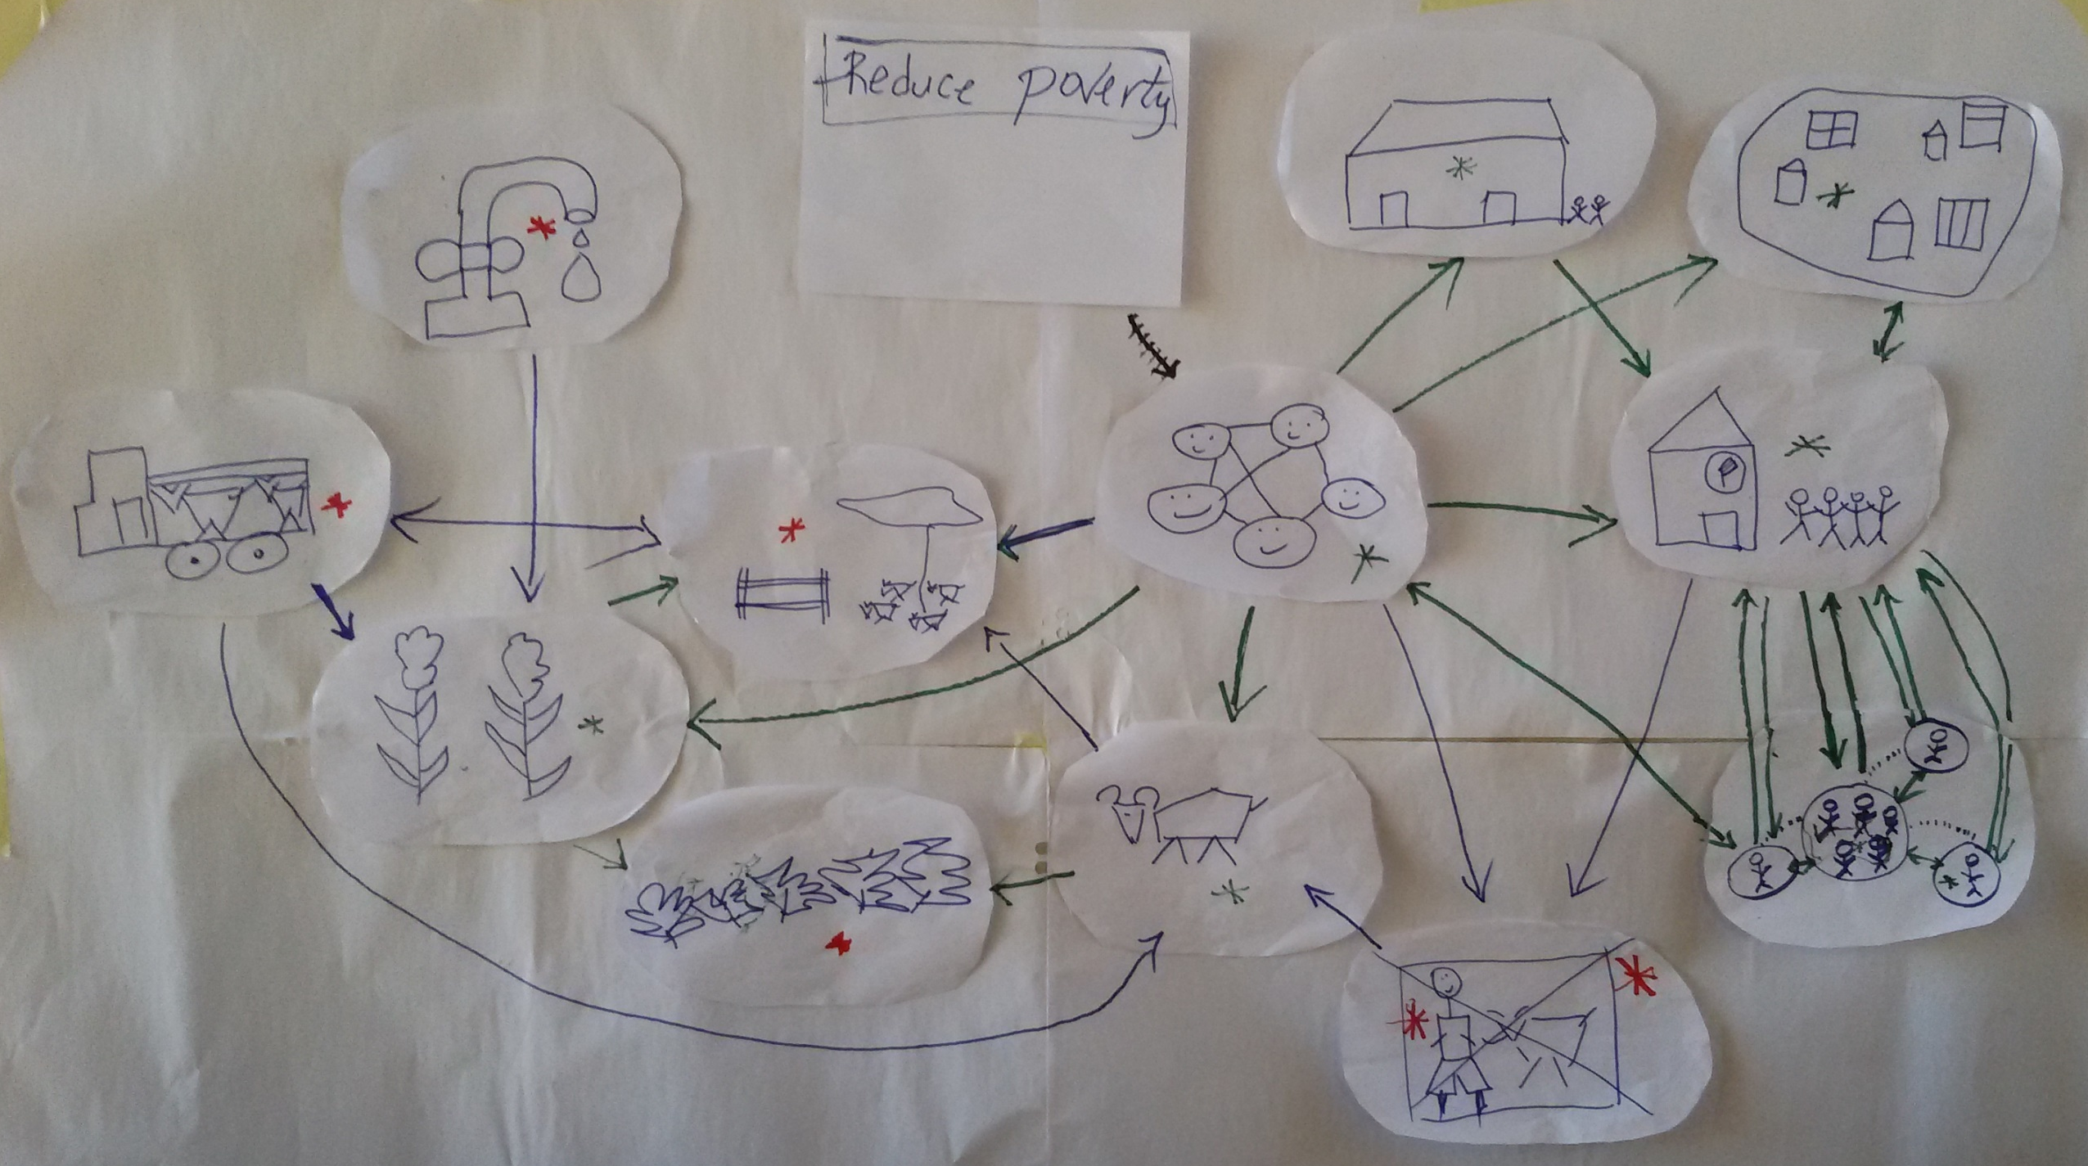

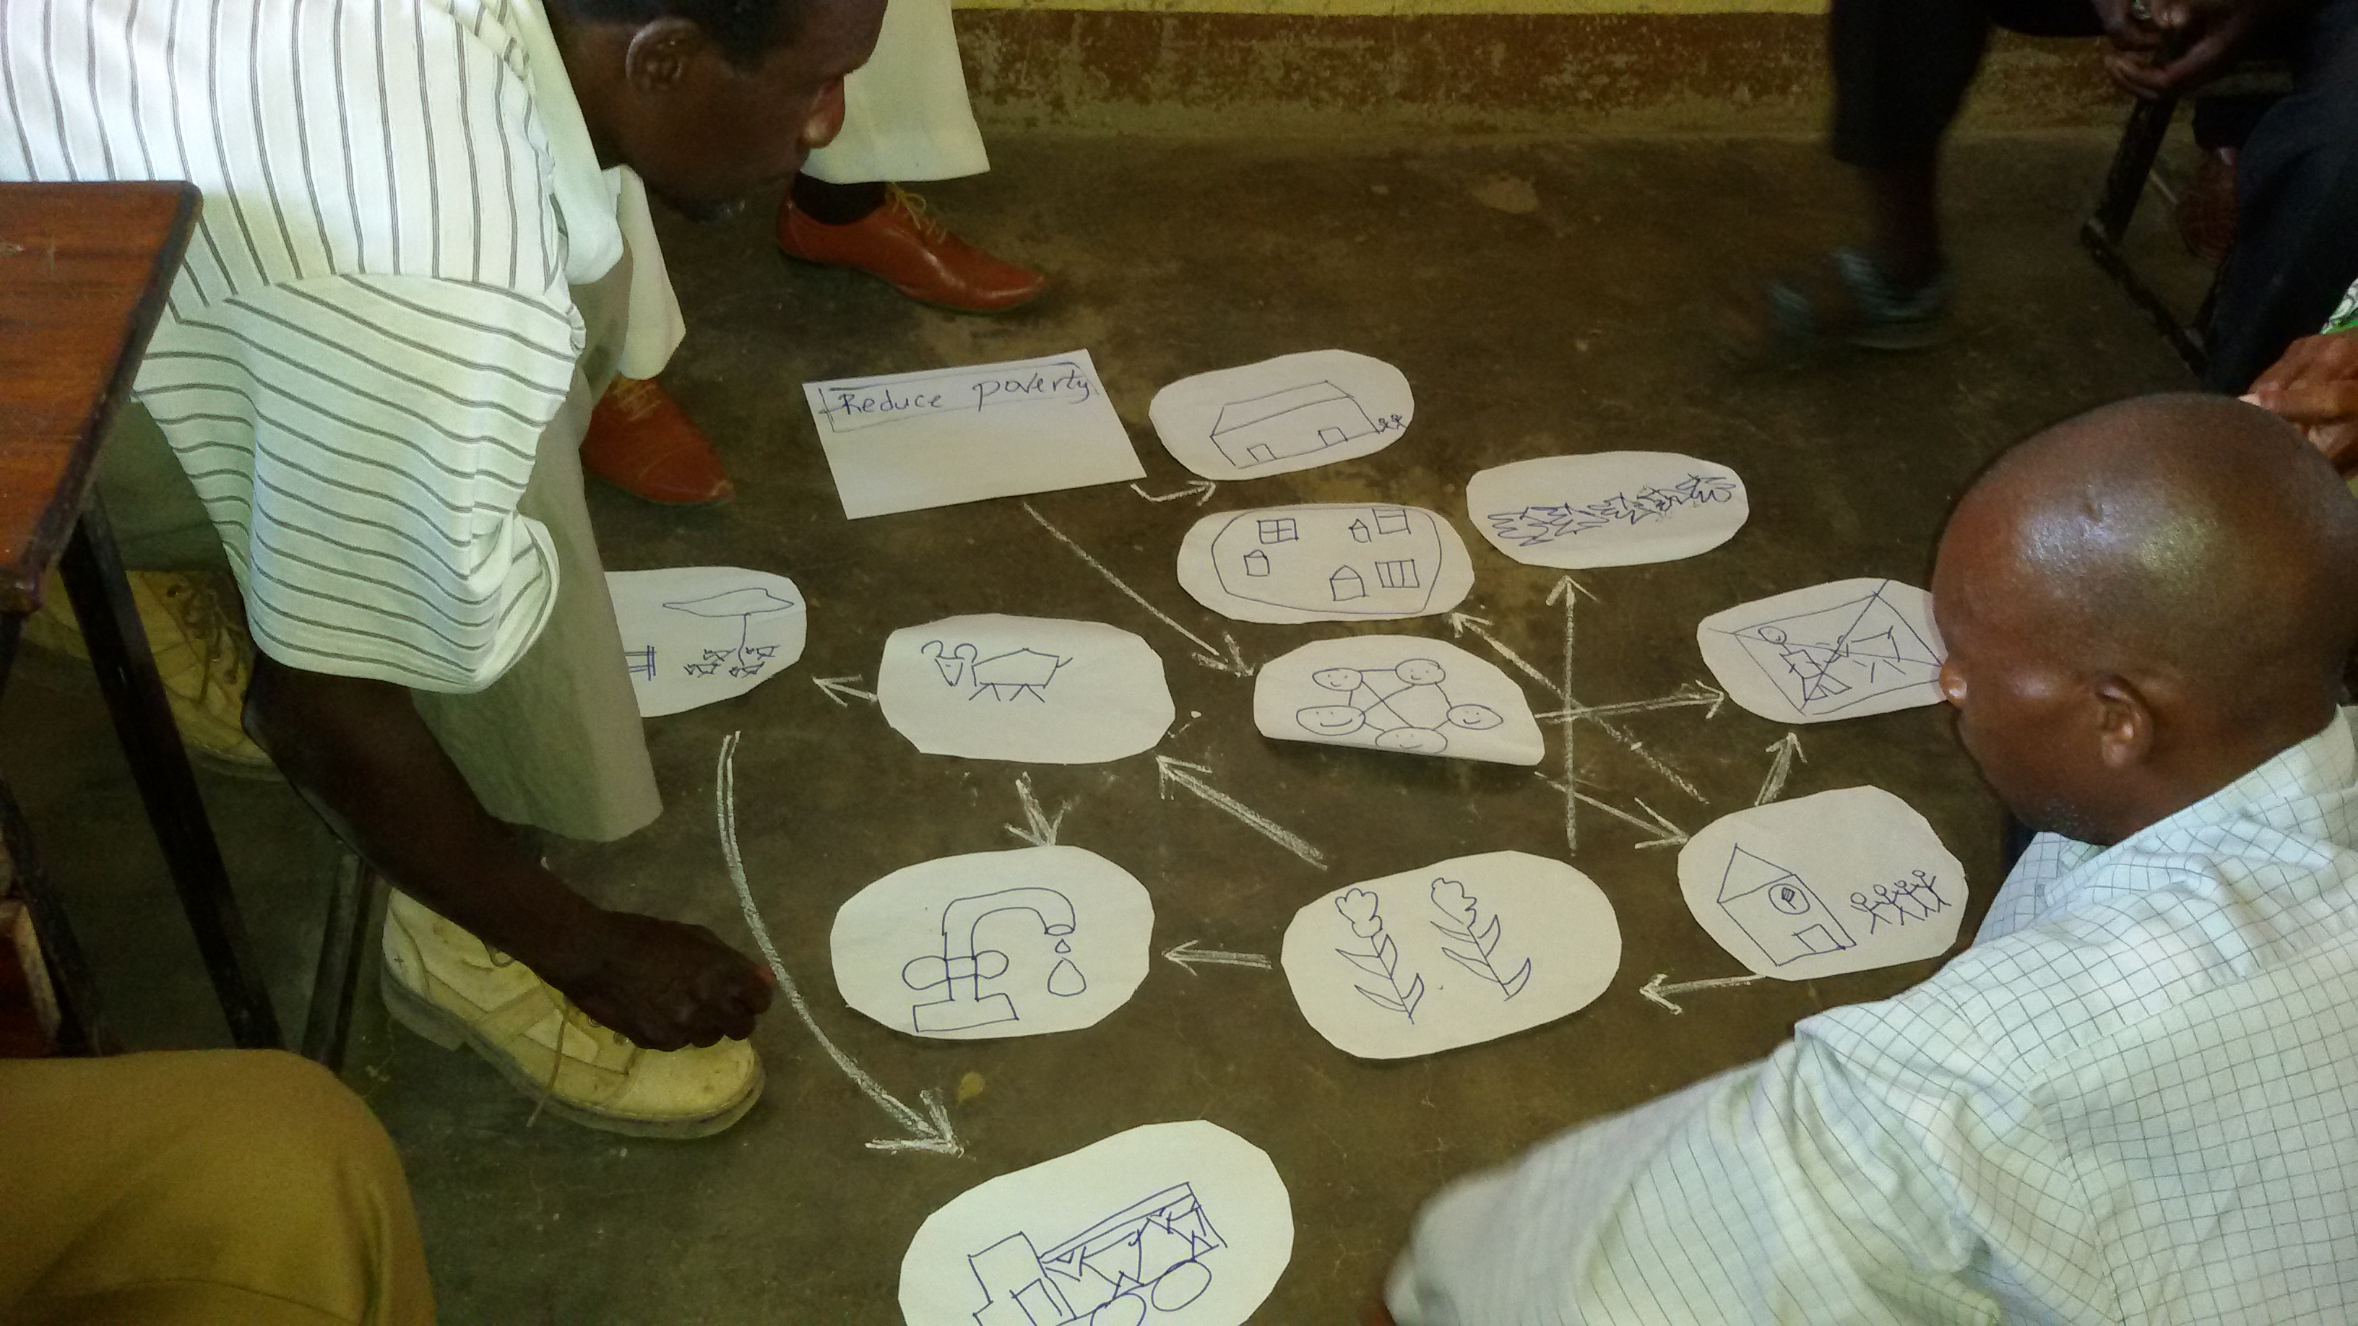
Photo 2. Farmers from Marara draft the IP achievements and gaps.

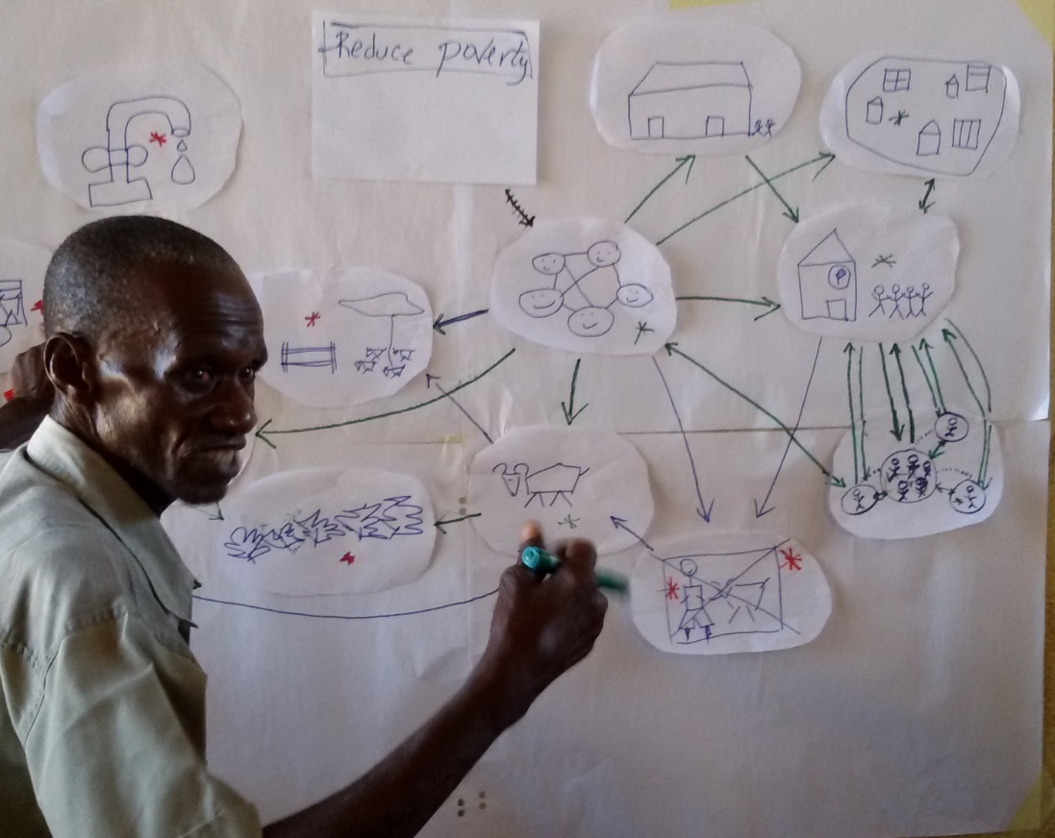
Photo 3. Farmer from Marara presenting the IP achievements and gaps.

3.3 Influence of the IP on self-organization
Note, that due to time constraints the exercise was not completed. The rest of self-organization assessments will be done at next workshop.

 | Components | Measure self organization performance indicators | Before MOREP (0 – 10 beans) | Today  (0 – 10 beans) | Was change influences by IP? (Yes/No) | Remarks, examples
A | Community-based management
A1 | Organization of goals | Ability to reach consensus on goals in groups (in relation to livestock marketing, feed technologies) | 2 | 4 | yes | In the past we did not agree on how to handle fire breaks. We now discuss in meetings, and align our objectives. People understand each other better and act together.
A2 | Self-steering | Ability to decide on technologies (e.g. collective seed purchase), markets (e.g. group sales, price negotiation) themselves | 1 | 4 | yes | People are active in the IP. We agree and no one disturb us. Other people outside the IP may not accept but we act on what we know.
A3 | Management of trust | Taking action to improve trust among each other within community (in relation to theft, knowledge sharing, sharing of inputs, other resources) | 2 | 4 | yes | People visit each other, and trust and try to follow what they observe from each other. IP has affirmed exchange visits in the communities.
A4 | Coordination | Measures to improve culture for local coordination (e.g. land use planning, market information, political issues, other emerging issues …) | 2 | 4 | yes | In the past information stayed with few people, today people share more information.
A5 | Problem solving | Strengthening of mechanisms for local problem solving (livestock theft, trespassing, land use planning, market infrastructure) | 2 | 5 | yes | Today we have better structure for solving problems. People are better organized to solve conflicts.
A6 | Rule setting | Investments into rules and governance procedures (e.g. by laws, constitutions, etc.) | 2 | 4 | Yes | Today we have a local court to solve our problems in the communities. There are now rules that help us not to involve the police. In the past we brought all problems to the police, today we can address most of them ourselves. This was however not much through the IP. Some regulations are done through the IP,e.g. firebreaks or theft.
A7 | Participation | Strengthening inclusiveness of participation in IP activities (e.g. women raise their voice for what they need, poor farmers participation equally) | 4 | 4 | yes | We meet 2 x per year, and everybody contributes. We share the costs. Women and different types of farmers are represented. There is no separation, everybody can participate.
B | Cross-scale collaboration capabilities
B1 | Organization of goals | Ability to agree on goals and priorities with partners (MozAgri, MozBeef, DPA, Extension, etc.) in IP | 2 | 4 | yes | If buyers of cattle suggest low price, we discuss to find consensus. All farmers try to stick to that price. If the difference is too high we don’t sell.
B3 | Withstanding shocks | Ability to withstand external shocks and sudden crises (drought, land tenure, etc) | 2 | 4 | yes | The IP contributed indirectly. The whole community contributes. If there are problems we discuss with partners about options.

Photo 5. Indicators for self organization, self assessment by farmers from Marara.

3 Key informant interviews
3.1 Project staff, 10. May 2015
Feedback on recent activities
- Farmers rarely see extension agents, i.e. farmers claim that extension agents visit farmers and their fields only when project staff is around. Engagement of extension staff could be better.
- Between farmers and provincial level, the communication is better than the communication relations between farmers and the extension staff.
- What is the reason for poor cooperation? The usual responses are: Lack of transport, despite MOREP sponsored a motorbike, including services and provision of spare parts.
- Extension agents also take on addition activities to make a living and therefore neglect MOREP IPs. For instance, since Marara has become its own district, new administrative and political structure absorb labor for extension staff. This is a challenge for all jobs regarding agriculture.
- Farmers themselves are organized. But farmers miss information about crops and there are delays in providing inputs to farmers. For example, MOREP provided pesticides but farmers have not received those. Also farmers complained that even though the posto formento is producing mucuna, which was provided by MOREP, the mucuna seed was only handed to farmers in February. This has affected the yields of the mucuna.
- Farmers do not see the advantage of extension staff. They recommend to channel inputs to farmers and groups directly, hence bypassing the extension staff.
- Farmers are not yet selling in groups. But IP “organized” bulk sales of goats at a time, for example 20 goals. IP facilitates this transitions through the introduction of MozAgri. This company is based in Chimoio and explained to farmers that markets are available.
But why has the MozAgri arrangement not worked for Tete based slaughter house? One reasons is the lack of fiance , although they pay cash, farmers do not respond to them as to MozAgri.
- MozAgri travels to farmers for collection only when farmers offer goats. The Tete based slaughter house asks farmers to supply a specific amount.
- MozBife and MozAgri have contact persons in the field. The Tete slougher house may not have contact persons, but deal with farmers directly.
What about the communities’ ability to organize farmers for bulk sales.
- There is a difference between poor and small farmers and big and better off farmers. The latter have a higher degree of self-organizations for feed.
Does the IP take care of social stratification, hence organizing the community to share opportunities and benefits?
- Small / less well farmers plant late and sell late. However, IPs are indifferent to social strata and works with farmers who can deliver rather than strengthening a social agenda.
- For IPs it is difficult to overcome lack of livestock. But it supports those who have livestock and participate in meat value chains
- Some of the larger farmers cannot control all their livestock. Hence, livestock keeping is outsources to poorer farmers, on the condition that such farmers provide feed to animals. Farmer use cattle for plouging and some and keep offsprings. Although such arrangements existed before the IP, farmers strengthened this existing arrangement. This is an indirect unintended benefit for IP.

3.2 NGO, 12. May 2015
Missing in the IP presentation are the challenges among the actors at community level.
All members of APACHIMA association belong to the IP. The way the IP functions, the IP must improve its capacity in various areas: one is organisation.
He suggests to change the management of APACHIMA, especially the vice president. Through election this has happened this January. This was not difficult. The old members were busy with other activities. The IP itself saw that there was no progress. IP members themselves realised that change is necessary. Three years ago it would have been very difficult to achieve the same. The reason is that the leaders understand or noted that people are now better integrated and understand what IPs are and their roles. The problem is that those working in the IP were people that everyone knows, e.g. that the one person leads farmers and the other works in rural areas. They were invited to other positions, such as deputy in assembly. They do not have the time to invest in the IPs anymore. Because farmers had trainings, they had information regarding democracy and the process of change.
The IP is now the community umbrella for the association APACHIMA. The IP and AAPACHIMA have mixed members to represent the entire communities. AAPACHIMA was created to protect the IP and its interest. Today we talk about IP and there is not much difference between the IP and APACHIMA. People and the leaders of APACHIMA are also the leaders of the IP. For instance Njanje was elected as leader in absence.
Today its easy to mobilize farmers. They know about how to establish demonstration plots, and improved livestock production. The extension system however has not much improved. Extension officers visit farmers only a few times.
Discussion of indicators for self-organization
A1 Organisation of goals: improved. IP and other things
A2 Self-steering: generally improved, goat and cattle improved; communities have become more independent; in agriculture, more independent. Communities now know where to sell and by millet and tomatoes, irrigation system, harvesting, about the time for selling goats.
A3. Trust: increased. In Marara, there are only few migrants; this improved cohesion and trust.
A4. Coordination: I think for crops it is now very easy. Generally it has improved; now in the communities they have many possibilities trough sub-organisations, through which planning takes place.
A5. Problem solving: improved; in Marara they have new leadership. The IP contributed to that. Through information, conflict over land and land registration was solved.
A6 Rules: Fencing took place. It is not very consistent.
Dealing with outsiders: Today communities demand services.
The relationship between farmers and outsiders improved.

3.3 DPA staff, 13 May 2015
Feedback for DPA based on the field day:
It was nice to see farmers explaining the overall program. From 2013 to now it is about 3 years, but we need more to improve some issues. Since the project started, Marara was an administrative section. Now it is a district, this will improve the effectiveness of the project.
Technologies in crop production are positive, because we kown that Marara has low rainfall. I suggest to introduce conservation agriculture and animal traction. Another problem in Marara is the short rainfall season. The problem should improve water retention for watering the animals and forages.
The project could also increase the amounts of seeds to encourage farmers to increase the area.
Mucuna works well in dry areas such as in Marara.
We (DPA) advice farmers to intercrop Mucuna. It retains up to 200 kg N per ha; first plant maize, six weeks after germination, plant Mucuna. IN the IP, goats entered the Mucona and finished it.
Next to intercropping, Mucuna could also be grown in a forage bank. This allows more people to see it. Then another option is to rotate Maize and Mucuna.
FTA (Ministry of Agricutlrue + IFAD) fund.
Groups also increase social pressure, for instance members in group realise that group members do, how they improve crop production, hence they function as models.
Short cycle varieties are essential.
Groups own their own plots, the together with extension officer do their job, then farmers replicate – ICRISAT calls them mother and baby plots.
The situation has improved in Marara since we have the new administrator. Many crop technologies are available, however the low and erratic rains, and short rainy season are a major problem. Not only for crop production, interventions should provide technologies for water harvesting, e.g. use water for livestock, use of water for small irrigation and forages.
Promoting Conservation Agriculture and animal traction are important technologies for Marara. Its important to encourage farmers in local seed multiplication, also of forage seed. Also, cattle branding would also help. Another option is on livestock, in forage, one things to use to reduce cattle theft is krqals building Also, improved fodder technologies at home at the kral. Cattle remember that there is feed in kral, then animal would move back.

Entry points for crop production: CA, suitable for short seasons in dry areas, build kraals against livestock theft, feeding livestock also helps against cattle theft as the animals learn to return home on a daily basis. After harvesting most farmers keep their animals free, this gives thieves the opportunity to steel. Interventions should also diversify crops, e.g. promote sweet potatoes.

Extension should train farmers on crop technologies, and also promote farmer group formation. Its easier to share technologies where groups of e.g. 10 farmers exist. In a group the most innovative farmers will adopt new technologies, others follow with delay.

The new project should engage an agronomist, and establish good leadership to the local government. After joint planning of the activities DPA can delegate their technicians as trainers, so that we can jointly implement the cropping activities. DPA should be strong partner in the future project. The project should invite DPA from the planning stage on. The project can invite DPA M&E to guide the process.

There is a coordinating meeting on the 27 th May; DPA will invite all NGOs. There are 2 types of activities. 1. DPA outsources activities, 2. The project develops an extension model together with DPA, e.g. linking farmers to markets. The second option can be taken over by DPA after the project is over.

3.4 Marara District Administrator, 14 May 2015
I heard from Rainde, last week, when we met in Marara, he introduced me about the project. He said that the project is in a final stage. Also, he said that the project will have second phase. If you want some assistance from Marara, you are welcome. We also want you to empower our communities and our extension officers so that they continue when you are not there.
Rainde explains IP processes and the impact diagram farmers in Marara drew. Sabine takes over. No minutes of this part until administrator responds.
- This image reflects what is happening in the communities and in the district. Also in our discussions and before the IP we make decisions, we discuss issues with farmers. In our government we have to involve people, farmers, and hear their ideas
- As government we are also involved in the cattle value chain. We would like to draw good policies, together with our partners, address challenges farmers face
- We plan to improve the market place, through fencing, for keeping cattle, also a scale, and a small structure for slaughtering, without the animal suffering too much
- Unfortunately the budget was not correctly used, hence these activities could not be closed. We are trying with other partners to solve the upgrading of the market place.
Where do you us collaborating with you with regard to these issues?
- Support farmers capacity building so that they open their mind on how to better improve and use technologies to improve crop and animal production;
- If the project can analyse how to best put in place and irrigation system, not only for crops, but also for animals.
- The average rainfall declines every year;
What other form of engagement for farmers to organise themselves can the project support, including structures?
- The association APACHIMA is the best way to organise farmers; there are different forms of associations, such as association of farmers, buyers, etc;
- Associations strengthen farmers, it helps to allocate resources, supports coordination, and it makes work for administration easier;
- In Marara, because of the challenges in crop production, the farmers keep animals; this is different to the north of the province.
Do you see a direct role for you in forming or supporting a livestock association?
- Maybe I was misunderstood. The role of UPC is not only on crops. UPC also works on livestock.
- When the government created the association laws, it says that one can form association of workers, economics, culture, and other forms of associations of civil society.
- That’s way farmers created an association – the national union of farmers and their provincial branch, the associations are legalised by government;
- It is not necessary to inform the UPC about the formation of a new association; the UPC and other organisations are regulated by government; the role of UPC is to defend and represent farmers interest, but associations do not have to go through UPC;
I felt that UPC could be the platform through which farmers express their interest at higher levels, such as with regard to infrastructure, etc.
- There is not obligation of UPC to control the association. But if associations feel that they need assistance, the have two ways to express themselves
- One is the government, through which they have been authorised; second, UPC cold help and association could request UPC for assistance;
- That’s why when the association are created, they must have statutes; but associations are autonomous, UPC cannot interfere.
- If the association is not known in the province, it is not because they are not linked to UPC, but because the association does not promote itself;
How does your office support the associations or strengthen them?
- The process of starting an association begins at the district, before it was depending on ministry of justice, but now mainly this is not necessary anymore. Now the local administrator authorises association;
- Authorisation takes less than two weeks, provide that all documents exist;
- When the association is legalised, then the district has development funds to support associations; the association is the first beneficiary of such credits;
- But the association must proof that they are able to return the funds, also they must demonstrate a nice business plan;
- We have the breeding improvement programme, and again, the first beneficiaries are the farmers’ association;
- But to promote the association, it is not our job – otherwise we will interfere in the internal matters of the association, and this is we should not do
- However, when there are conflicts, government will interfere and help to assist in solving the conflict.

Is there need for more associations such as APACHIMA in Marara?
- Marara became district one year ago, therefore I cannot say how many associations exist;
- Most documents are still in Changara
- You stay in Zimbabwe and I know Zimbabwe is in a different stage – what can you tell me regarding the Zimbabwe experience? How could you assist us in improving our work?
- Extension service is free for farmers, but they face challenges. The government and other partners called research into forages
- Vaccination for cattle is for free too, but in the long run, this the government will not sustain;
How do you plan next to support the self-organization of communities?
We don’t want to make farmers dependent on support. Even during drought people contribute work to get food aid, they also contribute to the diptank fees. We sell drugs at the diptanks.
Marara is in the process of hiring new extension officers. Maybe the new people have to be trained, it is up to you, but you could engage these.
Four extension for livestock; five for crop production; one for land planning; one for forestry; no we are building houses for extensionists in villages;
But up to now, central government has not send funds to all provinces. Because budget was approved last week only.

