2.4.2.1. Identifying genes and QTL associated with heat tolerance. Genomic regions for heat tolerance identified in interspecific progeny.
Objective and intended output: Interspecific crosses offer the option of introgressing genes to common bean from close relatives that are better adapted to extreme environments. Sequencing offers the opportunity to track introgression with special attention to QTL regions. With this activity we hope to identify genomic regions important for heat tolerance.
Materials and methods: A set of lines derived from interspecific crosses of common bean (Phaseolus vulgaris) and tepary bean (Phaseolus acutifolius) were analyzed by GBS (Genotyping by Sequencing). The parental tepary bean was sequenced by WGS (whole genome sequencing). QTL analysis is underway with a colleague in USDA-Puerto Rico with a population derived from one interspecific line INB 841.
Results and interpretation: Initial results with GBS suggested that introgression had occurred across a wide part of the genome when a large number of lines were considered (Figure 1). GBS also suggested that heat tolerant line INB 841 had very limited introgression on one extreme of chromosome 8. This was exciting as it would permit ready manipulation of a small segment that had significant phenotypic effects. WGS in contrast recognized widespread introgression of SNP in small segments on most chromosomes. WGS results were more coherent with results of the QTL analysis that recognized regions for heat tolerance on most linkage groups. In this case, GBS was inadequate to track introgression, and WGS appears to be an important complement to GBS, which samples only parts of the genome. Nonetheless, it is a surprise that introgression has occurred in such small segments instead of large blocks, since the small segments imply frequent crossing over between foreign chromosomes and widespread genetic interchange.
Next steps: SNP recognized by WGS and in the regions of QTL will be chosen to develop a plan for MAS for heat tolerance.

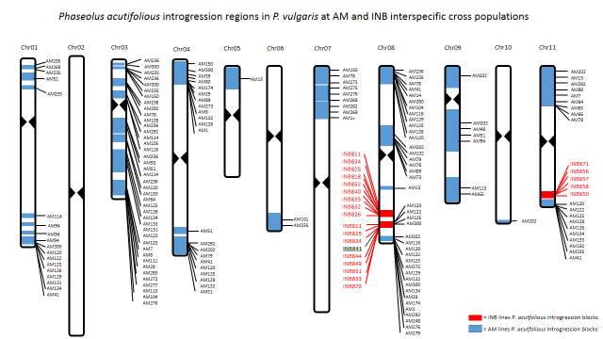

Figure 1: Segments of tepary bean (Phaseolus acutifolius) detected as introgression into a common bean background in a number of breeding lines. Segments in red are those in advanced breeding lines after a second cycle of crossing and selection, including the line INB 841.

