Flagship Project: 2: Improved Varieties and Hybrids
COA: Sorghum-WCA
BCNAM drought tolerant population with CSM63E as recurrent parent
Baloua Nebie¹, Aboubacar Toure¹, Colette Ouedraogo1, Santosh Deshpande³ Sidi Bekaye Coulibaly ², Ibrahima Sissoko¹, Ramadjita Tabo¹
¹ ICRISAT-Mali, ² IER and ³ICRISAT-India
Objective of activity
The objective of this activity was to develop drought tolerant population using CSM63E as recurrent parent, to evaluate the BC1F3 progenies under post flowering stress environment and select adapted material for the target zone.
Materials and methods
The material characterized here are progenies in BC1F3 generation. These progenies were obtained by crossing seven (7) drought-specific donor parents (IS15428; IS16044; IS16173; IS10876; IS3583; BBISS08; BBISS09) with CSM63E whish was used as recurrent parent and largely grown in the sub-sahelian zone (target zone of the project).
Phenotypic selection has been applied in the BC1F2 population based only on plant flowering time to recover adaptation characteristics of the recurrent parents. The BC1F3 populations were phenotyped in Cinzana (target zone) and then individual plant (BC1F4 seed) was selected for seed increased and multi-locations phenotyping.
Results and interpretation
A total of 611 BC1F3 drought progenies, developed from 7 specific donor parents has been assessed. The number of progenies has mostly 70 to 108 per population, only the population IS3583//CSM63E records progenies number < 50 (Fig.1). Among the populations, IS15428 //CSM63E recorded the higher grain yield per plant and IS16173//CSM63E had the lowest grain yield/plant (Figure 2).
The figure 3 and 4 show respectively the means and variability of heading date and plant height for each population. Most of progenies belonging to the different populations (except IS15428//CSM63E) have early maturity compared to the recurrent parent (CSM63E, horizontal line = 268 Julian days or JD). The earliest maturity progeny reaches 50% heading 3 weeks before the recurrent parent (with a sowing date of July, 21) and the shortest one is 126 cm inferior to the recurrent parent (263 cm). The recurrent line CSM63E and the check Seguifa did not differed for heading date which is 268 days.
All of 611 BC1F3 progenies were advanced by plant selfing using appropriated bags in to BC1F4 generation and seed are available.

Fig. 1 Number of progenies/population Fig. 2. Grain yield of the different population developed grain weight per population
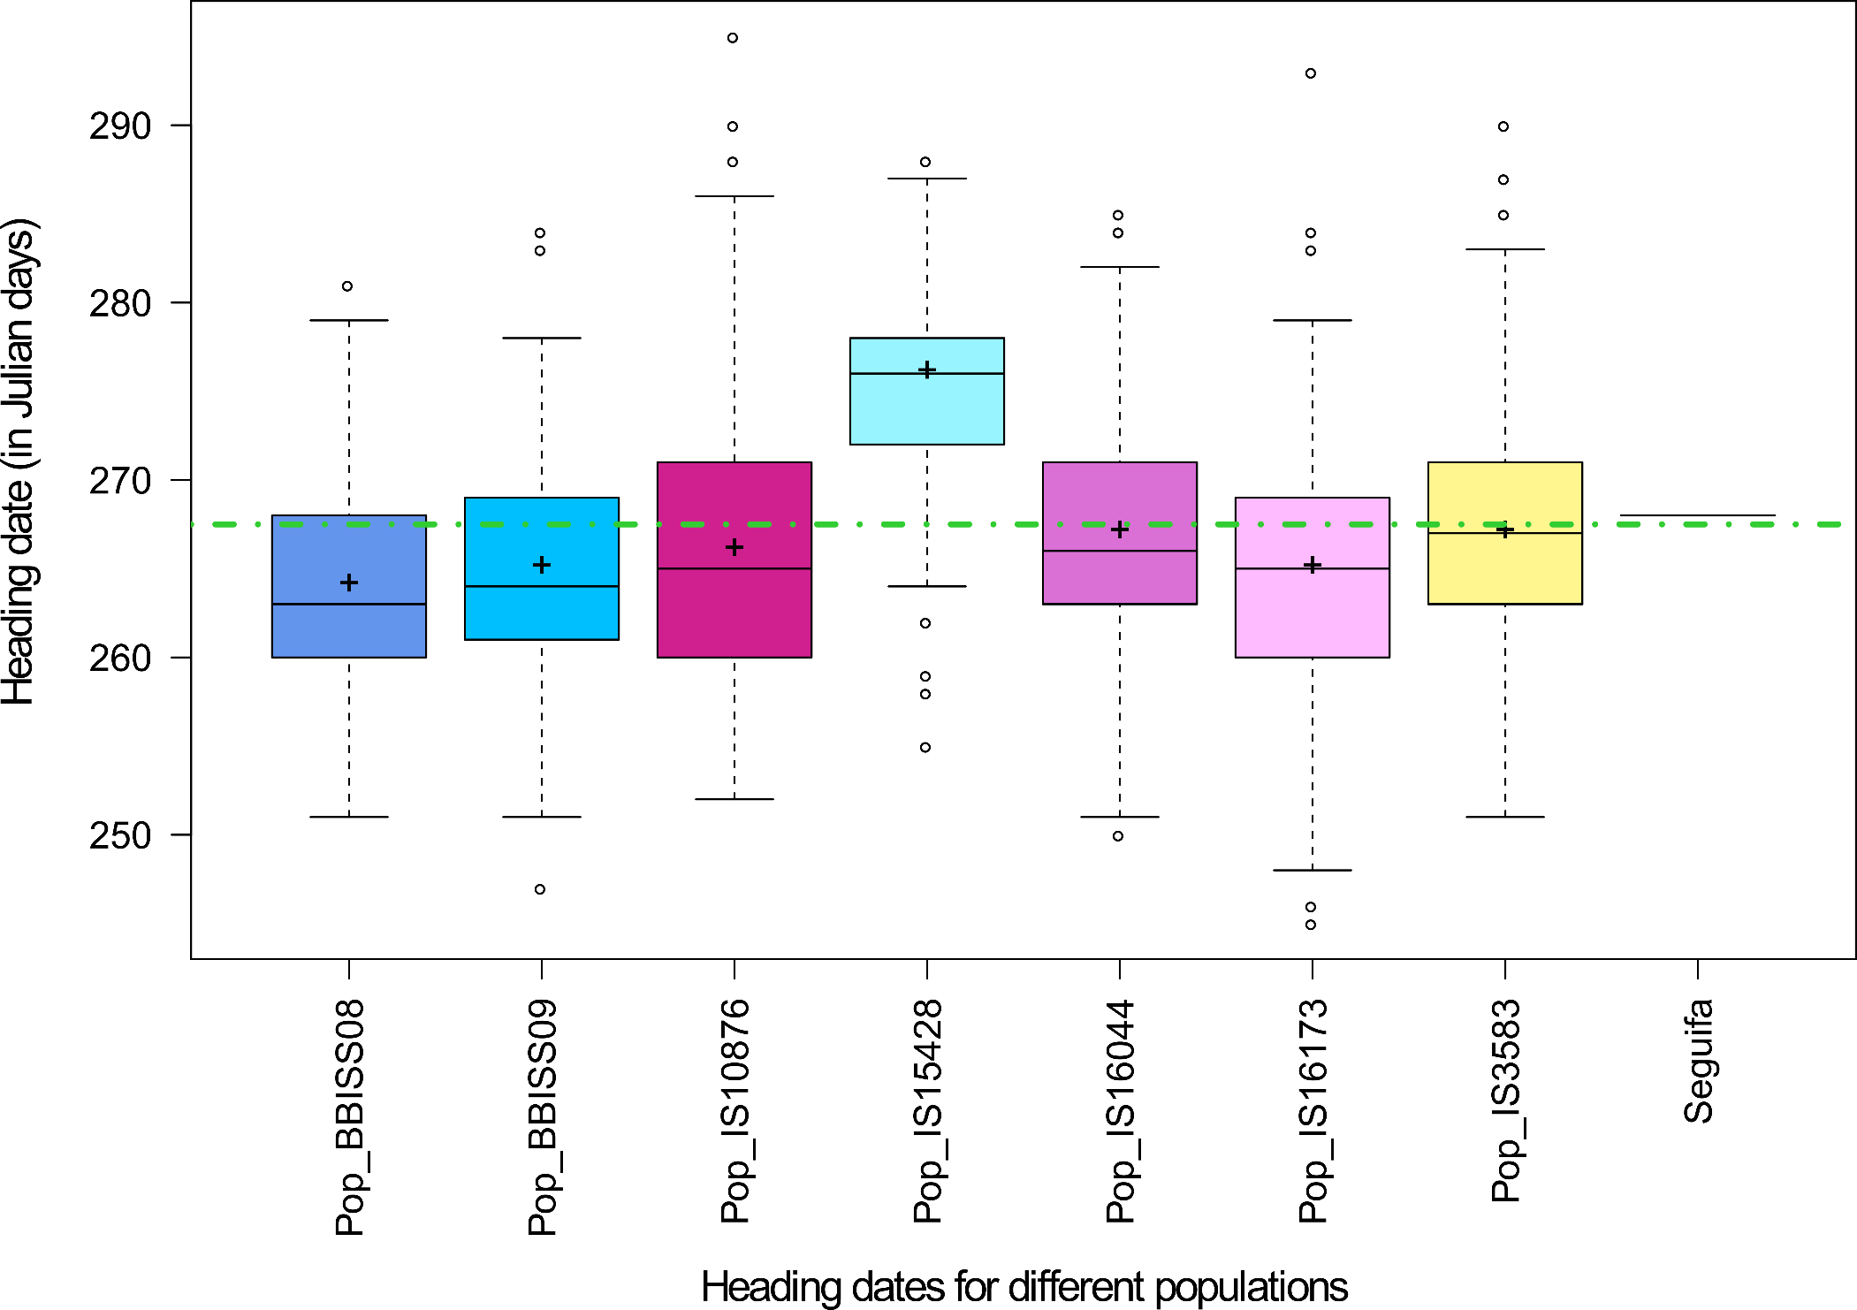

Fig. 3 Heading Date of the different populations
The horizontal line represents the mean (268 JD) of the recurrent parent (CMS63E)

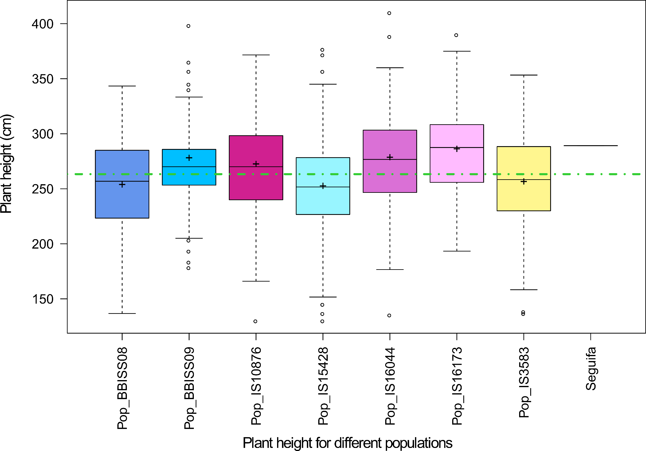

Fig. 4 Plant height of the different populations
The horizontal line represents the mean (263 cm) of the recurrent parent (CMS63E)
Next steps
The plan on this activity is to increase seed of the BC1F4 seed in off-season and bulking around 24 plants per accession. This seed will be then used of phenotyping in drought area in the sub-sahelian zone. Also, all of BC1F3:5 progenies will be assess for their drought tolerant in India using modern tools of physiology team and leaves samples will be taken to generate GBS data for association analysis in order to map drought tolerance QTLs and convert them to easy markers for breeding programs.

