De novo transcriptome analysis of finger millet and identification of genes involved in Striga infestation
Mikwa Erick¹, Wamalwa Mark¹, Stomeo Francesca², Oduor Richard¹, Macharia Mercy² and Odeny Damaris³
Abstract
Background: Finger millet is a highly nutritious annual cereal grass mainly cultivated in the semi-arid tropics of the world. Despite its high yielding potential, finger millet production is mainly affected by Striga hermonthica in Sub-Saharan Africa. The survival of Striga on finger millet depends on a complex host-parasite interaction delineated by three critical infestation time points, 3 days’ post-inoculation (dpi), 5 dpi and 7 dpi. Using RNA-seq it is possible to identify functional transcripts in finger millet and to profile immunity related genes at the specific time points.
Methods: In this study, the transcriptome of two resistant and two susceptible finger millet genotypes were sequenced upon infecting with Striga hermonthica seeds. The main aim of the study was to elucidate molecular responses to Striga in finger millet and to identify some of the genes acting at each time point. Roots of finger millet seedlings were infected with Striga seeds and whole seedling samples were collected after 3, 5 and 7 dpi for RNA extraction and sequencing. The resulting reads from each genotype were assembled using Shannon assembler and analyze separately.
Results: The sequencer generated slightly over 67.5 million clean reads from the four genotypes, which were assembled per genotype to produce a total of 139,162 non-redundant transcripts. The transcripts were annotated by querying against NCBI RefSeq plant, Uniprot plant, Pfam and COG databases. A total of 76,415, 78,825, 2049 and 17930 transcripts mapped to RefSeq plant, Uniprot plant, Pfam and COG databases, respectively. 33, 527 Gene Ontology (GO) terms and 459 Kyoto Encyclopedia of Genes and Genomes (KEGG) pathways were annotated using BLAST homologies from NCBI databases at an e-value of 1e-5. Further classification of Uniprot protein homologies produced about 2713 Panther protein classes. A total of 407 transcripts were differentially expressed (DE) at least 4-fold at a false discovery rate (FDR) of 0.1% in a pairwise comparison of all samples. Of the DE of 320 transcripts were down-regulated and 97 up-regulated between Striga infested Eleusine coracana and their respective controls. In all the genotypes a majority of genes were up-regulated at 5 dpi as compared to 3 dpi and 7 dpi.
Conclusion: The results showed that a large number of photosynthesis related genes and housekeeping genes were expressed after 3 dpi. Each genotype had a partial stage-specific tolerance to Striga, as opposed to the overall compatibility or incompatibility revealed by the previous screening field methods.
Key words: Finger millet, transcriptome, Striga hermonthica, host-parasite interaction, and resistance
Author details: ¹Department of Biochemistry and Biotechnology, Kenyatta University, Nairobi, Kenya. ²Biosciences east and central Africa- International Livestock Research Institute (BecA-ILRI) Hub. ³International Crop Research Institute for the Semi-Arid Tropics (ICRISAT)
Background
Finger millet (Eleusine coracana) is one of the most nutritious and well adapted cereal crop in the semi-arid tropics of the world. It has the highest calcium and potassium content, very high dietary fiber, reasonable amounts of essential proteins and low fat content as compared to other cereal crops (Obilana 1994; Oduori 2005; Shobana et al. 2013). Finger millet can be processed to several essential commercial products for poverty alleviation, reduction of malnutrition and market enhancements in Sub-Saharan Africa (SSA) (Obilana 1994; Oduori 2005). It is well adapted to diverse agro-ecological regions, low amounts of rainfall in the drylands and varied tropical soils (Dida and Devos 2006). As an important millet in East and Southern Africa (Oduori 2005), as well as South Asia (Global Crop DiversityTrust 2011) finger millet is a potential food and nutritional security crop in these regions. Approximately 34.6 million tons of finger millet is produced worldwide (Dida et al. 2008). It covers about 19% of the area under millets in Africa, ranking second after pearl millet (Pennisetum glaucum) (Belton and Taylor 2004).

Regardless of the superior finger millet properties, inadequate yields in SSA caused by biotic and abiotic stresses such as, salinity, drought, blast disease and Striga weed hampers its economic value. Among the 23 Striga spp., Striga hermonthica causes the worst damages to major cereals in Africa (Khan et al. 2006; Midega et al. 2010). It is one of the prevalent weeds found in finger millet fields contributing to the low yields and intensive labour prerequisite in suppression of the weed (Midega et al. 2010). S. hermonthica can result in yield losses ranging from 15% to 100% depending on the prevailing weather conditions and susceptibility of the crop (Atera et al. 2013) leading to billions of dollars in losses in Africa. In Western Kenya, more than 50% of the farmers’ fields are badly affected by S. hermonthica necessitating urgent intervention (Ngesa et al. 2015).

The survival of Striga depends on three critical infestation phases of its life cycle, which are closely associated with the host plant physiology (Ejeta 2007). The three phases can be translated further into three time points (3, 5, and 7 days) after Striga inoculation (Mohamed, Housley, and Ejeta 2010). Ideally, the weed overwinters as seeds that germinate upon coming into contact with host root exudates, but also non-root exudates and synthetic compounds (Berner, Kling, and Singh 1995). During germination, a group of sesquiterpene lactones known as strigolactones stimulates the development of a radicle known as haustorium (Bouwmeester et al. 2003; Ejeta 2007; Yoshida and Shirasu 2012). The biosynthetic pathway of strigolactones has been shown to be mediated by b-carotene isomerase, two carotenoid-cleaving deoxygenases and cytochrome P450 (MAX2) (Yoshida and Shirasu 2012). Yoshida and Shirasu, (2012), also suggested a possible clue that strigolactone perception may be mediated by MAX2 and/or AtD14 genes since their mutants are both insensitive to strigolactones.
The development of haustorium is unique to the parasitic plants and supports nutrients acquisition and reduction of photosynthesis in the host plant (Ichihashi et al. 2015b). At the attachment stage, the haustorium detects a second group of stimuli known as haustorial initiation factors (HIF) to produce sticky haustorial hairs (Scholes and Press 2008). Striga triggers the host to produce 2, 6 dimethoxy-1, 4-benzoquinone (DMBQ), which induces the parasite’s quinone oxidoreductases to eventually convert DMBQ into an active free radical with suitable redox potential for haustorial induction (Ichihashi et al. 2015b). Other than DMBQ, little information is available concerning molecular perturbations in the host plant due to Striga presence at this stage. However, it will be interesting to observe the effects of increased accumulation of auxins, ethylene and gibberellin, shown to be involved in the induction and development of haustorium in several parasitic plants (Ichihashi et al. 2015b), to the host plant using next generation sequencing at this particular stage.

The development of a tubercle that penetrates to the xylem tissue of the host root delimits the last critical stage (Ejeta 2007). In the course of penetration the haustorium is known to form a vascular bridge at the point of attachment used for trafficking of host nutrients (Ichihashi et al. 2015b). Amongst the members of Orobanchaceae family, the genus Striga is known for its special structure, the Oscula, developed specifically for intrusive penetration into the host (Ichihashi et al. 2015b). Cell wall degrading enzymes like pectin methylsterases and specific cysteine proteases from the parasitic plants have been implicated in the infestation process (Yoshida and Shirasu 2012). Meanwhile, an R- gene has been shown to confer race-specific resistance in cowpea upon infection by S. gesnerioides (Yoshida and Shirasu 2012).

The complex host-parasite interaction coupled with the high diversity within the S. hermonthica population, especially in East and Western Africa regions (Bozkurt et al. 2014), are the major constraints to some of the previously proposed long term control strategies (Oswald 2005; Khan et al. 2014). However, marker assisted selection (MAS) and genetic engineering of novel resistant cultivars have been suggested as some of the polygenic durable control strategies (Scholes and Press 2008). Identification of the resistance genes and their associated markers to be integrated in the breeding strategies will be the foundation to developing Striga resistant finger millet cultivars.

Striga resistance has been studied in other cereal crops and reviewed (Haussmann et al. 2000). So far, specific Striga resistant mechanism like low germination stimulant production, low production of HIF, hypersensitivity and incompatible responses have also been described in sorghum (Ejeta 2007) and maize (Amusan et al. 2008). More information on the actual host defense that discourage parasitic growth and establishment have recently been made available for sorghum (Mohamed, Housley, and Ejeta 2010). Although no information is available for finger millet, recent advances in next generation sequencing (NGS) (Nagalakshmi, Waern, and Snyder 2010) makes it possible to profile genes acting at various Striga infestation levels.

RNA sequencing (RNA-Seq) provides a powerful tool for profiling gene expression levels at specific and different tissues of an organism or treatment conditions (Wang, Gerstein, and Snyder 2009). It is also emerging as the method of choice for studying functional effects of genetic variability and establishing causal relationships between genetic variants and diseases (Duitama, Srivastava, and Mandoiu 2011). Striga related transcriptome studies have been intensified recently. However, most of these studies have focused on understanding the transcriptome of Striga and its evolutionary origins (Westwood et al. 2012; Yang et al. 2014; Ichihashi et al. 2015b), rather than the host-parasite interactions. For instance, a comparative analysis of Striga unigenes showed that it shared 77% to 79% similarity with dicots and 75% with monocots (Yoshida et al. 2010). In a recent study, WKRY45 was identified as a major gene involved in Striga resistance to rice in an example of host-parasite interaction analysis (Mutuku et al. 2015). In other reports only a few genes acting at various Striga infestation stages have been identified and reviewed (Yoshida and Shirasu 2012). Besides, compared with QRT-PCR, data from RNA-seq have also presented a good starting point towards finding control genes during Striga development in finger millet (Fernández-Aparicio et al., 2013).

In the current study, we exposed four finger millet genotypes to Striga and investigated their transcriptomes globally and at specific Striga infestation time points. We then compared the transcriptome data between infested and control at different time. This study will form a basic background for genome-wide gene profiling of finger millet genes at specific Striga infestation phases, and provide a deeper understanding of the host-parasite interaction. The identified candidate genes and functional gene groups will be used to describe stage specific Striga tolerance and susceptibility in finger millet that can be integrated in future development of functional molecular markers for breeding of novel Striga resistant finger millet cultivars.

Materials and methods
Plant materials and laboratory screening
Finger millet seeds were sourced from four farmer-preferred varieties (two Striga-susceptible and two Striga-tolerant) from the department of Botany and Horticulture, Maseno University, Western Kenya. The four genotypes (Table 1) were maintained in the screen house while in vitro experiments were done in the laboratory. Roots of four finger millet seedlings were infested with ten pre-germinated Striga seeds. The number of seeds that produced haustorium hairs and developed to Striga seedlings with at least one primordial leaf were counted in nine different experiments. The time points were set at 3 days’ post-inoculation and 9 dpi. Striga seeds were obtained from Wad Medani Agricultural Research Station, Sudan.

Sample preparation for Striga infestation
Finger millet plants were germinated in vitro using the filter paper method described by Hess et al. (1992). The seeds were sterilized using 10% NaOCl (domestic bleach) (Kobian Scientific, EA, Kenya) for about 30-60 minutes. The seeds were then rinsed with double distilled water (ddH₂O) at least three times to totally remove any NaOCl residues and soaked in 0.5% Ridomil Gold (methyl N-(2,6-dimethyl) -N- (methoxyacetyl) –D- alaninate) (Sygenta, EA Ltd., Kenya) for about 12 hours in order to ensure both surface and systemic sterilization. This was followed by rinsing at least 3 times with sterile ddH₂O. The clean seeds were then planted in 90 mm petri dishes with moist filter papers, incubated in the dark at 29±2⁰ C for 72 hours.

Table 1| Field response to Striga by the finger millet genotypes in this study
Genotypes | Response to Striga
White Sel6 | Susceptible
IE2459 (GBK 033340) | Susceptible
GuluE | Tolerant
IE2396 (GBK 0333474) | Tolerant
The plants were subjected to Striga infested fields in Western Kenya for two seasons. The field was infested with more than one Striga spp. Tolerance is associated to the ability of the crop to minimize effects of infection and susceptibility is lack of the ability to minimize the effects of infection

Simultaneously, Striga seeds were washed in 30 ml ddH₂O in a 50 ml falcon tube containing about 5 drops of Tween 20. The seeds were shaken and vortexed several times followed by removal of debris using a pipette. The seeds were then sonicated for 3 minutes with occasional swirling to remove any leftover sand and debris. Once sonicated the seeds were rinsed three times, and then soaked for at least 10 minutes in ddH₂O. Clean Striga seeds were then transferred into 90 mm petri dishes with two layers of moist filter paper. The petri dishes were conditioned in the dark at 29±2⁰ C for 18-20 days.
Infestation of pre-germinated finger millet seedlings with Striga
About 20 pre-germinated finger millet seedlings with long enough roots were transferred to new 90 mm petri dishes with moist (using 1-2 ml of water) filter paper. The petri dishes were sealed with parafilm, then wrapped using aluminium foil and incubated at 29±2⁰ C for 3 days followed by RNA extraction. For the subsequent phases of growth (attachment and penetration) rac-GR24 (synthetic strigolactone) (Chiralix Nijmegen, The Netherlands) was used. The strigolactone analogue was diluted to 0.1 ppm or 0.1 mg/L before use. About 1 ml of the GR24 was then added to the pre-conditioned Striga seeds in a 90 mm petri dish. The petri dish was sealed, covered with aluminium foil and then kept at 29±2⁰ C for at least 8 hours. Whole finger millet seedlings were harvested at different stages of Striga infestation followed by immediate RNA extraction. Total RNA was extracted at 5 dpi for the attachment phase, and 7 dpi for the penetration phase. Finger millet seedlings planted in the absence of Striga seeds were used as control.
RNA extraction
RNA was extracted from 24 E. coracana plant tissues including controls. Fresh plant tissues were pooled from 20 seedlings and immediately flash frozen in liquid nitrogen. Total RNA was extracted using the Zymo Research Plant RNA MiniPrep RNeasy kit (ZR, Irvine, CA, USA) according to the manufacturer’s instructions. Before proceeding to the library preparation, the integrity and the concentration of the RNA were checked using denaturing gel electrophoresis and Qubit® 3.0 Fluorometer (Life Technologies, Carlsbad, CA, USA), respectively.
Library preparation and sequencing
The cDNA libraries were prepared from about 0.6-1 ug of RNA using the Illumina TruSeq Stranded Total RNA Sample Preparation kit with Ribo-ZeroTM Plant (Illumina, San Diego, California, USA) according to manufacturer’s instructions. After the rRNA depletion, the mRNA was fragmented before synthesis of the first and second strand cDNA. The double stranded cDNA fragments were adenylated with single ‘A’ base, ligated with adapters and enriched using PCR. The libraries were assessed for quality and concentration using Agilent Bioanalyzer2100 (Agilent Technologies, Palo Alto, CA, USA) and Qubit® 3.0 Fluorometer (Life Technologies, Carlsbad, CA, USA), and normalized to 4nM. Final concentration of 12pM and 1% PhiX control of pooled equimolar ratios of the libraries were used for sequencing. The libraries were sequenced using the Illumina Miseq System available at the BecA-ILRI Hub, Nairobi, Kenya. A 300 bp paired-end run sequencing was performed using a 600 PE v3 kit (Illumina, San Diego, California, USA) according to the manufacturers’ instructions.

Processing reads and de novo assembly
Raw fastq reads were trimmed using trimmomatic (Bolger, Lohse, and Usadel 2014). The trimming conditions were set as, headcrop: 15 minlen: 50 illuminaclip: crop: 175. Further quality control was achieved by filtering contaminants from rRNA and PhiX control. All reads were aligned to the respective databases using bowtie2/2.2.5 (Song, Florea, and Langmead 2014) . De novo assembly was done using Shannon (http://sreeramkannan.github.io/Shannon/) incorporating default settings. The assembly was performed per genotype by combining all the samples in the genotype.

Annotation and classification of Transcripts
Transcriptomes for were annotated against proteins from NCBI RefSeq plants (http://www.ncbi.nlm.nih.gov), Uniprot Viridiplantae (www.uniprot.org), Protein Families (Pfam) and Cluster of Orthologous Groups (COG) databases using BLAST at an e-value of 1e-3. Transdecoder (Trinity utility) (Haas et al. 2013) was used to find proteins with the longest open reading frames (ORFs) before searching against the Pfam database. Blast2GO software was used to classify Gene Ontologies (GO) on transcripts and to identify major KEGG pathways per genotype. Blast output from Refseq plant at an e-value of 1e-5 was used in blast2GO analysis. GO distribution was visualized using WEGO online software. Panther (http://pantherdb.org/) was used to classify Uniprot BLAST hits from all the genotypes into various protein classes.

Transcript expression analysis
RSEM (RNA-seq by Expectation Maximization) was used to estimate read abundance in the assembly. RSEM uses bowtie for alignment, calculates transcripts abundance and estimate FPKM (fragments per kilo base of target transcript length per million reads mapped) and TMM (trimmed mean of M-values) (Li and Dewey 2011). The matrix generated by RSEM was used to identify significantly expressed transcripts at each time point for every condition and genotype using edgeR (Robinson, Mccarthy, and Smyth 2010) . Differentially expressed transcripts were considered at an FDR of 0.05. Over-represented transcripts were considered at a log₂(fold change) of at least 2 between the infected and control libraries ((log₂(infected/control) ≥2).

Results
Laboratory screening at each time point
Observable germination began as early as 2 dpi. However, optimal germination was seen at 3 dpi. For instance, a clear germination was observed in IE2459 after 3 dpi (Figure 1A). Similar observations were taken from all other genotypes. Development of haustorium hairs was most visible at 5 dpi or 2-3 days after optimal germination depending on the genotype. There was delay in attachment is some genotypes like GuluE and White Sel6. Attachment was observed two days after germination in IE2459 (Figure 1B).
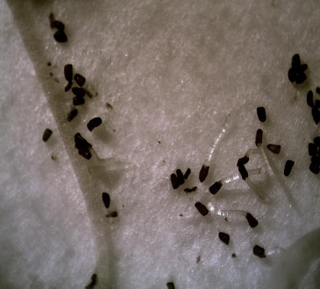
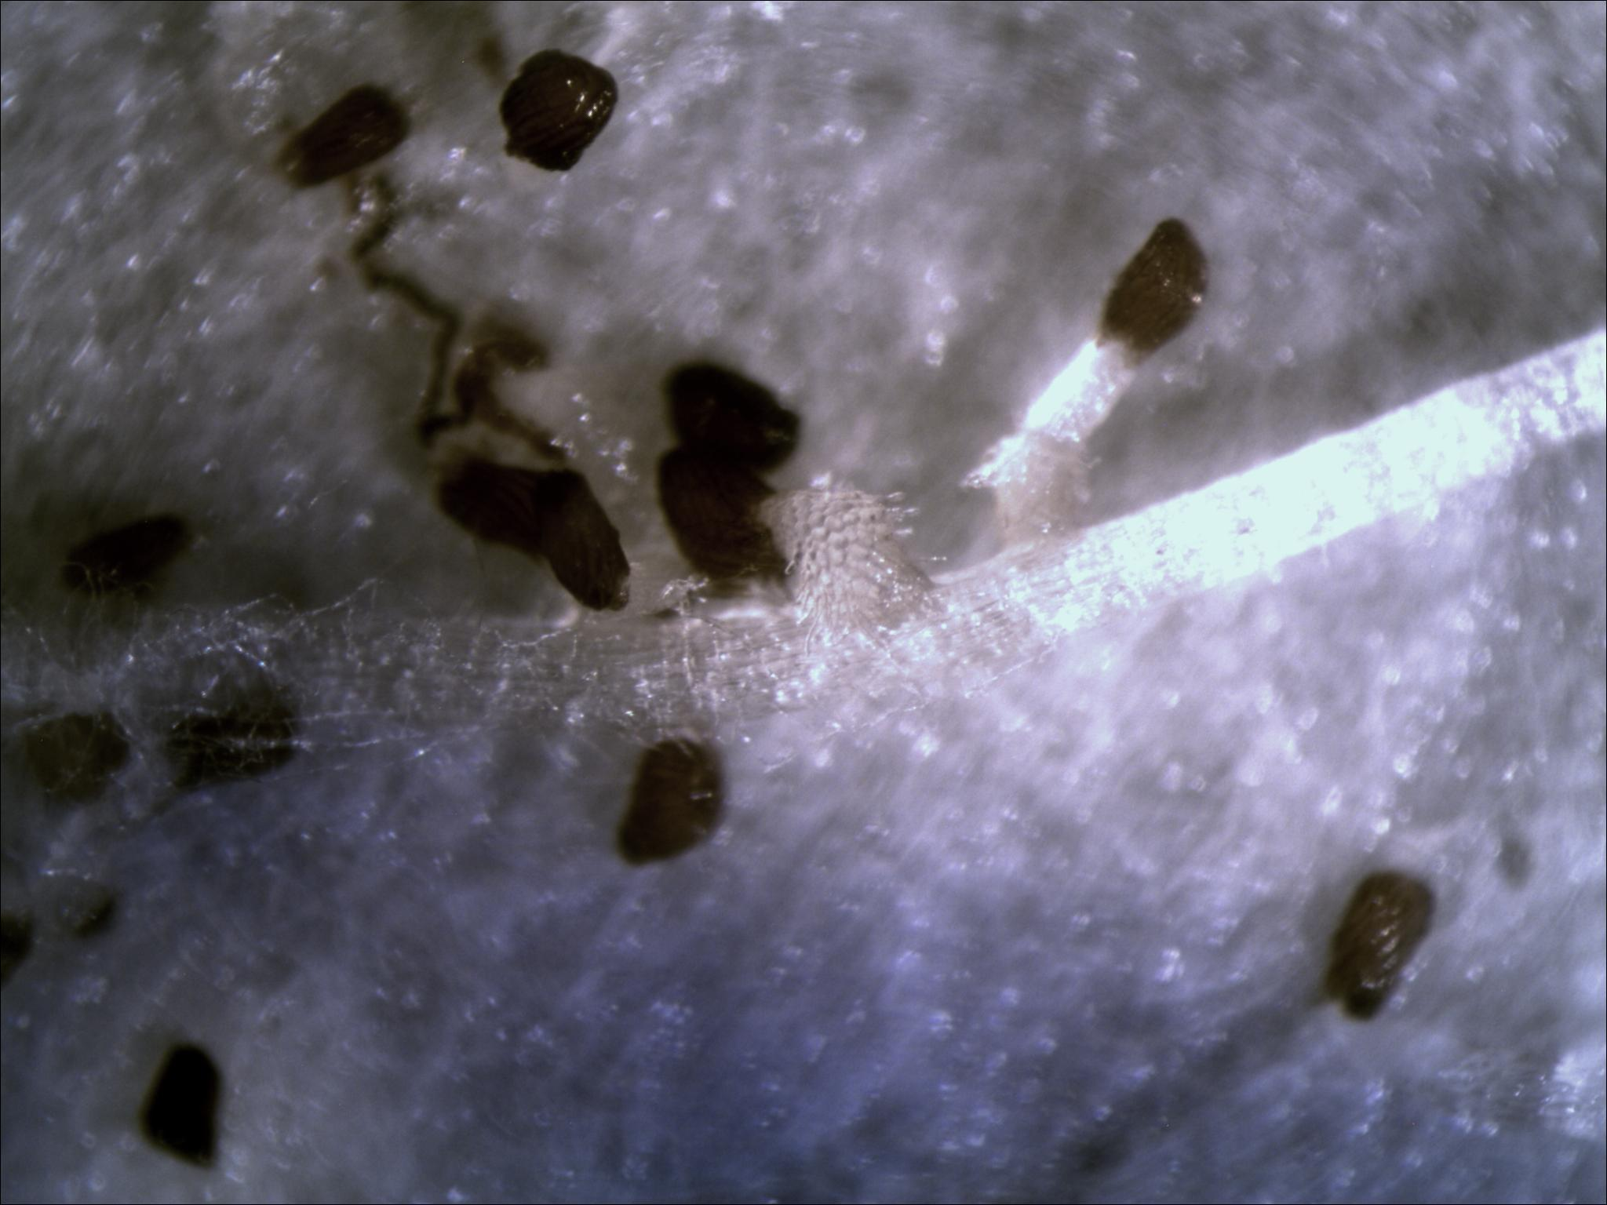
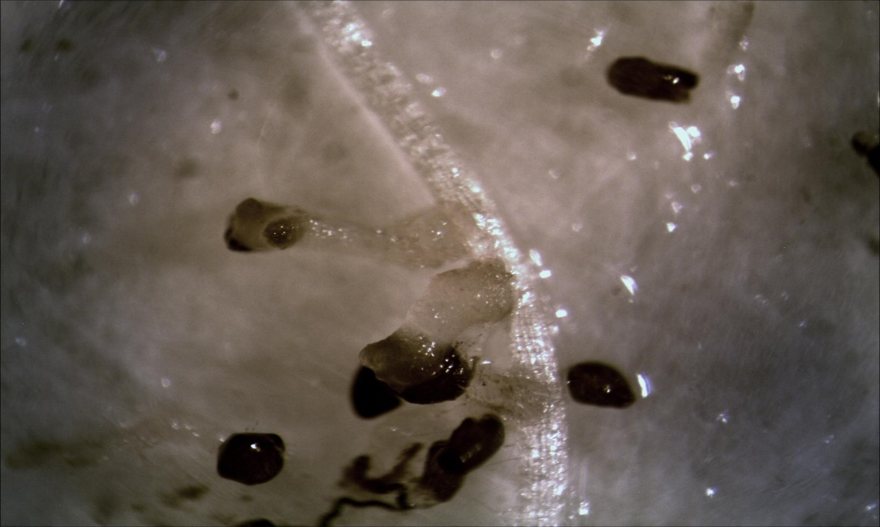
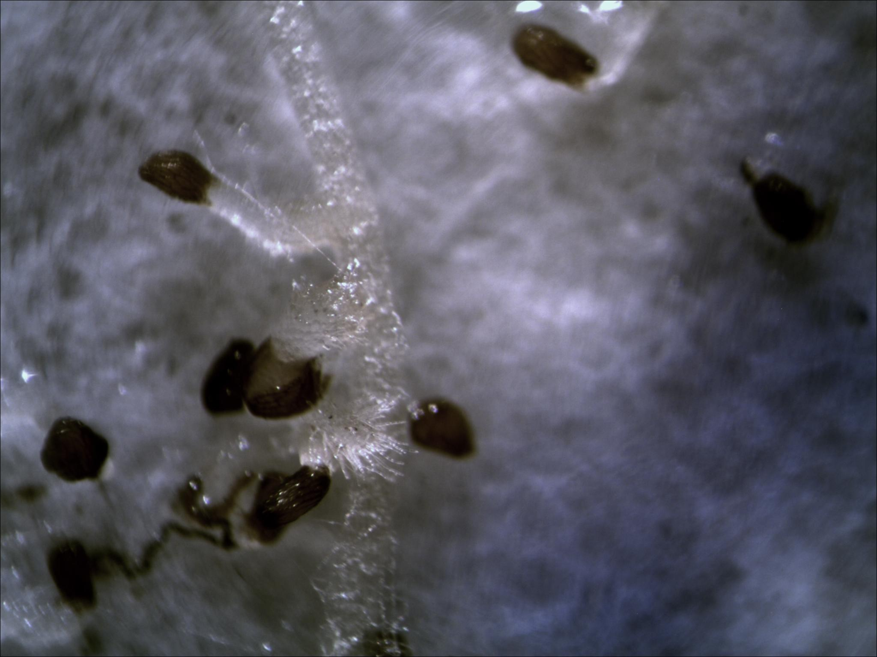
On a separate experiment, the pre-germinated Striga seeds developed the highest number of haustorium hairs on average per plate after 3 days in IE2459 (Figure 2). The frequency of haustorium hair development in GuluE and WhiteSel6 were almost equal in the nine replicates. The lowest number of seeds that developed haustorium hairs after 3 days were observed in IE2396 petri dishes (Figure 2).
IE2459
A
B
C
IE2459
9-9-2014:1:43 pm
Start of growth
IE2459
Attachment point
16-9-2014, 9: 11 pm
D
Figure 1: Optimal Striga infestation stages. Optimal germination was achieved after three days (A), attachment two days after germination (B), and penetration two days after attachment (C). Continued development was monitored as a confirmation of the establishment of Striga (D).
Germinating Striga seed
Finger millet root
7-9-14; 12:30 p.m.
11-9-2014: 3:51 pm
Seed coat opening
IE2459
Attachment point
Attachment point
Developing shoot

Penetration was observed 2 days after attachment (7 dpi) (Figure 1C). Observations past the 7 days’ limit was used to elucidate immune responses of the genotypes against Striga (Figure 1D). Even though there was no observable clear necrosis of Striga at 7 dpi, delay in development of haustorium hairs was observed in IE2396 (previously identified as a tolerant genotype) (Supplementary Figure 1) since no apical growth ensued as seen in IE2459 (Figure 1C).

Figure 2: Summary of laboratory screening for resistance and susceptibility. This figure shows a comparison of the mean Striga seeds counts per genotype for each in all the four seedlings at 3 and 9-days post infestation.

The highest number of pre-germinated Striga seeds growing to seedlings with at least a single primordial leaf after 9 days was observed in IE2459 (Figure 2). Both GuluE and WhiteSel6 also had significant germinating seeds developing to Striga seedlings (Figure 2). However, the results from all the experiments showed low Striga development in for IE2396, which did not have many of haustorium hairs developing after 3 days as well (Figure 2). The rate of successful penetration was determined to a larger extent with the preceding attachment phase. Each experiment was independent of the other, but replicates were running at the same time and conditions.

Transcriptome sequencing and assembly
The 24 finger millet cDNA libraries sequenced using Illumina Miseq platform yielded slightly above 85.6 million 250bp long paired end reads (Table 2). Of the total about 67.6 million (78.9%) clean reads remained after quality (Table 2). The Shannon assembly generated 39186 contigs for White Sel6, 63604 contigs for IE2459, 28110 contigs for GuluE and 33156 contigs for IE2396 (Table 3). The average contig length for at least half (N50) of these assemblies were 346bp, 429bp, 287bp, and 310bp for White Sel6, IE2459, GuluE and IE2396, respectively (Table 3). After a CD-HIT run at a similarity level of 95%, 33368, 51627, 25154 and 29013 non-redundant contigs remained from the original assembly in White Sel6, IE2459, GuluE and IE2396, respectively (Table 3). The average GC content for all the assemblies was 48.75%.
Table 2 | Summary of the sequencing data for all the finger millet genotypes included in this study
Genotypes | Raw reads pairs | Clean reads | Percentage of Clean reads
White Sel6 | 13,662,914 | 10,805,204 | 79.1
IE2459 | 23,266,972 | 18,981,926 | 81.6
GuluE | 27,895,666 | 21,967292 | 78.7
IE2396 | 20,783,796 | 15,816,112 | 76.1
Total | 85,609,348 | 67,570,534 | 78.9

Table 3 | Statistical summary of the de novo assembly results per finger millet genotype
Genotypes | White Sel6 | IE2459 | GuluE | IE2396
No. of contigs for reference assembly | 39186 | 63604 | 28110 | 33156
No. of nr contigs from CD-Hit (95%) | 33368 | 51627 | 25154 | 29013
N50 (bp) | 346 | 429 | 287 | 310
GC (%) | 48.64 | 48.21 | 50.28 | 47.88
The minimum contig length for the reference assembly is 200 bp. Nr (non-redundant)
Functional Annotation and Classification of Transcripts
Blast results from the four transcriptomes produced a total of 76415, 78825, 2049 and 17930 hits against RefSeq, Uniprot, Pfam and COG databases respectively (Supplementary Table 1). The highest Blast hits were obtained from both RefSeq plants (54.9%) and Uniprot (56.6%) databases (Supplementary Table 1). There was more than 50% mapping rate in the two databases in all the genotypes except GuluE (Supplementary Table 1). The number of proteins with at least 70bp open reading frame (ORF) from Transdecoder used for Pfam Blast for each genotype were 12980, 26620, 5606 and 8247 for WhiteSel6, IE2459, GuluE and IE2396, respectively. Many transcripts were commonly annotated in the four databases with less than 1000 hits mapping uniquely to a single database (Figure 3). The transcripts that did not map to any of the four databases were assumed to be unique to finger millet. A large number of transcripts were identified in IE2459 and WhiteSel6 as compared GuluE and IE2396 against Uniprot plant proteins (Supplementary doc 1, 2 and 3), which was corresponding to the large numbers from the respective assemblies (Table 3). Similar results were observed with the other three queried databases (Supplementary Table 1). The high numbers of transcripts in one genotype from the other was not related to the input number of reads (Table 2), but maybe associated with the varying response to Striga exposure. Paralogs could be the cause of the large number of contigs in the two genotypes.
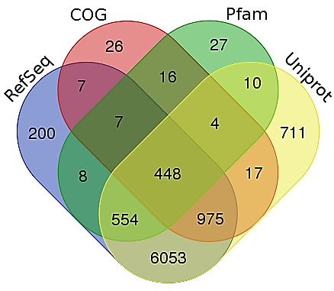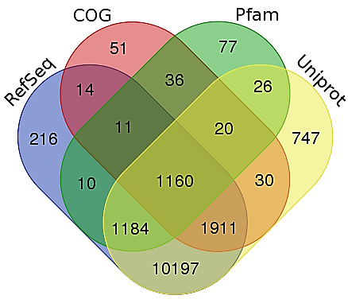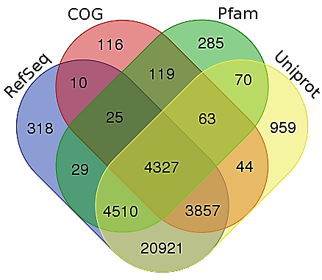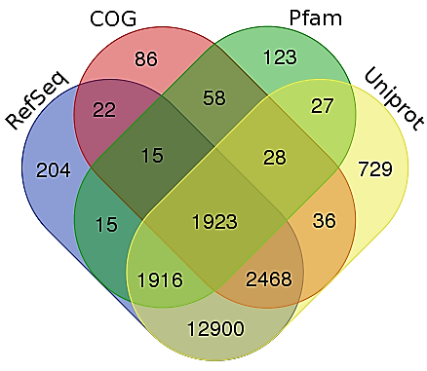
A
B
C
D
Figure 3: Venn diagram of transcript homology in four databases for each genotype. A. GuluE, B. IE2396, C. IE2459 and D. WhiteSel6. The Blastx was done at an e-value of 1e-3.
Gene ontology (GO) mapping followed similar results as RefSeq blast. A total of 15783, 8599, 6262, and 2883 GO terms were recovered from IE2459, WhiteSel6, IE2396 and GuluE respectively (Figure 4). The most abundant “Cellular Components” terms in the four genotypes were “Cell part” (GO: 0044464) (11625), “cell” (GO: 0005623) (11806), and “organelle” (GO: 0043226) (7556). The top “Biological Processes” were “metabolic process” (GO: 0008152) (12268) and “cellular process” (GO: 0009987) (11367). The most abundant GO “Molecular Functions” were “binding” (GO: 0005488) (13383) and “catalytic activity” (GO: 0003824) (12589). Other significantly represented GO terms per genotype include: “Cellular Component”, “macromolecular complex” (GO: 0032991) in GuluE, IE2396 and IE2459; “Biological Process”, “localization” (GO: 0051179), “response to stimuli” (GO: 0050896) and “establishment of localization” (GO: 0051234); and “Molecular Function” “transporter activity” (GO: 0005215) and “structural molecule activity” (GO: 0005198).

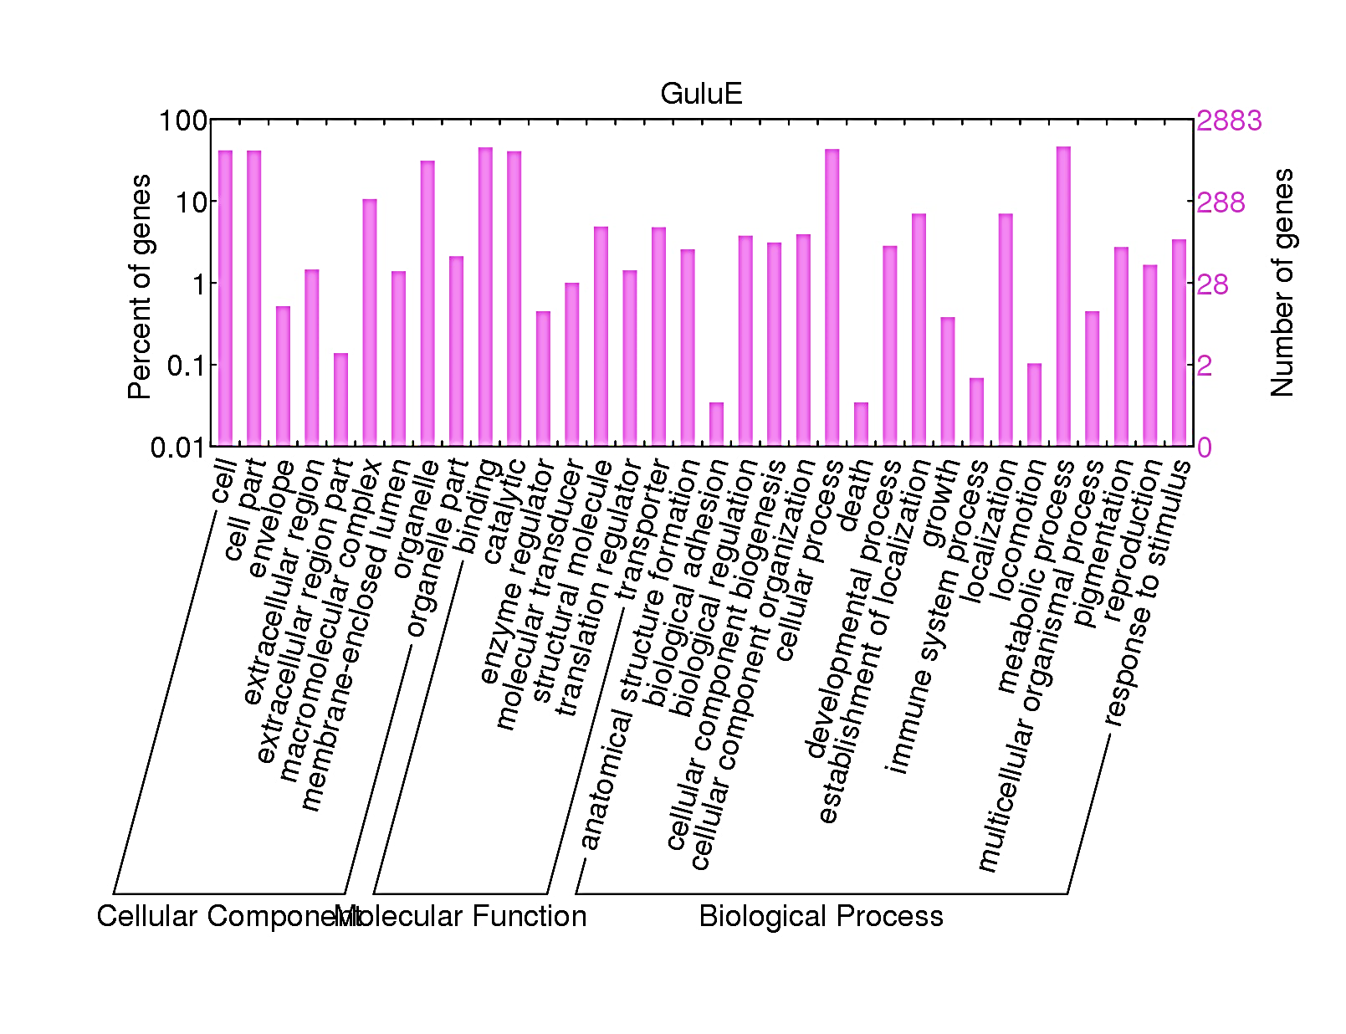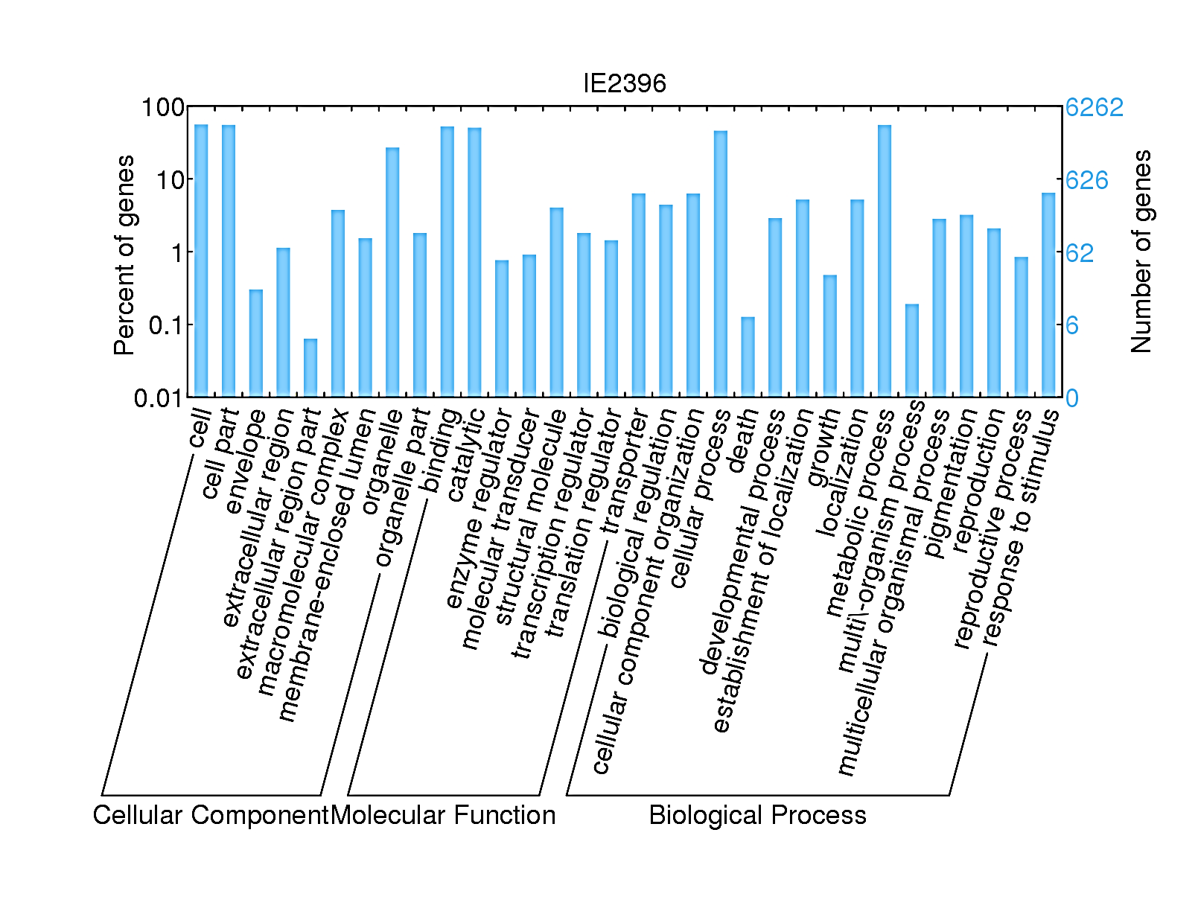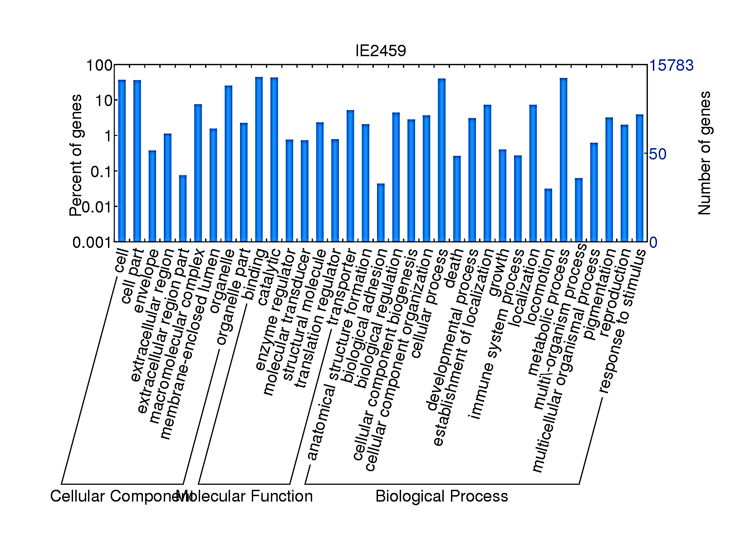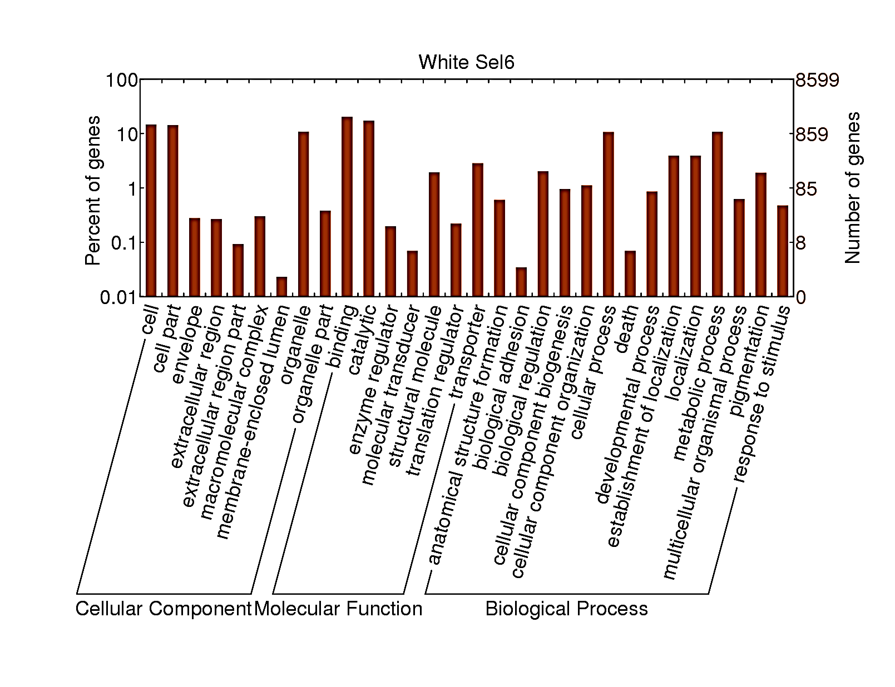
Figure 4: Global view of Gene Ontology in the four Genotypes. WEGO software was used to classify all the GO terms into “Cellular Component”, “Molecular Function” and “Biological Process” annotated by Blast2GO from all the Blast hits from RefSeq per genotype at an e-value of 1e-5.
Orthologous transcripts from all the genotypes mapping to the COG were further classified into 25 major clusters (Figure 5). The top most abundant COGs in all the genotypes were, “Translation, ribosomal structure and biogenesis” (1760), “Signal transduction mechanisms” (1759), “Posttranslational modification, protein turnover, chaperones” (1501), “Energy production and conversion” (1076), “Amino acid transport and metabolism” (1038), “General function prediction only” (979), “Carbohydrate transport and metabolism” (821), “Replication, recombination and repair” (650), “Inorganic ion transport and metabolism” (580) “Cell wall/membrane/envelope biogenesis” (543), and “Defense mechanisms” (401). Most of the “Defense mechanisms” orthologs mapped to IE2459 (192) and WhiteSel6 (133) as compared to IE2396 (51) and GuluE (25). “Signal transduction mechanisms” also showed similarly trends with more orthologs mapping to IE2459 (992) and WhiteSel6 (403) than IE2396 (266) and GuluE (98).

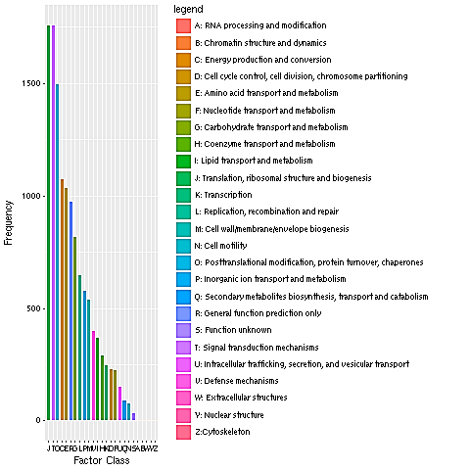
Figure 5: Cumulative view of Cluster of Orthologous Groups in all the genotypes. The clusters were derived from pooling classes from each genotype together.
A total of 17,039 RefSeq Blast hits mapped to 459 KEGG pathways, which matched to 3,063 enzymes. The highest number of pathways were recovered from IE2459 (128), while GuluE (102) was the least. This was equivalent to the starting number of RefSeq proteins from IE25459 (7702) and GuluE (1530). Similarly, 4554 and 3253 protein sequences in WhiteSel6 and IE2396 mapped to 119 and 110 pathways, respectively. The top twenty pathways were consistent in all the genotypes (Figure 6). “Purine metabolism”, “Thiamine metabolism” and “Biosynthesis of antibiotics” pathways were also overrepresented consistently in that order in all the genotypes were (Figure 6). Other pathways varied in numbers from one genotype to the other. For example, “Oxidative phosphorylation” was overrepresented as compared to “Glycolysis / Gluconeogenesis” in both IE2396 and GuluE, and underrepresented in IE2459 and WhiteSel6 even though the relative numbers in IE2459 and WhiteSel6 were higher than GuluE and IE2396 (Figure 6).
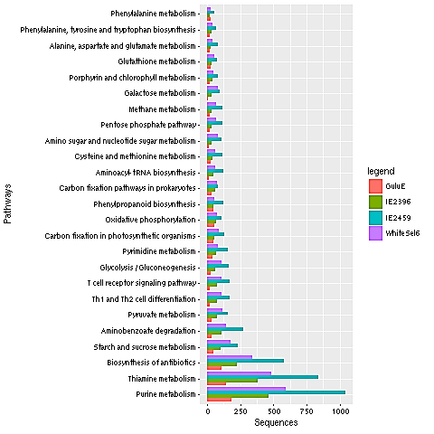
Figure 6: Major KEGG pathways per genotype. The pathways were identified from RefSeq Blastx (e-value 1e-3) output using Blast2GO. Three major pathways, Purine metabolism, Thiamine metabolism and Biosynthesis of antibiotics were overrepresented in all the genotypes respectively.

Of the 78825 Uniprot blast hits, a total of 2713 protein class hits were recovered from Panther. The top overrepresented classes were nucleic acid binding (17.8%), hydrolase (12.9%), transferase (11.6%), transporter (9.4%) and oxidoreductase (9.3%) (Figure 7). The least represented classes were cell junction protein (0.1%) and structural protein (0.1%). A summary of the protein classes per genotype also reflects the same trend defined above (Supplementary Table 6).

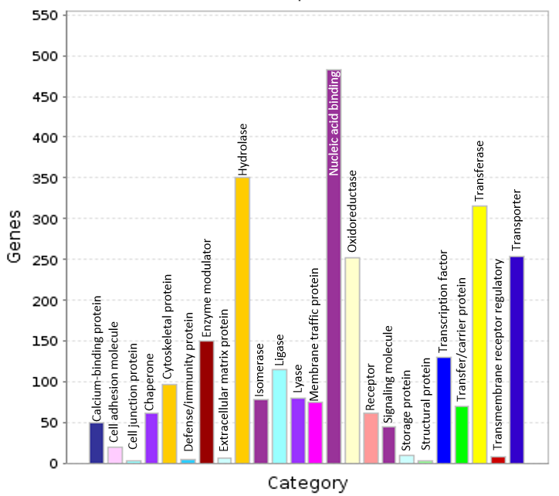
Figure 7: Protein classes. The distribution of the protein classes derived from the transcripts mapping to Uniprot BLAST at an e-value 1e-3. The top represented protein class was nucleic acid binding.
Gene expression at Striga infestation time points
The total number of transcripts with at least 4-fold differential expression at 1% FDR in all pairwise comparisons in all samples were 407 (Table 4). 320 were up-regulated, while 97 were down-regulated between infested samples and their respective controls (Table 4). Many transcripts were highly expressed at 5 dpi in almost all the genotypes in comparison to the expression at 3 dpi and 7 dpi (Table 4).
Table 4 | Number of differentially expressed transcripts at a false discovery rate (FDR) of 1 % and a log2FC of 4 between infected and control samples per stage for each finger millet genotype
Genotypes | Infection stages | DE | Up-regulated | Down-regulated
IE2459 | Germination | 7 | 2 | 5
IE2459 | Attachment | 143 | 141 | 22
IE2459 | Penetration | 4 | 2 | 2
White Sel6 | Germination | 0 | 0 | 0
White Sel6 | Attachment | 68 | 24 | 44
White Sel6 | Penetration | 17 | 9 | 8
GuluE | Germination | 31 | 29 | 2
GuluE | Attachment | 33 | 13 | 10
GuluE | Penetration | 47 | 47 | 0
IE2396 | Germination | 9 | 9 | 0
IE2396 | Attachment | 47 | 44 | 3
IE2396 | Penetration | 1 | 0 | 1
Total |  | 407 | 320 | 97

Gene expression at 3 days’ post-inoculation
Varying gene expression trends were observed at 3 dpi from different genotypes. In GuluE, among all the top expressed transcripts at this time point only a single transcript mapped to a signal anchor protein, the rest were identified as either hypothetical or uncharacterized using NCBI’s RefSeq database (Supplementary Table 3). Similarly, all the transcripts mapped to either hypothetical or uncharacterized proteins except three transcripts mapping to signal anchor proteins and metal transporter Nramp5 in IE2396 (Supplementary Table 3). In IE2459, the top up-regulated transcripts mapped to cytochrome b6, NADH-quinone oxidoreductase protein and maturase K, while the top down-regulated transcripts mapped to senescence-associated protein, NADH-quinone oxidoreductase protein, probable galactinol--sucrose galactosyltransferase 2, alpha-L-arabinofuranosidase 1-like, dehydrin DHN1 and a few hypothetical proteins (Supplementary Table 3). The three top up-regulated transcripts in White Sel6 mapped to envelope membrane protein, cytochrome b6 and an uncharacterized protein LOC100274305 (Supplementary Table 3). At 3 dpi, only five common protein hits could be annotated of which two signal anchor proteins (XP_003627937 and XP_003616487) were conversely up and down-regulated in GuluE and IE2396 (Table 6).

Table 6: Differentially Expressed (5% FDR) proteins (both up-regulated and down-regulated) across all the genotypes at 3 dpi. The top transcripts mapping to Refseq proteins at an e-value of 1e-3 and a log₂(fold change) of at least 2 between the infected and control.
Proteins | Refseq ID | Species | LogFC
 |  |  | GuluE | IE2396 | IE2459 | White Sel6
Hypothetical protein MTR_8g040260 | XP_003627937 | M. truncatula | -2.69 ↓ | 5.50 ↑ | -14.08 ↓ | *
Signal anchor, putative | XP_013455718 | M. truncatula | 2.83 ↑ | 4.60 ↑ | * | *
Hypothetical protein L484_018823 | XP_010104771 | M. notabilis | 3.67 ↑ | 4.14 ↑ | * | *
Hypothetical protein | YP_009162764 | B. braunii | 2.63 ↑ | * | -8.05 ↓ | *
Signal anchor, putative | XP_003616487 | M. truncatula | -3.54 ↓ | 2.84 ↑ | * | *
↑=Up-regulated, ↓=Down-regulated, *=Not Expressed
LogFC=log₂(fold change) = log₂(Infected/Control)

Gene expression at 5 days’ post-inoculation
Unlike the preceding critical infestation phase at 5 dpi several top expressed transcripts mapped to known proteins in RefSeq in all the genotypes except GuluE, which mapped mostly to hypothetical proteins (Supplementary Table 4). Subsequently, a majority of the transcripts with shared annotations to NCBI’s Refseq proteins were observed at this phase (Table 7). From the Refseq Blast hits, hypothetical protein PHAVU_011G146200g, cytochrome b6 and hypothetical protein CARUB_v10011286mg were consistently up-regulated in all the genotypes (Table 7). Protein hits such as ADP, ATP carrier protein 2, putative cytochrome P450 superfamily protein, NADH-plastoquinone oxidoreductase subunit K, cytochrome f, photosystem II protein M and cysteine proteinase 1 were also up-regulated in all the genotypes except GuluE (Table 7). Similarly, chlorophyll a-b binding protein 1, hypothetical protein POPTR_1605s00200g and hypothetical protein CARUB_v10001685mg were also up-regulated in all the genotype except White Sel 6 at 5 dpi (Table 7). Contrastingly, commonly down-regulated proteins were inconsistent with only hypothetical protein PHAVU_006G011900g and senescence-associated protein being down regulated in all the genotypes except in IE2396 (Table 7).

Table 7: Differentially Expressed (5% FDR) proteins (both up-regulated and down-regulated) across the genotypes at 5 dpi. The top transcripts mapping to Refseq proteins at an e-value of 1e-3 and a log₂(fold change) of at least 2 between the infected and control.
Protein name | Refseq ID | Species | LogFC
 |  |  | GuluE | IE2396 | IE2459 | White Sel6
Hypothetical protein PHAVU_011G146200g | XP_007133039 | P. vulgaris | 5.36 ↑ | 4.49 ↑ | 3.77 ↑ | 2.96 ↑
Cytochrome b6 | YP_009155818 | O. officinalis | 3.15 ↑ | 3.145 ↑ | 13.18 ↑ | 3.97 ↑
Hypothetical protein CARUB_v10011286mg | XP_006306006 | C. rubella | 4.56 ↑ | 3.78 ↑ | 10.43 ↑ | 2.55 ↑
Maturase K | YP_009233928 | S. michauxianus | 2.53 ↑ | * | 2.96 ↑ | 3.69 ↑
ADP, ATP carrier protein2 | XP_004953705 | S. italica | * | 4.43 ↑ | 3.13 ↑ | 4.16 ↑
Putative cytochrome P450 superfamily protein | NP_001140726 | Z. mays | * | 3.75 ↑ | 11.47 ↑ | 3.59 ↑
NADH-plastoquinone oxidoreductase subunit K | YP_009053884 | A. calcareus | * | 2.67 ↑ | 3.35 ↑ | 3.18 ↑
Cytochrome f | YP_009172152 | S. viridis | * | 2.60 ↑ | 3.14 ↑ | 2.79 ↑
Photosystem II protein M | YP_009233850 | H. cenchroides | * | 2.84 ↑ | 4.75 ↑ | 2.73 ↑
Cysteine proteinase 1 | XP_004952477 | S. italica | * | 3.85 ↑ | 4.47 ↑ | 3.96 ↑
Chlorophyll a-b binding protein 1 | XP_004957570 | S. italica | 8.41 ↑ | 9.62 ↑ | 11.18 ↑ | *
Hypothetical protein POPTR_1605s00200g | XP_006387178 | P. trichocarpa | 8.45 ↑ | 4.82 ↑ | 3.26 ↑ | *
Hypothetical protein CARUB_v10001685mg | XP_006288426 | C. rubella | 9.23 ↑ | 3.12 ↑ | 2.75 ↑ | *
Hypothetical protein MTR_8g040260 | XP_003627937 | M. truncatula | -2.67 ↓ | -15.58 ↓ | 4.28 ↑ | -3.47 ↓
hypothetical protein PHAVU_006G011900g | XP_007146093 | P. vulgaris | -4.01 ↓ | * | -3.19 ↓ | -3.29 ↓
Senescence-associated protein, putative | XP_013442963 | M. truncatula | -4.42 ↓ | * | -3.46 ↓ | -3.46 ↓
↑ =Up-regulated, ↓=Down-regulated, *=Not Expressed
LogFC=log₂(fold change) = log₂(Infected/Control)

Gene expression at 7 days’ post-inoculation
Just as there were a few differentially expressed transcripts at this Striga infestation phase only a few transcripts mapped to known proteins in NCBI’s RefSeq (Supplementary Table 5). Most of the known protein hits were identified in down-regulated transcripts of White Sel6 (Supplementary Table 5). Only five of the annotated proteins against NCBI Refseq were commonly expressed among the genotypes, all of which were either hypothetical proteins or uncharacterized except metal transporter Nramp5 protein (Table 8).

Table 8: Differentially Expressed (5% FDR) proteins (both up-regulated and down-regulated) across the genotypes at 7 dpi. The top transcripts mapping to Refseq proteins at an e-value of 1e-3 and a log₂(fold change) of at least 2 between the infected and control.
Proteins | Refseq ID | Species | LogFC
 |  |  | GuluE | IE2396 | IE2459 | White Sel6
Hypothetical protein MTR_0055s0130 | XP_013442970 | M.truncatula | -19.55 ↓ | -9.75 ↓ | * | -2.93 ↓
Hypothetical protein L484_018823 | XP_010104771 | M. notabilis | -6.83 ↓ | * | * | 4.24 ↑
Metal transporter Nramp5 | XP_010112784 | M. notabilis | -6.85 ↓ | * | * | 4.52 ↑
Hypothetical protein | YP_009162764 | B. braunii | -6.62 ↓ | * | * | -8.64 ↓
Uncharacterized protein LOC100502416 | NP_001183823 | Z. mays | -5.48 ↓ | * | * | -7.62 ↓
↑=Up-regulated, ↓=Down-regulated, *=Not Expressed
LogFC=log₂(fold change) = log₂(Infected/Control); except in Gulue where LogFC= log₂(Control/Infected)

Discussion
The main focus of this study was to understanding the transcriptome of finger millet at critical phases of Striga infestation. The critical phases or time points used were 3, 5 and 7 dpi, which have been evaluated and used in other studies previously (Ejeta 2007; Mohamed, Housley, and Ejeta 2010). Striga effects on the four E. coracana genotypes used in this study (Table 1) were evaluated in Western Kenya in a field with several Striga spp. for a period of two seasons (Prof. Mathews Dida, Unpublished). No previous studies have been done to identify the various effects of Striga, when exposed to finger millet genotypes at the molecular level. The study design used here was unique and helped in a broad as well specific comparison of finger millet transcriptome of the four genotypes.
In vitro laboratory observation showed that IE2459 displayed the highest frequency of attachment and penetration at 9 dpi, while IE2396 had the lowest number of attachment (Figure 2). GuluE and White Sel6 attained nearly similar penetration frequency (Figure 2). Prior to attachment of Striga the haustorial initiation factors (HIF) stimulates the elongation of the radicle to the root, a process which is directly linked with the attachment frequency. According to Mohamed, Housley, and Ejeta (2010), low haustorial initiation and high germination stimulant producers could be viable sources for depletion of Striga seed banks. In a different study, Striga resistant maize had fewer Striga attachment, delayed parasitic development and high mortality of attached parasites compared with susceptible in bred line (Amusan et al., 2008). Further incriminating evidences on impacts of the parasite to the four finger millet genotypes were determined by the genetic variations behind the responses to Striga.
Generally, plants respond almost in similar ways when exposed to biotic or abiotic stresses. In a previous study, Aegilops variablis (highly resistant to cereal cyst nematode) was exposed to nematode attack and some of the overrepresented GO terms included “localization” and “establishment of localization”, “metabolic process”, “cellular process”, and “response to stimuli” (Xu et al. 2012). Huang et al, (2012), also found that GO categories such as “catalytic activity”, “transferase activity” and “response to stimuli” were enriched at a late infection stage (13 dpi) of cowpea infested by Striga gesnerioides-race SG3. Finger millet transcriptome in all the genotypes revealed related molecular functions and biological processes that influence specific physiological processes (Figure 2). For instance, abundant representation of genes in the “transporter activity” category can be associated with nutrients and molecules transfer between the host and the parasite during active Striga parasitism. Previously, parasitic plants have shown their capacity to exchange genes with their hosts (Gunjune et al. 2014). Cuscuta spp. (holoparasite) was associated with responses to stimuli, increased transporter activity and reduced photosynthesis during parasitism (Ranjan et al. 2014). Transporter-related genes involved in the acquisition of nutrients from the host have also been in identified in Cuscuta spp. (Ichihashi et al. 2015a).
To adapt to the environmental stresses, plants also stimulate the production of different classes of proteins acting in specific metabolic pathways. In prior studies, some of the enzymes and genes associated with “Phenylpropanoid metabolism” were up-regulated during resistance reactions in rice against S. hermonthica (Swarbrick et al. 2008) and cowpea against Striga gesnerioides (Huang et al. 2012). Likewise, “Phenylpropanoid metabolism” was one of the top most represented pathways in all the genotypes in this study. Significant detection of genes related to “Oxidative Phosphorylation” pathway was a clear indication that finger millet seedlings were in an active process of minimizing the effects of reactive oxygen species produced under both abiotic and biotic stresses (Zheng et al. 2010). Three major enzymes groups, transferases, oxidoreductases, and hydrolases, were identified when Chickpea (Cicer arietinum L.) was exposed to both salinity and drought stresses (Varshney et al. 2009). Related protein classes were also overrepresented in the finger millet transcriptome when exposed to Striga (Figure 5). This may be attributed to an active response of finger millet seedlings towards a stressful environment caused by Striga infestation. A specific quinone oxidoreductase have also been implicated in the stimulation of haustorium development in hemiparasite plant Tryphasaria (Bandaranayake et al. 2010), which can directly be associated with haustorium in Striga in this study.
Different genes are expressed and act at specific Striga infestation time points in plants in response to the infestation. In this study, fewer numbers of transcripts were differentially expressed at 3 dpi and 7 dpi as compared to 5 dpi (Table 4). One of the reasons for fewer DE transcripts at the 3 dpi is because at this time the plants do not have any contact with Striga, therefore, limited host-parasite interaction that can elicit substantial gene expression between control and infested finger millet is likely to occur. Secondly, germination of Striga is expected to be stimulated by strigolactones from the host. It is also known that plants would produce strigolactones in the presence of stress and during a symbiotic interaction with AM fungi (Yoshida and Shirasu 2012). Therefore, the presence of non-germinated Striga seeds do not provide any stress to the host. Both the infested and control finger millet seedlings were at the same growth conditions and had the same conditions to produce strigolactones whether Striga seeds were present or not. Hence, the very few numbers of DE transcripts. Some of the annotated proteins were two signal anchor proteins (XP_003627937 and XP_003616487) conversely up and down-regulated in GuluE and IE2396 (Table 6). When fully identified the signal proteins can provide a clue of how the two genotypes react to different stressful conditions, but not necessarily to Striga.
The stimulation, attachment and penetration of a haustorium is key to the infection and survival of Striga hermonthica. These are the key interactions taking place at 5 dpi of Striga infestation. This explains partly the reason for many DE transcripts at this time point (Table 4). A part from cytochrome P450 superfamily protein (“monooxygenase activity”) and cysteine protease 1 (“hydrolase”), the rest of the commonly up-regulated proteins at 5 dpi were involved in transport, photosynthesis and oxidation-reduction processes. Some of the counteractive responses from finger millet against Striga exposure are increase transport and photosynthesis. This is because Striga as an obligate parasite will tend to derived most of nutrients and water from its host. Redox changes have been implicated in plant parasite interactions, where the changes are catalysed by quinone oxidoreductases to initiate haustorium induction in plant parasites (Ichihashi et al., 2015).
From the DE results it also clear that a full invasion of the host by Striga took place at 5 dpi. Not much of defensive genes were detected at this point because it has been shown that Striga and other parasitic plants do not damage the host cells during invasion (Volker, Max, and Markus 2017). Unlike other pathogens like fungi or bacteria plant parasites sometimes go unnoticed by their hosts (Volker, Max, and Markus 2017). However, the up-regulation of cytochrome P450 superfamily protein in at least three genotypes could as well suggest some degree of defense mechanism. Cytochrome P450 gene was one of the defense related genes identified to be up-regulated during ethylene or jasmonate treatment or during plant attack (Gachomo, Shonukan, and Kotchoni 2003). Other proteins up-regulated in individual genotypes like pathogenesis-related protein (PRB1-2-like) and glycine-rich RNA-binding protein 1-like (GRPA) (Supplementary Table 4) may also suggested resistance reaction to the Striga invasion. In a recent study, RAB15 (a GRPA gene) was observed as central to ABA and JA signaling, transferring the signal to receptors to induce the expression of JA responsive defense genes in maize (Zhang et al., 2015). And pathogenesis-related proteins have been shown to confer broad-spectrum protection against fungal and bacterial pathogens in rice, exhibiting stronger and quicker defense response during pathogen infection (Gómez-Ariza et al., 2007).
The few number of differentially expressed transcripts at 7 dpi (Table 4) could be as a result of the limited effect on finger millet by Striga. Apparently, once a vasculature connection has been established between the Striga and the host at 7 dpi the parasite develops mechanisms of survival for its host. This is until it is fully developed to the seed production stage, since an untimely death of the host will lead to its death as well. The parasite lifecycle is always synchronized with the host thereby requiring a trade off in survival tactics (Volker, Max, and Markus 2017). It has been shown that Striga hermonthica handles this trade off by increasing its transpiration rates leading to high potassium concentrations accumulation on the leaves (Volker, Max, and Markus 2017). This leads to drought stress to the host plant that causes increased development of its root systems. Up-regulation of Metal transporter Nramp5 at this time point in White Sel6 and GuluE may be as result of active transpiration in the parasite.

Conclusion
Transcriptome sequencing and de novo assembly of E. coracana resulted into the detection and analysis of differentially expressed transcripts at critical phases of Striga infestation in four genotypes. Classification and annotation of the differentially expressed transcripts showed discrete relationships between Striga infestation stages as well specific genotypes. Mapping the differentially expressed transcripts to metabolic pathways and classification using Gene Ontology terms revealed a potential interaction between Striga and the host. The immune and defense related proteins identified in this study will require further validation using real time PCR method. This is the first transcriptome study done on finger millet upon infestation by Striga and will be very useful in finger millet breeding programs.

Acknowledgements
We wish to gratefully thank International Crops Research Institute for the Semi-Arid Tropics (ICRISAT) through the CRP and Biosciences East and Central Africa - International Livestock Research Institute (BecA-ILRI) Hub for funding this project. We also wish to thank Dr. Rasha Ali and Professor Mathews Dida for providing us with the plant materials for the study.

References
Amusan, Idris O., Patrick J. Rich, Abebe Menkir, Thomas Housley, and Gebisa Ejeta. 2008. “Resistance to Striga Hermonthica in a Maize Inbred Line Derived from Zea Diploperennis.” New Phytologist 178: 157–66. doi:10.1111/j.1469-8137.2007.02355.x.
Atera, Evans Atuti, Takashige Ishii, John C. Onyango, Kazuyuki Itoh, and Tetsushi Azuma. 2013. “Striga Infestation in Kenya: Status, Distribution and Management Options.” Sustainable Agriculture Research 2 (2): 99–108. doi:10.5539/sar.v2n2p99.
Bandaranayake, Pradeepa C.G, Tatiana Filappova, Alexey Tomilov, Natalya Tomilova, Denneal Jamison-mcclung, Quy Ngo, Kentaro Inoue, and John I Yoder. 2010. “A Single-Electron Reducing Quinone Oxidoreductase Is Necessary to Induce Haustorium Development in the Root Parasitic Plant Triphysaria.” Plant Cell 22 (4`): 1404–19. doi:10.1105/tpc.110.074831.
Belton, Peter S, and John R N Taylor. 2004. “Sorghum and Millets : Protein Sources for Africa.” Trends in Food & Technology 15: 94–98. doi:10.1016/j.tifs.2003.09.002.
Berner, D. K., J.G. Kling, and B.B. Singh. 1995. “A Perspective from Africa.” Plant Disease 79 (7).
Bolger, A. M., M. Lohse, and B. Usadel. 2014. “Trimmomatic: A Flexible Trimmer for Illumina Sequence Data.” Bioinformatics, no. btu, 170.
Bouwmeester, Harro J., Radoslava Matusova, Sun Zhongkui, and Michael H. Beale. 2003. “Secondary Metabolite Signalling in Host-Parasitic Plant Interactions.” Current Opinion in Plant Biology 6 (Figure 2): 358–64. doi:10.1016/S1369-5266(03)00065-7.
Bozkurt, M L, P Muth, H K Parzies, and B I G Haussmann. 2014. “Genetic Diversity of East and West African Striga Hermonthica Populations and Virulence Effects on a Contrasting Set of Sorghum Cultivars.” European Weed Research Society 55: 71–81. doi:10.1111/wre.12117.
Dida, Mathews M, and Katrien M Devos. 2006. “Finger Millet.” In Genome Mapping and Molecular Breeding in Plants, Cereals and Millets, 1:11. Berlin Heidelberg.
Dida, Mathews M, Nelson Wanyera, Melanie L Harrison Dunn, Jeffrey L Bennetzen, and Katrien M Devos. 2008. “Population Structure and Diversity in Finger Millet ( Eleusine Coracana ) Germplasm.” Tropical Plant Biology 1: 131–41. doi:10.1007/s12042-008-9012-3.
Duitama, Jorge, Pramod K. Srivastava, and Ion I. Mandoiu. 2011. “Towards Accurate Detection and Genotyping of Expressed Variants from Whole Transcriptome Sequencing Data.” BMC Genomics 13 (Suppl 2): 1471–2164. doi:10.1109/ICCABS.2011.5729949.
Ejeta, G. 2007. “Breeding for Striga Resistance in Sorghum: Exploitation of an Intricate Host-Parasite Biology.” Crop Science 47 (S3): 216–27. doi:10.2135/cropsci2007.04.0011IPBS.
Fernández-Aparicio, M., K. Huang, E. K. Wafula, L. a. Honaas, N. J. Wickett, M. P. Timko, C. W. Depamphilis, J. I. Yoder, and J. H. Westwood. 2013. “Application of qRT-PCR and RNA-Seq Analysis for the Identification of Housekeeping Genes Useful for Normalization of Gene Expression Values during Striga Hermonthica Development.” Molecular Biology Reports 40: 3395–3407. doi:10.1007/s11033-012-2417-y.
Gachomo, Emma Wanjiru, Olusola Olusoji Shonukan, and Simeon Oloni Kotchoni. 2003. “The Molecular Initiation and Subsequent Acquisition of Disease Resistance in Plants.” African Journal of Biotechnology 2 (February): 26–32. doi:10.4314/ajb.v2i2.14826.
Global Crop DiversityTrust. 2011. “Global Strategy for the Ex Situ Conservation of Finger Millet and Its Wild Relatives.”
Gómez-Ariza, Jorge, Sonia Campo, Mar Rufat, Montserrat Estopà, Joaquima Messeguer, Blanca San Segundo, and María Coca. 2007. “Sucrose-Mediated Priming of Plant Defense Responses and Broad-Spectrum Disease Resistance by Overexpression of the Maize Pathogenesis-Related PRms Protein in Rice Plants.” Molecular Plant-Microbe Interactions : MPMI 20 (7): 832–42. doi:10.1094/MPMI-20-7-0832.
Gunjune, Kim, LeBlanc Megan L, Wafula Eric K, W dePamphilis Claude, and James H Westwood. 2014. “And Its Hosts.” Science 345 (6198): 808–11.
Haas, Brian J, Alexie Papanicolaou, Moran Yassour, Manfred Grabherr, Philip D Blood, Joshua Bowden, Matthew Brian Couger, et al. 2013. “De Novo Transcript Sequence Reconstruction from RNA-Seq Using the Trinity Platform for Reference Generation and Analysis.” Nature Protocols 8 (X): 1494–1512. doi:10.1038/nprot.2013.084.
Haussmann, B. I G, Dale E. Hess, H. G. Welz, and Hartwig H. Geiger. 2000. “Improved Methodologies for Breeding Striga-Resistant Sorghums.” Field Crops Research 66: 195–211. doi:10.1016/S0378-4290(00)00076-9.
Hittalmani, Shailaja, H. B. Mahesh, Meghana Deepak Shirke, Hanamareddy Biradar, Govindareddy Uday, Y. R. Aruna, H. C. Lohithaswa, and A. Mohanrao. 2017. “Genome and Transcriptome Sequence of Finger Millet (Eleusine Coracana (L.) Gaertn.) Provides Insights into Drought Tolerance and Nutraceutical Properties.” BMC Genomics 18 (1). BMC Genomics: 465. doi:10.1186/s12864-017-3850-z.
Huang, Kan, Karolina E Mellor, Shom N Paul, Mark J Lawson, Aaron J Mackey, and Michael P Timko. 2012. “Global Changes in Gene Expression during Compatible and Incompatible Interactions of Cowpea (Vigna Unguiculata L.) with the Root Parasitic Angiosperm Striga Gesnerioides.” BMC Genomics 13 (1). BMC Genomics: 402. doi:10.1186/1471-2164-13-402.
Ichihashi, Yasunori, J. Musembi Mutuku, Satoko Yoshida, and Ken Shirasu. 2015a. “Transcriptomics Exposes the Uniqueness of Parasitic Plants.” Briefings in Functional Genomics 14 (4): 275–82. doi:10.1093/bfgp/elv001.
Ichihashi, Yasunori, J Musembi Mutuku, Satoko Yoshida, and Ken Shirasu. 2015b. “Transcriptomics Exposes the Uniqueness of Parasitic Plants.” Briefings in Functional Genomics 14 (4): 275–82. doi:10.1093/bfgp/elv001.
Khan, Zeyaur R., John a. Pickett, Lester J. Wadhams, Ahmed Hassanali, and Charles a.O. Midega. 2006. “Combined Control of Striga Hermonthica and Stemborers by maize–Desmodium Spp. Intercrops.” Crop Protection 25 (9): 989–95. doi:10.1016/j.cropro.2006.01.008.
Khan, Zeyaur R, Charles a O Midega, Jimmy O Pittchar, Alice W Murage, Michael a Birkett, J a Bruce, John a Pickett, Phil Trans R Soc B, and Toby J a Bruce. 2014. “Achieving Food Security for One Million Sub-Saharan African Poor through Push − Pull Innovation by 2020 Achieving Food Security for One Million Sub-Saharan African Poor through Push – Pull Innovation by 2020.” Phil. Trans. R. Soc., no. 369: 1–12.
Li, Bo, and Colin N Dewey. 2011. “RSEM : Accurate Transcript Quantification from RNA-Seq Data with or without a Reference Genome.” BMC Bioinformatics 12 (323): 1471–2105. doi:10.1186/1471-2105-12-323.
Midega, Charles, Zeyaur Khan, David Amudavi, Jimmy Pittchar, and John Pickett. 2010. “Integrated Management of Striga Hermonthica and Cereal Stemborers in Finger Millet (Eleusine Coracana (L.) Gaertn.) through Intercropping with Desmodium Intortum.” International Journal of Pest Management 56 (June 2014): 145–51. doi:10.1080/09670870903248843.
Mohamed, Abdalla H, T L Housley, and Gebisa Ejeta. 2010. “An in Vitro Technique for Studying Specific Striga Resistance Mechanisms in Sorghum.” Africa Journal of Agricultural Research 5 (14): 666–73. http://www.academicjournals.org/ajar/PDF/pdf 2010/18 Jul/Mohamed et al.pdf.
Mutuku, J. Musembi, Yoshida Satoko, Shimizu Takafumi, Ichihashi Yasunori, Wakatake Takanori, Akira Takahashi, Seo Mitsunori, and Ken Shirasu. 2015. “Resistance against Striga Requires WRKY45.” Plant Physiology Preview. doi:10.1104/pp.114.256404.
Nagalakshmi, Ugrappa, Karl Waern, and Michael Snyder. 2010. “RNA-Seq: A Method for Comprehensive Transcriptome Analysis.” Current Protocols in Molecular Biology, no. January: 1–13. doi:10.1002/0471142727.mb0411s89.
Ngesa, Henry O, Julius O Okora, Samson N Maobe, Martha A Opondo, and Philip O Ayako. 2015. “Assessment of the Damage , Severity and Effectiveness of Current Control Methods for Striga in Western Kenya.” African Journal of Agriculture and Utilisation of Natural Resources for Sustainable Development 1 (1): 60–64. www.ajausud.org.
Obilana, A.B. 1994. “Importance of Millets in Africa.” Icrisat.
Oduori, Chrispus. 2005. “The Importance and Research Status of Finger Millet in Africa.” Homily Service 38 (June): 3–14. doi:10.1080/07321870590933292.
Oswald, a. 2005. “Striga Control - Technologies and Their Dissemination.” Crop Protection 24: 333–42. doi:10.1016/j.cropro.2004.09.003.
Ranjan, Aashish, Yasunori Ichihashi, Moran Farhi, Kristina Zumstein, and Brad Townsley. 2014. “De Novo Assembly and Characterization of the Transcriptome of the Parasitic Weed Dodder Identi Fi Es Genes Associated with Plant Parasitism.” Plant Physiology 166 (November): 1186–99. doi:10.1104/pp.113.234864.
Robinson, Mark D, Davis J Mccarthy, and Gordon K Smyth. 2010. “edgeR : A Bioconductor Package for Differential Expression Analysis of Digital Gene Expression Data.” Bioinformatics Applications Notes 26 (1): 139–40. doi:10.1093/bioinformatics/btp616.
Scholes, Julie D., and Malcolm C. Press. 2008. “Striga Infestation of Cereal Crops - an Unsolved Problem in Resource Limited Agriculture.” Current Opinion in Plant Biology 11: 180–86. doi:10.1016/j.pbi.2008.02.004.
Shobana, S., K. Krishnaswamy, V. Sudha, N. G. Malleshi, R. M. Anjana, L. Palaniappan, and V. Mohan. 2013. Finger Millet (Ragi, Eleusine Coracana L.). A Review of Its Nutritional Properties, Processing, and Plausible Health Benefits. Advances in Food and Nutrition Research. 1sted. Vol. 69. Copyright &copy; 2013 Elsevier Inc. All rights reserved. doi:10.1016/B978-0-12-410540-9.00001-6.
Song, Li, Liliana Florea, and Ben Langmead. 2014. “Lighter: Fast and Memory-Efficient Sequencing Error Correction without Counting.” Genome Biology 15 (11): 509. doi:10.1186/PREACCEPT-9663167051308943.
Swarbrick, PJ, K Huang, G Liu, J Slate, MC Press, and JD Scholes. 2008. “Global Patterns of Gene Expression in Rice Cultivars Undergoing a Susceptible or Resistant Interaction with the Parasitic Plant Striga Hermonthica.” New Phytol 179: 515–29. doi:10.1111/j.1469-8137.2008.02484.x.
Varshney, Rajeev K, Pavana J Hiremath, Pazhamala Lekha, Junichi Kashiwagi, Jayashree Balaji, Amit a Deokar, Vincent Vadez, et al. 2009. “A Comprehensive Resource of Drought- and Salinity- Responsive ESTs for Gene Discovery and Marker Development in Chickpea (Cicer Arietinum L.).” BMC Genomics 10: 523. doi:10.1186/1471-2164-10-523.
Volker, Hegenauer, Korner Max, and Albert Markus. 2017. “Plants under Stress by Parasitic Plants.” Current Opinion in Plant Biology, no. 38: 34–41. doi:10.1016/j.pbi.2017.04.006.
Wang, Zhong, Mark Gerstein, and Michael Snyder. 2009. “RNA-Seq: A Revolutionary Tool for Transcriptomics.” Nature Reviews. Genetics 10: 57–63. doi:10.1038/nrg2484.
Westwood, James H., Claude W. dePamphilis, Malay Das, Mónica Fernández-Aparicio, Loren a. Honaas, Michael P. Timko, Eric K. Wafula, Norman J. Wickett, and John I. Yoder. 2012. “The Parasitic Plant Genome Project: New Tools for Understanding the Biology of Orobanche and Striga.” Weed Science 60 (2): 295–306. doi:10.1614/WS-D-11-00113.1.
Xu, De-Lin, Hai Long, Jun-Jun Liang, Jie Zhang, Xin Chen, Jing-Liang Li, Zhi-Fen Pan, Guang-Bing Deng, and Mao-Qun Yu. 2012. “De Novo Assembly and Characterization of the Root Transcriptome of Aegilops Variabilis during an Interaction with the Cereal Cyst Nematode.” BMC Genomics 13: 133. doi:10.1186/1471-2164-13-133.
Yang, Zhenzhen, Eric K Wafula, Loren A Honaas, Huiting Zhang, Malay Das, Monica Fernandez-aparicio, Kan Huang, et al. 2014. “Comparative Transcriptome Analyses Reveal Core Parasitism Genes and Suggest Gene Duplication and Repurposing as Sources of Structural Novelty.” Molecular Biology and Evolution, 1–24. doi:10.1093/molbev/msu343.
Yoshida, Satoko, Juliane K Ishida, Nasrein M Kamal, Abdelbagi M Ali, Shigetou Namba, and Ken Shirasu. 2010. “A Full-Length Enriched cDNA Library and Expressed Sequence Tag Analysis of the Parasitic Weed, Striga Hermonthica.” BMC Plant Biology 10 (55): 1471–2229. doi:10.1186/1471-2229-10-55.
Yoshida, Satoko, and Ken Shirasu. 2012. “Plants That Attack Plants : Molecular Elucidation of Plant Parasitism.” Current Opinion in Plant Biology 15 (6). Elsevier Ltd: 708–13. doi:10.1016/j.pbi.2012.07.004.
Zhang, Yi Tong, Yu Liang Zhang, Si Xue Chen, Guo Hua Yin, Ze Zhong Yang, Samantha Lee, Chun Guang Liu, et al. 2015. “Proteomics of Methyl Jasmonate Induced Defense Response in Maize Leaves against Asian Corn Borer.” BMC Genomics 16 (1): 1–16. doi:10.1186/s12864-015-1363-1.
Zheng, Jun, Junjie Fu, Mingyue Gou, Junling Huai, Yunjun Liu, Min Jian, Quansheng Huang, et al. 2010. “Genome-Wide Transcriptome Analysis of Two Maize Inbred Lines under Drought Stress.” Plant Molecular Biology 72: 407–21. doi:10.1007/s11103-009-9579-6.

