F4: Barley Seed systems and Input Markets-Barley: Annual report 2016

Introduction
ICARDA is implementing a project entitled ‘Deployment of malt barley and faba bean varieties and technologies for sustainable food and nutritional security and market opportunities in the highlands of Ethiopia’ with financial support from USAID in Ethiopia and Increasing the Productivity of Cereal-based Systems to Enhance Food Security in Iran (started in 2016-17). In Ethiopia, the project includes scaling-out improved barley varieties and associated crop management technologies in 21 zones and 62 districts of four regional states of Amhara, Oromia, Southern Nations, Nationalities and Peoples (SNNPR), and Tigray. In Iran, the project focuses in rianfed areas of four provinces i.e. East Azerbaijan, Kermanshah, Kurdistan and Lorestan provinces.

The following key areas are covered under CRP and bilateral projects in Ethiopia and Iran:
- Barley seed system study jointly with CRP-DS (including DNA finger printing) to analyze varietal adoption, farmer’s perception, seed sources, etc to understand systemic constraints and recommend solutions in Ethiopia
- Accelerated early generation seed (breeder, pre-basic and basic seed) production by NARS in Ethiopia and Iran particularly using off-season production under irrigation where feasible
- Accelerated early generation seed (basic) seed production by NARS (Iran) and with farmer seed producer’s cooperatives (Ethiopia). NARS identify and engage farmer groups to produce pre-basic and basic seed under their strict supervision and link them to regional seed certification agencies to ensure quality.
- Large-scale certified seed production by engaging the public/private sector where there is limited interest in barley seed production.
- Small seed pack distribution as part of on-farm quality seed production and scaling-out of barley technologies through revolving seed scheme in Ethiopia
- Popularization and demonstration of new improved malt barley varieties and integrated crop management technologies where farmers hosted both the demonstration and field days in Ethiopia
- Strengthening capacity of NARS partners, stakeholders and farmers for acquiring knowledge and skills for effective project implementation and provision of facilities where feasible
- Characterizations of farm households to establish benchmarks and measure the impact of the project on adoption and impact on food and nutritional security.
- Forging an effective partnership existing public, private and farmer-based actors for effective project implementation.

Popularization and demonstrations of barley varieties and ICM technologies
Variety popularization and demonstration included improved varieties combined with recommended integrated crop management practices including the use of Axial as post-emergence selective herbicide to control grass weeds in barley. In Ethiopia, 128 demonstrations were conducted in farmer’s fields (25 female) in 24 districts to create awareness of improved barley technologies. A total of 10 field days were organized and an estimated 4645 participants attended these events. This includes 3,897 farmers (905 female farmers. 23%) including members of farmer associations and/or cooperatives as well as 748 technical staff (86 female staff, 12%) from partner and stakeholder institutions including researchers, seed specialists, development agents, agriculture and cooperative specialists from district, zonal and regional Bureaus of Agriculture and NGOs and the private sector from federal and regional states.

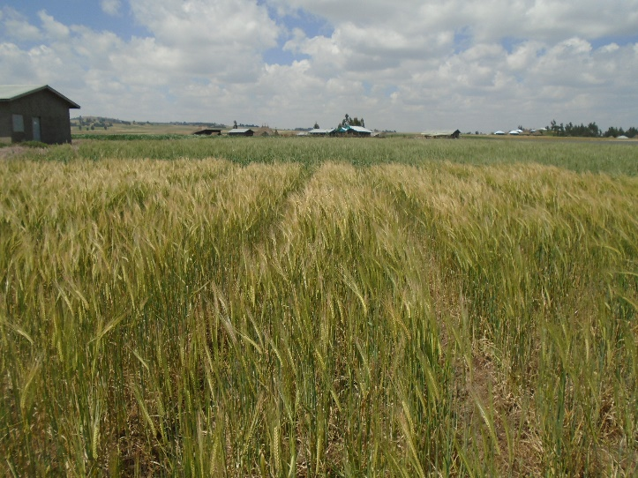 | 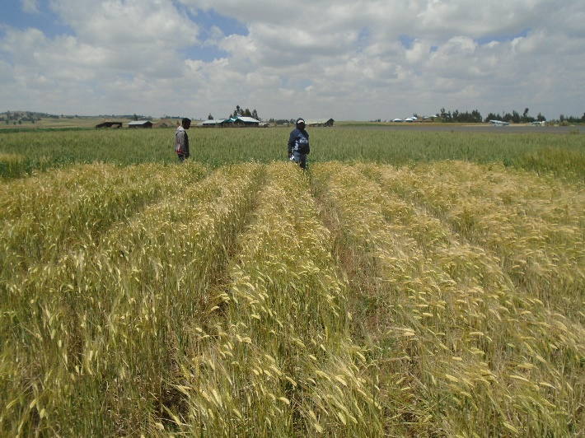
Demonstration plots of malt barley varieties by DBARC at Basona Worana districts: EH1847 (left) and IBON-174/03(right)

