Hedonic Analysis of Price Expectations of Goat Producers in Afghanistan: Implications for Production and Marketing Decisions
Srinivas Tavvaª , Aden Aw-Hassan^{b}, Barbara Rischkowsky^{c}, Markos Tibbo^{d}, Javed Rizvi^{e} and Abdul Halim Naseri^{f}
ª Visiting Agricultural Economist, International Center for Agricultural Research in the Dry Areas (ICARDA) - Afghanistan Research Program, P.O.:1355, Kabul, Afghanistan. e-mail: s.tavva@cgiar.org.
^{b} Program Director, International Center for Agricultural Research in the Dry Areas (ICARDA), Social, Economic and Policy Research (SEPR) Program, P.O.Box 5466, Aleppo, Syria.
e-mail: A.Aw-Hassan@cgiar.org.
^{c} Senior Livestock Scientist, International Center for Agricultural Research in the Dry Areas (ICARDA), Diversification & Sustainable Intensification of Production Systems (DSIPS) Program, P.O.Box 5466, Aleppo, Syria. e-mail: B.Rischkowsky@cgiar.org.
^{d} Small Ruminant Scientist, International Center for Agricultural Research in the Dry Areas (ICARDA), Diversification & Sustainable Intensification of Production Systems (DSIPS) Program, P.O.Box 5466, Aleppo, Syria. e-mail: M.Tibbo@cgiar.org.
^{e} Country Manager, International Center for Agricultural Research in the Dry Areas (ICARDA) - Afghanistan Research Program, P.O.:1355, Kabul, Afghanistan. e-mail: j.rizvi@cgiar.org.
^{f} National Coordinator, Goat Project, International Center for Agricultural Research in the Dry Areas (ICARDA)- Afghanistan Research Program. Email: abdulhalim.nasery@gmail.com.
Abstract
This paper describes the goat markets in Afghanistan by analysing goat producers’ price expectations and by identifying the factors that determine these price expectations. Data on expected prices for goats transacted were collected from 280 goat producers from Baghlan and Nangarhar provinces, along with information on factors anticipated to influence the price expectation from May 2008 to April 2009. A price expectation model was built and analysed using a general linear model.
Results indicated that goat producers adjusted expected prices for marketing day (Saturday and Thursday), location of sales (district and provincial markets), live weight, and goat producers’ market network. However, goat producers didn’t expect a premium for goat attributes like breed and age. The implications of the study are that the goat producers can expect more when they plan their goat sales based on live weight, market day, marketing place and sex of goat. [Econlit citations:Q130; Q120 and C100)
Key words: Hedonic pricing, General Linear Model, Goats, Afghanistan
1. Introduction
Goats in Afghanistan are multi-purpose animals providing meat and milk for direct home consumption, providing income through sales and serving as a living asset that can be liquidated when needed. With a national herd of 7.3 million goats and an average holding size of 2.4 animals (FAO Livestock census 2003), goats are an essential element in the farming systems and the livelihoods of rural communities. A quarter of total goats in Afghanistan are in Herat, Helmand and Nuristan provinces and the highest number of goats per family is in Nuristan (23.5 goats), followed by Kunar (8.2) in eastern Afghanistan (Fig. 1).
Goat producers sell live goats either directly themselves or through middlemen. As goats are commonly traded for cash, every goat producer naturally will have some price expectation on the basis of which he/she initiates the bargaining process. The price agreed by producers and buyers depends on their knowledge of market supply and demand, coupled with their skills in assessing animal condition (and weight) as goats are not weighed before purchase (Bett et al., 2011); and their market information including their knowledge of different attributes of goats preferred by different buyers (Francis, 1990). Market price information generally in livestock markets in developing economies is mainly limited to personal interactions between market agents due to poor market intelligence systems (Rodriguez et al., 1995). In a conflict affected country like Afghanistan, one cannot expect to have an effective market intelligence system. Under such circumstances, it is likely that producers’ production and marketing decisions may not yield high returns. It is therefore necessary to understand factors influencing price expectations of market agents, complexities within the market price determination mechanisms and the importance of transparent market information that can be used by goat producers in formulating better strategies for production and marketing of goats.
This study was conducted to evaluate the factors that determine price expectations of goat producers in Baghlan and Nangarhar provinces having 3.28 and 3.24 per cent of total goats in the country with 1.75 and 2.2 goats per family respectively. This information provides important insights into the management and marketing practices that influence expected prices and will indicate how producers can better tailor their goat sales to increase profitability. The hypothesis of this study was that price expectations are influenced by the different attributes of goats and by farmer access to information networks. The specific objectives were to develop a price expectation model for live goats and to identify different factors influencing goat producers’ price expectations.
2. Methodology
A hedonic model of prices is one that decomposes the price of an item into separate components that determine the price (Martínez-Garmendia, 2010). According to Lancaster (1966a; 1976b; 1979c), goods are seen as bundles of quality characteristics and the ‘marginal value’ consumers attribute to each of the characteristics explains the variation in prices of goods. Rosen (1974) introduced a market-based approach for deriving a hedonic price function, where utility-maximizing buyers and sellers interact to establish the market value for a given attribute. A differentiated product can therefore be completely described by the vector of objectively measured characteristics of the product such that the observed price will be a composite of the coefficients of the embedded attributes. This technique can be used in relating the price per animal to its various attributes and characteristics (Jabbar and Diedhiou, 2003). Analysis of Covariance (AnCov) technique is a combination of linear regression and analysis of variance (ANOVA). In the AnCov technique, the results are adjusted for the linear relationship between the dependent variable and the factors (qualitative variables) and covariates (quantitative variables) (Singh-Knights et al., 2005). In principle, both linear regression and AnCov techniques perform the same function except that the AnCov technique allows for more direct interpretation and comparison of differences between categories of a factor (Gujarati, 1988).
This technique of hedonic pricing has been previously applied to investigate factors affecting selling prices of small ruminants in Nigeria (Francis, 1990; Jabbar, 1998), in Pakistan (Rodriguez et al., 1995), in Philippines (Orden et al., 2005) and in Ethiopia (Andargachew and Brokken, 1993; Ayele et al., 2006). Turner and Williams (2002) examined the factors influencing prices received by livestock producers at the level of primary markets in rural villages and found that price formation is socially biased by gender, wealth and location, reflecting differential access and powers within local markets.
A hedonic price model (modification of Andargachew and Brokken (1993) model) was used in our analysis to assess the extent to which the goat, producer, market and other characteristics affect the goat producers’ price expectations.

2.1 Model specification

The price expectation model developed to identify factors determining the producers’ price expectations was,
Wprice=β₁ + β₂ Lwt + ∑β₃ E+ ∑_{i}β_{i} Season_{i} + ∑_{i}β_{i} BR_{i} + ∑_{i}β_{i} S_{i} + ∑_{i}β_{i} PS_{i} + ∑_{i}β_{i} MNW_{i} +
∑_{i}β_{i} BC_{i} + ∑_{i}β_{i} C_{i} + ∑_{i}β_{i} MD_{i} + ∑_{i}β_{i} MP_{i} + ∑_{i}β_{i} B_{i} + ∑_{i}β_{i} A_{i} + ∑_{i}β_{i} LwtSeason_{i}
+ ∑_{i}β_{i} LwtBR_{i} + ∑_{i}β_{i} LwtS_{i} + ∑_{i}β_{i} LwtPS_{i} + ∑_{i}β_{i} LwtMNW_{i} + ∑_{i}β_{i} LwtBC_{i} + ∑_{i}β_{i} LwtC_{i}
+ ∑_{i}β_{i} LwtMD_{i} + ∑_{i}β_{i} Lwt MP_{i} +∑_{i}β_{i} Lwt B_{i} + ∑_{i}β_{i} LwtA_{i} + e_{i}
Table 1 shows different variables that are included in this model. Due to wide variations in per head live weight of goats transacted (from 7 kg to 42 kg), goat producers price expectations per head adjusted to live weight i.e., expected price per kg live weight, was used as dependent variable (Wprice). Sets of dummy variables were used for season of transaction, breed (BR), sex (S), production system (PS), access to market network (MNW), body condition (BC), goat carrier to market (C), marketing day (MD), market place (MP), and buyer (B). The variable specification included three season dummies, three breed dummies, female and male goats for sex, good and bad body condition, three categories of goat age, two categories of goat carrier to market, four categories of marketing days, three categories of market place and three categories of buyers. Interactions of live weight with season, breed, sex, body condition, marketing day, marketing place, buyer, carrier, production system, access to market network and age were also included.
As more than half goat sale transactions were in the winter and summer compared to fall and spring, three season dummies considered were for winter, summer and other seasons’ (combined sales during fall and spring) sales.
Three categories for goat breed dummies (Watani, Gujry and other breeds) were also introduced because Watani and Gujry breeds dominated the goats sold and the aim is to see if they yield significantly different price expectations from other less traded goats.
Marketing on Thursdays, Fridays and Saturdays were included as marketing day dummies because goat producers sold 24, 31 and 13 per cent of goats on Thursday, Friday and Saturday respectively in Baghlan and Nagarhar provinces. As district and provincial markets in both the provinces and village markets in Nangarhar province are held on these market days, the majority of goat producers carried out goat sales on these days. Hence transactions done on Sunday, Monday, Tuesday and Wednesday were clubbed into one category as ‘other days’ under market day dummy variables, thus making only four categories of marketing days.
The βs’ represent the structural parameters in the equation. Mean and per cent of cases of variables included in the price expectation model are presented in Table 2. The model was fitted using the general linear model procedure in SPSS package.
2.2 Data
A total of 280 goat producers were randomly selected in equal proportions for rainfed and irrigated systems from 28 villages in four districts (Baghlan-e-Sannhati, Pul-I-Kumiri, Dar-e-Noor and Achin) in Baghlan and Nangarhar provinces (Fig.2). The districts were purposively selected in order to represent areas where development activities under the “Goats for Women Project” were implemented and to include others without project activities. Seven villages from each district and ten households from each village were selected randomly.
Data on production, goat market structure, expected price, live weight, sex, age, breed, body condition, carrier (person who takes the animal to market), month and day of marketing, location of market place, access to market network and buyer of the latest live goat transactions during the previous year (May 2008 to April 2009) were collected from goat producers using a structured questionnaire. In the absence of any records on goat transactions, producers were asked to give prices they expected to receive for their goats during their latest goat transactions.
3. Results and discussion
3.1 Price expectation model for goats
The parameters estimated for goat price expectations are shown in Table 3. The adjusted R² of the model was about 55 per cent indicating the percent of variation in goat producers’ price expectations that the model explains. An analogous model for expected price per goat head had adjusted R² of 82 per cent.
Expected prices and per kg live weight were negatively related. With one unit increase in the live weight of goat, expected price decreased by Afs 15 per kg. Rodriguez et al. (1995) also reported findings similar to our results that per kg live weight was negatively related to the expected prices. This is true because in the survey data, per kg price expectation for a goat weighing 7 kg was Afs 286 and for a goat weighing 42 kg, it was Afs 167. As the animal weight increases, price expectation did not increase proportionately. Thirty four per cent of goats sold were less than 20 kg in weight. Hence the inverse relationship is as expected.
Goat sex was identified to have a significant role in price determination. When male goats or bucks were taken to market, the expected unit price increased by Afs 42 per kg live weight, which is significant. From the observed prices received by goat producers, it was clearly evident. Male goats fetched higher prices (Afs 147 per kg) than females (Afs 139 per kg). However the difference was not statistically significant. Thus, goat producers were expecting high price for male goats or bucks than for does in Baghlan and Nangarhar provinces. Interestingly when live weight interacted with sex, price expected for male goat decreased by Afs 18.3 per 10 kg live weight. This indicates that goat producers expect more for relatively heavier female goats.
Marketing day was also an influencing factor on price expectations of goats. Expected prices were high when goats were sold on market days such as Saturdays and Thursdays in the week. Also if goats were marketed on Friday, the expected price was high but not significant. Butchers indicated that in general demand for goat meat was high on Thursdays (Baghlan, Nangarhar and Kabul). Also goat producers were expecting high prices on Thursdays (Afs 195 per kg live weight) and Fridays (Afs 172 per kg live weight) compared to other marketing days (Afs 168 per kg live weight) as observed from the survey data.
The nature of the market (village, district or province) was another important factor having significant influence on expected prices. Consistent with other studies (Mlozi et al. 2003; Emuron et al. 2010; Moges et al. 2010), expected as well as observed prices were higher in provincial markets than in district markets. Expected prices were high when goat producers sell in a provincial and district market than in a village market itself. Data collected from butchers has confirmed that prices were higher in provincial markets than in district markets by Afs 15 per kg weight. However when live weight interacted with market place, expected prices decreased more in provincial market (Afs 62 per 10 kg weight) than in district market (Afs 23 per 10 kg weight). This suggests that provincial and district markets do not prefer heavier goats.
Consistent with the findings by Dossa et al. (2008) in Southern Benin, Okali and Upton (1985) in Southern Nigeria and by Rodriguez et al. (1995) in Pakistan, breed also had no significant effect on price expectations in the present study. Gujry breed was top ranked by goat producers for meat purposes. However this was not translated significantly in the model results. It may be due to the fact that buyers gave preference to live weight rather than to breed. Negative correlation between expected price and live weight for female Gujry goats transacted from Nangarhar province also supports the view that live weight is an important factor in expectations of goat prices.
Similarly goat body condition did not have significant influence on price expectations as was also the case by Bett et al. (2011) in Kenya. The season of sale also did not have significant influence on goat price expectations as indicated by the seasonal coefficients obtained from the model.
Price expectations of goat producers with access to information network decreased by Afs 30 per kg live weight. This may be due to the fact that goat producers’ market network was not well developed and were poorly informed about the prices leading to high price expectations. However, the price expectations of goat producers with access to market network when interacted with live weight have increased by Afs 11 per 10 kg live weight. Similar to the study by Brett et al. (2011), poor market network/information of goat producers limited their marketing decisions and consequently affected production and sales decisions. Upton (2000) acknowledges that the lack of information results in poor integration of spatially dispersed markets and cyclical fluctuations in production and prices. However, the relatively high margins for the intermediaries reflect opportunities present at the market (Aklilu et al. 2007). These opportunities can therefore be effectively utilised by the farmers if they are provided with adequate and reliable information as well as through group marketing. The goat production system is not having significant influence on the price expectations, even with the interaction of live weight.
3.2 Live weights and prices of goats traded
In the price expectation model, live weight of goat has played an important role among different variables considered. Therefore an attempt is made in the following sections to explain the goat marketing in Baghlan and Nangarhar provinces taking into account the variations in the live weight and prices of goats with respect to breed, sex, production system, province, etc. The prices and live weights of goats correspond to the actual transactions reported by goat producers.
3.2.1 Goat sales by breed, sex and province: Watani breed dominated goat sales. Out of goats sold by surveyed producers, Watani was the most frequent (57 per cent) followed by Gujry (19 per cent), Tedipk (19 per cent), Asmari (four per cent) and Chily (one per cent). Though goat producers indicated Gujry as the preferred breed for meat purposes, large sales of the Watani breed is due to its larger share in the population. Also ninety percent of Gujry goats transacted were from Nangarhar as it was the dominant breed amongst Nangarhar producers.
Male goats dominated the sales volume in all breeds. Seventy eight per cent of goats transacted by goat producers were males and 22 per cent were females. Males sold at a higher percentage in Nangarhar province (83 per cent) than in Baghlan (77 per cent). Male goats of Watani were marketed at a lower weight than were females, indicating that they were marketed at a younger age due to their high market demand while females were kept for breeding. In the case of the Gujry breed, males were heavier than females. As Gujry is the most preferred breed for meat purpose, males were sold at a later stage after attaining good weight, coinciding with Eid Al Adha, as 50 per cent of them were sold in December. The average live weight of male and female goats of Nangarhar province was almost same (28 kg each), but female goats were heavier than the male goats (19 kg) of Baghlan province.
Overall, males fetched higher prices than females. This is also the case in all breeds except for Gujry and Tedipk. Price per kg live weight of males was higher in Baghlan while in Nangarhar province it was higher for females. The high prices for females need to be further probed especially in Nangarhar province, as the total number of female Gujry and Tedipk goats sold were only eight and five respectively in the current survey sample.
The high price per kg and live weight correlations obtained indicated that prices offered were proportional to live weights. This also suggests that goats were mainly purchased for slaughter and prices were arrived based on live weight of the goat. The low correlation coefficient (0.21) of price and live weight for overall female Gujry goats may be due to poor condition of these goats as is evident from the negative correlation for the same in Nangarhar province (Table 4).
3.2.2 Weights and prices by production system: Prices and live weights of goats were also analysed by production system (Table 5). There was no significant difference in the weight of goats sold between irrigated (23 kg) and rainfed (24 kg) production systems. Price per kg live weight was more in irrigated production system (Afs 146) than in rainfed (Afs 141). The high price-live weight correlation coefficient obtained for both production systems indicates that prices offered for animals were proportional to live weights except in Pul-I-Kumiri district.
3.3 Live weight and seasonality of goat sales
Differences in the live weight of goats transacted in different seasons between production systems and provinces are shown in Fig. 3. The live weight per goat was high during the spring and summer in irrigated production system while it was high in the winter in rainfed production system. Goat producers spend more on supplementary feed in rainfed production systems than the producers from irrigated production system do to fatten the goats in winter. This high expenditure on supplementary feed may be the reason for more goat weight during winter for the goats from rainfed production system. Live weight of goats marketed from Nangarhar province was higher compared to animals from Baghlan province. This is due to early age sales of goats in Baghlan (1.5 years) than in Nangarhar (1.8 to 2 years). Overall, live weight of goats marketed was higher during spring and fall through the year. High prices in fall and more live weights of goats sold in fall indicate that goats were priced mostly for their body condition and weight. High price in the fall season in spite of large supply and sales of goats, was due to high demand for goat meat during festivals (Eid Al Fitr and Ramadan) in this season during 2008. Similarly, other studies noted the existence of the same scenario relating to the price and the socio-cultural events especially the Christian and Muslim festivals (Aklilu et al. 2007; Halima et al. 2007; Emuron et al. 2010; Moges et al. 2010; Brett et al. 2011). The goat producers should therefore take advantage of the demand shifts resulting from such festivals.
3.4. The differences between expected and observed prices
The price differential between anticipated and observed indicates the bargaining power of goat producers. Irrespective of the production systems, the difference between expected and observed goat prices was higher in summer and winter (Fig. 4). These price differences were statistically significant. The expected price was more during summer while the observed price per kg live weight was more during fall in both the production systems. Similar results of greater difference in the expected price for goats in summer were obtained by Rodriguez et al. (1995) in Pakistan. Large sales of goats during summer (as cross checked with traders), caused a decline in observed prices and hence the large difference between expected and observed prices in summer. The high observed price during fall might be due to Ramadan and Eid Al Fitr festival demand in 2008.
When the difference between anticipated and observed prices of live goats were examined by province, as represented in Fig. 5, it was clear that the difference was high during fall and winter in Baghlan province and during spring and fall in Nangarhar province. Overall, the difference was high in Baghlan compared to Nangarhar province. The average price differential for goats marketed in Baghlan represented 26 per cent of the average expected price per kg live weight with a coefficient of variation of 10 per cent. In contrast, the price difference for goats marketed in Nangarhar represented only seven per cent of the price expected per kg live weight with a coefficient of variation of 79 per cent. This indicates that Nangarhar goat markets have more room for bargaining than Baghlan markets.
4. Conclusions
The foregoing analysis identified live weight, sex, marketing day, market place and access to market net work as important factors influencing goat producers’ price expectations in Baghlan and Nangarhar provinces in Afghanistan. The study also further indicates that live weight has more influence (40 per cent) on goat producers’ price expectations than the breed or age of goats. The study only analysed the components of goat producers’ price expectations and it provided a baseline for goat producers to plan their sales. Goat producers can expect more when they plan their goat sales based on live weight, market day, marketing place and goat sex. Improving grazing sources such as green fodders, crop residues etc. in the countryside can be of help to goat producers in reducing their feed cost for production, as live weight is an important determinant of prices.
Acknowledgments
The authors are grateful to the International Fund for Agricultural Development (IFAD) for their financial support to the project “Rehabilitating Agricultural Livelihood of Women in Marginal and Post-Conflict Areas of Afghanistan and Pakistan”. The authors gratefully acknowledge the hard work of the ICARDA team based in Afghanistan in a very difficult and insecure environment. Sincere thanks are due to the Ministry of Agriculture, Irrigation and Livestock (MAIL) of Afghanistan, and its provincial Directorates in the two target provinces. Without the full cooperation and support received from the Ministry of Women Affairs, trading and farming communities, ‘Shuras’ and ‘Village Elders’, and security updates / assistance from providing agencies, it would not have been possible to conduct this study.
References
Aklilu, H., Almekinders, C., Udo, H., &, van der Zijpp, A. (2007). Village poultry consumption and marketing in relation to gender, religious festivals and market access. Tropical Animal Health and Production, 39, 165-177.
Andargachew, K., & Brokken, R. (1993). Intra-annual sheep price patterns and factors underlying price variations in the central highlands of Ethiopia. Agric. Econ., 8, 125-138.
Ayele, G., Jabbar, M.A., Teklewold, H., Mulugeta, E., & Kebede, G. (2006). Seasonal and inter-market differences in prices of small ruminants in Ethiopia. Journal of Food Products Marketing, 12, 59 -77.

Bett, H. K., Peters, K. J., & Bokelmann, W. (2011). Hedonic price analysis to guide in breeding and production of Indigenous chicken in Kenya. Livestock Research for Rural Development, 23, 6. Retrieved on October 19, 2011, from http://www.lrrd.org/lrrd23/6/bett23142.htm.
Doolarie Singh-Knights, Dennis K. Smith, & Marlon Knights (2005). A Hedonic Analysis of Sheep and Goat Prices in a Changing Environment: The Role of Consumers and Implications for Management. Selected paper prepared for presentation at the American Agricultural Economics Association Annual Meeting, Providence, Rhode Island.
Dossa, L.H., Rischkowsky, B., Birner, R., & Wollny, C. (2008). Market potential for the local Djallonke goat in Southern Benin: empirical evidence from two rural markets. Livestock research for Rural Development, 20, Article 7. Retrieved January 5, 2010, from http://www.lrrd.org/lrrd20/5/doss20078.htm.
Emuron, N., Magala, H., Kyazze, F. B., Kugonza, D. R., & Kyarisiima, C. C. (2010). Factors influencing the trade of local chickens in Kampala city markets. Livestock Research for Rural Development, 22, Art. #76. Retrieved February 21, 2011, from http://www.lrrd.org/lrrd22/4/emur22076.htm
Food and Agriculture Organisation (2003). Livestock Census of Afghanistan, FAO- Kabul. Francis, P.A. (1990). Small-ruminant marketing in Southwest Nigeria. Agric. Econ., 4,193- 208.
Gujarati, D. N. (1995). Basic Econometrics. Third Edition, United States Military Academy, West Point. McGraw Hill, Inc., New York.
Halima, H., Neser, F., van Marle-Koster, E., & De Kock, A. (2007). Village-based indigenous chicken production system in north-west Ethiopia. Tropical Animal Health and Production, 39, 189-197.
Jabbar, M.A. (1998). Buyer preferences for sheep and goats in southern Nigeria: A hedonic price analysis. Agric. Econ., 18, 21 – 30.
Jabbar, M. A., & Diedhiou, M. L. (2003). Does breed matter to cattle farmers and buyers? Evidence from West Africa. Ecological Economics, 45, 461-472.
Lancaster, K. J. (1966). A New Approach to Consumer Theory. The Journal of Political Economy, 74, 132-157.
Lancaster, K. J. (1976). Hierarchies in goods-characteristics analysis. Advances in Consumer Research, 3, 348-352.
Lancaster, K. J. (1979). Variety, Equity and Efficiency. Columbia University Press, New York.
Martínez-Garmendia, J. (2010). Application of hedonic price modelling to consumer packaged goods using store scanner data. Journal of Business Research, 63, 690-696.
Mlozi, M. R. S., Kakengi, A. V. M., Minga, U. M., Mtambo, A. M., & Olsen, J. E. (2003). Marketing of free range local chickens in Morogoro and Kilosa urban markets, Tanzania. Livestock Research for Rural Development, 15 (2). Retrieved February 3, 2011, from http://www.lrrd.org/lrrd15/2/mloz152.htm
Moges, F., Azage, T., & Tadelle, D. (2010). Indigenous chicken production and marketing systems in Ethiopia: Characteristics and opportunities for market-oriented development. IPMS (Improving Productivity and Market Success) of Ethiopian Farmers Project Working Paper 24. ILRI, Nairobi, Kenya.
Okali, C., & Upton, M. (1985). The market potential for increased small ruminant production in Southwest Nigeria. In J. E. Sumberg and K.A. Cassaday (Eds.), Sheep and goats in humid West Africa. Proceedings of the workshop on Small Ruminant Production systems in the Humid Zone of West Africa, 23-26 Jan 1984, Ibadan, Nigeria,. ILCA, Addis Ababa, Ethiopia, pp. 68 – 74.
Orden, M.E.M., Jamandre, W.E., Brown, E.O., Orden, E.A., Cruz, E.M., Alo, A.P., & Villar, E.C. (2005). Traders’ preference for goat characteristics in selected markets of Pangasinan, Philippines. Animal Science Journal, 76, 179-185.
Rodriguez Abelardo, Imran Ali, Muhammad Afzal, Nisar A. Shah, & Usman Mustafa (1995). Price expectations of sheep and goats by producers and intermediaries in Quetta market, Pakistan. Agric. Econ., 12, 79-90.
Rosen, S. (1974). Hedonic Prices and Implicit Markets: Product Differentiation in Pure Competition. The Journal of Political Economy, 82, 34-55.
Timothy O. Williams, Iheanacho Okike, & Ben Spycher (2006, August). A Hedonic Analysis of Cattle prices in the Central Corridor of West Africa: Implications for Production and Marketing Decisions. Contributed paper prepared for presentation at the International Association of Agricultural Economists Conference, Gold Coast, Australia. http://purl.umn.edu/25423.
Turner, M. D., & Williams, T. O. (2002). Livestock market dynamics and local vulnerabilities in the Sahel. World Development, 30, 683-705.
Upton, M. (2000). The ‘Livestock Revolution’ – Implications for smallholder agriculture: A case study of milk and poultry production in Kenya. Food and Agriculture Organization (FAO) Livestock Information and Policy Branch, AGAL. Available at. http://www.fao.org/ag/againfo/resources/en/publications/sector_discuss/PP_Nr1_Final.pdf

Table 1: Variables in the goat price expectation model
Name of Variable Explanation of Variable Expected effects
Dependent
Expected price of goat per kg Expected price of goat transacted
live weight (Wprice) is divided with the live weight
Independent (Quantitative)
Live weight (Lwt) Live weight of goat transacted Negative
Experience in goat rearing (E) Number of years of experience Positive
in rearing goats
Independent (Qualitative)
Season dummies If the goat is transacted during Negative in Winter
(other seasons as base) the corresponding season=1; Positive in summer
a. Summer (April, May, June) otherwise=0
b. Winter (Oct., Nov., Dec.)
Goat Breed dummies (BR) If the goat transacted is Positive for Watani and
(other breeds as base) respective breed=1; otherwise=0 Gujry
a. Watani dummy
b. Gujry dummy
Sex of goat dummy (S) If the goat transacted is Male=1; Positive for male
Otherwise=0
Production system dummy (PS) If the goat transacted is from Positive for irrigated
irrigated production system=1;
Otherwise=0
Market net work dummy (MNW) If the goat producer Positive for goat producer
with access to market network=1; with access to market
Otherwise=0 network
Body condition of goat If the body condition of Positive for good body dummy (BC) condition goat transacted is Good=1;
Otherwise=0
Person carrying goat to market If husband carries goat to market=1;
dummy (C) Otherwise=0
Marketing day dummies (MD_{i}) If the goat is transacted on the Positive for Thursday,
(other days as base) respective week day =1; Friday and Saturday
a. Thursday Otherwise=0
d. Friday
e. Saturday
Market place dummies (MP_{i}) If the goat is sold in respective Positive for district
(Village market sales as base) market=1; Otherwise=0 and provincial markets
a. District
b. Provincial
Buyer of goats dummies (B_{i}) If the buyer is corresponding to Positive for butcher
(Other buyers as base) the market functionary dummy=1;
a. Wholesaler Otherwise=0
b. Butcher
Age of goat dummies (A_{i}) If the goat transacted is in the Positive for 1-2 year dummy
(>2 year as base) corresponding age group=1;
a.<one year Otherwise=0
b.1-2 year
Table 2: Mean and per cent of cases of independent variables
Variable Mean Number of cases per cent of cases in
sample
Expected price per kg live weight 178 100
Live weight 24 100
Experience in goat rearing 11 100
Season dummy 1 (Summer) – 15
Season dummy 2 (Winter) – 41
Season dummy 3 – 44
(Spring and Fall seasons)
Watani – 57
Gujry – 19
Other breeds – 24
(Asmari, Chily and Tedipk)
Goat Sex (Male) – 78
Goat Sex (Female) – 22
Production system dummy (Irrigated) – 50
Production system dummy (Rainfed) - 50
Access to Market Network dummy
(With access) – 50
Access to Market Network dummy
(Without access) – 50
Body condition (Good) – 91
Body condition (Bad) – 9
Goat carrier dummy (Husband) - 74
Goat carrier dummy (Others) - 26
Market day dummy 1 (Thursday) - 24
Market day dummy 2 (Friday) - 31
Market day dummy 3 (Saturday) - 14
Market day dummy 4 (Other days) - 31
Market place dummy 1 (District) – 63
Market place dummy 2 (Province) – 7
Market place dummy 3 (Other places) – 30
Buyer dummy 1 (Wholesaler) – 16
Buyer dummy 2 (Butcher) - 60
Buyer dummy 3 (Others) – 24
Age dummy 1 (less than one year) – 8
Age dummy 2 (one to two years) – 84
Age dummy 3 (more than two years) – 8

Table 3: Price expectation model for goats in Baghlan and Nangarhar provinces in Afghanistan.
Parameter Coefficient Std. Error
(β_{i})
Intercept 539.89** 87.27
Live weight -15.13** 3.80
Experience in goat rearing 0.19 0.24
Season dummy 1 (Summer=1; Otherwise=0) 19.36 19.48
Season dummy 2 (Winter=1; Otherwise=0) 20.34 15.69
Breed dummy 1 (Watani=1; Otherwise=0) 3.56 26.71
Breed dummy 2 (Gujry=1; Otherwise =0) -36.84 35.60
Sex (male=1, female=0) 42.03* 17.72
Production system -4.98 12.21
(irrigated=1; Otherwise=0)
Access to Market network -29.93* 14.83
(with access=1; Otherwise=0)
Body condition (Good=1; Otherwise=0) -0.77 20.12
Goat carrier (Husband=1; Otherwise=0) 10.12 15.80
Marketing day dummy 1 36.97* 20.11
(Thursday=1; Otherwise=0)
Marketing day dummy 2 18.00 20.55
(Friday=1; Otherwise=0)
Marketing day dummy 3 60.79* 24.81
(Saturday=1; Otherwise=0)
Market place dummy 1 64.34** 18.05
(District=1; Otherwise=0)
Market place dummy 2 154.02** 29.61
(Province=1; Otherwise=0)
Buyer dummy 1 4.29 23.40
(Wholesaler=1; Otherwise=0)
Buyer dummy 2 (Butcher=1; Otherwise=0) -6.40 15.86
Age dummy 1 (<one year=1; Otherwise=0) 42.97 40.48
Age dummy 2 (1-2 years=1; Otherwise=0) 46.75 31.62
Live weight X Season dummy 1 -1.12 0.86
(Summer=1; Otherwise=0)
Live weight X Season dummy 2 -0.78 0.62
(Winter=1; otherwise=0)
Live weight X Breed dummy 1 -0.13 1.14
(Watani=1; Otherwise=0)
Live weight X Breed dummy 2 1.35 1.33
(Gujry=1; Otherwise=0)
Live weight X Sex (Male=1; Otherwise=0) -1.83* 0.73
Live weight X Production system dummy 0.33 0.50
(Irrigated=1; Otherwise=0)
Live weight X Market Net work 1.12* 0.60
(With access=1; Otherwise=0)
Live weight X Body condition 0.40 0.98
(Good=1; Otherwise=0)
Live weight X Goat Carrier ) -0.25 0.61
(Husband=1; Otherwise=0
Live weight X Marketing day dummy 1 -1.64* 0.99
(Thursday=1; Otherwise=0)
Live weight X Marketing day dummy 2 -0.74 0.87
(Friday=1; Otherwise=0)
Live weight X Marketing day dummy 3 -1.97* 0.98
(Saturday=1; Otherwise=0)
Live weight X Market place dummy 1 -2.27** 0.70
(District=1; Otherwise=0)
Live weight X Market place dummy 2 -6.22** 1.57
(Province=1; Otherwise=0)
Live weight X Buyer dummy 1 -0.01 0.94
(Wholesaler=1; Otherwise=0)
Live weight X Buyer dummy 2 0.42 0.62
(Butcher=1; Otherwise=0)
Live weight X Age dummy 1 -2.00 1.78
(Age less than one year =1; Otherwise=0)
Live weight X Age dummy 2 -1.95* 1.09
(Age one to two year =1; Otherwise=0)
Adjusted R² 0.55
*P< 0.05 and **P<0.01

Table 4: Live weights, prices per head and per kg and live weight-price correlations for goats in Baghlan and Nangarhar provinces (Breed and sex wise)
Province Breed Sex Mean goat Mean live weight Mean live weight Correlation
price (Kg) price (Afs/kg) coefficient
(Afs*/head) (price-live
weight) (r)
Baghlan Watani Male 2514 18 142 0.57
Province Female 2477 19 133 0.46
Gujry Male 1850 17 109 1.00
Female 4000 30 133 -
Asmari Male 2875 22 132 0.69
Female 4000 33 121 -
Tedipk Male 3183 19 172 0.82
Female 3500 25 143 -
Nangarhar Watani Male 4170 28 148 0.85
province Female 4783 34 142 0.88
Gujry Male 4737 34 138 0.79
Female 4633 31 151 -0.91
Asmari Male 3100 21 145 0.33
Female 3800 24 158 -
Chili Male 5100 30 170 1.00
Tedipk Male 3714 24 152 0.69
Female 4025 26 158 0.80
Overall Watani Male 2947 20 144 0.77
Female 2909 21 136 0.82
Gujry Male 4542 33 137 0.85
Female 4533 31 145 0.21
Asmari Male 2971 22 138 0.46
Female 3900 29 137 1.00
Chili Male 5100 30 170 1.00
Tedipk Male 3631 23 155 0.80
Female 3900 25 158 0.82
Baghlan All male 2588 18 151 0.62
All female 2610 20 133 0.58
Nangarhar All male 4203 29 146 0.78
All female 4494 30 150 0.81
Overall Male 3423 24 147 0.82
Female 3277 24 139 0.81
* Afs is the abbreviation for the Afghanisthan currency Afghani. One US $ = Afs 48 in 2012.

Table 5: Live weights, prices per head and per kg and price/live weight correlations for goats (Production system and province wise)
Category District Mean price Mean live Mean price Correlation
per head weight per kg coefficient
(Afs) (Kg) live weight (r)
(Afs) (Price-Liveweight)
Irrigated Baghlan-e-sannhati 2467 17 142 0.82
production Pul-i-kumiri 2545 17 153 0.35
system Dar-i-noor 4562 32 143 0.66
Achin 3763 25 150 0.62
All 3396 23 146 0.86
Rainfed Baghlan-e-sannhati 2566 19 137 0.84
production Pul-i-kumiri 2815 21 131 0.29
system Dar-i-noor 4664 33 142 0.93
Achin 3668 24 154 0.69
All 3418 24 141 0.82
Baghlan Baghlan-e-sannhati 2515 18 140 0.83
province Pul-i-kumiri 2692 19 140 0.33
All 2515 18 140 0.83
Nangarhar Dar-i-noor 4608 32 143 0.80
province Achin 3712 24 152 0.66
All 4251 29 146 0.83
Overall 3407 24 143 0.84

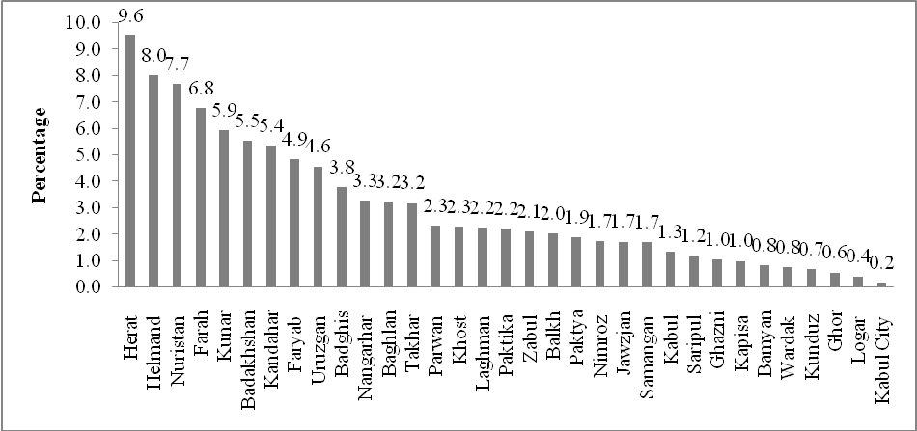
Fig. 1. Distribution of goats in different provinces of Afghanistan

Note: Afghanistan Province and District Boundaries shown on this map are provisional based on the UNFPA/
CSO HHL Project field work and it does not signify official acceptance by the United Nations.
Fig.2. Districts surveyed in Baghlan and Nangarhar provinces in Afghanistan

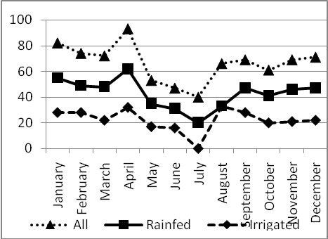
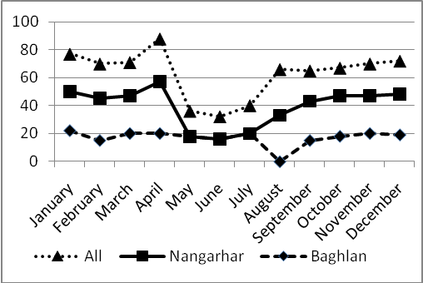

Fig. 3. Production system, province and season wise live weight of goats marketed

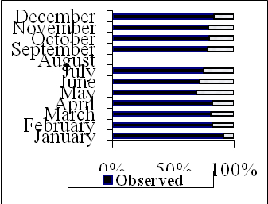
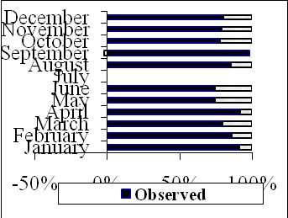
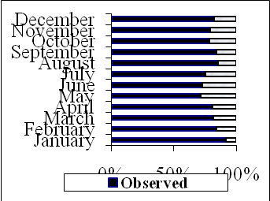

Irrigated Rainfed All
Fig. 4. Goat producer prices and deviations from expected prices per kg live weight under irrigated and rainfed production systems

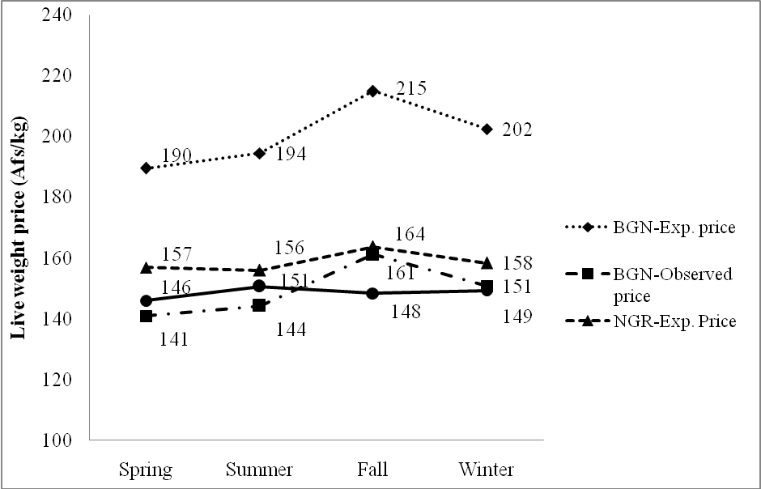
Fig. 5. Goat producers’ expected and observed live weight prices in Baghlan and Nangarhar provinces

Presently working as Senior Scientist, Agricultural Economics, Section of Social Sciences, Central Tuber Crops Research Institute, Thiruvananthapuram 695 017, Kerala, India. e-mail: srinictcri@yahoo.com.
To improve the skills and knowledge of rural women in raising dairy goats, processing and marketing surplus products and improving the use of natural resources and their access to technologies, the International Centre for Agricultural Research in the Dry Areas (ICARDA) implemented International Fund for Agricultural Development (IFAD)-co-funded pilot research programme “Rehabilitation of Agricultural Livelihoods of Women in Marginal and Post-conflict Areas of Afghanistan” in Nangarhar (Dar-e-Noor district) and Baghlan (Baghlan-e-Sannhati district) provinces of Afghanistan.

