Microdosing – Increasing yields and lowering costs in Chikantapura
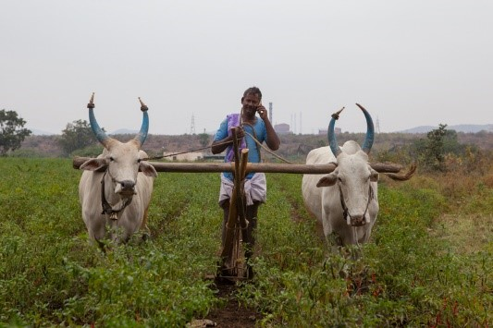
Rudramma’s husband ploughs the land for the chickpea.

For Rudramma, a farmer in Chikantapura Village in Karnataka, India, the source of information matters. “When my son comes to me with new ideas, I have to listen to him,” she says simply.
One of the new ideas introduced by her son, Shivappa, is the use of micronutrients on their farm.
“The micronutrients make our soil smooth,” Rudramma says. “Last year the maize grew without fertilizer. We only applied micronutrients. We got 18 quintals per acre. This is more than expected. The average we were getting was 15 quintals per acre.”
This season, Rudramma and her husband, Honnurswamy, are growing chickpea intercropped with chilies. They are growing JG 11, a short-duration chickpea variety they obtained from the International Crops Research Institute for the Semi-Arid Tropics (ICRISAT), which is highly resistant to fusarium wilt disease.
Before sowing the chickpea seeds, they sprinkle a mixture of zinc and gypsum between the rows of chilies. They also treat their seeds with Trichoderma, a fungus that promotes chickpea germination and vigor.
In the last five years, Shivappa has helped more than just his family by becoming a farmer facilitator and receiving training under the Bhoochetana project. “While training I told my family how to increase our yield. They listened to me and applied micronutrients,” he says.
Shivappa works with 50 farmers. “Most of them are older but they are open to learning new things.”
In his opinion, one of the best ways of convincing farmers is to experiment with them. The project creates demo plots that compare crop yields under usual farmer practice with those grown with interventions deemed suitable by crop researchers for a given village.
“It is done by farmers and so other farmers can see and believe the results,” Shivappa says. “Around twenty farmers believed the results immediately when they saw the experiment plot.”
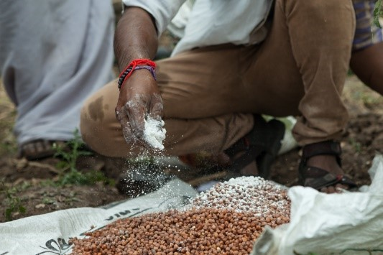
Chickpea seeds being prepared for planting.

Project
Improving rural livelihoods through integrated watershed management in Bellari district in Karnataka
Funder
JSW Foundation, Bellari, Karnataka
Partners
- Department of Agriculture (DoA), Government of Karnataka
- Watershed Development Department (WDD), Government of Karnataka
- University of Agricultural Sciences (UAS), Raichur
- JSW Foundation
- Farmers Association
- ICRISAT, Patancheru
CGIAR Research Program
WLE and DS

A passionate facilitator is helping farmers adopt better technologies

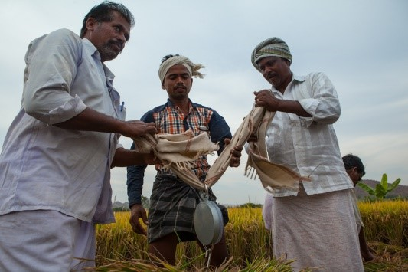
Weighing the rice yields.

Satisfaction for a farmer sometimes lies outside the boundaries of his/her fields. Gowder Mallikarjuna has been a farmer facilitator for the last four years, working with both Phases 1 and 2 of the Bhoochetana project. Originally from Devalapura village in Bellary district of Karnataka, India, he works with 200 farmers in 23 villages.
“I’m very happy to show these farmers new ways of farming,” he says. “But I am happiest when they show me what they have achieved.”
Mallikarjuna has seen the effects of the new methods of farming firsthand. He cultivates three and a half acres, all sown with BPT 5204, a variety of rice popular with farmers in the region.
“There is a difference in chemical use. I used to use 5 quintals of fertilizer per acre. We used as much as we liked. Now I use 3.5 quintals of fertilizer and organic manure and the expenditure is so much less.”
Despite the reduction in fertilizer use, Mallikarjuna’s yields have increased. “I used to get 35 bags (70 kg each) of rice per acre before. Now I get 45 bags per acre.”
This is the very definition of intensification. As Mallikarjuna describes it, “If I can increase my yield and decrease my costs without increasing my land, then it is a very good solution.”
The solution lies in what Mallikarjuna calls the use of balanced fertilizer. He uses a mix of NPK (Nitrogen, phosphorous and potash), Zinc, Boron, Gypsum and PSP instead of just the traditional NPK mix that most farmers use.
Farmers in nearby villages can see for themselves the effects of using a different mix of fertilizer and micronutrients. The project establishes demo plots each season and farmers are involved in setting up the two treatments: one, using traditional farmer practices and the other with an improved fertilizer package.
When it is time for harvest, Mallikarjuna and the farmers cut a five sq. m. swathe of the rice crop and measure the yields. On the farmer plot this season, the yields were 66.5 kg and in the improved demo plot, the yields were 84 kg.
“At first, the farmers seem reluctant. But then they changed their minds by looking at these plots and also by looking at what their neighbors are doing,” Mallikarjuna says.
Project
Improving rural livelihoods through integrated watershed management in Bellari district in Karnataka
Funder
JSW Foundation, Bellari, Karnataka
Partners
- Department of Agriculture (DoA), Government of Karnataka
- Watershed Development Department (WDD), Government of Karnataka
- University of Agricultural Sciences (UAS), Raichur
- JSW Foundation
- Farmers Association
- ICRISAT, Patancheru
CGIAR Research Program
WLE and DS

Vermicomposting helps farmers improve soil quality, cut costs

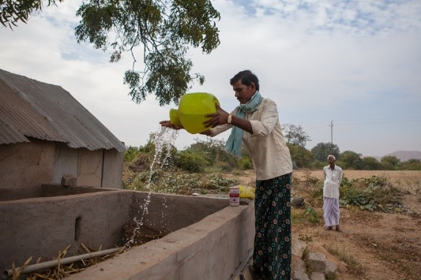
Nagabhushana waters the vermicomposting trough.

For the last three years, Nagabhushana, a famer in Kodalu Village in Bellary District, Karnataka, India, has been using earthworms to make compost, a process known as vermicomposting.
“There is no hard work in this at all,” Nagabhushana says. “First you take cow dung and crop residues and water it. This mix rots. Then you put the worms in. You water it every two days so that the worms have water. In three months, you have compost.”
Nagabhushana learned about vermicomposting and its benefits a few years ago during a training held by the watershed project, which in addition to helping villagers capture and store rainwater, helps farmers learn about microdosing, the benefits of vermicomposting, and even creates self-help groups to help farmers diversify their incomes.
During the 2013/14 season, the project helped him create permanent cement structures in which to house his worms.
Nagabhusana has seven acres on which he plants two acres with cotton, two acres with chili, and the rest with maize and sorghum. He first mixes the compost with gypsum and zinc and then applies the compost to his fields.
Nagabhusana has seen some definite benefits of using the compost. “There is more yield from the earth. The soil is looser and there’s less disease. Because the soil is looser, the roots are able to grow deeper,” he says.
Using organic compost that he makes himself also saves him money. “It saves me money because I do not use as much other fertilizer. Earlier, I used four-five bags of complex fertilizer. Now I use six bags of compost and only two bags of DAP,” he says. A bag of DAP costs INR 1200 (USD 18) and Complex costs INR 900 (USD 14) per bag.
The reason that vermicomposting is catching on is a simple, yet transformative one – water.
The availability of water in the area has improved because of field bunding and better watershed management.
“Earlier there was no water in the field so how could we water worms? Now with field bunding, we have more water. The bunding slows the water down and there’s less soil erosion as a result,” Nagabhushana says. And there is enough water for the earthworms to make compost and improve soil health.

Project
Improving rural livelihoods through integrated watershed management in Bellari district in Karnataka
Funder
JSW Foundation, Bellari, Karnataka
Partners
- Department of Agriculture (DoA), Government of Karnataka
- Watershed Development Department (WDD), Government of Karnataka
- University of Agricultural Sciences (UAS), Raichur
- JSW Foundation
- Farmers Association
- ICRISAT, Patancheru
CGIAR Research Program
WLE and DS

Watershed management creates more planting seasons, increases area under cultivation

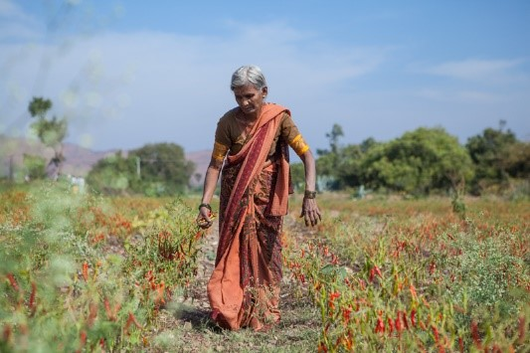
Woman in red chillies field.

Thimayya’s farm in Chikantapura village in Bellary, Karnataka, India, is spread over eight-to-ten acres. Shared between three brothers, the land is used to grow a number of dryland crops. “I grow chillies, pigeonpea, cotton, maize, jowar and vegetables.
Not so long ago, Thimayya had taken up employment at a factory; “I used to work at Jindal Steel Works (JSW) but now I am farming full-time and farming provides most of our income.”
The farm used to have one borehole but after a project built a check dam nearby, Thimayya’s family is able to run three boreholes, though they still need rain; “we used to have one borehole but now we have three boreholes with water pumps.” This year has been bad, with only 200 mm rainfall instead of 600, which is the usual average.
With the increased access to water, Thimayya can now plant three seasons: June to November, November to February, and January to March.
Before they had enough water for irrigation, they used to leave significant portions of their field uncropped - because they did not see much point in planting all of it. “Earlier, we left that land fallow, but now we are clearing the land and growing more than before since we are more interested in agriculture.”
Thimayya’s mother, Hanumakka says that with the project to bund water, the family is better able to use rainwater: “When the rain comes, we now make full use of it. It’s good.”
The farmers have also learnt to diversify crops, based on their water requirements, “every year what we grow changes. But last year we didn’t plant on all our farm,” says Hanumakka.
Referring to bunding, she says, “Without this, the water is lost. The water comes from those hills and stays now.”
From the fields, the first picking has been of chilies and some have already gone to the local market.
They also grow vegetables on the bunds, allowing them to utilize larger areas and diversify incomes. All this has been possible because of increased access to water, though groundwater depletion remains a concern through long, hot summer spells.
Project
Improving rural livelihoods through integrated watershed management in Bellari district in Karnataka
Funder
JSW Foundation, Bellari, Karnataka
Partners
- Department of Agriculture (DoA), Government of Karnataka
- Watershed Development Department (WDD), Government of Karnataka
- University of Agricultural Sciences (UAS), Raichur
- JSW Foundation
- Farmers Association
- ICRISAT, Patancheru
CGIAR Research Program
WLE and DS

