Activity : Modelling activities in peanut/chickpea (paper writing)

Objective of activity and intended output – This activity is part of long term efforts to use modelling tools to better frame and target crop improvement and crop management efforts. In this part, we explored the means to enhance groundnut productivity in West-Central Africa and East-Southern Africa, assessing essentially the prevalence of water stress, the optimal sowing densities, the optimal crop duration. In addition, the validity of weather data generated by Marksim was tested.

Materials and Methods: The SSM-legume model of Soltani and Sinclair (2011) was used in this study. It was used here to test the validity of Marksim-generated weather data, to assess the extent of yield reductions caused by water deficit, and to test the effect of: (i) increasing sowing density from 20 to 40 plant m-2; (ii) growing earlier maturing cultivars.

Results and interpretation:
Comparison of simulations with observed and Marksim-generated with observed weather data gave evidence of the validity of the generated weather across the 12 locations in Mali used in these comparisons.
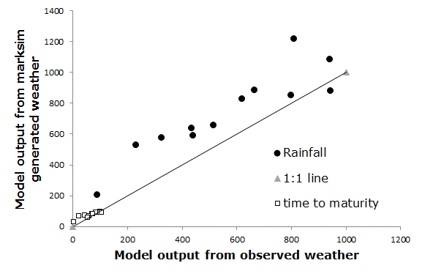 | 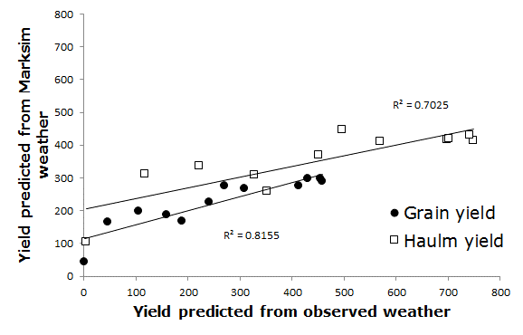
Figure 1. Comparison of rainfall from observed weather at 12 locations in Mali and Marksim-generated rainfall at these locations (a, closed circles), and resulting predictions by the crop model of time to maturity (a, open square), Grain yield (b, closed circles), and haulm yield (b, open squares).

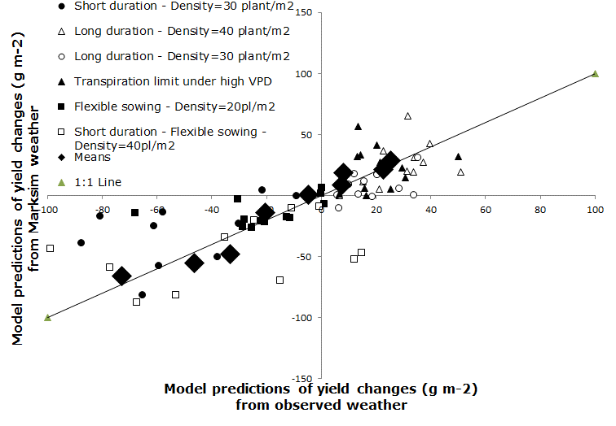 | Figure 2. Model predictions of yield changes from six trait / trait combinations using either observed weather or weather generated by Marksim. The diamond represents the mean of the model predictions across the available weather (30 to 50 years for the observed weather and 50 years for Marksim)

Figure 2 illustrate the changes in grain yield following an alteration in 6 coefficients or groups of coefficients. Three alterations led to an increase in the grain yield across locations while three other alterations led to a decrease in grain yield across locations. In all cases, both negative and positive increases were predicted both with the output coming from the simulations using observed weather data and with simulations using Marksim weather data.

Yield reductions caused by water deficit – To estimate the yield losses caused by water deficit, the model was run to irrigate the crop each time the fraction of transpirable soil water fell below 0.35, and yield simulated under rainfed conditions was subtracted from the yield simulated for fully irrigated conditions. In West Africa, the yield losses causes by water deficit ranged from -100 g m⁻² (minus 100 g m⁻²) to 245 g m⁻². Losses caused by water deficit were mostly circumvented to latitudes above 13 degrees North and as such, countries like Senegal, Mali and Niger would have most of their groundnut production suffering from severe water deficit. By contrast, a large majority of the pixels in that block were not suffering from water deficit, for example Nigeria (Fig. 3a). In the South East block, the yield penalty caused by water deficit ranged from about -50 g m⁻² to 225 g m⁻². Here also, a large majority of the block showed only a minor yield penalty caused by water deficit, except the Northern part of Tanzania and the South East part of Mozambique where water deficit had a substantial effect on yields with penalty ranging commonly from 1 to 2 tons/ha (Fig. 3b).

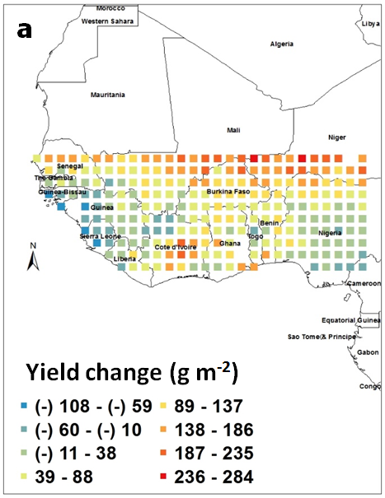 | 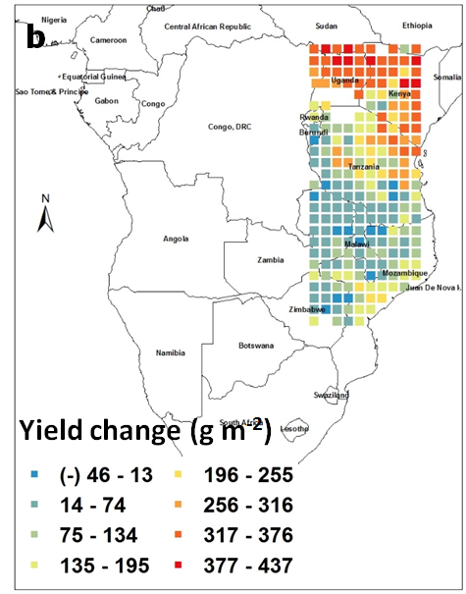
Figure 3. Groundnut pod yield changes (g m⁻²) caused by water deficit in West Africa (a) and in South East Africa (b). Each square represents the differences in the means of simulated outputs under rainfed conditions subtracted from those under fully irrigated conditions. These means were those of simulated outputs over 50 years of weather data generated by Marksim. The colour coding provides indicating of yield ranges in the different squares.

Simulating the effect of increasing the sowing density from 20 to 40 plant m⁻² on yield – Model simulations were run with a higher sowing density and the grain yield from the simulation under lower density were subtracted from those under higher density for each pixel. In West Africa, the increase in yield caused by increasing plant density were positive in all cases and ranged between 15 and 100 g m⁻². These yield increased were below 40 g m⁻² in countries like Senegal, Mali, Niger. By contrast, countries like Nigeria or Ivory Coast showed a major yield increase from increasing the sowing density (Fig. 4a). Similar observations were made in the South East block where yield increase were positive in the entire block and ranged from 15 to 120 g m⁻². Here also, there was a clear East/West gradient in the effect of increasing sowing density, with the Eastern parts of Tanzania and Mozambique benefitting little from an increase in density, whereas countries like Zambia, Zimbabwe and the Western part of Tanzania would benefit a lot from increase planting density (Fig. 4b).

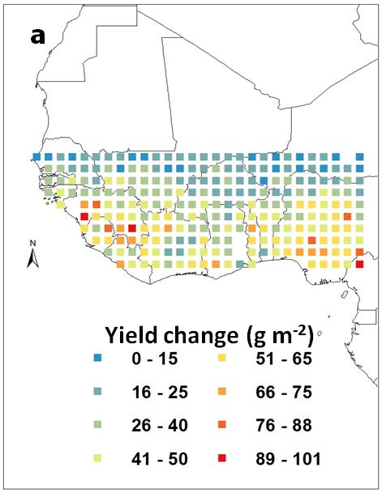 | 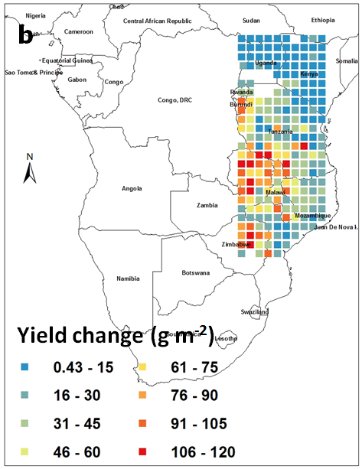
Figure 4. Groundnut pod yield change (g m⁻²) caused by increasing the sowing density from 20 to 40 plants m⁻² in West Africa (a) and in South East Africa (b). Each square represents the means of simulated outputs under 40 plants m⁻² subtracted from those under 20 plants m⁻². These means were those of simulated outputs over 50 years of weather data generated by Marksim. The colour coding provides indicating of yield ranges in the different squares.

Next steps: Groundnut production is limited in sub-saharan Africa (SSA) and water deficit, so called ‘drought’, is often considered as the main yield-limiting factor. Marksim provided good weather representation across a large gradient of rainfall, representative of the region, and simulations using observed or Marksim weather agreed closely (RMSE=99g.m⁻²; R² = 0.81 for pod yield). More importantly, simulation of yield changes upon agronomic or genetic alterations in the model were equally predicted with Marksim weather. ‘Drought’-related yield reduction were limited to latitudes above 12-13 degrees north in West Central Africa (WCA) and to the Eastern fringes of Tanzania and Mozambique in East South Africa (ESA). Simulation and experimental trials also showed that doubling the sowing density of Spanish cultivars from 20 to 40 plants m⁻² would increase yield dramatically in both WCA and ESA. However, increasing density would require growers to invest in more seeds and likely additional labor. If these trade-offs can’t be alleviated, genetic improvement would then need to re-focus on a plant type that is adapted to the current low sowing density, like a runner rather than a bush plant type, which currently receives most of the genetic attention. Genetic improvement targeting ‘drought’ adaptation should also be restricted to areas where water is indeed an issue, i.e. above 12-13ºN latitude in WCA and the Eastern fringes of Tanzania and Mozambique. Testing on the ground has started and needs now to be scaled up.

