Flagship Project: 2: Improved Varieties and Hybrids
COA: Sorghum-WCA
Analysis heterotic pools for hybrid sorghum breeding across the West-African Savannah zones based on genetic diversity analysis
Baloua Nebie¹, Aboubacar Toure¹, Ignatius Angarawai², Abdoulaye Diallo³, Moctar Kante⁴, Willmar L. Leiser⁴, Bettina I.G. Haussmann⁴, I. Sissoko¹ and Ramadjita Tabo¹
¹ ICRISAT-Mali, ² ICRISAT-Nigaria, ³IER, ⁴ University of Hohenheim

Objective of activity
The objective of this activity was to establish heterotic groups for sorghum hybrids breeding in West and Central Africa (WCA). Specifically, we want to access:
- combining ability (GCA & SCA) for new hybrids parents in high Phosphorus conditions
- combining ability (GCA & SCA) for new hybrids parents in low Phosphorus conditions
- genetic diversity of WCA sorghum material
Materials and methods
For this study, a set of hybrids (over 200) was developed using new 16 A (14 new and 2 checks) lines and R lines from different breeding programs and countries. These hybrids were evaluated for their combining ability (GCA and SCA) in mainly one location (Samanko) in 2015 and in 2 locations in 2016 (Samanko and Kolombada). In each location, the trials were implemented in 3 replications, 2 contrasted conditions (High P and Low P). Hybrids parents (corresponding B lines and R lines were included).
For further identification of heterotic pools, around 288 accessions including landraces, B lines and R lines from Mali and Nigeria were sent to University of Hohenheim for genotyping using 20 SSRs markers.
Results and interpretation
Hybrids grain yield renged from 1.4 t/ha to 2t/ha per familly (Table 1). The means of grain yield for yields from A lines used as checks was 1.3 to 1.6t/ha. The figure 1 shows that the performance of some families varie largely between high P and low P fields when considering their rank however few families rank does not much change between high P and low P.
GCA values were higher (˃ 10) for 8 families of hybrids compared to the checks families Fambe A (GCA = -34.56) and 12A (GCA = 4.47). These results show that several hybrids parents give better combinaison with available R lines than the 2 female parent used to develop popular hybrids (Fadda and Pablo) those are released in Mali and Burkina Faso.
The DNA of samples sent to University of Hohenheim was extrated and genotyping is on-going. These results combined with phenotypic information will be used to established solide heterotic pools for hybrids development in WCA.

Table1. General Combining Ability
Female parents | Hybrids Mean | GCA | Comments
12B | 165.04 | 4.47 | Check
FambeB | 126.01 | -34.56 | Check
ISX-09001-7-3-1-BC-1-6-3 | 140.09 | -20.48
ISX-09001-7-3-1-BC-4-1-3 | 170.85 | 10.28
ISX-09004-1-3-1-BC-3-6-7 | 172.72 | 12.15
ISX-09005-10-1-2-BC-6-6-6 | 126.39 | -34.18
ISX-09005-11-1-1-BC-3-1-2 | 141.89 | -18.68
ISX-09005-11-1-2-BC-13-6-9 | 132.75 | -27.82
ISX-09005-11-1-5-BC-2-5-4 | 179.22 | 18.65
ISX-09005-11-5-2-BC-9-5-9 | 183.42 | 22.85
ISX-09005-11-7-1-BC-6-5-11 | 172.85 | 12.28
ISX-09005-1-3-3-BC-1-3-11 | 196.26 | 35.69
ISX-09005-3-1-5-BC-11-5-8 | 148.19 | -12.37
ISX-09005-3-1-7-BC-2-8-7 | 186.96 | 26.39
ISX-09005-7-1-4-BC-4-12-22 | 191.30 | 30.73
ISX-09006-6-2-1-BC-1-3-7 | 135.19 | -25.38
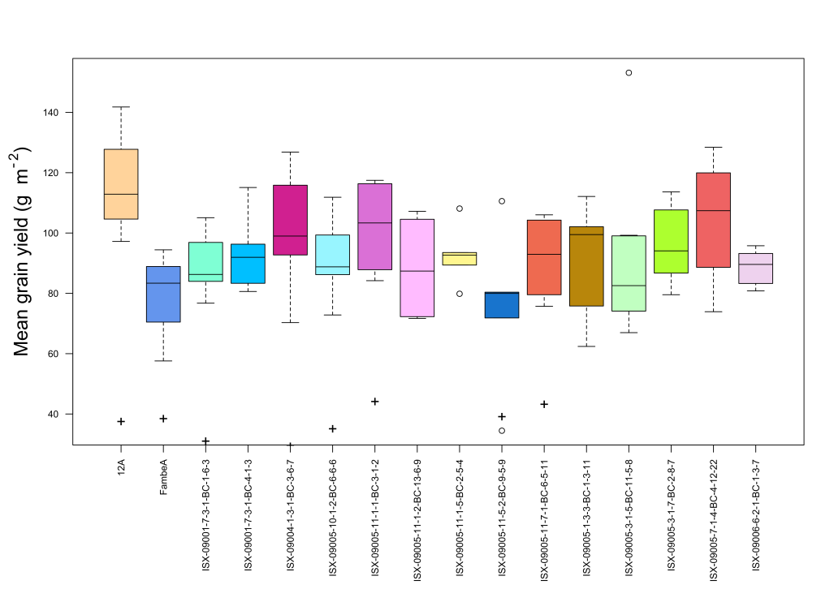
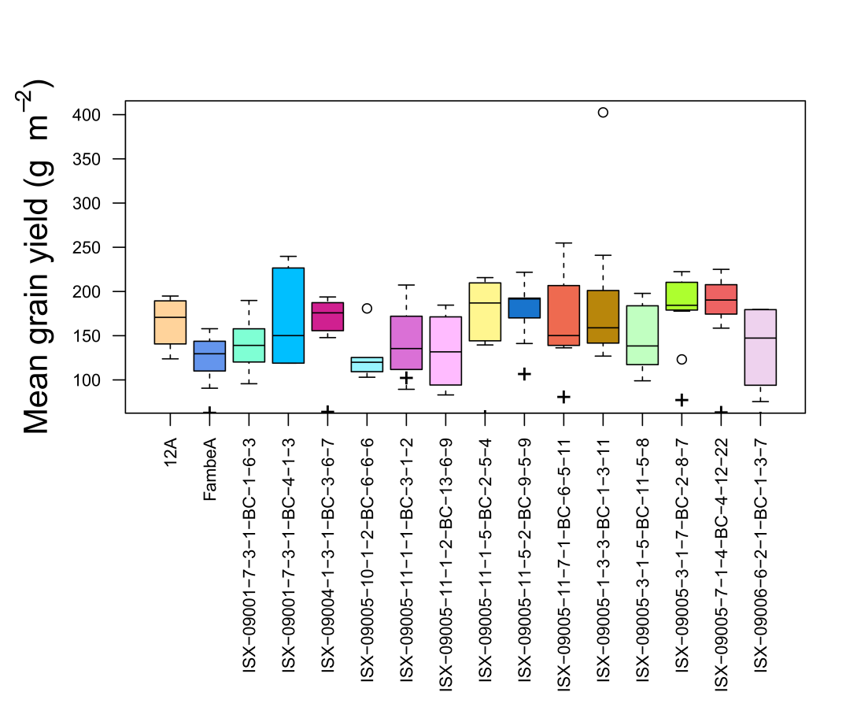

Grain yield in Low P
Grain yield in High P

Fig. 1 Grain yield of hybrids in High P and Low P conditions in Samanko

Next steps
Phenotypic data analysis will be pursued and SCA will be performed to identify the best new hybrids for further evaluation including on-farm testing. Aso genotyping will be completed and a manuscript will be published on WCA the sorghum heterotic groups. PhD student is also completed is thesis on that topic.

