Impact evaluation of SLM options to achieve land degradation neutrality

Food security and better livelihoods

for rural dryland communities

April 2017

The IARC applicant | ICARDA
Project title | Impact evaluation of SLM options to achieve land degradation neutrality
Funding type,  GIZ Project Number and Contract Number | Small Grant  GIZ Project number: 14.1432.5-001.00  Contract number: 81204252
Reporting Period | From 01/08/2016 to 28/02/2017
Project Coordinator and Project Scientists | Richard Thomas (project coordinator)  Address: ICARDA Abdoun, Khaled Abu Dalbouh Street  Buildings No. 15, Amman, Jordan  Phone number: +962-6-5903120  Phone number: +1 289-888-1400  e-mail address: r.thomas@cgiar.org  Quang Bao Le (Scientist)  Address: Abdoun, Khaled Abu Dalbouh Street  Buildings No. 15, Amman, Jordan  Phone number: +962-6-5903120  e-mail address: Q.Le@cgiar.org  Enrico Bonaiuti (Scientist)  Address: Abdoun, Khaled Abu Dalbouh Street  Buildings No. 15, Amman, Jordan  Phone number: +962-6-5903120  e-mail address: E.Bonaiuti@cgiar.org  Chandrashekhar Biradar (Scientist)  Address: Abdoun, Khaled Abu Dalbouh Street  Buildings No. 15, Amman, Jordan  Phone number: +962-6-5903120  e-mail address: C.Biradar@cgiar.org  Fajr Fradi (Junior Project Officer/Scientist)  Address: Abdoun, Khaled Abu Dalbouh Street  Buildings No. 15, Amman, Jordan  Phone number: +962-6-5903120  e-mail address: fajr.fradi@cgmel.org
Project Partners | iMMAP  Badabate Diwediga (Multi-functional Landscape Expert)  Jim Jaspe (Web-based GIS technician)  Bashar Ayyash (IT/Programmer)  Codeobia  Moayyad AlNajdawi  Institut National de Génie Rural, Eaux et Forêts  Taoufik Hermassi (SLM Scientist)

State of Project Implementation
The aim of the project is to develop and implement a web-based GIS tool for defining sustainable land management (SLM) options by social-ecological context at global scale. This Global Geo-informatics Context and Options (GeoCOs) tool aims to support the implementation of SLM practices by the international community. The GeoCOs is designed to provide stakeholders/projects and programmes with plausible, robust extrapolation domains for guiding decisions on SLM options, and an open platform for docking different disciplinary projects into integrative/holistic, converging actions for SLM.
The alpha version of the tool has been developed within 6 months of the project’s initiation and is ready for testing with partners in March 2017 to achieve output 2, a country-specific knowledge base of standardized geo-referenced SLM options by context compendium.

General Achievements and Problems encountered
- DESIGN CRITERIA

The criteria for the development of GeoCOs includes:
- based on a systems framework that is science-sound and coping sufficiently with the diversity of social-ecological contexts
- improved linkages among different scales (from global to regional and local landscape) and between pixelized codes and descriptive/profile data (e.g. GIS rasters of socio-biophysical data and standardized profiles of SLM data),
- multiple entry points for diverse needs and preferences of users
- common use functions, yet easy-to-use
open for improvements and customizations (version-by-version)

- SYSTEMS-BASED RATIONALES

Our review of contemporary systems frameworks has pointed out three main gaps. Firstly some frameworks commonly used in SLM analysis and assessment (e.g. Driver – Pressure – State – Impact – Response (DPSIR)) generally overlook the contextual diversity that would shape SLM outcomes. Secondly, many current studies use typologies as strata to aggregate/design management options without testing whether the types do actually shape SLM outcomes. Thirdly there is a lack of spatially explicit tools capable of generalizing regional/global patterns from place-based findings.

The thrust of conceptual framework for GeoCOs is a systems-based clarification of the relationship between context (including drivers) and management options as the basis for data integration, selection of objective-oriented indicators and analysis/assessment of the diversity of land use systems and related contexts over space (Figure 1).
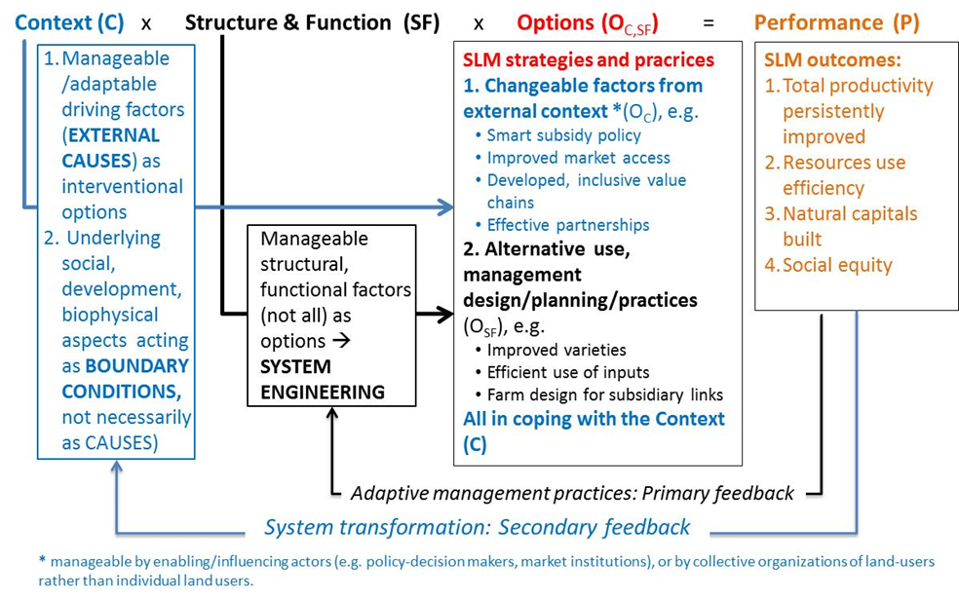
Figure 1: Relationship between SLM management options, structure and function of land use systems and context with a system-in-transition thinking. Sources: (Le et al., 2016b; Le et al., in prep-c)

Based on the systems framework in Figure 1, the structure of GeoCOs database includes three domains and influencing linkages as showed in Figure 2. The contextual data include not only the social, economic and biophysical drivers of land management, but also the identities of the land use system itself and land users’ needs/preferences. The SLM data is a portfolio of technical and institution options that is kept open for continuous addition by stakeholders in the course of learning and development.
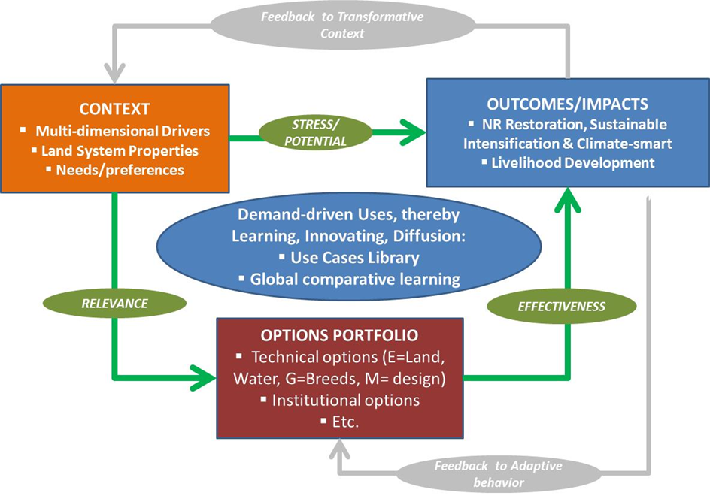Figure 2: Data domains and influencing linkages in GeoCOs. Source: (Le et al., 2016a)

Contextual variables in the current version of GeoCOs are briefly described in Table 1, Annex 1. The global data are collected and resampled (up- or down-scaled to 1 km resolution) from different sources (such as USGS, FAO-IIASA, UNEP, IUCN, CIESIN-CIAT, CGIAR-CSI). Important data such as inter-annual trends of rainfall, social-ecological contextual types are driven from the analyses of CRP-DS‘ data on integraetd systems work. Agricultural resource poverty, proximities to roads, towns and water bodies were calculated by ICARDA Geoinformatics Unit (ICARDA, 2016; http://geoagro.icarda.org/en/).
The innovation introduced by the tool is the initiation of the functional context socio-ecological types (fCSET) approach to overcome these challenges of socio-ecological context diversity. Details of this approach are included in Annex 1
- USE FUNCTIONS AND USE-CASES

  - Use functions
GeoCOs has web-based GIS Graphic User Interface (GUI) and integrated databases that allow users to start from the entry points they prefer. The tool will allow querying the different SLM measures from around the world to search ‘similar’ environments based on their geographical, biophysical and socioeconomic context and to search ‘similar’ SLM measures or SLM types or SLM techniques with the same goals. By showing all the options for a certain context, the platform facilitates the dissemination of SLM techniques to researchers, policy decision-makers, and land manager (including farmers). The main functions of the GeoCOs are expressed in Figure 3.
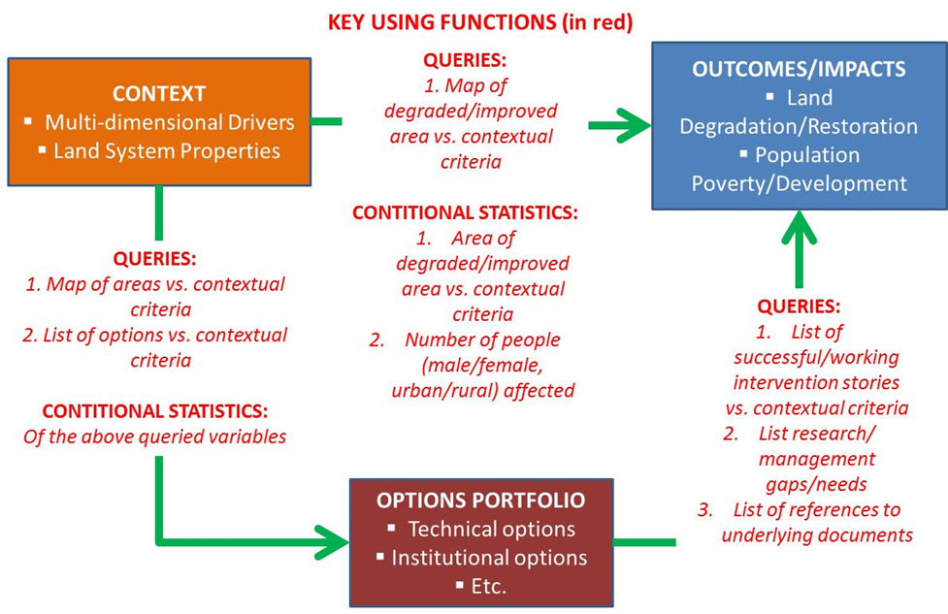
Figure 3: Key functions (expressed by the red texts in linking with three data domains) of the GeoCOs (Le 2016, Le et al. 2016b)

  - Use Cases’ approach
A common challenge in this type of work deals with the absence of sufficient guidance to utilize complex data resources for diverse users' contexts, including user-specific purpose, objective, application scales, institute's or group's capacity and many other factors. Today, system informatics deals with this complex challenge by following use case approach. A typical use-case is a sequence of limited steps that describes the interactions between a typical user (or users group) and the information system to accomplish a typical goal. To cope with diverse uses needed, the approach aims at establishing a use cases library that consists of as many as possible typical use cases. Given a use case library, a specific user can find a typical use case that is similar to his/her need for rapid application with low cost. Recognized strengths of the approach are: (1) strong analytical perspective and complete analysis assurance, (2) simple and easy to understand and adopt, (3) widely recognised market standard, (4) encourage join work between users and system designers to develop typical use case library.
We are developing the three typical use cases in line with common entry points:
- Context-based analysis: searching implemented SLM options with a defined context
- Option-based analysis: searching similar contexts given a considered SLM option
Outcome-by-context evaluation: Evaluation of outcomes (via a limited set of performance indicators) given a defined context.

Conclusions for the following Reporting Period
DATA DOMAINS
Since the context data is already set, the GIS conultant will develop the outcome-Impact data according to the Impact variables as described in Table 2 (Annex 1). In addition,the web-based template is being tested now and the first version will be finalized in tthe middle of 2017.
USE FUNCTIONS AND USE-CASES
The iMMAP developers in cooperation with CRP Dryland Systems and ICARDA have specified the web-based GIS system’s IT architecture and wrote IT installation guide (Cumani et al., 2016). They are working on the three typical use cases. Already the context-based analysis is almost done; the work now will be focused on two other use cases: option-based analysis and outcome-by-context evaluation.
A first version of the tool will be released officially by March 2017. We plan to test with the research partners in Tunisia during a training in Tunisia in March 2017.
RESEARCH DISSEMINATION PRODUCTS
A training on the job and a workshop to announce the Web-GIS tool is planned for March where we test its first version with NARS and other partners. Depending on the findings, we plan to release a journal article where we will work on analysing the pre and post impact of SLM practices in Tunisia. Furthermore, we will release a policy brief to the policy makers in Tunisia pointing out the potential of our tool to support decision making in SLM national policies. Videos are planned also with the stakeholders, the potential users of the tool to caption the different activities of the project.

Publications, Papers and Reports
Websites of the project:
https://mel.cgiar.org/projects/slmoxc
https://mel.cgiar.org/projects/slmoxc/52/impact-evaluation-of-sustainable-land-management-slm-in-tunisia
Website of the web-based GIS tool: http://192.168.1.41/webgis/
Publications (Reports, Workshop/Conference Proceedings, Papers):
Cumani, R., Jaspe, J., Hagen, C.V., Le, Q.B., Bonaiuti, E., El-Shamaa, K., Biradar, C. (2016). Monitoring, Evaluation and Learning Platform: Web-based GIS SLM Option by Context - System Architecture & Installation Guide. CGIAR Research Program on Dryland Systems (CRP-DS) - Information Management and Mine Action Programs (iMMAP) - International Center for Agricultural Research in Dry Areas (ICARDA), Amman, Jordan, p. 85.
ICARDA (2016). Geoinformatics Spatial Solutions for Integrated Agro-ecosystems – Open-access data portal. URL: http://geoagro.icarda.org/
Le, Q. B., Biradar, C., Bonaiuti, E., and Thomas, R. (2016a). Systems Approach to Link Big Socio-ecological Geo-data to Food Systems Sustainability. In "Proceedings of the 8th International Congress on Environmental Modelling and Software, July 10-14" (S. Sauvage, J. M. Sánchez-Pérez and A. E. Rizzoli, eds.), Vol. 3, pp. 677. International Environmental Modelling and Software Society (iEMSs), Toulouse, France.
Le, Q. B., Biradar, C., Thomas, R., Zucca, C., and Bonaiuti, E. (2016b). Socio-ecological Context Typology to Support Targeting and Upscaling of Sustainable Land Management Practices in Diverse Global Dryland. In "Proceedings of the 8th International Congress on Environmental Modelling and Software, July 10-14" (S. Sauvage, J. M. Sánchez-Pérez and A. E. Rizzoli, eds.), Vol. 1, pp. 294. International Environmental Modelling and Software Society (iEMSs), Toulouse, France.
Le, Q. B., Biradar, C., Thomas, R., Zucca, C., and Bonaiuti, E. (in prep-c). Socio-ecological Context Typology to Support Targeting and Upscaling of Sustainable Land Management Practices in Diverse Global Dryland. Journal manuscript in preparation.

Summary
The alpha version of the GeoCOs tool has been developed and is under testing and further refinement pending the first training session of potential users in March 2017. Data domains on the contexts and SLM options have been established using global data from various freely available databases that combine biophysical and socio-economic data. From this information extrapolation domains for specific SLM options are being developed that will allow better targeting of the options for improved land management. Examples are being developed for specific countries that will aid their objectives for achieving land degradation neutrality and production and social benefits for land users. A library of use case studies is being established for widespread dissemination of targeted SLM option. The Web-based GIS tool has entry points for pre-defined contextual types; user defined contextual criteria, pre-defined option types, and a search facility for users. Further work will develop outcome-impact data related to the application of SLM options.

