RTBFoods  WP2: Biophysical characterization of quality traits |  |  | 
Determination of amylose content in yam flour
SOP: Yamylose
Date: 22/03/2019 |  | Release: 1
Written by : Lucienne Desfontaines (INRA), Denis Cornet (CIRAD), Christian Mestres (CIRAD)

For information on this SOP please contact :
- Christian Mestres, WP2 Leader
- Lucienne Desfontaines, Head of lab at INRA UR-Astro

This document has been approved by :
Partner | Name of the person who approved |  | Date  DD/MM/YY
XX
XX
XX

Table of contents

1 Scope and application 3
2 References 3
3 Définitions 3
4 Principle 3
5 Reagents 3
6 Apparatus 3
7 Procedure 3
8 Expression of résults 3
8.1 Method of calculation and formulae 4
8.1.1 Calculation 4
8.1.2 Formulae 4
8.2 Repeatability 4
9 Critical points or Note on the procedure 4
10 Test report 4
11 Revision record 4
12 Appendix 5

Scope and application
This procedure specifies a reference method for the determination of the amylose content of dried, milled (<0.2 mm) yam flour. The method is applicable to yams with an amylose mass fraction between 8% and 30% DM.

References
This procedure adapted the ISO norm n°6647 (2015) to determine amylose content on rice.

Definitions
Amylose: polysaccharide constituent of starch, the macromolecules of which have glucose units linked in a predominantly linear structure.
Yam flour: yam product obtained after drying peeled yam tuber at 60-70°C during 48h followed by grinding and sieving at 0.2mm.

Principle
Dried peeled yam tubers are ground to a very fine flour (0,2 mm) to break up the endosperm structure in order to aid complete dispersion and solubilization. Compare to reference method and taken the low fat content of yam tubers, the flour is not defatted. A test portion is dispersed in a sodium hydroxide solution, to an aliquot portion of which an iodine solution is added. The absorbance, at 620 nm, of the color complex formed is then determined using a spectrophotometer. The amylose mass fraction of the sample is then read from a calibration graph, which is prepared using simple solution of potato amylose and amylopectin to make allowance for the effect of amylopectin on the colour of the amylose–iodine complex of the test solution.
The method actually determines the affinity of amylose for iodine at 620 nm and for amylopectin at 545 nm. The determination is made at 620 nm and 545 nm to take account interfering effects of amylopectin.
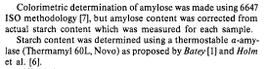

Reagents
- Demineralized water (18,5 Méga Ohm)
- Ethanol, a volume fraction of 95%
- Sodium hydroxide dispersal solutions, 1 mol/l and 0.09 mol/l
- Acetic acid, 1 mol/l
- Potassium iodide (KI : 303166, Fluka)
- Iodine (I₂ : 6617, Prolabo)

Apparatus
- Spatulas
- Watch glasses
- Graduated round-bottom flask of 100 ml and 250 ml
- Bottle-top dispenser from 0 to 10 ml (e.g. Dispensette©)
- Glass volumetric flask of 100 ml and 250 ml
- Test tubes of 10 ml
- Micropipettes de 200 à 1000 µl et 2 ml à 10 ml
- Analytical balances (e.g. Mettler AE100 BALCO with precision 0.1mg and Mettler PE 360 with precision of 0.001g)
- Diluter (e.g. Microlab 600 series)
- Syringes of 10 ml and 2ml (e.g. Hamilton)
- Spectrophotometer (e.g. Cary 100 UV-Vis, Agilent)
- Racks
- Protection clothes (e.g. gloves, blouse)

Procedure

Preparation of solutions

Iodine solution
In two watch glasses, weight 2g of Potassium iodide (KI) and 0.2 g d’iode (I₂) with a precision of at least 5mg. Fill them into a graduated round-bottom flask of 100 ml and adjust with demineralized water. Mix during one hour before until complete dissolution.

NaOH 1 mol/L and 0,09 mol/L solutions
For NaOH 1 mol/L : Weight 10g of sodium Hydroxyde (NaOH) and fill them into a graduated flask of 250 ml, and adjust with demineralized water. Mix during until complete dissolution
For NaOH 0,09 mol/L : Take 9 ml of the solution at 1 mol/L of NaOH, then introduce them into a graduated flask of 100 ml. After shaking, the volume was adjust with demineralized water and mix for homogeneisation..

Sample and standard solution preparation

10 mg of sample and standards (amylose and amylopectine) were weighted in a glass tube of 10 ml, then solubilizedby 1M NaOH solution according to the following table 1.

 | Glass tube of 10 mL
 | Amylose | Amylopectin | Blank essay | Sample
Amylose | 10 mg | --- | --- | ---
Amylopectin | --- | 10 mg | --- | ---
Sample | --- | --- | --- | 10 mg
Ethanol à 95% | 0,1mL | 0,1 mL | 0,1 mL | 0,1 mL
 | Mix lightly
NaOH 1M | 0,9 mL | 0,9 mL | 0,9 mL | 0,9 mL
Keep 15h to 24h at ambient temperature, or in a water bath at 100°C for 10 minutes.
Then, add in each glass tube 9 ml of demineralized water.
Table 1. Solubilization procedure
Amylose and Amylopectin are prepared in duplicate to build the calibration curve. All sample are prepared in triplicate.

Standard curve of Amylose and Amylopectin, and development of iodine - coloration preparation

Standard curve of Amylose (0-400 µg/ml)
In the stock solution of amylose at 1 mg/ml, the curve of calibration was prepared as described in the following table. 500 µl of each sample are used to iodine-coloration in same time.
Glass tube of 10 ml | Blank | 1 | 2 | 3 | 4 | 5 | 6 | Sample
Amylose (µg/ml) | 0 | 50 | 100 | 200 | 250 | 300 | 400 | ?
Vol. Amylose 1 mg/ml (µL) | 0 | 25 | 50 | 100 | 125 | 150 | 200 | 0
Vol. NaOH 0,09 N (µL) | 0 | 475 | 450 | 400 | 375 | 350 | 300 | 0
Vol. extract (µL) | 500 | 0 | 0 | 0 | 0 | 0 | 0 | 500
Vol. pure water (mL) | 4.5
Vol. acetic acid 1M (µL) | 100
Vol. Iode (µL) | 200
Vol. pure water(mL) | 4.7
Vol. total (mL) | 10
Reading absorbance (nm) | The absorbance of standard and sample were measured at 620 and 545 nm after 20 minutes

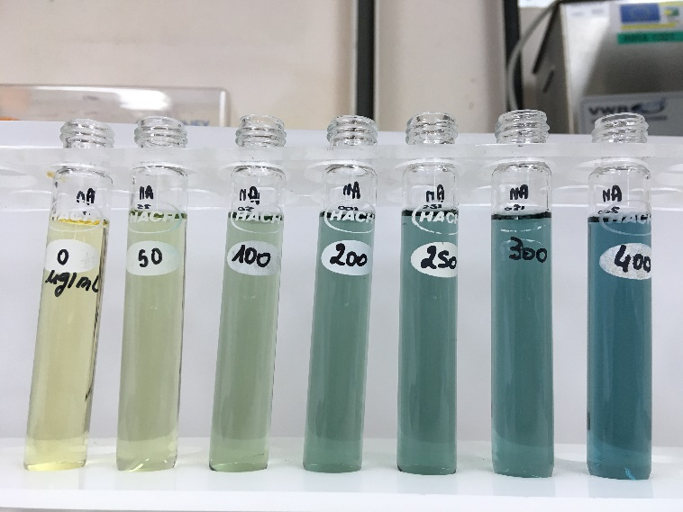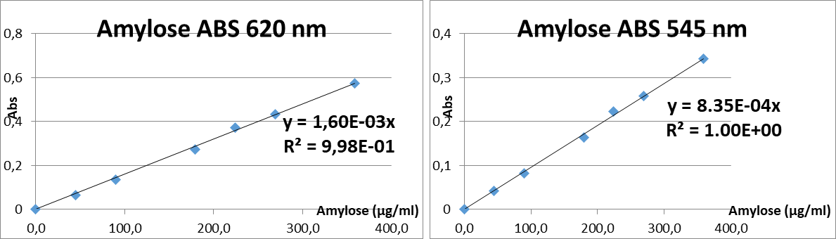
Photo 3 : Standard curve of Amylose

Standard Curve of Amylopectin (0-1000 µg/ml)

In the stock solution of amylopectin at 1 mg/ml, the curve of calibration was prepared as described in the following table. The same tube of 500 µl of each sample is used for iodine coloration
Glass tube of 10 ml | Blank | 1 | 2 | 3 | 4 | 5 | 6 | Sample
Amylopectin (µg/ml) | 0 | 100 | 200 | 300 | 600 | 800 | 1000 | ?
Vol. Amylopectin 1 mg/ml (µL) | 0 | 50 | 100 | 150 | 300 | 400 | 500 | 0
Vol. NaOH 0,09 N (µL) | 0 | 450 | 400 | 350 | 200 | 100 | 0 | 0
Vol. extract (µL) | 500 | 0 | 0 | 0 | 0 | 0 | 0 | 500
Vol. pure water (mL) | 4.5
Vol. acetic acid 1M (µL) | 100
Vol. Iode (µL) | 200
Vol. pure water (mL) | 4.7
Total Vol. (mL) | 10
Absorbance (nm) | The absorbance of standard and sample were measured at 620 and 545 nm after 20 minutes

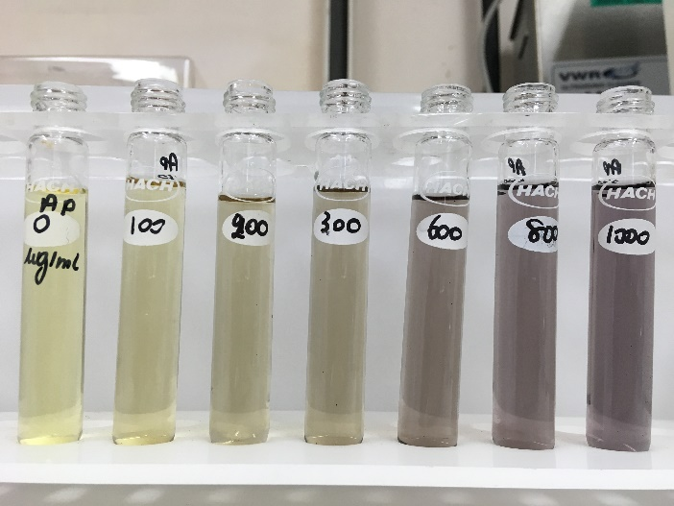
Photo 4 : Standard curve of Amylopectin
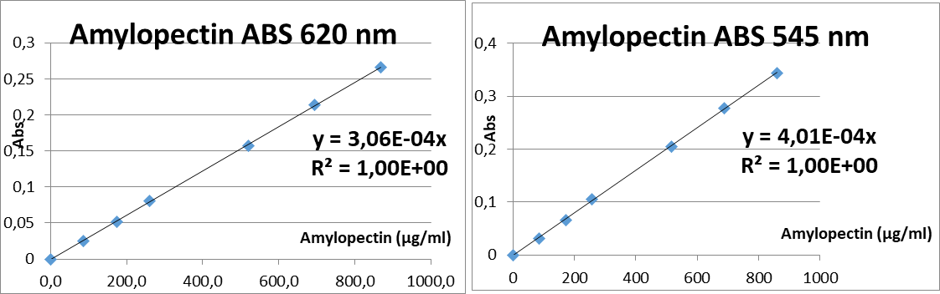

Expression of results

Method of calculation and formulae

Calculation
Calculation of Amylose and starch contents according to Mestres et al. (1997) modified
Linear regression coefficients were calculated for the absorbance of amylose (Y620 and Y545) and amylopectin (P620 and P545) at 620 and 545 nm, respectively. Correlation coefficients were always over 0.99. Sample absorbance at 620 and 545 nm will be noted S620 and S545, respectively.

Formulae
$Amylose (Amy, µg/mL)=$ $\frac{P_{545} S_{620} {- P}_{620} S_{545} }{\left( Y_{620}-P_{545}\right) - (Y_{545}-P_{620})}$

$Amylopectin (Amp, µg/mL)=$ $\frac{Y_{620} S_{545} + Y_{545} S_{620}}{\left( Y_{620} P_{545}\right) - (Y_{545} P_{620})}$

$$Starch \left(Sth, µg/ml\right)=Amy+Amp$$

$$Amylose (\% starch basis)=\frac{Amy ×100}{Sth}$$

NB : Excel sheet for the calculation of Amylose (µg/ml) and Amylose (% Starch).

We can then calculate the content of Amylose, Amylopectin and Starch in % of DM according the formula:
Amylose % MS = Amy (µg/ml) * Vextract (10 ml) * 100*0.1/PE(10 mg) * DM (%)
Amylopectin % MS = Amp (µg/ml) * Vextract (10 mL) * 100*0.1/ (PE (10 mg) * DM (%)
Starch % MS = Amy + Amp
Amylose % Starch = Amy % MS * 100/Starch % MS
NB : Excel Sheet for the calculation of concentration in % of DM

Repeatability
According to C-Mestres and al 1997 (2), the accuracy of the method is fairly well for solutions having starch content from 13.5 to 27 µg/ml or Amylose content from 25 to 75 % (starch basis).
In yam dry flour, we found that the method is validated for amylose content > 8% MS or amylose >15% starch basis.
An acceptable difference between duplicate or triplicate sample carried out simultaneously by the same analyst < 0.8 % was determined.
The function to estimate the error upon the result is given by the formula Y = 232.41.X^{(-1.093)} with R² = 0.9877
This method is actually validated for amylose content in yam dry flour comprise within the range of 8.2 to 29.5 % MS.
It would be interesting to evaluate in other samples with larger content of amylose to extend the range.

Bibliographie
- Norme internationale – ISO 6647 – Riz – Détermination de la teneur en amylose
- Mestres C., Nago M,. Akissoe N., Matencio F. – End Use Quality of Some African Corn Kernels. 2. Cooking Behaviour of Whole Dry-Milled Maize Flours; Incidence of Storage. J Agric. Food Chem 1997, 45 565-571.
- Norme NF T90-210 (mai 2009). Protocole d’évaluation initiale des performances d’une méthode dans un laboratoire

Critical points or Note on the procedure
Dry matter of each sample was determined using a deshumidificator Radwag at 105°C.
Sample were cut in pieces of 1 cm x 1 cm before drying at 50-60°C. Then the dry sample were ground in fine particules < 0.2 mm

Test report
The test report shall indicate the method used and the results obtained. In addition, it shall mention all operating conditions not specified in the international procedure, or regarded as optional, as well as any circumstances that may have influenced the results.
The test report shall include all details necessary for the complete identification for the sample.

Revision record
Date | Responsible person | Description of change
22/03/2019 | Denis Cornet | Beginning of the redaction
27/11/2019 | Lucienne DESFONTAINES | Complete the methodology

Appendix

