
Field Scientific Report

Participatory Processing Diagnosis of Pounded Yam in Nigeria
Understanding the Drivers of Trait Preferences and the Development of Multi-user RTB Product Profiles, WP1, Step 3
Umudike, Nigeria, March 2020
Tessy MADU, National Root Crops Research Institute (NRCRI), Umudike, Nigeria
Nnaemeka ONYEMAUWA, NRCRI, Umudike, Nigeria
Blessing UKEJE, NRCRI, Umudike, Nigeria
Miriam OFOEZE, NRCRI, Umudike, Nigeria
Benjamin OKOYE, NRCRI, Umudike, Nigeria

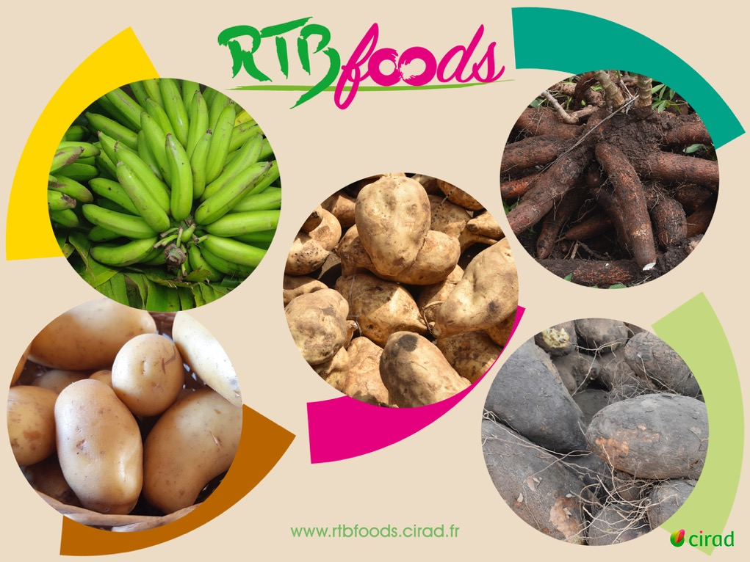
This report has been written in the framework of RTBfoods project.

To be cited as:
Tessy MADU, Nnaemeka ONYEMAUWA, Blessing UKEJE, Miriam OFOEZE, Benjamin OKOYE, (2021). Participatory Processing Diagnosis of Pounded Yam in Nigeria. Understanding the Drivers of Trait Preferences and the Development of Multi-user RTB Product Profiles, WP1, Step 3. Umudike, Nigeria: RTBfoods Field Scientific Report, 16 p.

Ethics: The activities, which led to the production of this manual, were assessed and approved by the CIRAD Ethics Committee (H2020 ethics self-assessment procedure). When relevant, samples were prepared according to good hygiene and manufacturing practices. When external participants were involved in an activity, they were priorly informed about the objective of the activity and explained that their participation was entirely voluntary, that they could stop the interview at any point and that their responses would be anonymous and securely stored by the research team for research purposes. Written consent (signature) was systematically sought from sensory panelists and from consumers participating in activities.

Acknowledgments: This work was supported by the RTBfoods project https://rtbfoods.cirad.fr, through a grant OPP1178942: Breeding RTB products for end user preferences (RTBfoods), to the French Agricultural Research Centre for International Development (CIRAD), Montpellier, France, by the Bill & Melinda Gates Foundation (BMGF).

Image cover page © LAJOUS P. for RTBfoods.
This document has been reviewed by:
Final validation by:
Alexandre BOUNIOL (CIRAD) | 26/11/2021

CONTENTS
Table of Contents
1 Study area 6
2 Raw material choice 6
3 Product profile processing 6
4 Results 7
4.1 Material characteristics 7
4.1.1 Dry matter Content and Starch Yield 7
4.2 Qualitative information collected on the raw material 7
5 Product profile process description 9
5.1 Unit operations characterization 10
5.1.1 Peel Yield (% w.b) and Processing Time (min) 10
5.1.2 Global processing yield (%) 12
5.1.3 Rate of Browning 12
5.2 Results of the processors' evaluation of the end-produce ready to eat (Pounded Yam) 13
6 Discussion and conclusion 13
7 Annex 1 14

ABSTRACT
In this study, pounded yam product profile in Nigeria was conducted among 4 processors; who processed each of the 4 varieties used for the study. All the varieties were coded thus; A, B, C and D. However, the experiment started with peeling down to pounding. The time allotted and quantity of water used for each activity was recorded. The qualitative and quantitative information were taken on every step of the processing. The raw tubers were accessed before and after processing, the final products were also accessed. The varieties used were, TDA11000477, TDA1100203, TDR1100497 and TDR11/00101. They were obtained from the African Yam Improved barn of NRCRI Umudike. The yam has been stored for 5 months in the barn before use. The yam tubers were selected to represent good and bad yams after a pilot sensory evaluation. The percentage dry matter content of the 4 varieties were recorded, the result shows that TDR’s ranked higher than TDA’s, with TDA1100497 having the highest dry matter of 37.58%, the variety with the lowest dry matter is TDR110203 (29.70%). The percentage of starch yield shows that the variety TDA1100497 also has the highest starch yield of 23.20%, and TDA11000477 (16.40%) as the lowest in the study area. On the qualitative data however, some questions were asked on raw materials during processing that gave good information thus: “Which variety do you dislike the most among the selected varieties for the processing demonstration? Why? What are the characteristics when you look at it? Another important question that was asked during the processing was; “What are the characteristics of that favorite variety that you notice when you look at the raw material? Are they similar to the characteristics of the variety you normally use for making pounded yam? The result of the experiment showed variations in the yam varieties accessed by processors in different unit of operations. During peeling, it was observed that TDA11000477 and TDA1100203 has a higher peeling time of 1.8 and 2 mins respectively while the peeling yield showed that both TDR1100497 and TDR11/00101 has a higher peel yield of 90.70% and 89.40% respectively. For cooking, TDA1100203 has the highest cooking time of 25.3mins while the lowest variety was TDR11/00101 at 19.5mins. During pounding, varieties that ranked high has starch that formed good dough and was easy to pound. The yams that were low in starch could not form good dough. TDA11000477 and TDA1100203 recorded high pounding time of 10.1 and 7.6min respectively with the lowest being TDR11/00101 at 5.3mins. The processors accessed the end product of the pounded yam and reported good and bad qualities. The good qualities were, easy to swallow, smooth, mouldable, no lumps, good aroma, moderately soft, easy to cut, bright (white) colour, milk (cream) colour and draws a little while bad qualities represent difficult to swallow, sticky, too soft, dark/dull colour, brown colour, scatters and has lumps. The assessment of the pounded yam by the processors indicated that the preferred colour ranged from cream to white, while brown was not acceptable. The dough with lower starch were sticky to the hand and was not preferred.

Key Words: Pounded yam, participatory processing, processing diagnosis, local processing methods, characteristics, Nigeria

Study area
The study was carried out in the South East Region of Nigeria. (Onueke, Ebonyi State). The inhabitants are the major Yam farmers and consumers in southeast, Nigeria.
GPS Location:
Latitude: 6.15540
Longitude: 8.03794

Raw material choice
The varieties used were, TDA11000477, TDA1100203, TDR1100497 and TDR11/00101. They were obtained from the African Yam Improved barn of NRCRI Umudike. The yam tubers were selected to represent good and bad yams after a pilot sensory evaluation. The yam has been stored for 5months in the barn before use.
The rate of browning was assessed by cutting cross-sectional slices approx. 20 mm from the proximal end of the yam tubers. These were observed immediately and after the slice had been allowed to stand 1 and 24h at 20°C. The degree of browning was assessed subjectively on a scale of 0 (no browning) to 3(marked browning all over the surface)
TDA11000477
The skin is dark brown and has a lot of strong hair. The skin is tough and very difficult to peel. From looking at it the pounded yam will be dark and brittle. It will be difficult to pound to form dough. The boiled yam will not be mealy.
TDA1100203
The skin is dark brown and it also has a lot of hairs. The skin is tough and difficult to penetrate with a knife, making peeling difficult. The rate of browning is 2+. The pounded yam and yam will be brown and not attractive to eat.
TDR1100497
The colour of the skin is light brown; the skin is soft and light. It will not be difficult to peel. Once cut there is little or no colour change. The flesh is white. It will have starch and will be easy to pound and chewing the boiled one will be pleasant in the mouth. The shape is round and smooth.
TDR11/00101
The colour of the skin is light brown, the skin is light and it will be easy to peel. The rate of browning is 0 but the head region is darkening a little but can be cut off or ignored. The yam will be easy to pound and it will form dough quick. The boil yam will be strong in the mouth; it will not melt. The shape is round and smooth.

Product profile processing
The experiment was conducted with 4 processors; who processed each of the 4 varieties used for the study. All the varieties were coded thus; A, B, C and D. The experiment started with peeling to pounding. The time allotted and quantity of water used for each activity was recorded. The qualitative and quantitative information were taken on every step of the processing. The raw tubers were accessed before and after processing, the final products were also accessed.

Results

Material characteristics

Tableau 1: Dry matter content (%) and starch yield (%)

Dry matter Content and Starch Yield
The percentage dry matter content of the 4 varieties were recorded, the result shows that TDR’s ranked higher than TDA’s, with TDA1100497 having the highest dry matter content of 37.58%, the variety with the lowest dry matter content is TDR110203 (29.70%). The percentage Starch yield was done using Sedimentation method in triplicate and was calculated by expressing as the percentage of the original weight of the yam sample (100g), the result shows that the variety TDA1100497 also has the highest starch yield of 23.20%, and TDA11000477 (16.40%) as the lowest in the study area (Fig. 1).
T-Grouping | Variety | N | Mean
A | TDR1100497 | 3 | 37.58
B | TDR11/00101 | 3 | 32.76
C | TDA11000477 | 3 | 30.02
D | TDA1100203 | 3 | 29.71
Table 1: Mean dry matter content (%) of roots

Qualitative information collected on the raw material
On the qualitative data, some questions that was asked on raw materials during processing that gave good information were: “Which variety do you dislike the most among the selected varieties you will process for that processing demonstration? Why? What are these characteristics when you look at it? (Please, collect the local name of the variety cited by the processor and if possible scientific name)?
Processor A answered thus; “variety A, it is hard and does not have bright colour and will easily have lumps during pounding which will give a poor quality pounded yam, not easy to mould, with dark colour.
Processor B said; ‘’Variety A, because it is one spots on the body which will give a poor quality pounded yam, not easy to mould, with dark colour
Processor C: Variety B (TDA100203): The body has a lot of strong hairs, if I boil it will be watery so pounding in will be a waste of time because it cannot hold and will be too sticky, it will darken when I peel it.
Processor D said; “For pounded yam, variety A is the worst because when pounding it is difficult to reconstitute.
Another important question that was asked during the processing is; what are the characteristics of that favorite variety that you notice when you look at the raw material? Are they similar to the characteristics of the variety you normally use for making this [product under study]? The processors answered the questions thus”
Processor A; Yes, It has smooth body, it has light skin, it has light brown colour. Processor B; said not as smooth as the one for boiled yam, the colour should be very bright, it should have less sugary taste.
Processor C said: The colour is light brown and it has smooth body like the one I eat at home while processor D answered; yam has different types the best variety is opoko and it is similar to variety

Product profile process description
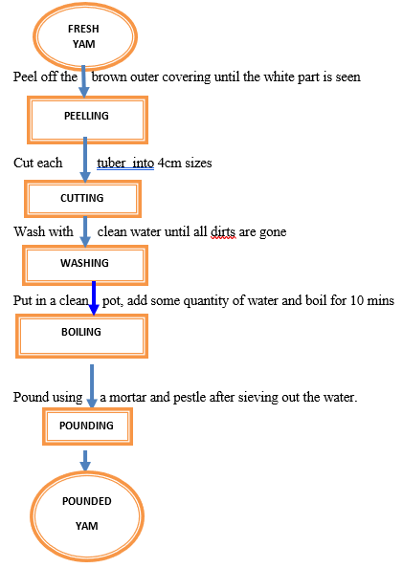
Tableau 2: Unit operations of product profile process

Unit operations characterization

Peel Yield (% w.b) and Processing Time (min)

Tableau 3: Peel Yield (%) of yam tuber for each variety under study
The first stage of operation is peeling, the peeling yield ranges from 84.62% to 90.70% showing significant difference between the 4 varieties (Appendix 1). TDR1100497 has the highest peel yield of 90.70% followed by TDR11/00101 (89.40%) and TDA11000477 having the lowest peel yield at 84.62%.
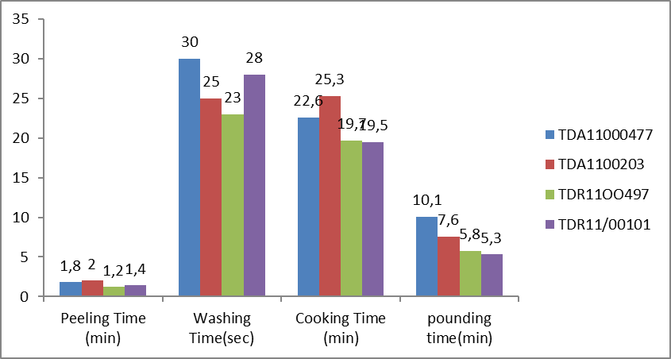
Tableau 4: Processing Time (min) of yam tuber for each variety under study

Peeling time
The figure 3 shows that for the peeling unit operation the variety TDA1100203 obtained the highest peeling time of 2mins followed by TDA11000477 with 1.8mins. TDR has the lowest peeling time of 1.2min while TDR11/00101 has the peeling time of 1.4.

Washing time
In the second stage of the experiment, where the yam is washed and put in a pot before cooking, the result of the washing productivity ranged between 1.2 to 2.0kg/hour/operator, the highest washing productivity was obtained with the varietyTDA1100203, followed by TDA11000477 at 1.8 min and TDA1100497 as the lowest at 1.2min. This result is linked with the quantitative data collected.

Cooking Time
This is the third stage of the processing operation after washing, the yam is put in a pot and place on fire to be cooked. The cooking time ranged between 19.5 and 25.3 min. The highest cooking time was 25.3 min with TDA1100203 variety, followed by TDA11000477 variety at 22.6 min while the variety with the lowest cooking time was TDR1100101at 19.5 min (Fig.4).

Pounding time
This is the final stage of the processing operation in the experiment, the pounding time for 1kg of each variety ranged between 5.3 to 10.1 min. The result shows that TDA11000477 has the highest pounding time of 10.1mins, followed by TDA1100203 at 7.6min and TDR1100101 has the lowest pounding time of 5.3 (Fig. 4).

Tableau 5: Weight of pounded dough (kg)
The weight of the result in Fig.5 shows that TDR1100497 and TDR1100101 weigh higher than the TDA1100203 and TDA11000477. TDR1100101 (1.75kg) and TDR1100497 (1.6kg) while TDA1100203 (1.3kg) and TDA11000497 (0.9kg) respectively.

Global processing yield (%)
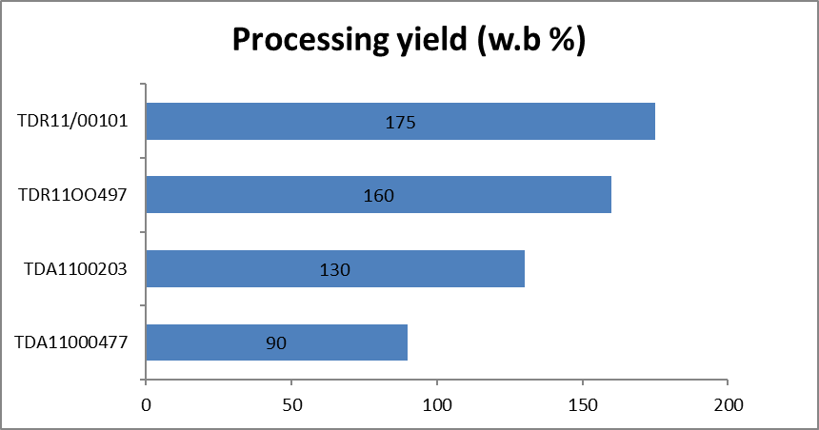
Tableau 6: Processing yield (% w.b)

Processing yield
The result of the processing yield shows that the processing yield increase ranged from 175% to 90% with TDR11/00101 having the highest and TDA11000477 having the lowest. The second was TDA1100497with the processing yield of 160% this could be attributed to the absorption and retention of water by the yam varieties. It can also be linked to the dry matter content of the fresh tuber.

Rate of Browning
Table 2: Rate of browning
Variety | Browning
TDA11000477 | 3+
TDA1100203 | 2+
TDR11OO497 | -
TDR11/00101 | -
Values were obtained by cutting cross-sectional slices approx. 20 mm from the proximal end of the yam tubers. observed immediately and after standing for 1 and 24h at 20°C. The degree of browning was assessed subjectively on a scale of 0 (no browning) to 3(marked browning all over the surface).
The result of the rate of browning shows that TDA11000477 has the highest browning rate of 3+ followed by TDA1100497 (2+) both are D. alata the browning effect was not observed in the D. rotundata varieties used. This had a tremendous effect on the acceptability of the Yam final products.

Results of the processors' evaluation of the end-produce ready to eat (Pounded Yam)
In the end product assessment, the processors were asked to assess the end product of pounded yam. Processor A said; ‘’It has lumps; It scattered and will not be easy to swallow. It was smooth and will be easy to mould and swallow and draws a little. The mouldability is good. It is moderately soft.
Processor B responded thus; “the texture is sticky in the hand, it cannot be moulded easily. It is easy to mould and draws.
Processor C answered; “I like it, it is smooth, it is soft not too soft. It has no lumps, it is drawing like normal and colour is bright while processor D said; “Variety A (TDA11000477sticks to the hand. Variety B (TDA1100203) does not form together, Variety C (TDR1100497) does not stick to the hand while Variety D (TDR 11/00101): it was smooth and not sticky, the taste is sweet.

Discussion and conclusion
The result of the experiment showed variations in the yam varieties as accessed by processors in different unit of operations. During peeling, it was observed that TDA11000477 and TDA1100203 has a higher peeling time of 1.8 and 2 mins respectively while the peeling yield showed that both TDR1100497 and TDR11/00101 has a higher peel yield of 90.70% and 89.40% respectively. For cooking, TDA1100203 has the highest cooking time of 25.3min while the lowest variety was TDR11/00101 at 19.50%.
During pounding, varieties that ranked high (TDR11OO497 and TDR11/00101) has starch that formed good dough and was easy to pound. The yam that were low in starch could not form good dough. TDA11000477 and TDA1100203 recorded high pounding time of 10.1 and 7.6min respectively with the lowest being TDR11/00101 at 5.3mins.
The assessment of the pounded yam by the processors indicated that the preferred colour ranged from cream to white, while brown was not acceptable. The dough with lower starch were sticky to the hand and was not preferred (Appendix 1).

Annex 1
Average statistics of the end product descriptors
Variety | DM (%) | Starch Yield (%) | Browning | Peel Yield (%) | Peeling Time (min) | Washing Time (sec) | Cooking Time (min) | Pounding time (min) | Weight of pounded dough (Kg)
TDA11000477 | 30 | 16 .4 | 3+ | 84.62 | 1.8 | 30 | 22.6 | 10.1 | 0.9
TDA1100203 | 29.7 | 17.8 | 2+ | 85.2 | 2 | 25 | 25.3 | 7.6 | 1.3
TDR11OO497 | 37.58 | 23.2 | - | 90.7 | 1.2 | 23 | 19.7 | 5.8 | 1.6
Appendix 1TDR11/00101 | 32.76 | 20.8 | - | 89.4 | 1.4 | 28 | 19.5 | 5.3 | 1.75
TDA11000477, TDA1100203, TDR1100497, TDR11/00101

Preferred and non-preferred varieties
Preferred Varieties | Non-Preferred Varieties
TDR11OO497 | TDA11000477
TDR11/00101 | TDA1100203

Overview of quality traits of raw yam, yam processing and Pounded yam
Name of varieties | Rawproduct |  |  |  |  |  | On the cooked
Name of varieties | Agronomical characteristics | Technological characteristics at each step of the process |  |  |  | Sensory characteristics
Name of varieties | Agronomical characteristics | Peeling | Shaping/ washing | Example | When you look at |  |  | Texture when you touch | When you smell | Taste (In mouth) | Texture when you chew | After-taste
TDA 11000477 | 94% establishment rate, Early maturing, 40.2 t/ha, Cylindrical in shape, Smooth in south and rough in N. Central, Slight oxidation after 1 hr | Easy to peel, smooth skin, | Cylindrical, No itching, slippery, slight oxidation |  | The colour is not good |  |  | It doesn’t mould well  Not smooth in the hand. It sticks to the hand. | Good aroma | Bitter taste |  | Difficult to swallow.
(TDA 1100203) | 84% establishment rate, Mid maturing, 42.1 t/ha, Smooth across location, Slight in less than 1 hr | Easy to peel, smooth skin, light skin | Cylindrical in shape, Slight oxidation during washing |  | Slimy, white colour, not fibrous, Cylindrical in shape. |  |  | It scatters in the hand, it doesnt form together. |  | Little sweet |  | Difficult to swallow
(TDR 1100497) | 87% establishment rate,late maturing, 36.7 t/ha, Cylindrical in shape, Smooth across location. | Smooth skin, Easy to peel, light skin, | Itches slightly, slippery, no oxidation |  | Bright colour (White) and cylindrical in shape |  |  | Moderately soft, It does not stick to the hand, Mouldable | Good aroma | It is sweet | It is smooth in the mouth
DR 11/00101 | 74.6% establishment rate, early maturing, 34.8 t/ha, Cylindrical in shape, Smooth across location, slight oxidation rate. | Smooth skin, Easy to peel | Cylindrical, No oxidation, slippery |  | Good colour (Milk colour) |  |  | It is smooth, Hard when you touch it | Good aroma | Surgary (sweet) taste



Institute: Cirad – UMR QualiSud
Address: C/O Cathy Méjean, TA-B95/15 - 73 rue Jean-François Breton - 34398 Montpellier Cedex 5 - France
Tel: +33 4 67 61 44 31
Email: rtbfoodspmu@cirad.fr
Website: https://rtbfoods.cirad.fr/

