
Field Scientific Report

Consumer Testing of Boiled Cassava in Rural and Urban Areas in Benin
Understanding the Drivers of Trait Preferences and the Development of Multi-user RTB Product Profiles, WP1, Step 4
Cotonou, Benin, December 2021
Laurent ADINSI, Université d’Abomey-Calavi, Faculté des Sciences Agronomiques (UAC-FSA), Cotonou, Benin
Laurenda HONFOZO, UAC-FSA, Cotonou, Benin
Imayath DJIBRIL MOUSSA, UAC-FSA, Cotonou, Benin
Alexandre BOUNIOL, Centre de coopération Internationale en Recherche Agronomiques pour le Développement (CIRAD), Montpellier, France
Joseph HOUNHOUIGAN, UAC-FSA, Cotonou, Benin
Noël AKISSOE, UAC-FSA, Cotonou, Benin

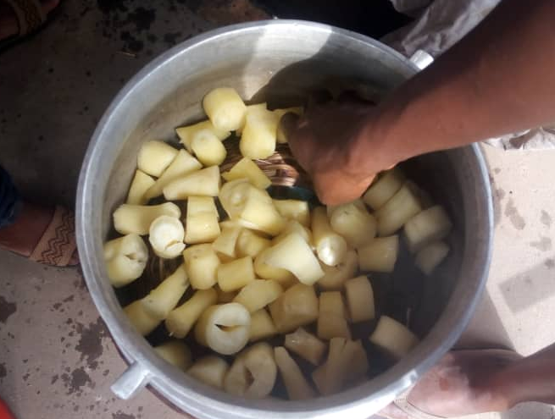

This report has been written in the framework of RTBfoods project.

To be cited as:
Laurent ADINSI, Laurenda HONFOZO, Imayath DJIBRIL MOUSSA, Alexandre BOUNIOL, Joseph HOUNHOUIGAN, Noël AKISSOE, (2020). Consumer Testing of Boiled Cassava in Rural and Urban Areas in Benin. Understanding the Drivers of Trait Preferences and the Development of Multi-user RTB Product Profiles, WP1, Step 4. Cotonou, Benin: RTBfoods Project Report, 23 p.

Ethics: The activities, which led to the production of this manual, were assessed and approved by the CIRAD Ethics Committee (H2020 ethics self-assessment procedure). When relevant, samples were prepared according to good hygiene and manufacturing practices. When external participants were involved in an activity, they were priorly informed about the objective of the activity and explained that their participation was entirely voluntary, that they could stop the interview at any point and that their responses would be anonymous and securely stored by the research team for research purposes. Written consent (signature) was systematically sought from sensory panellists and from consumers participating in activities.

Acknowledgments: This work was supported by the RTBfoods project https://rtbfoods.cirad.fr, through a grant OPP1178942: Breeding RTB products for end user preferences (RTBfoods), to the French Agricultural Research Centre for International Development (CIRAD), Montpellier, France, by the Bill & Melinda Gates Foundation (BMGF).

Image cover page © Adinsi L. for RTBfoods.
This document has been reviewed by:
Aurelie BECHOFF (NRI)  Geneviève FLIEDEL (CIRAD) | 16/09/2020  13/01/2021
Final validation by:
Aurelie BECHOFF (NRI) | 14/06/2021

CONTENTS
Table of contents
1 Background 7
2 Methodology 7
2.1 Boiled cassava samples 7
2.2 Consumer testing in rural and urban areas: overall liking, JAR and CATA tests 7
2.3 Data analysis 9
3 Results 9
3.1 Consumption habits of boiled cassava 9
3.2 Consumer overall liking of boiled cassava 10
3.3 Segmentation of consumers into groups of similar overall liking 10
3.4 Demographic data of the consumers interviewed 12
3.5 Identification of drivers of consumers’ liking for boiled cassava 13
3.6 Mapping of quality characteristics of boiled cassava varieties and relationship with overall liking 17
4 Conclusion 21
5 References 22

List of tables
Table 1: Distribution of respondents by region and gender within consumer testing area 7
Table 2: Sources* of characteristics used for building the CATA table 8
Table 3: Consumption habits of boiled cassava 9
Table 4: Mean overall liking scores of boiled cassava varieties tested in rural and urban areas 10
Table 5: Socio-demographic and boiled cassava consumption differences of the consumers 12
Table 6: Frequency (%) of citation of a cassava variety using a specific sensory descriptors 14
Table 7: Mean drops and penalties of overall liking 16
Table 8: Frequency of citations of each quality characteristic by consumers during CATA test 19

Table of figures
Figure 1: Mean overall liking scores of five boiled cassava varieties by consumer cluster type (%), irrespective of locations (rural and urban areas) 12
Figure 2: Mean overall liking of boiled cassava by consumer clusters in rural and urban areas 12
Figure 3: Percentage of consumers who scored the six selected sensory characteristics JAR or not JAR 16
Figure 4: Significant penalties of overall liking per percent of consumers 18
Figure 5: Sensory mapping of quality characteristics of boiled cassava and the overall liking scored by the consumers using principal component analysis 21

ABSTRACT
This report is a part of the RTBfoods project WP1 outputs, essentially devoted to consumer testing (Activity 5) of boiled cassava. This activity aims to provide information on the relationships between sensory properties and consumer overall liking of boiled cassava. For this purpose, information related to sensory quality characteristics and processing of the boiled cassava were collected from previous activities (Activity 3 “Surveys” and Activity 4 “Processing diagnosis”) on boiled cassava and used for consumer testing on boiled cassava.
Place: Benin
Date: 15th – 24th July, 2020
Authors: Université d’Abomey-Calavi/Faculté des Sciences Agronomiques
Content:
Boiled cassava is one of the most common consumption forms of cassava roots in both rural and urban areas of Benin, West Africa. The sensory quality of boiled cassava is very important for the acceptance of a new variety by consumers. As popular as boiled cassava is in Benin, there is a lack of information on consumers’ demand for quality characteristics of this product. Hence, this study aimed at understanding the consumers’ demand for quality characteristics of boiled cassava. Five cassava varieties (Adjaha, Alanmandou, Atinwéwé, Dossi and Koléahomè) were processed into boiled cassava pieces and tested by 240 consumers in rural (Bonou and Dangbo) and urban (Porto-Novo) areas. Consumer testing was performed using hedonic, JAR and CATA tests. The overall liking of boiled cassava varied widely between cassava varieties (from a score of 2.7 ‘dislike moderately’ to 8 ‘like very much’ for Koléahomè and Dossi respectively). For Atinwéwé and Alanmandou varieties, the mean overall liking depends also on the locations where consumer testing was conducted (rural and urban areas). Dossi and Atinwéwé varieties fulfilled the hedonic expectations of the majority of consumers, independently of the locations. High quality boiled cassava should be ‘attractive’ with ‘white homogenous’ or ‘white outside’ and ‘yellow inside colour’, ‘crumbly in the mouth’, ‘easy to break with the hand’, ‘sticky between fingers’, ‘with no fibres’, a ‘sweet taste’ (very or slightly) and a ‘good cassava smell’. Irrespective of the cassava variety, the overall liking of boiled cassava was greatly penalized by ‘too yellow colour’, ‘not easy enough to break with the hand’, ‘not crumbly enough in the mouth’ and ‘too bitter taste’ and ‘bitter aftertaste’ attributes.
Keywords: Boiled cassava, CATA (Check All That Apply) analysis, consumers’ liking, consumption habits, JAR (Just About Right) analysis, penalty analysis, sensory quality characteristics.

Background
Some sensory characteristics of the boiled cassava were collected during previous Activity 3 “Surveys” (Adinsi et al., 2020). In addition, during Activity 4 “Processing diagnosis” (Bouniol et al., 2020), the suitability (or not) of cassava varieties for processing into boiled cassava and their associated quality characteristics was determined. This activity 5 “Consumer testing” aims to provide information on overall liking scores of boiled cassava samples, optimum level of intensity for some sensory descriptors and mapping of sensory characteristics and boiled cassava varieties to better understand the relationships between sensory characteristics and consumer overall liking. Thus, the aim of this activity is to understand the consumers’ demand for quality characteristics of the boiled cassava in Benin. In addition, it aims to provide WP2 with a clear and visual mapping of the most liked products associated with high quality characteristics and high overall liking scores, and of the least liked products associated with low quality characteristics and low overall liking scores. Our specific objectives are to:
- relate sensory characteristics of boiled cassava to consumer overall liking;
- identify factors that could affect consumer overall liking of the boiled cassava varieties.

Methodology

Boiled cassava samples
Five cassava cultivars were processed into boiled cassava pieces by one skilled processor using steam-cooking conditions described in the previous processing diagnosis (Bouniol et al., 2020). These varieties were Dossi (6 months old at harvest time), Adjaha (9 months old), Alanmandou (12 months old), Atinwéwé (6 months old), Koléahomè (9 months old). In order to maintain the boiled cassava samples at hot temperature until consumer testing, batches of boiled cassava pieces that were cooked were stored in an insulated container (60-65 °C) to be tested by about fifteen consumers in one go.

Consumer testing in rural and urban areas: overall liking, JAR and CATA tests
Consumer testing was carried out with 240 consumers interviewed in different locations (Table 1): 127 people in eight rural communities and 113 in the city of Porto-Novo and its neighbourhood. Consumers were 18 to 72 years-old and included 50.8% females and 49.2% males.
Table 1: Distribution of respondents by region and gender within consumer testing area
Fieldwork period |  | Regions | Locations | Villages | Numbers of consumers
Start | End | Regions | Locations | Villages | Men | Women
15th July 2019 | 24th July 2019 | Rural | Bonou | Adido | 6 | 9
 |  |  |  | Agbomanhan | 7 | 9
 |  |  |  | Atchonsa | 13 | 0
 |  |  |  | Ouegbossou | 6 | 11
15th July 2019 | 24th July 2019 | Rural | Dangbo | Akpamè | 7 | 9
 |  |  |  | Fingninkanmè | 4 | 14
 |  |  |  | Hommè | 5 | 11
 |  |  |  | Zounta | 7 | 9
15th July 2019 | 24th July 2019 | Urban | Porto-Novo |  | 63 | 50
Total |  |  |  |  | 118 | 122
A boiled cassava sample (50-65 g per cassava variety) was presented one after the other in a random order to each consumer in a plastic glass coded with a 3-digit label. Mineral water was available for cleaning palate between sample testing. Consumers were asked to evaluate the overall liking of each boiled cassava sample using a 9-point hedonic scale (1 = “dislike extremely”, 9 = “like extremely”). The most important quality characteristics cited during the previous activities, including colour (white or yellow), texture (easy to break with the hand and crumbly in the mouth), and taste (sweet and bitter) were evaluated using the 3-point “just about right” (JAR) test (1 = “TW: too weak”, 2 = “JAR: just about right”, and 3 = “TS: too strong”). JAR test was used to identify the intensity of characteristics that could affect the overall liking. In addition, each boiled cassava sample was described with a Check-All-That-Apply (CATA) test including 20 sensory characteristics (‘white homogeneous’, ‘white outside and yellow inside’, ‘yellow homogeneous’, ‘sticky between fingers”, ‘easy to break with the hand’, ‘hard to break with the hand’, ‘no fibres’, ‘sticky mucilage’, ‘crumbly in the mouth’, ‘hard in the mouth’, ‘difficult to chew’, ‘cassava smell’, ‘bitter’, ‘slightly sweet’, ‘very sweet’, ‘tasteless’, and ‘bitter aftertaste’) and three emotional terms (‘attractive’, ‘unpleasant to eat’, and ‘very good’). All the 20 sensory terms were selected from activities 3 and 4 of WP1 (Table 2). The order of presentation of CATA terms to the consumer was randomised to limit bias.
Table 2: Sources* of characteristics used for building the CATA table
Groups | Characteristics | Activity 3 | Activity 4
Appearance | Attractive | × | ×
Appearance | White homogeneous | ×
Appearance | White outside and yellow inside |  | ×
Appearance | Yellow homogeneous | × | ×
Texture in touch | Sticky between fingers |  | ×
Texture in touch | Easy to break with the hand | × | ×
Texture in touch | Hard to break with the hand |  | ×
Texture in touch | No fibres |  | ×
Texture in touch | Sticky mucilage |  | ×
Texture in mouth | Crumbly in the mouth | × | ×
Texture in mouth | Hard in the mouth |  | ×
Texture in mouth | Difficult to chew | ×
Texture in mouth | Unpleasant to eat |  | ×
Odour/aroma | Cassava smell | × | ×
Taste | Bitter | × | ×
Taste | Slightly sweet |  | ×
Taste | Very sweet
Taste | Tasteless |  | ×
Taste | Very good |  | ×
Aftertaste | Bitter aftertaste |  | ×
* Activity 3 Surveys (Adinsi et al., 2020) and Activity 4 Processing diagnosis (Bouniol et al., 2020).

Data analysis
The overall liking scores were submitted to a one-way analysis of variance (ANOVA) with a Tukey’s test (p-value <0.05). An Agglomerative Hierarchical Clustering (AHC) analysis was used to organize consumers into similar groups of overall liking. JAR test data were analysed for the six selected characteristics (‘white colour’, ‘yellow colour’, ‘easy to break with the hand’, ‘crumbly in the mouth’, ‘sweet taste’ and ‘bitter taste’) by counting the percentage of consumers who evaluated each boiled cassava sample as JAR “just about right” or TW “too weak” or TS “too strong”. Penalty analysis was performed to identify potential directions for consumers demand on the basis of the six selected sensory characteristics. JAR and overall liking scores of all boiled cassava samples were combined to determine important mean drops in overall liking when the characteristics were cited TW or TS by at least 20% of consumers (Pareto principle). For CATA characteristics, a Q Cochran’s test was carried out to assess whether the frequency of citations of each characteristic significantly differed between the samples at a significant level of p<0.05. Principal component analysis (PCA) was conducted on the frequency of citations for all the quality characteristics with boiled cassava samples as the observation labels, and the mean overall liking for each sample as a supplementary quantitative variable. All statistical analyses were performed using XLSTAT version 2020 statistical and data analysis solution (Addinsoft, Paris, France).

Results

Consumption habits of boiled cassava
Irrespective of the study area, boiled cassava is mostly consumed at a weekly frequency for 65.9% of respondents (many times a week, once a week, and everyday for 54.2%, 9.6%, and 2.1% of respondents, respectively), monthly (many times a month and once a month for 17.5% and 2.1% of respondents, respectively) and yearly (rarely: 14.6% of respondents) frequencies (Table 3). Consumption of boiled cassava occurs mainly at lunch time (80.0%), although it is also consumed at breakfast (23.3%) or between meals (31.7%). Boiled cassava is consumed alone (27.9%), but more often with sauces made from tomato, pepper and oil (82.5%) and seasoned mashed beans (54.9%).
Table 3: Consumption habits of boiled cassava
Categories | Variables | Frequency (%,  n = 240 respondents)
Frequency of consumption | Everyday | 2.1
Frequency of consumption | Many times a week | 54.2
Frequency of consumption | Once a week | 9.6
Frequency of consumption | Many times a month | 17.5
Frequency of consumption | Once a month | 2.1
Frequency of consumption | Rarely | 14.6
Occasion of consumption | At breakfast | 23.3
Occasion of consumption | At lunch | 80.0
Occasion of consumption | Between meals | 31.7
Occasion of consumption | At dinner | 10.4
Consumption patterns | Alone | 27.9
Consumption patterns | Mashed beans (seasoned) | 54.6
Consumption patterns | With ingredients (groundnuts, coconut) | 8.3
Consumption patterns | With tomato sauce, pepper, oil | 82.5

Consumer overall liking of boiled cassava
The overall liking of boiled cassava significantly (p<0.05) differed between the five varieties and the two locations (rural and urban) (Table 4). Dossi was the most liked variety (score of 8.0, like very much) while Koléahomè was scored the lowest (2.7, dislike moderately). The five varieties were classified in five significantly different groups with a Tukey’s test (p-value <0.05). A significant difference between locations (rural and urban areas) was also observed for Atinwéwé and Alanmandou varieties which were rated significantly higher by urban consumers as compared with rural consumers.
Table 4: Mean overall liking scores of boiled cassava varieties tested in rural and urban areas
Location | Cassava varieties
Location | Dossi | Atinwéwé | Adjaha | Alanmandou | Koléahomè
Rural areas (n = 127) | 7.9^{a1} | 6.4^{b1} | 5.0^{c1} | 3.4^{d1} | 2.7^{e1}
Urban areas (n = 113) | 8.0^{a1} | 6.8^{b2} | 5.2^{c1} | 4.0^{d2} | 2.7^{e1}
Mean overall liking (n = 240) | 8.0ª | 6.6^{b} | 5.1^{c} | 3.7^{d} | 2.7e
Mean scores with different letters in the same row are significantly different (p <0.05).
For each variety, means in column followed with different figures are significantly different (p <0.05).

Segmentation of consumers into groups of similar overall liking
Due to the location difference evidenced, the overall liking data were analysed in two steps: firstly, all data were addressed (Figure 1) and secondary, data were analysed taking into account location difference (Figure 2). Irrespective of the study areas, the Agglomerative Hierarchical Clustering (AHC) analysis using Ward’s method and automatic truncation indicated that consumers were clustered into three groups as illustrated in Figure 1. The first largest cluster grouped Dossi and Atinwéwé likers (scores between 7.9 and 6.8, for 69% of the consumers) while the second cluster grouped “Koléahomè dislikers” (24% of the consumers, mean score of 3.8) and the third cluster grouped “Dossi likers” (mean score of 8.1 for 7% of the consumers). Therefore, Dossi was the only variety that fulfilled the hedonic expectations of consumers with a mean overall liking score of 8 (like very much) for the three consumer clusters.
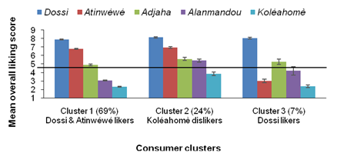
Figure 1: Mean overall liking scores of five boiled cassava varieties by consumer cluster type (%), irrespective of locations (rural and urban areas)
As far as location is concerned, and in addition to difference observed, the clustering showed some similarities in consumers’ preferences in both locations (Figure 2): among the three clusters identified, the first two (91% and 78% in rural and urban communities, respectively) showed similar trend while the third group (9% and 22% in rural and urban communities, respectively) pointed out the main difference in the two locations. Indeed, the first largest group was that of “Dossi, Atinwéwé and Adjaha” likers (47 and 40% of the consumers in rural and urban areas, respectively) while the second group which was dedicated to “Dossi and Atinwéwé” likers (44 and 38% in rural and urban areas, respectively). Concerning location difference, in rural community, the third cluster was devoted to “Dossi and Adjaha likers” (9%) while in urban community it was seen as “Koléahomè dislikers” (22%) only. This indicated that rural dwellers were more able to discriminate the quality differences between boiled cassava varieties when compared to urban dwellers. Dossi and Atinwéwé varieties were the only ones that fulfil the hedonic expectations of most of consumers (> 90%) either in rural or urban communities.
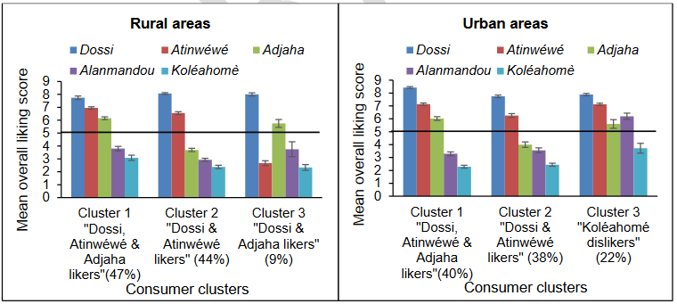Figure 2: Mean overall liking of boiled cassava by consumer clusters in rural and urban areas

Demographic data of the consumers interviewed
The socio-demographic characteristics of consumer interviewed and their dietary habits related to boiled cassava are summarized in Table 5. Findings from all consumers revealed a gender equality (49.2% of men and 50.8% of women) and a great disparity within the respondents’ age although majority of them belonged to young adults (18-35 years old, 49.6%) and middle aged adults (36-55 years old, 40.4%). Consumers belonged to various ethnic groups (Adja, Aïzo, Bariba, Fon, Goun, Haoussa, Mahi, Mina, Nagot, Sèto, Tori, Wémè, and Yoruba), among which Wémè and Goun were the most representative (43.8% and 35.8% of all consumers respectively). Most of the consumers were married (71.7%) and had an occupation of artisanship (30.0%) and trading (24.6%) whereas civil servants and employees in the private sector were less represented (5.5% of all consumers). Boiled cassava is mainly consumed at a weekly (63.8%) and a monthly (19.6%) frequencies. The main occasion for boiled cassava consumption is at lunch time (80.0%) followed by between meals (31.7%) and breakfast time (23.3%). Boiled cassava is usually consumed either with a tomato sauce, pepper and oil (82.5%), or with mashed beans (seasoned) (54.6%) or alone (27.9% of consumers). Similar trends in terms of consumers’ socio-demographic and consumption characteristics of boiled cassava were found between the total of consumers and the largest cluster “Dossi & Atinwéwé likers” (Cluster 1). Opposite trends were observed for the second “Koléahomè dislikers” (Cluster 2) and the third “Dossi likers” (Cluster 3) clusters. Cluster 2 had more men (53.4%) than women (46.6%) contrary to Cluster 3 (31.3% of men and 68.8% of women), while Cluster 3 had more food processors (31.3%) than artisans (25.0%) or traders (18.8%).
Table 5: Socio-demographic and boiled cassava consumption differences of the consumers
Categories | Variables | Total | Cluster 1 “Dossi & Atinwéwé likers” | Cluster 2 “Koléahomè dislikers” | Cluster 3 “Dossi likers”
 | Number of consumers (n) | 240 | 166 | 58 | 16
Gender | Men (%) | 49.2 | 49.4 | 53.4 | 31.3
Gender | Women (%) | 50.8 | 50.6 | 46.6 | 68.8
Age | 18-25 years old (%) | 25.4 | 27.7 | 17.2 | 31.3
Age | 26-35 years old (%) | 24.2 | 27.1 | 19.0 | 12.5
Age | 36-45 years old (%) | 27.1 | 27.7 | 24.1 | 31.3
Age | 46-55 years old (%) | 13.3 | 9.0 | 24.1 | 18.8
Age | > 56 years old (%) | 10.0 | 8.4 | 15.5 | 6.3
Ethnicity | Wémè (%) | 43.8 | 47.0 | 34.5 | 43.8
Ethnicity | Goun (%) | 35.8 | 31.3 | 50.0 | 31.3
Ethnicity | Tori (%) | 4.6 | 3.0 | 8.6 | 6.3
Ethnicity | Nagot (%) | 3.8 | 3.6 | 3.4 | 6.3
Ethnicity | Yoruba (%) | 3.8 | 4.8 | 1.7 | 6.3
Ethnicity | Others (%) | 8.3 | 10.2 | 1.7 | 6.3
Marital status | Single (%) | 10.8 | 12.0 | 8.6 | 6.3
Marital status | Married (%) | 71.7 | 69.9 | 72.4 | 87.5
Marital status | Widower (%) | 5.8 | 7.2 | 3.4 | 0.0
Marital status | Living with parents (%) | 11.7 | 10.8 | 15.5 | 6.3
Occupation | Student (%) | 11.3 | 12.7 | 8.6 | 6.3
Occupation | Artisanship (%) | 30.0 | 33.7 | 20.7 | 25.0
Occupation | Civil servant (%) | 3.8 | 1.8 | 8.6 | 6.3
Occupation | Farmers (%) | 15.8 | 15.1 | 19.0 | 12.5
Occupation | Food processors (%) | 12.9 | 10.2 | 15.5 | 31.3
Occupation | Traders (%) | 24.6 | 25.3 | 24.1 | 18.8
Occupation | Employed in private sector (%) | 1.7 | 1.2 | 3.4 | 0.0
Frequency of consumption | Everyday (%) | 2.1 | 2.4 | 1.7 | 0.0
Frequency of consumption | Many times a week (%) | 54.2 | 53.6 | 60.3 | 37.5
Frequency of consumption | Once a week (%) | 9.6 | 10.2 | 6.9 | 12.5
Frequency of consumption | Many times a month (%) | 17.5 | 16.3 | 15.5 | 37.5
Frequency of consumption | Once a month (%) | 2.1 | 2.4 | 1.7 | 0.0
Frequency of consumption | Rarely (%) | 14.6 | 15.1 | 13.8 | 12.5
Occasion of consumption | At breakfast (%) | 23.3 | 22.3 | 29.3 | 12.5
Occasion of consumption | At lunch (%) | 80.0 | 82.5 | 74.1 | 75.0
Occasion of consumption | Between meals (%) | 31.7 | 28.9 | 36.2 | 43.8
Occasion of consumption | At dinner (%) | 10.4 | 12.7 | 5.2 | 6.3
Consumption patterns | Alone (%) | 27.9 | 28.3 | 25.9 | 31.3
Consumption patterns | Mashed beans (seasoned) (%) | 54.6 | 51.8 | 65.5 | 43.8
Consumption patterns | With ingredients (groundnuts, coconut) (%) | 8.3 | 8.4 | 3.4 | 25.0
Consumption patterns | With tomato sauce, pepper, oil (%) | 82.5 | 84.3 | 77.6 | 81.3

Identification of drivers of consumers’ liking for boiled cassava
The boiled cassava samples were evaluated by consumers based on some descriptors, namely colour (‘white’ or ‘yellow’), texture (‘easy to break with the hand’ or ‘crumbly in the mouth’) and taste (‘sweet’ or ‘bitter’) as presented in Table 6. The five cassava varieties (Dossi, Atinwéwé, Adjaha, Alanmandou and Koléahomè) were evaluated using univocal texture descriptors (‘crumbliness’ or ‘breakable’) by all consumers (100%) while for colour and taste characteristics, two dichotomous descriptors were exclusively used. Thus, each cassava variety was assessed using one of the two descriptors of colour or taste characteristic (the sum of the percentage of consumers for the two descriptors of each characteristic is 100%). Hence, for the colour descriptors, the majority of consumers evaluated Dossi, Atinwéwé and Adjaha as ‘white’ (67–99%) while Koléahomè and Alanmandou were evaluated as ‘yellow’ (97% and 91%, respectively). Regarding the taste descriptors, Dossi, Atinwéwé, Adjaha and Alanmandou were evaluated as ‘sweet’ by the majority of consumers (75–98%) whereas the majority of consumers (68%) evaluated Koléahomè as ‘bitter’.
Table 6: Frequency (%) of citation of a cassava variety using a specific sensory descriptors
Characteristics | Descriptors | Cassava varieties
Characteristics | Descriptors | Dossi | Atinwéwé | Adjaha | Alanmandou | Koléahomè
Colour | White colour | 99.2 | 75.8 | 67.1 | 8.8 | 2.5
Colour | Yellow colour | 0.8 | 24.2 | 32.9 | 91.3 | 97.5
Texture | Easy to break with the hand | 100.0 | 100.0 | 100.0 | 100.0 | 100.0
Texture | Crumbly in the mouth | 100.0 | 100.0 | 100.0 | 100.0 | 100.0
Taste | Sweet taste | 98.8 | 95.4 | 97.5 | 75.4 | 31.7
Taste | Bitter taste | 1.3 | 4.6 | 2.5 | 24.6 | 68.3
The percentage of consumers evaluating the six selected descriptors (‘white colour’, ‘yellow colour’, ‘easy to break with the hand’, ‘crumbly in the mouth’, ‘sweet taste’ and ‘bitter taste’) of each boiled cassava variety as JAR “just about right” or TW “too weak” or TS “too strong” was counted (Figure 3). Dossi was scored JAR for ‘white colour’, ‘easy to break with the hand’, ‘crumbly in the mouth’ and ‘sweet taste’ by most of consumers (> 98%). This suggests that these four sensory descriptors are determinant in the overall liking and this corroborates with the fact that this variety is the most liked as shown in Table 4 (mean overall liking score of 8.0, ‘like very much’). Although Atinwéwé was considered JAR by a majority of consumers for both descriptors of texture (‘easy to break with the hand’ and ‘crumbly in the mouth’, 73 and 75% respectively) and for the ‘sweet taste’ (89%), the percentage of consumers who did not score “JAR” is higher than 20% of consumers for descriptors of texture (25–27%) and ‘white colour’ (38%), and therefore significant according to the Pareto principle. Alanmandou and Koléahomè were evaluated “Not JAR” by a high percentage of consumers for ‘yellow colour’ (86% and 94%, respectively) and the characteristics of texture (95–99%). These varieties were the least liked (mean overall liking scores of 3.7 ‘dislike slightly’ and 2.7 ‘dislike moderately’,) (Table 4). They were both found ‘too much yellow’, ‘not enough easy to break in the hand’ and ‘not enough crumbly in the mouth’ by the majority of consumers. Alanmandou was found ‘not enough sweet’ for 45% of consumers who evaluated its sweet taste, and Koléahomè ‘too bitter’ for 95% of consumers who assessed its bitter taste. Adjaha with a score of 5.1 (“neither like nor dislike”), was evaluated JAR for ‘white colour’ and ‘sweet taste’ by 43 and 69% of consumers who assessed its ‘white colour’ and ‘sweet taste,’ respectively. This indicates that this descriptor can be considered as a main criterion for boiled cassava with the white colour and the texture (easy to break with the hand and crumbly in the mouth).

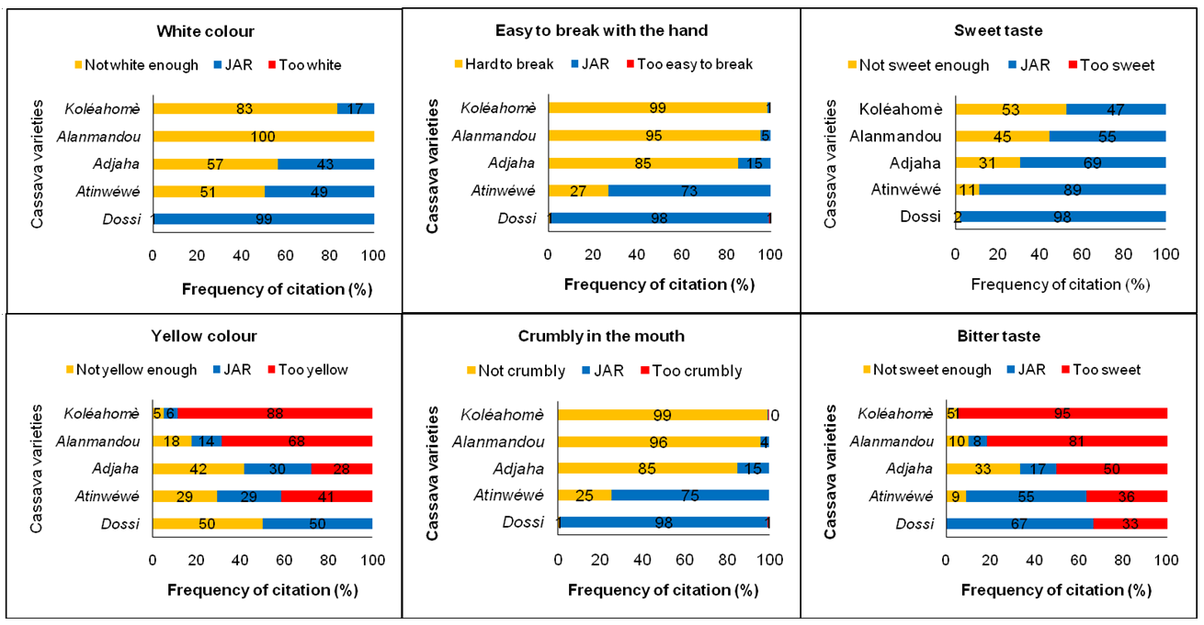
Figure 3: Percentage of consumers who scored the six selected sensory characteristics JAR or not JAR

Penalisation of sensory characteristics on consumers’ overall liking is presented in Table 7. Irrespective of cassava varieties, the significantly highest (> 3.0) mean drops in overall liking of boiled cassava were for “not crumbly enough in the mouth”, “not easy enough to break with the hand” and “too bitter” descriptors. The penalty values of boiled cassava ranged from 0.6 to 2.6. However, the descriptors that mostly determined the liking of boiled cassava (highest penalty, and highest mean drop in overall liking (> 3.5) for more than 60% of consumers) were related to texture “crumbly in the mouth” and “easy to break with the hand” mainly with the ‘too weak’ category of the following sensory characteristics: “not crumbly enough in the mouth” and “not easy enough to break with the hand”.
Table 7: Mean drops and penalties of overall liking
Descriptors | Not-JAR categories | Frequency (%) | Mean drops in overall liking* | P-value** | Penalty
White colour | Not white enough | 34.7 | 1.7 | < 0.0001 | 0.6
White colour | Too white | 0.0
Yellow colour | Not yellow enough | 17.2 | -0.2
Yellow colour | Too yellow | 68.1 | 1.4 | < 0.0001 | 0.9
Easy to break with the hand | Not easy enough to break | 61.6 | 3.5 | < 0.0001 | 2.2
Easy to break with the hand | Too easy to break | 0.2 | -0.6
Crumbliness in the mouth | Not crumbly enough | 61.3 | 3.6 | < 0.0001 | 2.2
Crumbliness in the mouth | Too crumbly | 0.3 | 2.1
Sweet taste | Not sweet enough | 23.4 | 2.8 | < 0.0001 | 0.7
Sweet taste | Too sweet | 0.0
Bitter taste | Not bitter enough | 7.0 | 2.5
Bitter taste | Too bitter | 86.8 | 3.0 | < 0.0001 | 2.6
*Score of overall liking lost because the characteristic was evaluated “not-JAR” by at least 20% of consumers.
**Significant mean drops in the overall liking based on 2-samples t-test.
Penalty (Figure 4) could not be significant if judged not JAR by at least 20% of the consumers. The penalty values were diversely associated with the selected sensory descriptors linked to ‘yellow colour’, texture (‘easy to break with the hand’ and ‘crumbly in the mouth’) and taste (‘sweet’ and ‘bitte’r) of four boiled cassava varieties (Adjaha, Alanmandou, Atinwéwé and Koléahomè). The ‘white colour’ of Adjaha and Atinwéwé as well as the ‘yellow colour’ and the ‘bitter taste’ of Dossi were also penalizing for more than 20% of the consumers. The ‘not enough easy to break with the hand’ and ‘crumbliness in the mouth’ of boiled cassava from Adjaha, Alanmandou and Koléahomè varieties, as well as the ‘too bitter taste’ of Koléahomè boiled cassava received the highest mean decreases in the overall liking score (penalty higher than 1.0 and for more than 65% of consumers). In addition, boiled cassava from Alanmandou and Koléahomè varieties were more penalised by the ‘too yellow colour’ (penalties of 0.3 and 0.4 for 68% and 88% of consumers, respectively) when compared to that from Adjaha and Atinwéwé varieties, while Adjaha and Alanmandou boiled cassava were less penalised for ‘not enough sweetness’ (penalties of 0.5 and 0.6 for 31% and 45% of consumers, respectively). These observations indicate that consumers grant great importance to ‘white colour’ and ‘sweet taste’ of boiled cassava while ‘too yellow colour’ and ‘too bitter taste’ together with ‘lack of enough easiness to break with the hand’ and ‘crumbliness in the mouth’ led to consumers’ rejection of boiled cassava (as recorded for Koléahomè and Alanmandou varieties, Table 4). ‘Not enough easiness to break with the hand’ and ‘crumbliness in the mouth’ of Atinwéwé boiled cassava was less penalised (penalty lower than 0.5 and for less than 30% of consumers) than that of Adjaha variety (penalty higher than 1.3 and for more than 85% of consumers), and this may be related to the fact that consumers gave higher overall liking scores for Atinwéwé boiled cassava and lower scores for Adjaha boiled cassava (Table 4).
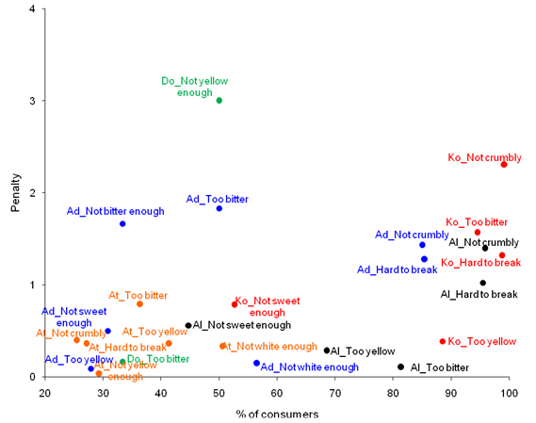Figure 4: Significant penalties of overall liking per percent of consumers
Legend: Variety_ not JAR category based on sensory descriptor (ex: Ko_Too bitter).
Varieties: Adjaha (Ad), Alanmandou (Al), Atinwéwé (At), Koléahomè (Ko).
Sensory descriptors: white colour, yellow colour, easy to break with the hand, crumbly in the mouth, sweet taste, bitter taste.
Not JAR categories: too weak (Not enough), too strong (Too much).

Mapping of quality characteristics of boiled cassava varieties and relationship with overall liking
The Q Cochran’s test revealed significant differences in the frequency of citations of each characteristic used by consumers to describe each boiled cassava sample (p < 0.05). The most frequent characteristics used to describe the five samples were ‘cassava smell’, ‘no fibres’, ‘hard to break with the hand’, ‘hard in the mouth’ and ‘attractive’ (Table 8). Figure 5 depicts a Principal component analysis (PCA) of the five cassava varieties and frequency of citations of CATA characteristics, with mean overall liking as supplementary variable. Three groups of varieties were distinctly established. Boiled cassava pieces made from Dossi and Atinwéwé varieties were qualified as high quality products (overall liking scores of 8 and 6.6 respectively) and were specifically described as ‘attractive’ (‘white homogenous’ for Dossi and ‘white outside and yellow inside’ for Atinwèwé), ‘sweet taste’ (‘very’ and ‘slightly’ for Dossi and Atinwéwé, respectively) with a specific texture (‘crumbly in the mouth’, ‘easy to break with the hand’, ‘sticky between fingers’, ‘no fibres’) and ‘good cassava smell’. Alanmandou and Koléahomè varieties, labeled as ‘unpleasant to eat, were considered as making poor quality boiled cassava (score < 4). They were specifically characterized by their colour (‘yellow homogenous’), taste (‘bitter’ and ‘bitter aftertaste’ for Koléahomè and ‘tasteless’ for Alanmandou, respectively) and texture (‘hard to break with the hand’, ‘hard in the mouth’, ‘difficult to chew’, with a sticky mucilage). Adjaha variety was considered intermediate in quality with a score of 5.1 and was described as ‘white outside and yellow inside’ and ‘slightly sweet taste’ or ‘tasteless’. Thus, the sensory characteristics associated with Dossi and Atinwéwé could be considered as the drivers of consumers’ liking while the sensory characteristics associated with Koléahomè and Alanmandou could represent a reason for consumers’ rejection of the boiled cassava (Figure 5
Table 8: Frequency of citations of each quality characteristic by consumers during CATA test
Quality characteristics | Boiled cassava varieties |  |  |  |  | Total | p-value  Q Cochran’s test
Quality characteristics | Alanmandou | Adjaha | Koléahomè | Dossi | Atinwéwé | Total | p-value  Q Cochran’s test
Cassava smell | 160 | 195 | 131 | 227 | 223 | 936 | < 0.0001
No fibres | 130 | 154 | 136 | 200 | 189 | 809 | < 0.0001
Hard to break with the hand | 212 | 180 | 224 | 2 | 43 | 661 | < 0.0001
Hard in the mouth | 224 | 166 | 221 | 1 | 48 | 660 | < 0.0001
Attractive | 25 | 121 | 15 | 235 | 193 | 589 | < 0.0001
Difficult to chew | 185 | 97 | 207 | 2 | 34 | 525 | < 0.0001
Sticky between fingers | 76 | 100 | 75 | 159 | 112 | 522 | < 0.0001
Easy to break with the hand | 22 | 39 | 5 | 232 | 181 | 479 | < 0.0001
Yellow homogeneous | 190 | 52 | 199 | 3 | 33 | 477 | < 0.0001
Slightly sweet | 69 | 127 | 22 | 102 | 128 | 448 | < 0.0001
Crumbly in the mouth | 7 | 31 | 1 | 224 | 165 | 428 | < 0.0001
Unpleasant to eat | 132 | 56 | 198 | 1 | 12 | 399 | < 0.0001
White homogeneous | 5 | 74 | 3 | 218 | 65 | 365 | < 0.0001
Very good | 0 | 15 | 0 | 210 | 77 | 302 | < 0.0001
Bitter | 35 | 3 | 156 | 1 | 7 | 202 | < 0.0001
Very sweet | 10 | 24 | 6 | 102 | 57 | 199 | < 0.0001
Sticky mucilage | 49 | 47 | 64 | 18 | 19 | 197 | < 0.0001
White outside and yellow inside | 19 | 47 | 3 | 3 | 114 | 186 | < 0.0001
Bitter aftertaste | 59 | 10 | 100 | 1 | 8 | 178 | < 0.0001
Tasteless | 48 | 34 | 18 | 4 | 9 | 113 | < 0.0001
Mean overall liking | 3.70 | 5.09 | 2.68 | 7.98 | 6.57

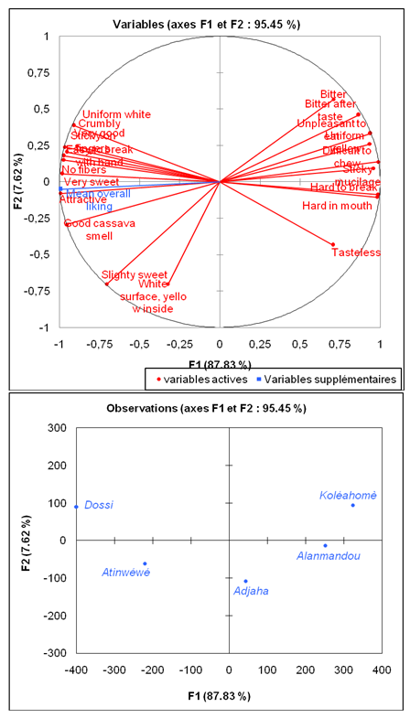
Figure 5: Sensory mapping of quality characteristics of boiled cassava and the overall liking scored by the consumers using principal component analysis

Conclusion
Field surveys and the processing diagnosis provided reliable descriptors that were mapped with overall liking scores to better understand the consumers’ expectations. This study focused on five cassava varieties (Adjaha, Alanmandou, Atinwéwé, Dossi and Koléhaomè), with contrasting characteristics, which were previously tested during the processing diagnosis. It revealed what the good and poor sensory quality criteria of boiled cassava were. In spite of the location effect on overall linking that was observed for two varieties, the consumer profile is similar in terms of JAR, quality characteristics, and sensory mapping in both (rural and urban) locations for all consumers (240). ‘Sweet taste’ (very or slightly) is the main liked criterion for boiled cassava whereas criteria such as ‘white colour’ (white outside and yellow inside to a lesser extent) and texture (‘crumbly in the mouth’ and ‘easy to break with the hand’) are also important because their failure significantly penalised the overall liking.
High quality boiled cassava should be ‘attractive’ with ‘white homogenous’ colour or ‘white outside’ colour and ‘yellow inside’ colour, ‘crumbly in the mouth’, ‘easy to break with the hand’, ‘sticky between fingers’, ‘with no fibres’, have a ‘sweet taste’ (very or slightly) and a ‘good cassava smell’. Poor quality characteristics of boiled cassava including ‘too yellow colour’, ‘too bitter taste’, ‘lack of enough easiness to break with the hand’ , ‘crumbliness in the mouth’ need to be addressed by biochemists and breeders/geneticists in order to develop more acceptable varieties in the future.

References
Adinsi, L., Honfozo L., Djibril Moussa, I., Bouniol A., Akissoé, N., and Hounhouigan, J. (2020). RTBFOODS - Work Package 1 – Activity 3 on Gendered Food Mapping: Boiled Cassava Quality Characteristics in Benin. RTBFOODS Project, Data collection report.
Bouniol, A., Adinsi, L., Honfozo L., Hounhouigan, J. and Akissoé, N. (2020). RTBFOODS - Work Package 1 – Activity 4 on boiled cassava product profile in Benin. RTBFOODS Project, Data collection report.



Institute: Cirad – UMR QualiSud
Address: C/O Cathy Méjean, TA-B95/15 - 73 rue Jean-François Breton - 34398 Montpellier Cedex 5 - France
Tel: +33 4 67 61 44 31
Email: rtbfoodspmu@cirad.fr
Website: https://rtbfoods.cirad.fr/

