
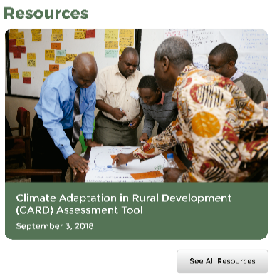

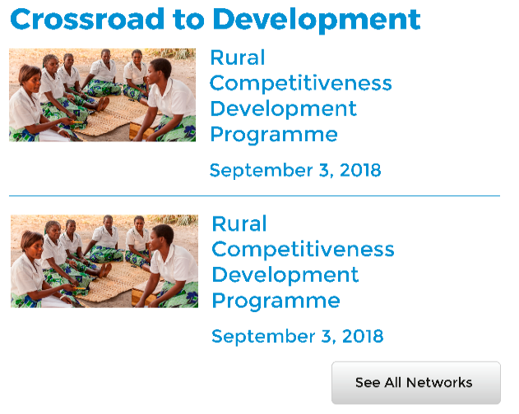
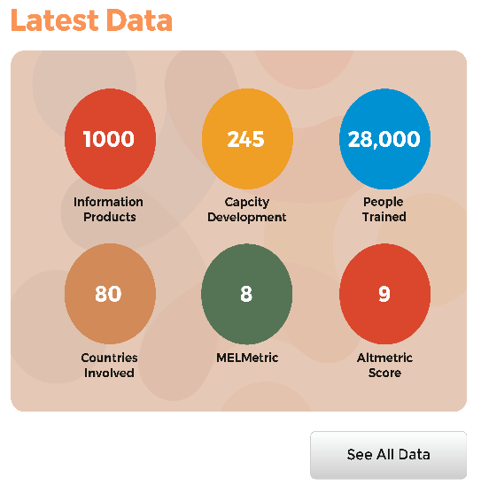

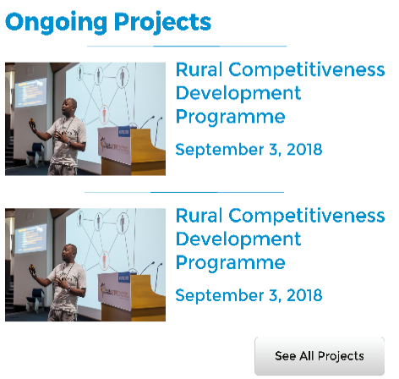
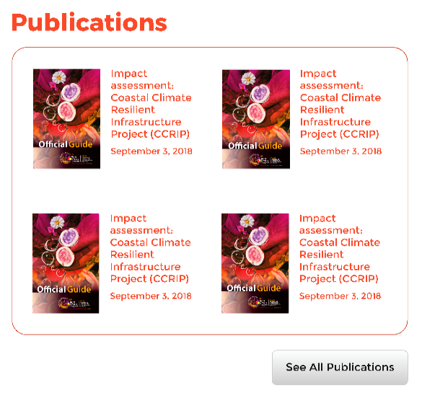
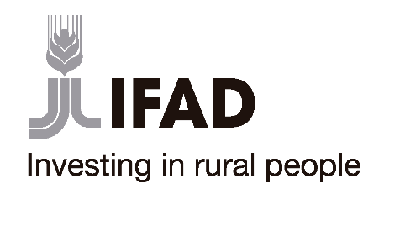




Strengthening Knowledge Management for Greater Development Effectiveness
in the Near East, North Africa, Central Asia and Europe (IFAD SKIM Project)

SKIM Writing Process Template

SKIM Writing Process Template
6 January 2020
Murat Sartas, Emilie Vansant

Project
Strengthening Knowledge Management for Greater Development Effectiveness in the Near East, North Africa, Central Asia and Europe (SKIM)

Funded by
International Fund for Agricultural Development (IFAD)

Prepared by, in collaboration with
International Center for Agricultural Research in the Dry Areas (ICARDA), in collaboration with the International Institute of Tropical Agriculture

Suggested citation
Akmal Akramkhanov, Enrico Bonaiuti, Valerio Graziano, Murat Sartas, Emilie Vansant (1/7/2020). SKIM Writing Process Template. Tashkent, Uzbekistan: International Center for Agricultural Research in the Dry Areas (ICARDA).

Keywords
Knowledge, Knowledge Management, Information, Data, Data Curation, Capacity Development, Capacity, Development, Research for Development, R4D, Writing Template, Template, Collaboration

Type: Working Paper
Working Papers are one of ICARDA’s global public goods; they capture and share knowledge and learning from projects and research partnerships. Each paper is internally reviewed as part of the Center’s publishing process.

Disclaimer
This document is licensed for use under the Creative Commons Attribution 4.0 Unported Licence. To view this licence, visit http://creativecommons.org/licenses/by-nc-sa/4.0/
ATTRIBUTION. The work must be attributed, but not in any way that suggests endorsement by the publisher or the author(s).

About SKIM
The Strengthening Knowledge Management for Greater Development Effectiveness in the Near East, North Africa, Central Asia and Europe project is a grant project led by the International Center for Agricultural Research in the Dry Areas (ICARDA) and funded by the International Fund for Agricultural Development (IFAD). The project also works with international partners Virginia Tech, CIHEAM-Bari, PROCASUR as well as National Agricultural Research Systems (NARS), governments, and agricultural extension services in Moldova, Morocco and Sudan.
Initiated in June 2018, the project facilitates and supports KM and capacity development activities in the three selected countries (with the possibility of extending to a further two) and will provide practical examples of KM best practices that will be analysed and adopted by participating institutions. Increasing the capacities of participating public institutions in this work, by providing necessary structures and systems at the country and regional levels, will ensure that knowledge being developed can be effectively managed for long-term growth and development.
Project website is created with related information at https://mel.cgiar.org/projects/SKIM .This website describes background information, project team in more details, partners and stakeholders engaged, key documents and proposal, goals and objectives, impact pathway, focus countries, resources uploaded on website, news and events calendar.

About IFAD
The International Fund for Agricultural Development (IFAD), a specialized agency of the United Nations, was one of the major outcomes of the 1974 World Food Conference. IFAD was set up as an international financial institution in 1977. Since then, IFAD-supported projects have reached millions of people. IFAD’s Strategic Framework 2016-2025 sets out how IFAD works over the decade in order to play a crucial role in the inclusive and sustainable transformation of rural areas. It articulates our contribution to the 2030 Agenda, including the larger role IFAD will play in supporting countries to fulfil their priorities relative to the Agenda. For more details: www.ifad.org

About ICARDA
Established in 1977, the International Center for Agricultural Research in the Dry Areas (ICARDA) is a non-profit, CGIAR Research Center that focusses on delivering innovative solutions for sustainable agricultural development in the nontropical dry areas of the developing world.
We provide innovative, science-based solutions to improve the livelihoods and resilience of resource-poor smallholder farmers. We do this through strategic partnerships, linking research to development, and capacity development, and by taking into account gender equality and the role of youth in transforming the non-tropical dry areas.
Address: Dalia Building, Second Floor, Bashir El Kasser St, Verdun, Beirut, Lebanon 1108-2010.
www.icarda.org

Table of Contents

Table of Contents iv
I. Objectives 1
II. Framing the Study 1
III. Study Structure 2
IV. Author Team 2
V. Abstract 3
VI. Paper Outline 4
VII. Action Plan 5

Objectives

- Authors plan and agree on an effective research process, write concept note
- Participants improve their knowledge on proposed paper topic
- Authors decide on research framework and questions
- Authors familiarize themselves with datasets
- Authors identify expected study results, develop hypotheses and variables
- Authors decide on the composition of the author team
- Authors explore journals and existing literature on the topic
- Authors write abstract for the paper and brainstorm an outline
- Authors contribute on assigned sections
- Authors include implications for SKIM project and ICARDA Knowledge Management
- Authors participate in team building activities

Framing the Study

Q1. What are the objectives of the study?
Q2. Which outputs should the study aim to produce?
Q3. Which research questions should the study address?

Table 1. Study Grid
Question Code | Output Codes | Objective Codes | Notes
Q1
Q2
Q3

Study Structure

Q1. Which conclusions should the study show?
Q2. Which striking results should the study present to reach these conclusions?
Q3. Which hypothesis is needed in order to validate these results?
Q4. Which variables in the datasets are necessary to test the hypothesis?

Table 2. Metric Framework
Hypothesis Code | Result Codes | Conclusion Codes | Variable Codes
Hypothesis 1
Hypothesis 2
Hypothesis 3

Author Team

Table 3. Author Descriptions
Name | Surname | Affiliation | Address | Roles

Abstract

<Title>
<Subtitle>
Authors

Text:

Paper Outline

Introduction

Methods

Results

Discussion

Conclusions

Acknowledgements

Action Plan

Initial steps (all key authors):
- Online kick-off meeting
- Writeshop to frame the paper and agree on research questions, hypothesis
- Creating the outline of the paper by visioning
- Brainstorm expected results and main discussion points
- Agree on other authors
- Brainstorm journals for publication
Drafting paper (each author contributes and gives feedback following agreed procedure)
- ______________________
- ______________________
- ______________________
- ______________________
- ______________________
Second draft and finalization
- Key authors hold writeshop for editing first draft
- All authors give feedback on second draft
- Finalization of paper and submission (all key authors)

Submission date: _____________________

Strengthening Knowledge Management for Greater Development Effectiveness
in the Near East, North Africa, Central Asia and Europe (IFAD SKIM Project)

