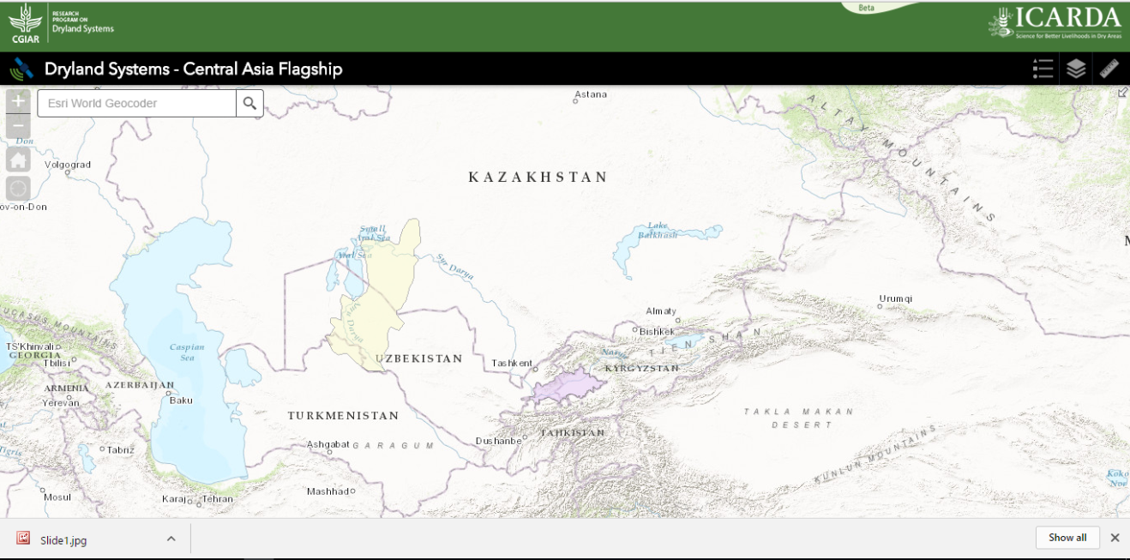
Dryland Systems - Central Asia Flagship

