F4: Barley Seed systems and Input Markets-Barley: Annual report 2016

1. Introduction
ICARDA is implementing a project entitled ‘Deployment of malt barley and faba bean varieties and technologies for sustainable food and nutritional security and market opportunities in the highlands of Ethiopia’ with financial support from USAID in Ethiopia and Increasing the Productivity of Cereal-based Systems to Enhance Food Security in Iran (started in 2016-17). In Ethiopia, the project includes scaling-out improved barley varieties and associated crop management technologies in 21 zones and 62 districts of four regional states of Amhara, Oromia, Southern Nations, Nationalities and Peoples (SNNPR), and Tigray. In Iran, the project focuses in rianfed areas of four provinces i.e. East Azerbaijan, Kermanshah, Kurdistan and Lorestan provinces.

The following key areas are covered under CRP and bilateral projects in Ethiopia and Iran:
- Barley seed system study jointly with CRP-DS (including DNA finger printing) to analyze varietal adoption, farmer’s perception, seed sources, etc to understand systemic constraints and recommend solutions in Ethiopia
- Accelerated early generation seed (breeder, pre-basic and basic seed) production by NARS in Ethiopia and Iran particularly using off-season production under irrigation where feasible
- Accelerated early generation seed (basic) seed production by NARS (Iran) and with farmer seed producers cooperatives (Ethiopia). NARS identify and engage farmer groups to produce pre-basic and basic seed under their strict supervision and link them to regional seed certification agencies to ensure quality.
- Large-scale certified seed production by engaging the public/private sector where there is limited interest in barley seed production.
- Small seed pack distribution as part of on-farm quality seed production and scaling-out of barley technologies through revolving seed scheme in Ethiopia
- Popularization and demonstration of new improved malt barley varieties and integrated crop management technologies where farmers hosted both the demonstration and field days in Ethiopia
- Strengthening capacity of NARS partners, stakeholders and farmers for acquiring knowledge and skills for effective project implementation and provision of facilities where feasible
- Characterizations of farm households to establish benchmarks and measure the impact of the project on adoption and impact on food and nutritional security.
- Forging an effective partnership existing public, private and farmer-based actors for effective project implementation.

2. Barley seed multiplication
In order to expedite the availability of and access to seed NARS partners and formal and informal seed producers and suppliers have been supported to engage in seed production of improved barley varieties. In Ethiopia, both federal and regional agricultural research institutes were engaged in several activities including early generation seed (EGS) multiplication, on-farm community seed production and small pack seed distribution for technology out-scaling and variety popularization and integrated crop management (ICM) demonstration.

2.2 Large-scale certified seed production
In, Ethiopia, given limited activities by the formal seed sector, the project produced the certified seed (quality seed) by supporting existing seed producer groups or those newly established by the project. In, Iran, 1722 ha of barley planted by the formal seed sector with estimated production of 2583 t of certified seed which can cover 19,869 ha for barley grain production

2.3 Small seed pack distribution for on-farm seed multiplication
In Ethiopia, the barley project is working in 21 zones and 62 district with 20 licensed and 7 non-licensed seed producer cooperatives with total membership of 3053 farmers (354 female farmers,11.6%). Small seed packs were distributed to farmer groups in the form of revolving seed fund for scaling up/out activities. Farmers pay back the amount of seed received so that it can be used to reach new farmers in the community during the second year. Farmers are supervised by BoA and inspected by the regional seed certification office to produce certified/quality seed for marketing through formal sector or for own use, exchange with other farmers within or beyond their villages.

NARS partners mobilized the available barley seed and distributed the seed to farmers. About 1060 farmers (122 female farmers, 12%) were provided with 41.6 t of small seed pack of malt barley varieties as part of technology out-scaling-cum-on-farm seed multiplication through revolving seed fund scheme. About 415 ha was planted with anticipated production of 1037 t of seed as part of on-farm seed multiplication. This will be sufficient to plant 10,370 ha and producing 31,110 t of seed/grain the following year (Table 1). Moreover, 10.8 t of seed was exchanged through farmer-to-farmer reaching 259 farmers (32 female farmers,12%)and planted on 108 ha which will produce 269 t of seed/grain sufficient to plant 2690 ha producing 8,070 t in the next crop cycle. NGOs and other partners also purchased and distributed 4 t to 94 farmers (10 female farmers, 10.6%) and planted 40 ha with expected production of 100 t of seed/grain (if used as seed could plant 1000 ha and produce 3000 t next year).

Table 1. Summary of seed production for barley during 2015/16 cropping season in Ethiopia
Seed class | Seed provided (t) | Area planted (ha) | Expected production (t) | No of farmers benefitted |  |  | Remarks
 |  |  |  | Male | Female | Total | Remarks
Certified/Quality seed (small pack) | 32.3 | 323 | 807.5 | 611 | 90 | 701 | NARS & BoA on-farm
Quality seed (revolving seed) | 9.3 | 92 | 230.0 | 227 | 32 | 259 | NARS and BoA on-farm
Farmer-to-farmer seed exchange | 10.8 | 107.5 | 268.8 | 252 | 20 | 272 | Seed/grain by farmers
Stakeholders (NGOs, etc) | 4 | 40 | 100.0 | 84 | 10 | 94 | Seed/grain by farmers
Total | 56.4 | 562.5 | 1406.3 | 1174 | 152 | 1326

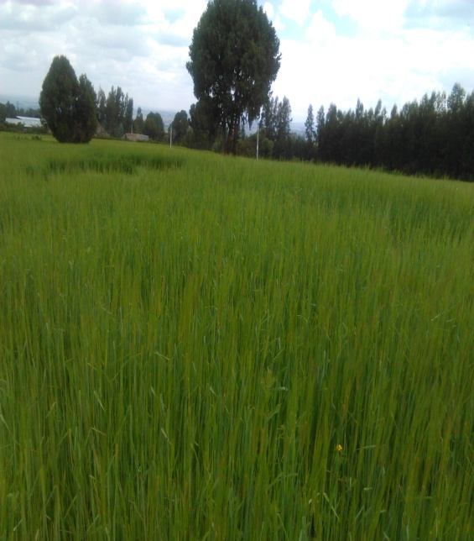 | 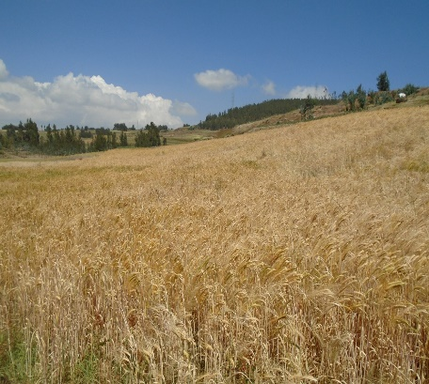 | 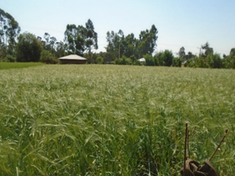
Malt barley seed production : on-station breeder seed at Sinana ARC (left); on-farm basic seed production in Basona Worana district by DBARC (center); and on-farm off-season seed production in Guagusa Shikudad district by AARC (right)

