Hassnain Shah, Anam Riaz, Boubaker Dhehibi and Abdul Majid

Food security and better livelihoods

for rural dryland communities

Gender mainstreaming in CRP dryland system Chakwal-Pakistan: Socio economic assessment and feedback

DECEMBER 2015

Contents
SUMMARY ii
INTRODUCTION 1
Objectives: 2
Methodology and Process Followed 3
Group of Participants: 4
Results and Discussions 4
Value Addition Training 4
Awareness and experiences on value addition: 5
Source of training on value addition: 5
Age and Education Composition of Participants: 5
Pre and Post Level of Knowledge about Value Addition: 6
Training Evaluation 7
Evaluation of Training relevance and process 8
Ability Rating before/after Training: 8
Training Demands on Other Value Added Product 11
Training Observations 11
Concluding session: 13
Conclusion and recommendations 13
References 14

SUMMARY
Considering the importance of the value addition at local lever for improving gender participation in income generation activities and improve household food security, training programs on the subject were included in the CRP (1.1) Dry-Land system work plan to be implemented at the project sites. This was the third activity since 2013 and was targeted on up scaling through training master trainers and developing further linkages with the local NGOs and community women organizations active in the villages. The training was organized by Barani Agricultural Research Institute (BARI), Chakwal in collaboration with ICARDA and local NGOs. The social sciences team collected data and documented feedback from the participants, both at pre and post stages of the training. Data for the present study was collected through structured questionnaires and participant observation.
The purpose of the study was to give awareness of females about the importance of value addition of fruits and vegetables because a large amount of fruits and vegetables could be wasted and used it as animals feed except this to preserve them for their own use. Another reason for the training was to empower the participants to embrace new methods of value addition on household level, prepare quality products at home, preserved them for a long time and starts their own business at family level. The other target of training was to train the participants as a master trainer for providing training to other females of their communities in the villages. Two days value addition training was conducted in which participants were trained and equipped with easy methods of preservation of different seasonal fruits and vegetables at household level by utilizing local level and own farm production along with market purchase during the flux of supply. In addition to the commercial focus, household level food preservation to avoid high prices during shortages was another aspect that participants were considering as their future planning through utilizing the skills learned during the training. Participants were also provided with recipe book and CDs.
The participants were practically involved in whole training through different practical sessions in a step by step fashions starting from lectures, on methods of preservations, sharing recipes and practical preparation of the individual products. At the end of the practical session they themselves tasted all the products which they made and asked to compare the products they used to consume by preparing at home or purchased from market.
The results of the assessment exercise exemplified the impact of value addition training in instilling positive orientation in terms of the magnitude of perceived knowledge, acquisition of skills and adoption levels. Moreover, the findings of the study conclude: (i) high intention to doe value addition especially for household level food security but with less commercial activity in the start, (iii) the master trainers were intended to extend their services for capacity building of rural women especially youth on value addition with their community organizations (iv) clear difference in knowledge and skills were found between pre and post training assessment v) the process and method of training was found satisfactory by participants as per evaluation criteria established in terms of contents, involvement, training material, resource persons knowledge and practicality of the training. Overall training was ranked as highly satisfactory yet further room exists for improving the space and arrangements for group activity during practical sessions and more engagement of the participants through encouraging for questions during the lecture and sharing practical experiences of the participants. Further follow up and backup is recommended for technical and marketing aspects to achieve the objectives.

INTRODUCTION
The majority of rural women depend on natural resources and agriculture for their livelihoods and make up over a quarter of the total world population. Women mostly produce, process and prepare much of the food available (World Bank, 2010). About 76 per cent of the extreme poor live in rural areas (FAO, 2010; World Bank and IMF, 2013) ensuring rural women’s access to productive agricultural resources contributing to decrease world hunger and poverty. Almost 70 percent of employed women in South Asia and more than 60 percent of employed women in Sub-Saharan Africa work in agriculture. In South Asia and Sub Saharan Africa agriculture is the most important source of employment for women as compared to manufacturing and services (FAO, 2010). In Pakistan, rural women provide most of the labour for post-harvest activities, taking the responsibilities for storage, handling, stocking, processing and marketing (Dawn, 2004). The processing of vegetables, fruits, and milk, in times of abundance for times of scarcity using indigenous techniques is exclusively the women’s task. There is a great potential for agriculture value addition and a high growth rate of 18% in agriculture value addition has been witnessed mainly due to private sector led investment with limited focus on farm level and women farmers inclusive processing (Chaudhry, 2004).
Diversity in land and climatic conditions favours cultivators to cultivate all the variety of fruits and vegetables in Pakistan. Presently more than 28 types of fruits and 30 types of vegetables are grown in the Pakistan all around the year and mostly consumed in the domestic markets. The country produces above 14 million tonnes of vegetables and fruits per annum, of which nearly one third is lost before it reaches at consumption level. Levels of postharvest losses in fruits owing to improper harvesting, handling, grading, packing, transportation and storage mainly due to low processing at local level (Rosa 2006) Keeping in view this situation the value addition of fruits and vegetables has become even a greater imperative and Government of Pakistan in its strategic trade policy framework (2012-2015) has supported a number of incentives for promotion of processing and value addition near to the production centres in the country.
Value addition in agriculture predominantly offers a means to increase, rejuvenate and stabilize farm income. Value-added agriculture has attracted considerable opportunities for increasing employment and revitalize attention in recent years as a means to increase and stabilize farm incomes and to rejuvenate primary agricultural. Value addition in agriculture is simply the act of adding value to a product with a view to improve an existing product. A number of studies (Lee et al 1991; Gandhi et al 2000; Mrema & Rolle 2002; Gulati et al 2007) have been highlighted the significance of value addition in agriculture. Consensus from these studies suggests that value addition in agriculture has vast untapped opportunities for increasing employment and revitalize rural communities, diversify the economic base of agricultural communities, increase farmer’s financial stability and opportunities for smaller farms and companies through the development of niche markets.
The current dependence on market led growth has diverted the policies of the developing countries to focus on farm level value addition. This is especially true to the countries having small farm dominated agriculture like India and Pakistan. Value-added agriculture is fundamentally market-driven. It needs trained and skilled manpower to cope with the demand of rapidly changing markets (Roy et al 2013).
In lieu of production potential and keeping in view the issue of post-harvest losses and low farm level processing and value addition along with opportunities for women empowerment through increased participation in commercial activities, capacity building in value addition of fruits and vegetables was made part of the CRP DS work plan since beginning. The successful implementation of the training on value addition during first year, further demand was generated from the target communities at Chakwal site. Based on the assessment of two activities conducted during 2014, it was recommended to upscale this activity by involving community organizations and NGOs working in the area. Owing to this training of master trainers to upscale and promote value addition activities with rural women folk was made part of the work plan for 2015.
Socioeconomic assessment is also an integral part of the CRP DS activities to help the technical partners to move along the impact pathway by incorporating market, social and gender factors required for an inclusive and sustainable growth for improved livelihood in the target regions.

Objectives:
The specific objectives for socioeconomic assessment of the capacity development activity was:
- To document the conduct of the training activity
- To assess the contribution of training in capacity development of target participants
- To provide feedback for effecting planning and implementation of such activities

Methodology and Process Followed
The study under discussion was one of the out puts of the socioeconomic component of CRP DS at Chakwal site was included as part of the work plan for 2015. To cover the first objective the socio economic team was integrated with the technical team to facilitate the resource persons in conducting the project activities through providing on-spot feedback. The team of social sciences participated to provide on-spot feedback as participant observer. Three social scientists from SSRI, NARC remain part during the execution of the training.

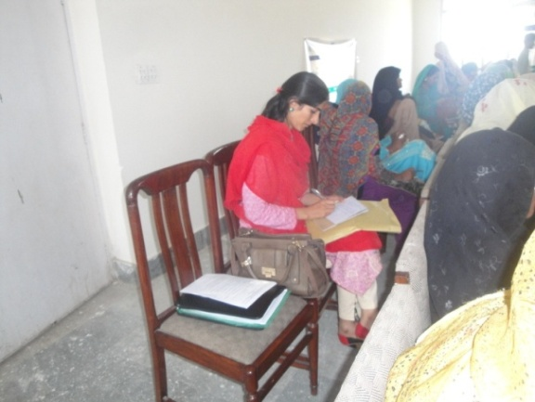
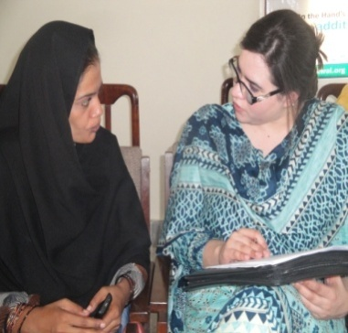
In addition to the observation, informal discussion with the training participants was done to get insight on each activity of the training. Structured questionnaire was implemented for pre and post assessment of the knowledge and skill levels of the participants using both quantitative as well as qualitative variables. Data accumulated as a result of person interview, group discussions as well as observations. An observational instrument as check list to look at the contents of the training and resource persons active engagment for skill development of the participants was used during different sessions of the training. Consultations with experts and discussions with participants helped to develop trust which stimulated the participants to share insights feelings with the data collection team.

Figure 1. Data Collection for Training Assessment` Figure 2 Observations recording during training
A pre-assessment survey was done from all the participants to look at their knowledge, skill, practical experience and intentions while a post training survey was conducted to provide a comparative analysis of the knowledge and skill development along with participant’s future plan to promote the value addition among rural masses to achieve the intended objectives. The social scientists participated in the whole training as participant observers. These devices help reach some kind of triangulation for gathering reliable and quality information. Pre-training information were gathered with the aim to consider features like participation of participant in value-addition, participants' present degree of awareness about value addition of fruits and vegetables. Some necessary information about the participants like age, education, experience towards value addition, level of knowledge, expectations etc., were also incorporated to evaluate the choice of the members according to the objective of the training. Intended for this reason information and details were gathered via personally interview from the 31 participants within the training at Barani Agricultural Research Institute (BARI), Chakwal. Likert scale was utilized to examine the data. Likert scale is a standard device to measure the approaches and understandings where each answer type on the size is usually assigned successively an integer value (Javaras 2007). Course contents and methodology was evaluated by ranking scores in the following manner.1= Disagree 2=partially convinced 3= Not clear/No response 4=Agree 5= strongly agree. Data was entered as well as tested applying SPSS spreadsheet. To measure current effectiveness before and after comparison of knowledge was tested using ‘paired t’ statistics. Descriptive analysis was conducted pertaining to some other details collected through observations and feedback of the participants with pre as well as post assessment survey instruments.
Figure 3. Number of participants by tehsil and villages

Group of Participants:
Overall the group of participant represented youth as is depicted in group photo (Figure 4) of all the participants attended the 2nd training course on Value Addition of fruits and vegetables.

Results and Discussions

Value Addition Training

Value addition training was based on two days training which was organized at BARI Chakwal on 16-17 June 2015, where around 35 females participated in training. The training starts with the recitation of Holy Quran by Mr.Ramzan after that the introductory session that included the welcome address followed by a brief discussion on value addition and objective of training. Awareness was given about the importance of value addition with fruits and vegetables.

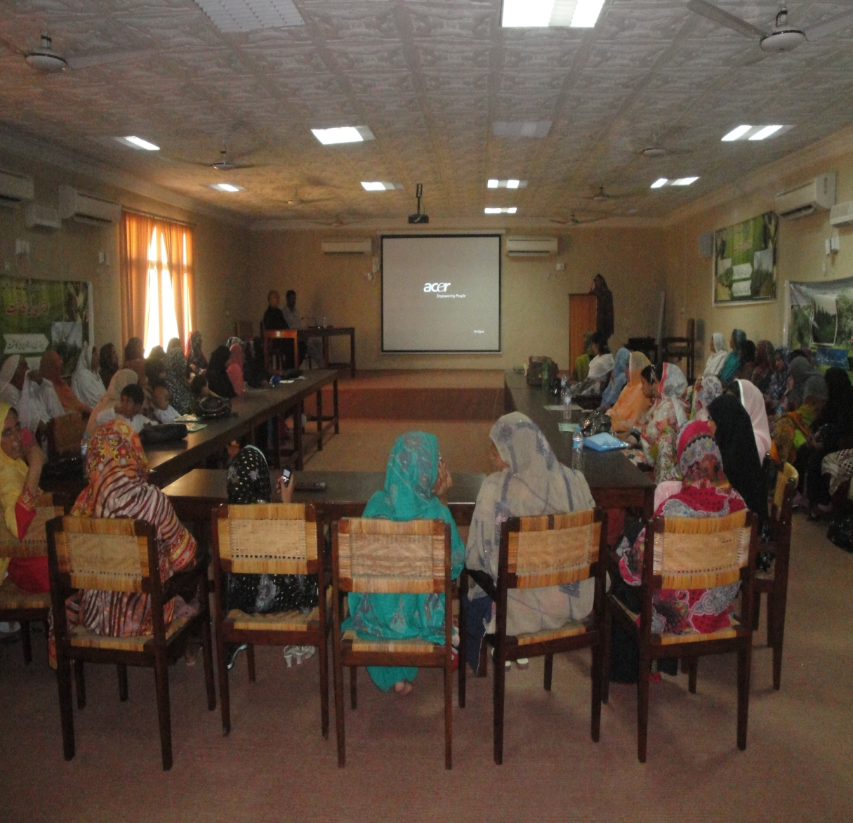
Figure-4 Inaugural Session and Project Background Sharing Session

Awareness and experiences on value addition:
Majority of the participants reported in Figure 4 that they had some kind of knowledge and awareness about value addition 51.6% had some practical experience. The remaining 48.4% were not having any skill for value addition from fruits and vegetables.

Source of training on value addition:
Majority of the participants did not have any formal training as among these participants practically involved in some kind of value addition majority only (38%) had some formal training on value addition while remaining (56%) learned through informal sources and (6%) from other source . Among these informal sources traditional knowledge within family was the main source.
Figure 5: Experience on VA

Age and Education Composition of Participants:
Majority of the participants in the training were in the age bracket of 26-40 years while another was 16-25 years of age. The remaining participants were middle and old age (41-55) years of age. The results highlighted in figure revealed that mostly educated and interested women were involved in the training on value addition of fruits and vegetables. It was learned that youth were particularly targeted in training. The education level of the youth was comparatively high as compared to old age group. Based on these aspects the results depicts that the selection/invitation of the participant for the subject training was rational.

Figure 7: Education level by Age group

Pre and Post Level of Knowledge about Value Addition:
The results on pre and post difference in knowledge on value addition clearly illustrates the comparison between pre and post training awareness level and knowledge of participants regarding value addition. It was categorized among scale of poor, very poor, average, good and very good. In the pre-training session participants were questioned about their knowledge level. The result in the figure below shows that almost all the participant used to do some level of value addition like pickles and jams preparation.

Whereas, same question were asked in the post-training appraisal. The results were found twisted towards very well. The high level of confidence was observed during post training assessment survey as compared to pre-training interaction. During pre-training the participants responded based on their household level experiences or interactions with any of the family member who used to do some kind of value addition reported having some knowledge. It was identified that training shows positive impact on the participant’s level of knowledge and they were quite skilled to utilize it at household level and disseminate this knowledge. In this regard training manual distributed among the participant would be helpful. It is appealing to mention that few participants were also of the view that in future these skills would be helpful to start some activity at commercial level to earn money in the field of food processing and value addition for the sustainable livelihood. The market demand and supply aspects were also shared with the participants and participants were motivated to do value addition and preservation activities during peak supply and low price period.

Training Evaluation
The results on assessment of training with respect to usefulness and compatibility with interests, expectation and utilization along with process and conduct of training including its training methodology, contents, resource persons, other materials and facilities provided during the training are presented in Table. The results show high level of satisfaction of the participants as majority of responses were in agree and strongly agree category for all queries. All of the participants agreed (61 percent) and strongly agreed (29.3percent) that training was useful for food preservation/value addition at home consumption. Similar results were found regarding compatibility with interests of the participants. However, regarding training usefulness to start some business activity some of the participants (36.6%) agree as some of the participants reported that due social and cultural barriers females could not directly do business activities linked with the market. However most of them considered that contents and practical training was conducted in a manner that could be useful for starting business.
The overall way to conduct the training was ranked high in terms of satisfaction level. The topics discussed during training were also found relevant to the interest of the participants. There source person was found knowledgeable and 43.9 percent participants agreed and 22 percent partially agreed that they delivered all the training contents very effectively. The participants agreed that training were more participatory on skill development. The duration of training, contents facilities provided for practical and hands on training were also considered adequate. Whereas, on the whole the capacity building training programme portrayed a positive impact on the rural women to take on value addition skills for effectively utilizing at household level. The detailed results for individual assessment indicators are given below.

Evaluation of Training relevance and process

Ability Rating before/after Training:
To evaluate the effectiveness and impact of the training various indicators were used to obtain precise information. These were also compared on pre and post scenario. The difference of mean was a statistically significant between the level of knowledge/skills before and after the training course.

The results in figure envisaged that, there were significant improvements (difference). The participants acquired much knowledge and ability to prepare value added products from fruits and vegetables as compared to their earlier knowledge and ability. The results imply that training was conducted successfully and shows positive impact on the participant’s expectation.

Table 1 represents the response of master trainers who are supposed to train other community, their intension to train the other females were asked, response was quite diversified so given the ranges to cover the numbers to which they are going to give the training. About 70 percent participants showed the intention to train 1-20 females, 13 percent participants say they will train 21-40 females at a time and 10 percent participants response that they easily train 41-60 females of community, 7 percent female said that they can easily trained 81-100 females at a time so all the females were quite enthusiastic to give the training.
Table1: Expected Target Beneficiaries of the Master Trainers for Training on community level
Possible beneficiaries for training | Frequency | Percent
1-20 | 22 | 70.0
21-40 | 4 | 13.0
41-60 | 3 | 10.0
81-100 | 2 | 7.0
Total | 31 | 100.0

Table 2: Support for Technical Backup:
Support to improved knowledge | Frequency | Percentage
BARI | 14 | 45.2
NRSP | 4 | 12.9
NGO | 4 | 12.9
Solved by own | 3 | 9.7
No Response | 6 | 19.4
Total | 31 | 100.0

Most females were interested to take value addition of fruits and vegetables as a business or work as a master trainer. They responded that we will train the ladies and with the help of technical support by the various institutes , high response was recorded for the consultation with BARI which shows the confidence level on BARI some females said they will consult NRSP and other local NGOS few participants said that they will try to solve their problems by own.
Table 3: Hurdles in further dissemination:
Problems in Dissemination | Frequency | Percentage
Time management issues | 5 | 16.1
Sometime family not allowed | 8 | 25.8
Lack of resources | 5 | 16.1
Females preferred trainings in proper organisation | 2 | 6.5
No hurdle | 11 | 35.5
Total | 31 | 100.0

In this table the hurdles in dissemination of these skills to other females is highlighted as the main purpose of the study is to train the participants as a master trainee but result shows that time management, lack of resources and sometime family permission are the problem however most of female also reported that there is no hurdle in dissemination of these activities they will continue this and disseminate this at large extend.

Table 4: Issues in taking up as business:
Issues in business | Frequency | Percentage
Family not allowed | 8 | 25.8
Lack of resources | 4 | 12.9
Product marketing | 3 | 9.7
No issues | 16 | 51.6
Total | 31 | 100.0

The data presents in this table depicts that to start value addition of fruits and vegetables as a business in rural areas was not easy for females because of social norms family not allowed and the other constraint in business was lack of resources and marketing of product and sometime family not allowed.
Table 5: Options for funding to organize trainings:
Options for funds | Frequency | Percentage
Used own resources | 11 | 35.5
NRSP | 4 | 12.9
Ngo | 3 | 9.7
BARI | 4 | 12.9
SARBAN | 1 | 3.2
Contribution from participants | 4 | 12.9
D.K | 4 | 12.9
Total | 31 | 100.0
According to the data mostly participants were not just dependent on NGO/Organisation for funding or resources to organize training; they want to train other females of their community by used their own resources as table presents 35.5percent participants interested to used their own resources, 12.9 percent participants need collaboration of NRSP and want that participants should contribute to organize training.

Training Demands on Other Value Added Product
The participants were asked that on what other aspects (products) they need training (products that could easily be prepared to input availability in target area) for which training should be organized. The participants although highlighted a number of other aspects of their individual interest. These were 1)mango production and preservation,2) value addition of peanuts, 3)plantation of seasonal fruits and vegetables, 4)sprays used on vegetables plants, 5)value addition of spinach, 6)peach and grapes production and jams for diabetes patients.

Training Observations
High level of satisfaction was overall reported by the participants of the training in terms of contents of the course as more positive responses in the category of strongly agreed or agreed were given. Satisfaction level in terms of improvement in knowledge about value addition was given highest score.
The different aspects of the training were recorded in the observation guide by the Social Sciences team and based on their observations and finding regarding training arrangements, facilitator’s interaction during lectures, presentation and practical session with the participants, involvement and interest level of participants and targeting learning objectives during exercise were incorporated. On first day the learning objectives of the training were successfully met during both days; facilitator also provided descriptive and simple examples for the better understanding and practical/exercise was conducted in an effective way to that helped skill improvement. Overall participants agree that the training was effective, well facilitated and proper procedures were followed and few of them find neutral that the exercise allowed participants to practice their skill.
In the comparison, second day training session was quiet effective all the contents were cover smoothly with the practical done by the participants which helped them to revise the learned techniques on value addition. They were strongly agreed with the learning objectives, facilitator clearly answered the quires to participants, exercise was an effective way to learn information and participants were actively engaged in exercise. The organizers made efforts to conduct the training in a professional manner and tried to satisfy the participants within the existing facilities available.
Table 6: Observation Based Analysis
Summary Analysis | Day 1 | Day 2
Learning objectives of the training were met | Strongly Agree | Strongly Agree
Facilitator clearly answered the quires of participants | Agree | Strongly Agree
Facilitator provided illustrative examples | Agree | Agree
Exercise was well facilitated | Agree | Neutral
Exercise allowed participants to practice their skills | Neutral | Agree
Exercise was an effective way to learn information | Strongly Agree | Strongly Agree
Participants were actively engaged in exercise | Agree | Strongly Agree
On the whole, exercise was effective | Agree | Agree
Proper process were followed | Agree | Agree
- Strongly Agree 2. Agree 3. Neutral 4. Disagree 5. Strongly Disagree

Concluding session:
The concluding session was conducted by Dr. Ramzan Ansar. He thanked the participants to come there and attend the training. He invited some of the participants on the stage to express their feelings. A few of the participants thanked and agreed that the training was according to their needs and fulfilling its purpose. At the end of the training certificates were distributed to the participants. The NRSP Resource person was also there. He encouraged the participants and expressed his feelings that this was a good opportunity for women living in village sides.. He added that NRSP is an organization, which is linked with many people living in different villages, so they will try to encourage women to involve in this activity.
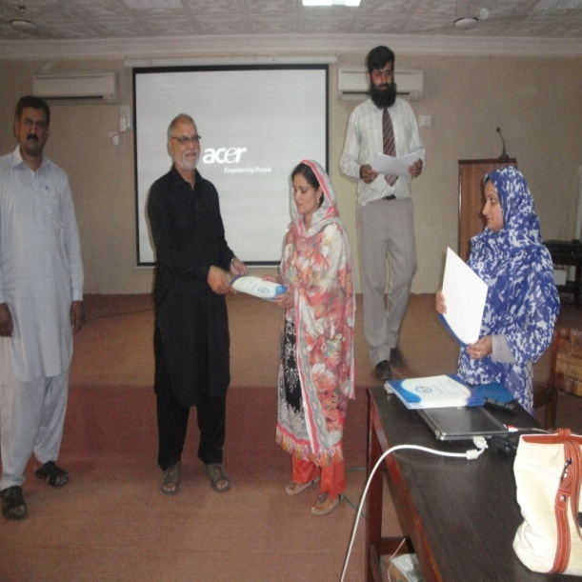
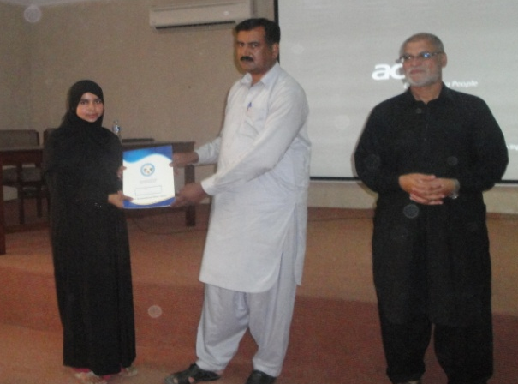

Conclusion and recommendations
Training was well organized as lecture and practical sessions were quite effective for improving knowledge and skills of participants on value addition of fruits and vegetables. The training had a significant positive effect on the participants’ abilities and approach towards value addition. This will help them to prepare healthy, economical & nutritious diet for their family as bulk of participants were found interested in beginning value addition at least for household level food consumption. The training was more focused on practical aspects. However, due to limited space available for engagement of all of the participants and to conduct group activities. This also resulted into less engagement of the participants during some of the session. More involvement in group activity and active engagement thronging encouraging participant to ask questions during lectures may also be considered in future training courses. The training was found useful to start their own business at household level by value addition of different seasonal fruits and vegetables. Therefore, a follow up plan to provide technical backup and provide business orientation for marketing and commercialization of their products is suggested. Product branding and developing linkages through local NGOs and rural development organization can be considered for future endeavours in this direction.

References
Chaudhary, A. H. 2004. Report of the APO Multi-Country Study Mission on Rural-Based Food Processing Industry (SME-OS1-00) Japan, 6–13 March 2001www.apo-tokyo.org/00e-books/AG-04_Rural-BasedFPI.htmEdited by Dr. Alastair Hicks, Bangkok, Thailand.
Dawn. 2004. Rural women at work, The daily Dawn, March 29, 2004. Islamabad, Pakistan. http://www.dawn.com/news/354959/rural-women-at-work
FAO, 2010. Woman contribution in Agriculture. http://www.fao.org/docrep/009/a0493e/a0493e03.html
Gandhi, V., Kumar, G., & Marsh, R. (2000). Agroindustry for rural and small farmer development: issues and lessons from India. The International Food and Agribusiness Management Review, 2(3), 331-344.
Gulati, A., Minot, N., Delgado, C., & Bora, S. (2007). Growth in high-value agriculture in Asia and the emergence of vertical links with farmers. Global supply chains: standards and the poor: how the globalization of food systems and standards affects rural development and poverty, 98-108.
Lee, J. H., Henneberry, D., & Pyles, D. (1991). An analysis of value-added agricultural exports to middle-income developing countries: The case of wheat and beef products. Southern Journal of Agricultural Economics, 23(2), 141-154.
Mrema, G. C., & Rolle, R. S. (2002). Status of the postharvest sector and its contribution to agricultural development and economic growth. In Proc. 9th JIRCAS International Symposium (pp. 13-20).
Rosa, S. (2006). Postharvest management of fruit and vegetables in the Asia-Pacific region: Asian productivity organization. Food and Agricultural Organization (FAO).
Roy, R., Shivamurthy, M., & Radhakrishna, R. B. (2013). Impact of Value Addition Training on Participants of Farmers Training Institutes. World Applied Sciences Journal, 22(10), 1401-1411.
World Bank and IMF. 2013. Global Monitoring Report 2013: Rural-Urban Dynamics and the Millennium Development Goals. http://pubdocs.worldbank.org/pubdocs/publicdoc/2015/9/961951442415876455/GMR-2013-Full-Report.pdf
World Bank, 2010. Gender and Governance in Rural Services, 1, DOI: 10.1596/978-0-8213-7658-4, http:// siteresources. worldbank. org/INTARD/ Resources/ gender_ and_gov_in_rural_services.pdf.

