2.3.2.1. Identification of genes and genetic mechanisms contributing to heat tolerance. Sources of heat tolerance.
Objective and intended output:
Evaluation of phenotypic variation in heat tolerance of wild accessions of germplasm of P. vulgaris, P. acutifolius and P. parvifolius
Materials and methods: Two temperature controlled greenhouses were used to conduct a trial at CIAT. A set of 192 genotypes including 101 accessions of P. vulgaris, 81 accessions of P. acutifolius and 10 accessions of P. parvifolius, were evaluated under heat stress conditions (Minimum temperature 25°C, Maximum temperature 35°C) to quantify phenotypic variation in heat tolerance. Experimental units consisted of 1 row of 1 m long with a row-to-row distance of 0.6 m and plant-to-plant distance of 7 cm. A number of plant traits were evaluated, that included: days to flowering (DF), days to physiological maturity (DPM), SPAD chlorophyll meter readings (SCMR), canopy temperature, photosynthetic efficiency, seed number per area (SNA), pod number per area (PNA), pod harvest index (PHI), and grain production.
We have also evaluated 9 high temperatures nurseries in Alvarado Tolima Colombia at 458 meters above sea level (4°32'45.76” N 74°57'38.86" W), where the minimum air temperature was 23.06 °C and the maximum air temperature was 33.16 °C (Fig. 1). We have included 2 yield trial and 3 advanced families generations (F3, F4, F5) and 4 advanced lines Mesoamerican nurseries (Table 1).

Results and interpretation: Fifteen wild accessions of germplasm of P. vulgaris showed grain formation under heat stress conditions: G10000, G11051, G11053, G11054, G12867, G12889, G19893, G19895, G19901, G22837, G23545, G23552, G23556, G23586 and G24345. Fifty wild accessions of germplasm of P. acutifolius were superior in grain production under heat stress conditions: G40043, G40063, G40064, G40238, G40037A, G40237A, G40144B, G40084, G40230, G40279, G40148, G40272, G40070, G40283, G40041, G40269, G40033, G40154, G40007, G40146, G40237, G40153, G40232, G40160, G40172, G40175, G40066, G40037, G40040, G40159, G40001, G40015, G40111, G40009, G40022, G40157, G40161, G40029, G40174, G40282, G40301, G40156, G40155, G40158, G40014, G40304, G40234, G40008, G40003 and G40173B.
Next steps: The germplasm accessions identified in this trial will be re-tested under higher temperature to identify the most elite materials. Wild P. vulgaris will be used directly in crosses, and accessions of P. acutifolius will enter interspecific crosses with bridging genotypes and embryo rescue techniques.

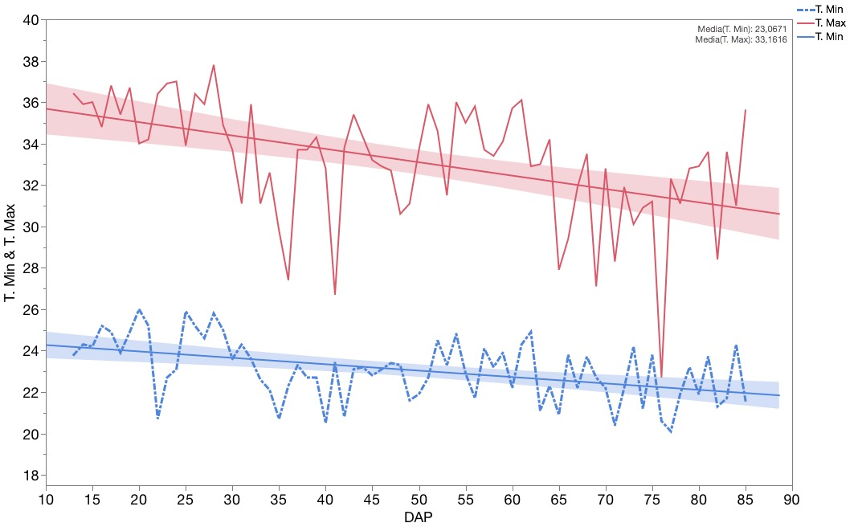
Figure 1. Minimum and maximum Temperature (°C), Alvarado Tolima Col. 4°32'45.76"N 74°57'38.86"W

Table 1. Mesoamerican bean lines planted in Alvarado Tolima
# | Trial | Fn | # mat planted | # checks | total | Design | Rep | Objective | observations | Fn Harvested | # mat harvested | # Individual selections | % Selection
1 | Nursery High temperature_7x7x3_Tolima16C | . | 49 |  | 49 | Latt 7x7 | 3 | Yield trial | in progress | . | all |  | .
2 | P. acutifolius_selec. Caribia 14D_Alvarado-Tolima_2016C | . | 25 | 9 | 34 |  | 2 | Yield trial | in progress | . | all |  | .
3 | Families F2.4 HT Armero_C15A-28_Tolima 16C | F2.4 | 30 | 30 | 60 |  | 1 | Obs. Nursery |  | F4.5 | 12 | 48 | 40
4 | Families F3.5 HT Caribia_C15A-40_Tolima 16C | F3.5 | 38 | 22 | 60 |  | 1 | Obs. Nursery |  | F5.6 | 10 | 38 | 26
5 | Families F1.3 SX_Fe C15D-18_Tolima 16C | F1.3 | 27 | 30 | 57 |  | 1 | Obs. Nursery |  | F1.4 | 2 | Bulk Selection | 7
6 | Selections_Armero y Caribia 2014_C15C_C15D-11_Tolima 16C | . | 91 | 14 | 105 |  | 1 | Obs. Nursery |  | . | 37 |  | 41
7 | Selections SAP 1_20_Tolima 16C | . | 20 |  | 20 |  | 1 | Obs. Nursery |  | . | - |  | .
8 | Lines GGR_Tolima 16C | . | 187 | 21 | 208 |  | 1 | Obs. Nursery |  | . | - |  | .
9 | Parents Lines GGB y GGR_Tolima 16C | . | 31 | 9 | 40 |  | 1 | Obs. Nursery |  | . | - |  | .

