Activity: Molecular and morphological diversity in Phytophthora cajani isolates in India
Objective: To assess the extent of diversity of Phytophthora cajani isolates collected from different climatic situations of India using morphological characters and molecular markers.
Materials and methods: Morphological and cultural variability of 14 isolates of Phytophthora cajani collected from major pigeonpea growing areas in India was studied on different media namely potato dextrose agar (PDA), V8 juice agar (V8JA), corn meal agar (CMA), oat meal agar (OMA), czepek dox agar (CDA) and pigeonpea seed extract agar (PPSE). Cultural characters in relation to mycelium colour and colony appearance of different isolates was also catalogued. For molecular diversity study, PCR amplification of the ITS regions (ITS1 and ITS2) and 5.8S ribosomal DNA was performed with the ITS1 (F) and ITS4 (R). Phylogenetic tree was constructed with 35 other Phytophthora spp. as out groups using the program MEGA6.06. Model was predicted by JModeltest 2.1.7 v20141120 software.
Results and interpretation: All the isolates produced a uniform to irregular colony pattern on almost all of the media (Figure). Profuse growth was observed on V8 and OMA. The pattern was rosaceous on PDA. Each isolate was observed on V8 juice agar medium under microscope for the morphological characters. Sporangia of P. cajani were non-papillate and ranged in shape from ovoid to obpyriform. All isolates produced proliferating sporangiaphores. Rarely, hyphal swellings were observed in the infected seedling tissues. Hyphal swellings were terminal and outer calary with finger like projection (Figure).

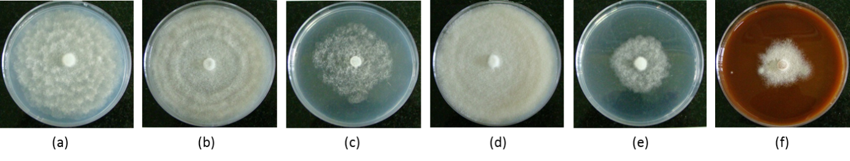
Figure: Colony morphology of P. cajani on different media (a) PDA, (b) V8JA, (c) CMA, (d) OMA, (e) CDA, (f) PPSE.
The phylogenetic relationship among the isolates as well as with other Phytophthora spp. was made based on nucleotide sequences of ITS region. In phylogenetic tree, it was found that all the isolates of P. cajani were grouped together in the same clade with the nearest relative P. sojae isolate.
Next steps: Investigation needs to be done involving more number of isolates of P. cajani.

