Performance of Bush and Climbing beans under the prolonged drought in different Cropping Systems and Fertility Management Regimes in Linthipe and Kandeu, Malawi

Gift B Ndengu, Lulseged Tamene, Powell Mponela, Barthlomew Chataika, Rowland Chirwa
International Centre for Tropical Agriculture, Malawi Office, Box 158, Lilongwe
Contact person: Lulseged Tamene Desta – lt.desta@cgiar.org

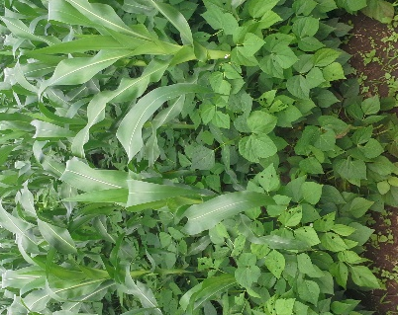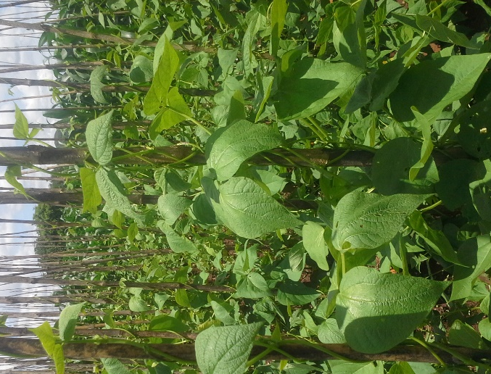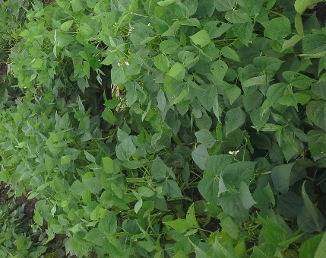

Abstract

CIAT in undertaking a participatory research in Linthipe and Kandeu in Dedza and Ntcheu districts respectively. The aim is to improve bean production through adoption of drought tolerant and high yielding varieties. The trial setup follows the Mother –baby approach, where a split plot design has been used, eight treatment based on stepwise ISFM for sole bean and bean-maize intercropping have been used, as split plots, while varieties (climbers DC86-263 and MBC33, bushbeans SER45 and SER83) were whole plots. Results showed high podloads in bushbeans (SER45 and SER83) 16.1 (14.2 – 18.0) than in climbers (DC86-263 and MBC33) 6.0 (4.2 – 8.6). A similar trend was observed in yields, where bushbeans had a mean yield of 1.05Mgha⁻¹ (0.9 – 1.2) which was higher than climbing beans 0.3 (0.2 – 0.5). Biomass at harvest was also found to be higher in bushbeans 0.6 Mgha⁻¹ (0.6 - 0.7) than in climbers 0.3 Mgha⁻¹ (0.3 – 0.4 Mgha⁻¹). The yield in bush beans was found to be 262.5% higher than the reported mean yield for Malawi (0.4Mgha⁻¹). The generally low values in podload, yield and biomass at harvest in climbers as opposed to bushbeans was attributed to drought that affected climbing beans more than bushbeans, due to the high sensitivity of climbing beans to water stress. The superior performance of the bushbeans (SER45 and SER83) under drought conditions underlined their potential and suitability for use in the current erratic weather patterns to boost bean productivity. In addition, evidences of synergies between the beans and ISFM technologies were observed, emphasising the need to use a combination of the technologies (i.e. improved varieties and ISFM) to gain extra units of yield to increase bean productivity). It was interesting to note that generally treatments under ISFM had better yield (0.5 - 1.2Mgha⁻¹) as opposed to those without (0.4 - 0.6 Mgha⁻¹). The performance interested different sections of the society such as farmers, scientists and a journalist, who wondered why the demonstrated bushbean varieties were not released as yet. A clear sign of success and readiness. Much as the scenario under drought significantly reduced yield of most crops, it presented an opportunity for the participating farmers to learn and experience effects of varieties (that are drought resilient) and ISFM technologies synergistically working together in lessening effects of drought on bean yields, which they could extrapolate to other crops as well.

Introduction:
Common beans (Phaseolus vulgaris L) play an important role in food and nutrition security in Malawi through a cheaper source of protein, vitamins and minerals for the rural households. The crop has also proved to be an import source of income for farmers when sold (Muthoni et al., undated). Eighty percent of the farming population is involved in bean farming in one way or another (Muthoni et al., undated). Despite the reported importance of bean production, mean yields in Malawi have persistently remained low (0.4 Mgha⁻¹) (Muthoni et al., undated). A combination of factors have been blamed for this. These include pest and diseases, declining soil fertility, poor quality of varieties (varieties) used, adverse climatic conditions such as drought, and slow rate in the adoption of the new technologies related to bean production (Muthoni et al., undated). The two main types of beans grown by farmers in Malawi are the climbing and erect (popularly known as bushbeans).

In general climbing bean varieties have longer periods of growth and maturity (4 months) as compared to bush beans (3 months) (Ramaekes et al., 2013). As such they are classified as late maturing, while bushbeans are early maturing, due to their short growth and maturing period. Under normal circumstances, climbing beans have the potential to produce between 4 -5 Mgha⁻¹, as compared to a maximum of 3 Mgha⁻¹ for the bush beans (Ramaekes et al., 2013). Unlike most other leguminous crops, common beans are not very well adapted to extreme weather conditions, such as very low and high temperatures (Irao et al., 2013). Drought or moisture stress at critical times significantly affects bean yield, however, severity of moisture stress depends on the stage of development at which the bean is and the type of bean (i.e. whether it is a climber or bushbean) (Irao et al, 2013). Literature further indicates that climbing beans are highly sensitive to drought, as opposed to bushbeans (Ramaekes et al., 2013). This means that with relatively shorter duration and low amount of rains, bush beans would most likely do better than climbing beans. Prolonged dry spells during the flowering stage, results in reduction in yield, caused by low production of pods, while if it strikes at pod forming stage, the cause in yield drop is embryonic abortions (Emam et al., 2010). Other manifestations of drought / moisture stress effects include reduction in nodulation, canopy biomass, seed weight, and number of days to maturity (Emam, et al., 2010; Irao et al., 2013).
Based on the low yield realized by farmers through use local bean landraces and erratic patterns of rainfall, associated with changes in climatic conditions, and low soil fertility of the soils, CIAT has been involved in the development of high yielding and drought tolerant varieties for the Malawian conditions, together with their associated Integrated soils fertility management technologies (ISFM). Some of these drought tolerant varieties released include Napilira, Kabalabala, maluwa, Mkhalira etc. (Muthoni et al., undated). Currently there are some promising bushbean varieties such as SER45 and SER83, showing positive signs of adaptability inform of high yields, resilience to environmental conditions (drought/ moisture stress) as well as pest and disease attack. Alongside the bushbeans, are the two climbers MBC33 and DC80 -263. These underwent a mid-altitude evaluation process by the McKnight foundation and the National Bean Programme in Malawi, and were identified to be promising varieties for yield and resistance to diseases. The varieties MBC33 is a large seeded variety, while DC 86-263 is a small seeded. These varieties were also tested in the Africa RISING sites in Linthipe (Dedza) and Kandeu (Ntcheu) under demonstration trials. The aim of these demonstration trials are aimed at disseminating bean production technologies based on integrated soil fertility management (ISFM) to bean farmers in the site, with an ultimate objective of increasing bean productivity. Notably, the definition of cropping systems in this document is either intercropping or monocropping.

The 2014-2015 season was characterised heavy rainfall late December to mid-January, followed by a terminal drought from mid-February to mid-march. Major crops including beans, groundnuts and maize had their yield negatively affected by the drought. However, the severity of effects depended on the sensitivity of the crop to moisture stress and stage at which the crop was when the drought occurred. This document is a report aimed at comparing (a) podload, seed-podratio, biomass at harvest and yield of climbing (DC86-263 and MBC33) and bushbeans varieties (SER45 and SER83) with a background of drought; (b) comparing yield performance of bush and climbing beans under stepwise ISFM and different management options. This document is a report of the performance of the promising bean varieties for the season 2014-2015 in the Linthipe and Kandeu trials sites.

Methodology

Experimental design

The basic design of the trials followed the Mother – Baby formulation. Mother trials were laid out in split-plot design, with each of the two promising bean variety (bush and climbing) as whole plots, while management options were split plots. These two climbing bean varieties were MBC 33 and DC86-263, whereas the bush bean seed varieties were SER45 and SER83. Maize seed (DK8033) was used in bean- maize intercrop option. Management options included mono-cropping, intercropping with maize, use of manure, fertilizer, a combination of manure and fertilizer for dwarf and climbing bean fields, as well as different staking options for climbing bean fields (See Table 1). Staking options included stick stakes, and maize. Treatments were randomized in three replicates taking into account that ridges were approximately 0.75m and 4m long, completing a 5m x 4m plot per treatment.

Table 1: Trial treatments in the 2014/15 growing seasons
Bushbeans | Climbers | Treatment symbol
2014-15 | 2014-15
Bean | Bean + Stick stakes | B
Bean + Manure | Bean + Manure + Stick stakes | Bc
Bean + Manure + fertilizer | Bean + Manure + Fertilizer + Stick stakes | Bcf
Bean + Maize | Bean + Maize | BM
Bean + maize + Manure | Bean + maize + Manure | BMc
Maize + Manure + Fertilizer | Maize + Manure + Fertilizer | Mcf
Bean + Maize + Manure + Fertilizer | Bean + Maize + Manure + Fertilizer | BMcf
Bean + Maize + Fertilizer | Bean + Maize + Fertilizer | BMf

Note: manure = chicken manure; symbol meanings: c = manure, f = fertiliser, cf (manure + fertiliser), B=beans, M= maize.

Each plot had 5 ridges and a dead row left in between the plots to act as path. Fertilizer was applied at emergence at the rate of 100 kg ha⁻¹ for top dressing, with 23:21:0 + 4 S, and basal dressing with Urea at 100 kg (46% N). Manure was applied at the rate of 17ton ha⁻¹ (air dried weight) for bush beans and 8.5tons ha⁻¹ (air dried weight) for climbing (air dried weight). In maize-bean intercrop, beans were planted 25 cm apart, one seed per station while in sole crop bush beans and climbing beans were planted 10 cm and 20cm apart, respectively. Maize was planted at 25cm between plants, one seed per station. In intercrops, the spatial arrangement included planting on the same station with maize, and in between.

Data collection and statistical analysis
Net plots for the harvesting were defined by the middle three ridges, 2m x 3m middle rows, discarding 1m from each end. To lessen the amount of work during harvesting, but still get a representative sample, five bean plants were randomly harvested from the net plot by cutting at the base. Haulms and pods were separated and weighted. Pods were counted to determine podload and then shelled. Seeds and husks from the five plants were weighed separately. Seeds from the five plants were counted to determine number of seeds per pod and a further 100 seeds weighed. Air-dried weights of the sampled haulms and husks were also collected. The pods were then shelled and seed and chaff weighed separately. Similarly, number of maize plants in the net harvest plot was counted and recoded. Similarly, five maize plants were randomly harvested, their cobs weighed and recorded. The resultant cobs were shelled, and the fresh weight of grains determined. Yield was determined on air-dried basis (natural weight for farmers). A template was used to guide the collection of the yield components. Pearson correlation was used to explore relationships between variables of interest.

Data analysis involved the use of descriptive statistics and analysis of variance (factorial and one-way) to compare the performance of the varieties between growth habits and different management options in the two sites. Graphing was used to illustrate comparisons and interaction effects between variables.

Results and discussions:
Results from the study show that high podloads were observed in SER45 where values ranged between 15.0 -18.0 (16.5) and SER83 14.2 – 17.0 (15.6) with least in MBC33 4.2 – 5.8 (5.0) followed by DC86-264 6.4 -8.6 (7.5) (Table 2). The difference between SER varieties was insignificant (p > 0.05), while that between MBC33 and DC86-263 was statistically significant (p< 0.05).

Table 2: Grain yield, podload and seed-pod ratio of the bean in the trial sites of Linthipe and Kandeu
Variable | GH | Variety | N | Mean |  |  | Conf  -95% | Conf  95% | CI | Max | CV | SE
Podload | Climber | DC86-263 | 72 | 7.5ª | ± | 4.7 | 6.4 | 8.6 | 2.2 | 21.4 | 63.1 | 0.6
Podload | Climber | MBC33 | 81 | 5.0^{b} | ± | 3.7 | 4.2 | 5.8 | 1.6 | 23.6 | 74.2 | 0.4
Podload | Dwarf | SER45 | 125 | 16.5^{c} | ± | 8.3 | 15.0 | 18.0 | 2.9 | 42.8 | 50.4 | 0.7
Podload | Dwarf | SER83 | 120 | 15.6^{c} | ± | 7.7 | 14.2 | 17.0 | 2.8 | 40.2 | 49.4 | 0.7
Seed-pod ratio
Seed-pod ratio | Climber | DC86-263 | 73 | 2.8ª | ± | 1.1 | 2.5 | 3.1 | 0.5 | 6.3 | 40.6 | 0.1
Seed-pod ratio | Climber | MBC33 | 82 | 1.5ª | ± | 0.7 | 1.4 | 1.7 | 0.3 | 3.5 | 43.7 | 0.1
Seed-pod ratio | Dwarf | SER45 | 126 | 3.4^{b} | ± | 4.0 | 2.7 | 4.1 | 1.4 | 45.8 | 119.9 | 0.4
Seed-pod ratio | Dwarf | SER83 | 121 | 2.9^{b} | ± | 0.9 | 2.7 | 3.0 | 0.3 | 5.8 | 32.0 | 0.1
Grain yield (Mg/ha | Climber | DC86-263 | 73 | 0.2ª | ± | 0.3 | 0.2 | 0.3 | 0.1 | 1.2 | 112.5 | 0.0
Grain yield (Mg/ha | Climber | MBC33 | 82 | 0.4^{b} | ± | 0.5 | 0.3 | 0.5 | 0.2 | 2.1 | 117.6 | 0.1
Grain yield (Mg/ha | Dwarf | SER45 | 125 | 1.1 ^{c} | ± | 0.8 | 0.9 | 1.2 | 0.3 | 4.6 | 70.9 | 0.1
Grain yield (Mg/ha | Dwarf | SER83 | 122 | 1.0^{c} | ± | 0.6 | 0.9 | 1.2 | 0.2 | 3.6 | 61.1 | 0.1

Note: Means which are within column and of the same variable are not significantly different (p>0.05), if have the same letter, while those with different letters are significantly different (p<0.05), GH = growth habit (i.e. being either a climber or bush)
These results meant that the average number of pods in climbers was different, where MBC33 generally produced less pods than DC86-263. On the other hand, bush beans (SER45 and SER83) produced almost equal numbers of pods per plant. The number of pods for both climbers was lower than in the either bushbean. This was an indication of low pod production in climbers than in bushbeans, which differed from the expectation. Similar trends were noted in the seed-pod ratio, where the highest was for SER45 2.7 – 4.1 (3.4) followed by SER83 2.7 - 3.0 (2.9), but their difference was insignificant (p > 0.05). On the other hand, comparison between the two climbers for the seed-pod ratio indicated significant differences between them, where DC86-263 was the highest 2.5 -3.1(2.8) and MBC33 the least 1.4 - 1.7 (1.5). The implication here was that bush beans had more seeds per pod than climbers, suggesting a relatively more successful podfilling process in bushbeans as opposed to climbers.

A look at yield, showed that bushbeans varieties had high yield as opposed to climbers (Table 2). Observations based varieties showed that the bush bean SER43 had the highest yield 0.9 – 1.2 Mgha⁻¹ (1.1 Mgha⁻¹), though almost the same as SER83 0.9 – 1.2 Mgha⁻¹ (1.0 Mgha⁻¹), as the difference between the two was insignificant (p >0.05). However, for the two climbing varieties, the story was different, MBC33 had higher grain yield ranging from 0.3 – 0.5 Mgha⁻¹ (0.4Mgha⁻¹), while DC86-263 ranged from 0.2 – 0.3 Mgha-1 (0.2Mgha⁻¹). This meant that productivity of the two bush varieties was the same, while that of climbing beans was different. The high yield in MBC33 was least expected, as both podload and seed-pod ratio were higher in DC86-263 than in MBC. This result gave false of hopes of a superior yield in DC86-263. Notably, MBC33 is a large seeded climbing varieties, while DC86-263 is small seeded. Despite MBC33 numerical inferiority in both podload and seed-pod ratio, the higher yield values of MBC33 as opposed to DC86-263, were a result of the difference in their seed sizes. The 100 seed weight for MBC in the trials was 47.0 g, while that of DC-86-263 was 25.3 g. Such a difference meant that a few seeds of MBC33 outweighed those of DC86-263. Based on weight, this result implied that the yield of MBC33 was higher than that of DC86-263 (p < 0.05). However regarding the numbers of seeds produced, DC86-263 outperformed MBC33.

Correlation between podload and yield was high and significant (r = 0.6; p < 0.05), but that between seed-pod ratio and yield was low and insignificant (r = 0.03; p >0.05). This meant that the more the number of pods the higher the yield for both bush and climbing varieties.

A B
Figure 1: Comparing podload (A) and seed-pod ratio (B) between bush and climbing beans in Linthipe and Kandeu

Interaction effects between treatment and growth habit on podload indicated that the sole bean in treatments (Bcf) had the highest podloads (1.6), while the least was the treatment BM (11.0) where beans were planted as an intercrop with maize without applying manure or fertiliser. Podloads in beans planted as an intercrop with maize were generally low (Figure 1A). The difference between podload in Bcf treatment and Bc was small and insignificant (p> 0.05). A similar response pattern to podload was found in climbers (Figure 1A), where the difference between the high podloads treatments Bcf and Bc was as well insignificant (P> 0.05). For the bean-maize intercrop, response to pod production was relatively better in bushbeans for the treatment MBcf, while the response was quite weak in climbers for the same treatment (Figure 1A). Nevertheless, the difference between treatments MBcf and MBc was insignificant. The difference between climbers and bush for each treatment was significant (Figure 1A), emphasizing the striking difference in the performance of the two. Seed-podratio followed a similar patter as that of podload in bushbeans, but not in climbing beans. The low ratios in climbing beans for most treatment indicated poor podfiling process, such that most pods had fewer seeds in them than in bushbeans. For bushbeans application of a combination of manure and fertiliser in sole beans (Bcf) resulted in increased sees-pod ratio implying that this treatment improved productivity unlike the others.

For treatments, yield in bushbeans was generally higher than that in climbers (Figure 2A). Specific varieties showed that in all treatments yield values did not differ significantly between SER45 and SE83, except for treatment Bc, where the response to yield in SER45 was better (1.7Mha⁻¹) than that of SER83 (1.2Mgha⁻¹) (Figure 2B). In climbers differences in yield between different treatments were not significant, though values were higher in MB33 for treatment Bc and Bcf, an indicator of some potential response to manure or manure and fertilized applied, which might have been surprised.

Bio mass production at harvest, showed generally higher values in bushbeans 0.6Mgha⁻¹ (0.6 – 0.7 Mgha⁻¹) than climbers 0.3 Mgha⁻¹ (0.3-0.4 Mgha⁻¹), however, the superior performance of bush beans over climbers was seen as an anomaly. In all treatments except for Bcf, the biomass yield in bushbeans was higher than in climbers and differences were significant (Figure 3). The positive response in climbing beans to biomass with treatment Bcf meant that application of both manure and fertlisers increased biomass production in climbing beans. This was expected as is the component of fertlisers supplemented nitrogen availability which encouraged vegetative growth of beans.

All in all, the generally low values in podload, seed-pod ratios, yield as well as biomass at harvest in climbers as compared to bush beans was surprising. Under normal circumstances climbing beans outperform bushbeans in most respects except for early maturity.

A B
Figure 2: Comparing bean yield (Mgha⁻¹) disaggregated by GH (A) and variety (B) in Linthipe and Kandeu, Malawi
The opposite performance seen in climbers is an indication that some conditions were not right for climbing bean production unlike bushbeans in the 2014-2015growing season.

Figure 3: Biomass (Mgha⁻¹) at harvest for bush and climbers in the different treatments

Based on growth habit (i.e. whether being a climber or bushbean), the average podload in bushbeans was 16.1(14.2 – 18.0), while that in climbing beans was 6.0 (4.2 – 8.6). In addition, the mean seed-podratio for bushbeans was 3.2 (2.7 – 4.1), and that in climbers was 2.2 (1.4 – 3.1Mgha⁻¹). The low pod production in climbers as compared to bush beans, is an indication of some factor that negatively affected their development and production as opposed to bush beans. The yield for climbers was 0.3Mgha⁻¹ (0.2 – 0.5 Mgha⁻¹) and the one in bushbeans was 1.05Mgha⁻¹ (0.9 -1.2Mgha⁻¹). Interesting to note was that despite the poor performance in climbers, the mean yield in bushbeans was 262.5% higher than the reported mean yields in Malawi (about 400kgha⁻¹). This strengthened the hope of improving the overall bean productivity in Malawi through use of the bush beans with the associated ISFM technologies used in these trials. Nevertheless, the performance in climbers in the 2014-2015 season was in contrast with the performance of the climbers in the normal year of 2013- 14 (without drought), where the yield range was 0.61 – 2.6 Mgha⁻¹ (mean = 1.5 Mgha⁻¹). Worth noting is the fact that the podding and podfilling process requires good soil moisture availability. This was compromised by the dry spell of the 2014/15 growing season. The timing for the dry spell was more disadvantageous to climbers than bush beans, as it came at a point when bush beans had gone beyond the critical stage, allowing them to continue their development with residual moisture, unlike the climbers which had just started flowering (Figure 4), and were a long way to physiological maturity.

Pictures taken on 27/02/2015 show that bush beans had already produced pods, while climbing beans were just starting flowering (Figure 1). The highly sensitive nature of climbers to water stress, and the critical stages (flowering and pod forming) of bean production at which the dry spell stroke, meant that the production of pods and pod filling was negatively affected. On the other hand, bushbeans were able to use residual moisture to complete their developments to physiological maturity. The low productivity in climbers was therefore attributed to drought.

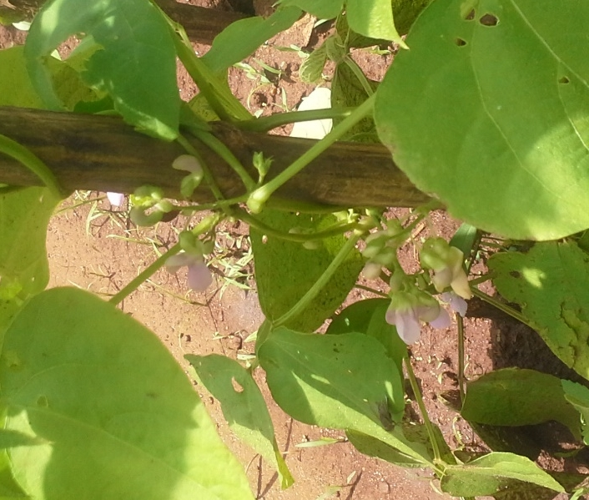
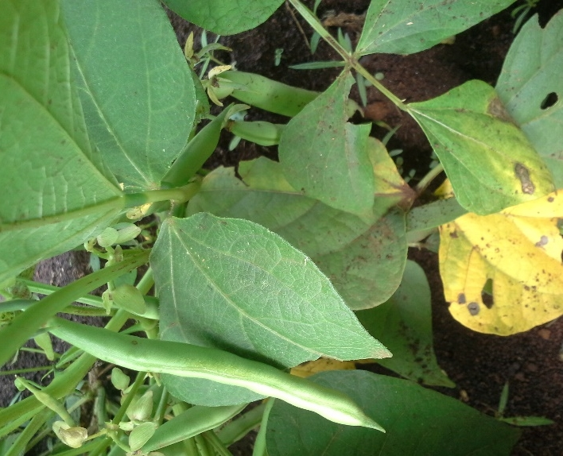
Figure 4: Flowering climbing beans (left) and bushbeans with pods taken in Linthipe on 27/02/2015 during drought.

The high performance of bush beans varieties (SER45 and SER83) in the advent of drought, was an indication that they are resilient to such environmental conditions, while the poor performance in climbers underlines the fact that the magnitude of drought effects are more on climbing beans than bush bean. This implied that with the current erratic weather patterns encouraging use of drought resilient varieties is important to ensure increased bean production.
The SER45 and SER83 astounding performance, under drought conditions was not only noticed statistically on paper, but even the participating farmers in the project and the visiting scientists as well. When a comparative random sampling was done during the field day in March, 2015, it was found that SER83 had a higher podload (124) than other varieties from adjust fields under similar management by nonparticipating farmers (27). “This is a magic bean. How I wished I had an opportunity to plant a big area,” were some of the sentiments expressed by Pokoma Lebita, a farmer hosting the Mother trial at Ungwe village in Linthipe, Dedza district. These sentiments indicated the extraordinary performance of the SER varieties with drought in the background of everything. Visiting scientists and development partners, wondered why the varieties were not yet released. The success story of the drought tolerant bushbeans varieties was complimented by the visit by a Journalist to the field site after being interesting by what he heard and saw during the Beating Famine International Conference (www.beatingfamine.com) organized by World Vision and World Agroforestry Centre at the Bingu International Conference Centre (https://vimeo.com/125072271). When the participating farmers saw the journalist, due to the excitement, they likened the success of the introduced beans, especially the SER varieties to a “Voice so loud as to attract the interest of an international journalist”.

Effects of ISFM Technologies on drought resilience.

Statistics on treatments under ISFM indicated that they generally had better yield (500 -1200 kgha⁻¹) as opposed to those without (350 -550 kgha⁻¹⁾. In addition, during the field visit (March, 2015), it was observed that leaves of beans in treatments which involved ISFM, had relatively greener leaves with evidences of residual moisture persisting in the plots at the peak of the drought. Random enquiry amongst participating farmers for their observations with regards to signs of moisture stress in the demonstration trials, indicated that treatments with manure (c), fertiliser (f), and a combination of these (cf), were relatively less affected by moisture stress. This was most probably due to the vigorous vegetation shading direct sunlight on the soil surface, and presence of organic matter, retaining moisture in the soil. These observations were a clear signs of the contribution of ISFM to drought resilience. In the end it could be said that the synergy between the ISFM technologies worked to the advantage of improving the performance of the beans even though the effects were clearer in bush beans (SER45 and SER83), due to their nature of drought resilience. As much as the year was a disaster for other crops, unfortunately, it presented a great opportunity for the participating farmers to experience, learn and gain first-hand information on how improved varieties (that are drought resilient) and ISFM technologies synergistically work together in lessening effects of drought on bean yields.

Conclusion:

The study has shown high mean podload in bushbeans (16.1), seed-pod ratio (3.2), yield (1.05Mgha⁻¹), and biomass at harvest (0.6Mgha⁻¹), than climbers at (6.0), (2.2), and (0.3 Mgha⁻¹) and (0.3 Mgha⁻¹), respectively. The general low values in bushbeans as opposed to climbing beans was found to be anomaly and was attributed to drought that took a greater toll on climbing beans than on the , due to the high sensitivity of climbing beans to water stress. The superior performance of the bushbeans (SER45 and SER83) under drought conditions has underlined their potential and suitability for use in the current erratic weather patterns to boost bean productivity. This further suggested the need for release to the wider population to benefit from drought and yield superior characteristics. Evidences of synergies between the beans and ISFM technologies were observed and emphasised the need to use the two technologies (i.e. improved varieties and ISFM) to gain an extra mile in increasing bean productivity. The performance interested different sections of the society such as farmers, scientists and a journalist. A clear sign of success. Much as the scenario under drought significantly reduced yield of most crop, some positive outcomes were still savaged out of it, as it presented a great opportunity for the participating farmers to learn and experience effects of varieties (that are drought resilient) and ISFM technologies synergistically working together in lessening effects of drought on bean yields. This could be extrapolated to other crops as well, as the sole maize and that under the bean-maze intercrop, performed well in these trials at 5.9Mgha-1 and 6000kgha⁻¹, respectively.

References:

Emam, Y., Shekoofa, A., Salehi F. and Jalali A.H. (2010). Water Stress Effects on Two Common Bean Cultivars with Contrasting Growth Habits. American-Eurasian J. Agric. & Environ. Sci., 9, 5, 495-499

Muthoni, R., Barungi, M., Chirwa, R., Chianu, J., and Birachi, E. (undated). Determining the market share of improved common bean varieties traded in selected markets in Malawi. Unpublished Report

Ramaekers, L., Micheni, A., Mbogo, P., Vanderleyden, J. and Maertens, M. (2013). Adoption of climbing beans in the central highlands of Kenya: An empirical analysis of farmers’ adoption decisions. African Journal of Agricultural Research, 8, 1, 1-19

Rao, I, Beebe, S., Polania, J., Ricaurte, J., Cajiao, C., Garcia, R., and Rivera, M. (2013). Can tepary bean be a model for improvement of drought resistance of drought resistance in common bean? African Crop Science Journal, 21, 4, 265 – 281.

Alley, M.M and Vanlauwe, B (2009). The role of Fertilizers in Integrated Plant Nutrient Management. International Fertiliser Industry Association (IFA), Paris, Tropical Soil Biology and Fertility Institute of the International Centre for Tropical Agriculture (CIAT), Nairobi, Kenya.

