Technical Report PK-CRP DS/BARI-04/2015

PARTICIPATORY SELECTION OF PROMISING WHEAT, CHICKPEA AND LENTIL CULTIVARS
(CRP 1.1 DRYLAND SYSTEMS)

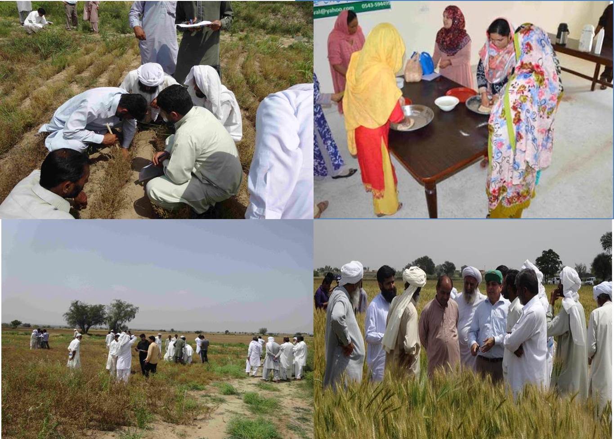
Dr. M. Ramzan Anser
Mr. M. Azeem Tariq
Hassnain Shah
Dr. Muhammad Tariq

Barani Agricultural Research Institute
Chakwal, Pakistan
June 2015

CONTENTS
Summary | 2
1. Introduction | 3
2. Methodology | 4
3. Results & Discussion | 11
4. Conclusion | 17
5. Recommendation | 17
6. Literature cited | 18

SUMMARY
Wheat, chickpea and lentil are important crops to ensure food and nutritional security in dryland region. However, yield of these are low. Farmers plant local varieties using their own unimproved seeds. Low crop yield affects livelihood of these low income group farming communities majority of who have limited livelihood beyond agriculture. Increasing population and shrinking land and other resources indicate that crop yields in barani areas will have to increase per unit area on a sustainable basis to ensure food and nutritional security.
Participatory varietal selection was therefore planned under CRP Dryland Systems to assist rural farming communities under CRP DS by providing them chance to select the most promising cultivars through on-farm PVS trials at representative locations in Chakwal-the hub of the rainfed region. The major objective was to identify promising crop varieties to increase resilience and improved use of marginal lands for crop production. The varietal selection was based farmers evaluation through farmer field days, evaluation of cooking quality by rural women in addition to technical evaluation by scientists through crop sampling for yield measurement. 102 male and 48 female farmers participated in the selection process. The selection process also involved 8 extension agents, 11 scientists and 8 internship students.
The Participatory selection activity revealed “Dharabi-11” and “Aas-2011” as the most promising wheat varieties while “Markaz-09” was identified as most promising lentil cultivar developed by NARS. Wheat yield in on-farm trails was above 3 tonnes ha⁻¹ against regional average of around 0.7 tonnes ha⁻¹, whereas lentil yield was almost double as compared to regional average yield in dryland areas. The results of participatory varietal selection imply that resource poor barani farmers can increase wheat and lentil production in a sustainable manner to meet the country's need. However, the adoption will depend on the availability of certified seed of selected cultivars. The present study also emphasized that the province needs to strengthen its chickpea breeding program as none of the latest cultivar showed disease tolerance/resistance during the study period.

INTRODUCTION:
The barani areas of Punjab contribute substantially to cropped area in Punjab, Pakistan (Fig. 1).

Fig.1 Percent contribution of dryland areas to cropped area in Punjab
Wheat, chickpea and lentil are important crops to ensure food and nutritional security in dryland region. However, yield of these are low. The last ten years statistics of dryland areas show average wheat grain yield ranged from 483 to 987 kg ha⁻¹; average chickpea yield varied between 213-764 kg ha⁻¹ while for lentil it was in the range of 475-592 kg ha⁻¹ in Punjab (Punjab Development Statistics, 2014).
Crop production in the region is considered risky due to climatic constraints and as such farmers are conservative in use of inputs. Farmers plant local varieties using their own unimproved seeds. Low crop yield affects livelihood of these low income group farming communities majority of who have limited livelihood beyond agriculture. Increasing population and shrinking land and other resources indicate that crop yields in barani areas will have to increase per unit area on a sustainable basis to ensure food and nutritional security. Improvement in crop productivity in rainfed areas would also ease the burden on and allow more of the irrigated land to be used for production of other important commodities.
The introduction and adoption of the improved technology to popularize it among the farmers through on-farm demonstrations and verifications has been reported to serve as catalyst to increase the productivity (Tabo et al., 1999 a,b). Furthermore, inclusion of farmers in the process may also help to reduce adoption lag of improved varieties. The participatory varietal selection (PVS) has proved successful to identify appropriate varieties and increase variety adoption rates particularly in area where choices are limited (Witcombe et al., 1996 & 1999).
Wheat, Chickpea and Lentil occupy substantial areas in dryland region with low land productivity. Therefore, it was planned to assist rural farming communities under CRP DS by providing them chance to select the most promising cultivars through on-farm PVS trials at representative locations in Chakwal-the hub of the rainfed region. The major objective during initial six month project duration was to identify promising crop varieties to increase resilience and improved use of marginal lands for crop production.

METHODOLOGY
A total of 30 participatory varietal selection trials (05 locations per crop) were conducted on wheat, chickpea and lentil in two clusters in Chakwal District. Each crop PVS trial included above mentioned varieties of respective crop at each location. The varietal selected was carried out from these on-farm trials.
The PVS trials comprised of following NARS cultivars duly approved by National/Provincial Seed Councils and recommended for general cultivation by the rainfed growers:
Wheat
Name of cultivar | Developed by (Institute)
Aas-2011 | Regional Agricultural Research Institute, Bahawalpur (RARI)
Chakwal-50 | Barani Agricultural Research Institute Chakwal (BARI)
NARC-09 | National Agricultural Research Centre Islamabad (NARC)
Pakistan-2013 | National Agricultural Research Centre Islamabad (NARC)
Dharabi-11 | Barani Agricultural Research Institute Chakwal (BARI)

Lentil
Name of cultivar | Developed by (Institute)
Masoor 2006 | Nuclear Institute for Agriculture and Biology Faisalabad (NIAB)
Masoor 2002 | Nuclear Institute for Agriculture and Biology Faisalabad (NIAB)
Chakwal Masoor | Barani Agricultural Research Institute Chakwal (BARI)
Markaz-09 | National Agricultural Research Centre Islamabad (NARC)
Punjab Masoor | Pulses Research Institute, Faisalabad (PRI, AARI)
Chickpea
Name of cultivar | Developed by (Institute)
Bittle 98 | Pulses Research Institute, Faisalabad (PRI, AARI)
Balkassar 2000 | Barani Agricultural Research Institute Chakwal (BARI)
Wanhar 2000 | Barani Agricultural Research Institute Chakwal (BARI)
Thal 2000 | Arid Zone Research Institute Bhakkar (AZRI)
Punjab 2008 | Pulses Research Institute, Faisalabad (PRI, AARI)
Bhakkar 2011 | Arid Zone Research Institute Bhakkar (AZRI)

The varietal selection was based on following parameters for wheat:
- Farmers evaluation through farmer field days
- Evaluation of cooking quality by rural women
- Technical evaluation by scientists (crop sampling at harvest)
In case of lentil, 50% weightage was given each to farmers’ evaluation, and crop sampling at harvest.
Sever blight attack eliminated chickpea crop in the trials as well as in the region (Fig 2.) and therefore, no evaluation of crop cultivars could be carried out during 2015.
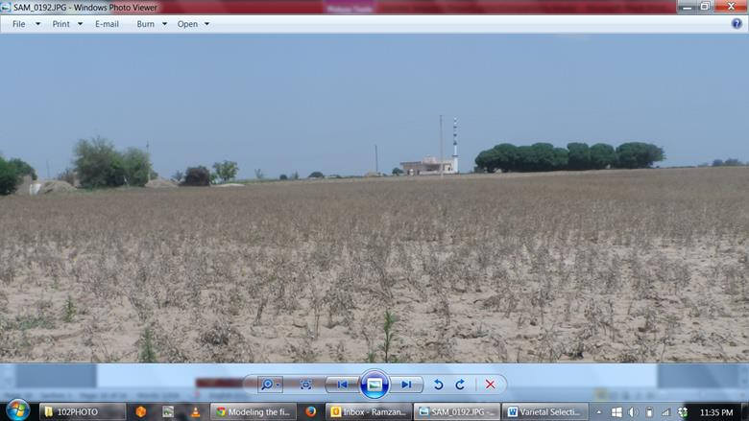
Fig. 2 A view of the chickpea crop failure in the field due to severe disease attack
- Farmers Evaluation through Field days
Field days are considered a good tool to get the immediate response/feedback of the farmers about any intervention established/demonstrated at a farmer site in participatory mode. BARI in collaboration with ICARDA conducted two field days (April 17 and 20, 2015) at already established on-farm varietal trial sites (Saghar and Latifal villages) in Chakwal. The total participation in the events was 177 (Fig. 3).

Fig. 3 Participation of different groups in farmer field days
Each farmer field day was conducted at a participatory experimental site & divided into 3 sessions. During session-1, all the participants were initially briefed (Fig. 4) about the objectives of the project in general and the event specifically.
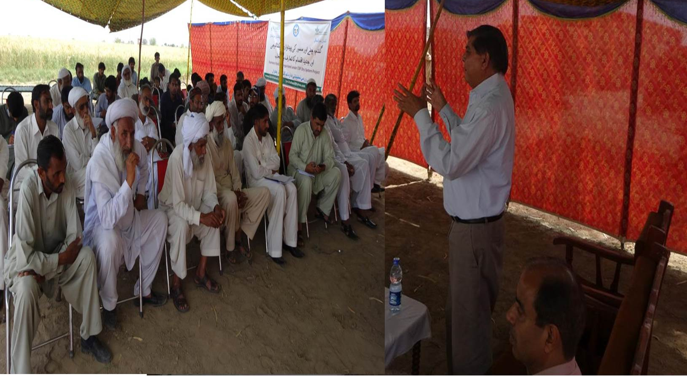
Fig. 4 Dr. Abdul Majid (ICARDA) sharing objectives with the participants
Afterwards they were divided into 3-5 groups and were taken to the experimental field for varietal selection, where each varietal plot was coded to avoid bias. Each group (farmers, extension agents, scientists, students) was given one proforma to document their criteria for varietal selection with a meter rod to measure the varietal attributes where required.
The groups first evaluated the lentil and then wheat at resilience (Saghar), while at intensification only wheat could be evaluated (Fig. 5, 6). One farmer was designated as group facilitator. One internee student was also attached with each group to learn & document the way farmers evaluate the cultivars. The scientists of BARI, SSRI and ICARDA also facilitated farmers in varietal evaluation.
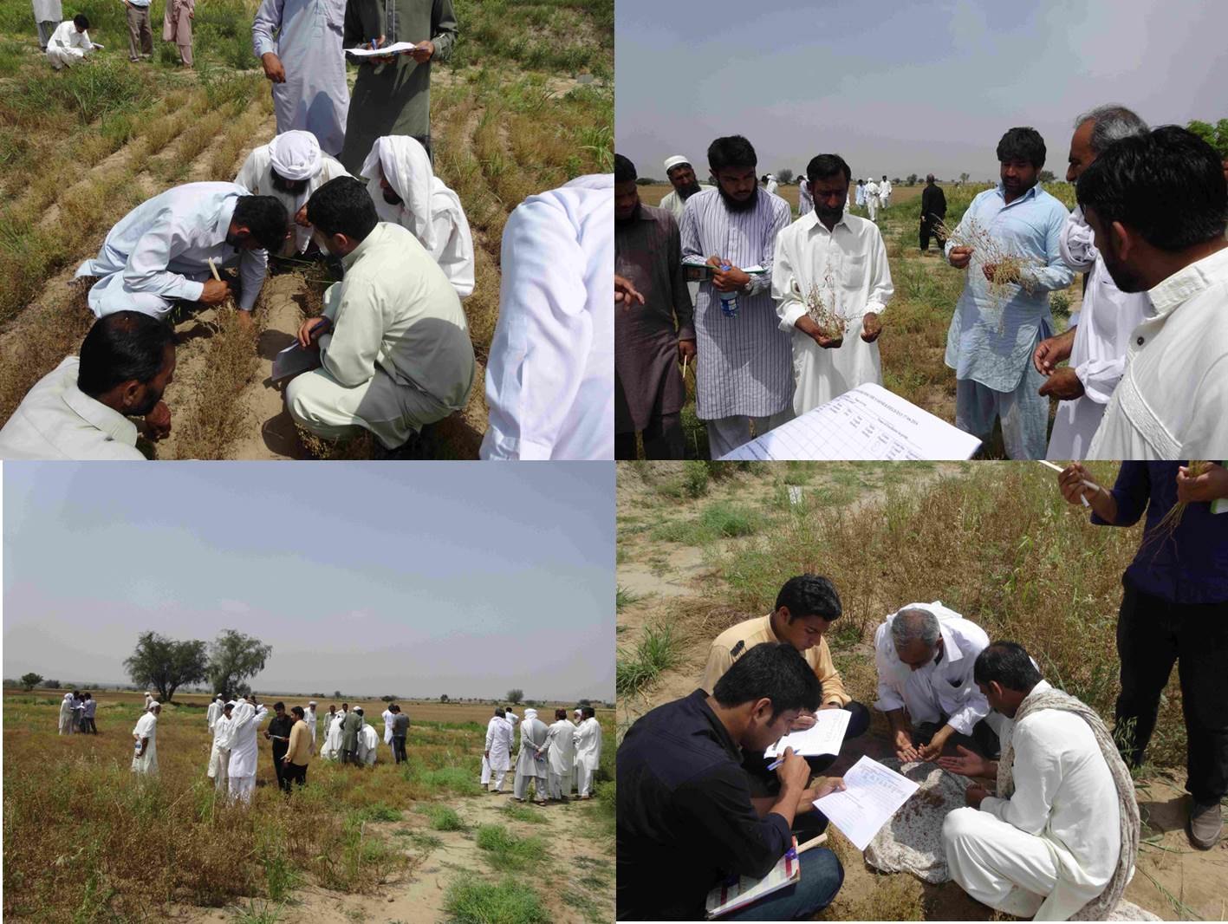
Fig. 5 Farmers in different groups evaluating lentil cultivars
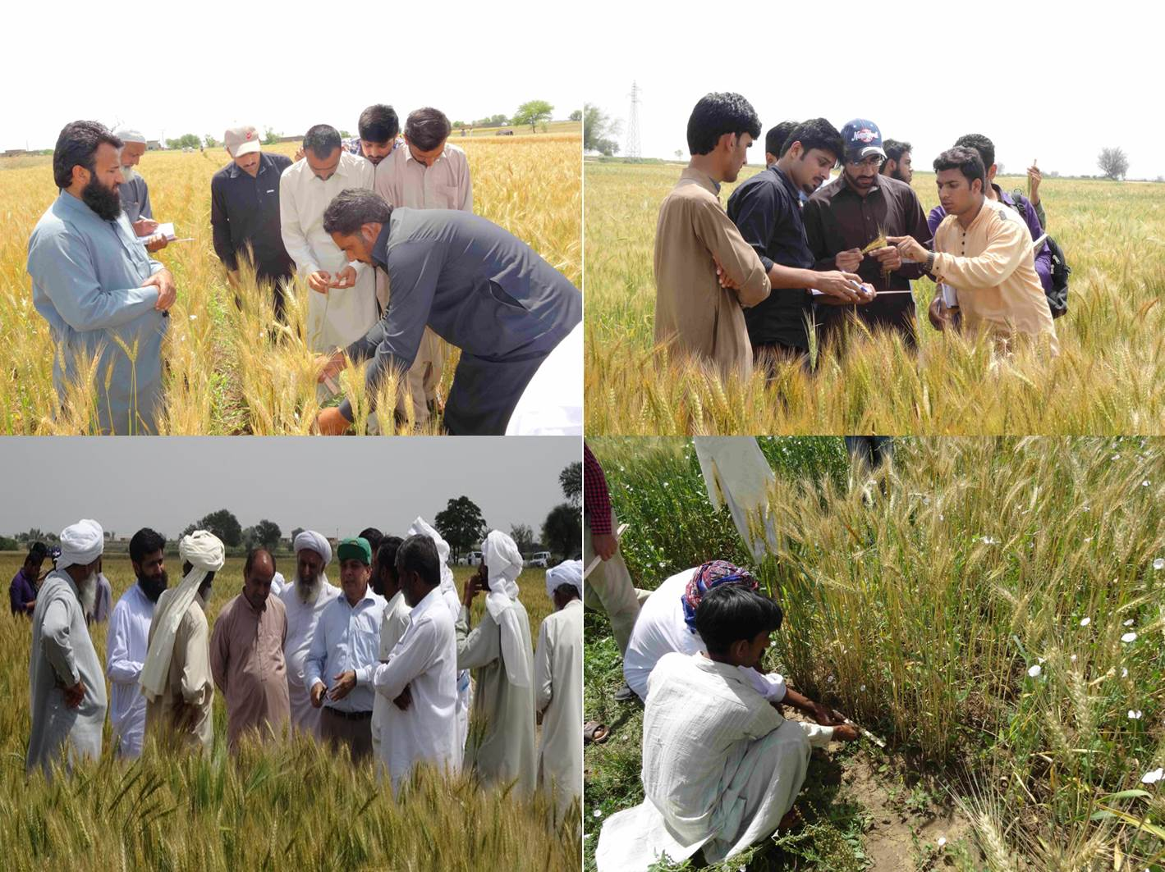
Fig. 6: Farmers in different groups evaluating wheat cultivars with on-site discussion
On completion of the varietal evaluation, the last session was convened in which each group leader shared their ranking of the cultivars (Fig.7).
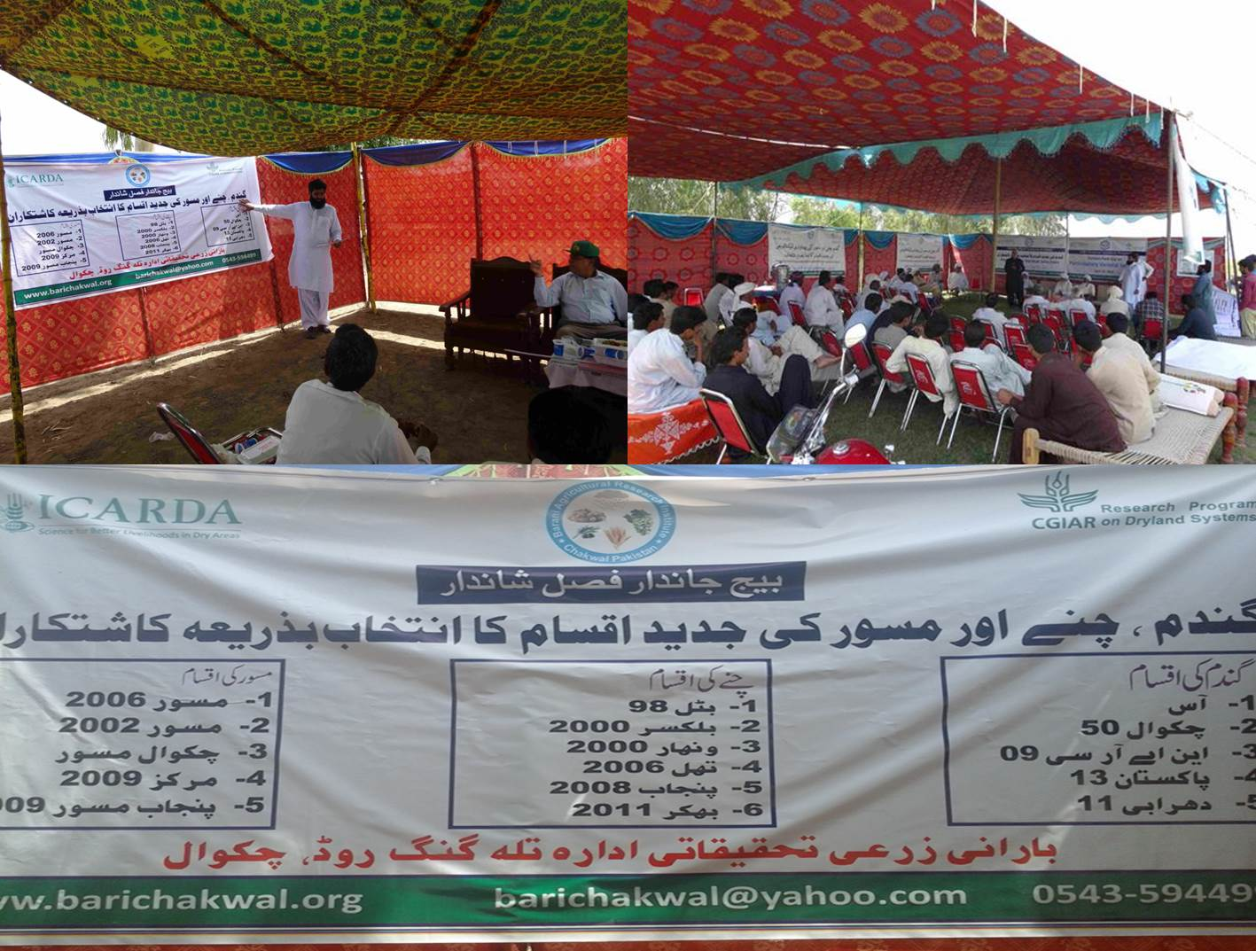
Fig. 7 Sharing of varietal codes and varietal performance at concluding session
The names of the varieties coded during farmers’ evaluation were told in the last session so that they actually know which cultivars they choose as most promising for their agro-ecology.

- Evaluation of wheat cooking Quality by female Farmers

Consumer preferences for wheat cooking quality were checked by making different groups of women at BARI. Flour of all the varieties was given to them without mentioning the name of variety. Women carried out all the process like doughing (Fig. 8), Making loaves and cooking the loaves to make bread (Fig. 9).

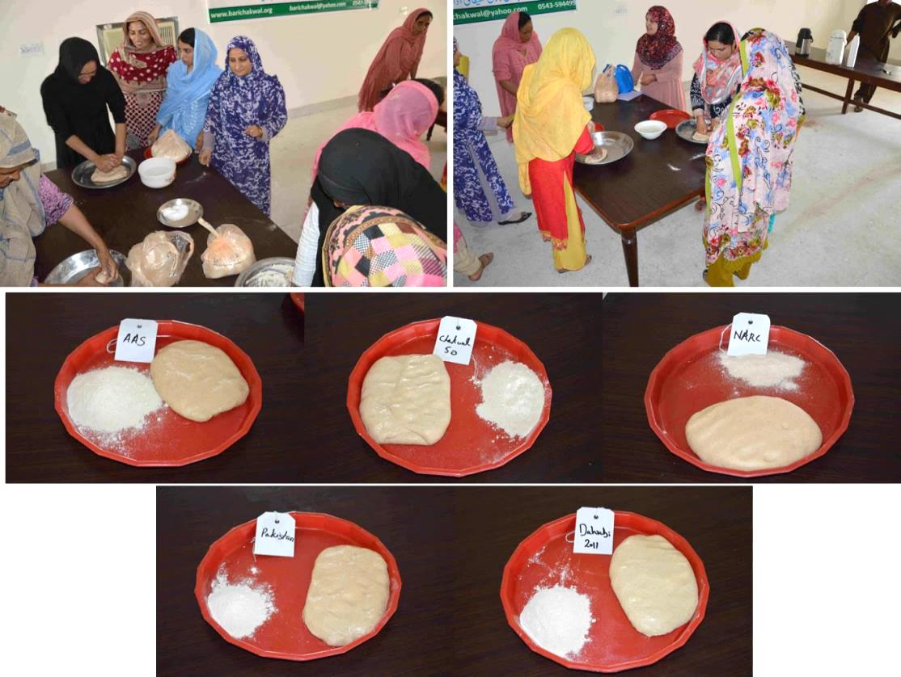
Fig. 8 Rural women preparing dough using flour different wheat cultivars
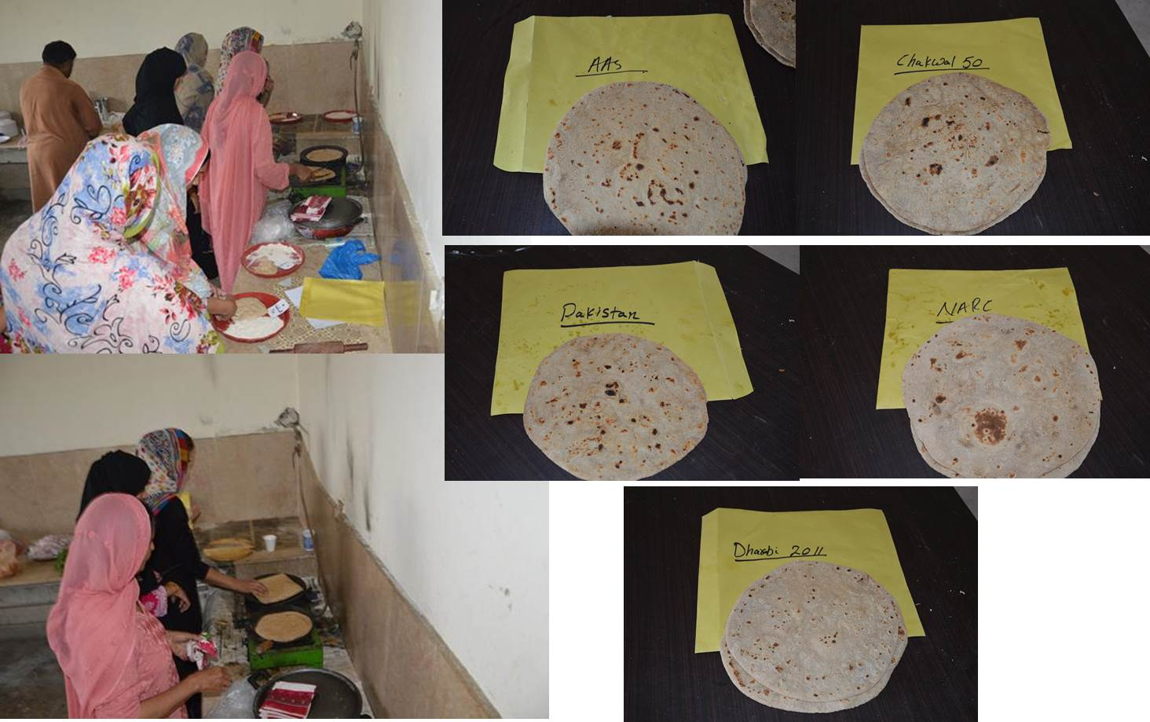
Fig. 9 Rural women making bread (Chapaati) and taking observations
- Technical Evaluation by Scientists
Technical evaluation involved harvesting above-ground crop samples from representative on-farm participatory trials. Two representative samples of 2m x 1m dimension (2m²) were collected at random for each variety/trial. The samples were brought to the institute where they were manually threshed for grain/seed yield measurement. The data was statistically analyzed in “Statistix 8.1” for Randomized Complete Block Design assuming locations at Replicates and crop cultivars as experimental treatments.

RESULTS AND DISCUSSION
3.1 Wheat
3.1.1 Varietal ranking based on Farmers Field Evaluation
Farmers ranked “Aas-2011” as the most promising wheat cultivar and was followed by “Dharabi-11” at resilience as well as intensification sites (Saghar & Latifal respectively). The ranking with crop attributes is presented in Table 1 and 2.

Table 1. Varieties evaluation of Wheat at Resilience
Variety | Plant-height (Inch) | Crop Condition in terms of Lodging  (%) | Disease infestation  (%) | Tillers  (Nos)  Per feet | Stem Length (Inches) | Spike Length (Inches) | Grains (No.) | Grain Size (1=small 2=Med. 3=Bold | Expected yield Mounds/ acre | Var. Ranking 1=top  5 lowest
AAS-2011 | 39 | 0 | 0 | 43 | 33 | 6 | 60 | 3 | 60 | 1
Chakwal-50 | 35 | 5 | 0 | 35 | 30 | 5 | 50 | 2 | 50 | 5
NARC-2009 | 37 | 0 | 0 | 36 | 30 | 5 | 45 | 2 | 50 | 3
Pakistan-2013 | 34 | 0 | 5 | 35 | 28 | 5 | 55 | 2 | 55 | 4
Dharabi-11 | 40 | 5 | 0 | 42 | 35 | 5 | 55 | 3 | 58 | 2

Table 2 .Varieties evaluation of Wheat at Intensification
Variety | Plant-height (Inch) | Crop Condition in terms of Lodging  (%) | Disease infestation  (%) | Tillers  (Nos)  Per feet | Stem Length (Inches) | Spike Length (Inches) | Grains (No.) | Grain Size (1=small 2=Med.. 3=Bold | Expected yield Mounds/ acre | Var. Ranking 1=top  5 lowest
AAS-2011 | 41 | 5 | 0 | 44 | 34 | 6 | 60 | 3 | 60 | 1
Chakwal-50 | 36 | 5 | 0 | 34 | 31 | 5 | 50 | 2 | 50 | 5
NARC-2009 | 34 | 10 | 0 | 39 | 29 | 5 | 45 | 2 | 50 | 3
Pakistan-2013, | 37 | 10 | 15 | 43 | 30 | 5 | 55 | 2 | 55 | 4
Dharabi-11 | 40 | 5 | 0 | 40 | 35 | 5 | 55 | 3 | 55 | 2
The incidence of “Loose smut” (5-15%) was observed in wheat cultivar Pakistan 2013 as depicted in Fig. 10:
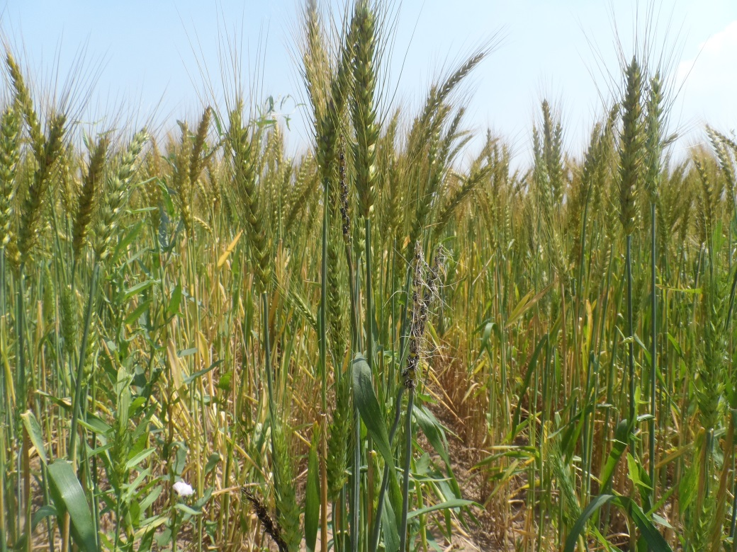
Fig.10 Wheat cultivar “Pakistan 2013” affected by loose smut in field trials
3.1.2 Varietal ranking based on wheat cooking quality by rural women
The results of all the varieties are shown in Table-3. Women ranked Dharabi-11 as first and AAS-2011 as second. It is important to note that the AAs-2011 was ranked 1st by farmers in field evaluation but consumer preferences revealed that Dharabi was having the best cooking quality as compared to Aas-2011.

Table 3. Consumer Preferences about the Wheat Varieties
Variety | General Appearance | Quality in doughing (Flour mixing with water) | Quality at preparing loaves | Taste in eating | Shelf life of wet floor to be used for more than a day | Self-life of loaves after some time | Rank
AAS-2011 | Medium | Better | Better | Better | Better | Medium | 2
Chakwal-50 | Medium | Better | Better | Medium | Medium | Better | 3
NARC-2009 | Better | Better | Medium | Medium | Medium | Better | 4
Pakistan-2013 | Poor | Better | Poor | Poor | Medium | Poor | 5
Dharabi-11 | Better | Better | Better | Better | Better | Better | 1

3.1.3 Varietal ranking based on crop sampling
The grain yield data (Fig. 11) revealed almost similar results as were observed during farmers evaluation i.e. Aas-2011 ranked at top followed by Dharabi-11 in resilience cluster. Mean wheat yield ranged from 3.1 to 4.3 tonnes ha⁻¹.
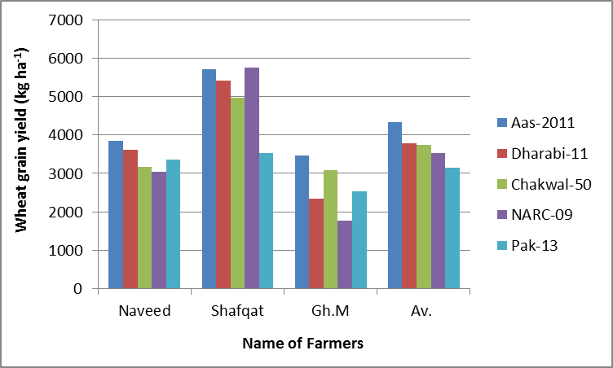
Fig. 11 Wheat grain yield recorded at resilience site
The ranking of varieties based on mean wheat grain yield is presented in Table 4.
Table 4: Ranking of Wheat cultivars at resilience site (Saghar)
 | Av. Wheat grain yield (kg ha⁻¹) of three farmers | Rank
Aas-2011 | 4340.0 | 1
Dharabi-11 | 3790.0 | 2
Chakwal-50 | 3740.0 | 3
NARC-09 | 3523.3 | 4
Pakistan 2013 | 3143.3 | 5
The statistical analysis did not indicate any significant difference between varietal means on account of substantial variation in grain yield from on site (Replicate) to other thereby contributing to increased experimental error.
Wheat grain yield data at Intensification site (Fig. 12) showed slightly variable results from farmers’ evaluation i.e. “Dharabi-11” out yielded all other varieties and stood 1st, whereas “Aas-2011” stood 2nd; while in farmers evaluation, the results were vice versa.

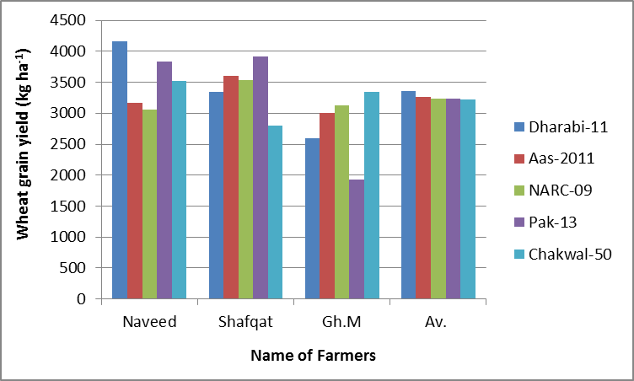
Fig. 12 Wheat grain yield recorded at intensification site
The ranking of varieties based on mean wheat grain yield is presented in Table 5.
Table 5: Ranking of Wheat cultivars at intensification site (Latifal)
 | Av. Wheat grain yield (kg ha⁻¹) of three farmers | Rank
Dharabi-11 | 3363.3 | 1
Aas-2011 | 3256.7 | 2
NARC-09 | 3240.0 | 3
Pakistan 2013 | 3231.3 | 4
Chakwal-50 | 3223.3 | 5
There are no significant pairwise differences among the means

3.1.4 Final Varietal ranking/selection
The results (Table 6) reveal Aas-2011 and Dharabi-11 as the most promising wheat cultivars. Consumer preferences for wheat cooking quality often out-weight therefore, Dharabi is ranked as the top most. Giving more weightage to consumer preferences is expected to encourage social acceptance of the promising cultivar in dryland ecologies.
Table 6. Final Ranking of wheat cultivars
 | Farmers Evaluation |  | Cooking Quality | Technical evaluation
 | Resilience site | Intensification | Cooking Quality | Resilience | Intensification
Aas-2011 | 1 | 1 | 2 | 1 | 2
Dharabi-11 | 2 | 2 | 1 | 2 | 1
Chakwal-50 | 5 | 5 | 3 | 3 | 5
NARC-09 | 3 | 3 | 4 | 4 | 3
Pakistan 2013 | 4 | 4 | 5 | 5 | 4

3.2 Lentil
3.2.1 Varietal ranking based on Farmers Field Evaluation
Farmers’ evaluation at resilience site revealed Masoor 2002 as the most promising lentil cultivar following by Markaz-09 (Table 7).

Table 7.Varieties evaluation of Lentil at Resilience
Variety | Plant-height (Inch) | Crop Condition in terms of Lodging  (%) | Disease infestation  (%) | Tillers  (Nos)  Per feet | Stem Length (Inches) | Spike Length (Inches) | Grains (No.) | Grain Size (1=small 2=Med. 3=Bold | Expected yield Mounds/acre | Var. Ranking 1=top 5 lowest
Masoor-2006 | 7-8 | 10 | 0 | 28 | 4 | 5 | 9 | 2 | 3 | 3
Masoor-2002 | 10 | 5-10 | 0 | 28 | 5 | 6 | 10 | 2 | 4 | 1
Chakwal Masoor | 10.5 | > 5 | 0 | 29 | 4.5 | 5 | 8 | 1 | 3 | 4
Markaz-09 | 9.5 | > 5 | 0 | 30 | 4 | 5 | 8 | 2 | 3.5 | 2
Punjab Masoor | 10 | 5 | 0 | 30 | 4 | 5 | 8 | 1 | 3.5 | 5

3.2.2 Varietal ranking based on crop sampling
The grain yield data (Fig. 13) revealed quite variable results as were observed during farmers evaluation i.e. Aas-2011 ranked at top followed by Dharabi-11.
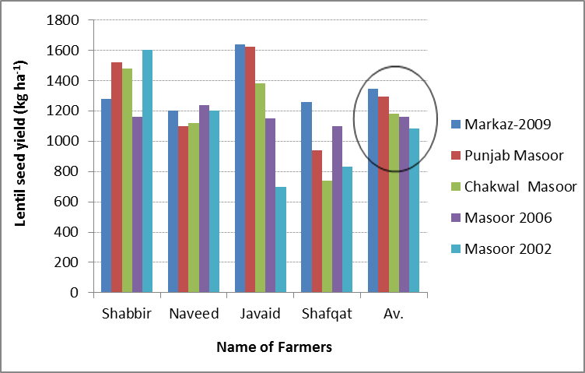
Fig. 13 Lentil seed yield recorded at resilience site
The ranking of varieties based on mean lentil seed yield is presented in Table 8.

Table 8.Varieties evaluation of Lentil at Resilience
Variety | Mean Seed yield (kg ha⁻¹) of four farmers | Rank
Markaz-09 | 1345 | 1
Punjab Masoor | 1296 | 2
Chakwal Masoor | 1180 | 3
Masoor 2006 | 1163 | 4
Masoor 2002 | 1083 | 5
There are no significant pairwise differences among the means

Profuse weed growth was observed in lentil and this emerged as the major constraint to lentil productivity in the region. No post-emergence weedicide is available in the country to control weeds in winter pulses yet. This issue requires serious attention of the scientists.
3.2.3 Final Varietal ranking/selection
The data (Table 9) revealed “Markaz-09” as the most promising lentil cultivar followed by Masoor-2002.
Table 9. Final Ranking of wheat cultivars
Variety | Farmers Evaluation | Technical evaluation (crop sampling) | Mean Rank
 | A | B | C=(A+B)/2
Markaz-09 | 2 | 1 | 1.5
Punjab Masoor | 5 | 2 | 3.5
Chakwal Masoor | 4 | 3 | 3.5
Masoor 2006 | 3 | 4 | 3.5
Masoor 2002 | 1 | 5 | 3.0

CONCLUSION
The Participatory selection process revealed “Dharabi-11” and “Aas-2011” as the most promising wheat varieties while Markaz-09 was identified as most promising lentil cultivar developed by NARS. Wheat yield in on-farm trails was above 3 tonnes ha⁻¹ against regional average of around 0.7 tonnes ha⁻¹, whereas lentil yield was almost double as compared to regional average yield in dryland areas. The results participatory varietal selection imply that resource poor barani farmers can increase wheat and lentil production in a sustainable manner to meet the country's need. However, the adoption will depend on the availability of certified seed of selected cultivars. The present study also emphasizes that the country needs to strengthen its breeding program on chickpea for developing disease resistant varieties.

RECOMMENDATION
Sustainable enhancement in wheat and lentil productivity in dryland areas of Punjab would require availability of certified seed of selected lentil and wheat cultivars. There is no private seed company operating in rainfed areas in northern Punjab, therefore, informal seed production could be the initial step with capacity development of the interested farmers in seed production and processing.

LITERATURE CITED
Punjab Development Statistics. 2015. Bureau of Statistics, Government of Punjab, Lahore. http://bos2.pitb.gov.pk/system/files/Dev-2014.pdf
Tabo, R., A.O. Ogungbile, S.C. Gupta, and D. Ajayi. 1999. Participatory Evaluation of Sorghum cultivars in Northern Nigeria. Intl. Sorghum Millet Newslet 40: 36-38.
Tabo, R., A.O. Ogungbile, S.C. Gupta, and D. Ajayi. 1999. Participatory Evaluation of Pearl Millet cultivars in Northern Nigeria. Intl. Sorghum Millet Newslet 40: 53-55.
Witcombe, J.R., Joshi A., Joshi, K.D. and Sthapit, B.R. 1996. Farmer participatory crop improvement. I. Varietal selection and breeding methods and their impact on biodiversity. Expt. Agric. 32:445-460.
Witcombe, J.R., Peter, R., Jones, S. and Joshi, A. 1999. Farmer participatory crop improvement: IV. The spread and impact of a rice variety identified by participatory varietal selection. Expt. Agric. 35:471-487.

