Activity: Multi-environment evaluation of pigeonpea disease nursery of 28 lines to wilt and SMD resistance
Objective: (i)To study the G x E interaction and identify stable and broad based sources of resistance to Fusarium wilt and SMD (Fusarium udum) and (ii) Share resistant germplasm and breeding material with NARS.
Materials and methods: Under the ICAR-ICRISAT collaboration, during 2015-16 crop seasons, Pigeonpea Wilt and SM Disease Nursery (PWSMDN) consisting of 30 entries (28 resistant cultivars and 2 susceptible checks) were evaluated for wilt and SMD resistance at different locations in India. Each entry was planted in one row of 4 m long and replicated twice. Wilt susceptible cultivar ICP 2376 and SMD susceptible cultivar ICP 8863 were planted after every four test entries in all locations. Additionally, all co-operators included a wilt and SMD susceptible checks of the local area as test entries for proper comparison. Data on wilt and SMD was recorded thrice at seedling, flowering, and at maturity stages of the crop and compiled to identify resistant sources across locations. Statistics of discriminating environments and stability of genotypes was also assessed.
Results and interpretation: Data on wilt was received from 7 locations (Badnapur, Bharuch, Dholi, Khargone, Kanpur, Coimbatore and Rahuri). Five entries (ICPLs 99044, 200095, 87051, 99009 and 99055) were found resistant to wilt. Entries having broad based resistance to SMD were identified based on data received from eight locations (Bharuch, Dholi, Patancheru, Bangalore, Coimbatore, Badnapur, Varanasi and Rahuri). One entry (ICPL 99099) was found resistant to both wilt and SMD and can be good resistant donor in breeding program.
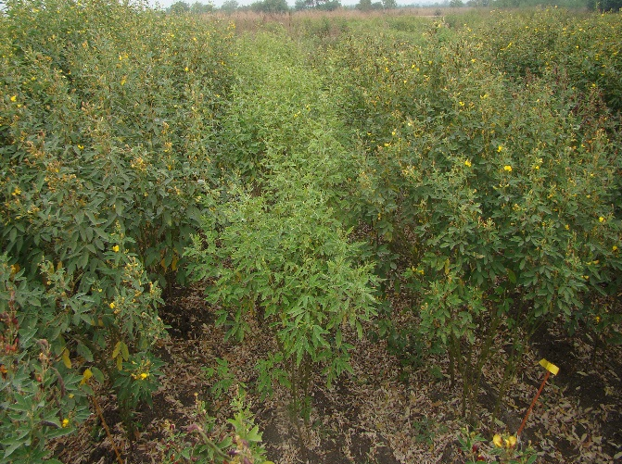
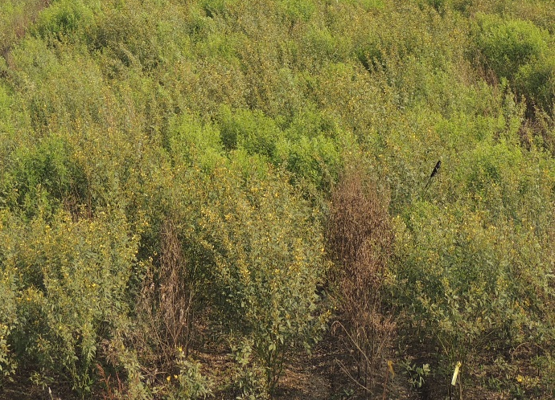
Next steps: This study facilitated the selection of genotypes with high level of resistance to wilt and SMD that can be exploited in pigeonpea resistance breeding programmes.
B
A
Figure: Field screening in disease nursery under artificial epiphytotic conditions (A) Fusarium wilt screening - expression of resistant and susceptible plants; (B) SMD screening - expression of resistant and susceptible plants.

