Sub-activity: Rehabilitation of food legumes

K. Daoui , M. Karrou, Mustapha El Bouhssini, Rachid Mrabet

6-month Progress Report
July 2015

Background

In Meknes area, the monoculture of wheat has increased because this crop is subsidized by the Government. The monoculture of wheat poses the problems of diseases and pest and nitrogen deficiency in the soil. The re-introduction of food legumes in the rotation in the region can help overcome these problems. However, these crops (legumes) require high amounts of phosphorus fertilizer and the development of improved varieties tolerant to abiotic and biotic stresses. The objectives of this study are to evaluate the response of small faba bean to the increase of phosphorus fertilizer rates and to select adapted varieties of food legumes (Faba bean, chickpea and lentil to Meknes-Sais environment.
In this report, only preliminary results are presented. The crops have just been harvested and we are in the process of analyzing the data.

Trial 1: Phosphorus use effciency among Moroccan small faba beans varieties.

Progress
Three Moroccan faba bean varieties (V) (Viciafaba minor) Alfia 5, Alfia 17 and Alfia 21 were grown under four phosphorus (P) rates (0, 20, 80 and 160 kg P₂O₅/ha). The experimental design was a split plot with four replicates. P was affected to the main plot and the variety to the sub plot. The measurements taken were the estimation of the nodules and aboveground biomass productions at flowering stage and yield and residual phosphorus at maturity to. Some preliminary resulst on the nodulation and biomass production at flowering are shown in figures 1-2. Data on yield and phosphorus level in the soil are still in the process of analysis.
Figures 1 and 2 show varietal differences in the response of biomass and biomass productions to the increase of phosphorus rate. In the case of the genotypes Alfia 5 and Alfia 17, the production increase up to 80 kg P₂O₅/ha. However, it seems that there is a negative relationship between the 2 measured parameters; Alfia 5 produced more biomass and less nodules than Alfia 17. For Alfia 21, there is no response to phosphorus for both variables.
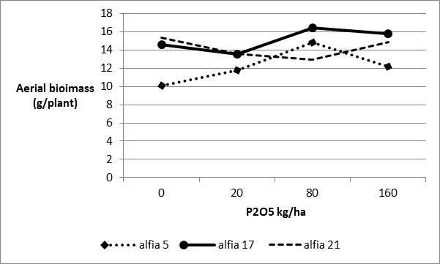 | 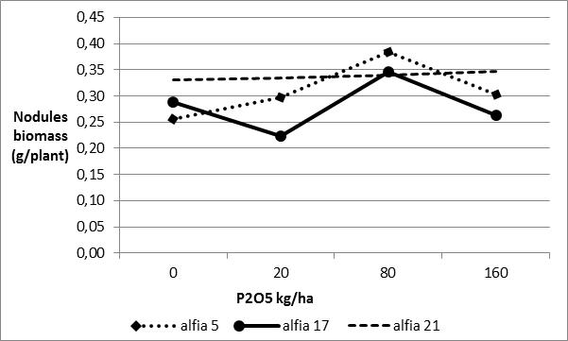
Figure 1. Effect of phosphorus application on aerial biomass of different small faba bean varieties | Figure 2. Effect of phosphorus application and small faba bean varities on nodulation

Trial 2: Effect of residual phosphorus on wheat and small faba bean production

Progress
Two field trials were conducted separately on wheat and small faba bean in Meknes region. Each crop was exposed to four treatments: For wheat, residual effect 4 phosphorus rates of 0, 20, 80 and 160 kg P₂O₅/ha applied previously on faba bean. For faba bean, residual effect of phosphorus rates of 0, 20, 80 and 160 kg P₂O₅/ha applied previously on wheat. At maturity yield and its components were measured. Preliminary results are shown in figures 3-6.
Figures 1 and 2 show a positive response of faba bean total biomass to residual phosphorus applications. However, grain yield was not affected.

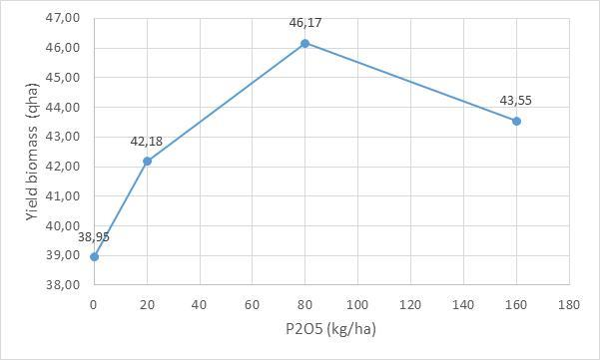 | 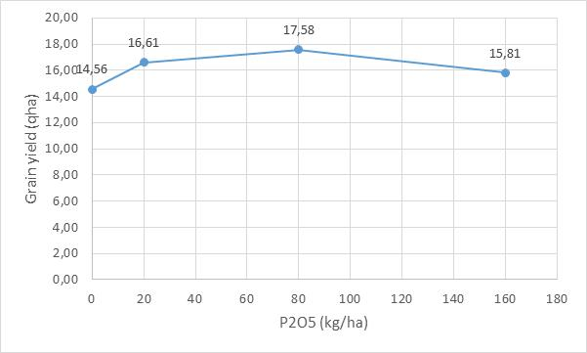
Figure 1. Effet of phosphorus residual effect on faba bean total biomass | Figure 2. Effect of phosphorus residual effect on faba bean grain yield

Oral Presentation in a conference
Daoui K., Karrou M., Mrabet R., Fatemi Z., Oufdou K. 2015. Fertilisation des légumineuses alimentaires au Maroc Acquis et Perspectives. 1erAtelier Nord-Africain sur la fertilisation des cultures Hotel Palm Plaza, Marrakech, 20-21 Janvier 2015

Trial 3: Cereal and food legume systems adaptation

1. Objectives
Test and validate the performance of advanced breeding lines of cereals (durum and bread wheat) and food legumes (chickpea and faba bean) for improved tolerance to abiotic (drought, heat) and biotic (disease, insect) stresses in wheat-grain legume cropping system.

2. Methodology
Plant material: Elite advanced breeding lines of cereals and food legumes evaluated

2.1. Trials conducted at Sidi Slimane location
- 16 Durum wheat lines (evaluated in 2014 and reevaluated in 2015): conducted as a replicated trial with 3 reps.
- 12 Bread wheat lines (evaluated in 2014 and reevaluated in 2015): conducted as a replicated trial with 3 reps.
- 12 Durum wheat lines (new advanced lines)
- 12 Bread wheat lines (new advanced lines)
- 12 Faba bean lines
- 6 Chick pea lines

2.2 Trials conducted at Douyet location
- 10 Durum wheat lines
- 10 Bread wheat lines
- 10 Barley lines
- 8 Faba bean lines
- 6 Chick pea lines
- 8 Lentil lines

3. Progress

3.1. Agronomic management
- Fertilization was applied at the recommended rates, P and K were applied just before planting and nitrogen was split 1/3, 1/3,1/3 at the tillering, stem elongation and heading stages.
- Due to shortage and uneven distribution of rainfall, and to allow a successful development of the trials at Sidi Slimane, supplemental irrigation was applied to all trials on 11-12 December and to late planted trials on 10-11 march.
- Chemical (for cereals) and manual (food legumes) weedings started early in the season due to the important development of weeds. Further manual weedings were frequently performed in order to keep the plots clean.
- Parasite and pest control were performed in order to have disease free plots.

3.2. Observations and measurements made

- Cereals
Recording of the main growth stages, components of yield (kernel weight, spike number), physiological parameters (stomatal conductance, chlorophyll content), total biomass, grain yield.

- Food legumes
The measurements taken were botrytis and ascochyta score, phenotypic score and grain yield

4. Capacity building
One Master level student from ENA supervised

