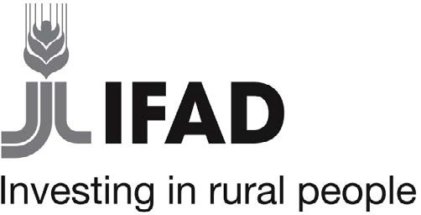

Strengthening Knowledge Management for Greater Development Effectiveness in the Near East, North Africa, Central Asia and Europe
Title

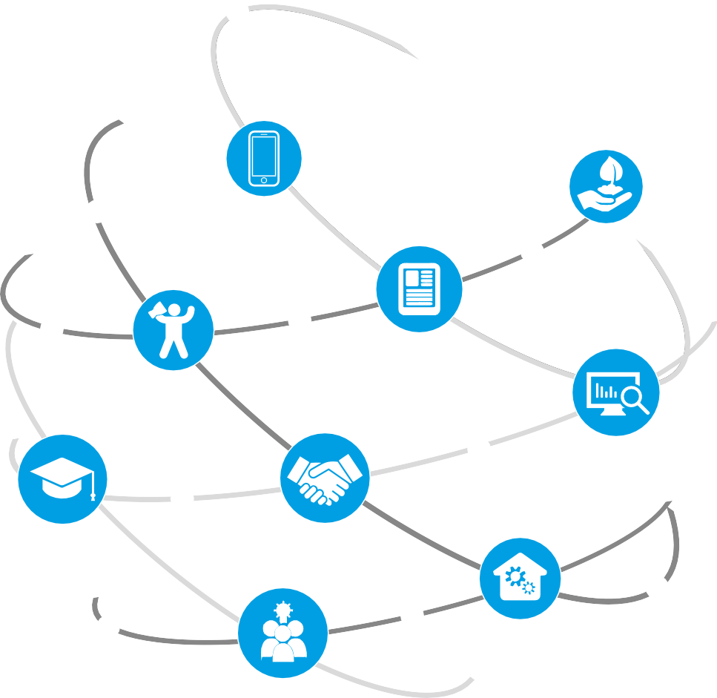

Title
Subtitle
Surname, N. (2019). Title: Subtitle. Strengthening Knowledge Management for Greater Development Effectiveness in the Near East, North Africa, Central Asia and Europe. Beirut, Lebanon: International Center for Agricultural Research in the Dry Areas (ICARDA).

Keywords
Knowledge, Knowledge Management, Management, KM, MGMT, Knowledge Sharing, Sharing, Knowledge Creation, Creation, Knowledge Discovery, Discovery, Knowledge Storage, Storage, Knowledge Curation, Curation, Information, Data, Data Curation, Capacity Development, Capacity, Development, Research for Development, R4D

Prepared by
International Center for Agricultural Research in the Dry Areas (ICARDA)

Project
Strengthening Knowledge Management for Greater Development Effectiveness in the Near East, North Africa, Central Asia and Europe

Funded by
International Fund for Agricultural Development (IFAD)

Type
Definition. Source: X

About ICARDA
Established in 1977, the International Center for Agricultural Research in the Dry Areas (ICARDA) is a non- profit, CGIAR Research Center that focusses on delivering innovative solutions for sustainable agricultural development in the nontropical dry areas of the developing world.

We provide innovative, science-based solutions to improve the livelihoods and resilience of resource- poor smallholder farmers. We do this through strategic partnerships, linking research to development, and capacity development, and by taking into account gender equality and the role of youth in transforming the non-tropical dry areas.

Address
Dalia Building, Second Floor, Bashir El Kasser St, Verdun, Beirut, Lebanon 1108-2010. www.icarda.org

Disclaimer
This document is licensed for use under the Creative Commons Attribution 4.0 International Public License.
To view this licence, visit http://creativecommons.org/licenses/by-nc-sa/4.0/
Unless otherwise noted, you are free to copy, duplicate, or reproduce and distribute, display, or transmit any part of this publication or portions thereof without permission, and to make translations, adaptations, or other derivative works under the following conditions:
 ATTRIBUTION. The work must be attributed, but not in any way that suggests endorsement by the publisher or the author(s).

Table of Contents

Executive summary I
Introduction I
Background I
Approach I
Methods I
Tools I
Chapter 1 1
Chapter 1.1 1
Chapter 1.1.1 1
Chapter 1.1.1.1 1
Chapter 1.1.1.1.1 1
Annex A 2

Abbreviations

AETTGD | Agricultural Extension and Technology Transfer General Directorate of Sudan
ARC Sudan | Agricultural Research Corporation - Sudan
ATTS | Agricultural Technology Transfer Society
AUW | Ahfad University for Women
CNA | Capacity needs assessment
CIHEAM Bari | Centre International de Hautes Études Agronomiques Méditerranéennes – Bari
CoP | Community of practice
CPIU IFAD | Consolidated IFAD Programs Implementation Unit of Moldova
CCU IFAD | Central Coordination Unit for IFAD Co-Financed Projects of Sudan
ENA Meknes | National School of Agriculture
GLDC | CGIAR Research Program on Grain Legumes and Dryland Cereals
IAV Hassan II | Agronomic and Veterinary Institute
ICARDA | International Center for Agricultural Research in the Dry Areas
ICT | Information and communication technology
IDIS Viitorul | Institute for Development and Social Initiatives “Viitorul” INRA
IFAD | International Fund for Agricultural Development
INRA | National Agricultural Research Institute
KariaNet | Knowledge Access to Inter-connected Rural Areas Network KM
KM | Knowledge Management
KS | Knowledge Sharing
MARDE | Ministry of Agriculture, Regional Development and Environment of Moldova
MoAF | Ministry of Agriculture and Fisheries of Morocco
MoANR | Ministry of Agriculture and Natural Resources of Sudan
MoAR | Ministry of Animal Resources of Sudan
NARS | National Agricultural Research Systems
NFFM | National Farmers Federation of Moldova
NGO | Non-governmental organization
ONCA | National Office for Agricultural Extension
PROCASUR | Procasur Corporation
SAUM | State Agrarian University Moldova
Selectia | Research Institute of Field Crops “Selectia”
SKiM | Strengthening Knowledge Management for Greater Development Effectiveness in the Near East, North Africa, Central Asia and Europe (acronym used after November 2019)
SKMNENACAE | Strengthening Knowledge Management for Greater Development Effectiveness in the Near East, North Africa, Central Asia and Europe (acronym used prior to November 2019)
SKS | Sudan Knowledge Society
UN | United Nations
UofK | University of Khartoum
USARB | Alecu Russo State University of Bălți
VT | Virginia Tech

Executive summary
Text.

Introduction
Text.

Background
Text.

Approach
Text.

Methods
Text.

Tools
Text.

Chapter 1
Text.

Chapter 1.1
Text.

Chapter 1.1.1
Text.

Chapter 1.1.1.1
Text.

Chapter 1.1.1.1.1
Text.

Text | Text | Text

- List
- List
- List

Annex A
Text.

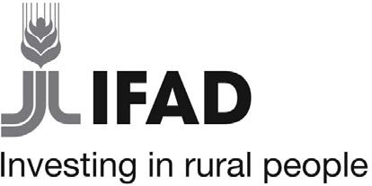

Strengthening Knowledge Management for Greater Development Effectiveness in the Near East, North Africa, Central Asia and Europe (SKiM) is a grant project led by ICARDA and funded by IFAD. The project also works with international partners CIHEAM-Bari, PROCASUR, Virginia Tech as well as NARS, governments, and agricultural extension services in Moldova, Morocco and Sudan.

Initiated in June 2018, the project facilitates and supports KM and capacity development activities in the three selected countries and will provide practical examples of KM best practices that will be analysed and adopted by participating institutions. Increasing the capacities of participating public institutions, by providing necessary structures and systems at the country and regional levels, will ensure that knowledge can be effectively managed for long-term growth and development.

The project website (https://mel.cgiar.org/projects/SKIM) provides background information and describes the project team, partners and stakeholders engaged. The website also shares key documents including the project proposal, and outlines the goals, objectives and impact pathway of the project, as well as additional resources and information on news and events.

