CRP: Dryland Systems
Center: ICARDA
Flagship: South Asia
Action Site: Chakwal (Pakistan)
Activity title: Evaluation, demonstration and dissemination of fodder and feed intervention
Short Title: Evaluation, demonstration and dissemination of fodder and feed intervention
Activity leader: Dr. Abdul Majid
Key partner(s): Fodder Program CSI, NARC, Islamabad, Pakistan
Progress report: Six months (January-June, 2015)

Objective: Validate promising fodder varieties and silage making; develop informal seed enterprise (oat)

Outputs Report I.
Data compilation of green fodder and dry matter yield from 6 validation plots (farmer vs. improved variety) of oats

Introduction
Oat (Avena sativa L.) provides an excellent choice to obtain higher green fodder yield among winter cereals and can be grown under both rainfed (400 mm) as well as irrigated conditions. It is a quick growing, palatable, succulent and nutritious fodder crop. Improved variety is the most desirable input for improving fodder yield and consequently increase in net income of livestock holders. In various studies in Pakistan reported that improved varieties of oat produce three-fold green fodder (60-80 tonnes per hectare) and can feed double number of animals per unit area as against the traditional fodder crop varieties. The existing oat varieties of fodder crops in targeted areas are low yielding, thus, do not adequately cover fodder scarcity periods. Therefore, high fodder yielding variety “NARC Oat” was introduced with recommended dose of fertilizer and line sowing method in two villages of Chakwal district.

Methodology
Six validation plots of improved variety of oat (NARC-Oat) vs. farmers practices were established at farmers field in two villages (Latifal rainfed and Sagher supplemental irrigation) during winter, 2014-15. Supplemental irrigation was applied by the farmers according to the needs of crop.
Under improved practices, oat variety "NARC-Oat” was sown through line sowing method. Fertilizer was applied at the rate of 75 kg N and 57 kg P₂O₅ per hectare at the time of sowing. Farmers practices comprised of local oat varieties were sown broadcast method with no fertilizer. All other practices were similar in both treatments. Sowing was done during the first week of November 2014.
The crop was harvested at 50% flowering stage from each plot of both practices for recording green fodder and dry matter yield. Green fodder yield was measured by harvesting one square meter plot randomly from three places. Each sample was weighed and averaged to calculate green fodder yield. Similarly, for the determination of dry matter yield one kilogram green fodder sample was collected at same stage randomly from each plot. The collected samples were weighed, dried in an oven at 60ºC for content weighted and to calculate the dry matter yield for each validation plot.

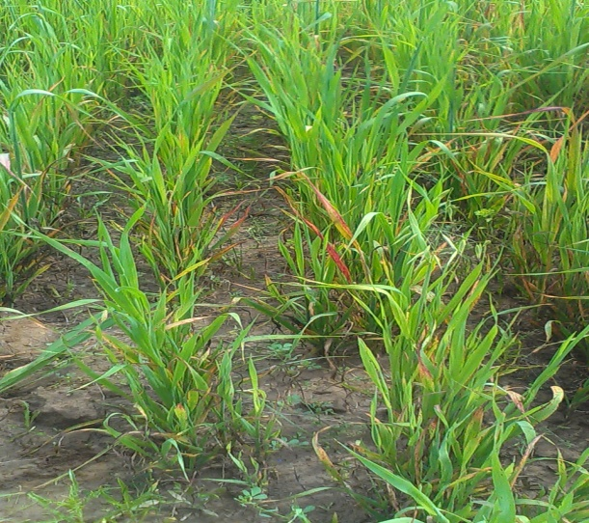  Figure-1: Oats crop under farmer practices | 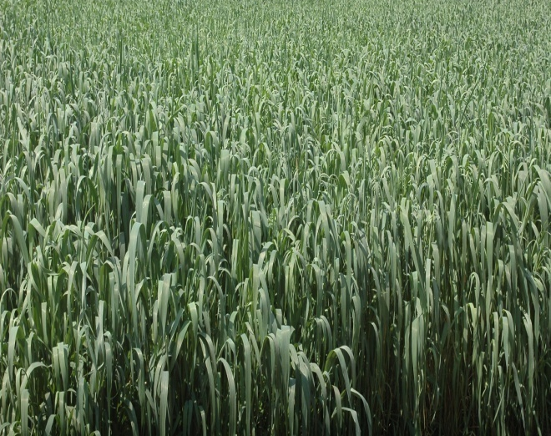  Figure- 2: Oats crop under improved practices

Results
At Sagher site, improved practice produced 51.2 t ha⁻¹ green fodder yield and 10.1 t ha⁻¹ dry matter yield. While farmer practices gave 34.5 t ha⁻¹ and 7.1 t ha⁻¹ green fodder and dry matter yield respectively (Fig 3). The improved practices gave 48 % and 43 % more green fodder yield and dry matter yield than farmers’ practices (Figure 5).
At Latifal site, improved practice produced 43.7 t ha⁻¹ and 9.3 t ha⁻¹ green fodder and dry matter yields, respectively. Under farmer practices, 30.5 t ha⁻¹ green fodder and 6.5 t ha⁻¹ dry matter yields were obtained (Figure 4). Improved practices at Latifal produced 43 % higher green fodder yield and 41 % greater dry matter yield vs. farmer practices (Figure 5).
Overall
The average data of six validation plots of green fodder and dry matter yield presented in Figure 3 and 4 shows that, improved practices gives better results compared with farmers practices at both locations. This increase in overall green fodder and dry matter yield in improved practices some of NARC-Oat variety with recommended dose of fertilizer.

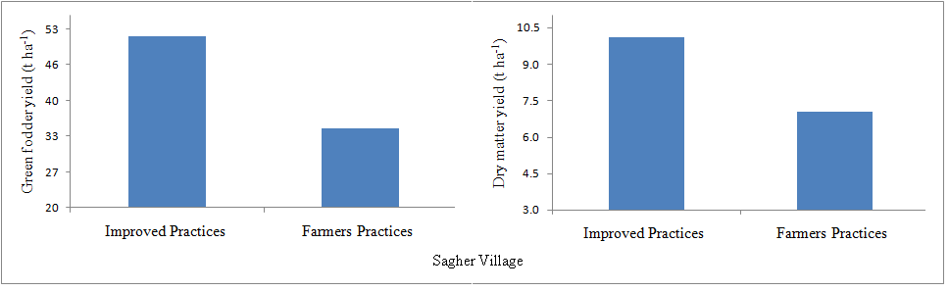
Figure-3: Average green fodder and dry matter yields of six oats validation plots at different farmers’ fields under improved vs. farmer practices
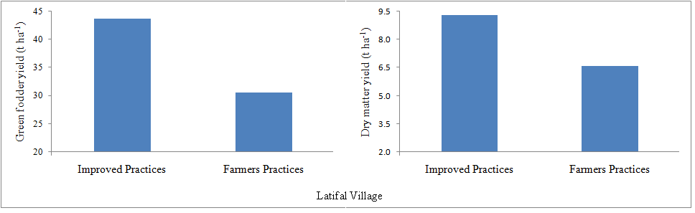
Figure-4: Average green fodder and dry matter yields of six oats validation plots at different farmers’ fields under improved vs. farmer practices

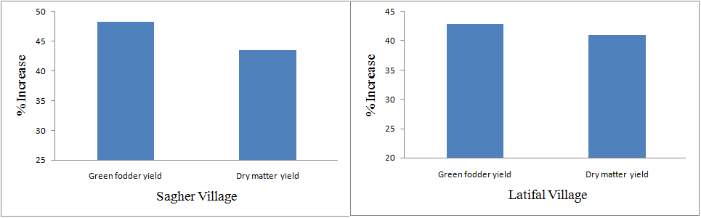
Figure- 5: Percentage increase in green fodder and dry matter yield over farmer practices
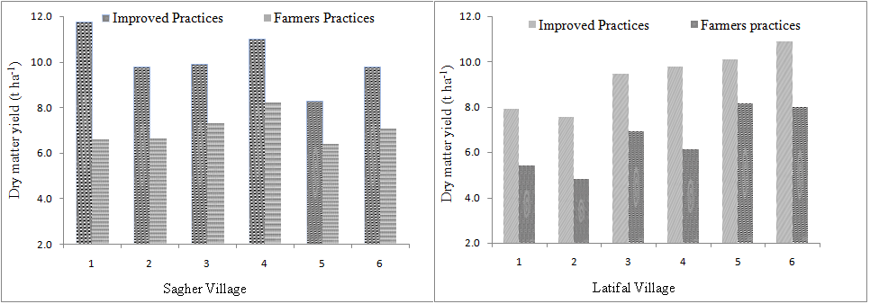
Figure- 6: Effect of improved vs. farmers practices on dry matter yield of oat at six farmers field

List of farmers engaged in the Activity in two villages
Sagher Village | Latifal Village
Syed Qasim Shah S/O Syed Muhammad Shah | Nazer Abbas S/O Ch. Fateh Khan
Sohail Akbar S/O Moqram Khan | Jahangir Haider S/O Muhammad Muzafar Khan
Ijaz Hussain S/O Sher Muhammad | Saleem S/O Zafar Ali Khan
M. Raees S/O Khuda Yar | Fazal Hussain S/O Sultan Mehmood Ashraf
Sadaqat Hussain S/O Ghulam Hussain | Tahir Iqbal S/O Muhammad Iqbal
Noor Khan S/O Fazal Din | Muhammad Akbar S/O Muhammad Khan

