Basic research on deciphering the crops water use components (e.g. TE, canopy growth, TR&VPD relation, role of aquaporins etc.) and their interaction with environment in order to assist breeding programs which aim for improvement of crop adaptation to drought.

Scientists: JKholova, VVadez, SudhakarReddy P., M. Tharanya, Siva Shakti, Choudhary S. (&team)
Region(s): basic research needed to support applied research on drought adaptations
Country(ies): plant scientists community around the world

Rationale: Better understanding of the plant water-use-related processes will help to explain differences in whole plant water use during the cropping cycle which contributes to crop adaptation in SAT. This knowledge is important to match crops demand for water to target agro-ecologies in SAT where the major crop production limitation is usually water availability.

Methodology:
This year, we focus on preparing MS describing the concepts and validation of phenotyping pipeline to validate relevance of the phenotyping technologies @ ICRISAT for breeding programs. For this, we use various pearl millet populations and screen them for water-use traits across phenotyping systems (pots, LeasyScan, Lysimeters, field) and subsequently progress with QTL mapping of these traits. Further, we co-localize the QTLs (in fine mapping population of pearl millet; ICMR01004xICMR01029) for particular traits across the systems which shows us which particular water use traits screened e.g. in pot culture are linked to crop performance under WS in the field conditions.

Results and discussion: Co-localization of water use components QTLs (measured during early development) with the crop production in different water regimes (crop grain and stover yield in the field) validates relevance of our phenotyping pipeline (example on figure 6).
Additionaly, one MS has been published (Component traits of plant water use are modulated by vapor pressure deficit in pearl millet [Pennisetum glaucum (L.) R. Br.]; Jana Kholová1, 2, Paul Zindy1, Srikanth Malayee1 Rekha Baddam1, Tharanya Murugesan1, Sivasakthi Kaliamoorthy1, C. Tom Hash1, Olga Votrubová2, Aleš Soukup2, Marie Kočová2, Mareme Niang3, Vincent Vadez1*, FPB). This work is the baseline for investigation of environmental effects (VPD) on canopy development which is the front-line of current research. Importantly, the principles drafted in this MS can be investigated on large scale using LeasyScan platform.

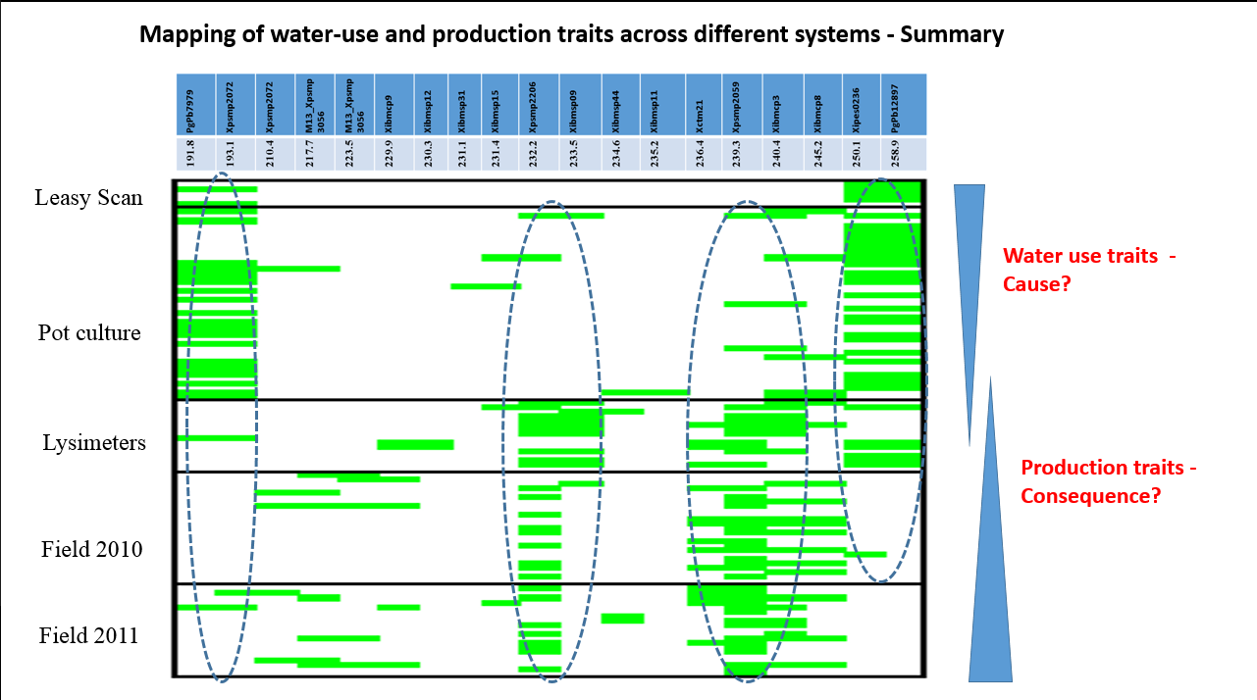

Figure 6. Examples of co-localization of QTLs for water-use related traits across the phenotyping experimental systems.

Conclusions: The relevance of phenotyping pipeline as a support for breeding for water limited environments has been validated through QTL co-localization technique on the example of pearl millet fine-mapping population (simultaneously in chickpea).

