CGIAR Research Program on Dryland Systems

Enhancing socio-ecological resilience and agricultural livelihoods in semi-arid India through integrated system research
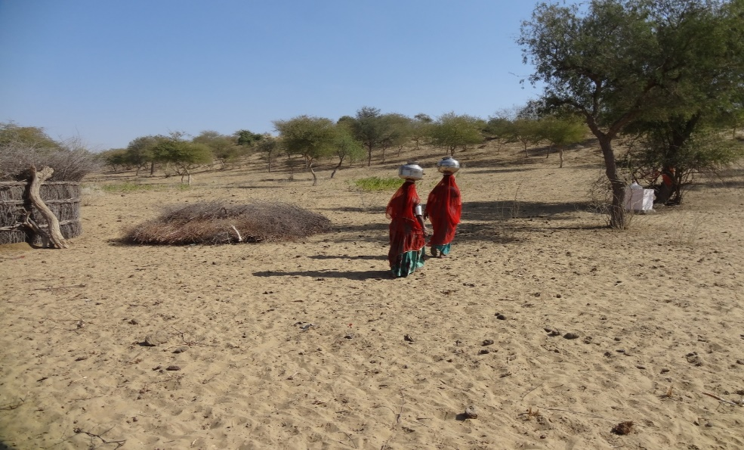
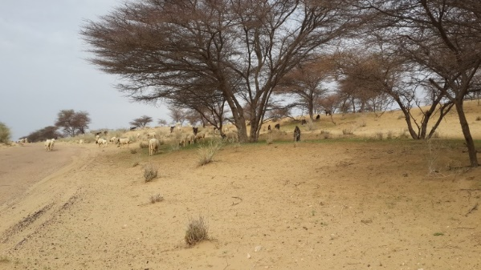
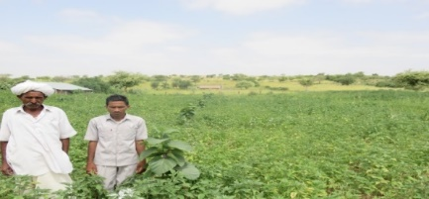

Shalander Kumar and Anthony Whitbread
International Crops Research Institute for the Semi-Arid Tropics
2016
Food security and better livelihoods
for rural dryland communities

CONTENT
Particular | Page number
Introduction | 3
Framework | 4
Operationalization of Systems Research | 5
Selection of action sites | 5
ALS operating in the same sub-region, village or even farm. | 5
Household survey | 5
Community engagement | 5
Typologies to guide interventions | 6
Highlighting gender | 6
Multi-actor stakeholder engagement | 6
Technology assessment | 6
On-farm trials and demonstrations | 7
Rehabilitation of degraded commons | 7
Higher productivity of common pasture lands: The improved condition of pastures has enabled farmers, | 8
Leadership of women | 8
Cooperation and innovation | 8
Creating market opportunities | 9
Lessons leant | 10
Conclusions | 10
Future Challenges/ way forward: | 11
References | 12
Blogs/success stories | 13

Enhancing socio-ecological resilience and agricultural livelihoods in semi-arid India through integrated system research

Introduction
The Drylands of the South Asian region spans India, Pakistan and Afghanistan supporting more than 1.4 billion people, or one fifth of the World’s population. The South Asia region remains with the highest prevalence of malnutrition with some 336 million people chronically hungry, and stunting affecting >46 % of children in the 0-5 year age group. These regions receive low rainfall ranging from 280-670 mm per annum, are frequently affected by water scarcity which is exacerbated by deteriorating soil and water quality, weak policies and institutions, continuously decreasing landholding size, a burgeoning population to name a few. Land degradation affects 65 million people across 465,000 km² in the region (CRP DS, 2013). In India for example, although food security is largely dependent on the smallholder farming sector, 84% of the landholdings are <2ha with livelihoods highly vulnerable to high climatic variability and market risk. Using limited water efficiently and effectively is the main challenge in this hot and dry region. Groundwater is a critical resource but in some areas, has been overexploited. Water tables are declining and water quality is poor. Irrigating crops with poor quality groundwater is exacerbating soil salinization across all vulnerable dryland areas. In areas where there are opportunities to raise productivity and intensify production, the challenges are the shortage of labor and ever-shrinking landholdings which are difficult to mechanize.
A major concern to researchers is how the dryland eco-regions and associated agricultural production systems might meet these challenges. Endogenic (e.g. land size and quality, water shortage, cultural and demographic) and exogenic (e.g. climate change, international market, migration) factors are most often cited as drivers of these changes. The targeting of technologies using farming system approaches are usually attempted on the basis of natural capital (e.g. land type and climate) and sometimes on physical infrastructure or social factors such as the presence of roads or population density (Riveiro et al. 2013; Milán et al. 2006 Giller 2013). To ensure the future livelihoods of farming communities, to enhance productivity and manage risk more effectively in these areas, the future trajectory of resilience building or intensification needs to acknowledge this diversity at farm and system scale using systems approaches (Tittonell et al. 2010).
The CGIAR research program on Dryland Systems (CRP DS) in South Asia promoted multi-disciplinary and systems approaches that build on the indigenous coping and adaptation strategies to achieve enhanced resilience and sustainable intensification in dryland farming systems. Based on the CRP DS work, we present a synthesis to answer the following questions:
- How the multi-disciplinary and integrated systems approach framework is implemented for enhancing socio-ecological resilience of smallholder drylands farm systems in India.
- What are the appropriate institutions and policy that enable stakeholders to adopt integrated systems approach to improve the farming sysytems resilience and economic viability?
- How ex-ante assessment approaches help in co-designing resilient and economically viable farming systems using integrated approaches and what is the potential impacts with examples from Rajasthan and other two Indian action sites.

Framework
The focus of the systems research in the CRP DS in South Asia was to co-design (with farmers and stakeholders) more resilient farm systems considering heterogeneity, current variability, markets and future climate change and engage government in designing policy interventions that favour resilient farming systems. The program targeted enhanced biomass productivity and systems resilience through appropriate integration of crops, tree and livestock using improved technologies, climate information and natural resource management and markets. Of particular focus was the development of modelling platforms (household, crop and livestock) to better understand temporal and spatial dynamics and therefore risk. Creating capacity to innovate, strengthening formal and informal institutions and social capital especially for women and youth were the key strategies. Stakeholder convergence was facilitated to encourage equitable and sustainable use of natural resources and improve delivery system & value chains for future trajectory development. Different options were tested against a range of social, economic and biophysical characteristics of the context (options x context). Learning from various past studies (Giller 2013; Tittonell et al. 2010; Ginkel et al., 2013; Keating et al., 2010) and our own context specific learnings in implementation of systems approach (Kumar et al., 2014; Kumar et al., 2015; Kumar et al., 2015; Kumar et al., 2016; Kumar et al., 2016; Kumar et al., 2016; Kumar et al., 2016), we proposed and following framework to implement integrated system approaches for enhancing farming systems resilience and improving rural livelihoods in South Asia as depicted in Figure 1.
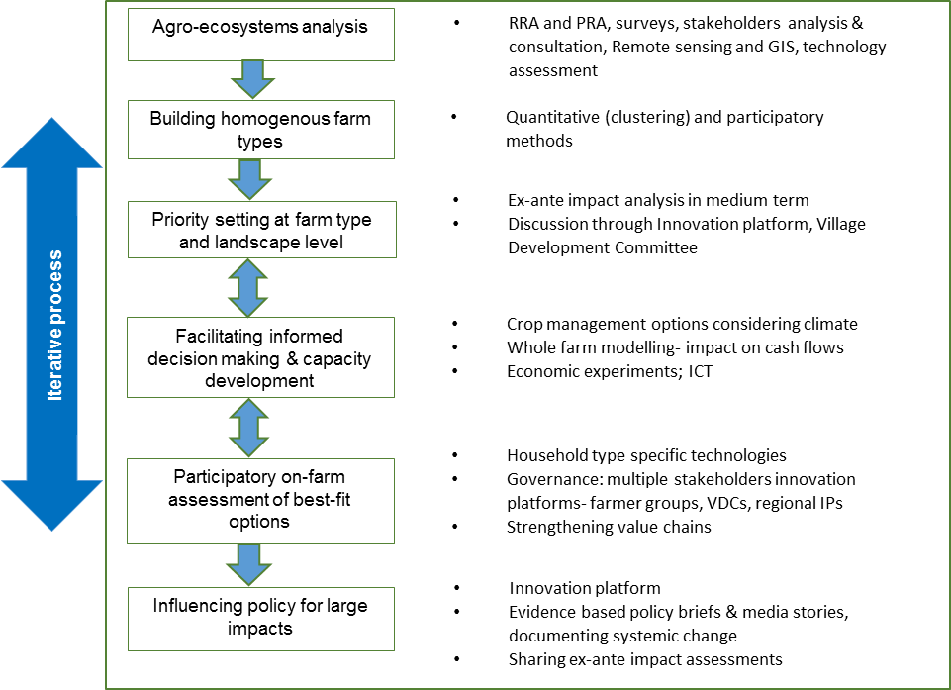
Figure 1: Framework for integrated systems approach implemented in South Asia
Tools used: Participatory rural appraisal, surveys, stakeholder analysis, spatial analysis, technology assessment, prioritization tools, statistical tools for farm typology building, ex-ante impact assessment, crop and household modelling, economic experiments and innovation platforms for technology adoption and value chain development.
Operationalization of Systems Research
Selection of action sites: The analysis of secondary data on socio-economic and agricultural indicators, spatial and climate variability analysis and stakeholder consultations were the basis of selecting three vulnerable dryland action sites and 15 action villages in Western Rajasthan (Barmer, Jodhpur, and Jaisalmer Districts), Andhra Pradesh (Anantapur, Kurnool Districts) and in Karnataka (Bijapur District) in India to demonstrate proof of concept and piloting the systems approach for enhancing farming systems resilience and income in the most vulnerable dry regions in India. As part of systems research we primarily focused on the ‘agricultural livelihood systems (ALS): agro-pastoral; rainfed cereal based; irrigated; and tree based systems. However in the South Asia region, these ALSs frequently overlapped with two or more ALS operating in the same sub-region, village or even farm.
Household survey: Well-designed household surveys (>1000 households) and participatory rural appraisal (PRA) in the 3 actions sites in India provided the socio-economic and agro-ecological basis to categorize households into farm typologies (Kumar et al. 2014; Dataverse 1, 2 & 3). The values of coefficient of variation (CV) in crop yields and net returns per standard animal unit indicated very high variability across farm households during the same agricultural year which was not significantly related to landholding size. Livelihood assets, access to institutional support, amongst other factors determined farm ‘trajectory,’ land use patterns, agricultural management practices. The farm-system typologies built based on key livelihood assets helped to explicitly understand the potential, expected and limitations of farms and thus develop a “recommendation domain”, which can be defined as “…a group of farm-systems, relatively homogenous, with similar circumstances, and for which we can make more or less the same recommendation.” (Giller 2013 ‎). A multivariate approach was used to exploit the large number of recorded variables in the most efficient way. Statistical analysis was carried out by using Principal Component Analysis (PCA) and Cluster Analysis (CA) (Usai et al., 2006; Rufino et al., 2013; Riveriro et al., 2013). Prior to building the farm typologies, the major constraints to the farming systems for the each selected village were identified based on focus group discussion (FGD) with farmers and stakeholders. Potential interventions were planned based on the available resources, preference and market and other incentives. The technological options were identified using technology assessment based on published literature and PRA as well as inputs from the multi-stakeholder innovation platform workshops.

Community engagement: Critical for developing effective and efficient solutions, was the acknowledgement of the specific needs of each community. Using data from primary surveys and FDG’s at three sites, we developed maps of how farming communities share resources to allow us to understand both the potential and the limitations of each community. NGOs, local government departments, and the farmers themselves, were then brought together to brainstorm for greater efficiency and to add value to their work. As a result of these discussions, a number of community-led solutions were designed and implemented from 2014 to 2016. Unfortunately, continuous budget cuts to CRP DS undermined the possibility to expand this work beyond the initial interventions.

Typologies to guide interventions: During this process, the major factors constraining agricultural production and livelihoods were prioritized for each farm typology by using pairwise comparisons of different constraints with farmer groups (Note that separate discussion with Men and Women were often required). The systems analysis and participatory approaches led to on-farm assessment and integration of multiple livelihood strategies based farm typology. Further, the estimation of composite sustainability indices (CSI) of each farm type guided investment decisions (Haileslassie et al. 2015). Such studies identify the livelihood factors influencing household resilience. A resilience capacity index was generated which includes variables on household expenditure on food and non-food, savings, food and feed reserves from a comprehensive socio economic panel data set. We then identified livelihood strategies through multi-factor analysis. The livelihood strategies reflect the heterogeneity in household characteristics. The newly developed resilience capacity index and derived livelihood strategies are a simple but promising way to understand the complexity of household level resilience (Ramilan et al., 2015).

Highlighting gender: The role of gender in agriculture and animal husbandry in the target villages and the vulnerability of women and men engaged in agriculture and allied enterprises was assessed in Rajasthan. Negative and high correlation coefficients (r values ranging from -0.64 to -0.96) indicated that gender roles were clearly segregated in the case of crop and animal husbandry activities. Data indicated that women were engaged in unpaid and unaccounted labour work involving drudgery. Vulnerability scale consisting of 20 statements revealed that women were highly vulnerable to livelihood insecurity in all target villages. Gender mainstreaming was the integral part of the systems approach to empower women in agriculture.

Multi-actor stakeholder engagement: In the systems approach, the key focus was on enabling participation of all relevant actors including smallholders, women and youth to find solutions to the given challenges. Enabling institutional mechanisms, strengthening value chains and enhancing the capacity of stakeholders to innovate were the key components of the systems approach. A village development committee (VDC) facilitated to be evolved in each action village was involved in planning, designing and implementing interventions as part of a systems approach. At district/region level, a multiple stakeholder innovation platform (IP) for technology adoption was facilitated in each action site. These IPs acted as innovation facilitators and contributed in the planning and co-design of need based interventions and enhancing linkages and convergence for success and upscaling of innovations. Interactions among all relevant actors; farmers, government departments, researchers, NGOs, industry and development institutions were encouraged to create innovations targeting sustainable resource management and enhanced economic viability and resilience of the farming systems (Blog 1).
Technology assessment: In complement with characterization of agro-ecosystems/livelihood systems, the technology assessment exercise was carried out using multiple data sources for all the three action sites. That provided a list and details of available technological options for enhancing farming systems resilience and income in the respective regions. The corresponding interventions were prioritized at two levels; first by the multi-stakeholders IP at regional level and then by farmer group (including VDCs) using ex-ante assessment and participatory methods (e.g. pairwise ranking) for each farm typologies. During the prioritization process, the stakeholders were exposed to various technological and institutional options as listed in the technology assessment report. All possible crop management options derived based on crop modelling outputs considering climate (forecast) were also considered. The farmers were encouraged to propose and discuss bets fit indigenous coping and adaptation strategies.
Based on the above analysis the best fit options were assessed on-farm as components of the integrated agro-ecosystem, targeting resilience and intensification at different scales: field, farm and landscape as well as household, community and value chains. The systems approach enabled acknowledging heterogeneity of agro-ecosystems and livelihood assets that led to development of location and farm household specific strategies and options. As a result context specific interventions for individual farm households’ type were complemented with landscape/community/value chain level interventions. Each action site have had different priorities; for example participatory assessment of natural resource management and institutional options for sustainable intensification of community silvi-pasture systems, integration of high value medicinal crops as well as rainwater harvesting were identified the key potential entry points in western Rajasthan.

On-farm trials and demonstrations: More than 1500 on-farm trials demonstrated suitable cultivars of cereals and legumes for cropping systems intensification and diversification, soil & water conservation, dual purpose crops, agro-horti-forestry systems and high value commodities (fruits, vegetables, medicinal plants) resulting in increased crop productivity by 18 to 150% over existing practices in different action sites. In the driest of areas in Western Rajasthan (<150 mm rainfall) Khadin water conservation systems, common silvi-pasture systems, agro-horti kitchen gardens, value chains of medicinal crops and small ruminant created enthusiasm and market led opportunities among the local stakeholders (Blog 2, 3, 4).
In collaboration with CCAFS climate smart villages, we facilitated arrangements to communicate seasonal rainfall forecast and model-based crop management scenarios to smallholder farmers (4 villages in Anantapuram and 3 villages in Bijapur district) in order to assist in informed crop planning for 2015. This could enable to provide alternative options for intercropping and short duration cultivars of cereals and legumes to help farmers cope with the difficult el Nino conditions of 2015.

Rehabilitation of degraded commons: As part of this initiative, we could successfully demonstrate participatory approaches for rehabilitation of severely degraded common pastures in 5 locations achieving increased productivity, equity, resource conservation and value for investment in community pastures. The management of common property resources (CPRs) and their synergistic linkages with farm systems was demonstrated and created awareness amongst key stakeholders for their sustainable management. The comprehensive understanding of the social-ecological systems around common property resources in dry areas of India focused on both the biophysical conditions and the socio-economic attributes of the community, the rules determining use of common resources, and the patterns of interactions among various actors which seemed to produce different outcomes in different scenarios.

An integrated approach for the rehabilitation of severely degraded community based silvi-pasture systems resulted in many fold increase in biomass yield (0.25-0.40 t/ha to 1.6 – 4.6 t/ha in 2 years). The proportion of edible species also increased from a baseline of 15 -24% desirable spp. to > 55%. The ex-ante impact analysis for 10 years’ time horizon indicates payback period of about three years with over 30% IRR. The participation of female livestock keepers was enlisted to manage common grazing areas which have become severely degraded due to poor governance. Our project created awareness amongst key stakeholders for the challenges in common property resources management. Communities were encouraged to design rules which gave every sub-group of the community equitable, but restricted, access and use rights to the land. Interestingly, across three sites different by-laws emerged. We believe that this is linked to different local situations for example social norms, livestock composition, feed and fodder supplies. The scale of decision making was decreased to the hamlet level. Women have played a key role in managing community-owned silvi-pastures where fodder grasses like Dhaman (Cenchrus ciliaris) and Sewan (Lasiurus scindicus), along with fodder and fruit trees, are grown. Four women sub-groups in Rajasthan and AP actively manage the pastures and harvesting, and sell the grass as livestock feed. Our research facilitated participation of all sections of users in formulating bylaws and governance structure, enhancing economic viability via introducing horticulture and agroforestry trees and highly productive and adapted grasses, as well as soil and water conservation measures to increase moisture availability and reduce soil loss. Community agreed mechanism for social protection of common silvi-pastures resources was key to their success. Active participation of all sections of the village ensured that the burden and benefits of new institutional arrangements are shared equitably.
Higher productivity of common pasture lands: The improved condition of pastures has enabled farmers, especially women, to herd goats and sheep. Improved breeding bucks provided to two women’s self-help groups helped in improving the animals' productivity. In the process another very useful innovation to improve market access occurred. High middlemen's market margin (10 percent to 35 percent) on the sale of live animals was a major constraint, so a weighing machine was introduced so that the locals could sell their own animals on the basis of weight. This (provision of information) improved their bargaining power and market integration. The women small ruminant keepers are now able to earn 25 percent to 30 percent more than what they were previously earning (Blog 5, 6).

Leadership of women: The women farmers in 15 villages adopted farming methods which show that there is hope to combat climate change impact in the drylands and move out of poverty. By facilitating leadership among rural women, innovations such as improved cereal varieties, fruit trees to provide nutrition and income, constructing embankments to improve the water table and prevent runoff and soil erosion, planting grasses and fodder trees to provide fodder for cattle were experimented with. The partnership with major stakeholders was the key to the success of the program promoting systems approach and featured in Al Jazeera and the Third Pole (Blog 7, 8, 9, 10, 11).

Cooperation and innovation: The systems approach enabled different farmers groups including women in a village and other stakeholders to work together and view the livelihood systems holistically. That led to new innovations: the farmers came forward to contribute to landscape level interventions, proactive role in value chains (medicinal herbs, small ruminants), and community level farm mechanization and seed production. These innovations resulted not only sustainable resource management and improved livelihoods at landscape and community level but farmers could see increased individual benefits by adopting systems approach. Participating in the CRP DS, smallholder farmers as well as related government and no-government actors/ departments, realized that effective solutions to many of their challenges could be found only by working together in a systems context. Such challenges in particular included the targeting sustainable natural resource management, mechanization, strengthening value chains and adapting to climate change/ variability. Some of the practical examples of the holistic systems approach implemented in India through CRP DS are depicted in Figure 2.

The process enabled optimal use of resources and encouraged collective action and local innovation. Context specificity resulted into differentiated focus in different action sites. For example in Rajasthan greater focus was on community level water harvesting (khadins), sustainable management of common pasture systems, integration of arid fruits and agroforestry as well as small ruminants and medicinal herb value chains along with millets and legumes. Participatory prioritization in AP suggested more on farm type specific interventions on in-situ moisture conservation, legume integration, farm level rainwater harvesting for high value crops and nutritional gardens by rural women. Mechanization assisted large scale moisture conservation for raising post rainy crops, integrating short duration pulses on rainy season fallows, dual purpose crops and recharging of open wells and efficient irrigation methods were the priorities in Karnataka.

Value chains and social capital
Type specific system components at farm level
NRM interventions at landscape level

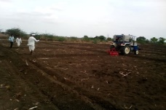
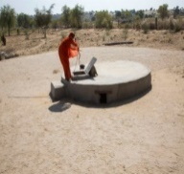
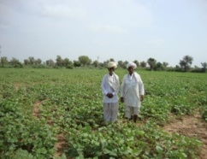
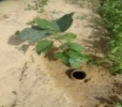
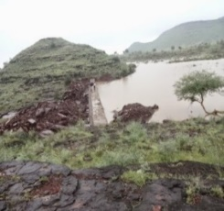
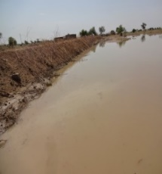
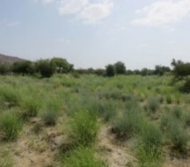
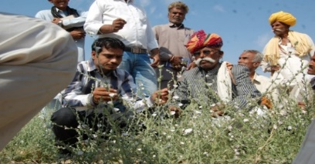
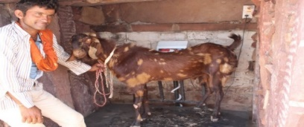
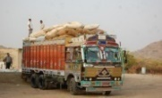
Diversification
Yield increase 20-120%
Increased income, food and nutrition security
Land restored 200 ha
Water table increased 10-15’
CPRs biomass yield increased by >100% Compartmental bunding/SWC increase yields by 20%, control erosion
High value commodities
Better market price
Increased farm family income (up to >tow folds)

Women empowered

Family khadin in Jaisalmer
Watershed/landscape

Community pasture

CBD in Bijapur

Women sub-committees- Village development committee- Multi-stakeholder innovation platform

Figure 2: Integrated systems approach implemented in Indian action sites

Creating market opportunities: As part of CRP DS stakeholders consultations and IP workshops played role of catalyst in identifying medicinal plants that grow wild in the region, motivating farmers to grow them as an intercrop that requires virtually no maintenance and linking them to a manufacturer of Ayurvedic (traditional Indian system of medicine) products, has hugely benefited farmers. The Shankhpushpi (Convolvulus pluricaulis), a native and naturally-occurring plant, was not cultivated by farmers due to lack of awareness and market. We facilitated a tripartite agreement in 2014 with Dabur India Ltd. (the largest herbal medicine manufacturing company in India) to buy back the produce and technical backstopping in terms of training the farmers is being done by ICRISAT and Krishi Vigyan Kendra, Barmer.

In the first year, 50 farmers came forward to cultivate Shankhpushpi. The additional income earned by farmers who grew Shankhpushpi attracted many other farmers. In the next year, 2015, about 500 farmers in five to six villages of Barmer district and then more than 1000 farmers from Barmer and neighbouring districts started cultivating Shankhpushpi during 2016 (without ICRISAT facilitation). The famers could earn an additional annual income of USD$75 to USD$600 by introducing this medicinal plant as an intercrop under arid rain-fed conditions. Another medicinal plant Jeevanti (Leptadenia reticulata), was introduced in 2015, and is being cultivated by 15 farmers. Jeevanti is a climber and planted as an intercrop with fruit trees. A farmer can earn around USD$4.50 to USD$6 per plant. Another drought-tolerant medicinal plant, Arna (Clerodendrum phlomidis), which was used for fencing and roofing, now has a buyback market providing an additional annual income of USD$90 to USD$320 per household. Furthermore, organizing these farmers into a medicinal plant growers group better facilitated the capacity building and collective marketing to the herbal medicine industry (Blog 12).

Another solution hit upon in community-led talks was the use of rainwater harvesting for perennial fruit-tree cultivation. Frequent failure of annual crops, millets and legumes due to drought is common in these dry areas. Hence the famers were encouraged to integrate fruit trees in order to stabilize farm income and enhance local nutrition. Intercropping legumes like moth bean, green gram and cluster bean with local fruit trees—ber (Ziziphus mauritiana) and gunda (Cordia myxa) and medicinal plants in Rajasthan; mango, sapota and citrus in Karnataka and AP—has been adding to the income of farmers.

Women particularly came forward to adopt agri-horticultural nutritional gardens directly contributing to improved household nutrition. As per their preferences, in one women's group, 20 women were given 20 fruit plants each and in another, 50 women were given 10 plants each. These units got started in 2014 in Govindpura and Mansagar villages of Jodhpur district; Dhirasar and Dhok villages of Barmer district; and, Didhu and Sankaria villages in Jaisalmer district. In AP, about 45 women contributed to household food security by adopting kitchen garden intervention. More than 150 farm women in Rajasthan and AP led the diversification through kitchen gardens, fodder development through CPRs, improving small ruminant productivity and selling them on weigh basis (blog 5, 6). Regular interactions with SHG members facilitated a platform for women to mobilize themselves and discuss issues that concern them. Gender responsive integrated approach has informed the initiatives and the impact of such interventions also has begun to manifest in increased participation of women. Two of these women from Rajasthan Geeta Devi from Jodhpur and Manibai from Barmer were recognized and got awarded a rural women leaders during the international women’s day.

Lessons leant:
- Acknowledgement of heterogeneity within communities and agro-ecosystems was critical for upscaling.
- Understanding agro-ecological and socio-economic systems and associated interactions with internal and external actors/components/drivers is important to identify entry points.
- Participatory identification and prioritization of context specific solutions.
- Ex-ante analysis needed to informs on economic benefits to individuals, households, community and development actors
- Nurturing inclusive institutional mechanisms (village to regional level) is critical to strengthen the capacity of community and stakeholders for increased adoption of innovations for improved livelihoods
- For sustainable management of common property resources (CPRs) all stakeholders should be given equal opportunity to participate in the governance structure. It should not only be dominated by the voluntary participants ready to join it in early phase of CPRs development.

Conclusions
Integrated systems research as implemented under CRP DS and its present analysis clearly indicates that the dryland smallholder farming systems occur within diverse agro-ecological and socio-economic environments and develop different livelihood strategies driven by opportunities and constraints encountered. Multiple livelihood assets determine different land use patterns and agricultural management practices in dryland systems in south Asia. Well-designed household survey on socio-economic and agro-ecological variables and statistical approach helped capture the diversity of livelihood assets to categorize households into homogenous farm typologies. The follow up FDG’s with farmers and stakeholder were equally important to validate farm typologies and prioritization of interventions. Engaging the innovation platform for identification of potential innovation options and their prioritization at district level; involving farmers for each farm typology, and ex-ante assessment of promising options led to the on-farm assessment of farm typology specific most appropriate interventions in the action villages. Landscape and community level options were prioritized with the VDC and proactive farmers. The institutional platforms experimented at village to regional level (VDCs, IPs) has strengthened the capacity of the community/stakeholders to innovate to improve the farming systems resilience and economic viability. An ex-post assessment demonstrates significant increase in farming systems productivity, household income and development of value chains as well as sustainable management of natural resource including CPRs. This study contributes to the understanding of how research for development through technology targeting for trajectory development can contribute towards stabilizing farm incomes, sustainable intensification and smoothening livelihood of resource poor farmers in vulnerable dry regions.
Integrated systems approach for dryland farming has helped farmers improve productivity and income. The complexity it entails is a challenge for government and non-government agents. Many times the impact is difficult to predict and measure where multiple system components interact. As a consequence, simple and standardised impact pathways are often preferred which ignore side effects and potential synergies. In Western Rajasthan, Karnataka and AP, a participatory approach, which allowed all involved parties to identify innovative solutions, has helped create markets and income earning opportunities and has facilitated self-organization among stakeholders. The key partners in this program included: Central Arid Zone Research Institute (CAZRI) Jodhpur, Agricultural University, Dharwad & Anantapur, the NGO’s- GRAVIS, RSDS, CORUS, AFEC, and SBMASS, Krishi Vigyan Kendra, Barmer and Dabur India Ltd. The activities implemented with ICARDA, IWMI, ILRI and Bioversity.

The CRP DS pave the way for actors at different levels in agricultural research and development—ranging from resource-poor women farmers to agricultural research, market and development policymakers to better interact. By doing so, they could bring their different perspectives and insights into the process of understanding the dynamics of the system and exploring how to deal with them. This made them better able to react quickly, flexibly and creatively to shocks, challenges and opportunities. Thus, the capacity to innovate is key for resilience—that is, for the survival and well-being of society.

Future Challenges/ way forward:

The proof of concept and pilots undertaken in the CRP DS have successfully demonstrated the utility of an integrated system approach as one of most effective strategies for enhancing farming systems resilience and improving rural livelihoods in resource poor dry areas. Although the major stakeholders including smallholder farmers also largely accept the suitability and need of the systems approach, scale such an approach is challenging. It’s important to highlight the following points in this context.

- Implementation of system research is facilitation intensive for which local development actors are generally trained to provide. The concept of an innovation platform as part of systems approach is very important to play the role of innovation broker and bring multiple actors on common platform. In a country like India with vast public extension services, the establishment and coordination of such innovation platform needs to be institutionalized through government extension apparatus.
- There is need for continuous effort to change the mind set of relevant stakeholders and build their capacity and awareness at different levels to able to implement the systems approaches.
- The capacity strengthening is needed for local partners on various participatory approaches and systems/ modelling tools.
- Programs like CRP DS could play an important role in institutionalizing and promoting systems approaches in the dryland, however the implementation of a systems CRP for a short period, cutting funding and abruptly ending the program undermined the possibilities to replicate these successes.
- There is need for horizontal coordination to engage with policy-makers at all levels to ensure that a supportive policy environment is in place to promote systems approaches for enhancing farming systems resilience and smallholder farmers livelihoods.

References
- CRP DS 2013. New Research Approaches to improve drylands agriculture to deliver a more prosperou future. CGIAR Dryland Systems Research Program, c/o International Center for Agricultural Research in the Dry Areas (ICARDA)
- Giller, K.E. 2013. Can we define the term ‘farming systems’ A question of scale. Outlook on agriculture, 42, doi 10.5367/oa.2013.0139
- Haileslassie Amare, P Craufurd, Thiagarajah Ramilan, Kumar, Shalander, Anthony Whitbread, Abhishek Rathor, Michael Blummel, Polly Ericsson, Krishna Reddy Kakumanu 2016. Empirical evaluation of sustainability of divergent farms in the dryland farming systems of India. Ecological Indicators 60: 710–723 doi:10.1016/j.ecolind.2015.08.014
- Keating, B. A., Carberry, P. S., Bindraban, P. S., Asseng, S., Meinke, H., & Dixon, J. 2010. Eco-efficient agriculture: concepts, challenges and opportunities. Crop Science, 50, 109–119.
- Kumar S., Whitbread, A. Bhati TK., 2016. Integrated ecosystems approach for sustainable intensification of community based Silvo-pastoral systems in arid Western Rajasthan, India: Implications for upscaling. World Congress Silvo-Pastoral Systems: functions, management and Systems in a changing world, Evora, Portugal, 26-30 September 2016. https://www.researchgate.net/publication/309033227
- Kumar Shalander, S Nedumaran, Ranjit Kumar, Anthony Whitbread. 2016. Livelihood Security and Farmers Prosperity in SAT Agriculture. 4th International Agronomy Congress, New Delhi 22-26 December 2016
- Kumar Shalander, Whitbread, A., Falk, T. 2016. Institutionalizing governance arrangements for sustainable management of community based Silvi-pasture systems in arid ecoregions in Rajasthan, India. World Congress Silvo-Pastoral Systems, Evora, Portugal, 26-30 September 2016. https://www.researchgate.net/publication/309033072
- Kumar, Shalander, Haileslassie Amare, Thiagarajah Ramilan; Wani, Suhas P. 2014. Assessing different farming systems for enhancing farm income and resilience in extreme dry region of India to 58th National AARES conference, Port Maquarie NSW, Australia, 4-7 February 2014,p. 54
- Kumar, Shalander, Whitbread A and Falk T. 2016. Pathways to Sustainable Intensification: Participatory Designing of Adapted Farming System Innovation, Solutions Journal, September 2016 issue: https://www.thesolutionsjournal.com/article/pathways-sustainable-intensification-participatory-designing-adapted-farming-system-innovations/
- Kumar, Shalander, Whitbread A, Ramilan T, Bhati T. Institutional and technological options for sustainable intensification of community based Silvi-pasture systems in arid ecoregions. 23rd International Grassland Congress, November 20-24, 2015, New Delhi. http://oar.icrisat.org/9339/
- Kumar, Shalander, Whitbread A, Ramilan T. Institutionalizing Systems Approaches for Improving Agricultural Livelihoods in an Arid Ecoregion of South Asia. 5th International Symposium for Farming Systems Design, 7-10 September 2015, Montpellier, France. http://oar.icrisat.org/9338/
- Maarten van Ginkel & Jeff Sayer & Fergus Sinclair & Aden Aw-Hassan & Deborah Bossio & Peter Craufurd & Mohammed El Mourid & Nasri Haddad & David Hoisington & Nancy Johnson & Carlos León Velarde & Víctor Mares & Andrew Mude & Ali Nefzaoui & Andrew Noble & K. P. C. Rao & Rachid Serraj & Shirley Tarawali & Raymond Vodouhe & Rodomiro Ortiz 2013. An integrated agro-eco system and livelihood systems approach for the poor and vulnerable in dry areas. Food Security, DOI 10.1007/s12571-013-0305-5
- Riveiro, J.A., Mantecón, A.R., Álvarez C.J. & Lavine, P. 2013. A typological characterization of dairy Assaf breed sheep farms at NW of Spain based on structural factors. Agricultural systems 120, 27-37
- Rufino, M.C., Thornton, P.K., Ng’ang’a, S.K., Muitie, I., Jones, P.G., Van Wijk, M.T. & Herrero, M. 2013. Transition in agro-pastoralist systems of East Africa: impacts on food security and poverty. Agriculture ecosystems and Environment 197, 215-230
- Kumar, Shalander, Anthony Whitbread and Thomas Falk 2016. Demand driven sustainable land management in dryland regions in India. UNFCC and Dryland Systems Write shop on Scaling up sustainable land management best practices, 11-13 April 2016, Amman, Jordan
- Usai, M.,G., Casu., S., Mille, G., Decandia, M., Ligioos, S., Carta, A. 2006. Using cluster analysis to characterize the goat farming system in Sardinaia. Livestock science, 104, 63-76

Blogs/success stories
- http://www.icrisat.org/newsroom/latest-news/happenings/happenings1625.htm#3
- http://www.hindustantimes.com/jaipur/desert-farmers-on-the-path-to-economic-self-reliance/article1-1353429.aspx
- http://www.icrisat.org/newsroom/latest-news/happenings/happenings1693.htm#1
- http://www.icrisat.org/newsroom/latest-news/happenings/happenings1699.htm
- http://www.icrisat.org/newsroom/latest-news/happenings/happenings1638.htm#5
- http://drylandsystems.cgiar.org/content/community-led-solutions-india%E2%80%99s-drylands;
- http://www.aljazeera.com/indepth/inpictures/2015/11/women-lead-poverty-indian-desert-151117123726261.html
- http://www.thethirdpole.net/2015/11/26/rajasthani-women-farmers-combat-climate-change-in-the-desert/
- http://www.thehansindia.com/posts/index/2015-11-29/COP21-Indian-women-leading-the-fight-against-climate-change-189667
- http://www.ruralmarketing.in/industry/case-studies/women-farmers-combating-climate-change-in-rajasthan
- http://timesofindia.indiatimes.com/city/hyderabad/Rajasthans-women-farmers-beat-climate-change-global-warming/articleshow/49935536.cms
- http://timesofindia.indiatimes.com/city/jaipur/Herb-cultivation-benefits-western-Rajasthan-farmers/articleshow/48417637.cms

Data verse created
- http://dataverse.icrisat.org/dvn/dv/crpds/faces/study/StudyPage.xhtml?globalId=hdl:11038/10143
- http://dataverse.icrisat.org/dvn/dv/crpds/faces/study/StudyPage.xhtml?globalId=hdl:11038/10146
- http://dataverse.icrisat.org/dvn/dv/crpds/faces/study/StudyPage.xhtml?globalId=hdl:11038/10152

