Training Course Technical Report
Advanced Technologies to Improve Sheep and Goat Production
2017-05-07/2017-05-18
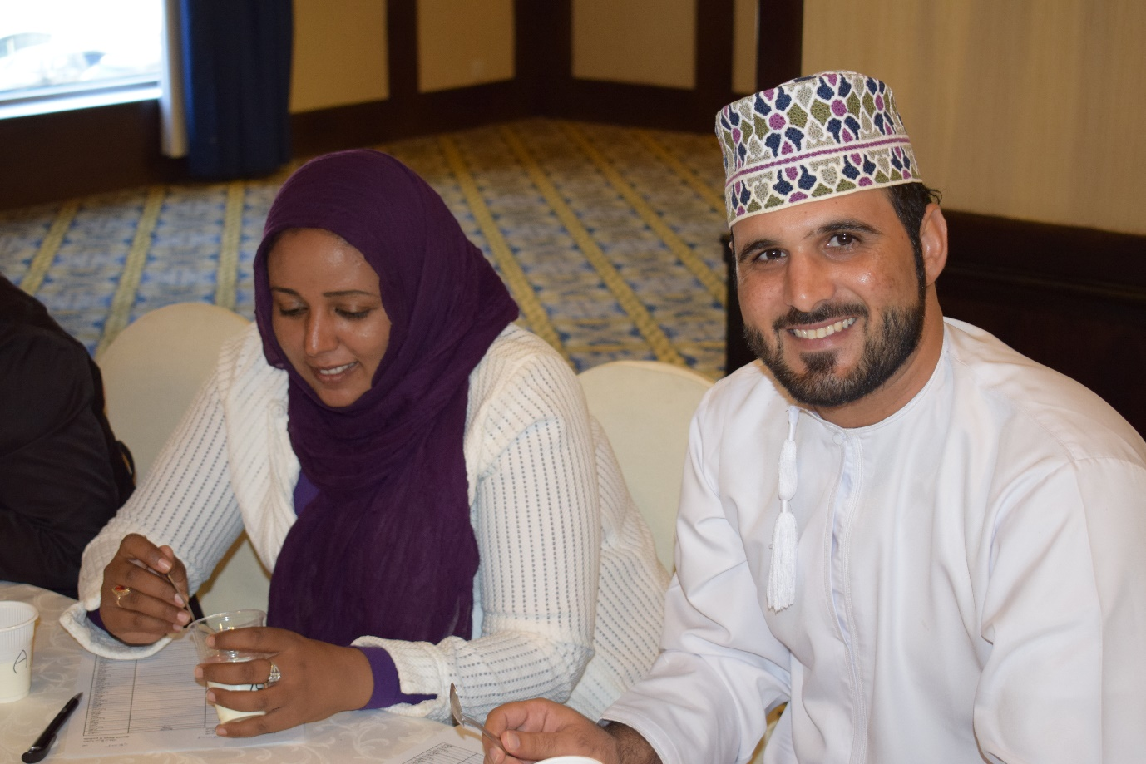
Amman, Jordan
Funded By:
Arab Fund for Economic and Social Development
Conducted By:
The International Center for Agriculture Research in the Dry Areas
In collaboration with:
National Center for Agricultural Research and Extension




Executive summary:
Name of the project:
Technical assistance to ICARDA’s training activities in the Arab countries
Donor
Arab Fund for Economic and Social Development (AFESD)
Partners
National Center for Agricultural Research and Extension (NCARE)
Purpose:
The purpose of the course is to enhance capacity development of government officials and researchers who are engaged in agricultural development in Arab countries.
Specific objectives of the training course of the Training Course:
to strengthen capacity in livestock research and extension in the field of sheep and goats production; to share new advances in the different areas of sheep and goats management (system management, breeding, feeding, reproduction, health, products processing and quality), to learn about the research activities and practical experiences of the trainees in their home countries and to develop partnerships with National Agricultural Research System (NARS) counterparts by the establishment of a knowledge exchange platform.
Specific outputs:
Twelve professionally-trained NARS partners from Tunisia (1), Sudan (2), Algeria (1), Morocco (1), Egypt (1), Lebanon (1), Jordan (1), Iraq (1), Palestine (1), Egypt (1) and Oman (1) were trained on advanced technologies to improve Sheep and Goat Production. Among them were seven females and five males.

General overview:
One distinctive feature of dryland livelihood systems is the key role of livestock in securing household income and asset security and alleviating rural poverty. Sheep and goat production is an integral part of crop-rangeland-livestock farming in the dry regions of the Near East, North Africa, Central Asia and South Asia. They are the primary form of savings, as living assets for the poor, and their products are an important source of income for rural women, who rank among the poorest livestock keepers. Over the last three decades, there have been significant increases in both the small ruminant population and production in drylands. This in turn has caused unrelenting pressure on natural resources, primarily on rangelands that are gradually giving way to desertification. With the gloomy predictions of high population growth in these developing countries, it is likely that constraints on both the land and food supply will become increasingly evident in both the mixed crop/livestock and grazing systems. On the other hand, projected increases in the demand for livestock products in these countries presents significant opportunities for poor livestock keepers to increase incomes and build assets to improve their livelihoods. The proposed intensive training course will tap into existing, already validated and new technologies to enhance sheep and goat production in drylands. It will target professionals in the national systems of selected Arab countries from NENA region both at the research and the development levels.

General objectives:
The main objectives of the course are as follow:
- To strengthen capacity in livestock research and extension in the field of sheep and goats’ production;
- To share new advances in the different areas of sheep and goats management (system management, breeding, feeding, reproduction, health, products processing and quality);
- To learn about the research activities and practical experiences of the trainees in their home countries and to develop partnerships with National Agricultural Research System (NARS) counterparts by the establishment of a knowledge exchange platform.

Target audience:
The training course is set to target twelve (five males and seven females) participants, from countries (Tunisia, Lebanon, Morocco, Oman, Sudan, State of Palestine, Egypt, Algeria, Iraq, and Jordan), funded by AFESD.

Organizing committee:
- Dr. Mourad Rekik, Senior Small Ruminant Production Scientist, The International Center for Agriculture Research in the Dry Areas
- Mr. Charles Kleinermann, Head, The International Center for Agriculture Research in the Dry Areas
- Mr. Masafumi Tamura, Technical Training Officer, The International Center for Agriculture Research in the Dry Areas

Course structure:
The course accounts for at least 60 theoretical and practical hours spread over two weeks. It is organized into 6 diﬀerent modules and a large share will be dedicated to practical demonstrations and field applications: 1. Module 1: Small ruminants’ disease epidemiology and control (Week I) 2. Module 2: Reproduction of sheep and goats, reproductive rhythms, interactions nutrition x reproduction, field packages to improve reproductive outcome under arid environments (Week I) 3. Module 3: Breeding programs of sheep and goats, phenotypic and genetic characterization, case studies presented by participants, guidelines for community based breeding programs (Week I). The 3 modules in week 1 were illustrated by 2 field visits: one to Khanassri station with a focus on sheep breeding, reproduction and health and the second to El Wala pilot station focusing on the specific case of Shami goat conservation and breeding efforts in Jordan. 4. Module 4: Genomic characterization of sheep and goats and new genomic tools for a higher efficiency of sheep and goats breeding programs (Week II). 5. Module 5: Forage production and feeding management, nutritional management and optimization of feeding systems (Week II) 6. Module 6: Value addition/ Processing of animal products (Week II). During this second week, at least 2 laboratory sessions were implemented and during which the participants were introduced to the manufacturing of several sheep dairy products (fresh cheese, yoghurt, ricotta…) and sensory panels were organized.

Course implementation:
The course implementation and program is summarized in the course agenda (Annex 1). The course progressed according to schedule with no major changes to be mentioned. High level of commitment and presence was shown by the trainees throughout the theoretical and the practical parts of the course.

Group Assessment:
Several assessments were organized during the course. Each lecturer while delivering his courses or during the practical work and field visits had the opportunity to assess individually some of the trainees in the course. A more formal, group assessment of all the trainees took place during the last day of the training when all lecturers asked questions related to the material they presented. The assessment was more of a knowledge acquisition test and its results are confidentially shared among the teaching staff.

General Course Evaluation by Trainees:
The contents of the course were well received and importance was noticed. Clarity, level and interaction was on high level. Time allocation for discussions could be improved. Time allocation and usefulness overall were good. Teaching aids were well used. Administrative arrangements were on high level, while transportation and payment of allowance should be improved. The use of case studies was highly appreciated and nearly all participants recommended to take the course in the future.

Conclusion:
Content and style of delivery of the course were valued and highly appreciated. For the future, trainees suggested to allow more time for the course in general especially for field and lab visits as well as discussions. If media such as Skype is used it should only be in emergencies as it is affecting clear delivery of the content.

Annex I: Training Program
Day 1: Sunday, 7 May 2017
08:30-09:30 | Registration and opening | C. Kleinermann
09:30:10:00 | Overview of program - Introductions | M. Rekik
10:00-10:30 | Coffee break
10:30-11:30 | Production systems and main challenges | M. Rekik
11:30-12:30 | Epidemiology of small ruminant diseases | M. Gharbi
12:30-13:30 | Lunch
13:30-15:00 | Reproductive rhythms of sheep and goats | M. Rekik
15:00 – 15:30 | Coffee break
15:30-16:30 | Small ruminants’ diseases (part I) | M. Gharbi
Day 2: Monday 8 May 2017
08:30-09:30 | Main areas of control means of reproduction in sheep and goats | M. Rekik
09:30:10:00 | Small ruminants’ diseases (part II) | M. Gharbi
10:00-10:30 | Coffee break
10:30-12:30 | Phenotypic characterization and breed description (concept of Production Environmental Descriptors) | A. Haile
12:30-13:30 | Lunch
13:30-15:00 | Control of small ruminant diseases | M. Gharbi
15:00 – 15:30 | Coffee break
15:30-16:30 | Interactions between nutrition and reproduction in sheep and goats | M. Rekik
Day 3: Tuesday, 9 May 2017
8:00 – 16:00 | Field Visit – Khanassri Station (NCARE) – Awassi sheep breeding – Reproduction – Health management | M. Rekik; M. Gharbi; A. Haile
Day 4: Wednesday, 10 May 2017
08:30-10:00 | Case studies to be presented by participants: sheep and goats breeding programs/ Breeding objectives and selection criteria | A. Haile
10:00-10:30 | Coffee break
10:30-12:30 | Field packages to improve reproductive outcome under low input systems | M. Rekik
12:30-13:30 | Lunch
13:30-15:00 | Community based breeding program: concepts and organization | A. Haile
15:00 – 15:30 | Coffee break
Day 5: Thursday, 11 May 2017
09:00-15:00 | Field visit – El Wala Station (MoA) Shami goat breeding | A. Haile; M. Rekik
Day 6: Sunday, 14 May 2017
08:30-10:00 | Integrated Crop-Livestock Production Systems | S. Hassan
10:00-10:30 | Coffee break
10:30-11:30 | Nutritional Management | J. Wamatu
11:30-12:30 | Milk Production and quality | M. Hilali
12:30-13:30 | Lunch
13:30-15:30 | Past efforts at genetic characterization of animal genetic resources and their drawbacks | J. Mwacharo
15:30 – 16:00 | Coffee break
Day 7: Monday, 15 May 2017
08:30-10:00 | Principles of proper rangelands grazing management | S. Hassan
10:00-10:30 | Coffee break
10:30-11:30 | Recent developments at genetic characterization of animal genetic resources | J. Mwacharo
11:30-12:30 | Introduction to meat processing | M. Hilali
12:30-13:30 | Lunch
13:30-15:00 | Optimizing Feeding Systems | J. Wamatu
15:00 – 15:30 | Coffee break
15:30-16:30 | Milk processing (cheese and yogurt) | M. Hilali
Day 8: Tuesday, 16 May 2017
08:00-12:30 | Practical session – Mushaggar station – dairy processing | M. Hilali
12:30-13:30 | Lunch
13:30-15:00 | Alternative Feed Resources | J. Wamatu
15:00 – 15:30 | Coffee break
15:30-17:00 | Discussions: Participants present individual country efforts at genetic characterization of animal genetic resources | J. Mwacharo
Day 9: Wednesday, 17 May 2017
08:00-13:00 | Field Visit – Karak district – Sheep milk processing | M. Hilali
13:00-14:30 | Lunch
14:30-16:00 | Sensory evaluation of dairy products | M. Hilali
Day 10: Thursday, 18 May 2017
08:30-10:00 | Control of acquired knowledge | M. Hilali; S. Hassan
10:00-10:30 | Coffee break
10:30-12:30 | Course evaluation and closing | T. Masafumi
12:30-13:30 | Lunch

Annex II: Trainers
Name & Surname | Institution | E-mail
Dr. Aynalem Haile | The International Center for Agriculture Research in the Dry Areas | A.Haile@cgiar.org
Dr. Jane Wamatu | The International Center for Agriculture Research in the Dry Areas | j.wamatu@cgiar.org
Dr. Joram Mwacharo | The International Center for Agriculture Research in the Dry Areas | J.Mwacharo@cgiar.org
Dr. Mohamed Gharbi | National School Veterinary Veterinary; École Nationale de Médecine Vétérinaire de Sidi Thabet | gharbim2000@yahoo.fr
Dr. Mourad Rekik | The International Center for Agriculture Research in the Dry Areas | m.rekik@cgiar.org
Dr. Muhi El-Dine Hilali | The International Center for Agriculture Research in the Dry Areas | M.HILALI@CGIAR.ORG
Dr. Sawsan Hassan | The International Center for Agriculture Research in the Dry Areas | s.hassan@cgiar.org

Annex III: Trainees
Country | Name & Surname | gender | Institution | E-mail
Tunisia | Samia Mleil | female | Institut National de la Recherche Agronomique de Tunisie; National Agricultural Research Institute of Tunisia | mleilsamia@live.fr
Lebanon | Celine Berbari | female | Lebanese Agricultural Research Institute | celineberbari1@gmail.com
Morocco | Samira El Otmani | female | Institute National de la Recherche Agronomique de Morocco | elotmani.samira@gmail.com
Oman | Sami Hamed Al-Hashmi | male | Ministry of Agriculture and Fisheries, Sultanate of Oman | samizo12345@gmail.com
Sudan | Elfadil Mohamed Eltayeb Elbashier | male | Agricultural Research Corporation | elfadilalbasheer@yahoo.com
Sudan | Fatima Ali Ahmed | female | Agricultural Research Corporation | fatimamokhtar86@gmail.com
State of Palestine | Mousa Rizq Khaled | male | National Agricultural Research Center | agro.mousa.rizq@gmail.com
Egypt | Nehal Metwally El Hendawy | female | Agricultural Research Center (ARC) Egypt - Animal Production Research Institute | h.agriculture@yahoo.com
Algeria | Faiza Yahiatene | female | Institut Technique des Elevages | yahiatene_faiza@yahoo.fr
Iraq | Fandia Husain Hady | female | Iraq Ministry of Agriculture | farahhady1@mail.com
Jordan | Ahmad Hassen Al amareen | male | National Center for Agricultural Research and Extension | ahmad_alathamma@yahoo.com

Annex IV: General course Evaluation
1. Contents of the course
Item | Score
Relevance of the course to your job | 3.82
Accomplishment of subject matter | 4.45
Clarity of course objectives | 4.55
Level of lectures | 3.91
Time allocated for discussion | 2.82
Interaction with participants enrolled in the course | 4.55
Overall, how would you rate this course | 4.55
2. Schedule and time allocation
Item | Score
Percentage of time allocated to lectures | 3.91
Usefulness of lectures | 4.36
How much time was allocated to the technical field/lab visits | 4.27
How would you rate the usefulness of the technical field/lab visits | 4.73
3. Teaching aids
Item | Score
Effectiveness of teaching aids in general | 4.18
Clarity of slides/overheads/Powerpoint | 4.36
Handouts and material | 4.27
4. Administrative arrangements
Item | Score
Pre-course communication | 4.55
Travel arrangements | 3.45
Quality of the accommodation | 3.27
Payment of allowance on time | 2.00
Transportation | 2.55
Lecture rooms | 4.27
6. Questions for the case studies
Item | Score
How useful were the case study sessions to you? | 4.27
How interactive were the case study sessions? | 4.55
How would you rate the clarity of speech during these presentations | 4.09
Did the case studies present opportunities to learn experiences from other countries | 4.36
Overall, how would you rate the sessions | 4.27
Would you recommend these sessions to be taken in future courses? | 1.91

7. Comments and suggestions on the course
1) Please state the three most important ideas/concepts that you learned from this course:
- The breeding season and the factor that influences this period
- What is the anestrus period and how we reduce it
- how we produce cheese and yogurt
- More ideas about forage analysis, near infrared.
- New look for using many crop and their leftover as a forage.
- Interaction with my colleague about their project.
- Importance of strong network programmes between countries to solve problems or to share knowledge
- Highlights to the foreign or exotic knowledge simultaneously with our knowledges
- I learned a lot about oestrus synchronization, breeding program and possible to improve it , and systems of production.
- I have gained a lot of knowledge and information about alternative feed resources, feed program, and possible ways to enhance feed stuff quality and quantity.
- I have learned about milk processing and examination of milk, also evaluation of products.
- Have an idea about different specialties in animal production, other than our specialty
- Learn about new races: 1) Importance of genomic in genetic improvement. 2) Importance in finding alternative resources to improve breeding. 3) Importance of the definition and characterization of the systems
- ideas about mechanical milking and manufacturing of the cheese and yogurt
- alternatives for forage production
- have ideas to manage better the different routes and calculations
2) Suggestions for future improvement of the course:
- Skype lecture was less clear and difficult to communicate for discussion.
- Increase time of course (more than 2 weeks)
- More time for visit Labs and field work
- It could have been better to have two topics per day

3) Do you recommend this course to be repeated in the future?
Yes: 100% No: 0%

